**HOME CHALLENG (LED SHOULD GLOW WHEN LIGHT IS PROVIDED TO THE ARDUINO)**

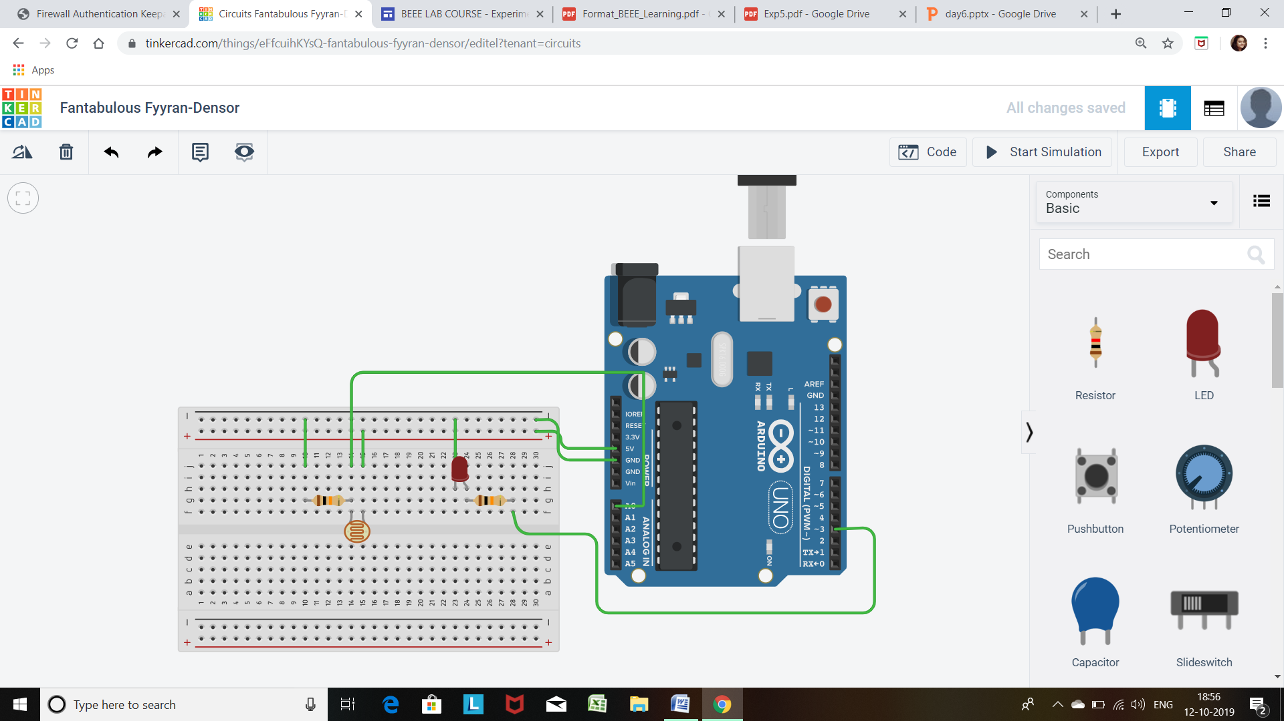

**CODE**

int sensorpin=A0;

int ledpin=3;

int sensorvalue=0;

void setup()

{

Serial.begin(9600);

pinMode(ledpin,OUTPUT);

}

void loop()

{

sensorvalue=analogRead(sensorpin);

Serial.println(sensorvalue);

If (sensorvalue<370)

{

digitalWrite(ledpin,HIGH);

}

else if (sensorvalue>370)

{

digitalWrite(ledpin,LOW);

}

}