**Car and Bike Insurance**

**When the customer knows the car number-Fastlane flow**

1. Quote page

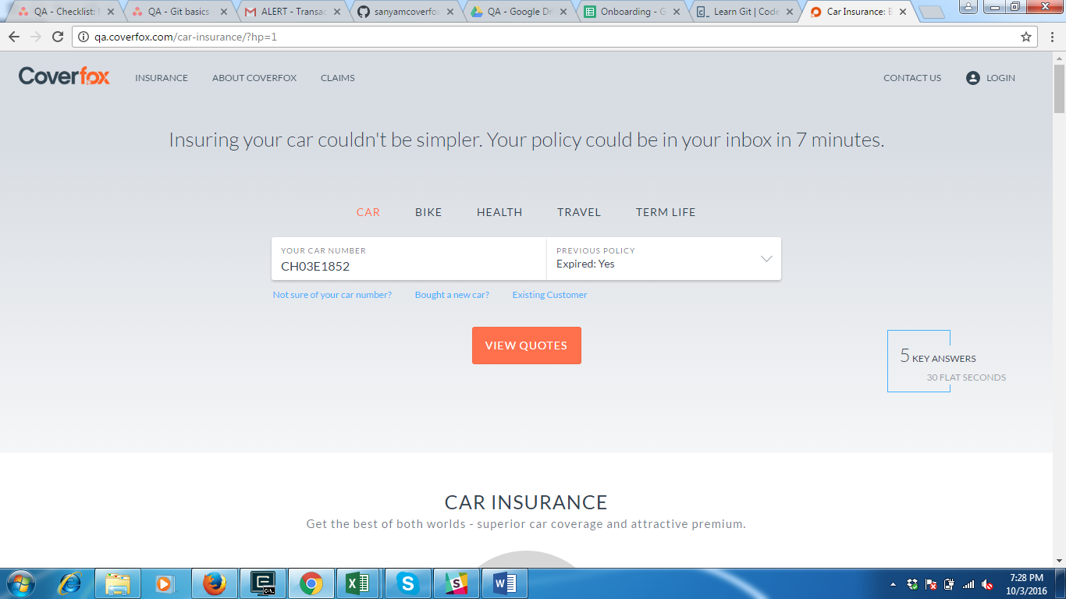

2a). Expired -> Yes

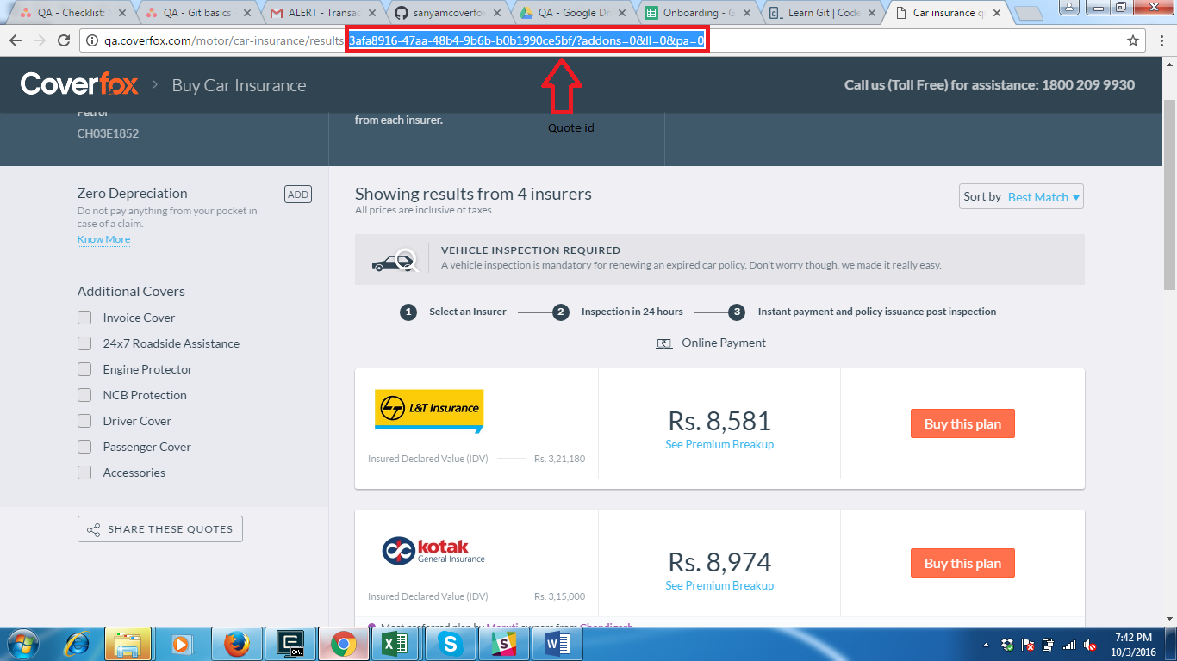

Under Additional covers, there are additional benefits provided by the insurers. And the amount of insurance plan will increase after adding covers.

3. Quote Result page

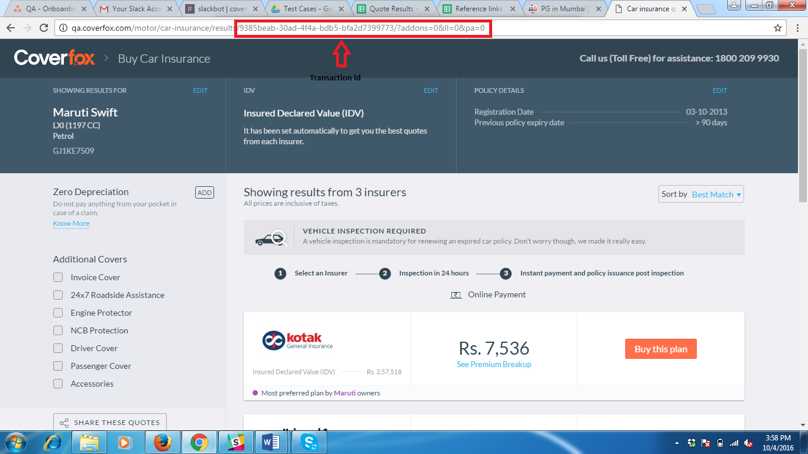

4. Car proposal form

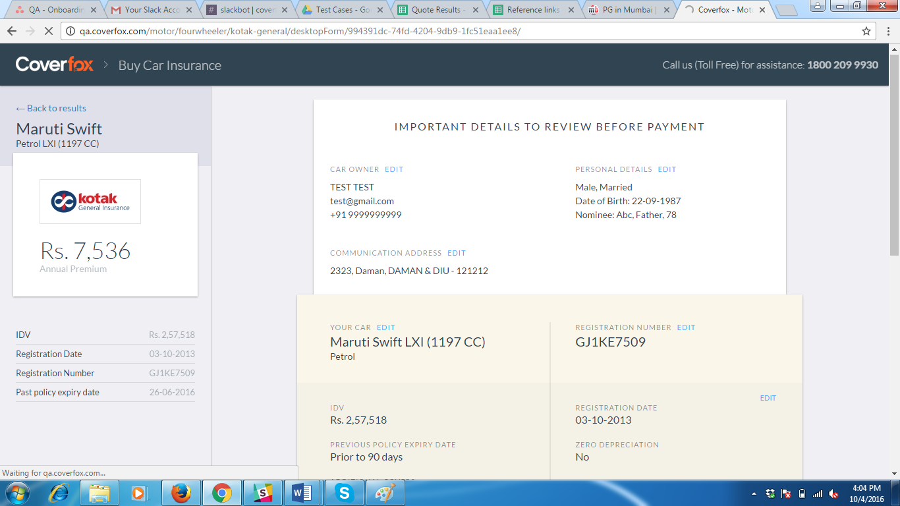

5. Inspection page

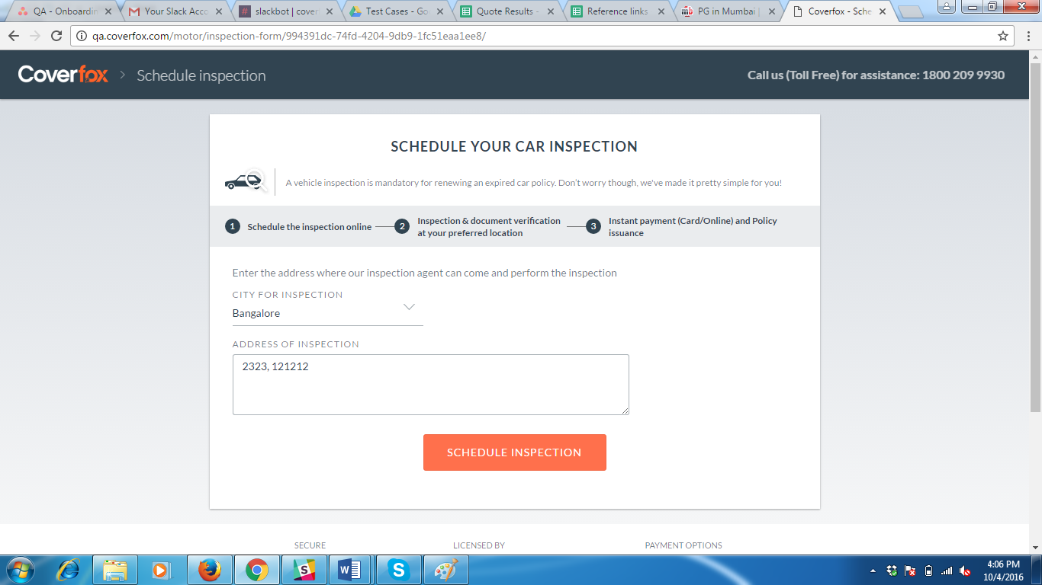

2b) Expired-> Not Claimed-> Not

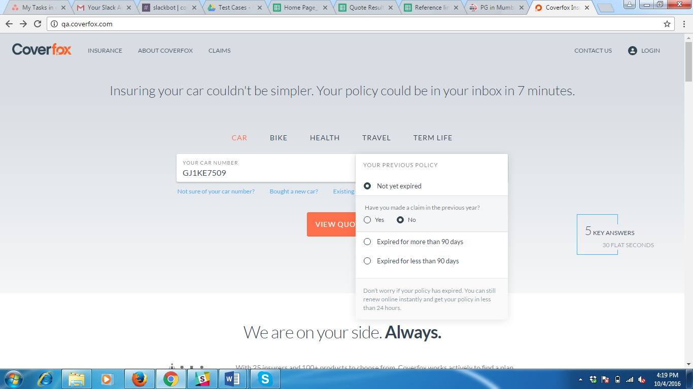

Now, the customer might have got some bonus for not claiming for insurance.

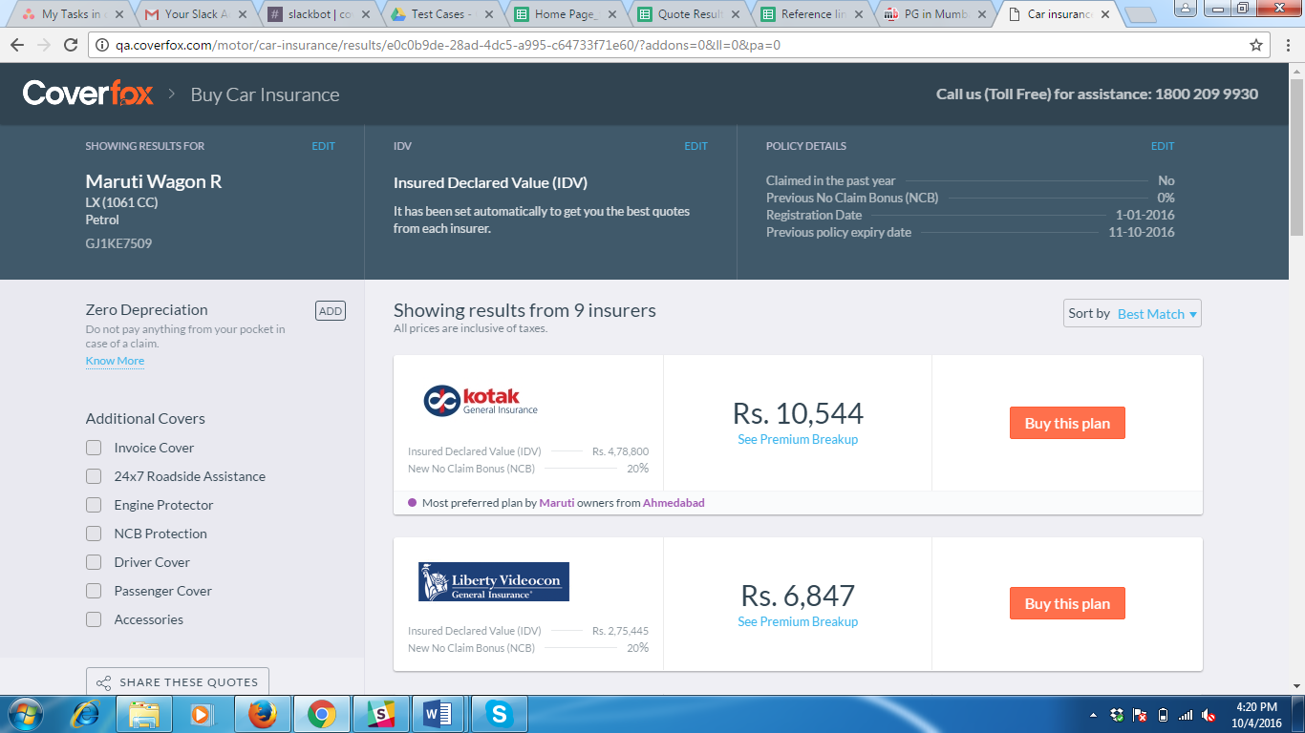

The amount for New No Claim Bonus will be revised according to the Previous No Claim Bonus amount.

2c) Expired -> Not Claimed-> Yes

Things will be same like mentioned under 2a).

**Remember:** *When the insurance policy is not expired, then it doesn’t require any inspection.*

**Payment Gateway**

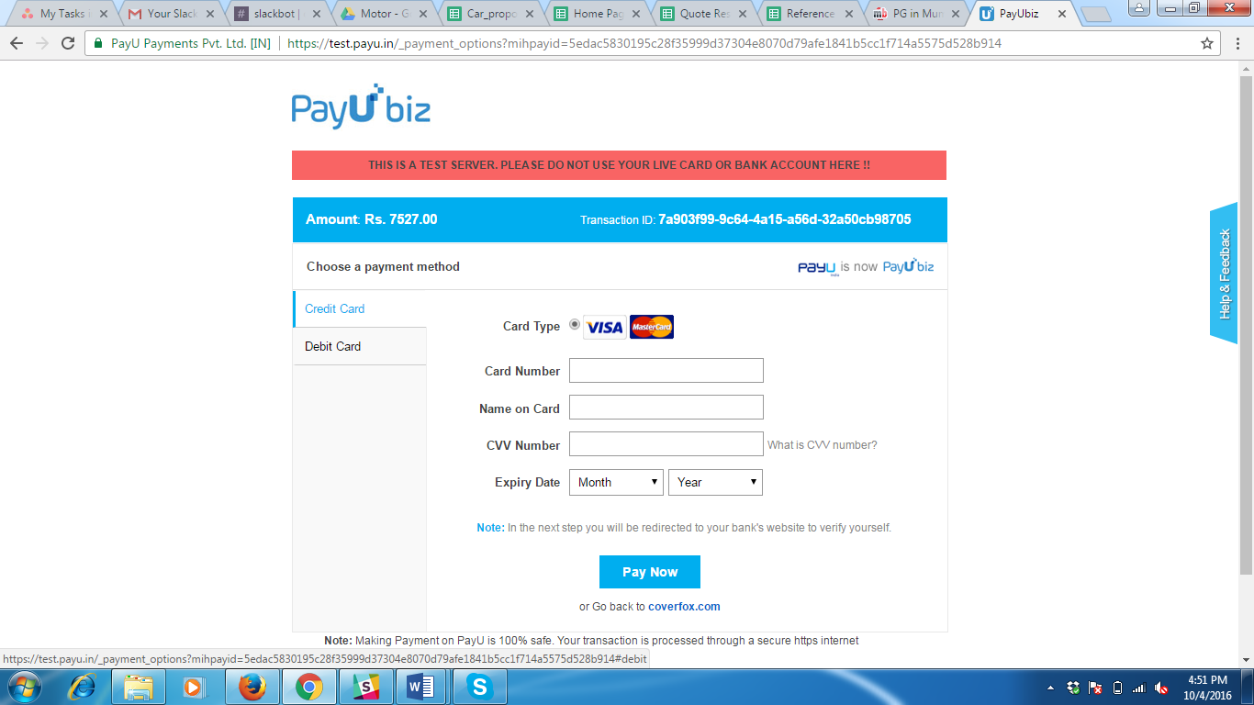

**When the customer doesn’t know the car number-Fallback flow**

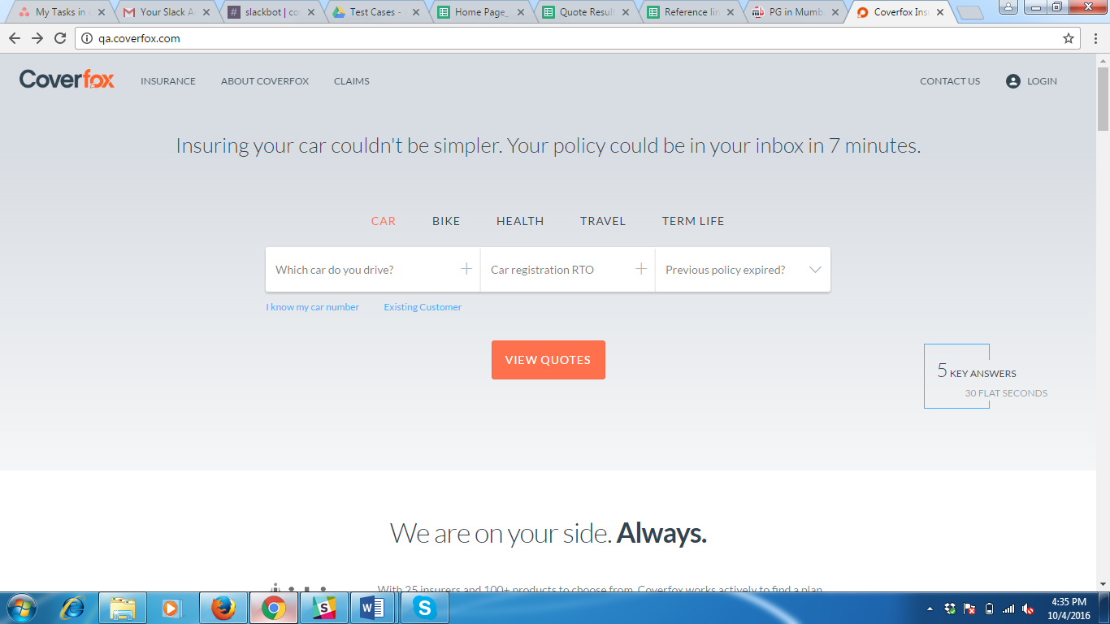

**When the customer is buying a new car**

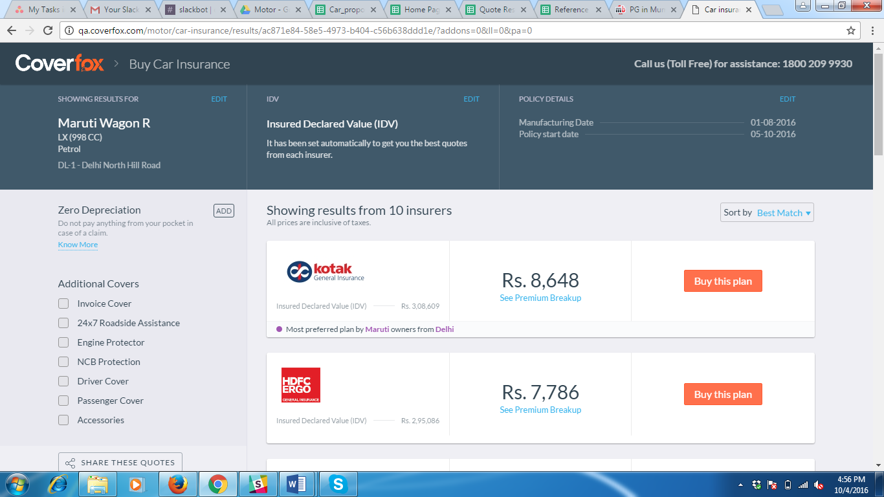

Now, the policy start date will be one day later than the current date.

**Landing Page**

**Url:** https://www.coverfox.com/lp/car-insurance/insurer/

