**Project Report**

**Of**

**Internship cum Training**

**At**

**Virtusa**

**On**

**Vyantra Mart**

**By**

**Sanyam Goyal , Anusha Khurana,**

**Avleen Kaur**

***DEPARTMENT OF COMPUTER SCIENCE & ENGINEERING***

**CHITKARA UNIVERSITY INSTITUTE OF**

**ENGINEERING AND TECHNOLOGY**

**JULY-2020**



**ACKNOWLEDGEMENT**

The Internship opportunity We had with "Virtusa'' was an amazing opportunities for learning and master unforeseen development. Thusly, We consider ourself to be an incredibly blessed individual as We are outfitted with an opportunity to be a bit of them. We are in like manner appreciative for getting a chance to meet such great people and specialists who drove me through this transitory position.

Remembering past We are utilizing this chance to offer my most profound thanks and unique gratitude to **Mr. Vilas Prabh, Mr. Rajkumar Sir**, who notwithstanding being remarkably occupied with his obligations, invested significant energy to hear, guide and keep me on the right way and permitting me to do my undertaking at their regarded association and reaching out during the preparation.

We would like to thank all our teachers at Chitkara University for helping me out at every step and for providing me the opportunity of gaining practical industry knowledge through internship training at Virtusa.

**ABSTRACT**

In the present quick changing business condition, it's critical to have the option to react to customer needs in the best and convenient way. If your customers wish to see your business online and have instant access to your products or services

Online Shopping is a lifestyle e-commerce web application, which retails various fashion and lifestyle products (Currently Women’s Wear). This project allows viewing various products available enables registered users to purchase desired products instantly using Cash on Delivery (Pay Later) option. This project provides an easy access to Administrators and Managers to view orders placed using Pay Later and Instant Pay options.

This software made in a user-friendly interface so everyone can understand and use easily. Through this project administration can manage their programs in effectively way.

**CONTENTS**

1. Introduction
2. Feasibility Study & Requirement Analysis
3. Modular Description of the Job
4. Design
5. Coding
6. Conclusion
7. Bibliography and References

**INTRODUCTION**

Online business is quick making progress as an acknowledged and utilized business worldview. Increasingly more business houses are actualizing sites giving usefulness to performing business exchanges over the web. It is sensible to state that the way toward shopping on the web is getting ordinary.

The target of this undertaking is to build up a universally useful online business store where item like garments can be purchased from the solace of home through the Internet. Be that as it may, for usage purposes, this paper will manage an internet looking for garments.

An online store is a virtual store on the Internet where clients can peruse the index and select results of intrigue. The chose things might be gathered in a shopping basket. At checkout time, the things in the shopping basket will be introduced as a request. Around then, more data will be expected to finish the exchange. Typically, the client will be approached to fill or select a charging address, a delivery address, a transportation choice, and installment data, for example, Mastercard number. An email notice is sent to the client when the request is put.

There are two types of users available in the project. First one is Customer and second one is Admin. Customers user have limited access right to access the system while the admin users have full control over the system.

I am sure that this can this project/Software package can be used by the Non-Programming Person avoid human chance of error.

* 1. **Input of the project**
* Register with the website.
* Login page get the input of user id and password.
* There are three users:

1. Customer.
2. Employee.
3. Manager.

* Add desired categories.
* Add Product.
* Edit Product.
* Delete and Update Product if sold.
* Search

**1.2 Output of the project**

* Homepage.
* View Cart
* My Orders.

**FEASIBILITY STUDY**

Feasibility is the dedication of whether or now not a undertaking is worth doing. This form of take a look at determines if a project can and have to be taken.

A feasibility study of a project/system thought is in line with its workability, that's the impact on the employer, ability to meet their person desires and effective use of sources.

A feasibility have a look at is carried out to select the satisfactory machine that meets overall performance necessities. Therefore whilst a new application is proposed it typically goes thru a feasibility study before it is authorized for development.

The record provide the feasibility of the project that is being designed and lists numerous areas that had been taken into consideration very carefully during the feasibility observe of this challenge inclusive of technical and operational feasibilities.

To check whether the proposed system is well worth making or not i performed the feasibility have a look at in which i studied the subsequent factors.

**4.1 TECHNICAL FEASIBILTY:-**

The system ought to be evaluated from the technical point of view first. The assessment of the feasibility must be based on an outline layout of the system inside the terms of the input, output, procedure and manner. After carrying out the diagnosis of the defined system, the investigation must move to indicate the formation of system,

Required approach for making the system and of testing the system once the machine has been designed. Technical feasibility centres at the exiting the systems that how much load or volumes can it carry, whether the site will not stop working if the load/customers are more. We must keep in thoughts the potential of the proposed system and take time to find out the manner how it will not overload the website/system.

The system must be created such that it carries the maximum basic functions and it performs good according to the user/customers as well as admin point of view. The project should be made so versatile if any new technology comes into use after certain period of time then it can be still used by either making changes in old technology or without any change in the previous technology.

So I have preferred using technologies: Angular 7 for front-end , Springboot with hibernate for backend . Xampp server is required for connecting to the database.

Now here we will concern about the hardware and software requirements of my project Vyantra Mart while studying the technical feasibility I observed the following aspects:

**Hardware Aspects:**

* There is adequate and regular power supply.
* Processor: 1GHz with a 256MB RAM /Intel/Pentium.
* There is easy availability of intranet network and also client of the system can avail the connection with minimum cost.

**Software Aspects:**

* AngularJS
* Spring Boot
* Spring Security
* Spring AOP
* Spring Hibernate or JPA

After observing the above said aspects I can say that this system is technically feasible.

**4.2 BEHAVIOURAL FEASIBILTY:-**

Here we take into account the human aspect of the company. This check of feasibility asks if the system will work while it is developed and established.

On this stage i found the factors:

• Everyone welcomes the new system and there was infrequently any resistance because of ease of get admission to and consumer friendly surroundings.

• The prevailing body of workers is professional enough and is laptop literate to deal with the brand new device.

**MODULAR DESCRIPTION**

There are two kinds of users for the Vyantra mart. One is the customer and the other is the administrator. The customers do not need to have any prior training to use the application. The Customers can go on the Home tab find the desired product suitable for them and then order . The administrators would however need to be trained in order to use the application. There are multiple modules in the project.

**USER MODULE :**

The user will have certain facilities:

* 1. Register: Register on the website for performing the booking operation.
  2. Login: Login through the username and password entered at the Register Module.
  3. Home/Product: Go to the product categories and order the required products.
  4. Cart: Assess the cart and order the product.
  5. Sign-out : Signing out from the website.

**REGISTRATION MODULE:**

This is the module for new users, they can register here and can start using all the

features of Vyantra Mart. Here the user has to fill multiple fields for the registration process.

**LOGIN MODULE:**

In this module The Registered User enters the User id and password, after that password will be checked and only valid user id and password will get entry into member’s zone else Validation will be used.

**ADMIN MODULE:**

The admin will have certain facilities:

* 1. Login:
* A special username and password which is created for the admin is being used here.
  1. Add Product Categories:
* Admin can add numerous cloth categories such as jeans, tshirt, shoes for the customer convenience.
  1. Add Product :
* Adding new products in the database.
  1. Add Product Photos:
* Admin can add photo corresponding to the products.
  1. View Room Products:
* Admin can view the information added by him and make changes if required like if product gets sold out then make it out of stock.
  1. Signout:
* Admin can logout from the system.

**DESIGN**

**INTRODUCTION:**

The main cause of the architecture layout document is to talk about the architectural design for the online management system undertaking in a clear and concise form. This design document will give a detailed description of the presentation tier, the business tier, persistence layer, database layer.

**Architecture of Vyantra Mart:**

The architecture of the VyantraMart is based on the four-tier architecture. This three-tier architecture mainly consists of three layers namely:

* Presentation Tier
* Business Tier
* persistence layer
* Data Access Tier

1. Presentation Tier:

It is the front layer or top layer of the architecture, as it consists of views. It is used to translate the JSON fields to objects and vice-versa, and also handles authentication and HTTP requests. After completing the authentication, it passes it to the business layer for further processes.

1. Business Tier:

It handles all the business logic and also performs validation and authorization as it is a part of business logic. For example, only admins are allowed to modify the user’s account. Only admins are allowed to modify the products and add it to the website.

1. **Persistence Layer:**

It contains all the storage logic, such as database queries of the application. It also translates the business objects from and to database rows.

1. Database Layer:

The database layer consists of the database such as MySQL, Postgre, MongoDB, etc. It may contain multiple databases. All the database related operations like CRUD (Create, Read/Retrieve, Update, and Delete) are performed in this layer.

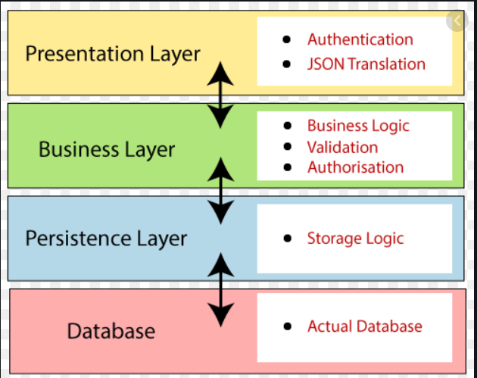

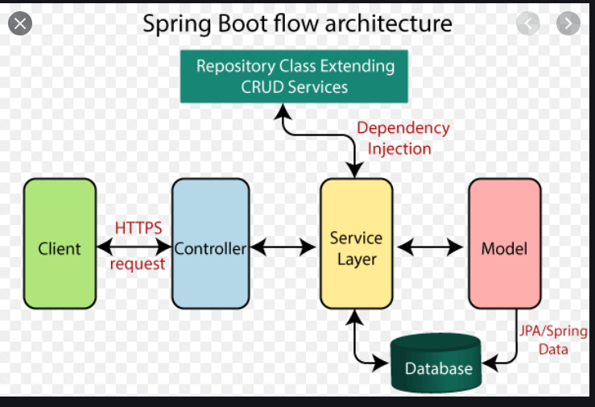

**UML DIAGRAMS**

* **Use Case Diagram of Admin:**

The use case of for an administrator where he or she has access to the application. The administrator can access the home page, select a category, or add/delete items to/from the cart.

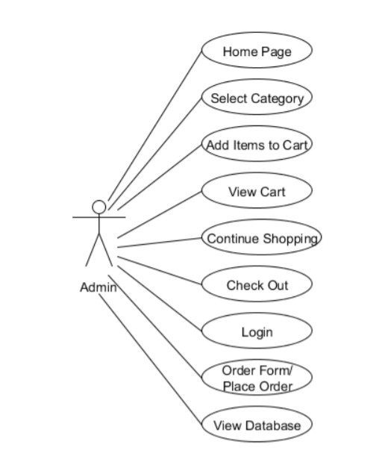

* **Use Case Diagram of User:**

The use case for users where they have access to the online shopping-cart application. They can access the home page, select a category, add/delete items to/from the cart, view the shopping cart, and decide to either continue shopping or check out. They are required to go through the user-authentication form (login) which would only allow them to place an order for the items they selected.

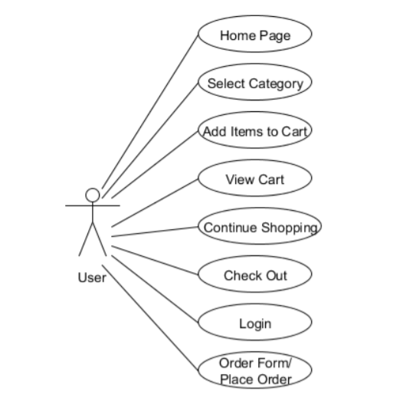

* **Sequence Diagram of Whole Process**

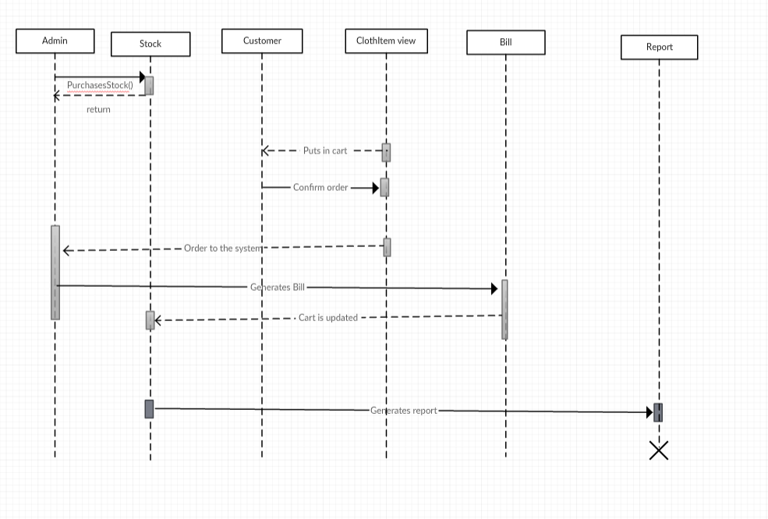

**Class Diagram of VyantraMart**

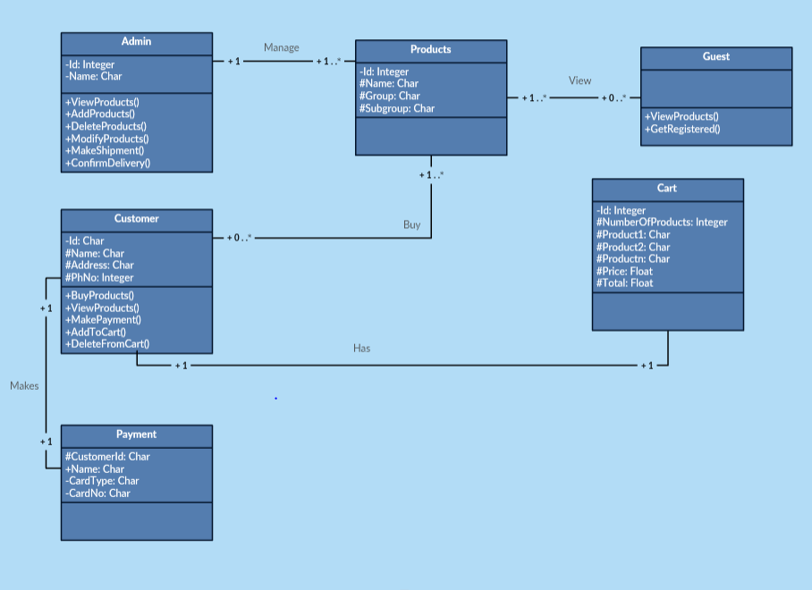

* **Activity Diagram of Vyantra Mart**

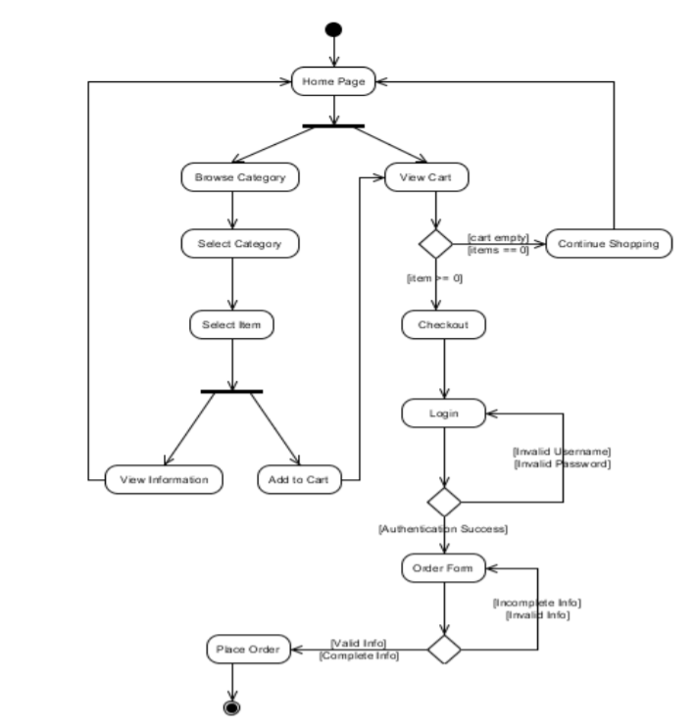

**ER Diagrams**

