NAME: - SANYAM JAIN, E-mail: - sanyamjain045@gmail.com

*Assignment 3*

**Q.** **For this challenge, create a bank account class that has two attributes**

**Owner’s name, Balance: Add two methods -> withdraw, deposit**

**As an added requirement, withdrawals may not exceed the available balance.**

**Instantiate your class, make several deposits and withdrawals, and test to make sure the account can’t be overdrawn.**

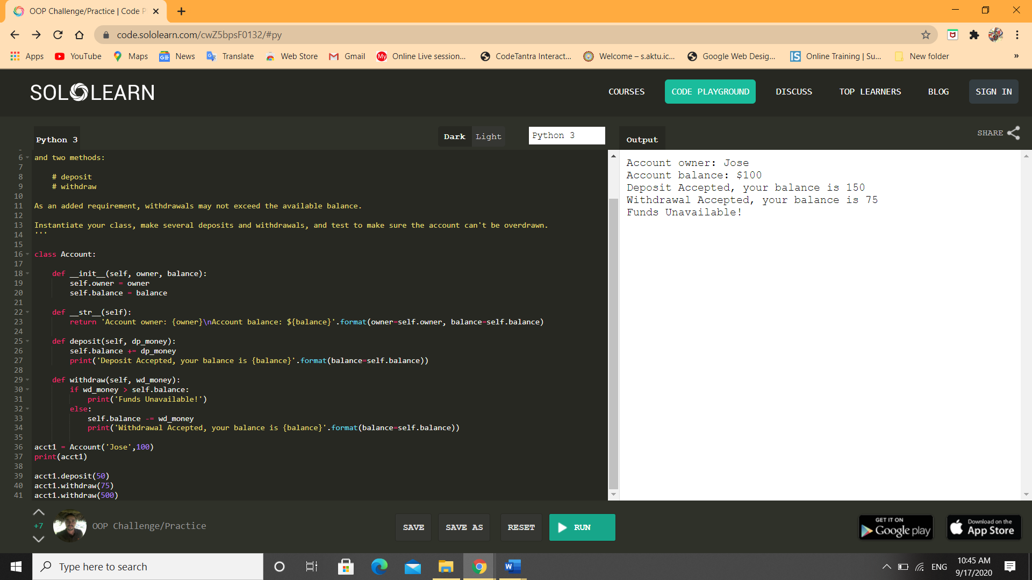

**Q2. For this challenge, create a cone class that has two attributes:**

**R=radius, h=height. And two methods. Volume=pi*r^2, side: pi*r*sqr(r^2+h^2)**

**Make only one class with functions, as in where required import Math.**

