NAME: - SANYAM JAIN, E-mail: - sanyamjain045@gmail.com

*Assignment 6*

**Q.Write a decorator function for your talking input for you any kind of function you want to build, for example - you make a Fibonacci series function , in which your input range is been defined by decorator program input.**

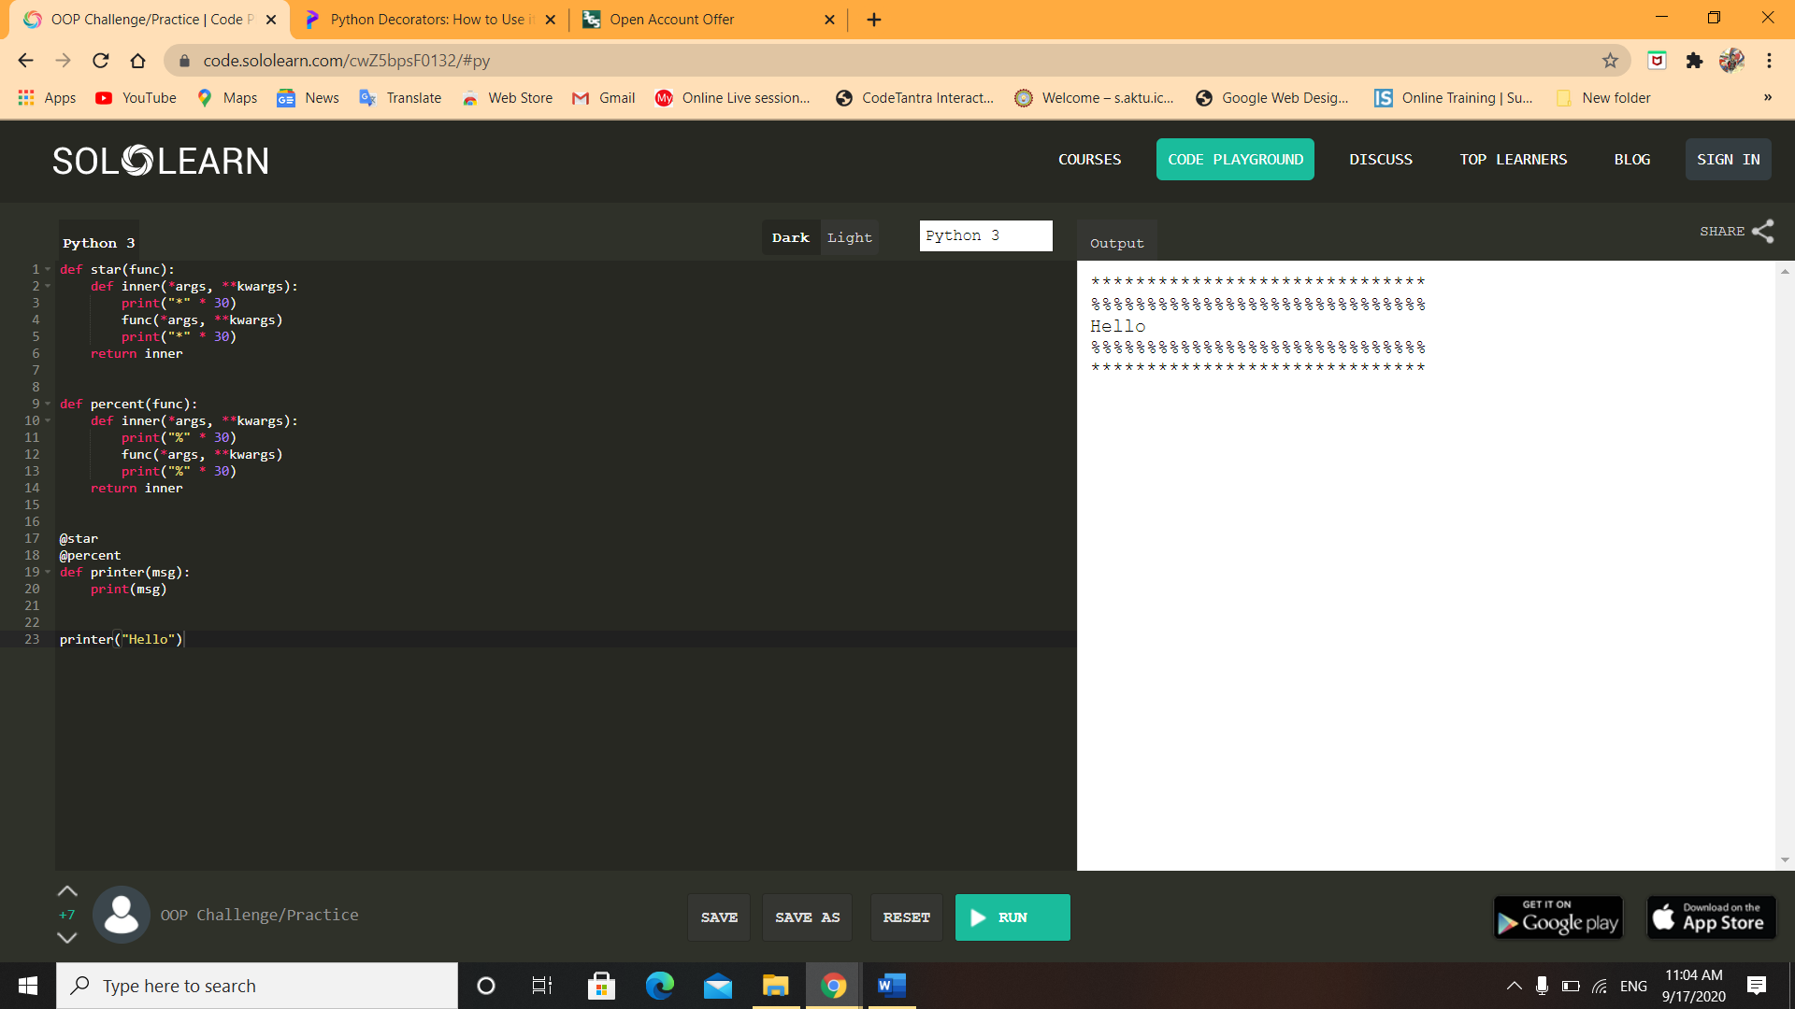

**Q.For this challenge you need to develope a python program to open a file in read only mode and try writing something to it and handle the subsequent errors using Exception handling.**

