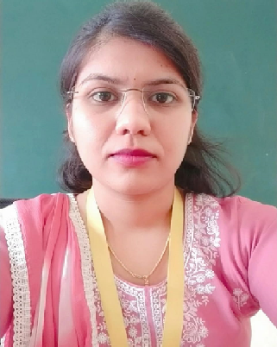

Faculty Profile

Ms. Reshma Dnyaneshwar Chaudhari
Qualifications | : M. Pharm
Specialization | : Pharmaceutics
Department | : Pharmaceutics
Designation | : Lecturer
Experience | Industry: 0 | Teaching: 6 months
Publication | : 3
Award/Recognition | : NA
Membership | : NA
Email | : reshmachaudhari914@gmail.com

