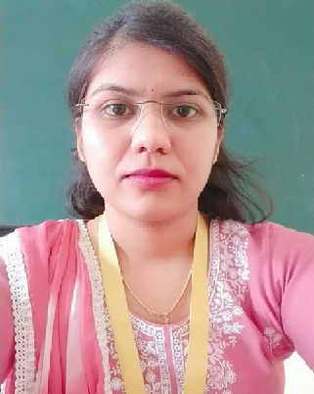

Faculty Profile

Ms. Reshma Dnyaneshwar Chaudhari

|  |  |  |
| --- | --- | --- |
| **Qualifications** | **: M. Pharm** | |
| **Specialization** | **: Pharmaceutics** | |
| **Department** | **: Pharmaceutics** | |
| **Designation** | **: Lecturer** | |
| **Experience** | **Industry: 0** | **Teaching: 6 months** |
| **Publication** | **: 3** | |
| **Award/Recognition** | **: NA** | |
| **Membership** | **: NA** | |
| **Email** | **: reshmachaudhari914@gmail.com** | |