Please read this document before running the program

1,

the program requires modules listed below:

Pytorch version 1.8.0

Python version 3.8

Module: cv2, datetime, numpy, os, json, PIL, matplotlib

2.

The program also requires a font name ‘simhei.ttf’. You can find it inside folder ’tools’ and copy it to your system font address, or you can change the font at line 309 in ‘video analysis.py’ to any font you have in your computer.

3.

Under the folder ‘tools’, there is my program for training the model and showing the training result in examples. If you want to retrain the model, please copy these two program to the main folder, and put it with ‘model2.py’, ‘{}Net_CIFAR10.pth’ and ‘class_indices.json’.

4.

I have change the original CIFAR10 dataset to my own CIFAR10-like dataset. So that before you run the program, you have to change the CIFAR10 setting as below

Find your CIFAR10 source code, it is under your environment of Anaconda setup package, find

your_environment/lib/site-packages/torchvision/datasets/cifar.py

Find your CIFAR10 source code, it is under your environment of Anaconda setup package, above is an example address.

Please comment lines below:

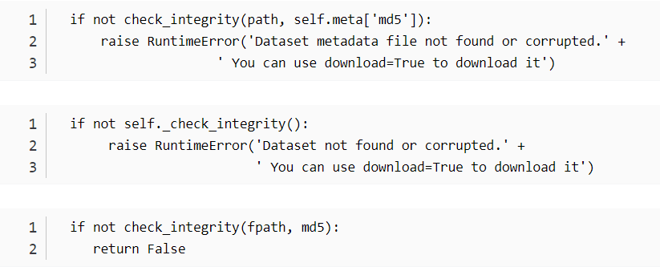

5.

Run ‘train_VGG_CIFAR10.py’ to create the model weights

6.

‘Video analysis.py’ is the main program, all others are sub programs. ‘gc126.mp4’ is the example video, put this video together with programs. You can rerun the main program to create your result folder. There is a regenerated video called ‘xor.avi’. Please have a look at this video to see the brief outcome of the program.