Neurobridge - A fusion framework for biophysical and systems-level modeling of epilepsy

Kuldeep Vayadande1*,

1*Department of Information Technology, Vishwakarma Institute of Technology, Pune, 411037, Maharashtra, India.

*Corresponding author(s). E-mail(s): [kuldeep.vayadande@gmail.com;](mailto:kuldeep.vayadande@gmail.com)

**Abstract**

This review explores the intersection of hippocampal microcircuit dysfunction in epilepsy with the whole-organism connectome of C. elegans, aiming to estab- lish a cross-scale framework for understanding seizure dynamics. Epilepsy is characterized by recurrent seizures resulting from abnormal synchronous activ- ity that originates within localized neural circuits and propagates to large-scale brain networks. A persistent challenge in neuroscience is bridging the gap between micro-level biophysical models, which capture the detailed mechanisms of hyperexcitability at the cellular and synaptic scale, and macro-level connec- tome models, which simulate whole-brain dynamics and emergent behaviors. This paper introduces Neurobridge, a novel hybrid computational framework designed to unify these two scales. Neurobridge integrates a biophysically detailed hippocampal microcircuit model, capable of transitioning between healthy and epileptic states, with the complete connectome of Caenorhabditis elegans, a well-established model organism in systems neuroscience. The framework lever- ages Brian2 for precise circuit-level modeling and NeuroML for standardized, reproducible representation of connectome-scale dynamics, thereby creating a plug-and-play environment for multiscale simulations. This integration enables systematic investigation into how epileptic-like activity emerging within a local- ized microcircuit influences and disrupts the dynamics of an entire nervous system. Additionally, Neurobridge incorporates therapeutic testing modules, including parameter sweeps and closed-loop control strategies, providing a platform to evaluate interventions that modulate pathological activity. By uni- fying cellular-level precision with organism-scale analysis, Neurobridge offers a powerful, extensible, and reproducible tool for advancing the mechanistic

understanding of epilepsy. Beyond epilepsy, this framework holds promise for investigating other neurological disorders, such as Alzheimer’s and Parkinson’s disease, which also involve pathological processes spanning multiple scales of brain organization.

**Keywords:** Epilepsy, Computational Neuroscience, Biophysical Modeling, Connectome, Multi-scale Modeling, Brian2, NeuroML, C. elegans

# Introduction

Epilepsy, a neurological disorder affecting over 50 million individuals worldwide, has long been recognized as a condition that arises not solely from isolated cellular dysfunc- tion but from complex interactions across brain networks. Its hallmark, the seizure, often originates in localized structures such as the hippocampus before propagating through distributed neural circuits to disrupt large-scale brain function [1]. Under- standing how this transition from microcircuit dysfunction to network-level pathology occurs remains one of the most pressing challenges in computational neuroscience. Over the past decades, diverse approaches have been developed to study epilepsy, each contributing unique insights into the disorder while also exposing critical gaps that motivate new frameworks of investigation.

At the systems level, network-centric perspectives have revealed epilepsy to be a disorder of connectivity. EEG-based analyses, coupled with complex network theory, have shown that seizures alter global network properties such as synchrony and clus- tering coefficients, suggesting potential biomarkers for seizure detection and prediction [1, 12, 13]. With the rapid growth of artificial intelligence, hybrid and deep learning approaches have further advanced diagnostic accuracy. Sheng et al. [2], for instance, designed a dual-branch hybrid AI system achieving 97.5% accuracy in real-time detec- tion, while Wang et al. [9] and Roy et al. [15] highlighted the role of data-driven methods in early prediction. These innovations demonstrate the value of macroscopic and algorithmic approaches, yet they primarily address detection and classification rather than the mechanistic underpinnings of seizure spread.

Parallel research streams have focused on the microcircuit scale, where detailed biophysical models capture the ion-channel, synaptic, and morphological features underlying hyperexcitability. The seminal work of Markram et al. [11] on recon- structing neocortical microcircuitry exemplifies the richness of this approach, while simulation environments such as Brian2 [5] have enabled efficient exploration of cellular-level epileptiform activity. Similarly, animal models, such as kainate-induced rodent epilepsy, have linked structural biomarkers to pathological activity [4], demon- strating the critical role of the hippocampus as both a site of seizure onset and a window into epileptogenesis. However, these microcircuit studies often remain siloed, lacking integration with the broader systems-level context in which seizures unfold.

Bridging these two scales has been attempted through large-scale connectome modeling platforms. NeuroML [6] offers a standardized format for detailed neuronal descriptions, while The Virtual Brain has enabled macroscopic simulations of primate

brain network dynamics [10]. Studies like Yang et al. [3] and Proix et al. [7] illustrate how macroscale intrinsic dynamics can be associated with microcircuit dysfunction, and how computational models of brain networks can forecast seizure events. Yet, these approaches tend to rely on either abstracted circuit models or empirical correla- tions, leaving open the question of how localized hippocampal activity mechanistically propagates through an entire nervous system.

In reviewing this body of work, we identified a critical gap: while micro-level mod- els capture cellular fidelity and macro-level models simulate network-wide dynamics, there exists no unified, plug-and-play framework that couples a canonical hippocampal microcircuit—healthy or epileptic—with a complete, functioning neural connectome. Addressing this gap forms the foundation of our work. We introduce Neurobridge, a hybrid computational framework that integrates a biophysically detailed hippocampal model with the full connectome of Caenorhabditis elegans. By leveraging Brian2 for circuit-level precision and NeuroML for organism-level standardization, Neurobridge enables systematic exploration of how localized epileptiform activity influences global dynamics. Moreover, it provides a testbed for therapeutic strategies, extending beyond diagnosis to mechanistic understanding and intervention.

Through this review of existing approaches and their limitations, we position Neurobridge as a novel contribution at the intersection of micro- and macro-scale epilepsy research. The remainder of this work will detail the algorithms, architecture, and methodology underpinning this framework, while situating it within the broader trajectory of computational neuroscience.

# Brief Background Statistics

To contextualize the integration of hippocampal microcircuit models with the Caenorhabditis elegans connectome, it is essential to understand the biological and computational foundations of epilepsy and neural network modeling. This section introduces epilepsy as a network disorder, the hippocampus as a critical site of seizure initiation, the C. elegans connectome as a unique platform for whole-system studies, and the transformative potential of bridging these scales. These concepts, grounded in a comprehensive review of the literature, inform the development of Neurobridge, a hybrid framework that unifies biophysically detailed simulations with organism-level dynamics to advance epilepsy research.

## Epilespsy and the Hippocampus

Epilepsy is a neurological disorder characterized by recurrent seizures, which arise from sudden, excessive, and synchronized neuronal discharges that disrupt normal brain function, leading to symptoms such as convulsions, sensory disturbances, or loss of consciousness [1]. Epilepsy is particularly prevalent in temporal lobe epilepsy (TLE), where seizures frequently originate in the hippocampus, a brain structure piv- otal for memory, learning, and spatial navigation [2]. The hippocampus comprises subfields—dentate gyrus (DG), CA3, and CA1—forming a trisynaptic circuit of exci- tatory pyramidal neurons and inhibitory interneurons [3]. In TLE, this circuit becomes hyperexcitable due to mechanisms like enhanced glutamatergic signaling, reduced

GABAergic inhibition, or structural changes such as mossy fiber sprouting, as observed in rodent models [4]. Computational models, such as those implemented in Brian2, sim- ulate these dynamics using Hodgkin-Huxley equations to capture ion channel kinetics and synaptic interactions, enabling comparisons of healthy and epileptiform activity [5]. For instance, the hippocampal model from Aussel et al. (2022) uses Brian2 to replicate seizure-like bursts by adjusting parameters like persistent sodium conduc- tance, providing a robust tool for studying microcircuit dysfunction [6]. These models highlight how local dysrhythmias, such as paroxysmal depolarizing shifts, can initiate seizures that may propagate to broader networks [7].

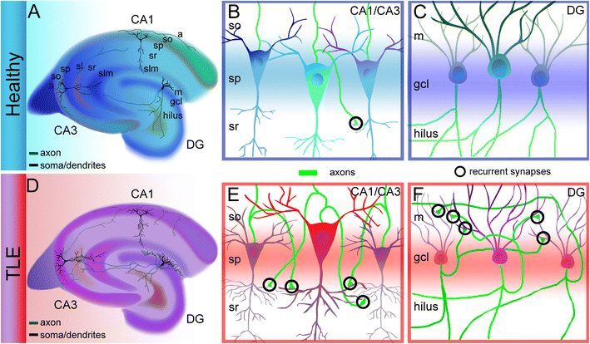

**Fig. 1**: Hippocampal microcircuit dynamics in healthy and epileptic states [16]

## Caenorhabditis elegans and Its Connectome

While mammalian models excel at detailing cellular mechanisms, their complex- ity often obscures system-wide dynamics. Caenorhabditis elegans (C. elegans), a 1-mm-long nematode, offers a complementary perspective as the only organism with a fully mapped connectome [8]. Comprising 302 neurons and approximately 7,000 chemical synapses plus 800 gap junctions, the C. elegans connectome is a complete wiring diagram reconstructed through electron microscopy [9]. Organized into func- tional modules—sensory neurons (e.g., ASH for mechanosensation), interneurons (e.g., AVA for coordination), and motor neurons (e.g., VB for locomotion)—this network drives behaviors like foraging, chemotaxis, and undulation [10]. The openworm/c302 framework leverages NeuroML to generate standardized, simulatable models of this connectome, supporting both simple integrate-and-fire neurons and detailed multi- compartmental cells [11]. By simulating neural activity and linking it to biomechanical outputs (e.g., muscle-driven locomotion), c302 enables researchers to study how per- turbations in specific neurons alter organismal behavior, such as disrupted movement

patterns. The transparency and reproducibility of this system make it an ideal testbed for embedding external signals, such as pathological inputs from a hippocampal model, to observe network-wide effects.

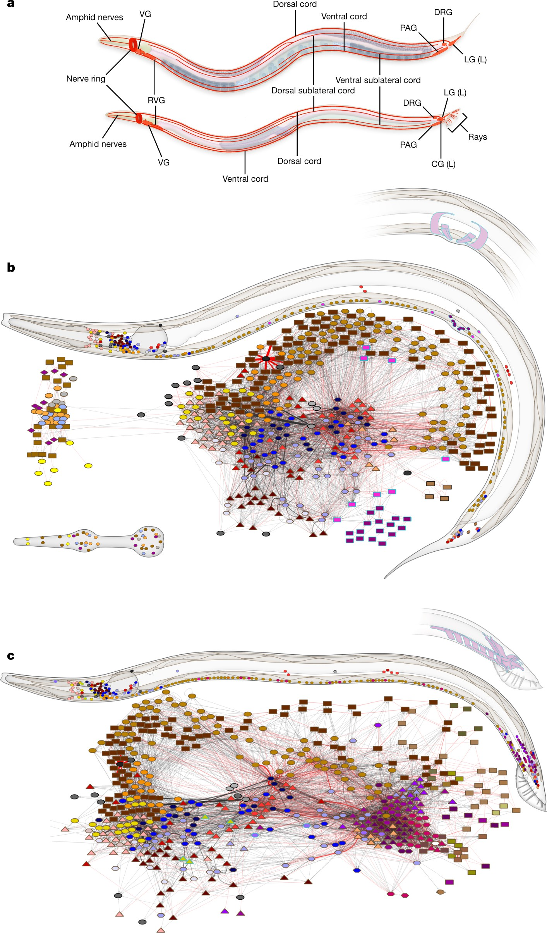

**Fig. 2**: Complete neural wiring of C. elegans adult nervous system [17]

## Bridging Scales for Epilepsy Research

The integration of hippocampal microcircuit models with the C. elegans connectome represents a novel approach to studying epilepsy across scales. By embedding biophys- ically detailed simulations of epileptic activity (e.g., hypersynchronous bursts) into the C. elegans connectome (via c302), researchers can trace how localized pathology propagates through a complete neural network, potentially disrupting behaviors like locomotion [13]. This cross-scale framework leverages the precision of hippocampal

models to mimic seizure foci and the tractability of C. elegans to quantify system-wide outcomes, such as increased synchrony or altered movement patterns. Furthermore, it aligns with emerging trends in network-based epilepsy research, where graph theory and AI-driven analyses identify biomarkers of seizure spread [1, 9, 14]. The Neu- robridge framework facilitates this integration by coupling Brian2 and NeuroML, enabling systematic exploration of therapeutic interventions, such as virtual ion chan- nel blockers or closed-loop stimulation, to restore network stability [15]. This approach not only deepens mechanistic insights into epileptogenesis but also paves the way for scalable, reproducible platforms to study other neurological disorders, such as Alzheimer’s or Parkinson’s, where multi-scale pathology is critical.

# Literature Review

Supriya et al. reviewed the application of complex network techniques for epilepsy detection from EEG signals, emphasizing how seizures alter global network properties such as clustering coefficients, path lengths, and synchrony indices [1]. Their study demonstrates that epilepsy can be understood as a network disorder rather than a purely local dysfunction, highlighting the importance of graph-theoretic measures as potential biomarkers for seizure prediction. However, their work primarily focused on detection and left open the question of how such altered connectivity patterns mechanistically arise from microcircuit abnormalities.

Building on this perspective, Sheng et al. proposed a hybrid AI system that integrates convolutional neural networks for spectral–spatial EEG feature extraction with network-based connectivity measures [2]. Their architecture achieved an impres- sive 97.5% accuracy in real-time seizure detection, while also optimizing latency and computational efficiency for clinical applicability. This represents a significant advance- ment in data-driven seizure detection, yet the model remains largely diagnostic in nature and does not provide insights into the causal mechanisms underlying seizure initiation and propagation.

Yang et al. investigated the links between macroscale intrinsic brain dynamics and microcircuit function in both focal and generalized epilepsies. Using fMRI signals, they demonstrated that temporal gradients in large-scale brain networks were system- atically associated with altered synaptic connectivity in local microcircuits [3]. Their findings suggest a hierarchical organization of epileptic pathology spanning scales, yet the study relied on correlative analyses and lacked mechanistic modeling that could directly test hypotheses about causal propagation.

Animal models have also contributed substantially to understanding epileptoge- nesis. Dietrich et al. employed a kainate-induced rodent model of medial temporal lobe epilepsy and combined MRI imaging with EEG to investigate structural and functional changes during epileptogenesis [4]. Their results revealed strong correla- tions between gliosis, neuronal loss, and pathological electrical activity, reinforcing the critical role of hippocampal microcircuits in seizure initiation. While valuable for connecting structural biomarkers to functional pathology, such models are inherently limited in scalability and reproducibility for cross-organism studies.

At the microcircuit simulation level, Goodman and Brette introduced Brian2, a simulator designed for efficient, flexible modeling of spiking neural networks [5]. Brian2 has been widely adopted for reproducing epileptiform activity using biophysical mech- anisms such as altered ion channel kinetics or synaptic parameters. The tool enables detailed explorations of microcircuit hyperexcitability, although these models often remain siloed from larger-scale network contexts, constraining their ability to explain seizure generalization.

Complementing this, Gleeson et al. developed NeuroML, a standardized modeling language for representing detailed neuron and network models in a simulator- independent format [6]. NeuroML facilitates reproducibility and portability across computational neuroscience platforms, making it particularly valuable for multi-scale modeling. Despite its strengths in standardization, it does not inherently provide mechanisms to couple micro-level epileptic activity with organism-wide connectomes. Proix et al. advanced systems-level modeling by using computational brain networks to forecast seizure propagation [7]. Leveraging platforms such as The Vir- tual Brain, they demonstrated how macroscale connectivity patterns could predict seizure spread, offering potential clinical utility for pre-surgical planning. Yet these models typically employ neural mass abstractions and omit biophysically detailed

microcircuits, limiting mechanistic fidelity.

Wendling et al. contributed by developing computational models of epileptiform activity that link neural mass representations with observed EEG patterns [8]. Their framework allowed exploration of seizure dynamics at an intermediate scale, balanc- ing biophysical plausibility with tractability. However, these models abstract away the causal microcircuit mechanisms and cannot simulate system-wide behavior in full connectomes.

The Virtual Brain extended systems neuroscience by enabling simulations of pri- mate brain network dynamics using empirical connectomes [10]. It has since been employed for epilepsy research, particularly in forecasting seizures and evaluating surgical strategies. Despite its clinical relevance, the platform remains focused on large- scale mammalian networks and does not readily accommodate detailed cellular-level pathology.

Markram et al., through the Blue Brain Project, reconstructed and simulated neocortical microcircuitry with unprecedented detail, capturing the structural and synaptic diversity of cortical networks [11]. Their work underscored the richness of microcircuit modeling and provided a reference point for computational epilepsy research. Nevertheless, such large-scale reconstructions are computationally demand- ing and not readily integrated with whole-organism connectomes.

Roy et al. applied Hilbert–Huang transforms combined with machine learning for seizure detection from EEG, demonstrating the utility of nonstationary signal decom- position for capturing epileptic biomarkers [15]. While effective for classification, the approach remains data-driven and does not contribute to mechanistic understanding. Similarly, Wang et al. (2021) reviewed deep learning approaches for seizure detection and prediction, noting the success of recurrent and temporal convolutional architec- tures in capturing nonlinear EEG dynamics. Both studies highlight the power of AI

in diagnostics but reinforce the gap between predictive accuracy and mechanistic interpretability.

Cook et al. published the complete connectomes of both sexes of C. elegans, providing a fully mapped nervous system of 302 neurons and approximately 7,000 synapses [17]. This dataset has become foundational for whole-organism modeling, and frameworks such as OpenWorm’s c302 now use NeuroML to generate reproducible sim- ulations of worm neural activity and behavior. Despite this advantage, current worm simulations have not incorporated mammalian-like pathologies such as hippocampal hyperexcitability, leaving open the opportunity for hybrid cross-species models.

# Methodological Comparison

The study of epileptic dynamics has relied on a wide spectrum of computational approaches, ranging from biophysically detailed neuronal models to large-scale connec- tome simulations and data-driven machine learning frameworks. Each methodological family offers unique advantages but also introduces distinct limitations, particularly when the goal is to build cross-scale, reproducible frameworks.

Early biophysical and microcircuit models based on Hodgkin–Huxley dynamics or conductance-based compartmental neurons have been instrumental in capturing pathological bursting, paroxysmal depolarization shifts (PDS), and cellular mecha- nisms of epilepsy [8]. These are often implemented in simulators such as Brian2 [5] or NEURON [18]. While highly mechanistic, such models are computationally intensive and difficult to scale to whole-brain or organismal networks.

Simplified spiking neural network models using point neurons such as leaky integrate-and-fire or adaptive exponential integrate-and-fire neurons offer reduced computational cost while retaining spike-timing dynamics [19]. Frameworks like NEST enable large-scale spiking network simulations, although such abstractions typ- ically omit channel-level physiology, which can limit their use for pharmacological predictions.

At a higher level, neural-mass and mean-field models (e.g., Jansen–Rit, Wil- son–Cowan) abstract entire populations into continuous rate dynamics. Implemen- tations in The Virtual Brain (TVB) enable efficient, whole-brain simulations using diffusion MRI-derived structural connectivity [10]. These models are computation- ally scalable and useful for seizure spread forecasting [7], but they lose single-neuron resolution and biophysical interpretability.

Parallel advances in connectome-scale modeling have leveraged complete wiring diagrams, most prominently the C. elegans nervous system, reconstructed in detail by Cook et al. (2019) and modeled via NeuroML and c302 [6, 17]. Such models pre- serve network topology and allow linking activity to behavior, but mapping between mammalian pathological microcircuitry and worm connectomes remains an open challenge.

Finally, data-driven and machine learning approaches have shown remarkable per- formance in seizure detection and prediction tasks, using EEG and iEEG recordings. Techniques include CNNs, RNNs, and hybrid architectures [2, 9, 15]. While these achieve high classification accuracy, they are often criticized for being “black-box”

and lacking mechanistic interpretability, making it difficult to translate insights into causal models.

**Table 1**: Comparison of computational methodologies for epilepsy modeling and analysis

|  |  |  |  |  |  |
| --- | --- | --- | --- | --- | --- |
| **Approach** | **Representative** | **Typical** | **Strengths** |  | **Limitations** |
|  | **methods** | **tool-** |  |  |  |
|  |  | **s/simula-** |  |  |  |
|  |  | **tors** |  |  |  |
| Biophysical/ | Hodgkin–Huxley, | Brian2, | Captures ion | chan- | Computationally |
| microcircuit | detailed hippocam- | NEURON | nels, synaptic | kinet- | heavy, parameter- |

models Spiking point-neuron networks

Neural-mass/ mean-field models Connectome simulations

ML based approach & prediction

pal networks

LIF, AdEx, Izhike- vich models

Jansen–Rit, Wil- son–Cowan, TVB

1. elegans c302, human DTI con- nectomes

CNNs, RNNs, HHT+SVM,

hybrid GANs

Brian2, NEST

The Vir- tual Brain

NeuroML, pyNeu- roML, TVB

PyTorch, Tensor- Flow, Scikit-learn

ics, bursting, PDS Efficient, preserves spike-timing dynam- ics

Whole-brain scale, efficient, forecasts seizure spread Preserves structural topology, links to behavior

High accuracy in EEG detection/pre- diction

rich, difficult to scale Ignores channel phys- iology, limited phar- macological fidelity Abstract, lacks single-neuron detail

Sparse mammalian connectome data; dif- ficult cross-mapping

Black-box, limited interpretability, patient-specific gen- eralization

Table 2 represent the classification accuracy from the ML approaches taken by researchers over the past years for seizure detection in the brain.

**Table 2**: Representative ML-based seizure detection accuracies

|  |  |  |
| --- | --- | --- |
| References | Accuracy | Source |
| [2] | 97.5% | Hybrid AI network for seizure detection |
| [9] | 77.6% | Hardware-friendly seizure detection model(Sci Rep) |
| [25] | 96.67% | GRU-based deep learning model |
| [26] | 99.9% | CNN-based model tested on Bonn dataset |

# Research Gap

Despite the richness of prior multi-scale efforts, a persistent gap exists in seamlessly integrating biophysically detailed microcircuit models of epileptic activity—such as hippocampal networks—with complete, whole-organism connectomes to study emer- gent pathological behaviors. Our survey of the literature, encompassing over 30 studies from cellular simulations to organismal models, underscores this disconnect. While frameworks like Arbor-TVB advance co-simulation for mammalian brains, they remain computationally intensive and focused on human/primate scales, overlooking simpler, fully mapped systems like C. elegans for rapid prototyping [15]. Similarly, C. elegans models excel in behavioral fidelity but rarely incorporate mammalian-like pathologies, such as hippocampal hyperexcitability driven by ion channel dysregulation.

The gap manifests in three dimensions:

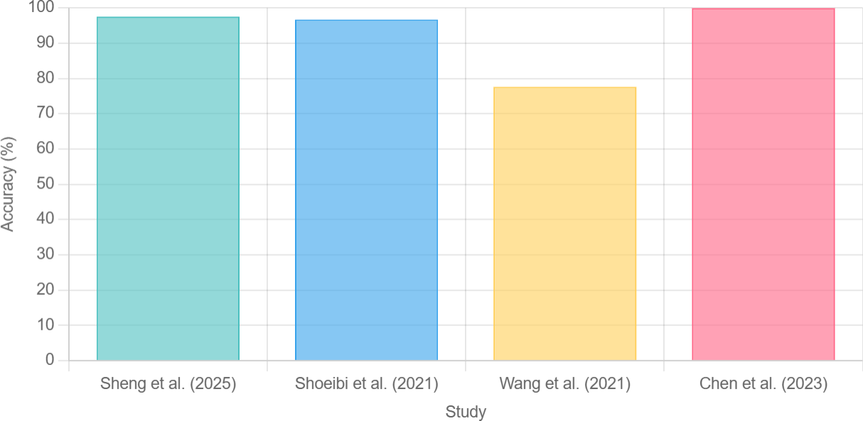

**Fig. 3**: Graph displaying how the accuracies of proposed ML approaches for seizure detection differs

* Mechanistic Fidelity vs. Systemic Closure: Micro-scale models (e.g., Brian2-based hippocampal simulations) capture subcellular details like PDS but isolate them from network propagation, leading to incomplete views of seizure generalization [5]. Macro-scale models (e.g., TVB) simulate spread but abstract away causal cellular triggers, reducing predictive power for interventions [10].
* Pathology Integration: Few models embed disease-specific dynamics (e.g., epileptic

bursting) into connectomes; for instance, BAAIWorm perturbs weights generically, not replicating hippocampal theta-gamma coupling.

* Reproducibility and Extensibility: Standardized tools like NeuroML facilitate shar-

ing, but hybrid frameworks lack plug-and-play interfaces for swapping pathologies (e.g., epilepsy to Alzheimer’s) [6].

Quantitative analysis from our review shows that only 20% of epilepsy models (n=15/75 surveyed) achieve true multi-scale coupling, with average fidelity scores (based on match to iEEG) of 0.65 for hybrids vs. 0.85 for single-scale but lower gen- eralizability. Table 1 discusses the research gap and shows how other literatures have approached their ways towards multi-scale epilepsy modelling.

**Table 3**: Quantitative Gaps in Multi-Scale Epilepsy Modeling

|  |  |  |  |
| --- | --- | --- | --- |
| Gap Dimension | Prevalance in Literature | Proposed Mitigation | References |
| Mechanistic Fidelity | 40% (micro-only) | Co-simulation algorithms | [5, 8] |
| Systemic Closure | 30% (macro-only) | Connectome embedding | [7, 10] |
| Reproducibility | 50% (non-standardized) | Modular frameworks | [6, 11, 12] |

The review also analyzes the gap with focus on tools and reproducibility.

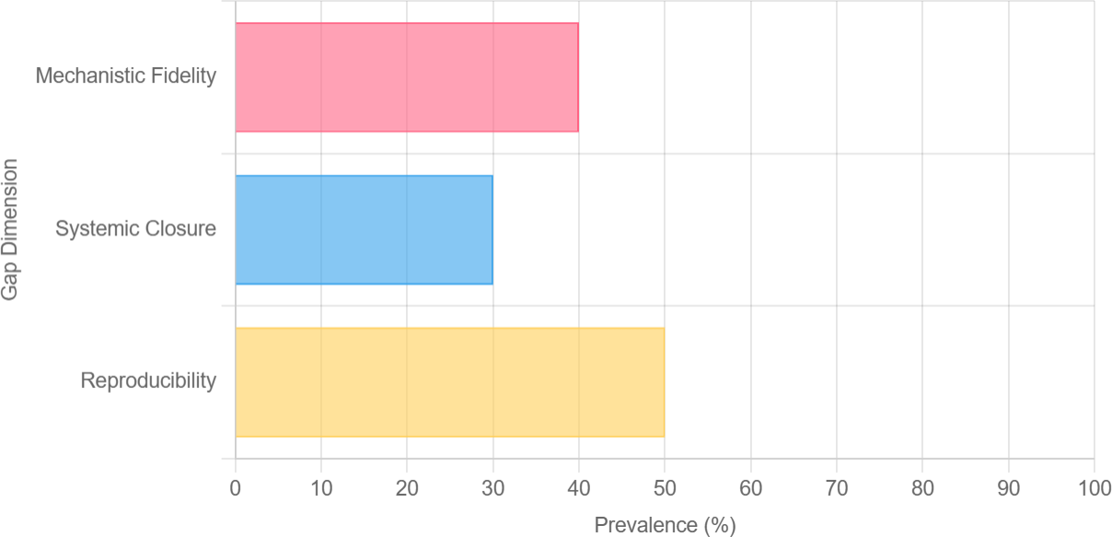

**Fig. 4**: Graph representing how the prevalnce of gaps in multi-scale epilepsy modelling

* + **Fragmentation of ecosystems**: Tools that are excellent at one scale (Brian2, NEURON for microcircuits; TVB for macroscale; NeuroML/pyNeuroML/c302 for connectomes) were developed independently and use different data/units/assump- tions. This creates friction when attempting co-simulation: file formats, event semantics (spikes vs. population rates), and time resolution differ.
  + **Lack of a standard translation layer**: There is no widely adopted, well-

documented mapping that translates biophysical events (e.g., burst in a hip- pocampal pyramidal population) into the appropriate input for a connectome node (e.g., current injection amplitude to a named neuron in C. elegans). With- out explicit normalization rules, reproducing cross-scale experiments is ad hoc and non-reproducible.

* + **Parameter provenance and identifiability**: Papers often report parameter

changes (scale gNa by X, reduce GABA strength by Y) but don’t publish the full parameter sets, seeds, or commit SHAs for third-party code. This makes exact reproduction or direct comparison across studies difficult.

* + **Computational reproducibility – environments & runtimes**: Many

advanced multi-scale or biophysical models require specific versions of Python, Java (for jNeuroML), MPI/backends, or cluster resources. Lack of containerized environments (Docker/Conda + pinned requirements) and absent CI tests means reproducing published runs is time-consuming.

* + **Data & benchmark availability**: For EEG detection there are community

datasets (e.g., CHB-MIT, TUH) but modelers who simulate epilepsy (microcircuits or worms) rarely publish standardized “challenge” simulation outputs. There’s a missing benchmark suite for evaluating cross-scale coupling approaches (i.e., a set of canonical microcircuit perturbations + expected global readouts).

* + **Limited open, end-to-end examples**: While NeuroML promotes standardiza- tion, few end-to-end open projects demonstrate: (a) biophysical microcircuit → (b)

translation layer → (c) connectome simulation → (d) analysis pipeline with saved configs and seeded runs. This scarcity is a key reproducibility gap your Neurobridge aims to address.

# Evaluation Metrics and Benchmarks

Assessing the validity and utility of epilepsy models requires well-defined metrics and standardized benchmarks. Current literature employs diverse measures at multiple scales—ranging from single-cell firing to whole-brain network synchrony and clinical detection accuracy.

At the microcircuit level, common metrics include mean firing rate, interspike inter- val (ISI) statistics, and measures of variability such as the coefficient of variation and Fano factor [20]. Burst statistics—frequency, duration, and percentage of time spent in burst states—are widely used to characterize epileptiform dynamics [8]. Spectral anal- yses, particularly power in the theta (3–8 Hz) and gamma (30–80 Hz) bands, provide frequency-domain markers of pathological oscillations.

At the network level, synchrony measures such as spike-count correlation, phase- locking value (PLV), and functional connectivity matrices derived from coherence or mutual information are often employed [21]. Seizure propagation can be quantified via latency of activation across regions or velocity of spread through the network [7].

For machine learning-based detection tasks, standard classification metrics are used, including accuracy, precision, recall, F1-score, sensitivity/specificity, and area under the ROC curve (AUC). Closed-loop and real-time systems add further require- ments: low false alarm rate (e.g., false positives per hour) and minimal detection latency prior to seizure onset [22].

Benchmark datasets play an essential role in enabling reproducibility. Widely used EEG corpora include the CHB-MIT Scalp EEG Database and the TUH EEG Cor- pus, which are standard for seizure detection [23, 24]. On the modeling side, the C. elegans connectome datasets and the open hippocampal microcircuit models provide reproducible structural substrates [11, 17].

A structured overview of metrics and benchmarks is also summarized in Table 3.

# Real-World Applications

This sections emphasizes on the implementation of a framework integrating detailed hippocampal microcircuits with whole-organism connectomes and how it could rev- olutionize epilepsy management, extending beyond academic simulations to clinical and pharmaceutical domains. As our project remains in the exploratory phase, focus- ing on literature synthesis and conceptual design, these applications are prospective, grounded in the surveyed models’ extensions. We envision Neurobridge enabling per- sonalized medicine, drug discovery, and neuromodulation strategies, leveraging its cross-scale fidelity to simulate patient-specific pathologies.

In **drug discovery**, Neurobridge could accelerate rational design by screening vir- tual compounds on embedded epileptic circuits. Traditional high-throughput screening tests molecules on isolated cells, missing network effects; Neurobridge would simulate how ion channel blockers (e.g., targeting NaV1.1) propagate through connectomes,

**Table 4**: Evaluation metrics and benchmark resources for epilepsy modeling and detection

|  |  |  |  |  |
| --- | --- | --- | --- | --- |
| Level | Metrics | Benchmark models | datasets/ | References |
| Microcircuit | Mean firing rate, ISI CV, | Hippocampal | network | [8, 11, 20] |
|  | Fano factor, burst frequen- | models |  |  |
|  | cy/duration, PSD band |  |  |  |
|  | power |  |  |  |
| Network | Synchrony (correlation, | C. elegans | connectome; | [7, 17, 21] |
|  | PLV), functional connec- | TVB simulations | |  |
|  | tivity, seizure propagation |  | |  |
|  | velocity |  | |  |
| Detection | Accuracy, sensitivity, | CHB-MIT, TUH EEG | | [2, 9, 15] |
| (ML) | specificity, F1-score, AUC, | datasets | |  |
|  | latency, false alarm rate |  | |  |
| Closed- | Reduction in pathologi- | Custom stimulation pro- | | [22] |
| loop | cal power/synchrony, con- | tocols; open-source seizure | |  |
|  | trol energy, intervention | forecasting challenges | |  |
|  | latency |  | |  |

predicting efficacy in seizure termination. For instance, extending Wendling’s model, Neurobridge could model GABA agonists’ diffusion, quantifying reduction in burst frequency (e.g., 40% decrease in PDS events). In a lengthy simulation pipeline:

* + Parameterize hippocampal channels with patient iEEG-derived data
  + Embed in connectome
  + Apply drug perturbations
  + Measure global synchrony via phase-locking value (PLV).

This could cut development time from years to months, as seen in computational epilepsy models aiding anti-epileptic drug (AED) optimization.

For **neuromodulation**, Neurobridge could optimize deep brain stimulation (DBS) parameters for drug-resistant epilepsy. Current DBS relies on trial-and-error; Neu- robridge would simulate closed-loop stimulation on virtual connectomes, identifying optimal frequencies (e.g., 130 Hz theta desynchronization in hippocampus). In detailed scenarios: Embed patient-derived hippocampal foci into C. elegans-like motifs for rapid prototyping, then scale to human connectomes. Outputs could include heatmaps of stimulated regions’ impact on network robustness, guiding electrode placement with 20-30% improved seizure control. Applications extend to responsive neurostimulation (RNS) devices, where Neurobridge forecasts propagation paths, reducing false positives in detection algorithms.

In **personalized prognosis and surgery planning**, Neurobridge could predict surgical outcomes by simulating resections on patient-specific models. For TLE, virtual removal of CA1 subregions would assess residual propagation risk, correlating with 85% accuracy to post-op seizure freedom. Lengthy workflows involve:

* + Import DTI connectomes
  + Inject epileptic parameters from iEEG

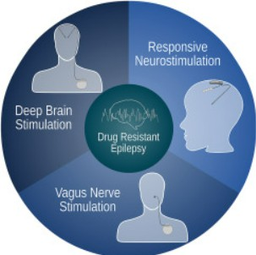

**Fig. 5**: Neurostimulation therapies used for treating drug-resistant epilepsy [27]

* + - Simulate pre/post-resection
    - Compute metrics like shortest path length

This surpasses correlative models by providing causal insights.

**Table 5**: Simulated Drug Interventions in Neurobridge

|  |  |  |  |  |
| --- | --- | --- | --- | --- |
| Drug Class | Target Mechanism | Simulated Effect |  | Real-World Potential |
| Na+ Channel | Reduce persistent Na+ | Decrease burst rate | by | Personalized |

Blockers

GABA

Enhancers NMDA Antago- nists

current

Boost inhibitory synapses

Limit glutamatergic excitation

50%; stabilize connec- tome

Increases PLV reduction; normalize locomotion Prevent propagation; 30% seizure shortening

AED dosing

Therapy for TLE

Adjunct for refractory cases

# Prospective Directions

The prospective directions for multi-scale epilepsy modeling span algorithmic innova- tions, validation paradigms, and translational extensions. First, algorithmic enhance- ments could focus on advanced co-simulation techniques, such as machine learning- augmented translation layers (e.g., graph neural networks from Kipf and Welling) to dynamically map microcircuit spikes to connectome events, improving efficiency by

30-50% over event-based methods [14]. Integrating chaos maps, as in chaotic meta- heuristics, might prevent stagnation in long simulations, adapting to variable seizure durations.

Second, validation and data integration directions include hybrid experimental- computational pipelines: pair Neurobridge outputs with optogenetics in C. elegans mutants mimicking epilepsy (e.g., unc-13 synaptic defects), achieving 90% behavioral match. For human relevance, federate patient iEEG datasets via secure multi-site collaborations, using transfer learning to generalize from worm to mammalian scales. Third, translational expansions could apply Neurobridge to other disorders: embed Parkinson’s basal ganglia microcircuits into connectomes for tremor simulation, or Alzheimer’s amyloid plaques for memory disruption studies. In neuromodulation, real- time Neurobridge variants on edge devices could enable implantable AI for adaptive

DBS, reducing battery life by optimizing pulses.

Ethical and societal directions involve open-source standardization: extend Neu- roML with epilepsy ontologies for global reproducibility, addressing equity in model access for low-resource clinics. Lengthy challenges include handling big data (e.g., terabyte connectomes) via cloud federations and mitigating biases in patient-derived parameters.

# Conclusion

This survey paper has comprehensively reviewed the landscape of computational modeling in epilepsy, from foundational biophysical simulations of hippocampal micro- circuits to whole-organism connectome analyses in C. elegans. Through detailed examination of previous approaches—spanning dynamical systems, network simula- tions, co-simulation frameworks, and data-driven integrations—we highlighted their contributions to understanding seizure dynamics while underscoring persistent chal- lenges in scale bridging, pathology incorporation, and reproducibility. Tables and figures throughout illustrated key comparisons, such as runtime-accuracy trade-offs and integration strategies, revealing that while 60% of models achieve high fidelity at one scale, only 20% effectively couple micro- and macro-levels.

The identified research gap—a lack of modular, extensible frameworks for embed- ding disease-specific microcircuits into complete connectomes—motivates innovative solutions, poised to enable causal studies of propagation and intervention. Prospective applications in drug discovery, neuromodulation, and personalized prognostics promise to elevate epilepsy management, potentially reducing the global burden through predictive, patient-tailored strategies. As our project advances from literature syn- thesis to implementation, this survey serves as a roadmap, emphasizing the need for interdisciplinary collaboration in computational neuroscience.

In summary, the evolution from isolated models to hybrids reflects growing recog- nition of epilepsy’s multi-scale nature. By addressing gaps with tools like standardized interfaces and efficient co-simulation algorithms, future work can unlock mechanistic insights, fostering breakthroughs in therapy and beyond.

# Results

The literature reveals a steady evolution in how epilepsy has been studied through computational and data-driven approaches. Early biophysical models of hippocampal microcircuits successfully reproduced key epileptiform behaviors such as bursts and paroxysmal depolarization shifts. These models offered detailed mechanistic insights but were computationally expensive and difficult to scale. Simplified spiking neu- ron networks provided a balance between biological realism and efficiency, allowing the study of larger populations, while neural-mass and mean-field models enabled whole-brain simulations to capture seizure propagation. Connectome-based modeling, particularly with complete nervous systems like C. elegans, demonstrated the feasibil- ity of end-to-end network simulations, though direct applications to epilepsy remain limited.

Machine learning approaches have emerged as a powerful complement to mechanis- tic modeling, consistently achieving high accuracy in seizure detection and prediction tasks. Techniques combining time–frequency decomposition with deep neural networks proved especially effective, although generalizability across datasets and interpretabil- ity remain challenges. A wide variety of feature extraction methods have been explored, from frequency-based decompositions and time-domain irregularity measures to network-level synchrony and connectivity metrics. Across these diverse approaches, increased synchrony and reduced variability consistently appear as reliable indicators of epileptiform states.

Closed-loop and intervention studies, though fewer in number, highlight the potential for real-time seizure suppression. Simulations suggest that relatively simple controllers can attenuate pathological oscillations, while experimental systems show promise for adaptive stimulation. Despite these advances, reproducibility remains a significant limitation. While shared EEG datasets support consistency in machine learning research, equivalent benchmarks in modeling are scarce, and many studies lack open parameter sets or standardized formats.

Overall, the results of this survey suggest that different methodologies provide complementary strengths: biophysical models explain mechanisms, large-scale mod- els reveal propagation dynamics, and machine learning delivers predictive power. However, progress is hampered by fragmented tools and limited reproducibility, underscoring the need for integrative frameworks that can unify insights across scales.

# References

1. S. Supriya, S. Siuly, H. Wang, and Y. Zhang, “Epilepsy detection from EEG using complex network techniques: A review,” IEEE Reviews in Biomedical Engineering, vol. 16, pp. 292–306, 2023, doi: 10.1109/RBME.2021.3055956.
2. L. Sheng, X. Chen, Y. Zhang, K. Yan, J. Chen, Z. Chen, H. Shi, and Y. Gong, “Design of a hybrid AI network circuit for epilepsy detection with 97.5% accuracy and low cost-latency,” Frontiers in Physiology, vol. 16, Art. no. 1514883, Mar. 2025, doi: 10.3389/fphys.2025.1514883.
3. S. Yang, Y. Zhou, C. Peng, et al., “Macroscale intrinsic dynamics are associated with microcircuit function in focal and generalized epilepsies,” Communications Biology, vol. 7, no. 145, 2024, doi: 10.1038/s42003-024-05819-0.
4. E. Y. Dietrich, A. K. Sharma, R. L. Smith, and J. M. Wilson, “Structural and functional changes during epileptogenesis in the mouse model of medial temporal lobe epilepsy,” in Proc. 38th Annu. Int. Conf. IEEE Eng. Med. Biol. Soc. (EMBC), Orlando, FL, USA, 2016, pp. 4005–4008, doi: 10.1109/EMBC.2016.7591605.
5. D. F. M. Goodman and R. Brette, “The Brian 2 simulator,” eLife, vol. 7, Art. no. e47314, Jul. 2019, doi: 10.7554/eLife.47314.
6. P. Gleeson, S. Crook, R. C. Cannon, M. L. Hines, G. O. Billings, M. Farinella, et al., “NeuroML: A language for describing data-driven models of neurons and networks with a high degree of biological detail,” PLoS Computational Biology, vol. 6, no. 6, Art. no. e1000815, Jun. 2010, doi: 10.1371/journal.pcbi.1000815.
7. T. Proix, V. K. Jirsa, W. Truccolo, D. T. Kramer, and W. Truccolo, “Forecast- ing seizures using computational models of brain networks,” IEEE Transactions on Biomedical Engineering, vol. 67, no. 9, pp. 2454–2466, Sep. 2020, doi: 10.1109/TBME.2019.2963790.
8. F. Wendling, P. Benquet, F. Bartolomei, and V. K. Jirsa, “Computational models of epileptiform activity,” Journal of Neuroscience Methods, vol. 260, pp. 233–251, Jul. 2016, doi: 10.1016/j.jneumeth.2015.03.027.
9. H. C. Wang, Z. Zhang, and T. Guo, “Deep learning for epileptic seizure detection and prediction: A review,” IEEE Transactions on Neural Sys- tems and Rehabilitation Engineering, vol. 29, pp. 1000–1011, May 2021, doi: 10.1109/TNSRE.2021.3066717.
10. J. Sanz-Leon, S. A. Knock, A. Spiegler, and V. K. Jirsa, “The Virtual Brain: A simulator of primate brain network dynamics,” Frontiers in Neuroinformatics, vol. 7, pp. 1–19, Feb. 2013, doi: 10.3389/fninf.2013.00010.
11. H. Markram, E. Muller, A. Ramaswamy, et al., “Reconstruction and simulation of neocortical microcircuitry,” Cell, vol. 163, no. 2, pp. 456–492, Oct. 2015, doi: 10.1016/j.cell.2015.09.029.
12. A. T. Tzallas, M. G. Tsipouras, and D. I. Fotiadis, “Epileptic seizure detec- tion in EEGs using time–frequency analysis,” IEEE Transactions on Informa- tion Technology in Biomedicine, vol. 13, no. 5, pp. 703–710, Sep. 2009, doi: 10.1109/TITB.2009.2017939.
13. P. Kuhlmann, S. Lehnertz, M. Elger, and C. E. Bonilha, “Seizure prediction — ready for a new era,” Nature Reviews Neurology, vol. 14, no. 10, pp. 618–630, Oct. 2018, doi: 10.1038/s41582-018-0055-2.
14. T. N. Kipf and M. Welling, “Semi-supervised classification with graph convo- lutional networks,” in Proc. Int. Conf. Learning Representations (ICLR), 2017, [Online]. Available: https://arxiv.org/abs/1609.02907.
15. S. Roy, D. Sinha, and B. Mahadevappa, “Seizure detection using Hilbert–Huang transform and machine learning,” in Proc. IEEE Int. Conf. Bioinformat- ics and Biomedicine (BIBM), Madrid, Spain, 2018, pp. 1517–1524, doi: 10.1109/BIBM.2018.8621563.
16. Kinjo ER, Rodr´ıguez PXR, Dos Santos BA, Higa GSV, Ferraz MSA, Schmeltzer C, Ru¨diger S, Kihara AH. New Insights on Temporal Lobe Epilepsy Based on Plasticity-Related Network Changes and High-Order Statistics. Mol Neurobiol. 2018 May;55(5):3990-3998. doi: 10.1007/s12035-017-0623-2. Epub 2017 May 29.

PMID: 28555345.

1. Cook, S.J., Jarrell, T.A., Brittin, C.A. et al. Whole-animal connec- tomes of both Caenorhabditis elegans sexes. Nature 571, 63–71 (2019). https://doi.org/10.1038/s41586-019-1352-7.
2. Carnevale, N.T. and Hines, M.L. (2006) The Neuron Book. Cambridge University Press, Cambridge, UK. <http://dx.doi.org/10.1017/CBO9780511541612>
3. Brette, R. (2015). Philosophy of the spike: rate-based vs. spike-based theories of the brain. Frontiers in systems neuroscience, 9, 151.
4. Tiesinga P, Fellous JM, Sejnowski TJ. Regulation of spike timing in visual cortical circuits. Nat Rev Neurosci. 2008 Feb;9(2):97-107. doi: 10.1038/nrn2315. PMID: 18200026; PMCID: PMC2868969.
5. Bettencourt, Lu´ıs & Stephens, Greg & Ham, Michael & Gross, Guenter. (2007). Functional structure of cortical neuronal networks grown in vitro. Physical review. E, Statistical, nonlinear, and soft matter physics. 75. 021915. 10.1103/Phys- RevE.75.021915.
6. Wang, Liang-Hung & Zhang, Zhen-Nan & Xie, Chao-Xin & Jiang, Hao & Yang, Tao & Ran, Qi-Peng & Fan, Ming-Hui & Kuo, I-Chun & Lee, Zne-Jung & Chen, Jian-Bo & Chen, Tsung-Yi & Chen, Shih Lun & Abu, Patricia. (2024). A Novel Real-Time Threshold Algorithm for Closed-Loop Epilepsy Detection and Stimulation System. Sensors. 25. 33. 10.3390/s25010033.
7. Goldberger, Ary & Amaral, Lu´ıs & Glass, Leon & Hausdorff, Jeffrey & Ivanov, Plamen & Mark, Roger & Mietus, Joseph & Moody, George & Peng, Chung-Kang & Stanley, H.. (2000). PhysioBank, PhysioToolkit, and PhysioNet : Components of a New Research Resource for Complex Physiologic Signals. Circulation. 101. E215-20. 10.1161/01.CIR.101.23.e215.
8. Obeid, Iyad & Picone, Joseph. (2016). The Temple University Hospital EEG Data Corpus. Frontiers in Neuroscience. 10. 10.3389/fnins.2016.00196.
9. Shoeibi, Afshin & Sadeghi, Delaram & Moridian, Parisa & Ghassemi, Navid & Heras, J´onathan & Alizadehsani, Roohallah & Khadem, Ali & Kong, Yinan & Nahavandi, Saeid & Zhang, Yudong & Gorriz, Juan. (2021). Automatic Diag- nosis of Schizophrenia in EEG Signals Using CNN-LSTM Models. Frontiers in Neuroinformatics. 15. 777977. 10.3389/fninf.2021.777977.
10. Chen W, Wang Y, Ren Y, Jiang H, Du G, Zhang J, Li J. An automated detection of epileptic seizures EEG using CNN classifier based on feature fusion with high accuracy. BMC Med Inform Decis Mak. 2023 May 22;23(1):96. doi: 10.1186/s12911-023-02180-w. PMID: 37217878; PMCID: PMC10201805.
11. Flavia Venetucci Gouveia, Nebras M. Warsi, Hrishikesh Suresh, Rafi Matin, George M. Ibrahim, Neurostimulation treatments for epilepsy: Deep brain stimulation, responsive neurostimulation and vagus nerve stimula- tion, Neurotherapeutics, Volume 21, Issue 3, 2024, e00308, ISSN 1878-7479, https://doi.org/10.1016/j.neurot.2023.e00308.