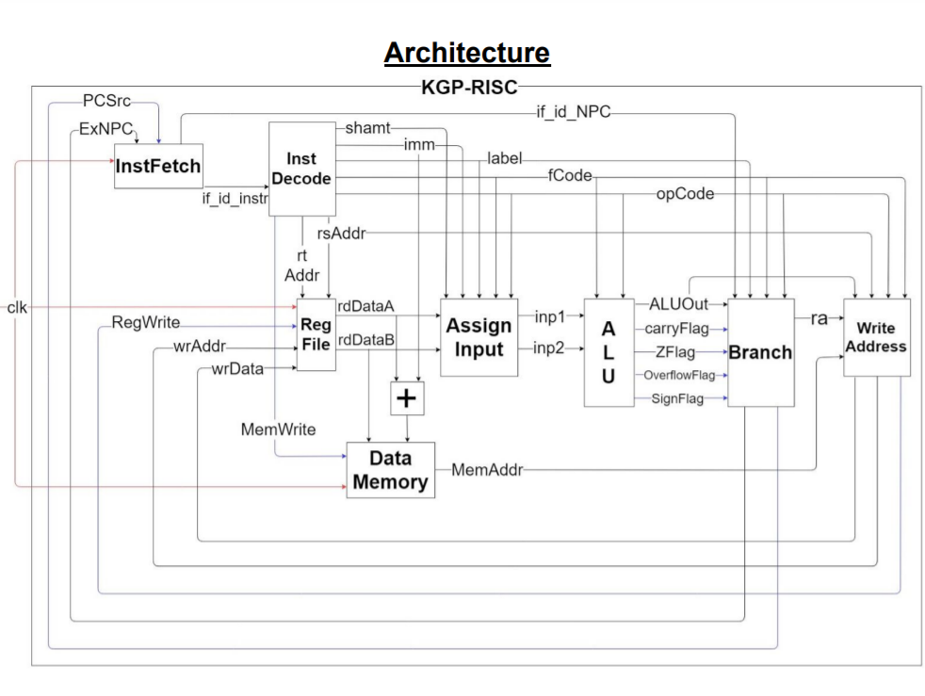

|  |  |  |
| --- | --- | --- |
| Opcode | Binary  Representation | Functions |
| 0 | 000 | Xor , and , comp ,add ,shll ,shrl ,shllv ,shra ,shrav ,shrlv |
| 1 | 001 | addi, compi |
| 2 | 010 | lw, sw |
| 3 | 011 | b, bz, bnz, bcy, bncy, bltz, bl |
| 4 | 100 | br |