# Instructions to run the project on local IIS

1. Download the project from the following

<https://github.com/sanzandsanz/ChequeDemoProject>

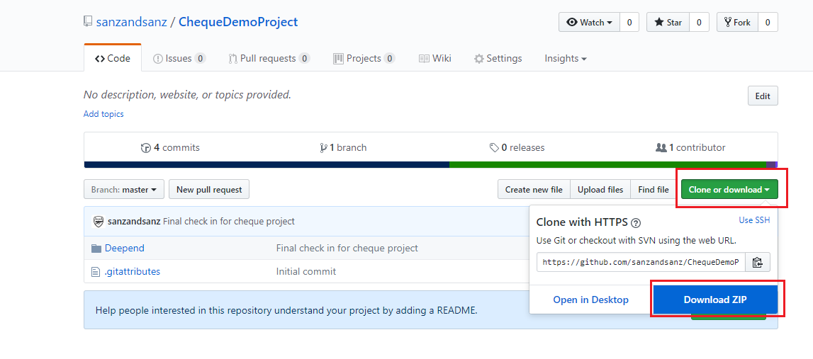

1. Unzip the file
2. Open the project on the Visual Studio (Note: Run the VS as administrator)
3. Built the solution
4. Go to Project’s properties and click the ‘Web’ tab
5. Click ‘Create Virtual Directory’ to create the virtual directory for the project. The default Project Url is set as <http://localhost/DeependCheque>
6. Built the solution again

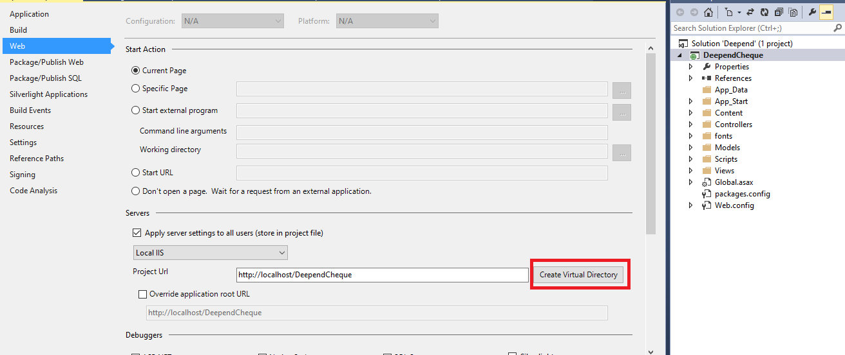

1. Browse the url <http://localhost/DeependCheque>’ to run the project.

Note: You can also run the project on IIS Express without creating the virtual directory for the project.