
Tribhuvan University
Faculty of Humanities and Social Sciences

ROOM RENTAL SERVICE

A PROJECT REPORT

Submitted to
Department of Computer Application
NIMS College
Kumaripati, Lalitpur

In partial fulfillment of the requirements for the Bachelor in Computer Application

Submitted by

Tejendra Rahun Magar
BCA 4 th Semester
Symbol No.: 75602029
2081/02/15

Under the Supervision of
Saroj Budhathoki



Tribhuvan University
Faculty of Humanities and Social Sciences
Nims College

Supervisor’s Recommendation

I hereby recommend that this project prepared under my supervision by Tejendra Rahun Magar entitled “ROOM RENTAL SERVICE” in partial fulfillment of the requirements for the degree of Bachelor of Computer Application is recommended for the final evaluation.

…..................................................
SAROJ BUDHATHOKI
SUPERVISOR
Nims College
BCA
Kumaripati, Lalitpur

Tribhuvan University
Faculty of Humanities and Social Sciences
Nims College
Kumaripati, Lalitpur

LETTER OF APPROVAL

This is to certify that this project prepared by TEJENDRA RAHUN MAGAR entitled “ROOM RENTAL SERVICE” in partial fulfillment of the requirements for the degree of Bachelor in Computer Application has been evaluated. In our opinion, it is satisfactory in the scope and quality as a project for the required degree.

…..................................................  Saroj Budhathoki (Supervisor)  BCA  Nims college  Kumaripati, Lalitpur | …..................................................  Shyam Thapa Magar(HOD of BCA)  BCA  Nims college  Kumaripati, Lalitpur
…..................................................  Saroj Budhathoki  Internal Examiner | …...............................................…  External Examiner

Abstract
The room rental service is one of the many projects that include customers, online booking of houses to book and rent rooms with a database, use of sorting, searching, and K-nearest neighbor algorithm. The main motto of this project is to help people to find their required room in technological marketing and commercial strategies. Front-end is covered with React JS and Back-end with Python Django and for database MySQL is used.
Since there is huge competition in the market, people find it difficult to find and provide room, this project can solve their issue by involving them in expanding their reachability and facilities in larger geographical areas and making their business competitively existable.

Keywords: Room rental service, K-NN, Django

Acknowledgment
The number of people helping me with my projects deserves a lot of thanks and consideration. Special thanks go to Saroj Budhathoki for guiding me to do this project and helping with documentation. Special thanks to my parents as well for helping me in a lot of ways in this project in regards to time, economy, comments, and many more. Enough cannot be expressed but thanks to my peers and teachers for helping me with little suggestions.
All the work done in this system is dedicated to my family for being part of me in the whole process, especially our dear friends who stood by me in all situations. Finally, thanks to YouTubers, bloggers, stack overflow community, developers, and every technical information provider for making this project possible.

Yours sincerely,

Tejendra Rahun Magar

TABLE OF CONTENTS

SUPERVISOR’S RECOMMENDATION
LETTER OF APPROVAL
ABSTRACT i
ACKNOWLEDGEMENT ii
LIST OF ABBREVIATIONS v
LIST OF FIGURES vi
LIST OF TABLES vii
CHAPTER: 1 INTRODUCTION 1
1.1 Introduction 1
1.2 Problem Statement 1
1.3 Objectives 2
1.4 Scope and Limitation 2
1.5 Development Methodology 3
1.6 Report Organization 3
CHAPTER: 2 BACKGROUND STUDY AND LITERATURE REVIEW 4
2.1 Background Study 4
2.2 Literature Review 4
CHAPTER: 3 SYSTEM ANALYSIS AND DESIGN 6
3.1 System Analysis 6
3.1.1 Requirement Analysis 6
3.1.2 Feasibility Analysis 6
3.1.3 Data Modeling: ER Diagram 10
3.1.4 Process Modeling DFD 11
3.2 System Design 14
3.2.1 Architectural Design 14
3.2.2 Interface Design 15
3.2.3 Physical DFD 15
3.3 Algorithm details 16
CHAPTER: 4 IMPLEMENTATION AND TESTING 17
4.1 Implementation 17
4.1.1 Tools Used 17
4.1.2 Implementation details of Modules 18
4.2 Testing 19
4.2.1 Test Cases for Unit Testing 19
Table 1: Unit Testing 20
4.2.2 Test Cases for System Testing 21
CHAPTER: 5 CONCLUSION AND FUTURE RECOMMENDATIONS 25
5.1 Conclusion 25
5.2 Lesson Learnt 25
5.3 Future Recommendation 25
APPENDICES 27
REFERENCES 32

LIST OF ABBREVIATIONS

Abbreviation | Meaning
K-NN  WWW  GHz  IDE  JSON  API  RAM  URL  DB  DFD  CASE  E-Commerce  ER | K Nearest Neighbor  World Wide Web  Gigahertz  Integrated Development Environment  JavaScript Object Notation  Application Program Interface  Random Access Memory  Uniform Resource Locator  Database  Data Flow Diagram  Computer-Aided Software Engineering  Electronic Commerce  Entity Relationship

LIST OF FIGURES
Figure 0: Development methodology 3
Figure 1: Use Case Diagram 7
Figure 2: Gantt chart for Room Rental Servive 9
Figure 3: ER Diagram 10
Figure 4: Level 0-DFD 11
Figure 5:Level 1-DFD 12
Figure 6: Level 2-DFD 13
Figure 7: Architectural Design 14
Figure 8: Interface Design-admin 15
Figure 9: physical DFD 15

LIST OF TABLES
Table 1: Gantt chart for Room Rental Servive 8
Table 2: Unit Testing 20
Table 3: System Testing-login 21
Table 4: System Testing-registration 23
Table 5: System Testing-Add To Cart button 24

CHAPTER: 1

INTRODUCTION

Introduction
In the modern era of science and technology, the internet and its services have become the basic need for the daily ritual of human beings. With the rapid growth of E-Commerce and everything online buying and renting sites are also taking place in the trend. In this Room Rental Service, people can order and book a room by viewing the various options available on the website with validated as well as correct information. The housing market is constantly changing and finding a place to live can be challenging. For many people renting a room is a practical and affordable alternative to buying a home or renting an entire apartment. Room rental can be a win-win situation for both parties. Whether you are a rental looking for a room or a landlord looking to rent one out. This guide will help to navigate the process and find the perfect match. The main advantage of my system is that it is easy to use for both customers as well as suppliers and the customer can always look over the updated site whereas customers can easily update their needs without wasting time. The application could also help the apartment and house owners promote their houses by simply uploading pictures of their units. An Internet connection is required to use this application.
Adding the properties (room/s, flat/s) and tenant details on the page is easy. Similarly viewing the details and updating it is easy. Here registration is a must for all the property owners having this page to add and keep the record of their properties and tenants. After registration, the property/house owner can use his/her registered email account and password to log in to the system. It can also help house owners promote their business. It promotes smart technology.

1.2 Problem Statement
The challenges faced by most people in booking and renting rooms in real-world scenarios are defining needs and preferences, and what kind of amenities are they looking for even if the room is available. One of the most common problem related to Room rental services is fraud and scams. Room rental service will solve the problem of finding a room easily for tenants and keep track of tenant maintenance requests, tenant records, and contact management, to make it easier for the tenant and control the rental payment. It also provides ubiquity to tenants to find their required rooms/flats. Also, house owners upload their room with detail.

1.3 Objectives
The objectives of the room rental service application are as follows:
- To find and rent a room or flats easily without investing a lot of time and effort.
- To get suitable tenants as per the details uploaded by the House owner.
- To overcome the old process of finding rooms and property.

1.4 Scope and Limitation
1.4.1 Scope
- It can be used by the room seekers to find and locate rooms.
- It can be used by common users easily thus saving their time and money.
- It can be used to handle inquiries, requests, and any issues of the user that may arise during finding rooms.

1.4.2 Limitation
This project is based within a boundary of NextJs, ReactJs, and Python. This project uses an international payment gateway like Stripe and Nepal has a low-country Stripe, and PayPal is still having trouble being implemented properly while the Nepali payment gateway does not have the proper documentation and packages required for this project. Even some of the territory boundary problems and some problems didn’t have solutions even in the world’s best forum like stack overflow which took a long time to be solved. This project is limiting the possibilities of providing rooms and apartments to the local people with the system implemented by room rental services.

1.5 Development Methodology
There are uncountable resources available as secondary sources and primary sources however this project is based more on Secondary sources like blogs, articles, books, official sites, and official materials. Tutorial videos from social media like YouTube, Udemy, and Coursera assisted widely in developing this project. Primary sources like the project supervisor, peers, and teachers were valuable sources for conducting this project and its documentation. This project is based on prototype methodology due to the uncertainty of materials that may be in demand or to cope with the changes. However, this project had to be made ready by the end of the semester so the prototype was presented in the proposal, then again updated prototype was proposed in mid-defense, and so on.

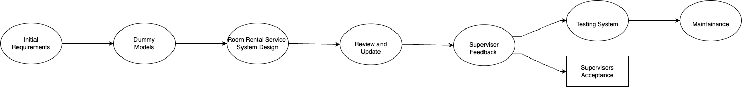

Figure 0: Development methodology

1.6 Report Organization
This report is organized in 5 different chapters based on the official documentation as per Tribhuvan University.

CHAPTER: 2
BACKGROUND STUDY AND LITERATURE REVIEW

2.1 Background Study
Since the management of rental housing has become an important part of modern society, a rental management system is necessary. If you are a stranger in the city and want to rent a house, it is difficult to find a suitable house in time. This is the main motivation behind the project development of the Room Rental System. An online web portal that allows you to manage rental properties and vehicles, allow tenants to view all properties listed, and search for needs by keywords such as property type, location, and more. We also need the ability for renters to view all property details, and shortlist their preferences, register, and book a site visit. The website requires a member registration form and a request to contact the administrator for marketing purposes.
Registered members must have the ability to book site visits, view recently viewed site visits, and review sites in his/her account. A property owner and vehicle owner can publish their property and vehicle on the portal, manage it, contract, and assign tenants Technologies used on the front end are HTML, CSS, Bootstrap, and JavaScript. These technologies can make your website responsive. This means your website works smoothly on all devices. The technologies used in the backend are MongoDB and MySQL. These allow you to dynamically design your website. The car carrier consists of all classes of automobiles from luxurious to finances. In addition, this venture’s utmost priority is fine.

2.2 Literature Review
D. Kesrarat, S. Songcharoenkit, P. Nanthapornpisut have evolved accurate Matching for lease-a-car in 2017. The goal of writing is to expand applications that permit customers to determine the vehicle's regularity with their desires and to procedure the apartment of each bike and vehicle. The event method used is the water method which consists of conversation, planning, modeling, construction, and deployment. The effects are evaluated with 8 golden rules of interface style and also the effects of the shape display that the equipment can be utilized by customers and providers to create the approach of rental and renting a vehicle. It is concluded that this utility may be used well and may perform the approach of condo and renting cars for motors and motorbikes. As a student who lives far from home and doesn't get a hostel, they have to locate a nearby residence to rent. A house rental which can be nearby to the university usually ends up a scholar's desire. The scholar who wants to rent a house will hardly ever find an appropriate one with them. The owner generally no longer advertises their house as they simply unfold the residence to the resident mouth to mouth. The student must ask the resident around to find a rental residence and it's going to take so much time. The motive of this application is to assist the student in locating a lease residence without problems. This application will show nearby residences to lease and make an evaluation to help the student in making their choice.
In the paper [1] Sahreen Afzal et. all will include Baseline Study Methodology and Software Design Methodology. 1. Baseline Study Methodology: Landlords will upload the data regarding their property and the tenants can check the available rooms according to their comfort. Structured Query Language (SQL) will be used to collect data and store it in databases. 2. Software Study Methodology: The software/website will be developed for common users by using web designing languages like HTML, CSS, bootstrap, etc. It consists of 3 parts: Client Web Server Database Server.

CHAPTER: 3

SYSTEM ANALYSIS AND DESIGN

3.1 System analysis
There are many functional and non-functional, internal and external components that build up this complete system and each of their roles is equally important to carry out different modules, testing, and partial deployment of the system so that it can be presented in the real world. Each and every module of a system is analyzed so that it passes every feasibility exam and produces a user-friendly and effective system.

3.1.1 Requirement Analysis
There were several requirements in this system and to make this system run well, using a device to do programming, programming language, real-world objects to implement and create the system, database to store the client and admin records and data in this system.

Functional requirements
A room rental service needs to let people do a few key things smoothly. First off all, users should be able to sign up easily and log in securely. Once they're in, people who want to rent out their rooms should be able to list them with all the important details like location, price, and what's included. Then, those looking for a room should be able to easily search for what they need, like specifying dates, price range, and location. When they find a room they like, they should be able to book it without any fuss. Both the person renting the room and the one renting it out should be able to manage their bookings and chat about details through the platform. And of course, there should be a way for people to leave reviews and ratings to help others make decisions. Lastly, it's important to make sure everything is safe and secure, including handling payments and keeping user information private.

Figure 1: Use Case Diagram

Non-functional requirements
Non-functional requirements for a room rental service focus on how well the system works rather than what it does. For example, it's essential that the website or app runs smoothly even when many people are using it at once, without getting slow or crashing. Another key aspect is reliability, meaning the service should work consistently without unexpected downtime or data losses. It's also crucial that users' information stays safe, so strong security measures like encryption should be in place to protect their data from hackers.
Additionally, the service should be available all the time, 24/7, so users can access it whenever they need to book a room. Usability is important too – the website or app should be easy to understand and navigate, even for people who aren't tech-savvy. For fairness and legal reasons, the service needs to comply with rules and regulations related to things like consumer rights and data protection. Lastly, keeping an eye on how the system performs is vital, so there should be tools in place to monitor things like speed, server load, and errors, allowing for adjustments to be made to keep everything running smoothly.

3.1.2 Feasibility Analysis
This system is a feasible project. For testing feasibility, different factors were analyzed and evaluated to determine if this system is technically feasible, feasible with the estimated cost and profitability.

Technical Feasibility
This system is technically feasible even as this system can be run on all modern technologies and devices without much trouble and our system does not require more specification devices to be carried out. Hence, our system can be implemented in the real world.

Operational
This system is operationally feasible as the system can be operated by normal users with basic computer skills without any additional training. This system has been developed with the willingness and ability to create, manage, and operate a system that is easy for end users to operate. Since the User Interface is also easy with the reduction of complexities there is no problem in the operation of the system.

Economics
This system is economically feasible as this is a cost-benefit analyzed project. It provides tangible and intangible benefits like a reduction in cost, more flexibility, faster activities, proper database management, etc. Since prime goal of this system is to target local and small-scale business premises, it is economically feasible.

Task Name | Duration
Phase 1 | January 24
Phase 2 | February 24
Phase 3 | March 24
Phase 4 | April 24
Phase 5 | May 24

Table 1: Gantt chart table for Room Rental Service
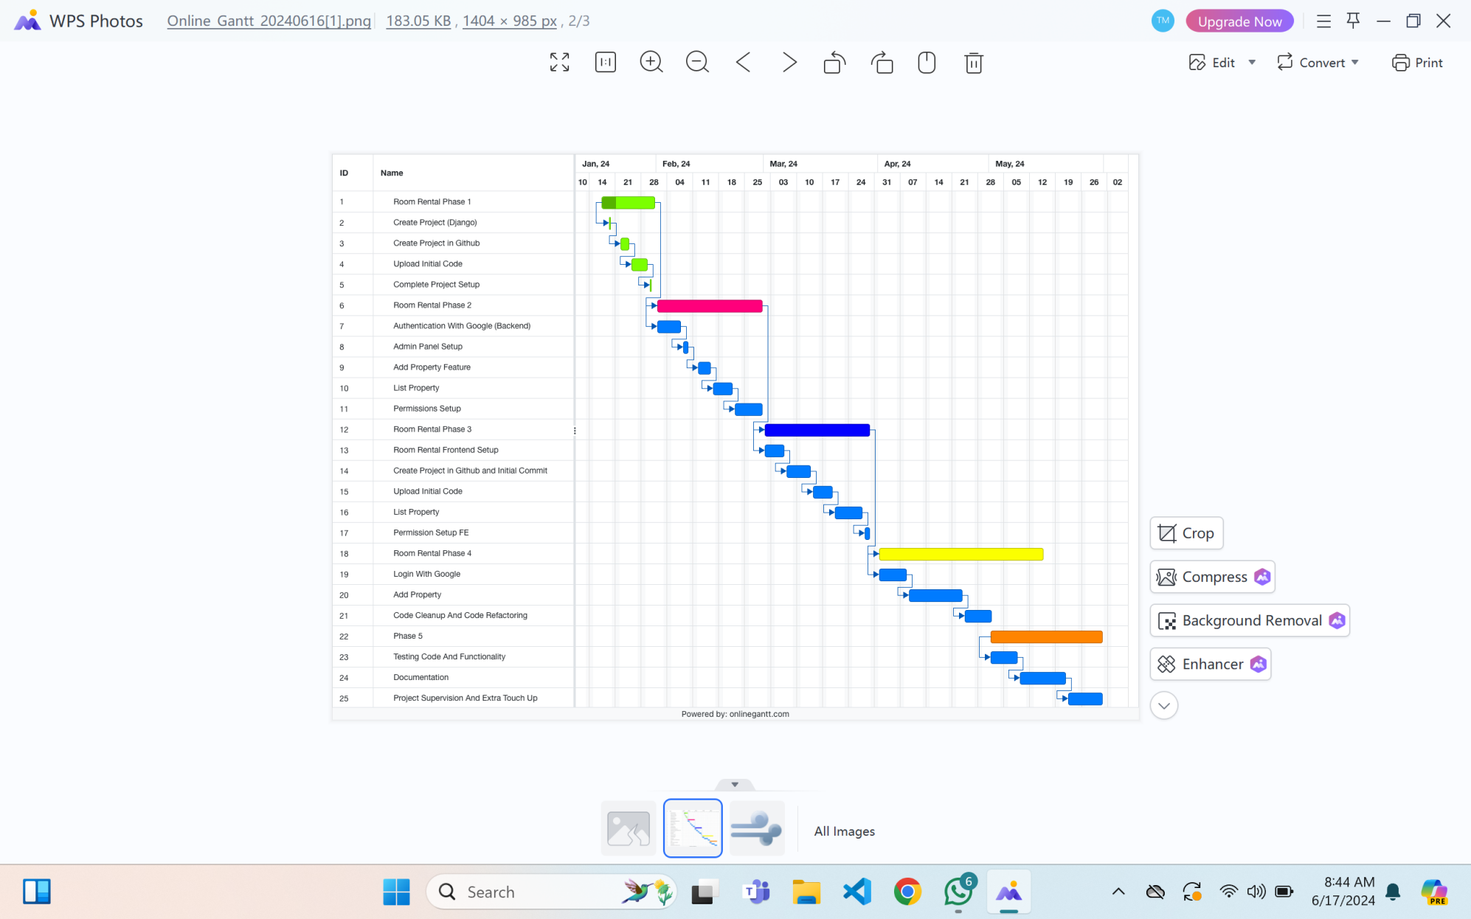

Figure 1: Gantt chart for Room Rental Service

3.1.3 Data Modeling: ER Diagram

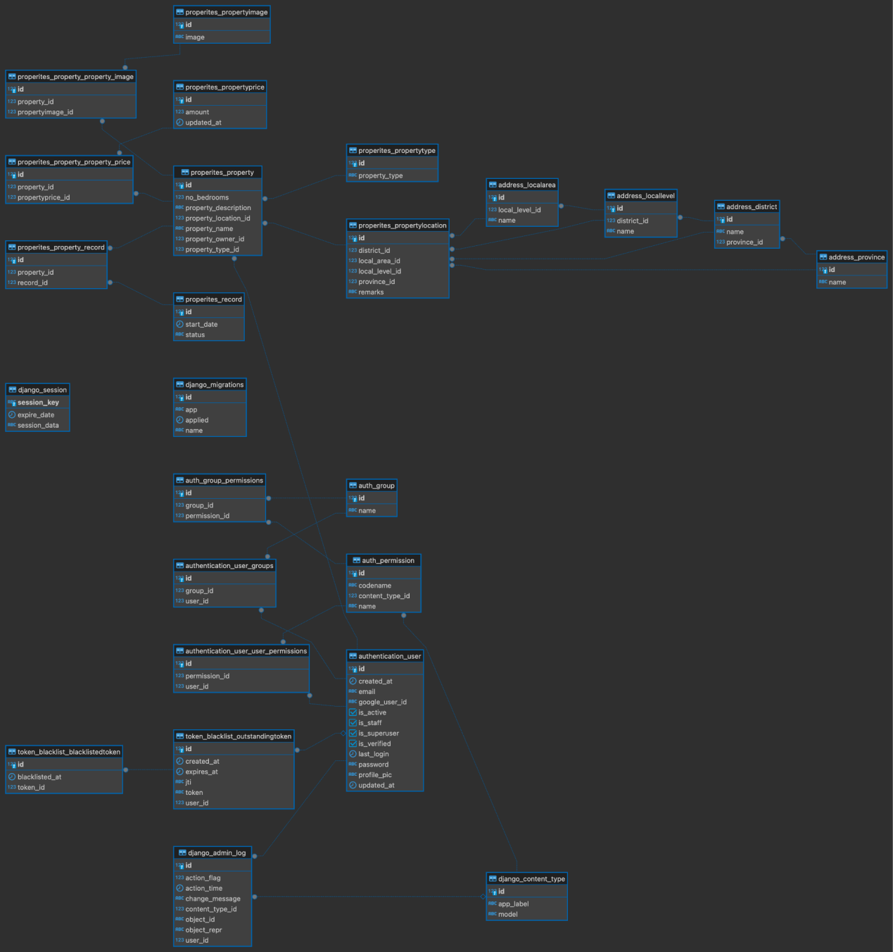
Figure 3: ER Diagram

3.1.4 Process Modeling DFD
To define the workflow or flow of data between several components I have created level 0, level 1, and level 2 Data flow diagrams illustrated below:

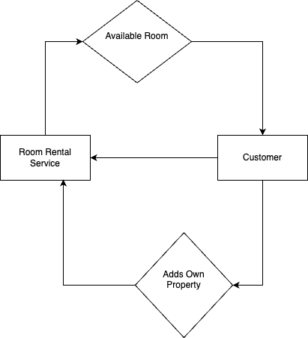
Figure 4: Level 0-DFD

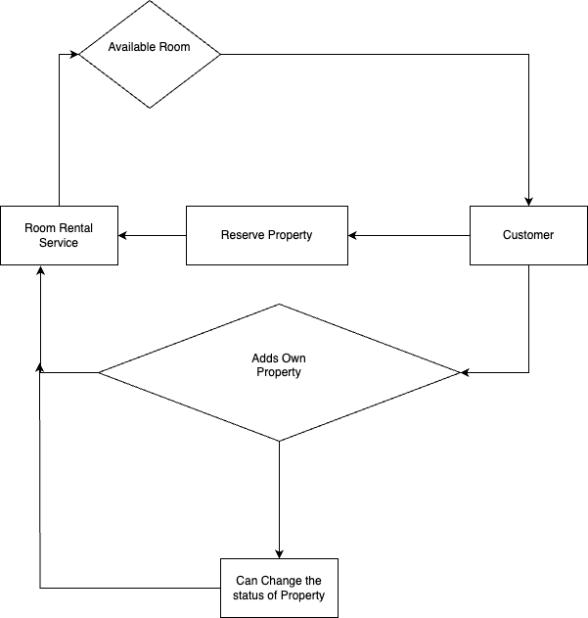
Figure 5: Level 1 -DFD

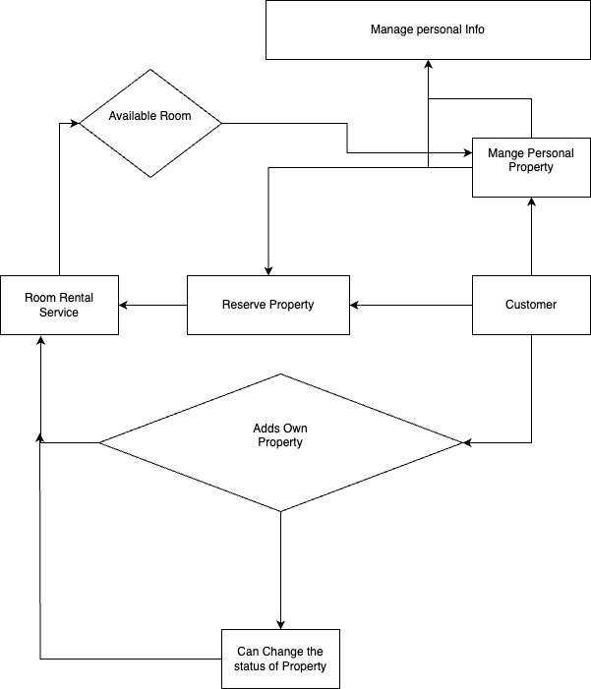
Figure 6: Level 2-DFD

3.2 System Design

3.2.1 Architectural Design
The architecture of this system is based on functional components that are integrated together to build a complete system.
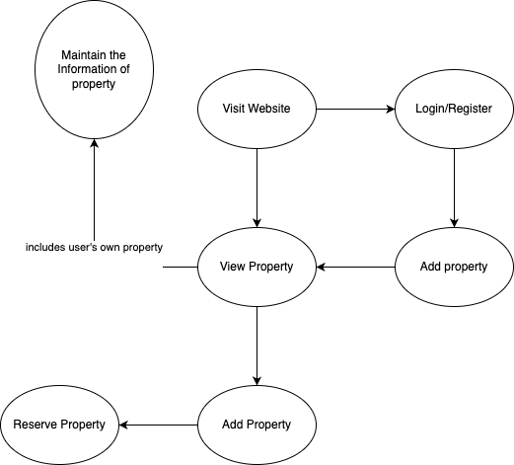
Figure 7: Architectural Design

3.2.2 Interface Design
In this project, there are three types of interfaces: a logged-in or registered user, a non-logged-in or non-registered user, and the admin can see and perform different calls to action on the available entities. The three different interfaces are illustrated below:
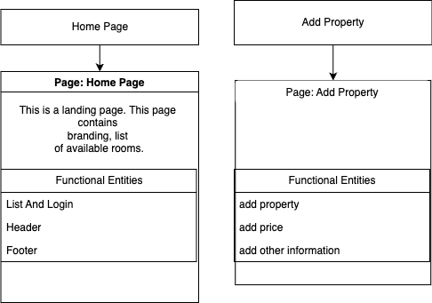S

Figure 8: Interface Design-admin

3.2.3 Physical DFD
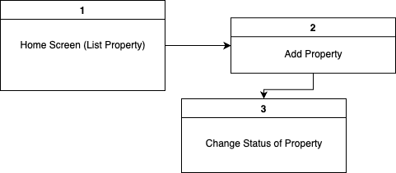

Figure 9: Physical DFD

3.3 Algorithm details
This system is based on a searching and sorting algorithm by which users can search for rooms of their wish and search results will be filtered on the user screen Users can also sort rooms based on their required amount and choice. The insertion sorting algorithm is used in this system, we can sort items on any variants that we like. Similarly, the linear searching algorithm is used to search for rooms from the list of available rooms. This system uses the analytics of bar diagrams and charts to track the business profit and loss which will make the administrator aware if the business is in a safe line or risk line from the budget margin. To support the analysis of the events required for better statistical data, the admin can set the events and set them according to the date or any margin of time for better business support and decision.

CHAPTER: 4

IMPLEMENTATION AND TESTING

4.1.1 Tools used
Different tools which are in favor of MERN stack are used to complete the system building, planning, analyzing, designing. React was used in front end, and Python Django was used in back end while MySQL was used as a database.
Software and Hardware Used
MySQL- To store the database of user and admin like id, password and order details and system Data.
Visual Studio- The Visual Studio IDE is used for programming code.
Programming language- The programming languages like React JS, NodeJS are used in this project.
Testing- The testing is done on the local server.
Designing- The designing of figures, logos were done on Canva and draw.io.
Web browsers- Google Chrome were used for testing this system.
Operating System- Build on machine with Linux OS or Ubuntu and Windows 11.
Version Control System- GitHub All the source code of this project is available in GitHub and git was used to commit the changes made and update several components in every instance of time.
Processor: Built on Intel® Core™ i5-1335U CPU @ 1.30 GHz processor.
Memory: This system was developed on a device with 16GB RAM

4.1.2 Implementation details of modules
This system is made up of functional modules that are divided into components so that building, readability, and understanding will not be affected. Since React JS is a component-based JavaScript library the modularization was easy and the chances of getting errors were less. Firstly, the client side or front end was focused in this system to complete the user interface and small logic. The client side consists of a home page or landing page where clients can view hotels and rooms and add hotels and rooms to a cart. The home page consists of a footer, header, and body and all parts were modularized so that they can be built independently without affecting one another. The client has all the functionality like add to cart, checkout, searching and sorting of products, and viewing of order history however, the client needs to log in and if they don’t have an account they can simply register for an account.
The back-end technology used in this system is Python Django for logic and dynamic asynchronous responding as well as building local APIs and implementing searching and sorting algorithms. Every API is based on the non-blocking module which follows the principle of asynchronous await due to which one dynamic request of the client will not be affected and client can make multiple requests and the server can respond to those requests without blocking one another just by using a single thread.
For databases MySQL is used which is a very trendy and preferred database in today's era. MySQL saves data in JSON format so that the data can be stored effectively without affecting one another and every data can be data which is also easy to read. In this system all data like images, client and admin records, room details, purchased details and favorite records are stored in MySQL cloud so it requires the internet to fetch all those data. Data are stored separately for users, and room details and purchased details are records so that the components can be used easily and the system can function well and efficiently.

4.2 Testing
This system was tested by friends, supervisors, and other teachers and the feedback is good. So that this system can be implemented in a real-time environment. Many important defects, flaws, or errors were caught up in the application code which is resolved now and this system is still in progress to be a better version.

4.2.1 Test cases for Unit Testing
In this testing individual pages, button, and functionality of a system is tested. Every module was tested to derive the best project for the deployment. Eventually, it helps to identify failures in the algorithms as well as logic to help improve the quality of the code that composes a certain function
SN | Test Description | Inputs | Expected Result | Status
1 | Add to cart button testing | Press Add to cart twice | Increase in cart number and double click increased quantity rather than cart number | Pass
2 | Searching for rooms to livng in Kathmandu | Typed keyword location ‘Kathmandu’ | Display all rooms lists having word Kathmandu in them | Pass
3 | Payment testing with wrong detail | Provided personal information and wrong card information i.e., 4211234567890123 | booking Unsuccessful | Pass
4 | Payment testing with correct detail | Provided personal information and right card information i.e 424242424242424242 | order Successful | Pass
5 | Logout button testing | Pressed on logout button | Logout and take to login page | Pass
6 | URL redirect without login test | Searched http://localhost:3000/orders without login | Don’t take to the user orders page | Pass
7 | URL redirect with login test | Searched http://localhost:3000/orders with login | Takes to user orders page | Pass

Table 2: Unit Testing

4.2.2 Test cases for System Testing
In this test I have tested the different modules as a whole by integrating them together to evaluate how the components are working together and showing their result in a group.
SN | Test Description | Test steps | Input | Expected Result | Actual Result | Status
1 | Testing login with correct username and password | 1. Enter email  2. Enter password  3. click login | Email: magartej123.com  Password: tej123 | Login successful | Login successful | Pass
2 | Testing login with incorrect username and password | 1. Enter email  2. Enter password  3. click login | Email: abcd@jpt.com  Password:  aabbb | Login  unsuccessful | Wrong Credentials | Pass

Table 3: System Testing-login

SN | Test Description | Test steps | Input | Expected Result | Actual Result | Status
1 | Testing with correct email expression and same passwrd | 1. Enter user name  2.Enter regular email  3. Enter same password for password and confirm password  4. click on register | Username: Tejendra  Email: magartej123.com  Password: tej123  Confirm password: tej123 | Successfully Registered | Successfully Registered | Pass
2 | Testing with correct email expression and different password | 1. Enter user name  2.Enter regular email  3. Enter a different password for password and confirm password  4. click on register | Username: Tejendra  Email: magartej123.com  Password: tej123  Confirm password: tej122 | Unsuccessful Registration | password did not match | Pass
3 | Testing with incorrect email expression and same password | 1. Enter user name  2.Enter irregular email  3. Enter the same password for password and confirm password  4. click on register | Username: Tejendra  Email: tejmagar@gmail.com  Password: tej123  Confirm password: tej123 | Unsuccessful Registration | invalid email expression | Pass
Table 4: System Testing-registration

SN | Test Description | Test steps | Input | Expected Result | Actual Result | Status
1 | Testing Add to list button with single click on many product | 1. Click on add to list button of the first item  2. Click on add to list button of the second item | Clicked add to cart button for room in Kathmandu and Lalitpur | Increase in list items | Increased in list items by 2 | Pass
2 | Testing Add to list button with double click on many product | 1. Click on add to list button of the first item  2. Click on add to list button of the second item | Multiple Click on add to list button for room in Kathmandu(clicked 3 times) and Lalitpur(clicked 4 times) | Cart items remain constant but increase in quantity. | constant cart item but increase in quantity by 4 and 5. | Pass

Table 5: System Testing-Add To cart button

CHAPTER: 5

CONCLUSION AND FUTURE RECOMMENDATIONS
Overall, this system is a real-world project that can assist business premises that want to be known in the digital market and want to extend their market. Since this project uses the latest technology and is user-friendly there might be huge demand for this system.
Also, this project is difficult to carry and built-in full flex by a single person. We have tried our best to implement every necessary component. Hence this project provides great learning innovation and spirit in the field of web with ReactJS, NodeJS, MySQL, Python, and other testing and designing tools and software.

5.2 Lesson learn
This system teaches us many things and polished my experience towards web technology which includes CURD Create, Update, Read, and delete operations along with different algorithms like searching algorithm, sorting algorithm, and k-nn algorithm that are used in this Room Rental Service. Working from plain vanilla JavaScript to entering advanced JavaScript this project enlightens the doors of real programming that can come in handy in markets and organizations. Since many big organizations that book rooms always take the spotlight of the digital market and website this system gives chances for local and small-scale organizations as well for their real-time growth.

5.3 Future Recommendation
With the existing constraints, the developed systems are not what was planned initially. The primary aim of this project has been met. All the objectives that were set out have been completed and have been giving positive results in the end. In the future, some features can be added like the full implementation of the K-nearest neighbor algorithm, customer auto notification sending, chat-bot, etc. Although the user requirements were successfully met the application is not yet fully utilized because the users of this website are just learning about the benefits and working of the website. The user testing and evaluation of the application did however highlight room for the expansion of the features that are yet to be included. The application could therefore be developed further as soon as the user is fully aware of its working.

APPENDICES
Landing page
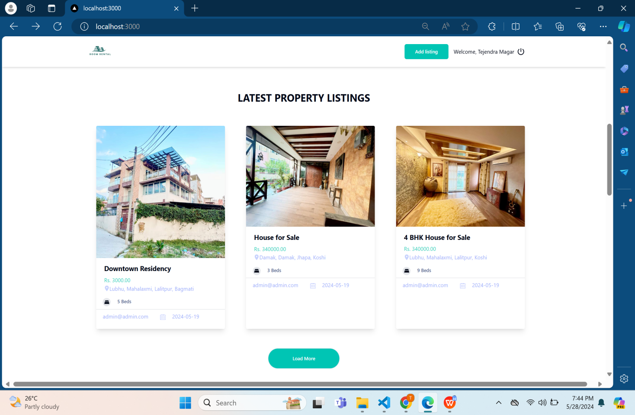

Source code
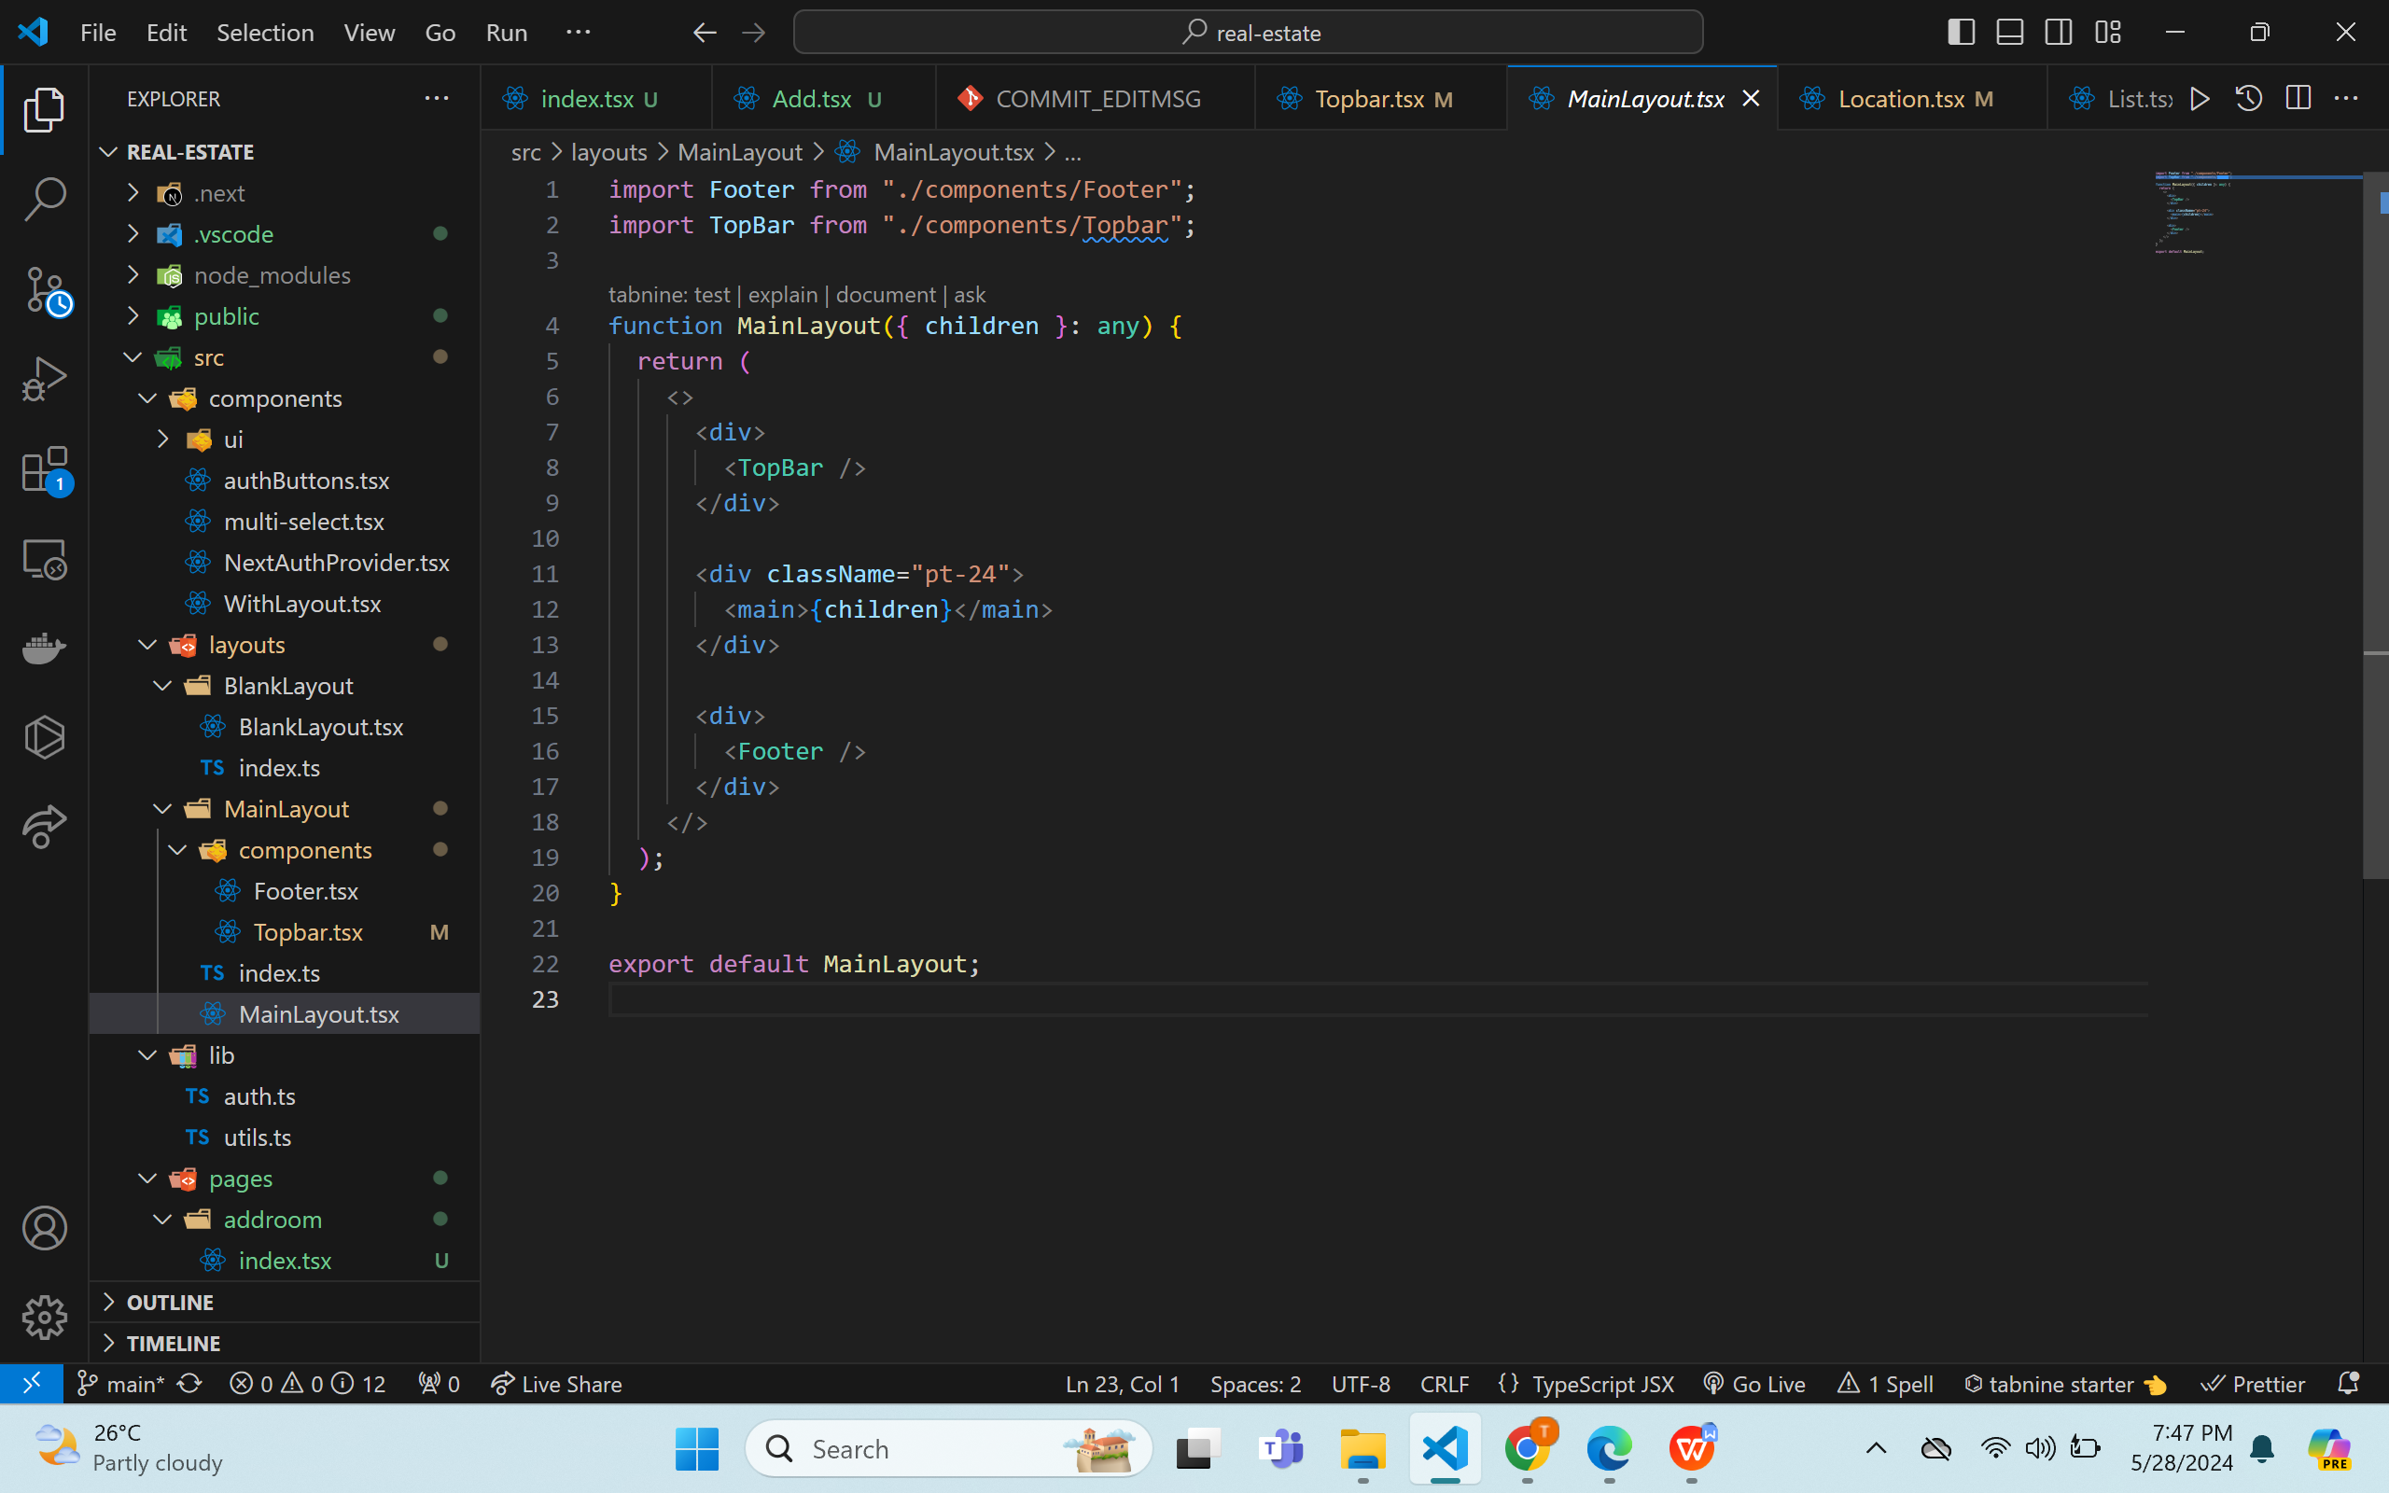

Add to list page

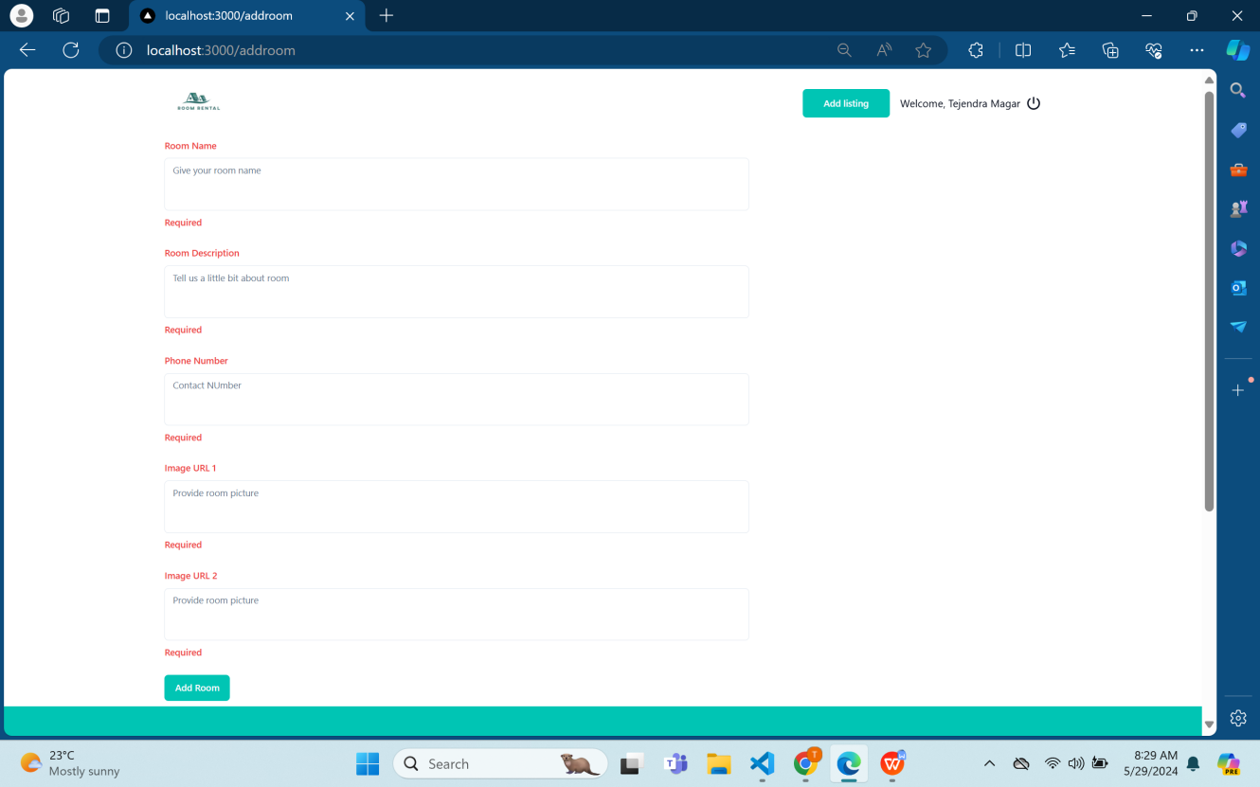

Login Page
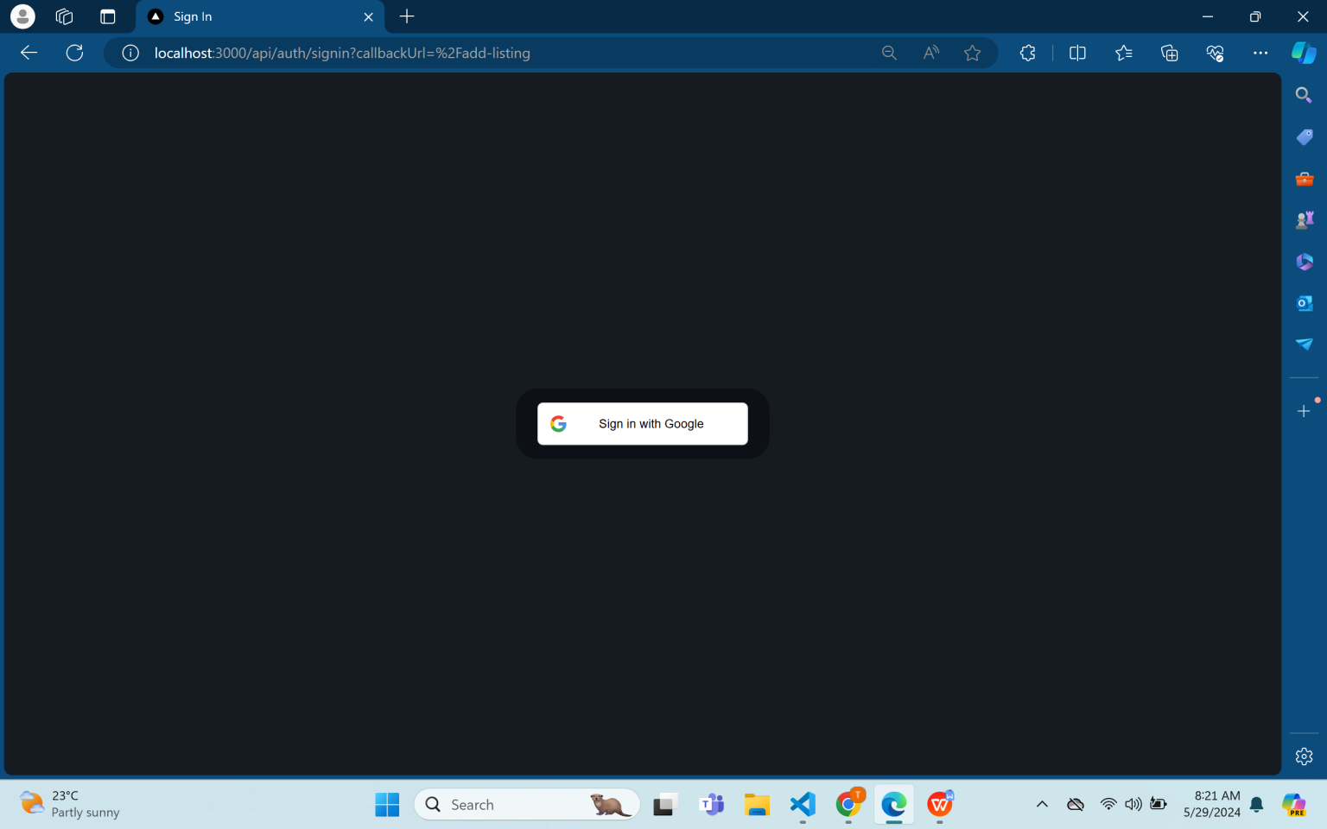
Source code
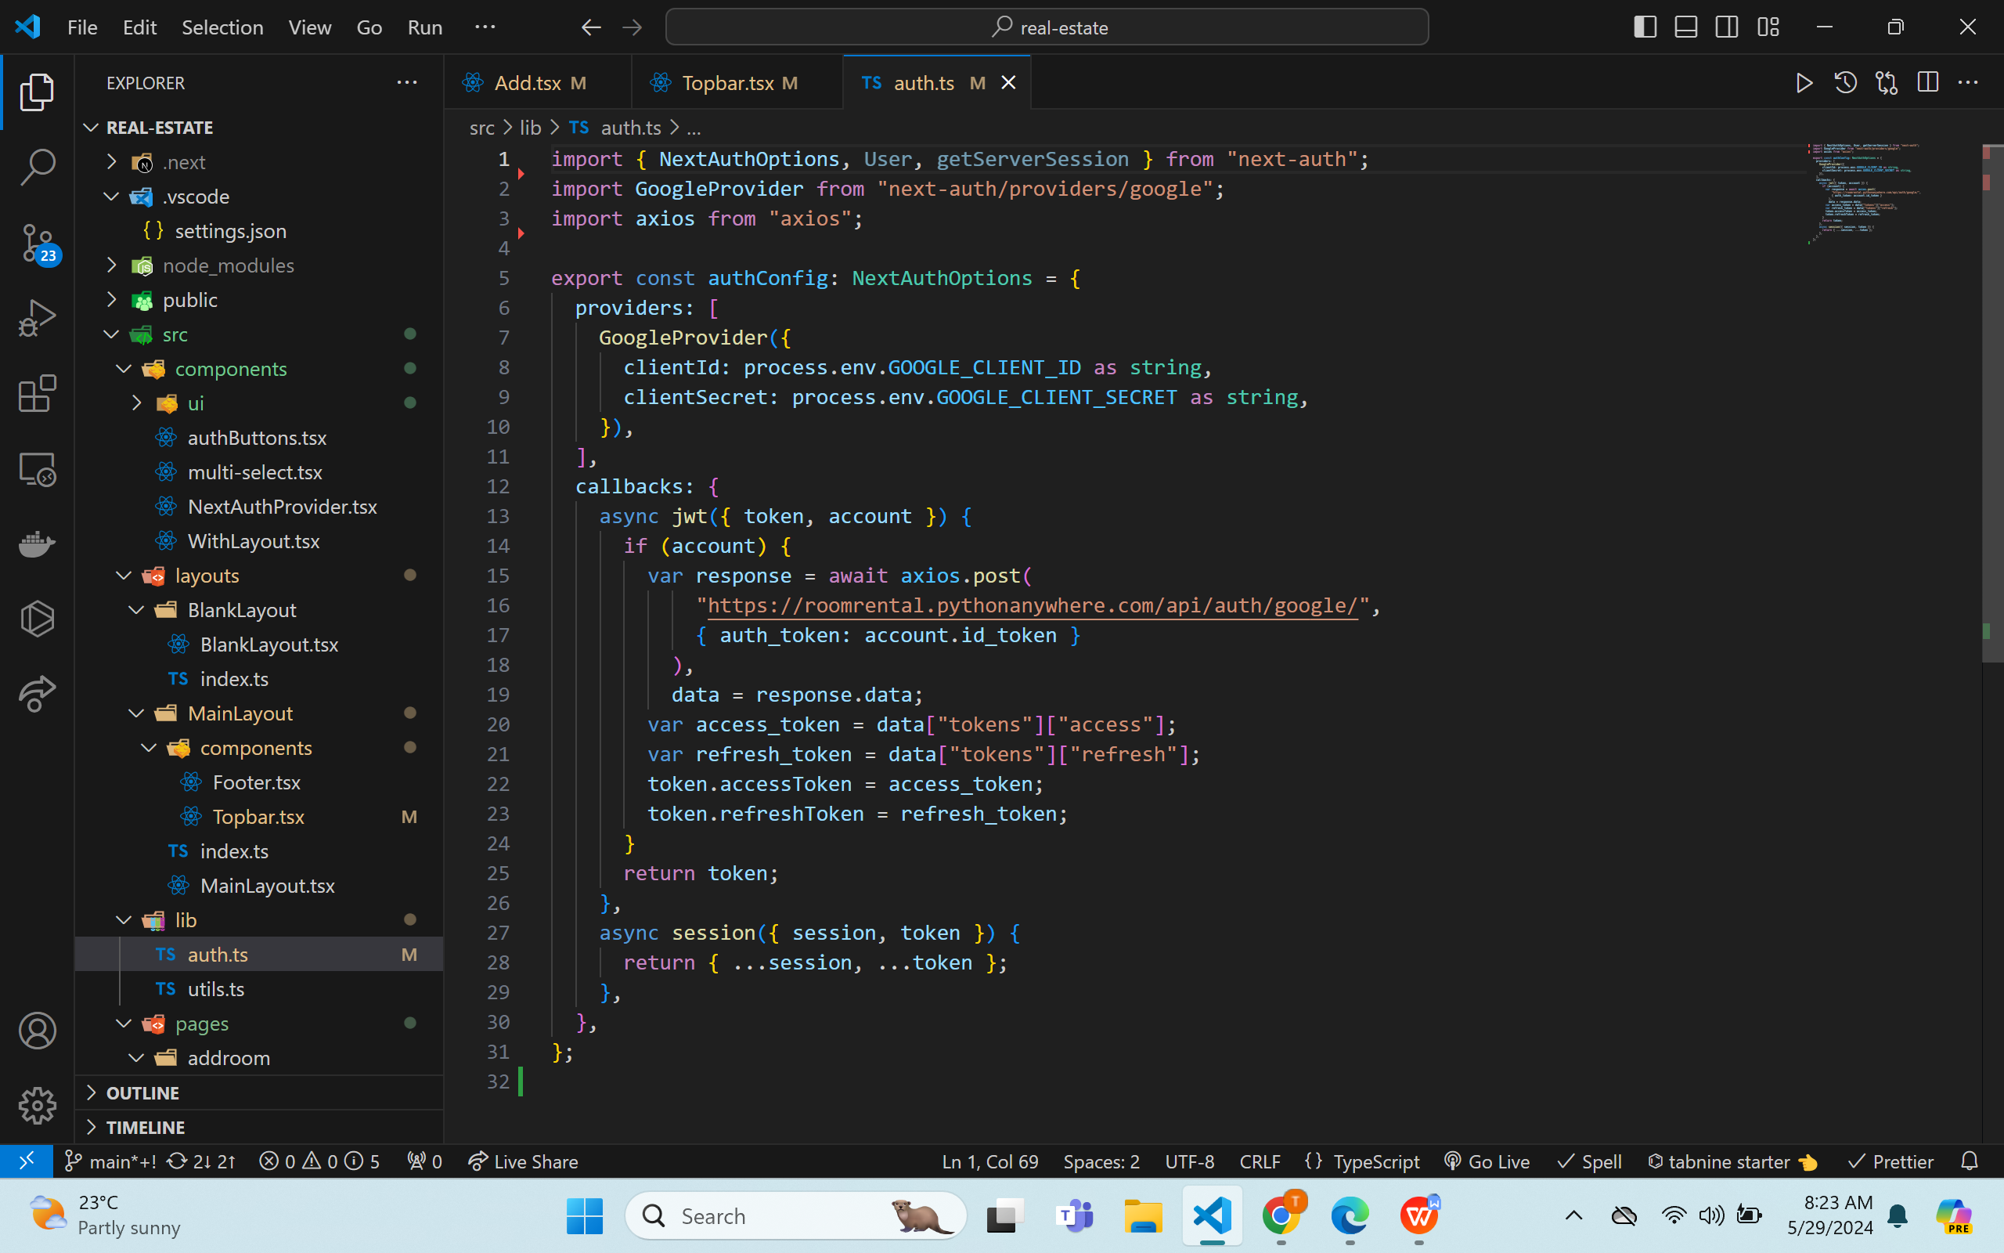

Orders Page
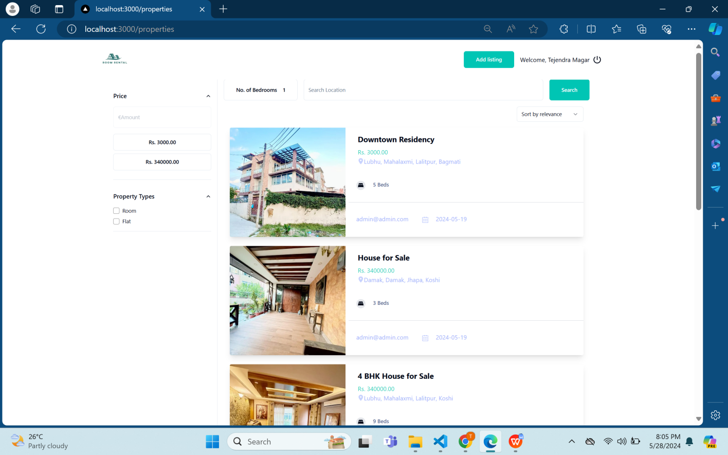

REFERENCES
- https://en.wikipedia.org/wiki/Rooming_house
- "Individual vs Joint Leasing Office of Residence Life Marquette University"
www.marquette.edu. Retrieved 2023-07-21.
- Kalmar, Jessica. "Renting with Roommates: What are Your Lease Options?"
LawDepot Blog. Retrieved 2023-07-21.

