
Education
2020 | Web Developer Bootcamp, taught by Colt Steele, Udemy  ~50 hour video course teaching a wide array of web-dev skills:  - Front-End development: HTML, CSS, JavaScript, Bootstrap, jQuery.  - Back-End technologies: RESTful routing (NodeJs, Express), data preservation and association (MongoDB, mongoose), user authentication & authorization (Passport).  - Hands-on experience gained through multiple project assignments.
2018 | B.Sc in Electrical Engineering, Technion, Israel Institute of Technology, Haifa  - Majors: Signal and Image Processing, Computers and Control Systems.  - Final Project A - “EEG Signal Analysis for Epileptic Seizure Detection”  A spectrum analyzer using STFT. In collaboration with Cornell Medical Center, NY.  - Final Project B - “Genre Classification of Songs Using MLP & Deep Learning Techniques”  A deep NN implementing advanced theory (regularization techniques, pooling, momentum, dual-architecture).


EXPERIENCE
2018-2019 | Firmware Engineer, SAMSUNG Semiconductors (SIRC)  - Developed firmware for camera sensors (in C, for SAMSUNG products and other phone vendors-contractors).  - Assumed responsibility for releases of thoroughly tested, high-quality code distributed to an enormous user base - TDD using GTest (C++).  - Gained familiarity with event-driven code, managing and handling interrupt signals.
2015-2018 | Software & Firmware Developer, IDF Intelligence Corps  - Selected for technical aptitude from within the engineering students group.  - Developed a sensor application built with both VHDL firmware, and software written in C# and Python.  - Utilized signal processing methods for data sampling and reconstruction in real time sub-nyquist systems.  - Added machine learning solutions for classification of data gathered by sensors.  - Experimented with computer vision technologies to extract additional data from existing systems.  - Introduced a NoSQL server for storing & querying a big database.

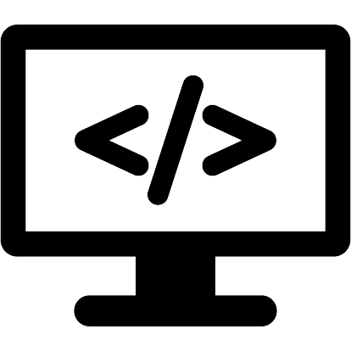
skills
Fields of Expertise |  | Development Tools |  | Languages
Machine Learning & Neural Networks  Signal & Image Processing  Computer Vision (OpenCV)  Full-Stack Web Development  FPGA (VHDL) | ★★  ★★★  ★★  ★★  ★★ | C/C++  Python & Scilab  Linux Environments  C#  Matlab & Simulink | ★★★  ★★★  ★★  ★★  ★★ | Hebrew  English  French  Spanish  German | ★★★  ★★★  ★★  ★★  ★


Hobbies
- Attends Capoeira and Improv (theater) groups weekly.
- Participates in a film collective. Co-directed our first short film in summer 2019 (currently in post-production).
- Developing my first indie game with two of my friends (in Godot game engine).

