**Standard Operating Procedure**

|  |  |
| --- | --- |
| Title: | **Astro_casco** |
| Project: | Asclepios II |
| Prepared by: | Sebasthian Ogalde C. |
| Approved by: |  |

**TABLE OF CONTENTS**

**PURPOSE** **1**

**REASON** **2**

**INVENTORY** **2**

**RESPONSIBILITY** **2**

**PREPARATION** **2**

**PROCEDURE** **2**

**APPROVAL** **3**

**REFERENCE** **3**

# **PURPOSE**

2021_SC_SOP_000X_ASTROCASCO illustrates the procedure to test the first prototype of Astro_casco corresponding to version 0.1.

# **REASON**

This task must be accomplished during EVA to test the prototype of Astro_casco v0.1, with focus on the stability, usability and reliability of the system.

# **INVENTORY**

* Astro_casco receiver v0.1
* Astro_casco transmitter v0.1
* Male USB-B – Male USB-A blue cable
* Spare AA batteries
* Computer with MicroSD card reading capability

# **RESPONSIBILITY**

The task must be performed by astronauts during EVA together with an astronaut in the base.

# **PREPARATION**

The preparation steps will be covered by the ‘Procedure for astro_casco preparation’ below.

# **OPERATIONAL INFORMATION**

Astro_casco is a device intended to read the temperature values inside the helmet of the astronauts in real time, and relay that information wirelessly to the base astronauts. The objective is to have a reliable and timely reading of this value to avoid risky environment conditions for the astronauts.

Astro_casco is composed of two devices:

* Astro_casco Transmitter: it is a device that reads the temperature of the astronaut and its environment, saves it locally inside an SD and transmits this information wirelessly to an Astro_casco Receiver.
* Astro_casco Receiver: it is a device that allows to visualize in real time the information transmitted by one or multiple Astro_casco Transmitters. During EVAs, it must stay at the base so that the base astronaut has the real time readings on hand as soon as they are available.

Astro_casco Transmitter is meant to be integrated inside the spacesuit/helmet. For version 0.1, astro_casco Transmitter will be a standalone plastic box to test reliability, usability and stability of the whole system. It features three temperature sensors, SD card slot for data saving, and wireless capabilities.

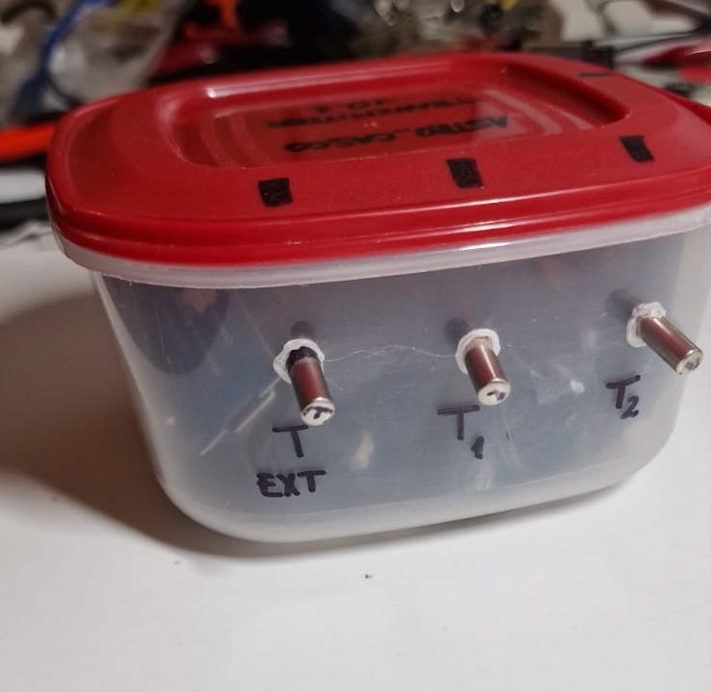

Astro_casco Receiver is built as a plastic box that features one USB port for power, and one LCD 0.96” screen that shows received astronaut information in real time.

The telemetry in astro_casco contains the following information

* Timestamp: in the format YYYY-MM-DDTHH:mm:ss. Example 2022-07-10T13:30:45.
* clock reliability: possible values OK, NOK. Indicates whether the timestamp is reliable or not. This information comes from an internal bit on the transmitter hardware clock that indicates if the external battery has been removed.
* Astronaut index: The index corresponds to the ID of each transmitter, which can be Astronaut 1 or Astronaut 2. For the version 0.1 only one transmitter is available, corresponding to Astronaut 1 only.
* Information the on-board sensors: three values are contained in the telemetry, corresponding to Text, T1 and T2. Text is the external environmental temperature. T1 and T2 are two temperature sensors reading inside the astronaut’s helmet.

The information shown on the receiver screen corresponds to the last telemetry received from an Astro_casco transmitter. Temperatures are contained in the telemetry, corresponding to Text, T1 and T2. Text is the external environmental temperature. T1 and T2 are two temperature sensors reading inside the astronaut’s helmet. RX CLK OK or NOK (not OK) whether the timestamp is reliable or not. This information comes from an internal bit on the hardware clock embedded in the receiver that indicates if the external battery has been removed.

# **PROCEDURES**

### Procedure for Astro_Casco Preparation

The next steps are to be executed as preparation of the astro_casco bundle before going to EVA.

|  |  |  |  |
| --- | --- | --- | --- |
| **Task number** | **Description** | **Check** | **Approval** |
| 1. | Check the availability of astro_casco transmitter v0.1 |  |  |
| 2. | Check the availability of astro_casco receiver v0.1 + Male USB-B – Male USB-A blue cable |  |  |
| 3. | Power on astro_casco transmitter. If the lateral red light does not blink, proceed to ‘Procedure for astro_casco trasmitter battery change’ |  |  |
| 4. | Write down the time at which astro_casco transmitter has been powered on. |  |  |
| 5. | Plug the blue cable to astro_casco receiver and connect it to a computer or USB power bank.  Note: astro_casco receiver must show a ‘stars’ pattern which is immediately replaced by the actual telemetry being received from the transmitter.  A screen shot of a computer  Description automatically generated with low confidence |  |  |
| 6. | Prepare a computer clock to see the difference in time seen by astro_casco receiver and the computer time. They should be roughly the same (not more than 20s of difference).  Write down this difference since it will be useful to assess the stability of the wireless transmission. |  |  |

#### Procedure for EVA

This procedure must be executed after ‘Procedure for astro_casco preparation’.

|  |  |  |  |
| --- | --- | --- | --- |
| **Task number** | **Description** | **Check** | **Approval** |
| 1. | EVA astronaut must take astro_casco transmitter with him/herself in a pocket inside the suit to register information during the whole activity. |  |  |
| 2. | Base astronaut must check periodically that the telemetry on the astro_casco receiver is being updated. |  |  |
| 3. | Base astronaut must write down the EVA astronaut position and time if:   * the time shown on astro_casco receiver is older than 5s the actual time * the data shown on astro_casco receiver is corrupt or shows strange characters. |  |  |
| 4. | After EVA is finished, power off Astro_casco transmitter. |  |  |
| 5. | After EVA is finished, disconnect Astro_casco receiver from PC or power source. |  |  |
| 6. | Proceed with ‘Procedure for astro_casco SD Card data extraction’. |  |  |

#### Procedure for astro_casco SD Card data extraction

This procedure must be performed only after the EVA has finished.

|  |  |  |  |
| --- | --- | --- | --- |
| **Task number** | **Description** | **Check** | **Approval** |
| 1. | Make sure that astro_casco transmitter is powered off. |  |  |
| 2. | On the transmitter, look at the position of the red cap. Then remove it.  Note: red cap fits only in one position on the transmitter. Make sure that you know how was put beforehand. |  |  |
| 3. | **Carefully** remove the SD card from the SD card reader module.   |  |  |
| 4. | Connect SD card to a computer and share the folder YYYYMMDD (corresponding to the current date) with MCC. This information must be relayed to PI.  Note: there must be a TXT file inside the folder named after the time astro_casco transmitter has been powered on. |  |  |
| 5. | **Carefully** put back the SD card inside the SD card reader module. |  |  |
| 6. | Put the red cap back on the right position on astro_casco transmitter (only one position works). |  |  |
| 7. | Power on transmitter. Check that after 10s the blue light (SD Error) is powered off, and the red light (Telem. Tranmission) flashes. |  |  |
| 8. | Power off transmitter. |  |  |

#### Procedure for astro_casco trasmitter battery change

This procedure must not be performed during EVA. This procedure must be performed only inside base as preparation.

|  |  |  |  |
| --- | --- | --- | --- |
| **Task number** | **Description** | **Check** | **Approval** |
| 1. | Make sure that astro_casco transmitter is powered off. |  |  |
| 2. | On the transmitter, look at the position of the red cap. Then remove it.  Note: red cap fits only in one position on the transmitter. Make sure that you know how was put beforehand. |  |  |
| 3. | **Carefully** replace the 4x batteries inside the plastic box. Be careful not to move any of the harness inside the plastic box. |  |  |
| 4. | Put the red cap back on the right position on astro_casco transmitter (only one position works). |  |  |
| 5. | Power on astro_casco transmitter and check its correct functioning. |  |  |

# **APPROVAL**

None.

# **REFERENCE**

None*.*