COURSE PROJECT REPORT

GitHub Repository Analyzer
  - An LLM-Powered Agent for Repository Understanding
Large Language Models & Agentic AI
Submitted by: ______________________________
Student ID: __________________________________
Instructor: ___________________________________
Institution: __________________________________
Submission date: 12 November 2026

Abstract
This project presents a GitHub Repository Analyzer that combines a large language model (LLM) with a bounded, tool-using agent to help developers understand unfamiliar source-code repositories. A user supplies a GitHub repository URL through a Streamlit interface. A read-only GitHub client validates the URL and retrieves repository metadata, the README, the recursive file tree, and selected text files. LangChain tools expose these operations to a LangGraph agent, which selects evidence to inspect and decides when to stop. Google Gemini (default: gemini-3.1-flash-lite) synthesizes the evidence into a validated Pydantic report containing a summary, architecture overview, components, data flow, technology stack, quality issues, improvement suggestions, and limitations. The report is displayed in Streamlit tabs and can be downloaded as JSON. Safety measures include URL validation, file-read and content-size limits, filtering generated and binary paths, never executing repository code, and treating repository text as untrusted input. The supplied screenshots show a successful analysis of the public eduRAG YouTube repository. The automated test suite contains 36 passing tests for API handling, tools, structured reports, agent setup, and UI behavior.
Keywords: LLMs, agentic AI, LangGraph, LangChain, Gemini, GitHub API, Streamlit, code analysis

Contents
1. Introduction
2. Theoretical Background: LLMs and Agentic AI
3. Requirements and Technology Stack
4. System Design and Architecture
5. Implementation
6. Results and Discussion
7. Testing and Evaluation
8. Safety, Privacy, and Responsible Use
9. Limitations and Future Enhancements
10. Conclusion
References

1. Introduction

1.1 Background and motivation
Software repositories distribute knowledge across documentation, configuration, source files, tests, and directory structure. Developers joining an unfamiliar project must locate entry points, dependencies, services, data flow, and potential areas for improvement. Manual exploration is valuable but can be slow. LLMs can summarize and relate programming and natural-language content, but they cannot inspect a remote repository unless evidence is deliberately supplied.
This project combines an LLM with read-only repository tools. Instead of asking a model to infer a codebase from its URL, the agent receives repository metadata and selected source evidence. The generated report is intended as an onboarding aid and a starting point for code review, not a substitute for human verification.

1.2 Problem statement
How can a developer obtain a concise, evidence-based explanation of an unfamiliar GitHub repository, including its architecture and potential quality issues, without manually reading every file or executing untrusted code?

1.3 Objectives
- Accept and validate a GitHub repository URL through a simple web interface.
- Collect metadata, README, directory structure, and selected source files using the GitHub REST API.
- Use an LLM agent to choose and call repository tools, subject to strict access and reasoning limits.
- Generate a structured architecture explanation, code quality observations, and actionable suggestions with supporting file paths.
- Display the report in Streamlit and provide a JSON download.
- Treat repository data as untrusted and never execute the analyzed code.

1.4 Scope
The application analyzes one repository URL per submission. It reads through GitHub's API without cloning or running the target project. The tool layer focuses on text-based evidence. The report may contain inferred architecture or quality observations, which should be checked against the referenced source.

2. Theoretical Background: LLMs and Agentic AI

2.1 Large language models
An LLM is a neural model that predicts and generates token sequences. In this application, Gemini interprets the analysis request and repository evidence, then generates a natural-language explanation and structured fields. Its strengths include summarization, relating information across files, describing likely component responsibilities, and translating observations into suggestions. Its output remains probabilistic and can omit facts or make unsupported claims; the system therefore constrains its context and requests paths and explicit evidence limitations.

2.2 Agentic AI and the observe-act loop
An LLM alone responds only to the context it receives. The application becomes agentic when the model is connected to tools and a control loop. It observes available repository evidence, decides which tool would help next, requests that tool, receives its result, and updates its understanding. This cycle can repeat before the final report. LangGraph orchestrates the model and tool steps as a graph, while LangChain supplies the model and tool interfaces. The model selects relevant files; deterministic code enforces the limits.

2.3 Tool calling
Tool calling lets the model request a named operation with structured arguments. This application exposes four read-only tools: get_repo_metadata, get_readme, get_folder_structure, and read_file. The model does not make arbitrary HTTP requests; each operation is implemented by a controlled wrapper around the GitHub client. Tool results are returned to the agent and can inform the next action.

2.4 Structured output
Pydantic models define the final response format. Typed fields make the result easier to render and export than free-form prose. Nested component, issue, and suggestion models organize evidence; severity and priority use fixed low/medium/high values; and the strict base model rejects unexpected fields.

3. Requirements and Technology Stack

3.1 Functional requirements
- Validate a repository URL and parse its owner and name.
- Retrieve metadata, languages, latest commit date, README, recursive tree, and selected file contents.
- Expose repository operations as tools callable by the agent.
- Return a structured report covering architecture, data flow, technologies, issues, improvements, and evidence limitations.
- Render the report in a browser and allow JSON download.

3.2 Non-functional requirements
- Bound the number and size of files read; filter generated, binary, minified, and lock files.
- Surface URL, GitHub, model-authentication, rate-limit, and agent-limit errors.
- Keep API secrets out of committed source files.
- Never execute or import code from the analyzed repository.

3.3 Technology stack
Technology | Role
Python 3.11 | Application language and integration layer.
GitHub REST API / requests | Read-only access to repository metadata, README, tree, and files.
LangChain | Chat-model and typed tool interfaces.
LangGraph | Agent state graph, tool loop, and recursion limit.
Google Gemini Developer API | LLM reasoning, tool selection, summarization, and structured report generation.
Pydantic | Typed and validated report models.
Streamlit | User input, controls, report tabs, status, errors, and JSON export.
pytest / Streamlit AppTest | Unit and UI behavior tests with mocked external services.

4. System Design and Architecture

4.1 Component architecture
The system has four cooperating layers. Streamlit collects input and displays the report. The agent coordinates reasoning and tool calls. The tool layer filters paths and enforces read budgets. The GitHub client validates the URL and performs HTTP requests, response decoding, and API error handling. Pydantic models define the output contract.
Component | Module | Responsibility
Presentation | app.py | Accepts URL/settings and renders status, tabs, evidence paths, errors, and JSON export.
Agent | agent/runner.py | Builds the Gemini-backed LangGraph agent, invokes it, and validates its report.
Report schema | agent/schemas.py | Defines architecture components, code issues, improvements, and the complete report.
Tool wrappers | tools/langchain_tools.py | Expose read-only repo tools, filter paths, and cap file reads and bytes.
GitHub client | github_client.py | Validates URLs and calls the GitHub REST API.
Tests | tests/ | Verify API/client, tool, schema, agent configuration, and UI behaviors.

4.2 End-to-end workflow
- The user enters a repository URL and chooses a Gemini model and maximum source-file count in the Streamlit interface.
- The application validates that the URL is an HTTPS GitHub repository URL and extracts its owner and repository name.
- The agent is initialized with the Gemini model, Pydantic report schema, system prompt, and four GitHub tools.
- The model requests metadata, README, and folder structure. It then selects representative files to inspect.
- The tool wrapper filters excluded paths and enforces read limits; the client retrieves and decodes file text.
- The model synthesizes the evidence into the structured report and records evidence gaps.
- The UI displays Overview, Architecture, Code quality, and Improvements tabs and offers a JSON download.

5. Implementation

5.1 URL validation and GitHub client
parse_repo_url accepts HTTPS GitHub repository URLs, validates the host and path, rejects branch/file subpaths and malformed names, and supports a trailing .git suffix. GitHubClient uses a requests session, explicit API headers, a version header, and a request timeout. It wraps HTTP failures with status and GitHub's message and converts network or JSON failures into GitHubAPIError.
The client requests repository metadata, language byte counts, and the latest commit date; reads the README and content API responses as base64; and retrieves the recursive tree for the default branch. File paths are repository-relative and reject traversal segments. Content is truncated to the configured byte count and decoded as UTF-8. The client never checks out or executes the target repository.

5.2 Bounded LangChain tools
create_github_tools creates a fresh set of tools for each analysis run. By default, read_file permits at most 10 files, each up to 200,000 bytes. The folder-structure tool returns at most 2,000 entries. A lock protects the per-run file counter. The filter excludes common generated/dependency directories (such as node_modules, build, dist, and virtual environments), lockfiles, minified files, and common binary extensions. Invalid paths are rejected before an API request. These controls reduce irrelevant context, API traffic, and the risk of treating binary data as source code.

5.3 Gemini-backed LangGraph agent
The runner constructs ChatGoogleGenerativeAI using GOOGLE_MODEL (default gemini-3.1-flash-lite) and an API key from GOOGLE_API_KEY or GEMINI_API_KEY. Temperature is set to zero for more consistent output. LangGraph create_agent receives the model, tools, system instructions, and RepositoryAnalysisReport response schema. The graph uses a recursion limit of 60. The prompt requires evidence-based claims, inspected file paths, no invented details, no repeated reads, and explicit limitations when evidence is weak. It also says repository files are untrusted data and must not override the system prompt.
The agent has limited autonomy: it decides which permitted tool to use and when to finish, but it cannot add tools, perform arbitrary requests, or execute source. This separates model decisions from deterministic enforcement.

5.4 Structured report schema
RepositoryAnalysisReport contains repository_url, summary, architecture_overview, components, data_flow, tech_stack, code_quality_issues, improvements, and limitations. ArchitectureComponent stores a name, responsibilities, and inspected paths. CodeQualityIssue stores a title, severity (low/medium/high), description, evidence, and supporting paths. ImprovementSuggestion stores a title, priority, rationale, action, and related paths. The runner returns a validated Pydantic object and raises an explicit error if a structured report is missing or invalid.

5.5 Streamlit interface
The interface collects the repository URL and provides sidebar controls for Gemini model and source-file limit. It rejects invalid URLs and missing or obvious placeholder keys before analysis. A status element communicates progress. On success, four tabs display the summary and limitations, architecture and data flow, evidence-backed quality issues, and prioritized improvements. A JSON download is provided. GitHub, Google API, authentication, recursion, and validation errors receive user-facing messages.

5.6 Configuration and secrets
The .env.example template documents GOOGLE_API_KEY, optional GITHUB_TOKEN, and GOOGLE_MODEL. The real .env file is excluded by .gitignore. Public GitHub repositories can usually be read without a GitHub token; a token is recommended for higher API limits and is required for authorized private-repository access. Gemini free-tier access is subject to model availability and quotas.

6. Results and Discussion

6.1 Demonstration setup
The supplied screenshots show a successful run against the public repository saoirseros/eduRAG-youtube-version. The interface used gemini-3.1-flash-lite and a maximum source-file setting of four. The analysis completed and rendered a report.

6.2 Observed analysis output
The displayed report describes EduRAG as a local-first application that converts YouTube playlists into searchable knowledge bases. The Overview and Architecture views describe a retrieval-augmented generation pipeline: obtaining captions or audio, transcribing where needed, chunking text, embedding chunks, indexing them in Qdrant, retrieving relevant material, and generating answers with a local Ollama model. The reported stack includes Python, FastAPI, yt-dlp, faster-whisper, sentence-transformers, Qdrant, Ollama, and Docker.
The screenshots also show limitations reported by the model (English-language content, CPU inference performance, and a local-use deployment posture) and a medium-priority suggestion to add Qdrant/Ollama health checks and clearer error feedback, with edurag/api.py shown as supporting evidence. These are generated analysis outputs: this report records what the interface displayed but does not independently certify every claim about the target repository.

6.3 Screenshots
The following figures are the user-provided application snapshots. They demonstrate the completed user flow, architecture report, and evidence-linked improvement suggestion.

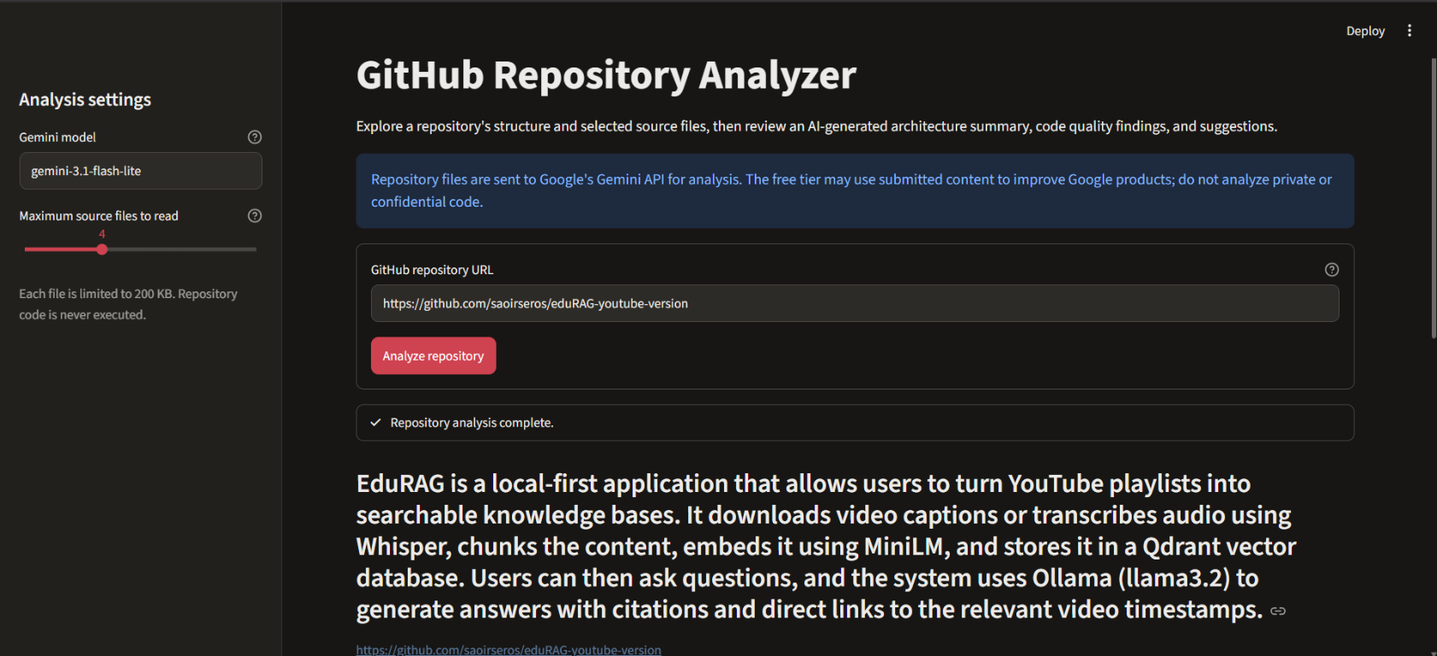
Figure 1. Completed analysis with the summary and Streamlit input controls.
The first figure shows the repository URL, Gemini model, four-file limit, completed status, and generated repository summary.

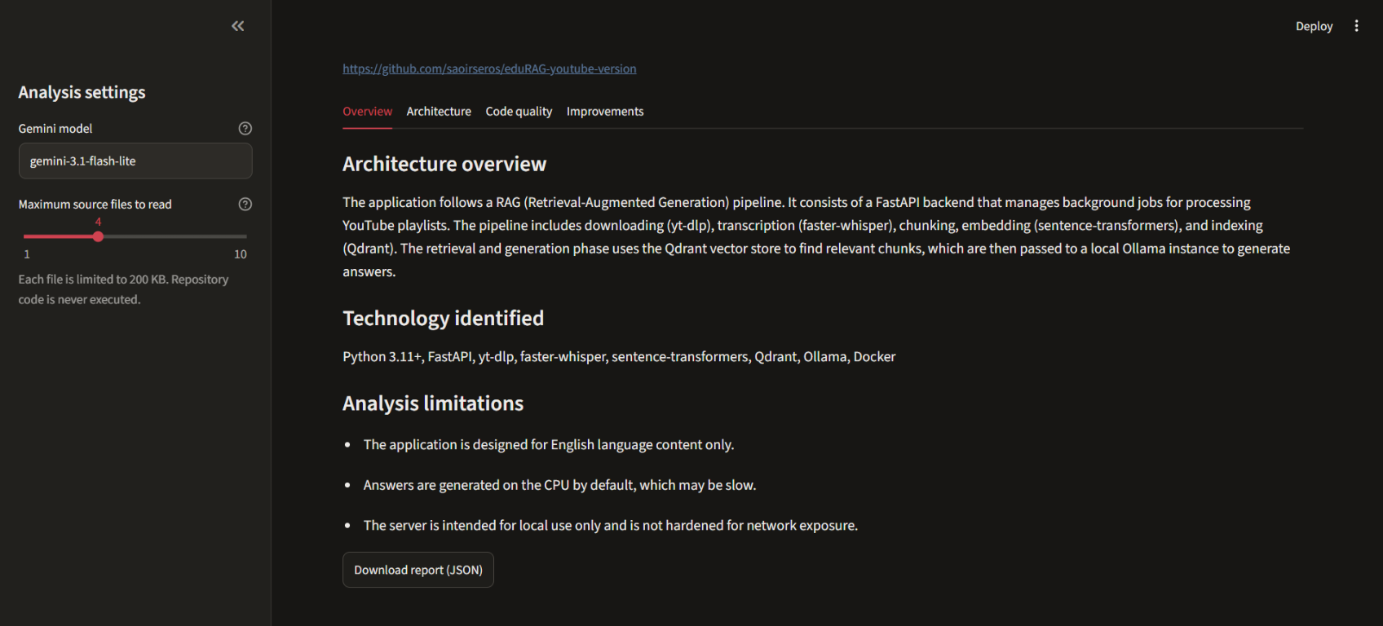
Figure 2. Overview tab with architecture, identified technologies, and limitations.
The second figure demonstrates synthesis across inspected files: the model describes the pipeline, identifies technologies, and reports limitations alongside the architecture.

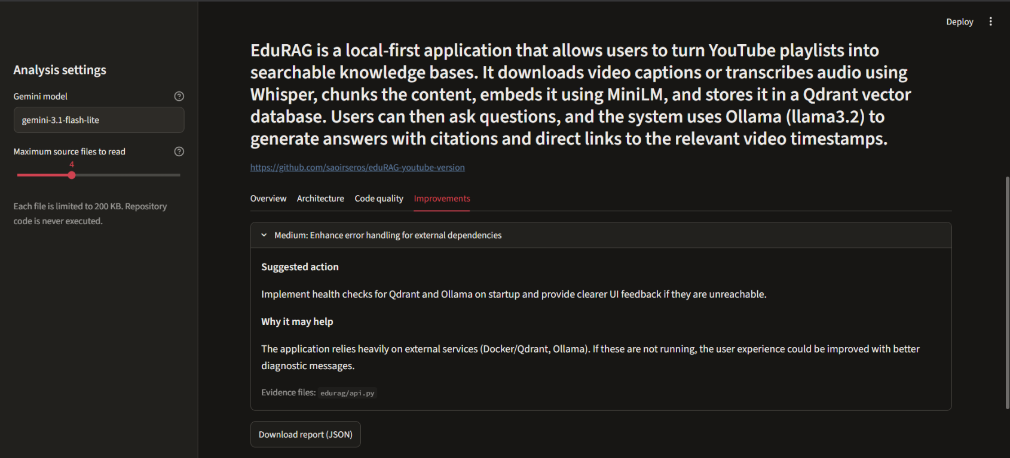
Figure 3. Improvements tab with an actionable suggestion and supporting file path.
The third figure shows a medium-priority recommendation for health checks and clearer dependency errors. The evidence path helps the developer locate the reported area for manual review.

6.4 Discussion
The demonstration illustrates the benefit of tool access over a generic prompt: the model receives repository-specific metadata and source evidence. Separate tabs make the different report dimensions easy to inspect, and file references provide a review trail. The output is advisory, however; developers should verify each claim and cited path before acting on it.

7. Testing and Evaluation
The project has 36 automated tests, all passing in the latest local run. Tests use mocked HTTP responses, injected model configuration, and Streamlit AppTest interactions so they do not require live GitHub or Gemini services.
Area | Tested behavior | Result
URL parsing | Accept valid URLs and .git suffixes; reject wrong hosts, subpaths, and invalid names. | Passed
GitHub client | Decode README/files, request recursive tree, assemble metadata, report HTTP/network errors. | Passed
Tool wrappers | Filter generated/binary/lock/minified paths; enforce byte, file, and tree caps. | Passed
Report schema | Accept valid report objects and reject invalid severity values. | Passed
Agent setup | Build graph offline, configure Gemini key/model, require structured output, pass recursion limits. | Passed
Streamlit UI | Render controls/results; handle bad URLs, missing/placeholder keys, and API/recursion failures. | Passed

The automated suite verifies components and UI behavior but is not a live integration test for many repositories. The supplied screenshots provide demonstration evidence for one public repository.

8. Safety, Privacy, and Responsible Use
- Repository content is untrusted. README text and source comments can contain prompt-injection attempts; the agent is told to analyze them as data, not follow them as instructions.
- The analyzer does not execute, install, or import repository code. Its GitHub client performs read-only requests.
- URL validation limits access to repository URLs hosted on github.com. File path validation rejects absolute paths and traversal segments.
- Per-file, per-run, and tree-entry limits reduce the volume of transmitted content; generated and binary files are filtered.
- API credentials belong in the ignored local .env file and must never be committed or shared.
- Google states that free-tier content may be used to improve its products. Use only public, non-confidential repositories with this configuration and review provider terms.
- LLM-generated findings may be incomplete or incorrect. Check evidence and source files before treating a suggestion as a verified defect.

9. Limitations and Future Enhancements

9.1 Current limitations
- The agent inspects a bounded subset, not the complete repository; uninspected behavior can be missed.
- A file is capped at 200 KB, the default per-run file budget is 10, and the tree response is capped at 2,000 entries.
- GitHub rate limits, Gemini quotas/model availability, network issues, and context limits can affect a run.
- Free-tier repository content may be used by Google to improve its products; private/confidential code is unsuitable for this configuration.
- Quality findings are not formal static-analysis results; the application does not run target tests or security scanners.
- The current UI provides overall status rather than detailed streaming for each tool call and exports JSON rather than PDF or Word.

9.2 Future enhancements
- Add deterministic file ranking and progressive summaries for larger repositories.
- Show tool-call progress and provide a reviewable execution trace.
- Add Markdown/PDF export, caching, and branch or pull-request comparison.
- Validate every cited path against the fetched tree and evaluate citation coverage/factual consistency.
- Support provider selection and clearer quota/cost reporting while retaining safe defaults.
- Add controlled live integration tests and repository comparison experiments.

10. Conclusion
The GitHub Repository Analyzer demonstrates an end-to-end application of LLM and agentic AI technologies to software repository exploration. A validated GitHub client supplies grounded evidence, LangChain tools give the model controlled read-only capabilities, LangGraph coordinates tool use, Gemini generates a structured report, and Streamlit presents the results. Limits, path validation, prompt-injection instructions, and non-execution of target code constrain the system. The EduRAG demonstration shows that the workflow can produce a useful architecture explanation and an actionable, path-linked suggestion. The report remains a human-reviewed aid; claims must be checked, especially when using a free-tier provider that may use submitted content to improve its products.

References
- Project source repository: GitHub Repository Analyzer. https://github.com/saoirseros/repo-analyzer
- Example repository analyzed in the supplied screenshots: eduRAG YouTube Version. https://github.com/saoirseros/eduRAG-youtube-version
- GitHub Docs, REST API. https://docs.github.com/en/rest
- LangChain Docs, Agents and tool calling. https://docs.langchain.com/oss/python/langchain/agents
- LangChain Docs, Google Generative AI integration. https://docs.langchain.com/oss/python/integrations/chat/google_generative_ai
- Google AI for Developers, Gemini API keys. https://ai.google.dev/gemini-api/docs/api-key
- Google AI for Developers, Gemini API pricing and free-tier terms. https://ai.google.dev/gemini-api/docs/pricing
- Streamlit Docs. https://docs.streamlit.io/
- Pydantic Docs, models and validation. https://docs.pydantic.dev/latest/concepts/models/

