DIP
Depth In Pond: pond water-level sensor
Assembly, soldering and testing guide
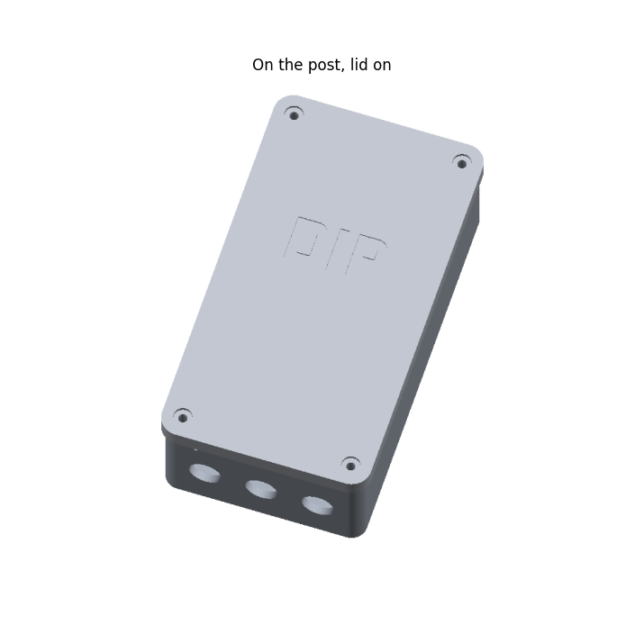
This guide takes you from a pile of parts to a working sensor at the pond. You don't need to know electronics. Every connection is shown in a picture, and you test as you go, so a mistake gets caught on the bench, not out by the water.
What DIP does:
- An ultrasonic sensor looks down a 3" PVC pipe standing in the pond and measures how far down the water is. The pipe keeps the waterfall and ripples from confusing it.
- A float switch in the same pipe wakes the sensor the instant the water drops too low.
- A water temperature probe hangs in the pipe.
- Every 20 minutes it wakes, sends its readings to Home Assistant over Wi-Fi, and goes back to sleep. Home Assistant graphs the level, turns off one pump when the water drops 3", and turns off all the pumps with an urgent phone alert when the water drops below the float, so they don't run dry.
- It runs on one rechargeable 18650 battery for months.

What's in this guide
1. Tools and supplies
2. The parts
3. Printing the case
4. Soldering basics (read this first)
5. Prepare the printed parts
6. Check the float switch
7. Wire the battery, XIAO and sensor board
8. Bench test
9. The probe cables
10. The 4-core cable and the pipe cap
11. Put the box together
12. Software: ESPHome and Home Assistant
13. Install at the pond
14. Final checks and troubleshooting
Appendix: every connection in one table

The whole circuit
This is the full wiring. Don't worry if it looks busy: chapter 7 builds it one wire at a time. Come back to this page whenever you want to see where a wire fits in the big picture.
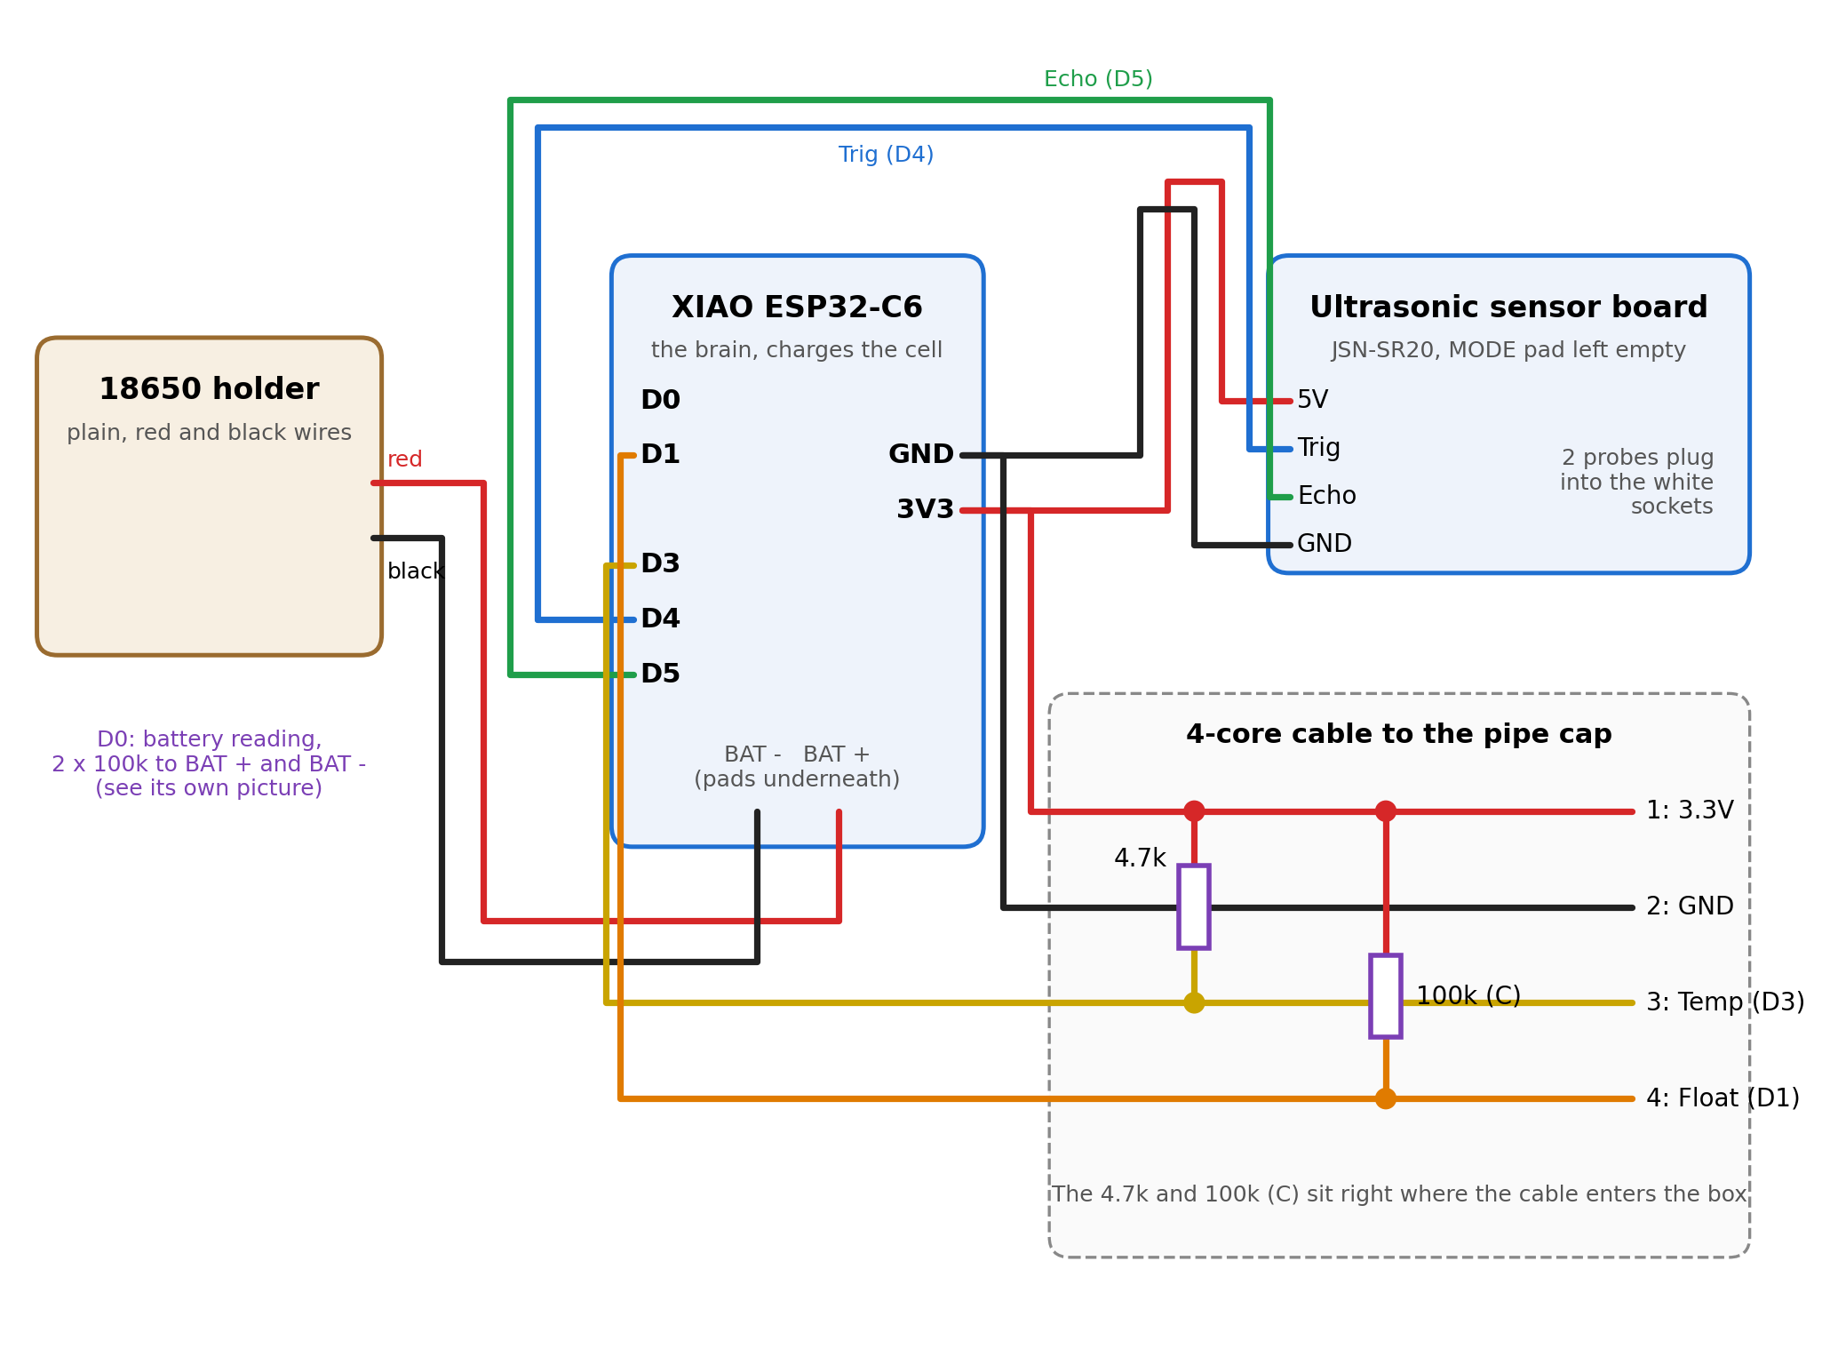
Everything DIP connects to. Colors match the steps later in the guide.

1. Tools and supplies
Tool / supply | What it's for
Soldering iron, fine tip (a temperature-controlled one at about 340 °C / 650 °F is ideal) | Joining wires and fitting the heat-set inserts
Solder: thin (0.6-0.8 mm) rosin-core, lead-free or 60/40 | The metal that makes the joints
Wire strippers | Taking the plastic off wire ends
Flush cutters (small side cutters) | Cutting wire and resistor legs
Heat shrink tubing, assorted small sizes, plus some adhesive-lined (glue-lined) pieces | Insulating every joint; the adhesive kind seals out water
Heat gun (a lighter works, carefully) | Shrinking the tubing
Multimeter (any cheap one with a beep/continuity mode) | Checking the float switch, the battery and your joints
"Helping hands" clamp or a lump of Blu-Tack | Holding parts still while you solder
Stranded hookup wire, 22-26 AWG, in red, black and a few other colors | Short wires inside the box
4 female-to-female jumper wires | Plugging onto the sensor board's 4 pins
USB-C cable and a computer | Loading the software onto the XIAO
Small screwdrivers, drill with 1/4", 1/8" and pilot bits, marker, tape | Assembly and the PVC pipe
Safety glasses, a fan or open window | Solder can spit, and the smoke isn't good to breathe

2. The parts
Lay everything out and check it off before you start.
Part | How many | Notes
Seeed XIAO ESP32-C6 | 1 | The small board with a USB-C socket and a metal can. This is the brain, and it charges the battery.
Plain single-18650 holder with wire leads + 18650 cell | 1 + 1 | Just a cradle with a red and a black wire. Use a name-brand cell (Samsung, LG, Molicel).
JSN-SR20 dual-probe ultrasonic sensor (sold as JSN-SR20-Y1) + 2 probes | 1 set | Blue board; the two round black probes plug into it.
Float switch (vertical, M10 stem) | 1 | Two yellow wires, either way round.
DS18B20 waterproof temperature probe | 1 | Steel tip on a black cable, red / black / yellow wires. Comes with a 4.7k resistor.
4.7k resistor | 1 | Came with the temperature probe.
100k resistors | 3 | Called (A), (B) and (C) in this guide.
4-core outdoor cable | box to pipe, plus slack | Four wires inside one jacket.
PG7 cable glands | 3 | Waterproof cable entries for the box.
M3 heat-set inserts | 8 | 4 for the box lid, 1 for the battery platform, 3 for the pipe cap top.
M3 screws: 4 with rubber washers (box lid), 3 more (pipe cap top) | 7 | About 10-12 mm long.
M2.5 x 6 screws | 5 | 4 for the sensor board, 1 for the XIAO clamp.
M3 x 8 screw + 1 more M3 heat-set insert | 1 + 1 | Holds the battery holder through the hole in its floor.
Short USB-C cable | 1 | Stays plugged into the XIAO, for charging with the lid off.
M4 screws, stainless | 2 | Float bracket to the pipe.
Wood screws, stainless | 2 | Hang the box on the post through its top tab.
Short stainless screw | 1 | Locks the pipe cap to the pipe.
3" PVC pipe, about 30" long | 1 | 89 mm outside, 76 mm inside.
Cinder block + a bag of pea gravel | 1 | Holds the pipe upright in the pond.

What the electronic parts look like
The XIAO's pin names (D0-D10, 5V, GND, 3V3) are printed on its back, and the two battery pads (BAT - and BAT +) are underneath too. Chapter 7 has a picture of the pins.
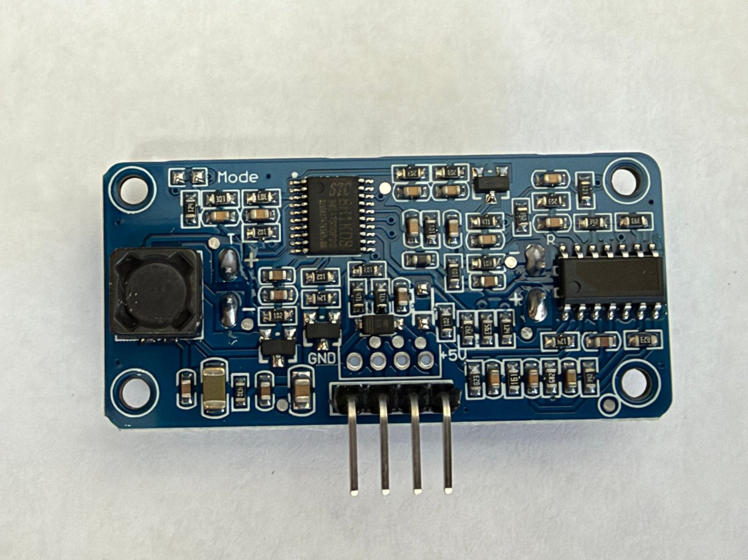 | 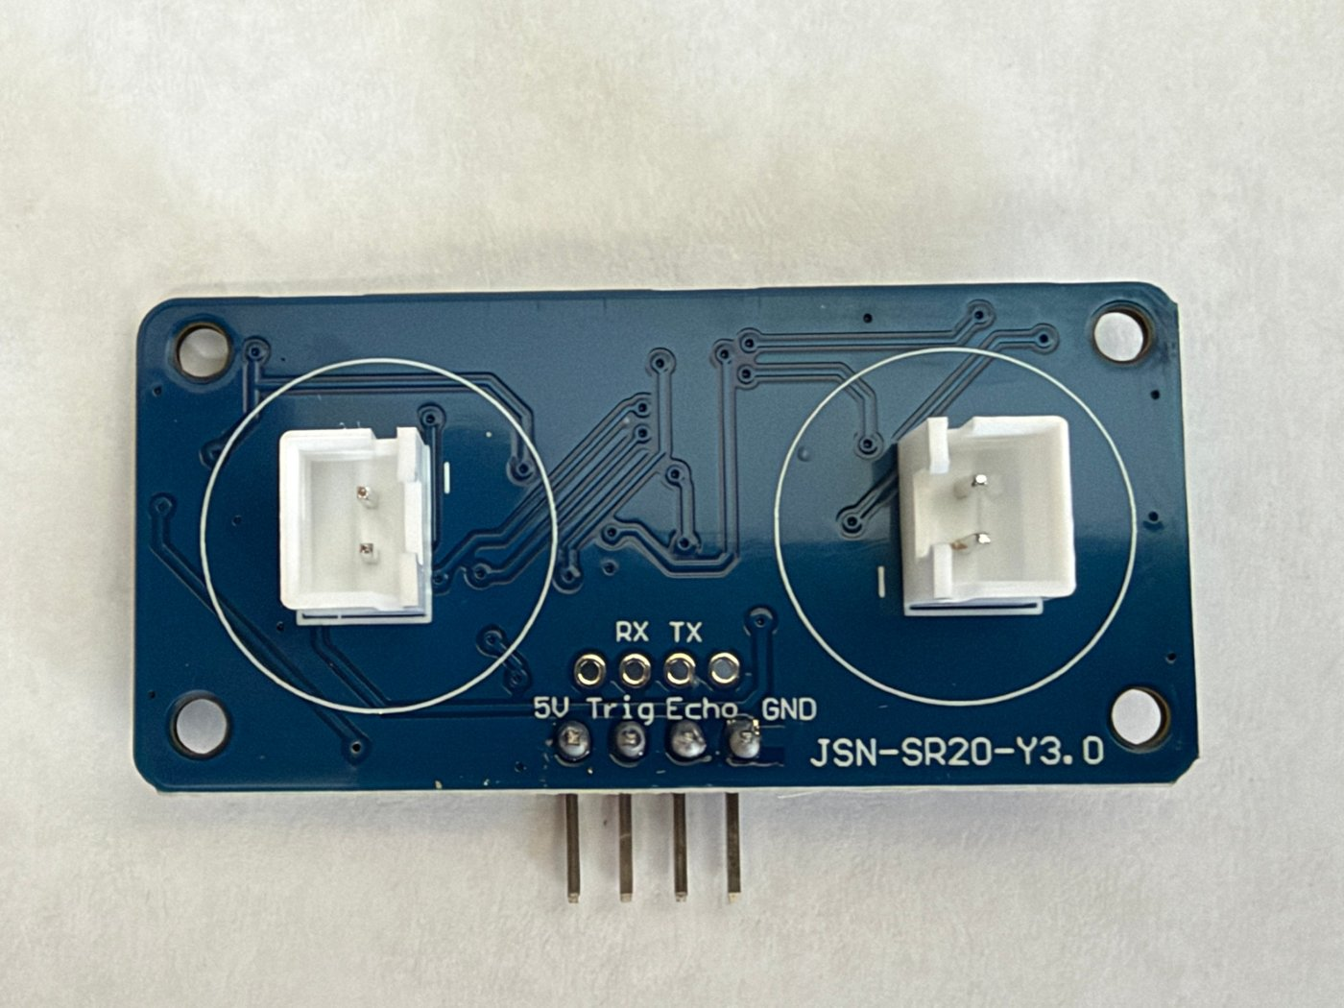
Ultrasonic sensor board, parts side (left) and connector side (right). Note the empty MODE pad top left: leave it empty.
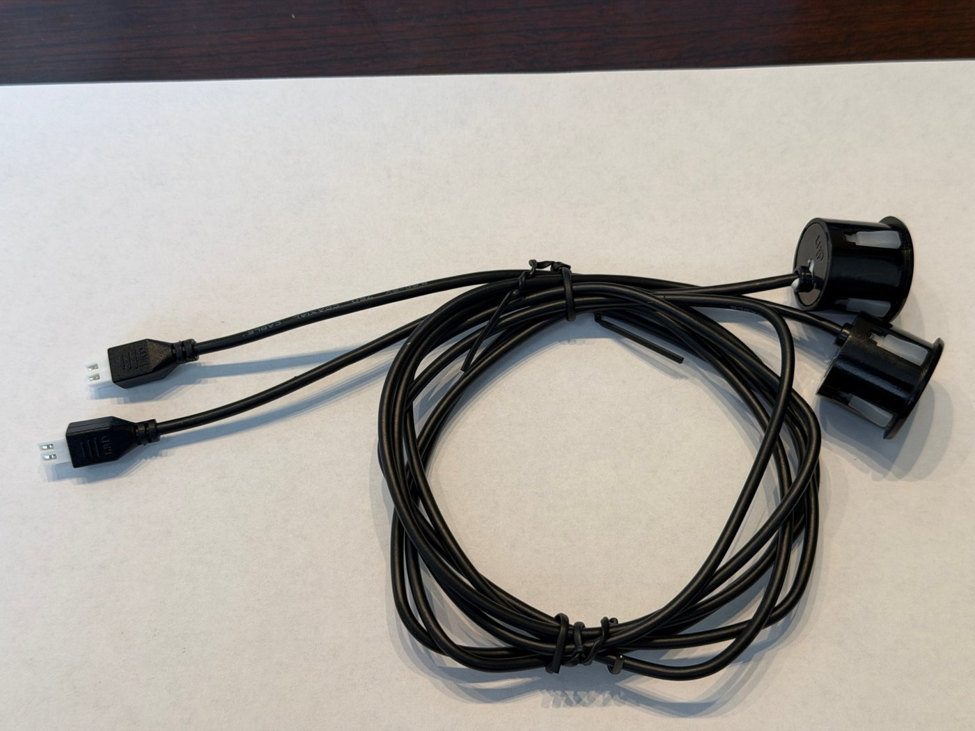 | 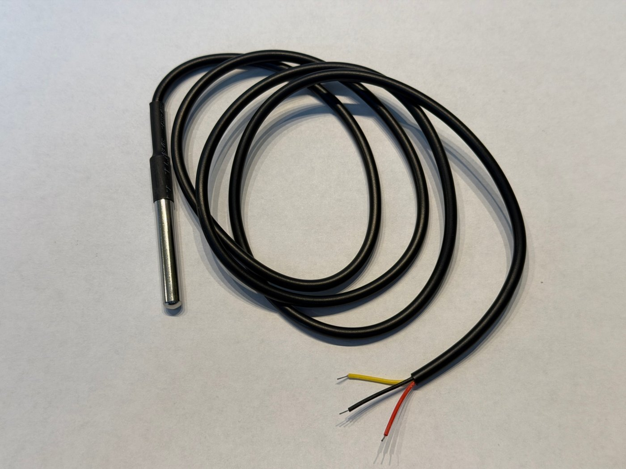
The two ultrasonic probes on their cables (left) and the temperature probe (right).
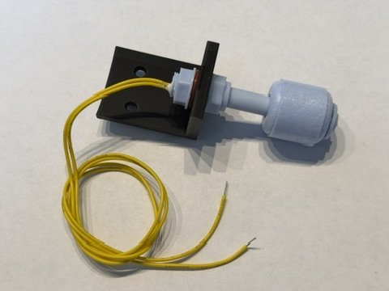 | 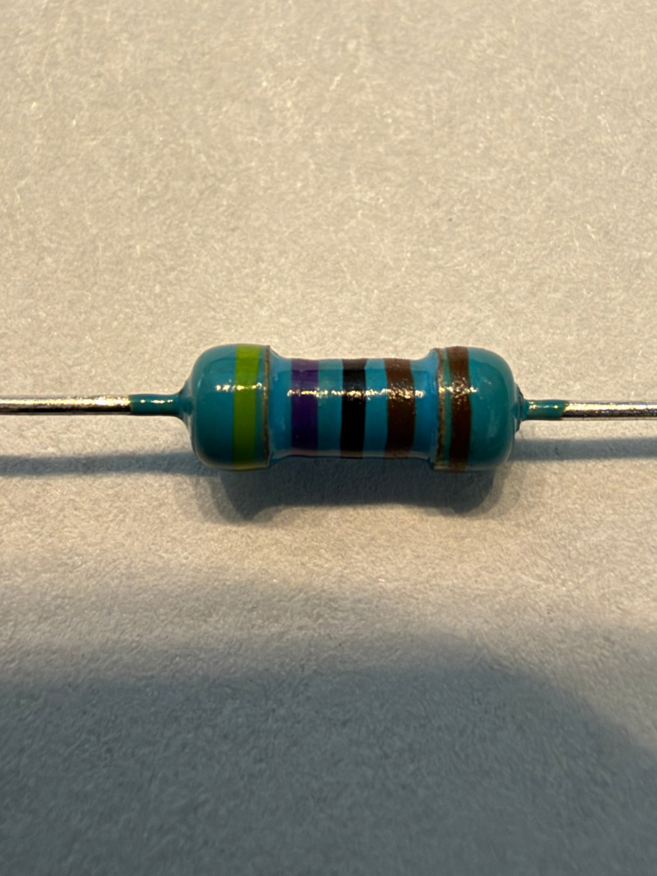
Float switch in its bracket (left) and the 4.7k resistor that came with the temperature probe (right).

Telling the resistors apart
Resistors are tiny and their value is shown by colored stripes. You have two kinds:
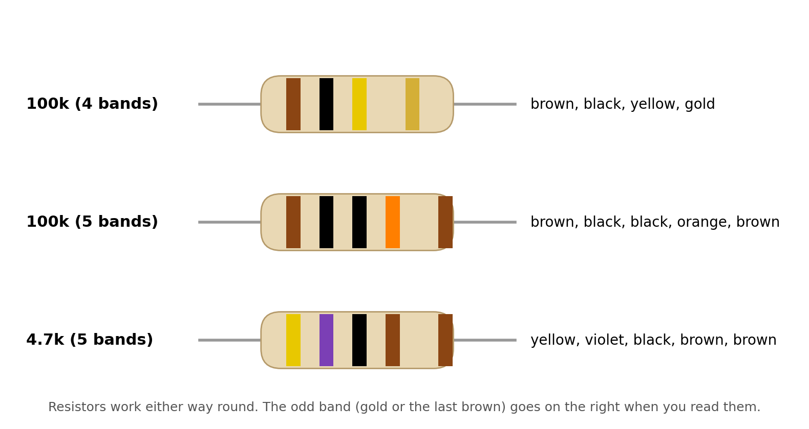
If your stripes are hard to read, set your multimeter to resistance (Ω) and touch the probes to the two legs: a 100k reads close to 100 kΩ, the 4.7k reads close to 4.7 kΩ.

3. Printing the case
All the printed parts are in the case/out folder of the project as STL files. PETG or ASA is best outdoors; PLA goes soft in the summer sun.
File | What it is | How to print
box.stl | The electronics box that hangs on the post | As it comes, back plate down, no supports
box_lid.stl | The lid, with DIP lettering | As it comes (already flipped)
esp_clamp.stl | Small tab that holds the XIAO down | Flat
gasket.stl | Rubber-like seal for the lid | 95A TPU, flat, 100% infill (or use 1.5 mm foam cord instead)
pipe_cap.stl | Sits on top of the PVC pipe and holds the probes | Upside down (rim on the bed); supports only under the probe band
pipe_cap_top.stl | Flat lid for the pipe cap | Flat
float_bracket.stl | Holds the float switch inside the pipe | As it comes (lying on its side)

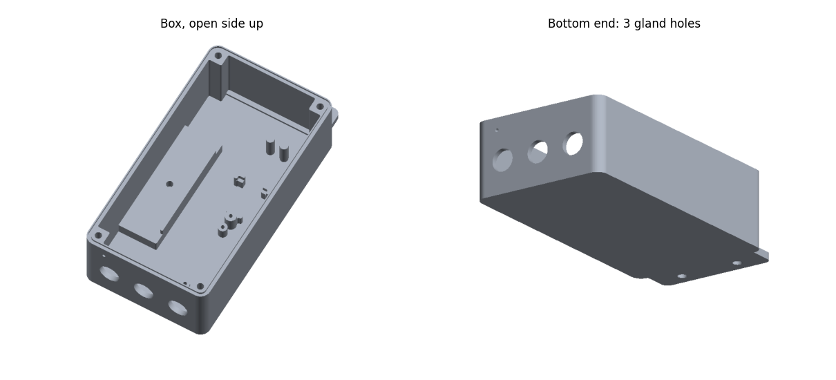
The box
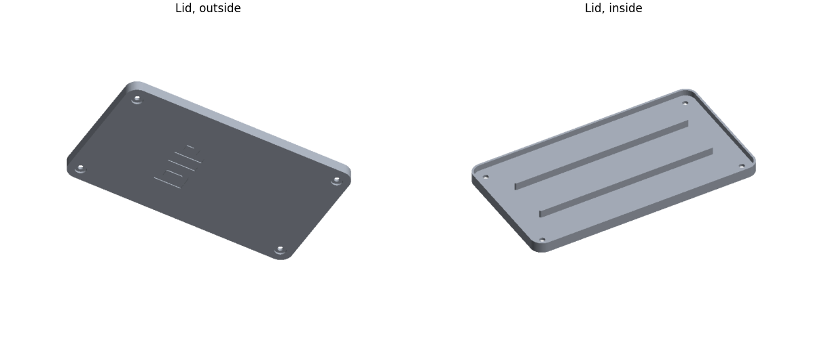
The lid: outside and inside
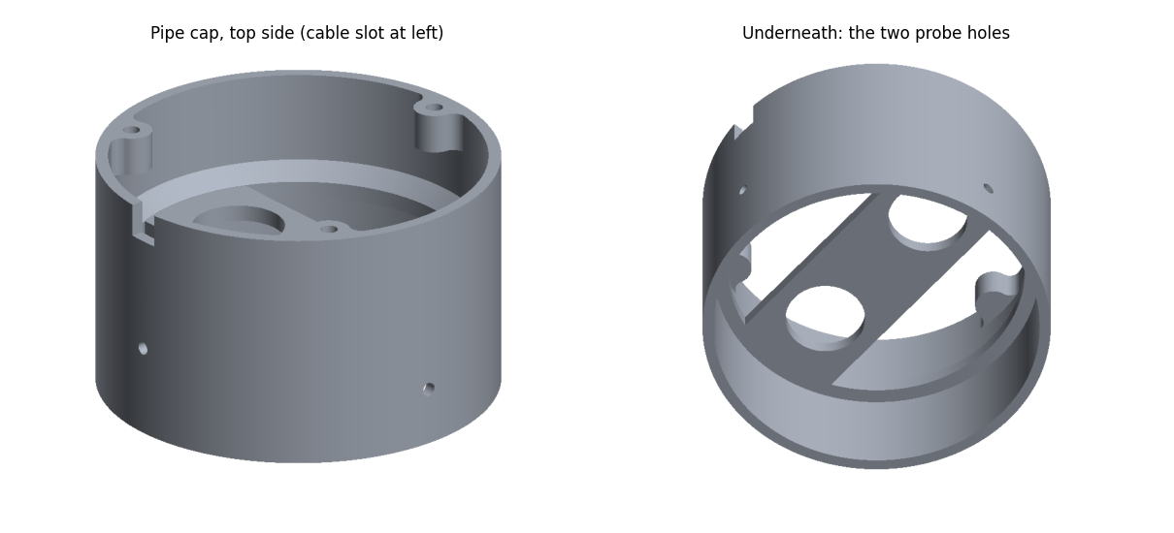
The pipe cap: top side, and underneath where the probes push in
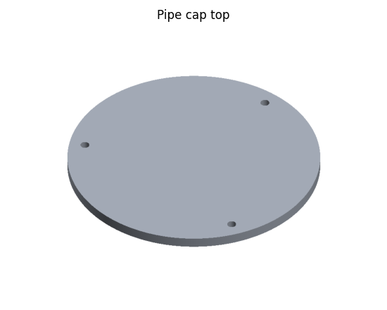 | 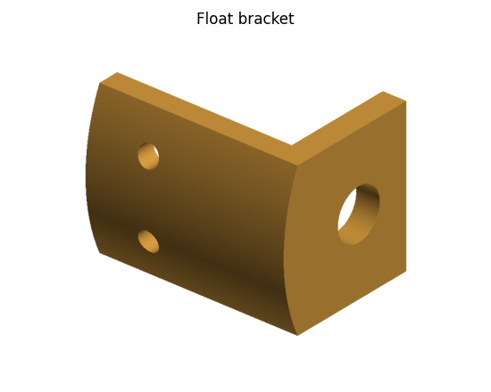
Pipe cap top (left) and float bracket (right)
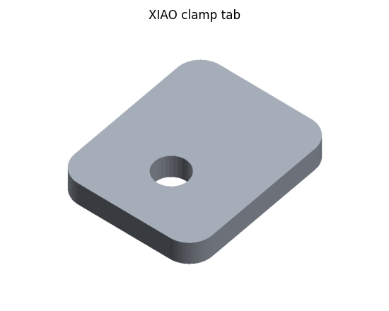 | 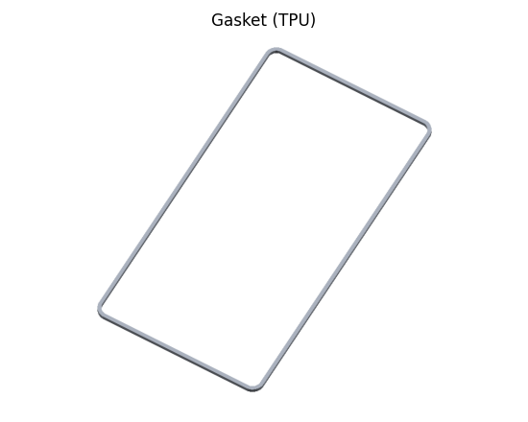
XIAO clamp tab (left) and gasket (right)

4. Soldering basics (read this first)
Soldering melts a little metal (solder) into a joint so it holds and conducts. Good joints are shiny and smooth, like a little volcano or a smooth sleeve. Dull, lumpy blobs are "cold" joints and should be re-heated.

How to make a joint
1. Heat the iron. Wipe the tip on a damp sponge or brass wool, then touch a bit of solder to it so the tip is shiny ("tinning").
2. Hold the tip against BOTH things you're joining (the wire and the pad) for 1-2 seconds.
3. Feed solder into the joint, not onto the iron. It should flow and wrap around in a second or two.
4. Take the solder away, then the iron. Don't move the joint for a few seconds while it cools.
Tip: Tin wire ends before joining them: strip, twist the strands, then melt a little solder into them. Tinned wires go into holes easily and join in a second.

Stripping wire
Strip about 5 mm for wires going into a board hole and about 8 mm for wire-to-wire splices. Don't nick the copper strands.

Splicing two wires (you'll do this a lot)
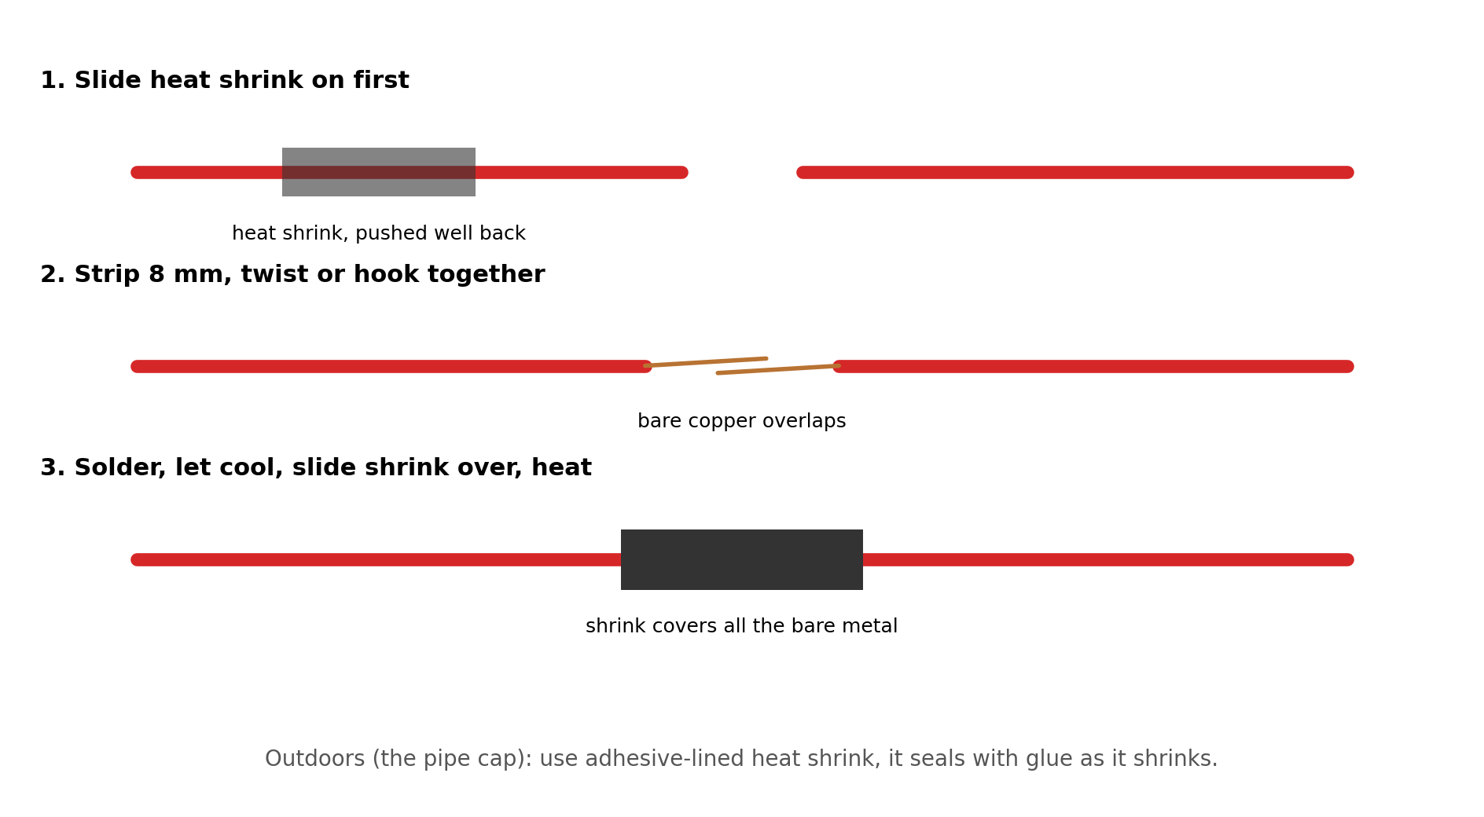
Careful: Always slide the heat shrink onto the wire BEFORE you solder. Everyone forgets this once; it means cutting the joint and doing it again.

Soldering into the XIAO
The XIAO's pins are half-holes along its edges. Push the tinned wire into the hole from the front, hold the iron against the gold pad and the wire, and feed in a little solder. Some holes take two wires (or a wire and a resistor leg): put both in, then solder them together.
Careful: Use as little solder as it takes. Too much can bridge to the next pin. If two pins get joined, touch the iron to the bridge and drag it away, or use solder wick.

5. Prepare the printed parts

Heat-set inserts
Inserts are little brass threads you melt into the plastic so screws hold strongly.
1. Find the 4 holes in the corner posts of the box, the 1 in the battery platform, and the 3 in the pipe cap's posts.
2. Set an insert on top of a hole, narrow end down.
3. Touch the hot soldering iron (a spare tip if you have one) into the insert and let it sink straight down slowly. Don't push hard. Stop when it's flush with the surface.
4. While it's still soft, press it flat with something metal. Let it cool.

Cable glands
Screw a PG7 gland into each of the 3 holes in the bottom end of the box, with its lock nut inside. The nuts just fit side by side: turn each one by hand, then snug it with pliers. Leave the domed caps loose for now: cables go through later.
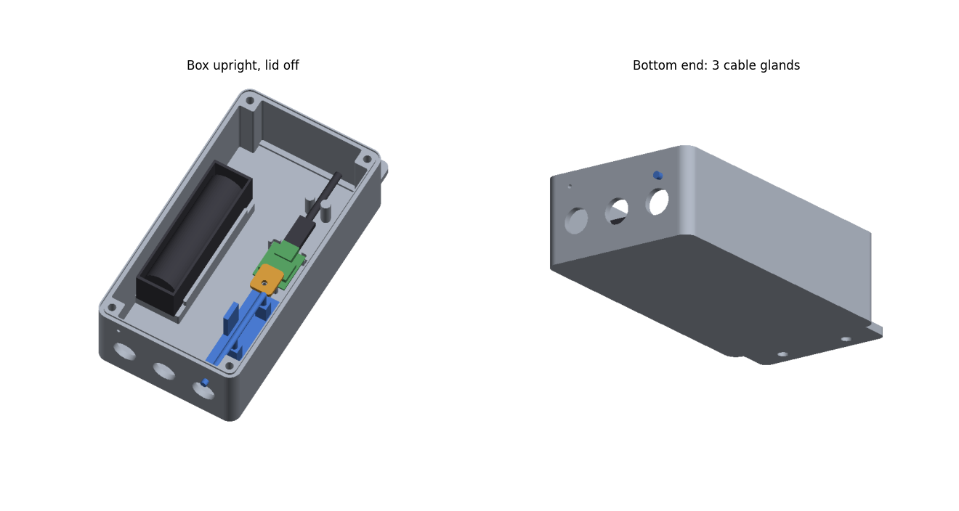
How it all goes together inside the box (battery holder, sensor board and XIAO), and the 3 gland holes in the bottom end

Gasket
Press the TPU gasket into the groove around the rim of the box (or lay 1.5 mm foam cord in the groove).

6. Check the float switch
The float switch is just a switch with no polarity: either wire can go anywhere. What matters is which way up it is. It must be OPEN (not connected) when the water is normal, and CLOSED when the water drops.
1. Set the multimeter to continuity (the beep setting). Touch the probes to the two yellow wires.
2. Hold the float the way it will sit in the pipe, stem up, float pushed UP toward the stem as if floating on water. The meter should be SILENT.
3. Let the float drop down (the water is gone). The meter should BEEP.
4. If it's the other way round, slide the clip off the bottom of the stem, turn the float over, and put the clip back. Check again.
5. Mount the float in the printed bracket: stem through the hole, nut on top, snug but don't crack the plastic.

7. Wire the battery, XIAO and sensor board
Careful: Take the battery OUT of the holder while you solder. Put it back only when a step tells you to.

First, find your way around the XIAO. Here it is from the front (metal can up, USB-C at the top):
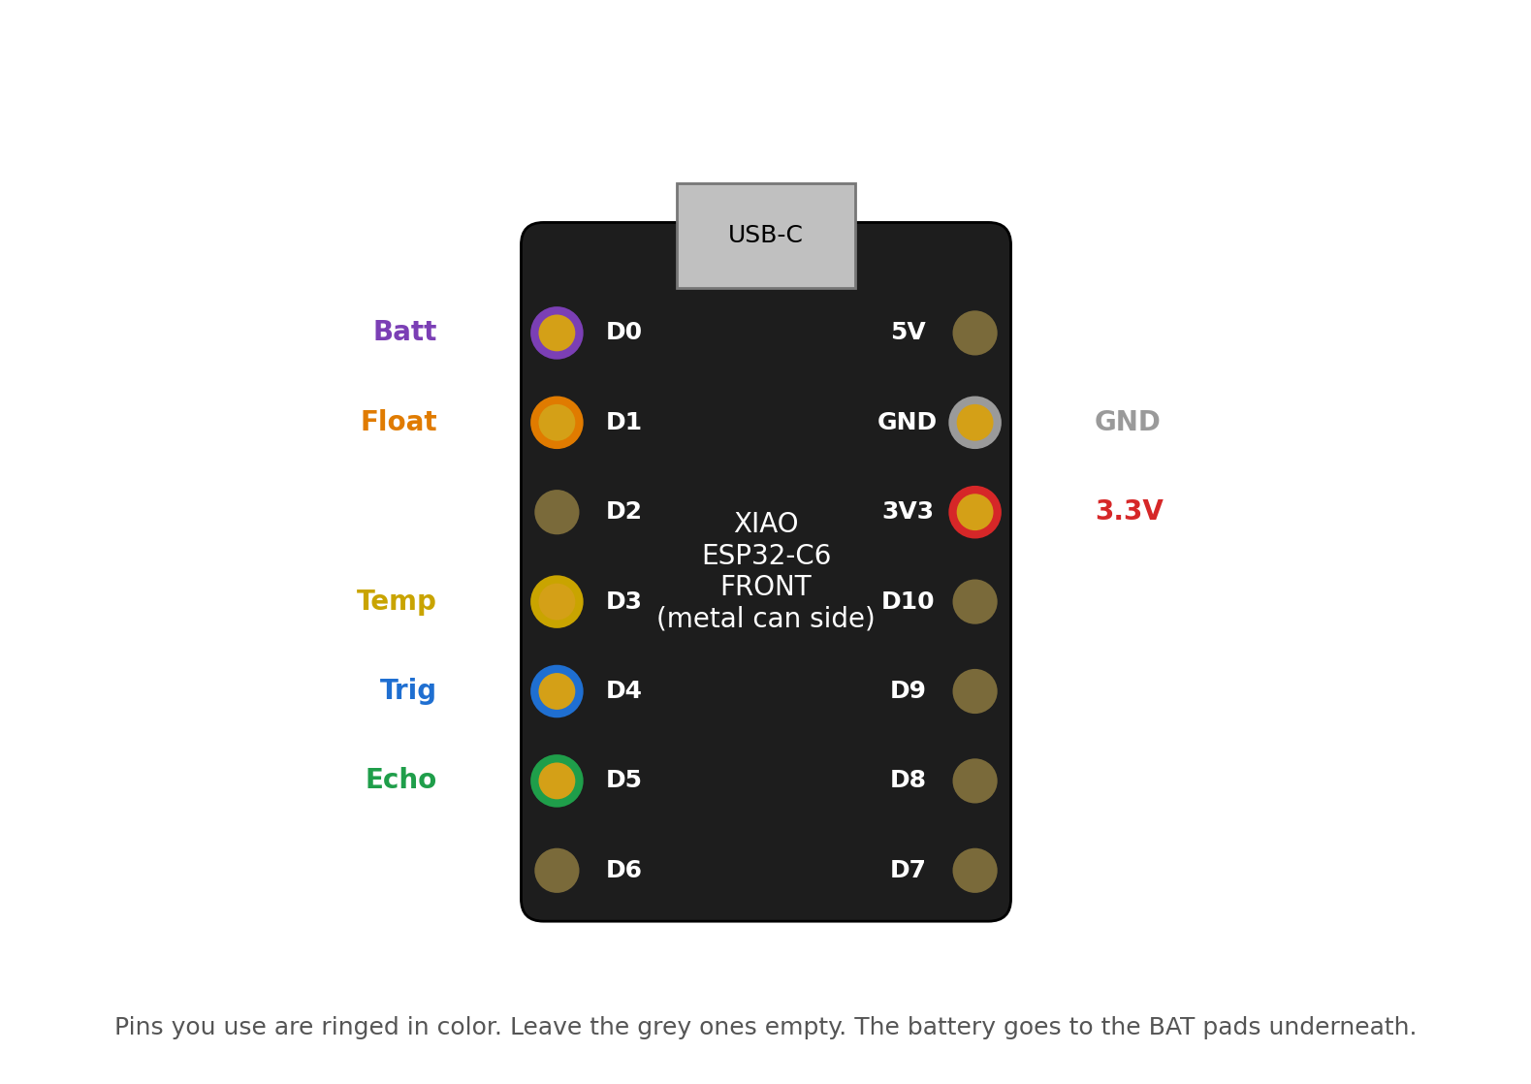
You'll use D0, D1, D3, D4 and D5 down one edge, GND and 3V3 on the other, and the two BAT pads underneath. The rest stay empty.

7a. Battery reading resistors (A) and (B)
These two 100k resistors let the XIAO measure how full the battery is. They go on its underside, next to the battery pads.
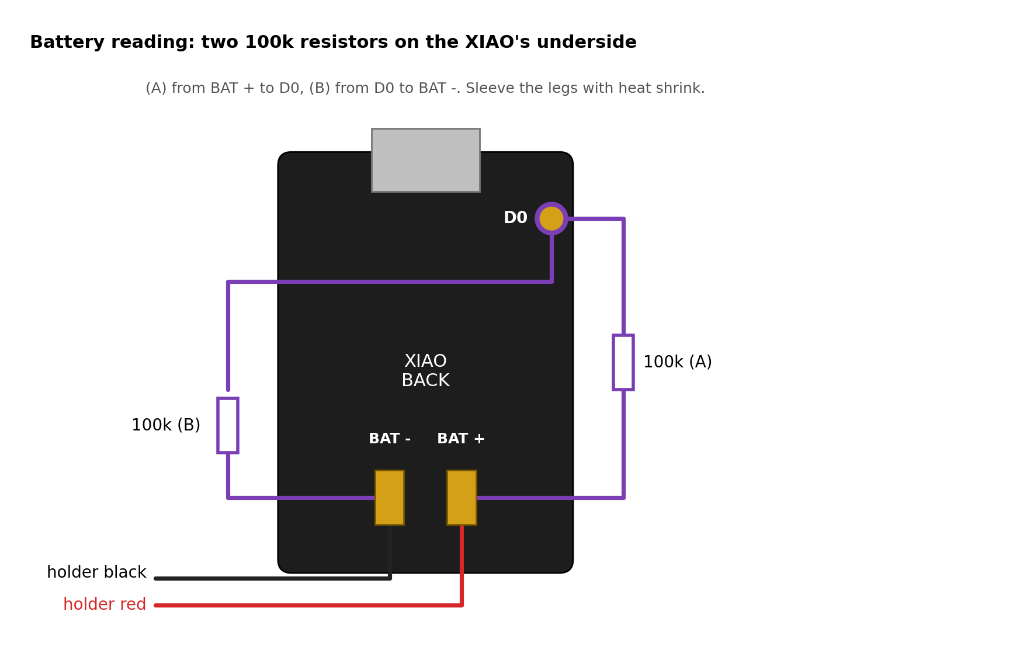
1. Slide heat shrink over the legs of both resistors. Lay them flat against the XIAO's back as in the picture.
2. Resistor (A): one leg to the BAT + pad, the other into hole D0. Resistor (B): one leg into hole D0 too, the other to the BAT - pad.
3. Solder D0 (both legs) from the back. Leave the BAT pads for the next step, so the battery wires and the resistor legs are soldered together.

7b. The battery to the XIAO
1. Shorten the holder's red and black wires so they reach the XIAO's spot in the box with a little slack. Strip and tin the ends.
2. Red to the BAT + pad, black to the BAT - pad, each together with the resistor leg already there.
Careful: Get these the right way round: red to +, black to -. The wrong way round ruins the XIAO's charger. Check the + and - marks next to the pads.

Tip: The XIAO charges the cell whenever its USB-C is plugged in. There's no switch: DIP is on whenever the cell is in.

7c. The sensor board
The sensor board has 4 pins sticking out, labelled 5V, Trig, Echo and GND (the labels are on the connector side). Use female jumper wires so you can plug on rather than solder to the board.
1. Take 4 female jumper wires. Cut each to about 12 cm, keeping the plug end. Strip and tin the cut ends.
2. Plug them onto the sensor board pins. Use red for 5V and black for GND if you have them.
3. Trig wire into XIAO hole D4, Echo wire into hole D5. Solder.
4. 5V wire into hole 3V3, GND wire into hole GND. Don't solder yet: the 4-core cable's wires 1 and 2 join them in chapter 10.
Why 3V? Yes, the sensor's "5V" pin goes to 3V3. This sensor normally works on 3.3V, and running it on 3.3V keeps its signals safe for the XIAO. The bench test in chapter 8 confirms it on your board.

Careful: Leave the MODE pad on the sensor board (two little pads top left, next to the word Mode) EMPTY. Putting a resistor there changes how the sensor talks and the readings stop.

8. Bench test
Now test what you've built before anything goes outside. The software has to be loaded first: chapter 12 explains how, but if someone else is handling the software, give them the XIAO at this point (still wired up).
1. Plug the two ultrasonic probes into the white sockets on the sensor board (they only fit one way round).
2. Solder the 3V3 and GND holes for now (you can add the cable wires later with a little more solder), then put the battery in.
3. Point the probes at a wall about 1 m (3 ft) away. In Home Assistant, turn on "DIP stay awake" and watch "Distance to water". It should read about 100 cm and change when you move.
4. Check "Battery voltage" reads 3.0-4.2 V, close to what your meter says.
Optional: Also worth checking if you have a meter that reads milliamps: with DIP asleep, the whole thing should draw well under 1 mA. Much more than that and the battery won't last.

If the distance stays empty or reads nonsense at 3.3V, stop here and ask for help. Don't move the sensor to the 5V pin on your own: at 5V its Echo signal is too strong for the XIAO and would need two extra resistors.

9. The probe cables
The probes' plugs are too big to fit through the cable glands, so each cable gets cut, fed through, and soldered back together inside the box.
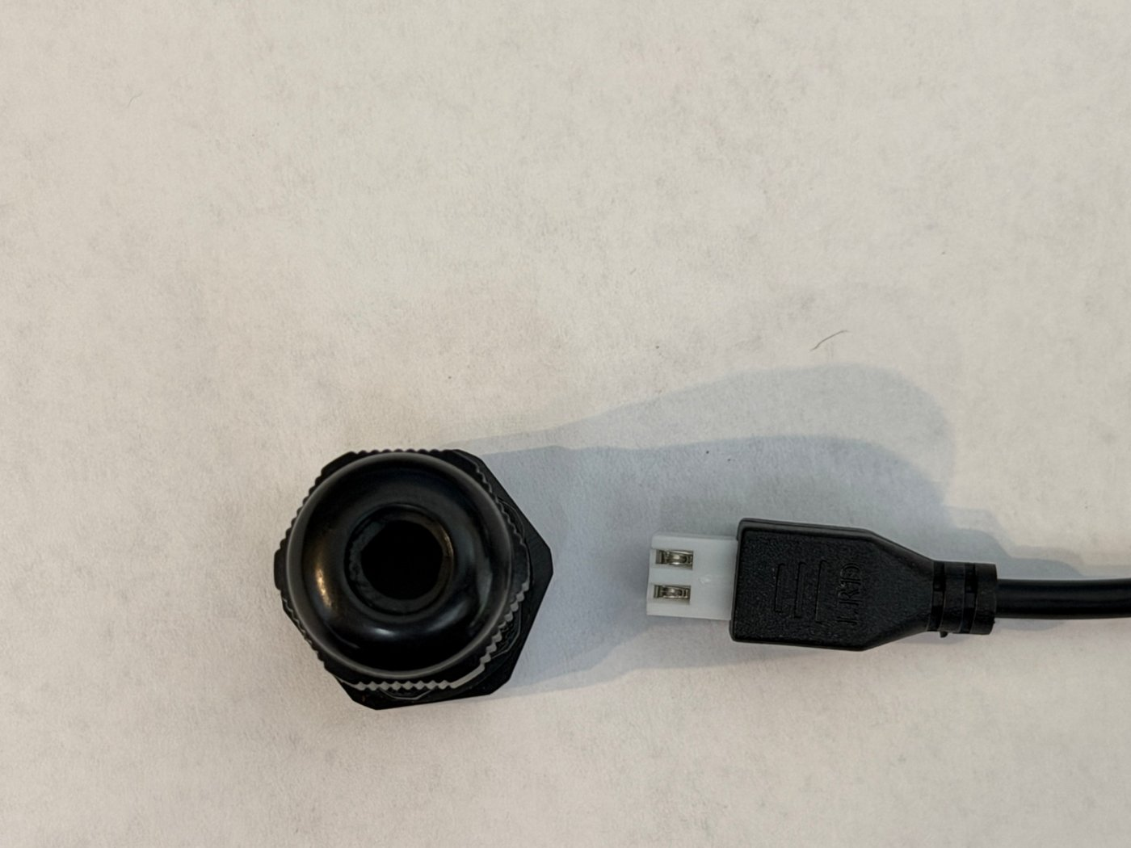
The plug's molded boot is bigger than the gland's hole.
1. Put a piece of tape on each probe cable right next to its plug and label them L and R, so the plug goes back on its own cable.
2. Cut each cable about 8 cm (3") behind its plug.
3. Feed the long (probe) end of each cable in through a gland, from outside the box to inside.
4. Slide on heat shrink: one small piece over the centre wire, one larger piece that will cover the whole splice.
5. Strip both ends: cut back the black jacket about 15 mm, twist the braided shield into a tail, then strip 5 mm off the centre wire's insulation.
6. Solder centre to centre. Slide the small shrink over and heat it.
7. Solder shield to shield, laid alongside the first joint. Slide the big shrink over everything and heat it.
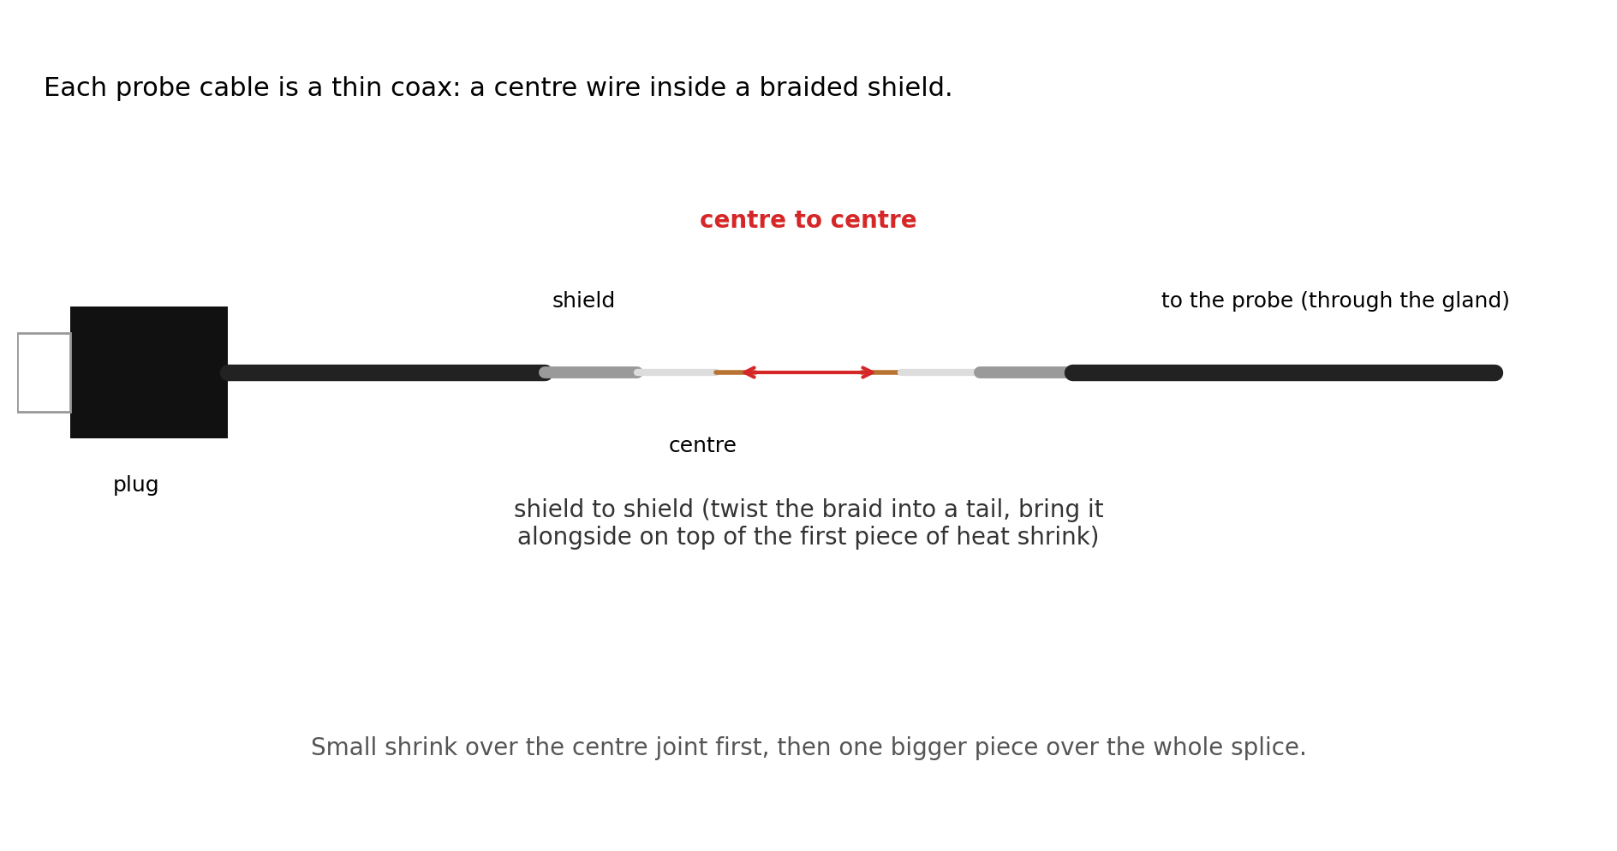
Check: Use the multimeter in beep mode to check: plug tip to the probe's centre should beep, plug tip to the shield should NOT.

10. The 4-core cable and the pipe cap
One 4-wire cable runs from the box to the pipe cap. Its four wires carry 3.3V, ground, the temperature signal and the float signal. Write down which color you use for each, here:
Wire | Job | Your cable's color
1 | 3.3V
2 | GND (ground)
3 | Temp data
4 | Float

10a. Box end
1. Feed the cable through the third gland into the box. Strip back about 8 cm of the outer jacket.
2. Add the two pull-up resistors as shown below: the 4.7k from wire 1 to wire 3, and 100k (C) from wire 1 to wire 4. Solder each leg onto the wire with a little heat shrink over each joint.
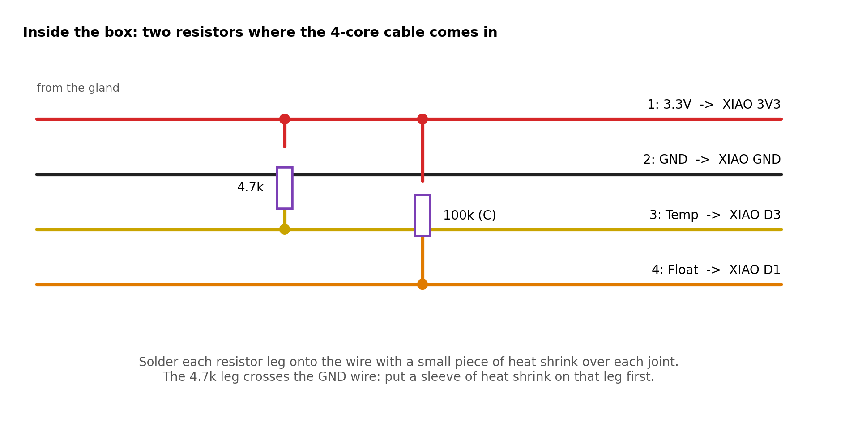
3. Wire 1 into XIAO hole 3V3, alongside the sensor's 5V wire. Wire 2 into hole GND, alongside the sensor's GND wire. Solder.
4. Wire 3 to XIAO hole D3. Wire 4 to XIAO hole D1.

10b. Pipe cap end
1. Feed the temperature probe's cable and the float wires up through the open part of the pipe cap's plate, and the 4-core cable in through the slot in the side of the cap.
2. Splice them as below. Use adhesive-lined heat shrink here: it's outdoors.
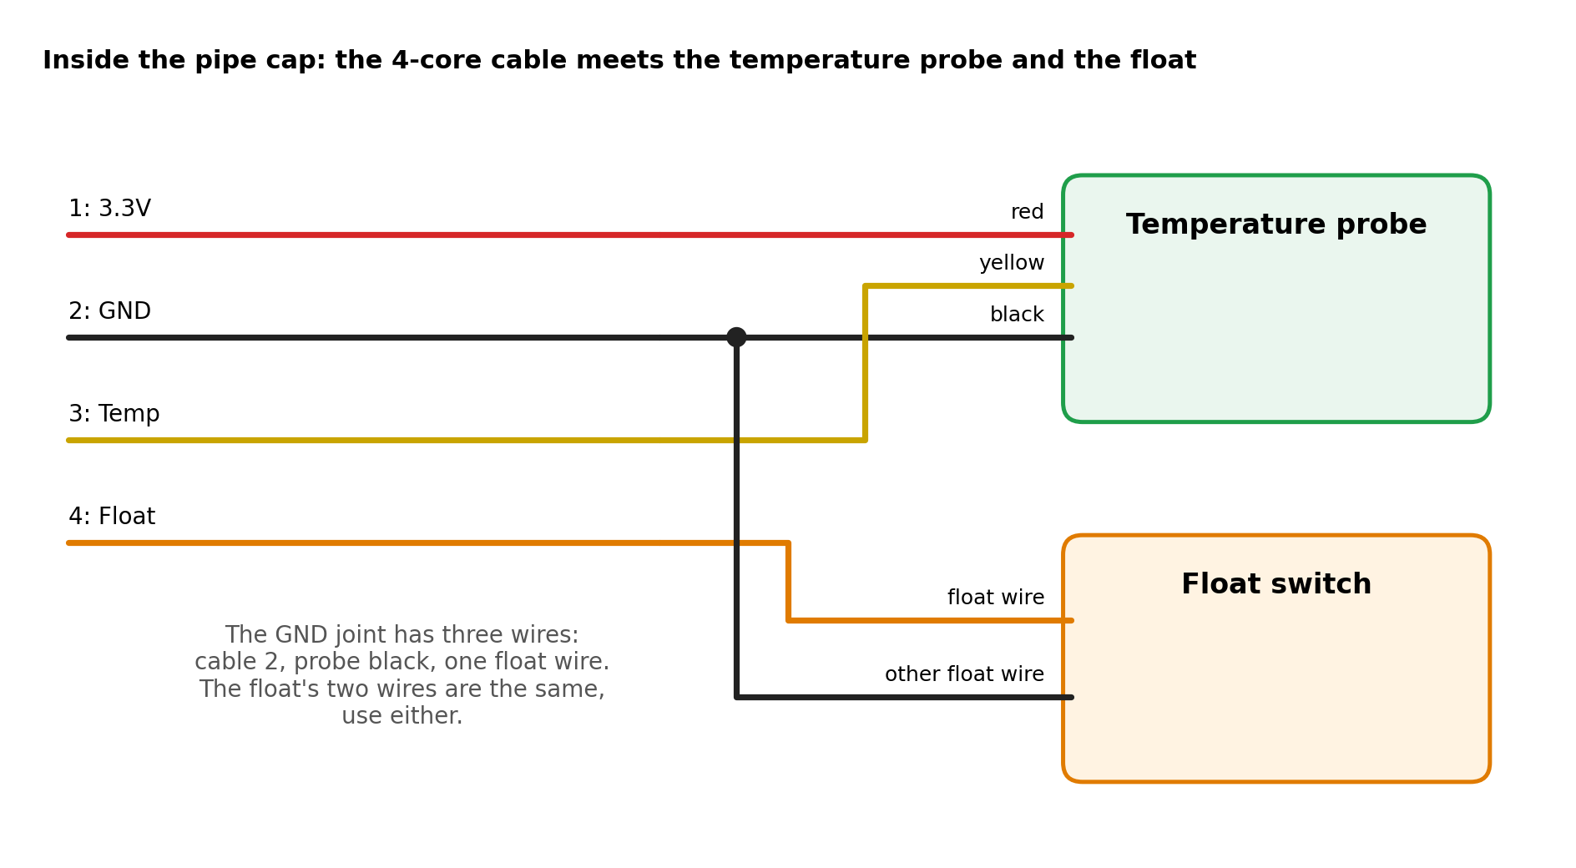
3. Push the two ultrasonic probes up into the round holes in the cap from underneath. They should be a snug push fit; a small dab of silicone holds them if they're loose. Bring their cables out through the side slot too.
4. Screw the pipe cap top on with its 3 M3 screws.

11. Put the box together
1. Set the battery holder on its platform (cell out) and screw it down through the hole in its floor with the M3 x 8 screw.
2. Screw the sensor board onto its 4 posts with the 4 M2.5 x 6 screws, parts side down (connectors and pins facing you).
3. Lay the XIAO on its rests, USB-C toward the top of the box, between the two corner stops. Screw the clamp tab over the far end with one M2.5 x 6 screw: it presses on the metal can, clear of the antenna.
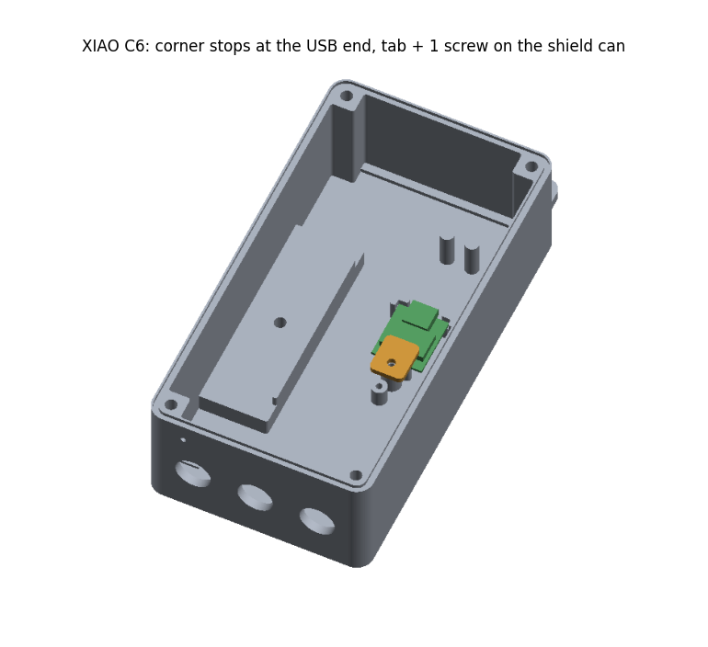
XIAO: USB end between the corner stops, clamp tab on the metal can
4. Plug the short USB-C cable into the XIAO and push its free end between the two clip posts near the top.
5. Plug the probe plugs into the sensor board. Tuck the wires so nothing is pinched.
6. Gently pull the cables back through the glands until they're snug, then tighten the gland caps by hand plus a quarter turn.
7. Put the battery in. Put the lid on with the 4 M3 screws and rubber washers; tighten evenly in a cross pattern.
Charging: To charge later: take the lid off and plug a charger into the free end of the USB-C cable. The XIAO charges slowly (a day or more from empty), so for a quick charge take the cell out and use an 18650 charger.

12. Software: ESPHome and Home Assistant
DIP runs ESPHome, which connects to Home Assistant. The project's firmware file is firmware/dip.yaml and the Home Assistant settings are in ha/dip_package.yaml.

12a. Load the firmware (first time, over USB)
1. Copy firmware/secrets.example.yaml to secrets.yaml and fill in the Wi-Fi name, password and an API key.
2. Connect the XIAO to the computer with a USB-C cable.
3. Run: esphome run firmware/dip.yaml (or use the ESPHome Builder app in Home Assistant). It needs ESPHome 2025.7 or newer.
4. If the board isn't found, hold the B (boot) button, tap R (reset), then let go of B, and try again.
After this first time, updates go over Wi-Fi. DIP sleeps most of the time, so first turn on "DIP stay awake" in Home Assistant and wait for its next wake (up to 20 minutes): it sees the switch and stays on. Turn the switch off when you're done. Left on, it drains the battery in a day or two.

12b. Add it to Home Assistant
1. Home Assistant usually finds DIP by itself: Settings > Devices & services, then Configure on the ESPHome device. Enter the API key.
2. Copy ha/dip_package.yaml into Home Assistant's packages folder. The steps at the top of the file show what to change: your two pump switches (the one that stops first, at 3" down, and the one that stops at the float) and your phone.
3. Check the configuration (Developer tools > YAML > Check configuration), then restart Home Assistant.

12c. Calibrate
1. Level: with the pond full, read DIP's "Distance to water" and type that number into "Pond full distance". From then on "Pond level below full" shows how many inches the water has dropped.
2. Battery: measure the cell with the multimeter and compare it with DIP's "Battery voltage". If they're more than about 0.03 V apart, multiply the multiply: number under the battery sensor in dip.yaml by (meter reading / DIP's reading) and load the firmware again. A full cell then shows 100 %.

13. Install at the pond
1. Drill 3-4 holes of 1/4" around the bottom 2-3" of the PVC pipe so water flows in and out, and one 1/8" vent hole near the top.
2. Decide how low is "too low": below this the pumps all shut off. 6-8" below the full level suits most ponds. Screw the float bracket inside the pipe at that height with the 2 M4 screws through the pipe wall (drill the pipe first).
3. Hang the temperature probe inside the pipe near the bottom.
4. Stand the pipe in the cinder block's hole in the pond. Pack pea gravel around it, checking it's straight up and down as you go.
5. Slide the pipe cap on, slot pointing toward the post. Pilot-drill the PVC through the hole in the cap's skirt and fit the short stainless screw so it can't turn or lift.
6. Hang the box on the post, glands at the bottom, with 2 stainless wood screws through the tab at the top. Run the cables along the back of the coping, under the net.
Why this way: Cables come out of the cap sideways and go into the box from below, so rain runs off them instead of into anything.

14. Final checks and troubleshooting

Once it's installed
- "Distance to water" and the pond level look right, and match your calibration.
- "Water temperature" reads a sensible number.
- Push the float down with a stick and hold it for a minute: "Float switch low" turns on within seconds, the pumps turn off and you get the alert. Let it go: the float clears, and the pumps come back on by themselves (the last one after 10 minutes, the first one at its next reading).
- "Battery" shows a percentage. Check it again in a week to see how fast it drops.

If something's wrong
What you see | Likely cause and fix
Nothing shows up in Home Assistant | Battery flat or in backwards, or Wi-Fi out of range. Plug in the USB-C cable with the lid off and see if it shows up.
Distance empty or jumping around | Probe plugs loose, a probe splice broken, or a probe not pointing straight down. Check the splices with the meter (chapter 9).
Temperature shows -127 or nothing | The temp wire (3) isn't reaching D3, or the 4.7k is missing or broken.
Float always "low" | Float upside down (chapter 6) or wire 4 touching ground somewhere.
Float never triggers | Float stuck, mounted too low, or 100k (C) missing.
Battery reading 0 or wild | Resistor (A) not on BAT +, or (A)/(B) not soldered in hole D0.
Battery drains in days | It isn't going to sleep: make sure "DIP stay awake" is off in Home Assistant.

Appendix: every connection in one table
From | To | Notes
Holder red | XIAO BAT + | underneath
Holder black | XIAO BAT - | underneath
Resistor (A) | XIAO BAT + to D0 | on the underside
Resistor (B) | XIAO D0 to BAT - | on the underside
Sensor board 5V pin | XIAO 3V3 | female jumper; shares the hole with cable wire 1
Sensor board GND pin | XIAO GND | female jumper; shares the hole with cable wire 2
Sensor board Trig | XIAO D4
Sensor board Echo | XIAO D5
Probes (2) | Sensor board white sockets | cut and re-soldered inside the box
Cable wire 1 (3.3V) | XIAO 3V3 | 4.7k and 100k (C) attach here
Cable wire 2 (GND) | XIAO GND
Cable wire 3 (Temp) | XIAO D3 | 4.7k from wire 1
Cable wire 4 (Float) | XIAO D1 | 100k (C) from wire 1
Cap end: wire 1 | Temp probe red
Cap end: wire 2 | Temp probe black + one float wire | 3-way splice
Cap end: wire 3 | Temp probe yellow
Cap end: wire 4 | Other float wire

