**Project Title*: PDF Reader***

**Group Members:**

Wajahat Raza(p176011)

M. Ahmed Arshed(p176099)

Tashfeen Latif(p176099)

Muneeb Raza(p176149)

Saood Ur Rehman(p176092)

Ahmad Hassan Hamdani(p176021)

**Client Name:**

Prof. Taimoor Khan



**Department of Computer Sciences**

**FAST National University of computer and Emerging Sciences**

**Peshawar, Pakistan October, 2019**

**Final Iteration**

**Traceability Matrix:**

|  |  |  |  |  |  |  |  |  |
| --- | --- | --- | --- | --- | --- | --- | --- | --- |
| **Requirement ID** | **Basic Use Case** | **Detailed Use Case** | **Use Case**  **Diagram** | **Activity Diagram** | **Domain Model** | **System Sequence Diagram** | **Sequence Diagram** | **Class Diagram** |
| 1 | Page 3 | Page 5 | Page 19 | Page 33 | Page 47 | Page 48 | Page 62 | Page 77 |
| 2 | Page 3 | Page 6 | Page 20 | Page 34 | Page 47 | Page 49 | Page 63 | Page 77 |
| 3 | Page 3 | Page 7 | Page 21 | Page 35 | Page 47 | Page 50 | Page 64 | Page 77 |
| 4 | Page 3 | Page 8 | Page 22 | Page 36 | Page 47 | Page 51 | Page 65 | Page 77 |
| 5 | Page 3 | Page 9 | Page 23 | Page 37 | Page 47 | Page 52 | Page 66 | Page 77 |
| 6 | Page 3 | Page 10 | Page 24 | Page 38 | Page 47 | Page 53 | Page 67 | Page 77 |
| 7 | Page 3 | Page 11 | Page 25 | Page 39 | Page 47 | Page 53 | Page 68 | Page 77 |
| 8 | Page 3 | Page 12 | Page 26 | Page 40 | Page 47 | Page 55 | Page 69 | Page 77 |
| 9 | Page 3 | Page 13 | Page 27 | Page 41 | Page 47 | Page 56 | Page 70 | Page 77 |
| 10 | Page 3 | Page 14 | Page 28 | Page 42 | Page 47 | Page 57 | Page 71 | Page 77 |
| 11 | Page 4 | Page 15 | Page 29 | Page 43 | Page 47 | Page 58 | Page 72 | Page 77 |
| 12 | Page 4 | Page 16 | Page 30 | Page 44 | Page 47 | Page 59 | Page 73 | Page 77 |
| 13 | Page 4 | Page 17 | Page 31 | Page 45 | Page 47 | Page 60 | Page 74 | Page 77 |
| 14 | Page 4 | Page 18 | Page 32 | Page 46 | Page 47 | Page 61 | Page 75 | Page 77 |

**Use Case:**

1. **Displaying a pdf document:**

The user is asked for a document to read. If the extension of file is pdf then user will be able to see the file.

1. **Highlighting a sentence:**

If the user finds something important information about a point or a sentence. He can easily highlight them so that they may be use in future.

1. **Jumping to the desired page:**

The user can easily jump to desire page by typing the page number that he want to visit. If the number is in desire range then it will be displayed.

1. **Maintain notes on some specific words**:

User will select a specific word or sentence on which user wants notes. After selecting that word or sentence he will be able to add notes.

1. **Share a pdf:**

User will be able to share documents by giving email address of the person he wants to share document with.

1. **Find and Replace**:

User will enter a word to replace. After the word is successfully found user will enter another word by which the word is to be replaced.

1. **Add a password on a document**:

To keep pdf private user will be given an option to protect its document by setting a password. On provision of the correct password the user is allowed save pdf in private mode.

1. **View meaning of a word:**

In this pdf reader there is an option for a user to find the meaning of particular word instead search online.

1. **Save Bookmarks for a document:**

If the user wants to open a pdf from where he closed. Before closing a pdf the user make bookmark so that he used this bookmark to open a document where he closed last time.

1. **Printing a Document:**

When the user selects the print option he will be asked for conformation. If he cancel the request the document will not be printed .Otherwise the document will be printed.

1. **Font size:**

The user can easily change font of the words by typing the font size. If the font size of pdf document is very large / very small. User will be able to adjust it by changing its font size.

1. **Night Mode:**

To use another theme in pdf user will be able to change the theme of the pdf if he want to change it. I.e. night mode

**13) Edit a pdf:**

In order to make some changes in the pdf user will be able to edit pdf by which he/she can easily make changes in the desire pdf.

**14) Combine a pdf:**

In order to Combine two pdf user select two pdf at a time and then will be able to combine pdf easily.

**Detailed Use Cases:**

**1)**

**Name:**

Highlighting a Sentence.

**Primary Actor:**

* User

**Interest and Stakeholder:**

* The word selected by user must be highlighted.

**Pre-condition:**

* User must select a desire word to be highlighted.

**Success guarantee:**

* + The document opened must be pdf.
  + User must have selected a word or sentence.

**Main success scenario:**

* + User will select a word or sentence he want to highlight.
  + System will note the desire axes to be highlighted.
  + The system will change the background of selected axes.

**Extensions:**

* + If the word or sentence is already highlighted then display the message that text is already highlighted.

**2)**

**Name:**

Maintain notes on some specific words.

**Primary Actor:**

* User

**Interest and Stakeholder:**

* User is able to store notes for specific word or sentence selected.

**Pre-condition:**

* User must select a desire word to make notes.

**Success guarantee:**

* + The notes for the desire word or sentence are added.

**Main success scenario:**

* + User must write notes for desire word or sentence**.**
  + The system will save the position of the words that selected.
  + System will be provide area where notes are to be added.

**Extensions:**

* + If the document selected doesn’t have an extension of pdf than the system will display the error message that document is not a pdf document.

**3)**

**Name:**

Displaying a pdf Document.

**Primary Actor:**

* User

**Interest and Stakeholder:**

* User is able to read the pdf document.

**Pre-condition:**

* User must open a pdf reader application.
* User just open the file that have extension of “**.**pdf”.

**Success guarantee:**

* + The user can reads pdf document.

**Main success scenario:**

* + User must select a pdf file.
  + System will save the location of the pdf.
  + System will display the pdf for the user.

**Extensions:**

* + If user can open the pdf reader but his document don’t have “.pdf” extension then the system display the message that given document is not pdf.

**4)**

**Name:**

Share a Document.

**Primary Actor:**

* User

**Interest and Stakeholder:**

* The User share the pdf document to whom he want.

**Pre-condition:**

* User must open the given document in pdf reader that he wants to share with anybody.
* User must have a document that he wants to share with someone.

**Success guarantee:**

* + User share the “.pdf” document successfully from system and other person will receive document.

**Main success scenario:**

* + System will ask the sender to enter the id of receiver.
  + There should be some medium to send the document.
  + There should be a success message if document is successfully send.

**Extensions:**

* If user can share the “pdf” document on that medium that does not exist then the error message that the id of receiver is incorrect will be displayed.

**5)**

**Name:**

Jumping to the desired page.

**Primary Actor:**

* User

**Interests and Stakeholders:**

* The User will able to Jumping to the desired page where he wants to go.

**Pre-condition:**

* User must open the pdf reader application.
* User must enter the page number.

**Success guarantee:**

* When the given page number is in desired range then it will display the page.

**Main success scenario:**

* User must open the pdf reader application.
* Usermust enter the page number.
* Error should be display when the page number is not present in desired range. Otherwise display the page.

**Extensions:**

* When the page number is not present is in desired range then it will display the error.

**6)**

**Name:**

Find and Replace.

**Primary Actor:**

* User

**Interests and Stakeholders:**

* The User will able to find some specific word and replaced by another word.

**Pre-condition:**

* User must open the pdf reader application.
* User must enter the word to replace or find.

**Success guarantee:**

* + Error will be displayed when the word is not present in the document.
  + If the word is present in document then it will be successfully replaced by given word.

**Main success scenario:**

* User must enter the word.
* If the word is present in the document then user will be asked for the word by which it should be replace.
* Fault can give when the word is not present in the document. Otherwise display replaced word.

**Extensions:**

* + When the word is not present in the document then display the error.

**7)**

**Name:**

Add a password on a document.

**Primary Actor:**

* User

**Interests and Stakeholders:**

* The User able to secure his document.

**Pre-condition:**

* The extension of document must be “.pdf”.
* The document must exist.

**Success guarantee:**

* + User document will get secured.

**Main success scenario:**

* User will type password that must be of the length six.
* Password must contains at least two integer values and one special character.
* User will allowed to get access to account by entering password.

**Extensions:**

* If the document extension is not “.pdf” then error will be displayed.

**8)**

**Name:**

View meaning of a word.

**Primary Actor:**

* User

**Interests and Stakeholders:**

* The User able to search the meaning of word.

**Pre-condition:**

* User must be connected to database.
* The word should be selected.
* The meaning of the word must be in database.

**Success guarantee:**

* + Meaning of the selected word will be displayed.

**Main success scenario:**

* User must select the desired word.
* The user must be connected with database.
* The desire word should be in database.

**Extensions:**

* When the document extension is not “.pdf” then display an error.

**9)**

**Name:**

Save Bookmarks for a document.

**Primary Actor:**

* User

**Interests and Stakeholders:**

* The User will be able to make bookmark on the page that he think will be used in future.

**Pre-condition:**

* User must be login.
* Document open must have extension “.pdf”.

**Success guarantee:**

* Bookmarks on the desire page will be formed.

**Main success scenario:**

* User will select a page.
* System will check the validity of page.
* System will make bookmark on the desire page.

**Extensions:**

* When the page number is not present is in desired range then it will display the error.

**10)**

**Name:**

Font size.

**Primary Actor:**

* User

**Interests and Stakeholders:**

* The User will able to change font size of the document.

**Pre-condition:**

* Document open must have extension “.pdf”.

**Success guarantee:**

* When user try to change font size the action must be successfully performed.

**Main success scenario:**

* User must type the font size he want.
* If the user enter font size and if it is in the defined limit then font size will be changed.
* User can’t exceed the font size limit defined by the system.

**Extensions:**

* If the font size is lesser or greater then defined limit then error message will be generated.

**11)**

**Name:**

Night Mode.

**Primary Actor:**

* User

**Interests and Stakeholders:**

* User will be able to apply night mode.

**Pre-condition:**

* Document must be open.

**Success guarantee:**

* + User will be able to see night mode that will help him to study document with black background.

**Main success scenario:**

* The extension of document must be “.pdf”.
* The background color of the whole document will change or night mode theme will be used.
* System will enable night mode.

**Extensions:**

* When the document is already in night mode disable the night mode.

**12)**

**Name:**

Printing a document

**Primary Actor:**

* User

**Interests and Stakeholders:**

* User will be able to print a desired document.

**Pre-condition:**

* Document must be open.
* Printer must attached with the system.

**Success guarantee:**

* + The document is printed and it is present with user in hard form.

**Main success scenario:**

* The extension of document must be “.pdf”.
* Printer is attached with the system.
* System will print the document.

**Extensions:**

* If the pdf is empty then display a message that pdf does not have any word.

**13)**

**Name:**

Edit a pdf

**Primary Actor:**

* User

**Interests and Stakeholders:**

* User will be able to edit the pdf.

**Pre-condition:**

* Document must be open.

**Success guarantee:**

* + User will be able to make changes in the desire pdf according to its needs.

**Main success scenario:**

* Document must be opened.
* The word or sentence on the desire location will be added.
* If the user wants permanent change he will save the pdf.

**Extensions:**

* When the document is already in edit mode display an error that system is already in edit mode.

**14)**

**Name:**

Combine a pdf

**Primary Actor:**

* User

**Interests and Stakeholders:**

* User will be able to combine two pdf’s.

**Pre-condition:**

* The two Document’s must have extension “.pdf”.

**Success guarantee:**

* + The two Document’s must have extension “.pdf”.

**Main success scenario:**

* The two documents must be selected.
* The extension of documents must be “.pdf”.
* System will combine the pdf’s.

**Extensions:**

* If both pdf are empty then system will display a message that pdf can’t be combined.

**Use Case Diagrams:**

1. **Display the PDF:**

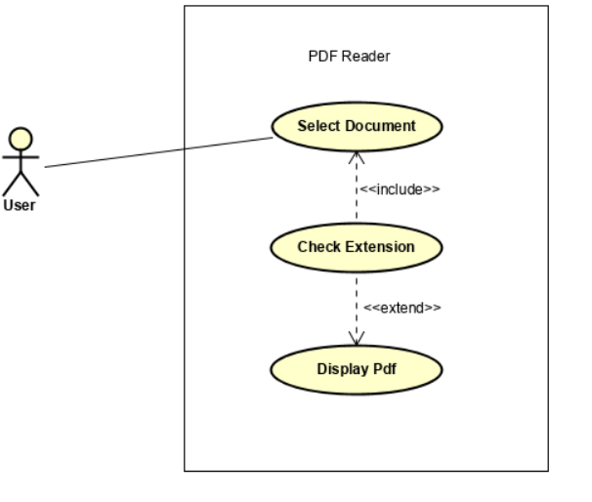

1. **Highlighting a Sentence:**

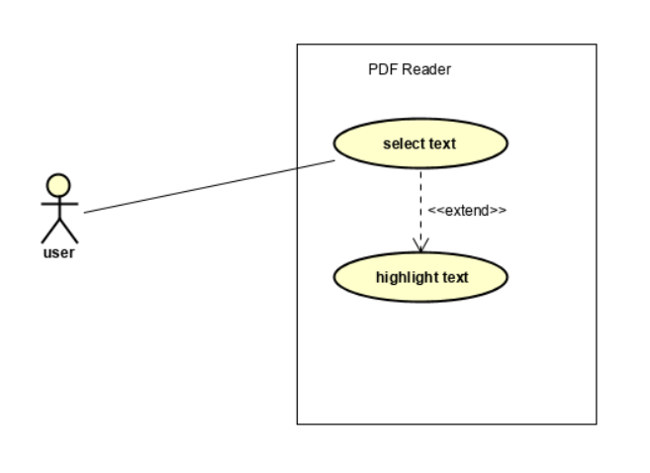

1. **Jumping to the desired page:**

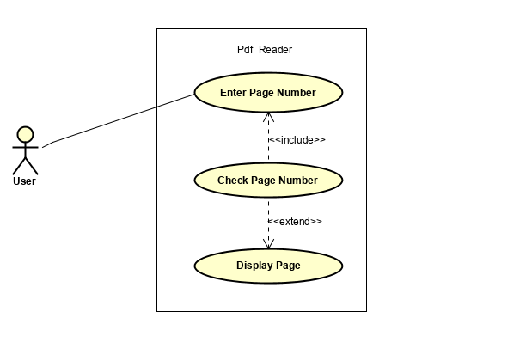

1. **Maintain notes on some specific words**:

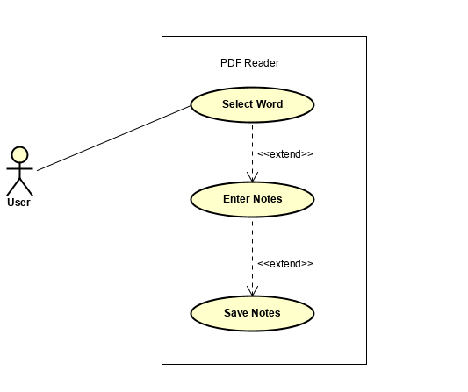

1. **Share a pdf:**

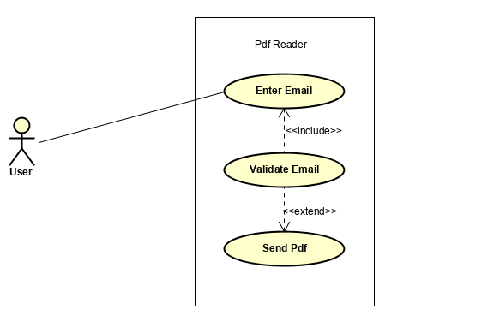

1. **Find and Replace**:

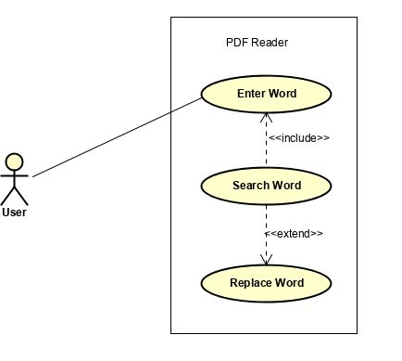

1. **Add a password on a document**:

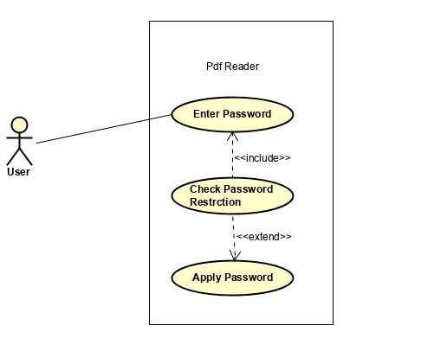

1. **View meaning of a word:**

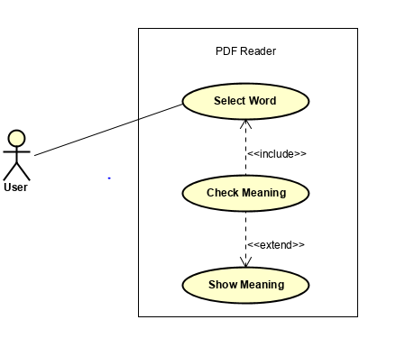

1. **Save Bookmarks for a document:**

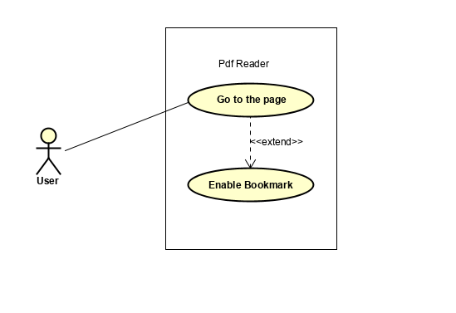

1. **Printing a Document:**

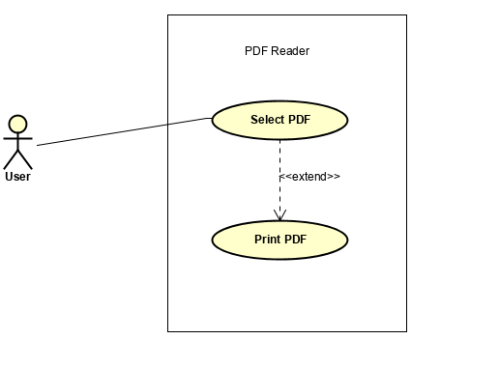

1. **Font size:**

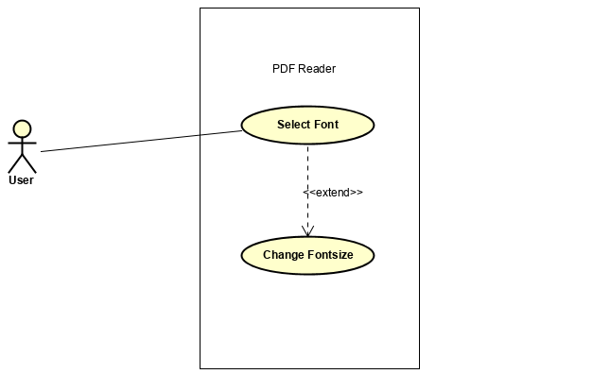

1. **Night Mode:**



1. **Edit a pdf.**

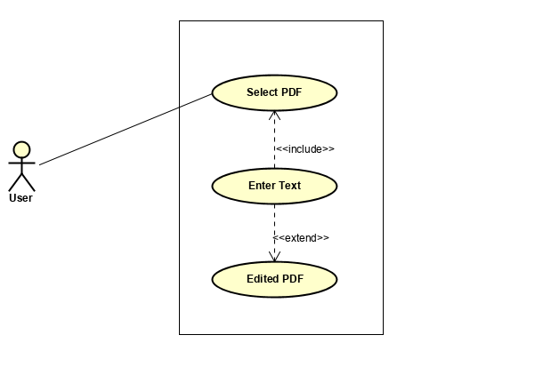

1. **Combine a pdf.**

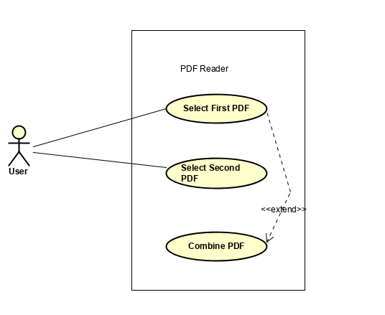

**Activity Diagram:**

1. **Displaying a pdf document:**

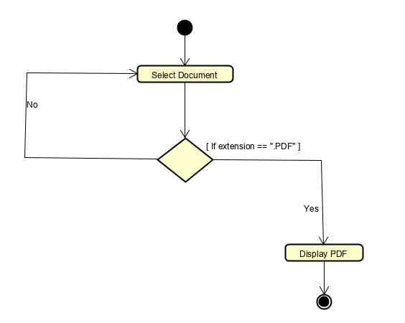

1. **Highlighting a sentence:**

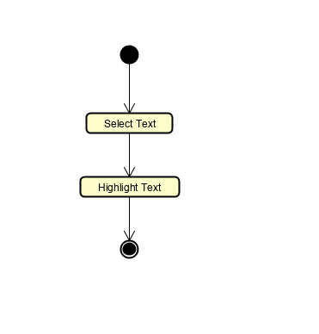

1. **Jump to the Desired Page:**

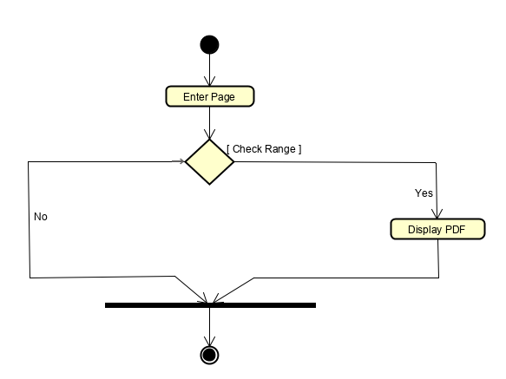

1. **Maintain notes on some specific words**:

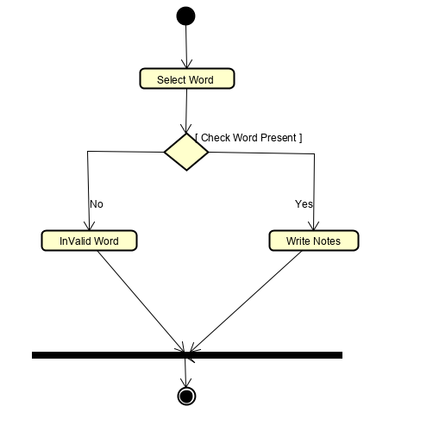

1. **Share a pdf:**

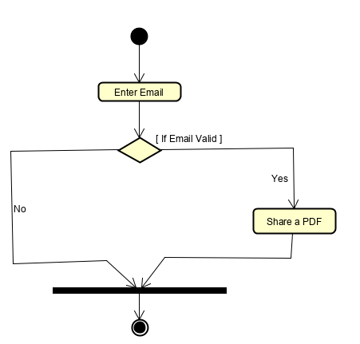

1. **Find and Replace**:

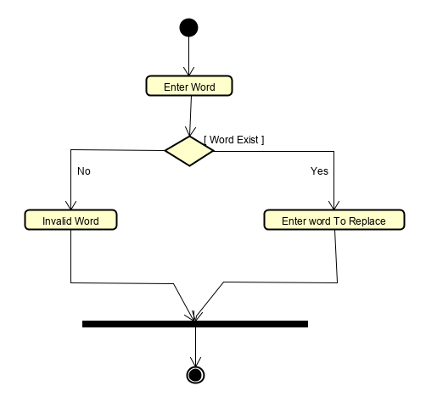

1. **Add a password on a document**:

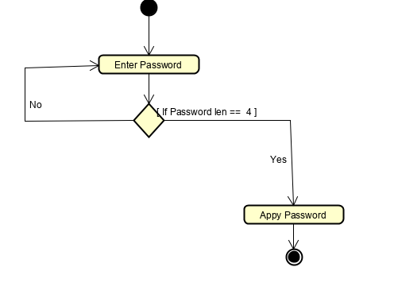

1. **View meaning of a word:**

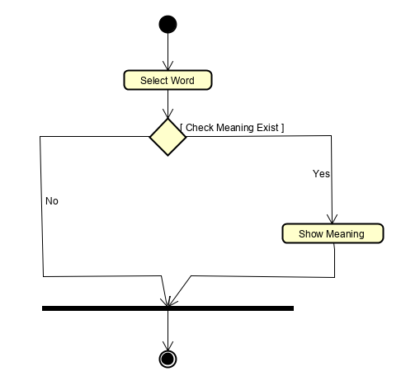

1. **Save Bookmarks for a document:**

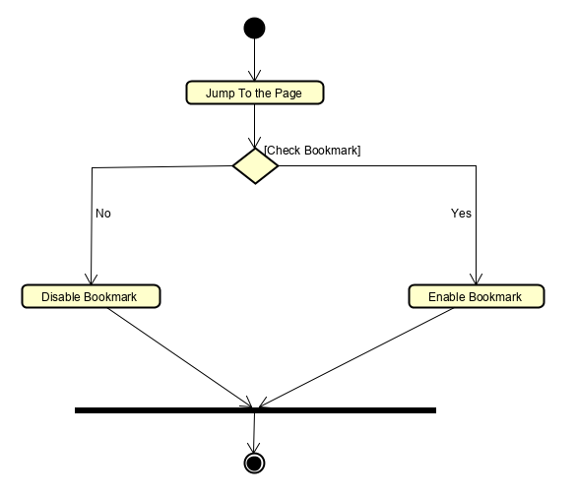

**10. Printing a Document:**

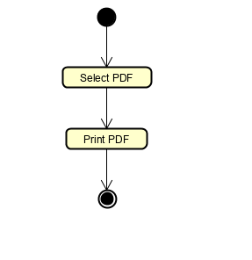

**11. Font size:**

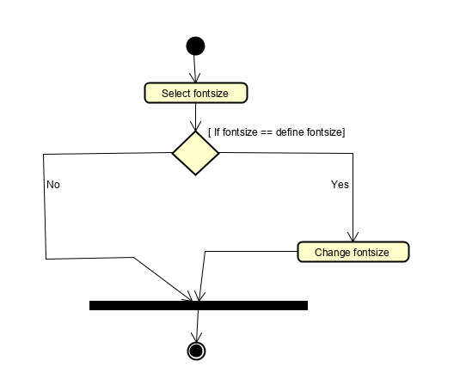

1. **Night Mode**

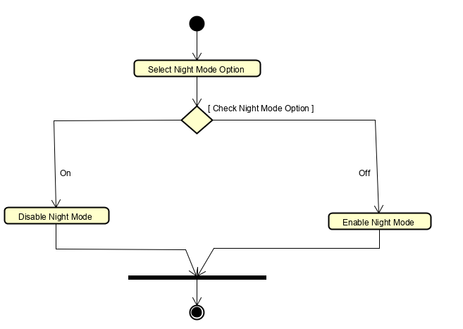

1. **Edit a pdf**

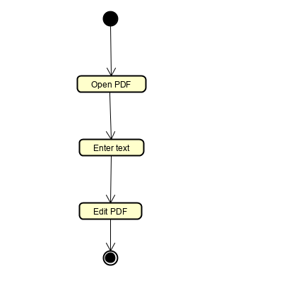

1. **Combine a pdf**

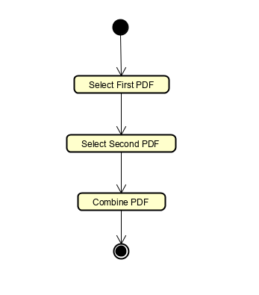

**Domain Model:**

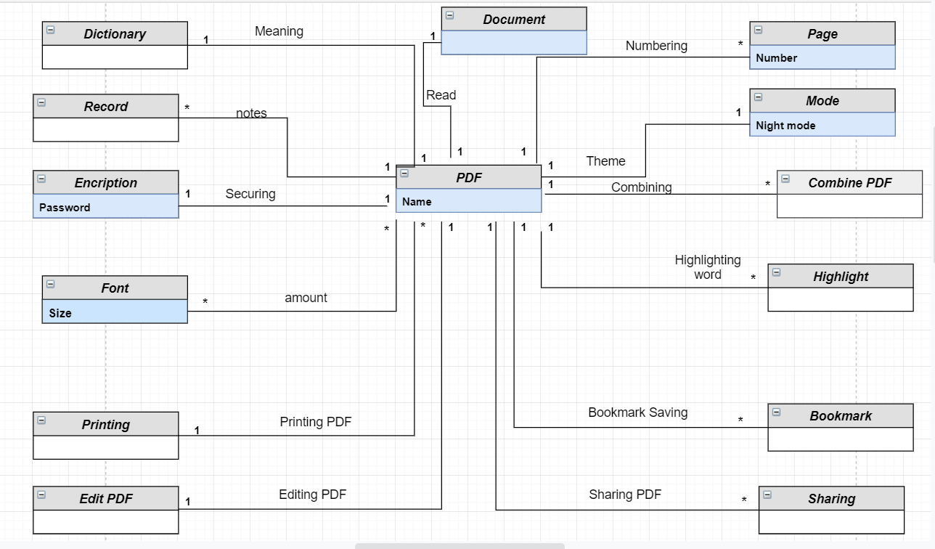

**System sequence diagram:**

1. **Displaying a pdf document:**

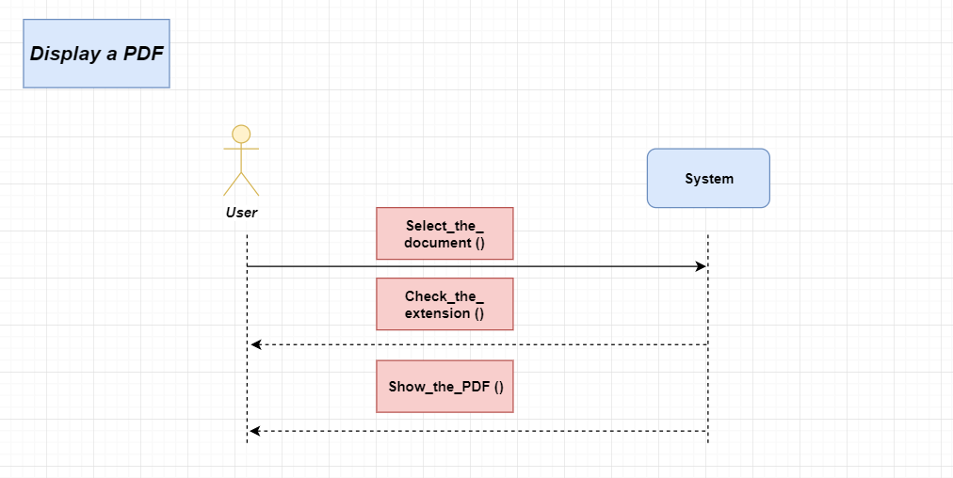

1. **Highlighting a sentence:**

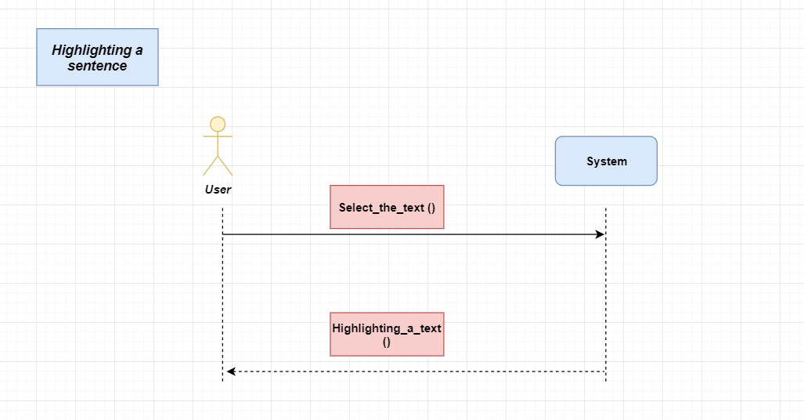

1. **Jumping to the desired page:**

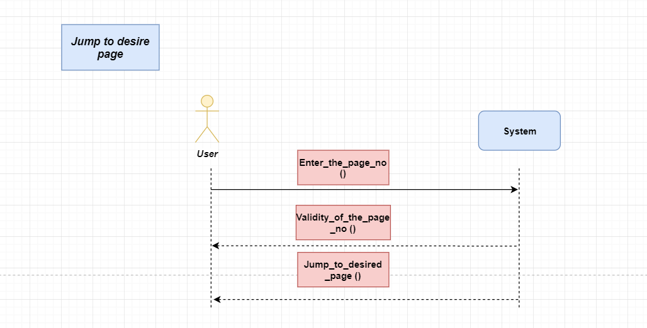

1. **Maintain notes on some specific words**:

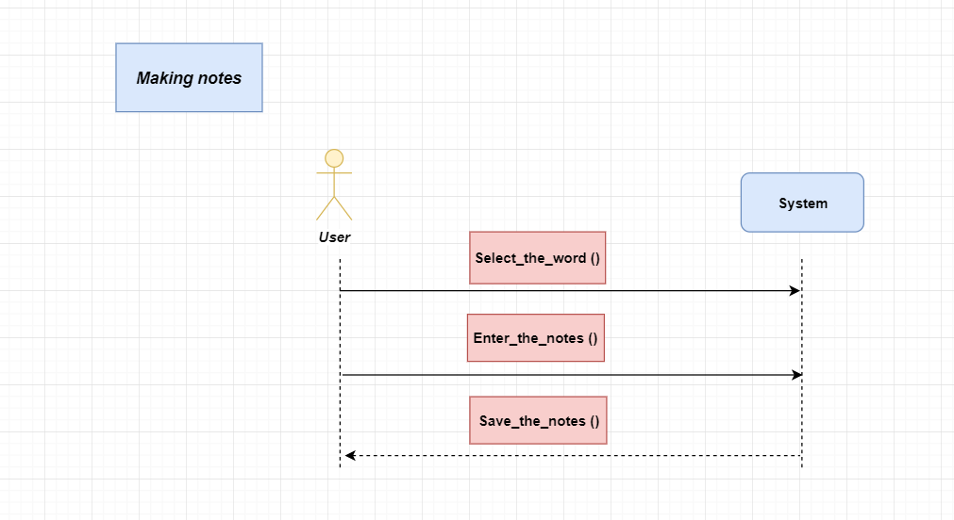

**5. Share a pdf**

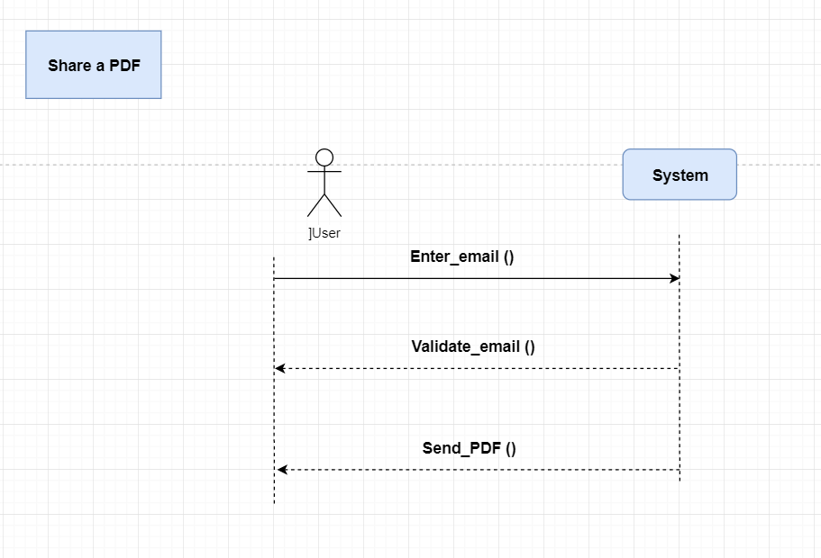

**6. Find and Replace**:

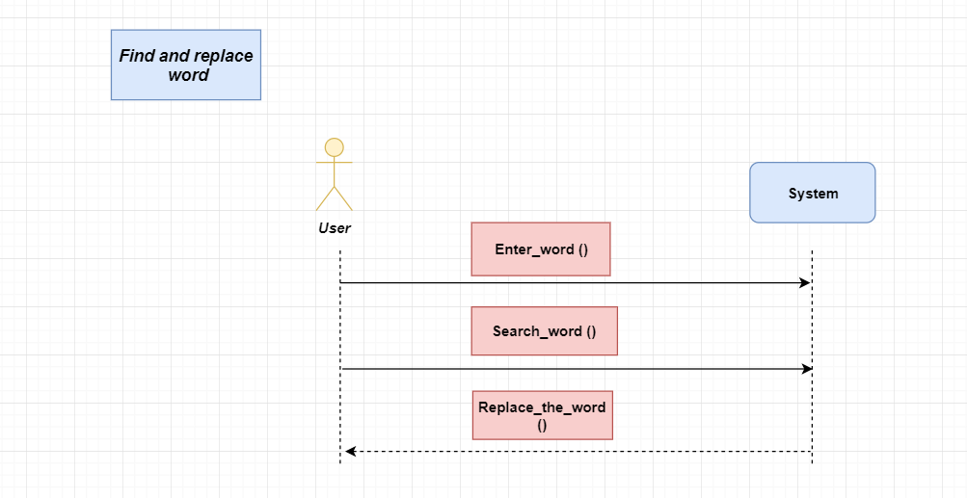

1. **Add a password on a document**:

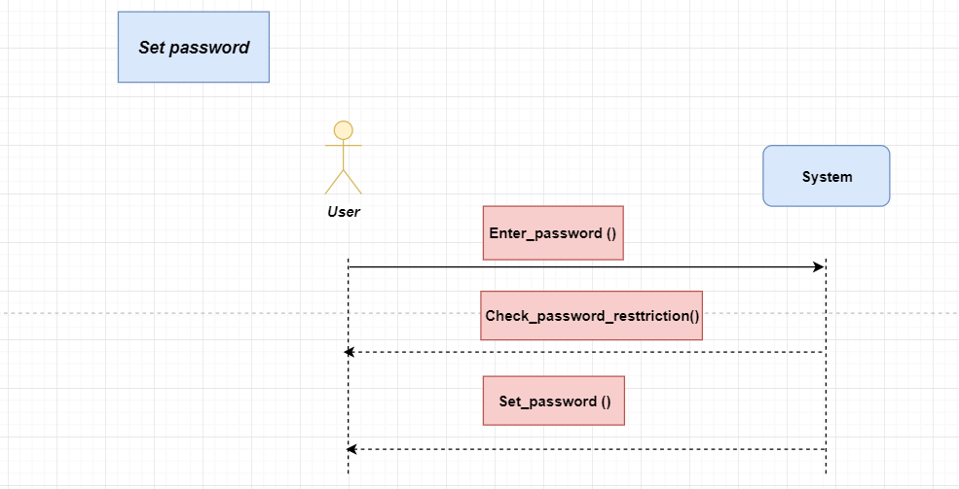

1. **View meaning of a word:**

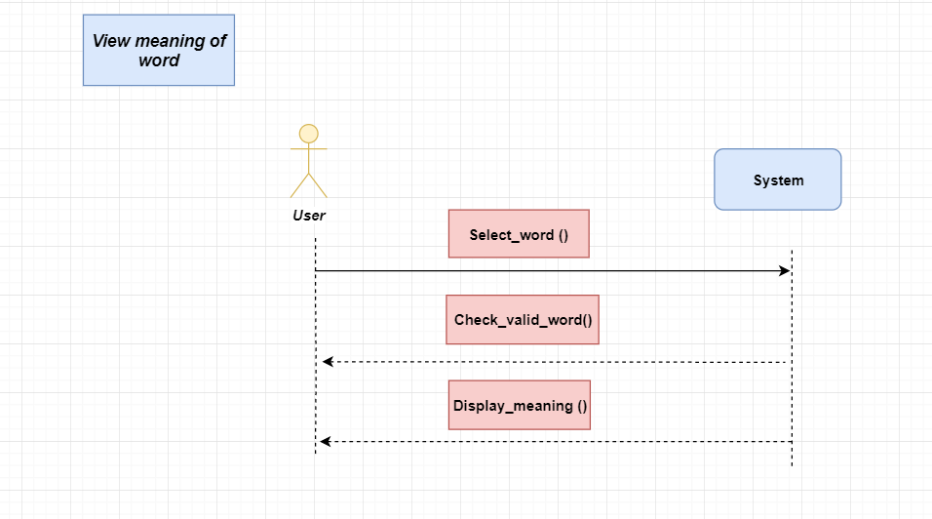

1. **Save Bookmarks for a document:**

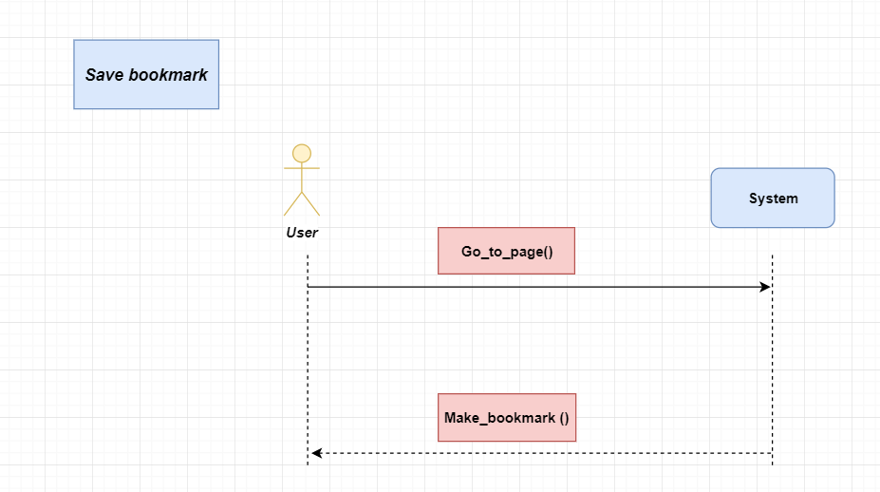

1. **Printing a Document:**

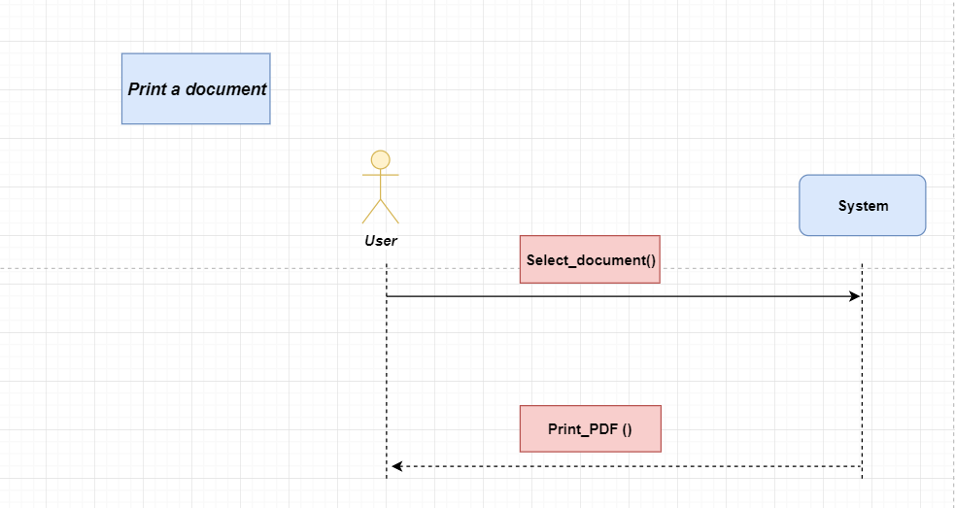

1. **Font size:**

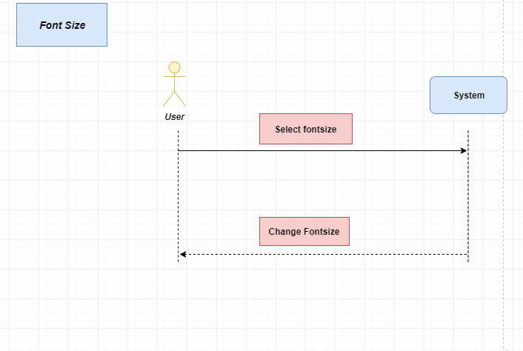

1. **Night Mode:**

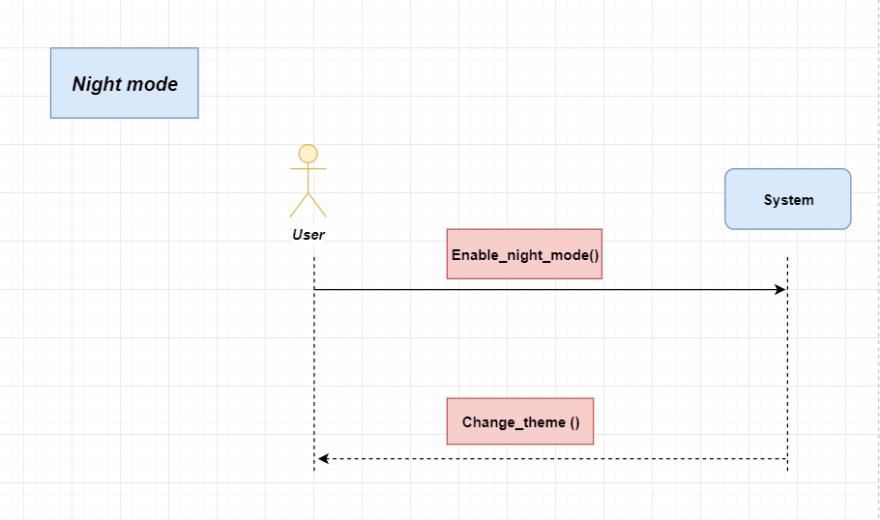

1. **Edit a pdf**

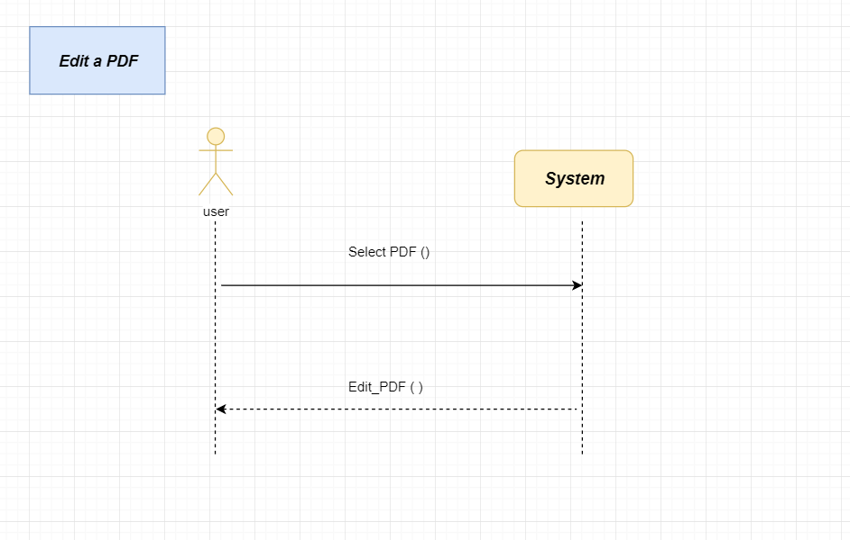

1. **Combine pdf**

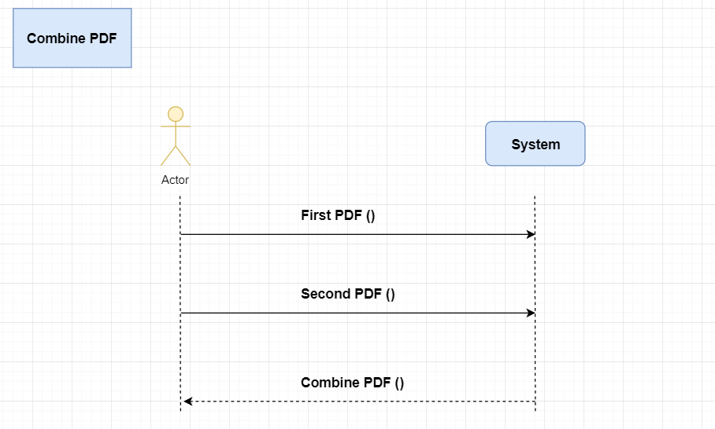

**Sequence Diagram:**

1. **Displaying a pdf document:**

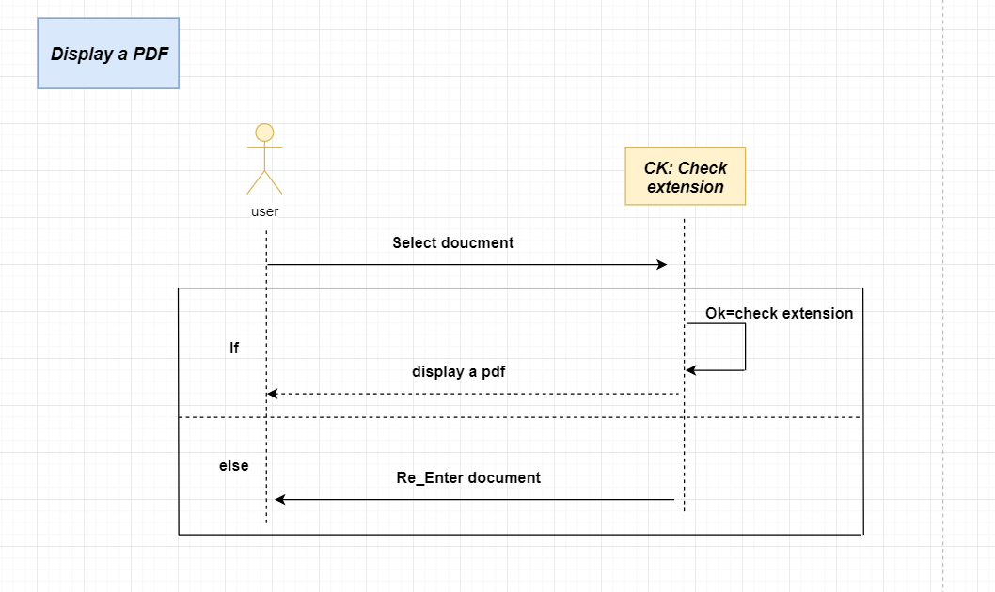

1. **Highlighting a sentence:**

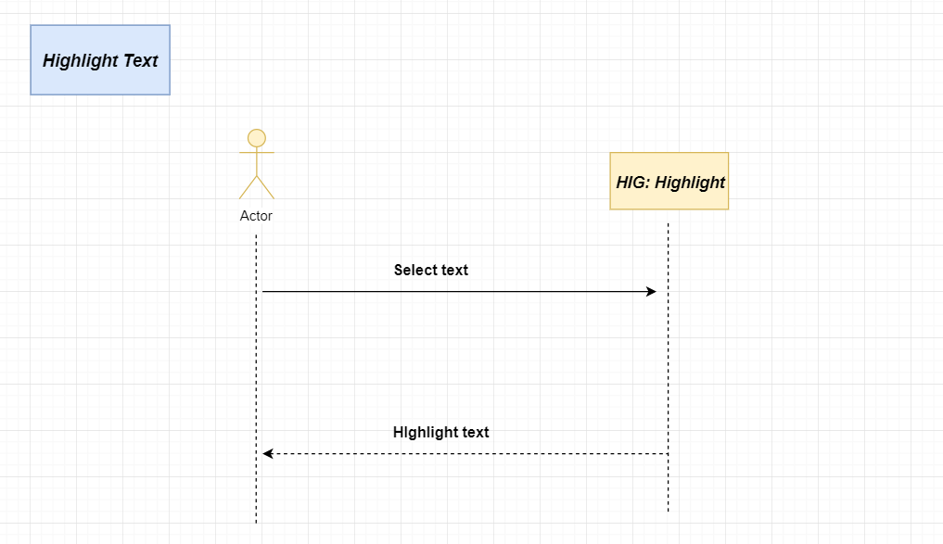

1. **Jumping to the desired page:**

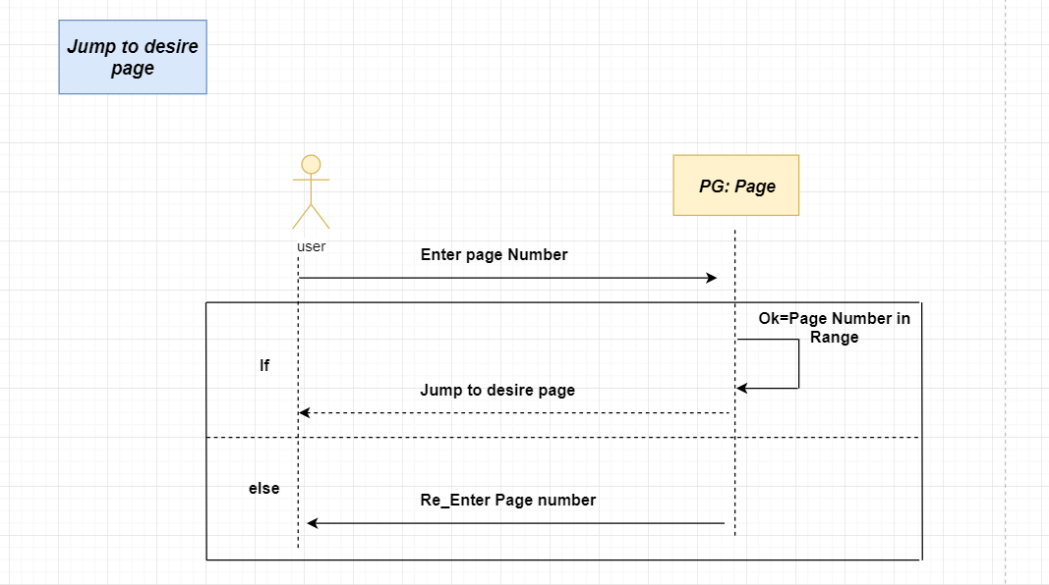

1. **Maintain notes on some specific words:**

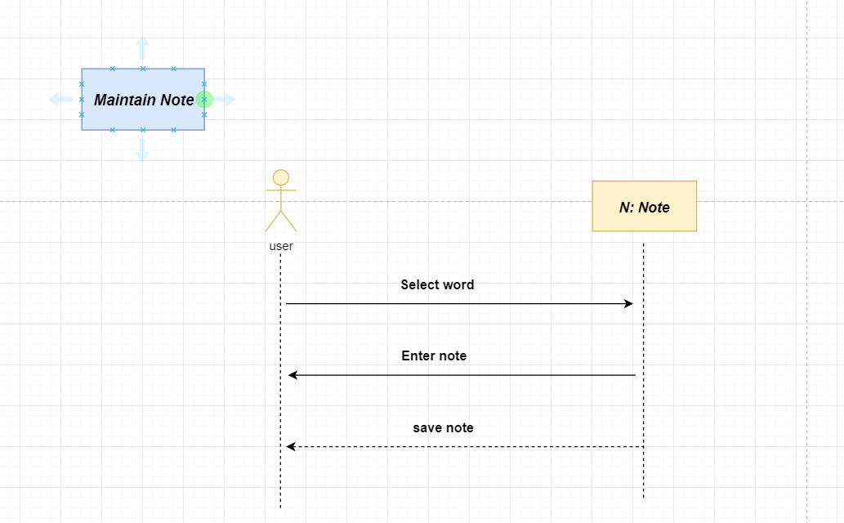

1. **Share a pdf:**

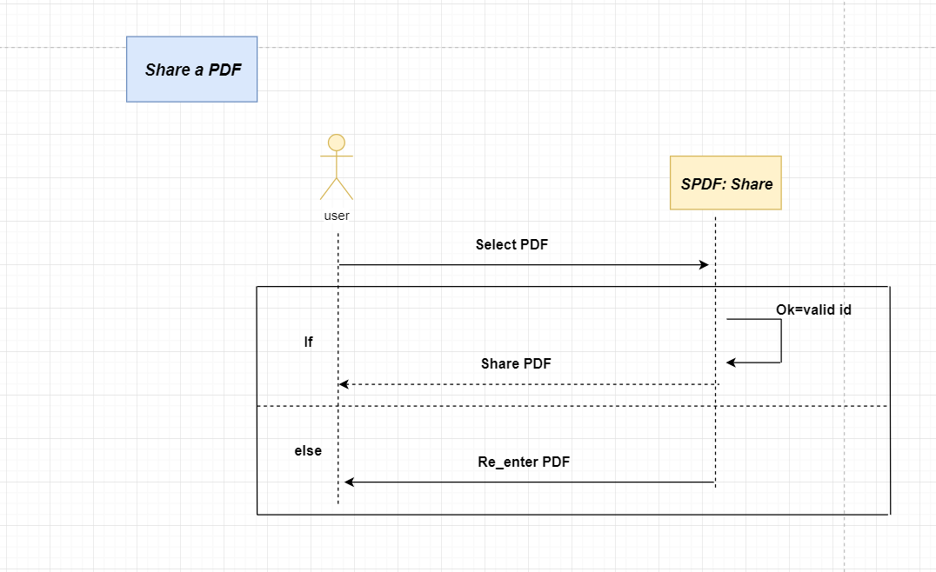

1. **Find and Replace:**

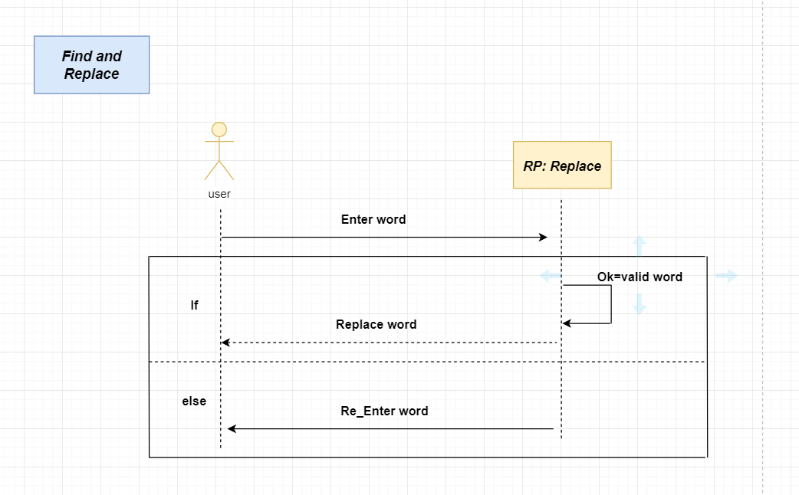

1. **Add a password on a document:**

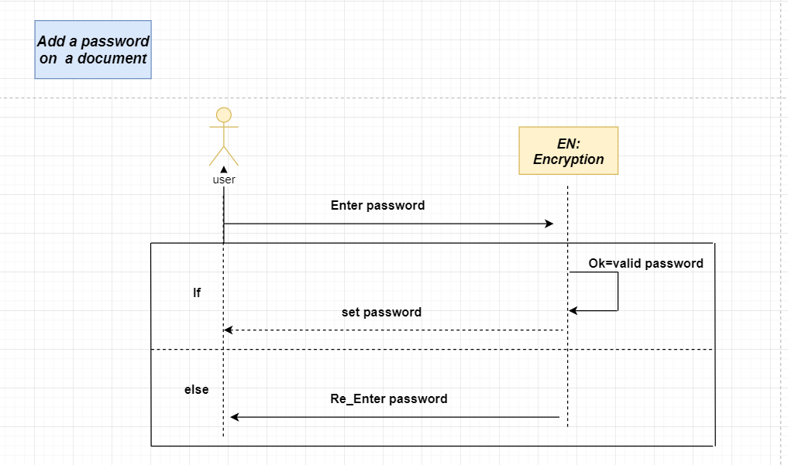

1. **View meaning of a word:**

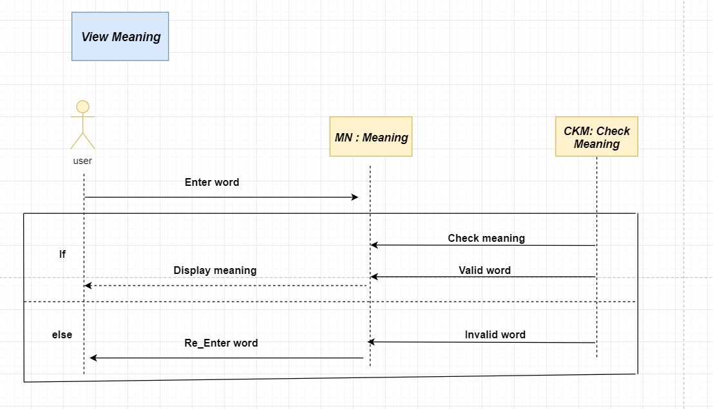

1. **Save Bookmarks for a document:**

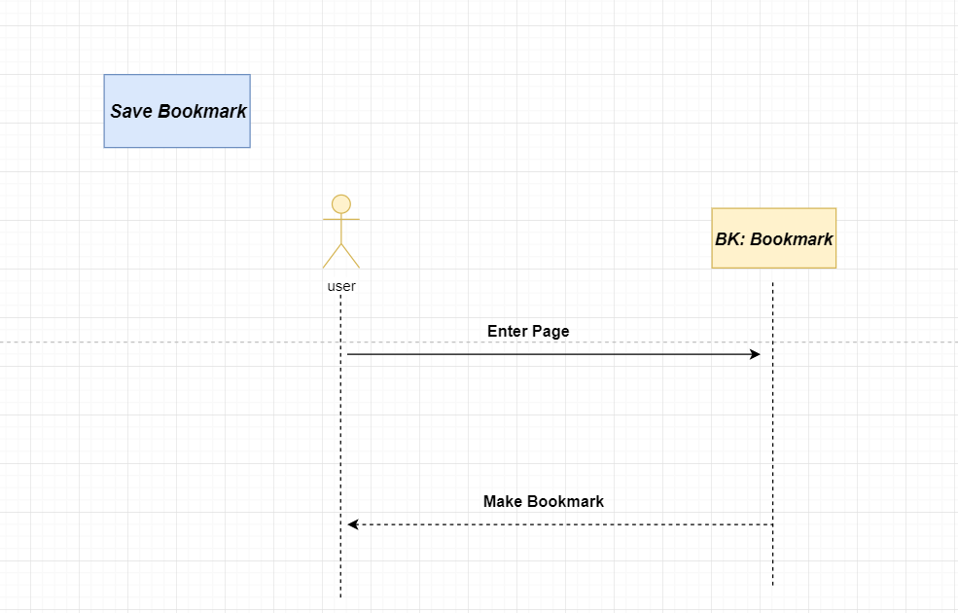

1. **Printing a Document:**

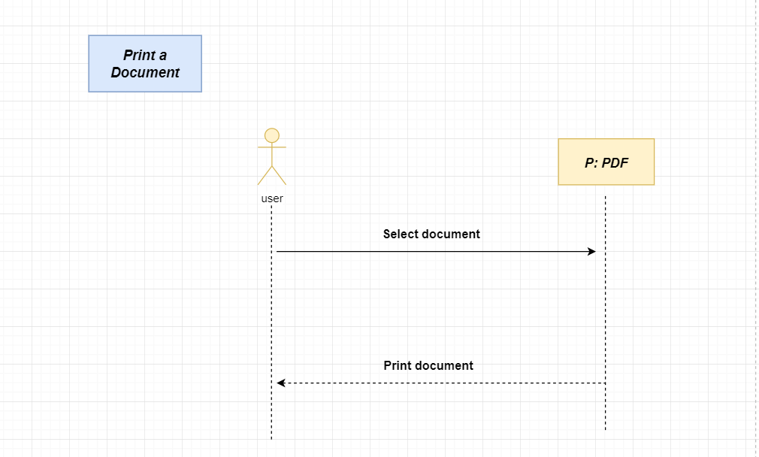

1. **Font size:**

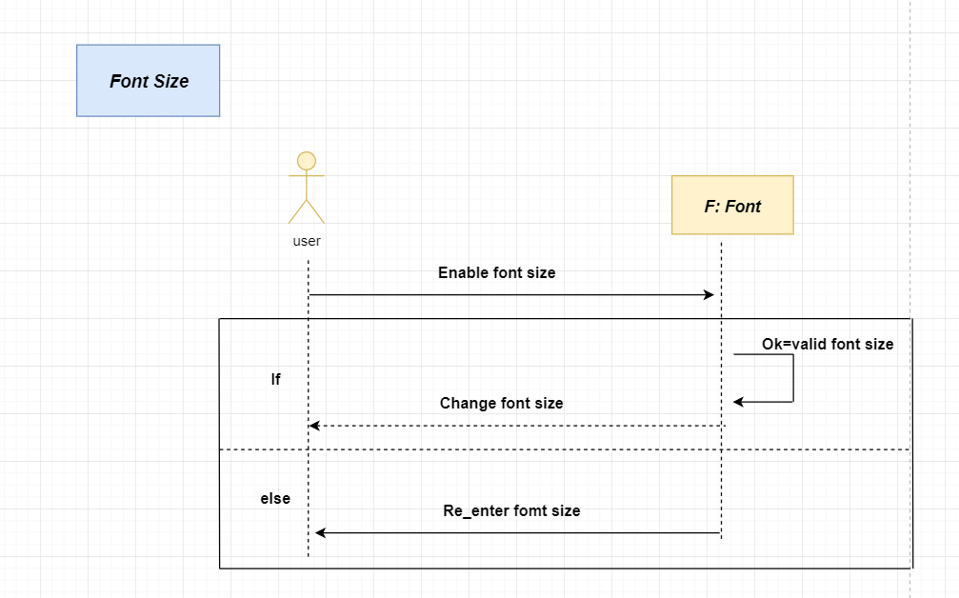

1. **Night Mode:**

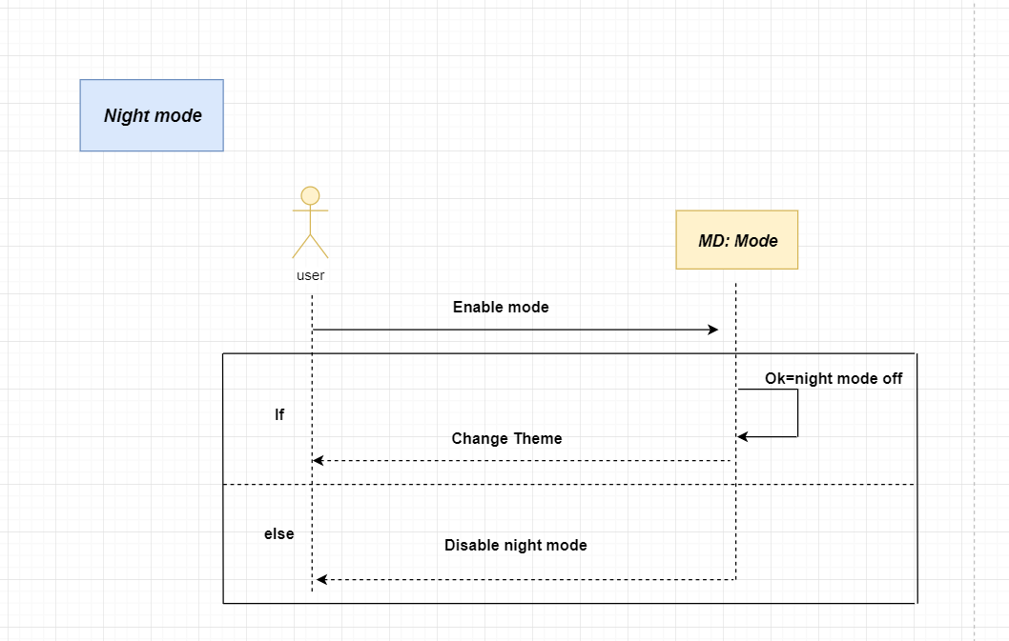

1. **Edit a pdf:**

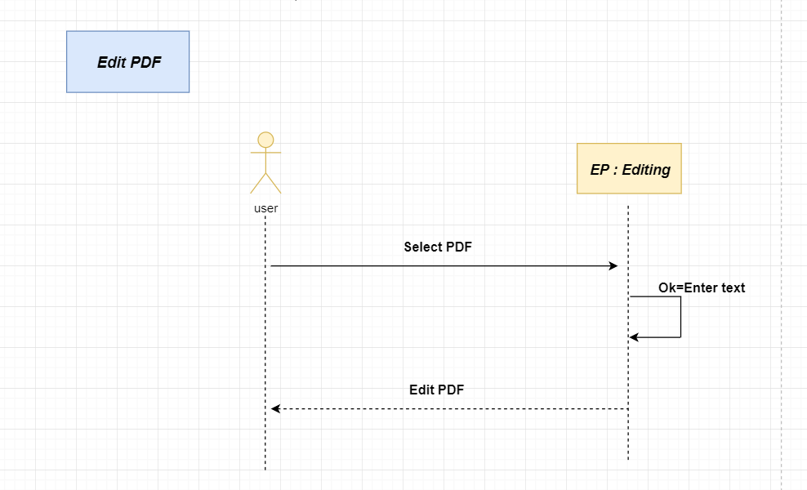

1. **Combine a pdf:**

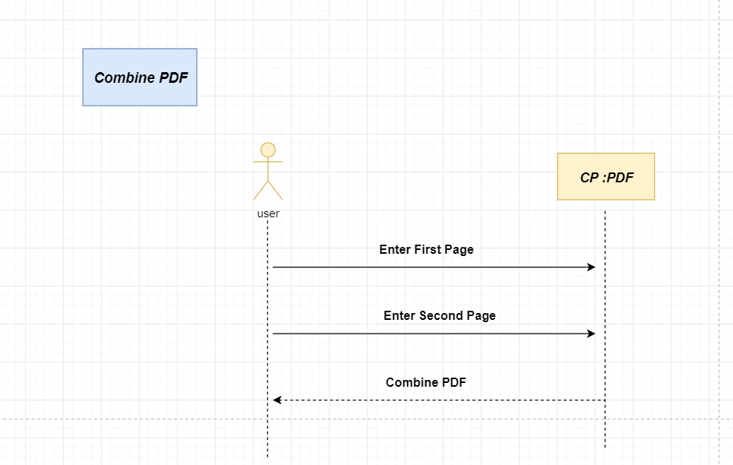

**ERD:**

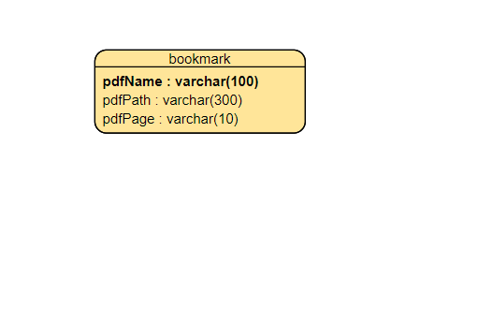

**Class Diagram:**

