1. In TWS, go to edit->Configuration and change to these settings

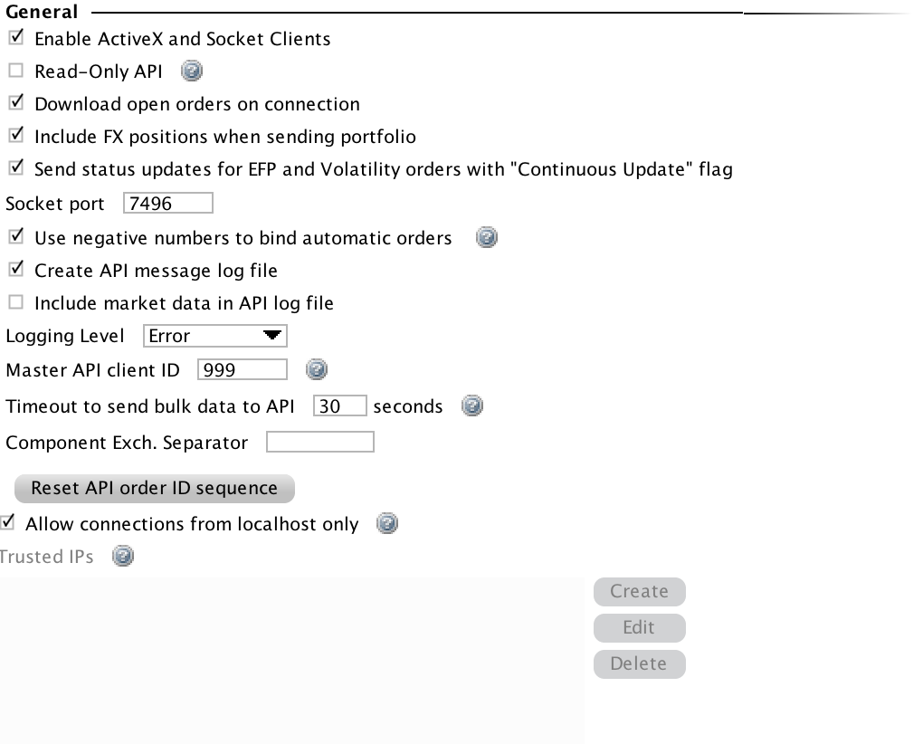

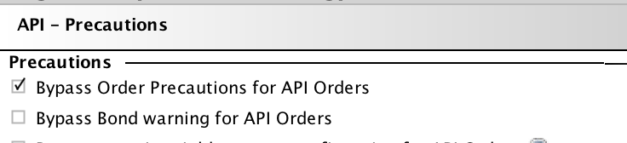

1. Download ibpy <https://github.com/blampe/IbPy>. Unzip it, right click on folder -> open command window here.
2. Type: setup.py install
3. The libraries should be in your python directory. You should be able to run the code