**`**



Scheme of Instructions & Syllabi

of

**Master of Computer Applications**

**(2023-25)**

With the collaboration of

CSED

(Center for Skill and Entrepreneurship Development)

**[As per CBCS guidelines given by UGC]**

|  |  |  |  |  |  |
| --- | --- | --- | --- | --- | --- |
| **Total Credit of the Program** | | | | | |
| **Semester** | **I** | **II** | **III** | **IV** | **Total** |
| **Credits** | 26 | 24 | 26 | 24 | **100** |

**Faculty of Computer Applications**

INVERTIS UNIVERSITY

Bareilly-243123 U.P.

**STUDY AND EVALUATION SCHEME**

**Master of Computer Applications**

***(2023-25)***

**SEMESTER I, YEAR I**

| **SNo** | **Course Code** | **Course Title** | **L+T+P** | **CA** | **EE** | **Total** | **Credit** |
| --- | --- | --- | --- | --- | --- | --- | --- |
| **1** | MCA106 | Object Oriented Programming Concepts | 3+1+0 | 30 | 70 | 100 | 4 |
| **2** | MCA108 | Advanced Database Management Systems | 3+1+0 | 30 | 70 | 100 | 4 |
| **3** | MCA109 | Advanced Computer Networks | 3+1+0 | 30 | 70 | 100 | 4 |
| **4** | MCA110 | Advanced Data Structure and Algorithms | 3+1+0 | 30 | 70 | 100 | 4 |
| **5** | IIOT1 | Fundamentals of IOT Development | 3+1+0 | 30 | 70 | 100 | 4 |
| **PRACTICAL / PROJECTS** | | | | | | | |
| **6** | MCA153 | Object Oriented Programming Concepts Lab | 0+0+4 | 15 | 35 | 50 | 2 |
| **7** | MCA154 | Advanced Database Management Systems Lab | 0+0+4 | 15 | 35 | 50 | 2 |
| **8** | MCA155 | Advanced Data Structure and Algorithms Lab | 0+0+4 | 15 | 35 | 50 | 2 |
| **TOTAL** | | | **15+5+12** | **195** | **455** | **650** | **26** |

**STUDY AND EVALUATION SCHEME**

**Master of Computer Applications**

***(2023-25)***

**SEMESTER II, YEAR I**

| **SNo** | **Course Code** | **Course Title** | **L+T+P** | **CA** | **EE** | **Total** | **Credit** |
| --- | --- | --- | --- | --- | --- | --- | --- |
| **1** | MCA208 | Advanced Operating Systems | 3+1+0 | 30 | 70 | 100 | 4 |
| **2** | MCA209 | Advanced Software Engineering | 3+1+0 | 30 | 70 | 100 | 4 |
| **3** | MCA210 | Web Technologies | 3+1+0 | 30 | 70 | 100 | 4 |
| **4** | MCA211 | Machine Learning with Python | 3+1+0 | 30 | 70 | 100 | 4 |
| **5** | IIOT2 | Industrial Communication Protocols & Connectivity | 3+1+0 | 30 | 70 | 100 | 4 |
| **PRACTICAL / PROJECTS** | | | | | | | |
| **6** | MCA254 | Web Technologies Lab | 0+0+4 | 15 | 35 | 50 | 2 |
| **7** | MCA256 | Machine Learning with Python Lab | 0+0+4 | 15 | 35 | 50 | 2 |
| **TOTAL** | | | **15+5+8** | **180** | **420** | **600** | **24** |

**STUDY AND EVALUATION SCHEME**

**Master of Computer Applications**

***(2023-25)***

**SEMESTER III, YEAR II**

| **SNo** | **Course Code** | **Course Title** | **L+T+P** | **CA** | **EE** | **Total** | **Credit** |
| --- | --- | --- | --- | --- | --- | --- | --- |
| **1** | MCA308 | Cryptography and Cyber Security | 3+1+0 | 30 | 70 | 100 | 4 |
| **2** | MCA321 | Advanced Java | 3+1+0 | 30 | 70 | 100 | 4 |
| **3** | MCA* | Elective I | 3+1+0 | 30 | 70 | 100 | 4 |
| **4** | MCA* | Elective II | 3+1+0 | 30 | 70 | 100 | 4 |
| **5** | IIOT3 | Introduction to Data Analytics | 3+1+0 | 30 | 70 | 100 | 4 |
| **PRACTICAL / PROJECTS** | | | | | | | |
| **6** | MCA319 | Industrial Training Viva ** | 0+0+0 | 15 | 35 | 50 | 2 |
| **7** | MCA355 | Advanced Java Lab | 0+0+4 | 15 | 35 | 50 | 2 |
| **8** | MCA* | Elective 1 Lab | 0+0+4 | 15 | 35 | 50 | 2 |
| **TOTAL** | | | **15+5+8** | **195** | **455** | **650** | **26** |

| **Elective I** | | | |  | | **Elective II** | | |
| --- | --- | --- | --- | --- | --- | --- | --- | --- |
| **SNo** | **Course Code** | **Course Title** |  | | **SNo** | | **Course Code** | **Course Title** |
| **i** | MCA309 | Artificial Neural Network | **i** | | MCA314 | Digital Marketing |
| **ii** | MCA310 | Android Programming | **ii** | | MCA315 | Theory of Computation |
| **iii** | MCA311 | PHP | **iii** | | MCA316 | Distributed DBMS |
| **iv** | MCA312 | Search Engine Optimization | **iv** | | MCA317 | Advanced Data Mining Techniques |

| **Elective I Lab** | | |
| --- | --- | --- |
| **SNo** | **Course Code** | **Course Title** |
| **i.** | MCA356 | Artificial Neural Network Lab |
| ii | MCA357 | Android Programming Lab |
| iii | MCA354 | PHP Lab |
| iv | MCA359 | Search Engine Optimization Lab |

**STUDY AND EVALUATION SCHEME**

**Master of Computer Applications**

***(2023-25)***

**SEMESTER IV, YEAR II**

| **SNo** | **Course Code** | **Course Title** | **L+T+P** | **CA** | **EE** | **Total** | **Credit** |
| --- | --- | --- | --- | --- | --- | --- | --- |
| **1** | MCA405 | Cloud Computing and Virtualization | 3+1+0 | 30 | 70 | 100 | 4 |
| **2** | MCA* | Elective III | 3+1+0 | 30 | 70 | 100 | 4 |
| **3** | IIOT4 | Machine Learning | 3+1+0 | 30 | 70 | 100 | 4 |
| **PRACTICAL / PROJECTS** | | | | | | | |
| **4** | MCA454 | Major Project | 0+0+24 | 90 | 210 | 300 | 12 |
| **TOTAL** | | | **9+3+24** | **180** | **420** | **600** | **24** |

| **Elective III List** | | | | | |
| --- | --- | --- | --- | --- | --- |
| **SNo** | **Course Code** | **Course Title** | **SNo** | **Course Code** | **Course Title** |
| **i** | MCA406 | Internet of Things | **vi** | MCA415 | Big Data Analysis |
| **ii** | MCA407 | Design & Analysis of Algorithms | **vii** | MCA416 | Compiler Design |
| **iii** | MCA408 | Digital Image Processing | **viii** | MCA417 | Advanced Soft Computing |
| **iv** | MCA409 | Block Chain Technology | **ix** | MCA418 | Data Science |
| **v** | MCA410 | Artificial Intelligence | **x** | MCA419 | Natural Language Processing |

**\* Students can choose Electives from Elective 1 & Elective 2 lists.**

**\*\*After 2nd Semester, students will undergo 6 weeks’ summer training compulsorily in Public Sector undertakings or Private Sector, known as Industrial Training/Internship. 25 marks will be on viva of students on their Project experience in 3rd Semester.**

|  |  |  |
| --- | --- | --- |
| **Program Outcomes (POs)** | | |
| **PO1** | Computational Knowledge | Understand and apply mathematical foundation, computing and domain knowledge for the conceptualization of computing models from defined problems. |
| **PO2** | Problem analysis | Ability to identify, critically analyze and formulate complex computing problems using fundamentals of computer science and application domains. |
| **PO3** | Design / Development of Solutions | Ability to transform complex business scenarios and contemporary issues into problems, investigate, understand and propose integrated solutions using emerging technologies |
| **PO4** | Conduct Investigations of Complex Computing Problems | Ability to devise and conduct experiments, interpret data and provide well informed conclusions. |
| **PO5** | Modern Tool Usage | Ability to select modern computing tools, skills and techniques necessary for innovative software solutions. |
| **PO6** | Professional Ethics | Ability to apply and commit professional ethics and cyber regulations in a global economic environment. |
| **PO7** | Life-long Learning | Recognize the need for and develop the ability to engage in continuous learning as a Computing professional. |
| **PO8** | Project Management and Finance | Ability to understand, management and computing principles with computing knowledge to manage projects in multidisciplinary environments. |
| **PO9** | Communication efficacy | Communicate effectively with the computing community as well as society by being able to comprehend effective documentations and presentations. |
| **PO10** | Societal & Environmental Concern | Ability to recognize economic, environmental, social, health, legal, ethical issues involved in the use of computer technology and other consequential responsibilities relevant to professional practice. |
| **PO11** | Individual & Team Work | Ability to work as a member or leader in diverse teams in multidisciplinary environment. |
| **PO12** | Innovation and Entrepreneurship | Identify opportunities, entrepreneurship vision and use of innovative ideas to create value and wealth for the betterment of the individual and society. |

|  |  |
| --- | --- |
| **MCA106: Object Oriented Programming Concepts** | |
| **Teaching Scheme** | **Examination Scheme** |
| Lectures: 3 hrs/Week | Class Test -12Marks |
| Tutorials: 1 hr/Week | Teachers Assessment - 6Marks  Attendance – 12 Marks |
| Credits: 4 | End Semester Exam – 70 marks |

**Prerequisite: -**

1. Computer Fundamentals
2. Principles of computer programming
3. Basic mathematical formulas.

**Course Objectives:**

1. Be able to write a C++ program to solve a well specified problem.
2. Understand a C++ program written by someone else.
3. Be able to debug and test C++ programs;
4. To make the students understand the features of object oriented principles.
5. Familiarize them with virtual functions, templates and exception handling.
6. To make the students to develop applications using C++.

**Detailed Syllabus**

|  |
| --- |
| **UNIT I (10 Hours)**  **Introduction to OOP:** Basic concepts of OOPs, Advantages of OOP, characteristics of object-oriented languages, Object, Classes, Encapsulation, Data Abstraction, Inheritance, Polymorphism, Dynamic binding, Message Passing, keywords, identifiers, data types, manipulators, **O**perators in C++, Operator Precedence, Typecast operator, Control structures, Loops. |
| **UNIT II (6 Hours)**  **Functions:** Function Prototyping, Call by reference, Return by Reference, Default and Constant Arguments, Inline Function, functions Overloading, Friend and virtual Functions, static function. |
| **UNIT III (10 Hours)**  **Objects and classes:** Specifying class & object, Arrays as class member data, Arrays of objects, Constructors and Destructors, objects as function arguments.  **Operator Overloading: O**verloading Unary & Binary operators, |
| **UNIT IV (10 Hours)**  **Inheritance: introduction, defining deriv**ed classes, overriding member functions, Single Inheritance, multilevel Inheritance, multiple Inheritance, Hierarchical Inheritance, Virtual Base Class.  F**iles and Streams:** Introduction, classes for file stream operations, opening and closing files, file pointers and their manipulations, Error Handling, command-line Arguments. |
| **UNIT V (10 Hours)**  **Object Modeling:** Objects and classes, links and association, generalization and inheritance, aggregation, abstract class, multiple inheritance, Meta data, candidate keys, constraints. **Dynamic Modeling:** Events and states, operations, nested state diagrams and concurrency, advanced dynamic modeling concepts, a sample dynamic model. |
| **UNIT VI (10 Hours)**  **Functional Modeling:** Data flow diagram, specifying operations, constraints, a sample functional model. OMT, examples and case studies to demonstrate methodologies, comparisons of methodologies, SA/SD, JSD. |

|  |
| --- |
| **Text and Reference Books**   1. Object Oriented Programming with C++, E. Balaguruswamy, 4th Edition. 2. Object Oriented Programming in C++, Robert Lafore, Sams, Dec., 2001. 3. C++ Programming, D. Ravichandran, TMH, 2nd Edition, Dec. 2002.   Mastering C++, Venugopal, TMH, September, 1997. |

**Course Outcomes:**

|  |
| --- |
| 1. Understanding the concept and recognize the basic terminology used in computer programming. |
| 2. Students will be able to apply the computer programming techniques to solve practical problems. |
| 3. Students will be able to understand the concepts and implementation of class, constructors and destructors. |
| 4. Students are able to learn C++ data types, memory allocation/deallocations, functions and pointers. |
| 5. Use different data structures and create / manipulate basic data files and developing applications for real world problems. |

|  |  |
| --- | --- |
| **MCA108: Advanced Database Management System** | |
| **Teaching Scheme** | **Examination Scheme** |
| Lectures: 3 hrs/Week | Class Test -12Marks |
| Tutorials: 1 hr/Week | Teachers Assessment - 6Marks  Attendance – 12 Marks |
| Credits: 4 | End Semester Exam – 70 marks |

**Prerequisite: -**

Computer Organization, Operating System, Data Structure, Mathematics

**Course Objectives:** The objectives of this course are

1. Understand values of Data.
2. Understand significant role of DBMS.
3. Understand need for normalizing a Database.
4. Understand problems with unnecessary duplication of data.
5. Understand concepts of transaction and concurrent transactions

**Detailed Syllabus**

|  |
| --- |
| **Unit-1 (6 Hours)** **Introduction Database Systems:** An overview of database management system, Database System Vs File System, Database system concepts and architecture, data models schema and instances, data independence and data base language and interfaces, Data definitions language, DML, Overall Database Structure. |
| **Unit-II (10 Hours)** **Data Modeling using Relational Data Model:** Modeling Techniques-Different Types of Models. Hierarchical Database, Network Database, and Relational Database. Relational data model-Codd's Rules, Concept of Domain, Tuple,and Cardinality. Introduction to ERD-ER model concepts, notation for ER diagram, mapping constraints, keys, Concepts of Super Key, candidate key, primary key, Generalization, aggregation. |
| **Unit-III (10 Hours)** **Data Base Design & Normalization:** Functional dependencies, normal forms, first, second, third normal forms, BCNF, inclusion dependence, loss less join decompositions, normalization using FD, MVD, and JDs. |
| **Unit-IV (10 Hours)** **Structured Query Language:** Features of SQL, SQL *PLUS, SQL V/s SQL *PLUS, Rules for SQL, SQL Delimiters, Components of SQL. **Constraints:** Data constraints, Types of data constraints: UNIQUE, NOT NULL at column level, CHECK, NULL value constraint  **PL/SQL:** Basic Introduction, Advantages of PL/SQL, The generic PL/SQL block, Literals, Variables, Constants, Comparisons, Comments. **Control Structure:** Conditional Control, Iterative Control and Sequential Control. **PL/SQL Transaction:** Oracle Transactions, Cursor, Types of Cursor: Implicit cursor, Explicit cursor. |
| **Unit-V (10 Hours)** **Transaction Processing Concepts:** Transaction system, testing of serializability, Serializability of schedules, conflict & view serializable schedule, recoverability, Recovery from transaction failures, log based recovery. Concurrency Control-Concurrency control, Protocols for concurrency control-locking, Time stamping, validation based protocol. Multiple granularity, Multi-version schemes, Recovery with concurrent transaction. |
| **Unit-VI (10 Hours)** **Modern Database Systems:** Transaction Processing in Distributed system, data fragmentation, Replication and allocation techniques for distributed system, overview of concurrency control and recovery in distrusted database. Parallel databases, multimedia databases, spatial and temporal databases, data warehousing and data mining, deductive databases. |

|  |
| --- |
| **Text and Reference Books**   1. Database System Concepts, Henry Korth , A. Silberschatz, 5th Edition, 2005. 2. An Introduction to Database System, Bipin Desai, Galgotia Publications, 1991. 3. SQL, PL/SQL the Programming Language of Oracle, Ivan Bayross, BPB Publications, 4th Edition. 4. Schaum’s Outline of “Fundamental of Relational Databases”, Ramon A. Mata, Pauline K.   Cushman, McGraw Hill, December, 2006. |

## **Course Outcomes:**

|  |
| --- |
| 1. Acquire knowledge of handling large volume of data. |
| 2. Acquire skills to deal with Real life database implementation. |
| 3. Response off faster queries and serve as many users as possible concurrently. |
| 4. Attain the capability to represent various real life problem domains using logic based techniques and  use this to perform inference or planning. |
| 5. Fit with any Database project in industry after completion of degree. |

|  |  |
| --- | --- |
| **MCA109: Advanced Computer Networks** | |
| **Teaching Scheme** | **Examination Scheme** |
| Lectures: 3 hrs/Week | Class Test -12Marks |
| Tutorials: 1 hr/Week | Teachers Assessment - 6Marks  Attendance – 12 Marks |
| Credits: 4 | End Semester Exam – 70 marks |

**Pre-requisites:** Data Communication and Computer Network, INTERNET, Router

## **Course Objectives:**

1. To discuss and explain about basics of data communication and networking concepts
2. Explain how the data link layer prepares data for transmission les and list the component parts of a Layer
3. To discussed the medium access control and to create a logical design and physical design of a simple Ethernet LAN
4. Describe how routers use next-hop addresses to determine the path that packets need to take to reach their destinations and their describe the IP addressing structure
5. Explain the difference between TCP and UDP and describe how TCP and UDP function are worked
6. Describe and application layer for using end user application such as DNS, SMTP and Telnet etc

|  |
| --- |
| **Unit 1**  **Introduction –** Data Communication, Data encoding and Modulation, Broadband and Baseband transmission, The Internet Today, Protocols and Standards, Internet Standards Network topologies design ,Connecting Devices, Network Types, OSI Reference Model, TCP/IP Protocol Suite |
| **UNIT 2** **Data Link Layer:** Error Detection and Correction, Techniques, CRC and Hamming Code. Flow Control and Error Control Techniques: Stop and Wait, Sliding Window, GoBack-N, Selective Repeat Protocol.Ethernet, Ethernet frame, Addressing. |
| **UNIT 3** **Media Access Sub layer-**Media Access Sub layer, ALOHA Protocol, Overview of protocol,Channel allocation, WLAN protocol, CSMA, CSMA/CD, CSMA/CA and CDMA Protocol,Wireless LAN |
| **UNIT 4** **Network Layer:** Network Layer - Point - to Pont Networks, Routing Protocols, TCP / IP, IP packet, IP address, IPv4 &IPv6. Bluetooth, Cellular telephony, IP Addresses: Class Addressing, |
| **UNIT 5** **Transport Layer:** TCP, & UDP protocol, Routing Protocols, Static & Dynamic Routing, Routing Table and Routing Module, Socket Interface: Definitions, Byte Ordering, Address Transformation, Byte Manipulation Function, Information about Remote Host, Socket System Calls, Connectionless Iterative Server, |
| **UNIT-6** **Application Layer:** Network Management and SNMP Multimedia and Data Compression,Electronic Mail: SMTP and MIME,DNS, TELNET & Rlogin, FTP, TFTP, SMTP, HTTP, WWW, RTP, BOOTP & DHCP,  DNS, TELNET & Rlogin. |

|  |
| --- |
| **Text and Reference Books** |
| 1. Behrouz A Frouzan: TCP/IP Protocol Suite, 4th Edition,2010, TMH |
| 1. Douglas E Comar: TCP/IP Protocol, 6th Edition,2008, Pearson Education |
| 1. Behrouz A Frouzan: Data Communication and Networking, 4th Edition,2006, TMH |
| 1. Richard Stevens: TCP/IP Illustrated Vol 1: The Protocols, 1st Edition,2006, Pearson Education, India. |

## 

## **Course Outcomes:**

After completing the course, students will be able to:

|  |
| --- |
| 1. Recognize and Describe about the working of Computer Networks and Illustrate reference models   with layers, protocols and interfaces. |
| 1. Illustrate data link layer for using different error Control techniques |
| 1. Examine problems of a computer networks related techiniques for CSMA/CD, Aloha, Ethernet   and WLAN |
| 1. Students will understand for network layer internetworking technologies, Routing, IP Addressing   and routing protocol for using shortest path for destination |
| 1. Students will understand TCP/IP implementation |
| 1. Students will understand the end user application for such domain name system , HTTP, UDP   Telnet and SMTP etc |

|  |  |
| --- | --- |
| **MCA110: Advanced Data Structure and Algorithms** | |
| **Teaching Scheme** | **Examination Scheme** |
| Lectures: 3 hrs/Week | Class Test -12Marks |
| Tutorials: 1 hr/Week | Teachers Assessment - 6Marks  Attendance – 12 Marks |
| Credits: 4 | End Semester Exam – 70 marks |

## **Prerequisite: -**

1. Familiarity with the fundamentals of C or other programming language
2. A solid background in mathematics, including probability, set theory

## **Course Objectives:**

1. Understand various data structures like array, linked list.
2. Implement operations like insertion, deletion and traversing mechanism on various data structures.
3. Implement Linear and Non-Linear data structures.
4. Implement sorting/searching technique.
5. Determine and analyze the complexity of given algorithms.

|  |
| --- |
| **UNIT I (10 Hours)** **Introduction to Algorithm Design and Data Structures:** Abstract data types, Fundamental and derived data types. Representation, Primitive data structures. Algorithm Definition, Analysis of Algorithm, Comparison of Algorithms. Top Down and bottom up Approaches, Complexity- time and space. Structured approach to programming.  **Arrays:** Representation of Arrays (Single and Multidimensional arrays), Address calculation using column and row major ordering, Operations on Arrays. Application of arrays- Matrix Multiplication, Sparse matrix. |
| **UNIT II (10 Hours)** **Stacks:** Abstract Data Type, Primitive Stack operations: Push & Pop, Array and Linked Implementation of Stack, Application of stack: Prefix and Postfix Expressions, Evaluation of postfix expression, Recursion, Tower of Hanoi  **Queues:** Operations on Queue: Create, Add, Delete, Full and Empty, Circular queues, Array and linked implementation of queues in C, Dequeue and Priority Queue. |
| **UNIT III (10 Hours)** **Linked lists:** Array Implementation and Dynamic Implementation of Singly Linked Lists, Doubly Linked List, Circularly Linked List, Operations on a Linked List. Insertion, Deletion, Traversal, Polynomial Representation and Addition, Generalized Linked List |
| **UNIT IV (10 Hours)** **Trees:** Basic terminology, Binary Trees, Binary Tree Representation: Array Representation and Dynamic Representation, Complete Binary Tree, Algebraic Expressions, Extended Binary Trees, Array and Linked Representation of Binary trees, Tree Traversal algorithms: Inorder, Preorder and Postorder, Threaded Binary trees, Traversing Threaded Binary trees, Huffman algorithm |
| **UNIT V (6 Hours)** **Searching:** Sequential search, Binary Search, Comparison and Analysis Internal Sorting: Insertion Sort, Selection, Bubble Sort, Quick Sort, Two Way Merge Sort, Heap Sort, Radix Sort, Practical consideration for Internal Sorting.  **Search Trees:** Binary Search Trees (BST), Insertion and Deletion in BST, Complexity of Search Algorithm, AVL trees, Introduction to m-way Search Trees, B Trees & B+ Trees  **Hashing:** Hash Function, Collision Resolution Strategies Storage Management: Garbage Collection and Compaction. |

|  |
| --- |
| **UNIT VI (10 Hours)** **Graphs:** Terminology, Sequential and linked Representations of Graphs: Adjacency Matrices, Adjacency List, Adjacency Multi list, Graph Traversal : Depth First Search and Breadth First Search, Connected Component, Spanning Trees, Minimum Cost Spanning Trees: Prims and Kruskal algorithm. Transistive Closure and Shortest Path algorithm: Warshal Algorithm and Dijikstra Algorithm, Introduction to Activity Networks |

|  |
| --- |
| **Text and Reference Books**   1. Data Structures and Program Design in C, R.L. Kruse, B.P. Leung and C. L. Tondo, PHI, 2008. 2. Data Structures, Seymour Lipscutz, Mcgraw Hill Publication, 2009 3. Data structures using C, Aaron M.Tenanbaum, Pearson education, 2004. 4. Data structure through C, Yashvant Kanetkar, BPB Publication, 2006. |

## **Course Outcomes:**

|  |
| --- |
| 1. Solving problems and simulate the insertion and deletion by using DS methods. |
| 2. Understanding the concept and recognize the basic terminology used in computer programming. |
| 3. Write, Compile and Debug programs in C language and use different data types for writing the  programs. |
| 4. Design programs connecting decision structures, loops and functions. |
| 5. Understand the dynamic behavior of memory by the use of pointers |
| 6. Use different data structures and create / manipulate basic data files and developing applications for real world problems. |

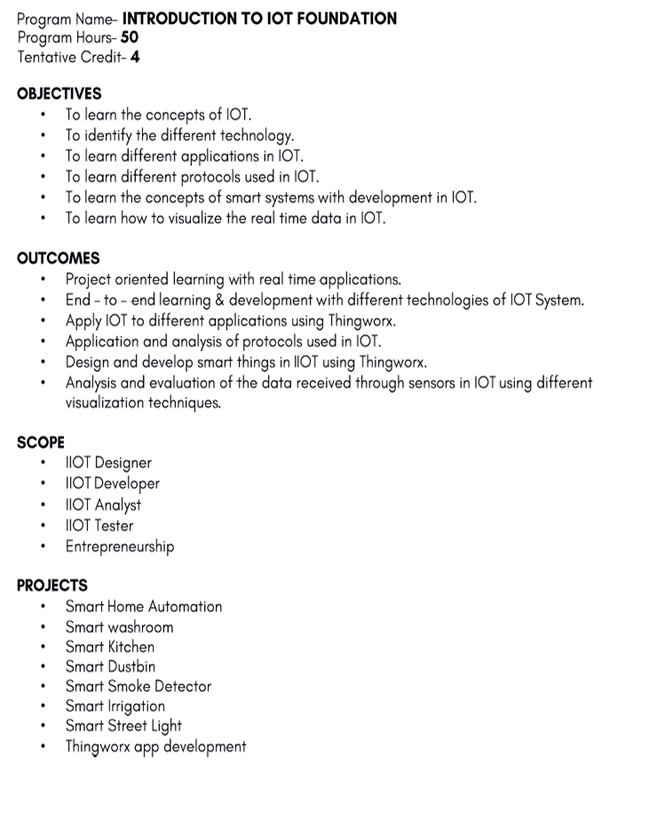

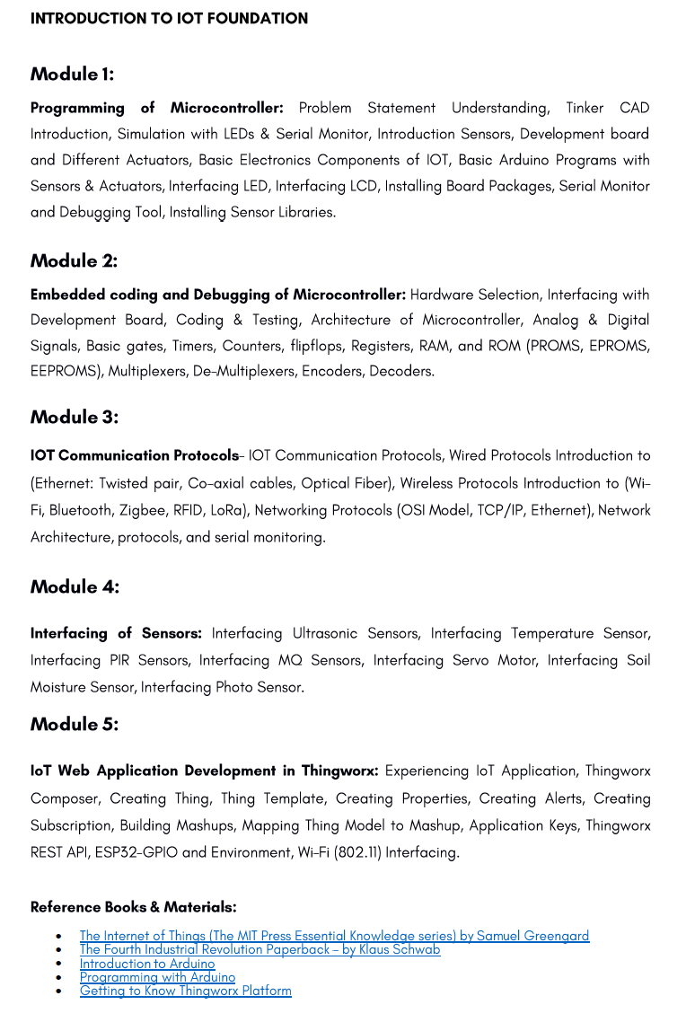

|  |  |
| --- | --- |
| **MCA208: Advanced Operating Systems** | |
| **Teaching Scheme** | **Examination Scheme** |
| Lectures: 3 hrs/Week | Class Test -12Marks |
| Tutorials: 1 hr/Week | Teachers Assessment - 6Marks  Attendance – 12 Marks |
| Credits: 4 | End Semester Exam – 70 marks |

**Prerequisite**: - Basic Computer Concepts

**Course Objectives:**

1. Understand the services of an operating system provides to its users and system itself.
2. Apply various CPU scheduling algorithms and recognize the classic synchronization problems
3. Compare methods for handling deadlocks and apply various memory management techniques.
4. Describe file systems.
5. To understand the disk scheduling.
6. Security issues in system

**Detailed syllabus:**

|  |  |
| --- | --- |
| **UNIT I**  **Introduction:** Definition of operating systems, Computer System architecture: single Processor, Multi-Processor, Clustered Systems. Operating system structure, Dual Mode Operating system Operations, Distributed System, Operating system services, System calls, system programs, Design Goals, Layered Approach. |  |
| **UNIT II**  **Process Management:** Process concept, Process scheduling, Cooperating processes, Threads, Inter-process communication, CPU Scheduling: Scheduling Queues, Schedulers, Context Switch, CPU scheduling criteria, Scheduling algorithms, Multiple-processor scheduling. |
| **UNIT III**  **Process Synchronization and Deadlocks:** The Critical-Section problem, Peterson’s solution, Semaphores, Classical problems of synchronization, Critical regions, Deadlocks-System model, Characterization: Necessary Conditions, Resource allocation Graph. Deadlock prevention, Avoidance and Detection, Recovery from deadlock. |
| **UNIT IV**  **Storage management:** Memory Management-Basic Hardware, Logical and Physical Address Space, Swapping, Fragmentation, Non Contiguous Memory allocation, Contiguous Memory allocation, Paging: Basic concept, allocation algorithm, Relocation, Protection. Segmentation: Basic concept, allocation algorithm, Relocation, Protection. Segmentation with paging, Virtual Memory, Demand paging, Page replacement algorithms, Allocation of frames, Thrashing: Cause of Thrashing, Working set Model. |
| **UNIT V**  **File concept, access methods, and Directory implementation:** Linear List, Hash Table. Disk structure, Disk scheduling methods, Disk management: Disk Formatting, Boot Block, Bad Block. Interrupt, Direct Memory Access. |
| **UNIT VI**  **Security & Case Study:** Protection and Security-Goals of protection, Domain of protection, Access matrix, Implementation of access Matrix, The Security problem, Authentication, One Time passwords, Program threats, System threats, Threat Monitoring, Encryption. |

|  |
| --- |
| **Text and Reference Books**   1. “Operating system concepts”, Galvin, TMH, IV, 2006 2. “Operating system concepts & Design”, Milankovic, AddisionWesely, 2010. 3. “Operating System”, Madnic,TMH, 1997 4. “Operating System”, A.s. Godbole, TMH, 2001.   5. “Operating System”, W.Stallings, Printice Hall, VI, 2007 |

**\**

**Course Outcomes:**

After completing the course, students will be able to:

|  |
| --- |
| 1. Experiment with various CPU scheduling algorithms with the understanding of operating system concepts |
| 2. Explain the need for process coordination |
| 3. Apply the various memory management strategies |
| 4. Illustrate the various file management strategies |
| 5. Explain about disk management |

|  |  |
| --- | --- |
| **MCA209: Advanced Software Engineering** | |
| **Teaching Scheme** | **Examination Scheme** |
| Lectures: 3 hrs/Week | Class Test -12Marks |
| Tutorials: 1 hr/Week | Teachers Assessment - 6Marks  Attendance – 12 Marks |
| Credits: 4 | End Semester Exam – 70 marks |

**Prerequisite: -**

1. Familiarity with the fundamentals of system analysis and design
2. Basic terminologies used in software development.

**Course Objectives:**

1. It aims to develop a broad understanding of the discipline of software engineering.
2. It seeks to complement this with a detailed knowledge of techniques for the analysis and design of complex software intensive systems.
3. It aims to set these techniques in an appropriate engineering and management context.

**Detailed Syllabus**

|  |
| --- |
| **UNIT I (10 Hours)**  **Introduction to Software and Software Engineering:** Software Characteristics and Applications, Software Engineering a Layered Technology, Software Process. |
| **UNIT II (10 Hours)**  **Software Life Cycle Models:** Classical Waterfall Model, Iterative Waterfall Model, Prototyping Model, Evolutionary Model, RAD Model , Spiral Model, Agile Software Development Model, Comparison of different Life Cycle Models. |
| **UNIT III (10 Hours)**  **Software Project Management:** Project Planning, Project size estimation-LOC and FP Metric, Project Estimation Technique-COCOMO Model, Project Scheduling-WBS, Gantt chart, PERT Chart, Activity Network and Critical Path Method, Risk Management, Software Configuration Management. |
| **UNIT IV (10 Hours)**  **Requirement Engineering:** Requirement Gathering, Requirement Analysis-ERD, DFD, Data Dictionary, Decision Tree, Decision Table, SRS Document, Characteristics of good SRS Document, SRS Verification and Validation. |
| **UNIT V (6 Hours)**  **Software Design:** Characteristics of good Software Design, Cohesion and Coupling. Function Oriented Design: Structured Analysis. Object Oriented Design: OOPS Concepts, UML and USE Case Model. |
| **UNIT VI (10 Hours)**  **Testing and Implementation:** What is Testing and Debugging, Design of Test Cases, Unit Testing, Integration Testing, White Box and Black Box Testing, System Testing, McCabe’s Cyclomatic Complexity, System Testing. Software Reliability Models, SQA, SEI/CMM, CASE. Software Maintenance Models. |
| **Text and Reference Books**   1. Software Engineering, Roger S Pressman, Tata McGraw Hill, 6th Edition 2005 2. Fundamentals of Software Engineering, Rajib Mall, PHI, 3rd Edition 1997 3. Software Engineering, I. Sommerville, Pearson Education, 8th Edition 2007 4. Software Engineering Concepts, R Fairley, Tata McGraw Hill, 4th Edition 1997 |

**Course Outcomes:**

|  |
| --- |
| 1. Be employed in industry, government, or entrepreneurial endeavors to demonstrate professional  advancement through significant technical achievements and expanded leadership responsibility. |
| 2. Demonstrate the ability to work effectively as a team member and/or leader in an ever-changing  professional environment. |
| 3. An ability to identify, formulate, and solve complex engineering problems by applying principles of  engineering, science, and mathematics |
| 4 an ability to apply engineering design to produce solutions that meet specified needs with consideration of public health, safety, and welfare, as well as global, cultural, social, environmental, and economic  factors |
| 5. an ability to function effectively on a team whose members together provide leadership, create a  collaborative and inclusive environment, establish goals, plan tasks, and meet objectives |
| 6. an ability to develop and conduct appropriate experimentation, analyze and interpret data, and use  engineering judgment to draw conclusions. |

|  |  |
| --- | --- |
| **MCA210: Web Technology** | |
| **Teaching Scheme** | **Examination Scheme** |
| Lectures: 3 hrs/Week | Class Test -12Marks |
| Tutorials: 1 hr/Week | Teachers Assessment - 6Marks  Attendance – 12 Marks |
| Credits: 4 | End Semester Exam – 70 marks |

**Course Objectives:**

The course content enables students to:

1. Understand best technologies for solving web client/server problems

2. Analyze and design real time web applications

3. Use Java script for dynamic effects and to validate form input entry

4. Analyze to Use appropriate client-side or Server-side applications

**Detailed Syllabus**

|  |
| --- |
| **UNIT I (6 Hours)**  Introduction: Introduction to web, protocols governing the web, web development strategies, Web applications, web project, web team. |
| **UNIT II (10 Hours)**  Web Page Designing using HTML: Structure of HTML page, link, list, table, images, frames, forms, CSS; DHTML |
| **UNIT III (10 Hours)**  XML: DTD, XML schemes, presenting and using XML |
| **UNIT IV (10 Hours)**  Java script: Introduction, documents, forms, statements, functions, objects; event and event handling; introduction to AJAX, VB Script |
| **UNIT V (10 Hours)**  Server Side Programming: Introduction to active server pages (ASP), ASP.NET, java server pages (JSP), JSP application design, tomcat server, JSP objects, declaring variables, and methods, debugging, sharing data between JSP pages, Session, Application: data base action , development of java beans in JSP, introduction to COM/DCOM. |
| **UNIT VI (10 Hours)**  PHP (Hypertext Preprocessor): Introduction, syntax, variables, strings, operators, if-else, loop, switch, array, function, form, mail, file upload, session, error, exception, filter, PHP-ODBC.  Web Page Designing using HTML: Structure of HTML page, link, list, table, images, frames, forms, CSS; DHTML |

|  |
| --- |
| **Text and Reference Books**  1.Heywood J.B., ―Internal combustion Engine Fundamentals‖, McGraw Hill, 1988  2.ObertE.F.,―InternalcombustionEngineandAirPollution‖,IntextEducationalPub,1974  3.Ganesan V.,―Internal combustion Engines‖, 6 th Ed.Tata Mc Graw Hill Publishing Co. Domkundwar V.M. ―Internal CombustionEngines‖-  4.Mathur M.C.,Sharma R.D.,―Internal combustion engines‖,8th Ed.; Dhanpat Rai publication.,2003 PulkrabekW, ―Engineering Fundamentals Of Internal Combustion Engine‖, Prentice Hall, 1997 |

**Course Outcomes:**

|  |
| --- |
| 1. Choose, understand, and analyze any suitable real time web application. |
| 1. Integrate java and server side scripting languages to develop web applications. |
| 1. To develop and deploy real time web applications in web servers and in the cloud. |
| 1. Extend this knowledge to .Net platforms. |

| **MCA211: Machine Learning with Python** | |
| --- | --- |
| **Teaching Scheme** | **Examination Scheme** |
| Lectures: 3 hrs/Week | Class Test -12Marks |
| Tutorials: 1 hr/Week | Teachers Assessment - 6 Marks  Attendance – 12 Marks |
| Credits: 4 | End Semester Exam – 70 marks |

**Prerequisite: -**

1. Familiarity with the C and C++ programming language.

# Course Objectives:

1. To acquire programming skills in core Python.
2. To acquire Object Oriented Skills in Python
3. To develop the skill of designing Graphical user Interfaces in Python
4. To develop the ability to write database applications in Python
5. To introduce students to the basic concepts and techniques of Machine Learning.
6. To become familiar with regression methods, classification methods, clustering methods

# Detailed Syllabus

| **UNIT I (8 Hours)**  **Introduction to Python**: Importance of Python, Installing and working with Python in Windows, Linux and Mac, Using Python as calculator, Comments, How to define main function in Python  The concept of data types - Variables, Arithmetic Operators and Expressions. |
| --- |
| **UNIT II (8 Hours)**  **String manipulations** - Subscript Operator, Indexing, Slicing a string, Converting strings to numbers and vice versa, split function, Control flow - if statements, for and while loops, nested loops, Short-circuit (lazy evaluation), range() function, break and continue statements, pass statements. |
| **UNIT III (10 Hours)**  **Data Structures**: Lists - Basic list operations, Replacing, inserting, removing an element; Searching and sorting a list, Methods of list objects, Using lists as Stacks and Queues, How efficient lists are when used as stack or queue, List and nested list Comprehensions Tuple, Sets, Difference between list and tuple, Dictionary - adding and removing keys, accessing and replacing values, traversing dictionaries. |
| **UNIT IV (10 Hours)**  **Python functions and modules** - **OS** and **SYS** modules, Defining python functions, calling a function, function arguments, Lambda and map function, Importing python module, **Useful Python Packages**– Beautiful soup, NumPy, iPython, tkinter, **Classes and OOP** - Class definition syntax, objects, class and instance variables, Inheritance and multiple inheritance, Polymorphism, Overloading, Overriding, Data Hiding. |
| **UNIT V (10 Hours)**  Overview of machine learning, related areas, applications, software tools. Supervised Learning: classification and regression. Unsupervised Learning. Reinforcement Learning. Parametric regression: linear regression, polynomial regression, logistic regression, locally weighted regression, numerical optimization, gradient descent, kernel methods. |
| **UNIT VI (10 Hours)**  DECISION TREE LEARNING - Decision tree learning algorithm- Inductive bias- Issues in Decision tree learning; Evaluating Hypotheses: Estimating Hypotheses Accuracy, Basics of sampling Theory, Comparing Learning Algorithms; Bayesian Learning: Bayes theorem, Concept learning, Bayes Optimal Classifier, Naïve Bayes classifier, Bayesian belief networks, EM algorithm; |

# 

|  |
| --- |
| **Text and Reference Books**   1. Python Programming for the Absolute Beginner By Laila M. Dawson 2. Learn Python the Hard Way By Zed A.Shaw Learning Python By Mark PutzPython Documentation ([https://docs.python.org](https://docs.python.org/) 3. Tom M. Mitchell, ―Machine Learning, McGraw-Hill Education (India) Private Limited, 2013. 4. EthemAlpaydin, ―Introduction to Machine Learning (Adaptive Computation and Machine Learning), The MIT Press 2004. 5. Stephen Marsland, ―Machine Learning: An Algorithmic Perspective, CRC Press, 2009. 6. Bishop, C., Pattern Recognition and Machine Learning. Berlin: Springer-Verlag. |

# Course Outcomes:

After completing the course, students will be able to:

| 1. Explain basic principles of Python programming language |
| --- |
| 1. Implement object-oriented concepts |
| 1. Implement database and GUI applications. |
| 1. Gain knowledge about basic concepts of Machine Learning. |
| 1. Identify machine learning techniques suitable for a given problem |
| 1. Solve the problems using various machine learning techniques |

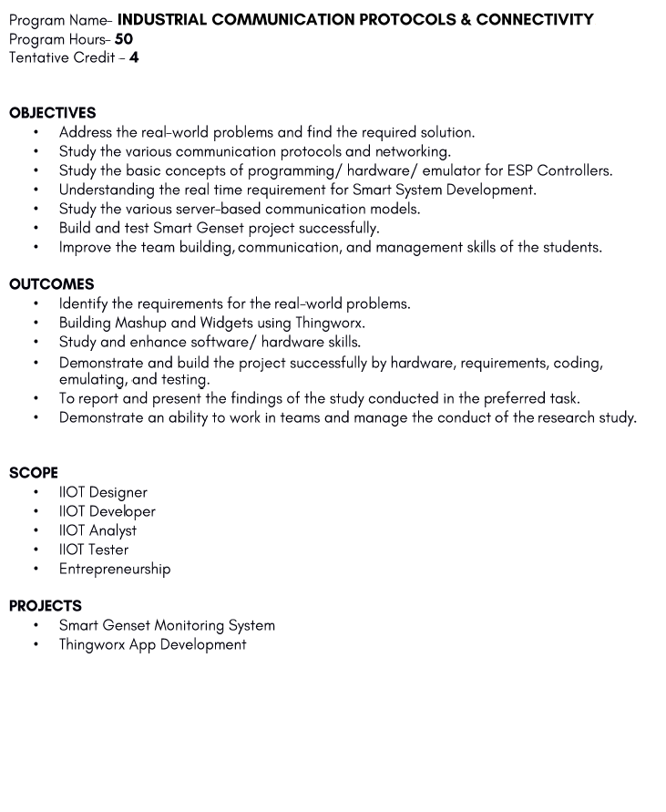

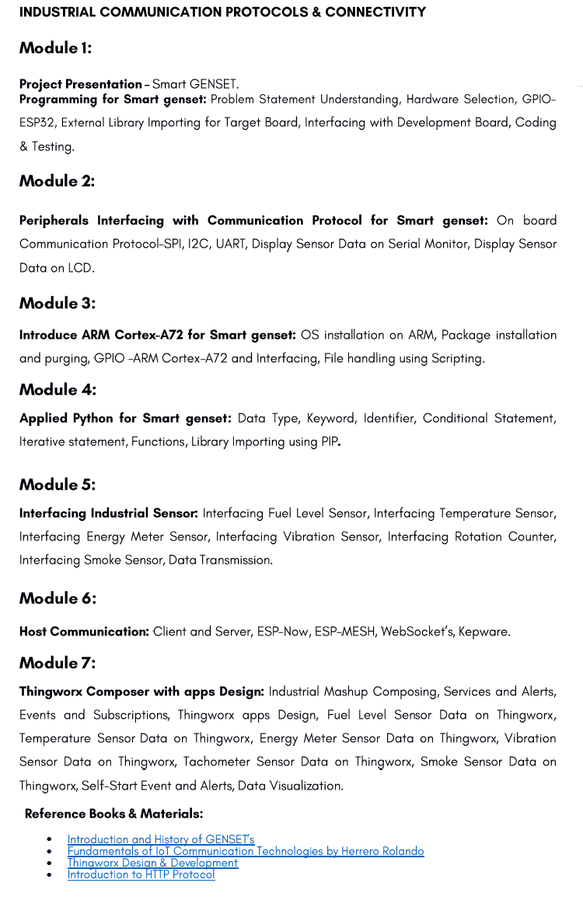

|  |  |
| --- | --- |
| **MCA308: Cryptography and Cyber Security** | |
| **Teaching Scheme** | **Examination Scheme** |
| Lectures: 3 hrs/Week | Class Test -12Marks |
| Tutorials: 1 hr/Week | Teachers Assessment - 6Marks  Attendance – 12 Marks |
| Credits: 4 | End Semester Exam – 70 marks |

**Prerequisite:**

Computer Concepts and C programming

Data Communication & Computer Network

# Course Objectives:

1. To define cryptography, its use, areas where cryptography is needed.
2. To understand security concepts, ethics in Network Security, security threats, and the security services and mathematical foundation required for various cryptographic algorithms.
3. To develop code to implement a cryptographic algorithm or write an analysis report on any existing security product.
4. To analyze all key less and keyed algorithms to identify their strength and weaknesses and try to solve and remove the limitations or optimize the complexity of algorithm(s).
5. To test different available algorithms in terms of complexity, response time, key size, data size, security assurance, etc.
6. To design an algorithmic solution of a problem either by applying existing algorithms or a new one. Identify and classify computer and security threats and develop a security model to prevent, detect and recover from attacks.

# Detailed Syllabus

|  |
| --- |
| **UNIT I**  Introduction to Cryptography and Network Security: Security Goals, Attacks, Services and Mechanisms, Techniques, Traditional Symmetric Key Cipher. |
| **UNIT II**  Modern Symmetric Key Ciphers: Fiestal Cipher, S-DES, DES, Double DES, Triple DES, AES, Block Cipher. Modes of Operation : ECB, CBC, CFB, OFB and CTR, KDC. |
| **UNIT III (10 Hours)**  Introduction to Mathematics for Cryptography: Modular Arithmetic, The Euclidian Algorithm, Extended Euclid, Farmet’s and Euler’s Theorem, Chinese Remainder Theorem. |
| **UNIT IV (10 Hours)**  Asymmetric Key Cryptography: RSA Algorithm, ECC, Key Management- Public Key Distribution, Sharing of secret key using A-symmetric Key Cryptosystem. |
| **UNIT V (10 Hours)**  Message Authentication: MAC, SHA-512 and MD5. Digital Signature: DSS Key Management: Symmetric Key Distribution, Kerberos. |
| **UNIT VI (10 Hours)**  Network Security: IPSec, SSL and TSL, PGP AND S/MIME, SET, System Security: Malicious Software, Firewalls and Intruders. |
| **Text and Reference Books**  1.Cryptography and Network Security, Behrouz A Frouzan, TMH, 1st Edition 2007.  2. Cryptography and Network Security, William Stalling, Pearson Education, 4th Edition, 2006.  3. Applied Cryptography, Bruce Schinner, Willy and Sons, 2nd Edition 1996. |

# Course Outcomes:

After completing the course, students will be able to:

|  |
| --- |
| 1. Identify some of the factors driving the need for network security. |
| 1. Identify and classify particular examples of attacks. |
| 1. Define the terms vulnerability, threat and attack. |
| 1. Identify physical points of vulnerability in simple networks. |
| 1. Compare and contrast symmetric and asymmetric encryption systems and their vulnerability to attack, and explain the characteristics of hybrid systems. |

|  |  |
| --- | --- |
| **MCA321:Advanced Java** | |
| **Teaching Scheme** | **Examination Scheme** |
| Lectures: 3 hrs/Week | Class Test – 12 Marks |
| Tutorials: 1 hr/Week | Teachers Assessment – 6 Marks  Attendance – 12 Marks |
| Credits: 4 | End Semester Exam – 70 Marks |

**Prerequisite:** C Programming, and OOPs Concepts.

**Course Objectives:**

1. To understand the basic concepts of Java, Importance of Classes & objects along with Method overloading and overriding.

2. To understand the conditional construction, arrays as well as Packages.

3. To learn the Exception Handling and I/o file handling with buffer reader and scanner class.

4. To understand importance of Multi-threading and AWT that respond to different user events.

5. To learn experience of Java swing and JDBC.

6. To understand Java beans and Java servlets for web development.

**Detailed Syllabus:**

|  |
| --- |
| **Unit-1**  **Introduction of Java**: Features of Java Language, Platform Independency, JVM, Byte-code, Operator, Data type, Variables, Robustness.  **OOPS:** Object, Class, Classifications, Methods & classes, Inheritance, Static and non Static methods, Call by Value, Call by Reference, Method Overloading, Method Overriding, Abstraction, Interface, Polymorphism, Inner Class & Anonymous Classes, Abstract Class. |
| **Unit-2**  **Conditional Construct in Java:** if, if else, nested if else, if else ladder, Ternary Operator, Switch.  **Array:** Introduction of arrays, Understanding and working with single, double dimensional arrays, Initialization of array, Linear and Binary Search.  **Packages and Exception Handling:** Data Encapsulation, Concept of Package, creating package, Importing packages, Child Packages. |
| **Unit-3**  **Exception Handling:** Exceptions & Errors, Types of Exception, Control Flow in Exceptions, Use of try, catch, finally, throw, throws in Exception Handling. Checked and Un-Checked Exceptions.  **I/O and File Handling:** Buffered Reader class, InputStreamReader class, Scanner class, Creating File, Reading File and Writing File |
| **Unit-4**  **Multi-Threading:** Understanding Threads, Needs of Multi-Threaded Programming, Solution of Producer consumer problem by Multi Thread, Thread Life-Cycle, Thread Priorities, Synchronization of Thread.  **AWT:** Introduction to AWT, AWT controls, Layout managers, Menus, Images. |
| **Unit-5**  **Java Swing:** Creating a Swing Applet and Application, Programming using Panes, Labels, Text fields, Buttons, Toggle buttons, Checkboxes, Radio Buttons, Scroll Panes, Scroll Bars, Lists, Combo box, Progress Bar, Menus and Toolbars, Layered Panes, Tabbed Panes, Split Panes, Layouts, Windows, Dialog Boxes.  **JDBC:** The connectivity Model, JDBC/ODBC Bridge, java.sql package, connectivity to remote database, navigating through multiple rows retrieved from a database. |

|  |
| --- |
| **Unit-6**  **Java Beans:** Application Builder tools, The bean developer kit (BDK), Developing a simple bean, The Java Beans API.  **Java Servlets:** Servlet basics, Servlet API basic, Life cycle of a Servlet, Running Servlet, Debugging Servlets, Thread-safe Servlets, HTTP Redirects, Cookies, Introduction to Java Server pages (JSP). |
| **Suggested Readings:**   1. The Complete Reference: Java, Herbert Schieldt, TMH, 7th Edition 2006 2. Programming in JAVA, E. Balagurusamy, TMH, 2nd Edition 2007 3. Object Oriented Modeling and Design, James Rumbaugh et al, PHI, 4th Edition 2003   Object Oriented Analysis & Design with Application, Booch Grady, Pearson Education, New Delhi, 3rd Edition, 2006. |

**Course Outcomes:**

After completing the course, students will be able to:

|  |
| --- |
| 1. Implement Object Oriented programming concept using basic syntaxes of controls Structures, strings and function for developing skills of logic building activity.  2. Demonstrates how to achieve reusability using inheritance, interfaces and packages and describes faster application development can be achieved.  3. Demonstrate understanding and use of different exception handling mechanisms and concept of multithreading for robust faster and efficient application development.  4. Demonstrate understanding and use of multi threading and AWT.  5. Identify, Design & develop complex Graphical user interfaces using Java Swing classes.  6. Demonstrates how to implement Java Beans and Java Servelets. |

|  |  |
| --- | --- |
| **MCA309: Artificial Neural Networks** | |
| **Teaching Scheme** | **Examination Scheme** |
| Lectures: 3 hrs/Week | Class Test -12Marks |
| Tutorials: 1 hr/Week | Teachers Assessment - 6Marks  Attendance – 12 Marks |
| Credits: 4 | End Semester Exam – 70 marks |

**Prerequisite**: - Machine Learning

# Course Objectives:

# Develop the skills to gain a basic understanding of neural network theory and fuzzy logic theory.

# Introduce students to artificial neural networks and fuzzy theory from an engineering perspective

# To give design methodologies for artificial neural networks

# To provide knowledge for network tunning and overfitting avoidance

# To offer neural network implementations.

# To demonstrate neural network applications on real-world tasks

# Detailed Syllabus

|  |
| --- |
| **Unit-1**  Overview of biological neurons: Structure of biological neurons relevant to ANNs. Fundamental concepts of Artificial Neural Networks: Models of ANNs; Feed-forward & feedback networks; learning rules; Hebbian learning rule, perception learning rule, delta learning rule, Widrow-Hoff learning rule, correction learning rule, Winner –lake all learning rule, etc. |
| **Unit-2**  Single layer Perception Classifier: Classification model, Features & Decision regions; training & classification using discrete perceptron algorithm, single layer continuous perceptron networks for linearly separable classifications. |
| **Unit-3**  Multi-layer Feed forward Networks: linearly non-separable pattern classification, Delta learning rule for multi-perceptron layer, generalized delta learning rule, Error back-propagation training, learning factors, Examples. Single layer feedback Networks: Basic Concepts, Hopfield networks, Training & Examples. |
| **Unit-4**  Associative memories: Linear Association, Basic Concepts of recurrent Auto associative memory: retrieval algorithm, storage algorithm; Bi-directional associative memory, Architecture, Association encoding & decoding, Stability. |
| **Unit-5**  Fuzzy Logic and Genetic Algorithms: Fuzzy set theory, Crisp set, Crisp relations, Fuzzy relations, Fuzzy systems – crisp logic, Predicate logic, Fuzzy logic, Rule based system, Defuzzification methods. Genetic Algorithms- Basic concept, working principle, flow chart of genetic algorithms. |
| **Unit-6**  Applications of Neural Network: Approach to solve hard problems- Travelling Salesman problem, Time Series prediction, Speech Recognition, Autonomous Vehicle Navigation, Handwritten Digit Recognition, Image compression, Visual processing networks. |

|  |
| --- |
| **Text and Reference Books**   1. “Introduction to artificial neural systems”, Jacek M. Zurada, 1994, Jaico Publ. House. 2. “Neural Networks- A comprehensive foundation”, Simon Haykin, Pearson Education Asia, II edition, 2002 3. “Neural Networks”, Kosko, 1992, PHI. 4. “Neural Network fundamentals with Graph Algorithms & Applications”, P. Liang and N.K. Bose, TMH, 2003. 5. “Neural Networks, Fuzzy Logic and Genetic Algorithms”, S. Rajasekaran and G. A. V. Pai, PHI, 2003. |

# Course Outcomes:

After completing the course, students will be able to:

|  |
| --- |
| 1. Comprehend the fuzzy logic and the concept of fuzziness involved in various systems and fuzzy set theory. 2. Understand the concepts of fuzzy sets, knowledge representation using fuzzy rules, approximate reasoning, fuzzy inference systems, and fuzzy logic 3. To understand the fundamental theory and concepts of neural networks, Identify different neural network architectures, algorithms, applications and their limitations 4. Understand appropriate learning rules for each of the architectures and learn several neural network paradigms and its applications 5. Reveal different applications of these models to solve engineering and other problems. |

|  |  |
| --- | --- |
| **MCA310: Android Programming** | |
| **Teaching Scheme** | **Examination Scheme** |
| Lectures: 3 hrs/Week | Unit Test -12Marks |
| Tutorials: 1 hr/Week | Teachers Assessment - 6Marks  Attendance – 12 Marks |
| Credits: 4 | End Semester Exam – 70 marks |

**Prerequisite: -** Basics of Java language and PL/SQL

# Course Objectives:

# To gain knowledge of installing Android Studio

# To learn designing of User Interface and Layouts for Android App.

# To learn how to use intents to broadcast data within and between Applications.

# To use Content providers

# To introduce Android APIs

# To design basic applications

# Detailed Syllabus

|  |
| --- |
| **UNIT I**  **JAVA Concepts (10 hrs):** Platform Independency, OOPs Concepts, Inheritance in detail, Exception handling, Packages & interfaces, JVM & .jar file extension, Multi threading (Thread class & Runnable Interface).**SQL:**  DML & DDL Queries in brief. |
| **UNIT II**  **Introduction to Android:** Introduction of Android, Setting up development environment, Installing the SDK, Creating Android Emulator, Android development Tool. **Fundamentals:** Basic Building blocks - Activities, Services, Broadcast Receivers & Content provider, UI Components - Views & notifications, Components for communication -Intents & Intent Filters, Android API levels (versions & version names) |
| **UNIT III**  **Application Structure:** AndroidManifest.xml, uses-permission & uses-sdk, Resources & R.java, Assets, Layouts & Draw-able Resources, Activities and Activity lifecycle, First sample Application. |
| **UNIT IV**  **Emulator-Android Virtual Device:** Launching emulator**,** Editing emulator settings**,** Emulator shortcuts**,** Logcat usage**,** Introduction to DDMS. **Second App: (**switching between activities), Develop an app for demonstrating the communication between Intents. |
| **UNIT V**  **Basic UI design:** Form widgets**,** Text Fields**,** Layouts**,** [dip, dp, sip, sp] versus px**,** Examples  **Preferences:** Shared Preferences**,** Preferences from xml**,** Examples. |
| **UNIT VI**  **Menu:** Option menu**,** Context menu**,** Sub menu**, M**enu from xml**, M**enu via code**,** Examples  **UI design:** Time and Date**,** Images and media**,** Composite**,** Alert Dialogs & Toast**,** Popup**,** Examples |
| **Text and Reference Books** Android Application Development (With Kitkat Support), Black Book, by Kogent Learning Solutions Inc. by Pradeep KothariAndroid Application Development Cookbook: 93 Recipes for Building Winning Apps (WROX), by Wei-Meng Lee  1. Professional Android 4 Application Development, by Reto Meier 2. Beginning Android 4 Application Development, Wei-Meng Lee 3. Android Application Development, by Lombardo John and Blake Meike |

# Course Outcomes:

After completing the course, students will be able to:

|  |
| --- |
| 1. Understand basic knowledge of Java fundamental concepts and PL/SQL |
| 2. Design and Implement User Interfaces and Layouts of Android App. |
| 3. Use Intents for activity and broadcasting data in Android App. |
| 4. Design and Implement Content Providers. |
| 5. Evaluate performance of Application in terms of activity switching |
| 6. Design menu driven applications |

|  |  |
| --- | --- |
| **MCA311: PHP** | |
| **Teaching Scheme** | **Examination Scheme** |
| Lectures: 3 hrs/Week | Class Test -12Marks |
| Tutorials: 1 hr/Week | Teachers Assessment - 6Marks  Attendance – 12 Marks |
| Credits: 4 | End Semester Exam – 70 marks |

# Course Objectives:

1. To give knowledge about server site programming.
2. To introduce latest web development language.
3. To give knowledge about MySQL database management.
4. To explore the skills of programming in the file of online web project.

# Detailed Syllabus

|  |
| --- |
| **Unit-1**  Introduction to PHP:- Evaluation of Php, Basic Syntax, Defining variable and constant, Php Data type , Operator and Expression, Making Decisions, Doing Repetitive task with looping, Mixing Decisions and looping with Html. |
| **Unit-2**  Function:- What is a function, Define a function, Call by value and Call by reference, Recursive function, PHP GET and POST, Built-in Functions, User-Defined Functions, Functions with Parameters, Values and arguments in Function.. |
| **Unit-3**  String and Array:-String - Creating and accessing String, Searching & Replacing String, Formatting String, String Related Library function , Array- Anatomy of an Array, Creating index based and Associative array, Accessing array Element, Looping with Index based array, Looping with associative array using each() and foreach(), Some useful Library function |
| **Unit-4**  Introduction to OOPS- Introduction, Objects, Declaring a class, The new keyword and constructor, Destructor, Access method and properties using $this variable, Public, private, protected properties and methods, Static properties and method, Class constant, Inheritance & code reusability, Polymorphism, Parent:: & self:: keyword, Instance of operator, Abstract method and class, Interface, Final |
| **Unit-5**  Exception Handling, file and Directories:-Understanding Exception and error, Try, catch, throw, Global Exception Handler, Defining Custom Exceptions, Understanding file& directory, Opening and closing a file, Coping, renaming and deleting a file, working with directories. |
| **Unit-6**  Database Connectivity with MySql:-Introduction to RDBMS,Connection with MySql Database, Performing basic database operation (DML) (Insert, Delete, Update, Select), Executing query. |
| **Text and Reference Books**   1. Lynn Beighley & Michael Morrison- Head First Php & MySQL. 2. Robin Nixon: Learning Php, MySQL, Java script and CSS: A step-by-step guide to creating dynamic websites. 3. Luke Welling & Laura Thompson: PHP & MYSQL web development |

# Course Outcomes:

After completing the course, students will be able to:

|  |
| --- |
| 1. Understand various types of website development using php and mysql. |
| 1. Analyze the latest language designing and optimize new technology. |
| 1. Identify difference between traditional web development and php web development. |
| 4. Understand level of web technology at corporate level. |
| 5. Learning professional framework of php and mysql for project development. |

|  |  |
| --- | --- |
| **MCA312 : Search Engine Optimization** | |
| **Teaching Scheme** | **Examination Scheme** |
| Lectures: 3 hrs/Week | Class Test -12Marks |
| Tutorials: 1 hr/Week | Teachers Assessment - 6Marks  Attendance – 12 Marks |
| Credits: 4 | End Semester Exam – 70 marks |

# Pre-requisites: Basic introduction about HTML and Internet.

# Course Objectives:

1. Define the Internet of Things.
2. To discussed keyword research, types of keyword Research, and their methodology.
3. Describe the essentials of good website designing and introduction of basic HTML tags.
4. Introduction to onsite optimization and their techniques.
5. Introduction to offsite optimization and their techniques.
6. Introduction to submission types and their significance.

# Detailed Syllabus

|  |
| --- |
| **Unit-1**  Internet and Search Engine Basics, Internet Marketing and its importance, Types of Internet Marketing Methods, Search Engines and its working, Importance of Search Engines, SEO is an Art or Science, Google Search Engine Architecture, Search Engine Algorithms, Google Algorithm Updates, Page Rank Technology, Panda Update and its Importance. |
| **Unit-2**  Introduction to Keyword Research, Business Analysis, Types of Keywords, Keyword Research Methodology, Keywords Analysis Tools, Competition Analysis, Preparing a Keyword List for Project, Localized Keywords Research |
| **Unit-3**  Basics of Website Designing / Development, Essentials of good website designing, HTML Basics for SEO, basic tag- Title, Meta, Header, Image, link, anchor etc.., Usability and User Experience in Website, Importance of Domain Names and Value, Domain Selection |
| **Unit-4**  Introduction to onsite Optimization Website Structure and Navigation Menu Optimization, Filename Optimization, Title Tag Optimization, Meta Tags Optimization, Headers Optimization, Anchor Links Optimization, Footer Optimization, Creating an HTML and XML sitemaps |
| **Unit-5**  Introduction to Offsite Optimization, Local marketing of websites depending on locations, Promoting Subsequent pages of the website, Black Hat / White Hat / Grey Hat SEO, Linking Building Methodology, Types of Linking Methods, Free Links / Paid Links |
| **Unit-6**  Submission-Directory, Blog, Press Release, Article, Video, Forums, Forum Signatures and Commenting, Social Bookmarking, Tracking the Links and Page Rank |
| **Text and Reference Books**   1. Eric Enge, Stephan Spencer, Rand Fishkin, Jessie C Stricchiola, “The Art of SEO : Mastering Search Engine Optimization”, O'Reilly Media, October, 2009 2. David Amerland, Google Semantic Search, Pearson 3. Jerri L. Ledford, “SEO: Search Engine Optimization Bible”, 2nd Edition, Wiley India, April, 2009 4. John I Jerkovic, “SEO Warrior: Essential Techniques for Increasing Web Visibility”, O'Reilly |

# Course Outcomes:

After completing the course, students will be able to:

|  |
| --- |
| 1. Understand to Search Engine and Search Engine Algorithms. |
| 1. To understand Keyword Research, Keyword Research Methodology and Keywords Analysis Tools. |
| 1. To understand the network protocol those are used for IoT Configuration. |
| 1. Students will understand onsite optimization and their techniques. |
| 1. Students will understand Offsite optimization and their techniques. |
| 1. Students will able to optimize web pages and to rank web pages. |

|  |  |
| --- | --- |
| **MCA314: Digital Marketing** | |
| **Teaching Scheme** | **Examination Scheme** |
| Lectures: 3 hrs/Week | Class Test – 12 Marks |
| Tutorials: 1 hr/Week | Teachers Assessment – 6 Marks  Attendance – 12 Marks |
| Credits: 4 | End Semester Exam – 70 Marks |

**Prerequisite:**

Knowledge of Social Media Platforms.

**Course Objectives:**

1. To understand the importance of Digital Marketing.

2. To study various types of Digital Marketing.

3. To know the significance of Digital and Internet Marketing.

4. To understand the recent trends in digital advertising and SEO.

5. To create a campaign on any social media platform.

**Detailed Syllabus:**

|  |
| --- |
| **Unit-1**  **Introduction to Digital Marketing**: Evolution of Digital Marketing from traditional to modern era, Role of Internet; Current trends, Info-graphics, implications for business & society; Emergence of digital marketing as a tool; Drivers of the new marketing environment; Digital marketing strategy; P.O.E.M. framework, Digital marketing plan, Digital marketing models. |
| **Unit-2**  **Internet Marketing and Digital Marketing Mix**: Internet Marketing, opportunities and challenges; Digital marketing framework; Digital Marketing mix. Introduction to Content Marketing, Email Marketing, Web analytics, Conversion Rate Optimization, Sales Funnels and Affiliate Marketing. |
| **Unit-3**  **Social Media Marketing**: Role of Influencer Marketing, Tools & Plan–Introduction to social media platforms, penetration &characteristics; Building a successful social media marketing strategy. Facebook Marketing, LinkedIn Marketing, Twitter Marketing, Instagram Marketing: Introduction and framing content strategy, Advertising. |
| **Unit-4**  **Mobile Marketing**: Mobile Advertising, Forms of Mobile Marketing, Features, Mobile Campaign Development, Mobile Advertising Analytics. |
| **Unit-5**  **Introduction to SEO and SEM**: Trends in Digital Advertising– - Introduction and need for SEO, How to use internet & search engines; search engine and its working pattern, On-page and off-page optimization, SEO Tactics, Introduction to SEM. |
| **Unit-6**  **Web Analytics**: Google Analytics & Google Ad Words; data collection for web analytics. Online Reputation Management.  **Application:** A group of two students (Maximum) has to work on creating an advertising campaign through any form of digital marketing viz: Mobile Marketing, Twitter Marketing, Facebook Marketing, LinkedIn Marketing, Instagram or Snapchat Marketing. The student/s should work on creating the campaign, running the campaign, presenting the results of the campaign in terms of Lead Generation and / or sales and / or web analytics. |

|  |
| --- |
| **Suggested Readings:**  1.Seema Gupta, Digital Marketing, Mc-Graw Hill, 1st Edition - 2017  2. Ian Dodson, The Art of Digital Marketing, Wiley Latest Edition  3.Puneet Singh Bhatia, Fundamentals of Digital Marketing, Pearson 1st Edition – 2017  4.Vandana Ahuja, Digital Marketing, Oxford University Press Latest Edition  5. Philip Kotler Marketing 4.0: – Moving from Traditional to Digital Wiley 2017 |

**Course Outcomes:**

After completing the course, students will be able to:

|  |
| --- |
| 1. Understand the concept of Digital Marketing 2. Develop insight on Current Trends – Digital and Social Statistics (Infographics) 3. Provide an introduction to Digital Marketing Platforms like Facebook, Twitter, YouTube, etc. 4. Understand the basics of Search Engine Optimization (SEO) and Mobile Marketing. 5. Know various strategies involved in Marketing products and Services Digitally. |

|  |  |
| --- | --- |
| **MCA315: Theory of Computation** | |
| **Teaching Scheme** | **Examination Scheme** |
| Lectures: 3 hrs/Week  Tutorials: 1 hr/Week | Class Test -12Marks |
|  | Teachers Assessment - 6Marks  Attendance – 12 Marks |
| Credits: 4 | End Semester Exam – 70 marks |

**Prerequisite:** Sets, Relations, Trees, Graphs, Boolean Algebra etc.

# Course Objectives:

1. Introduce concepts in automata theory and theory of computation.
2. Identify different formal language classes and their relationships.
3. Design grammars and recognizers for different formal languages.
4. Prove or disprove theorems in automata theory using its properties.
5. Determine the decidability and intractability of computational problems.

**Detailed Syllabus**

|  |
| --- |
| **UNIT I**  Mathematical preliminaries: sets, relations, functions, graphs, trees, string and their properties, principle of induction, proof by contradiction. |
| **UNIT II**  **Theory of automata:** Alphabets, Strings and Languages; Automata and Grammars, Deterministic finite Automata (DFA)-Formal Definition, Simplified notation: State transition graph, Transition table, Language of DFA, Nondeterministic finite Automata (NFA), NFA with epsilon transition, Language of NFA, Equivalence of NFA and DFA, Minimization of Finite Automata. |
| **UNIT III**  **Regular sets and regular grammars:** Regular expression (RE), Definition, Operators of regular expression and their precedence, Algebraic laws for Regular expressions, Kleen’s Theorem, Regular expression to FA, DFA to Regular expression, Arden Theorem, Non Regular Languages, Pumping Lemma for regular Languages. Application of Pumping Lemma, Closure properties of Regular Languages, Decision properties of Regular Languages, FA with output: Moore and Mealy machine, Equivalence of Moore and Mealy Machine, Applications and Limitation of FA. |
| **UNIT IV**  **Context free grammar (CFG) and Context Free Languages (CFL):** Definition, Examples, Derivation, Derivation trees, Ambiguity in Grammar, Inherent ambiguity, Ambiguous to Unambiguous CFG, Useless symbols, Simplification of CFGs, Normal forms for CFGs: CNF and GNF, Closure properties of CFLs, Decision Properties of CFLs: Emptiness, Finiteness and Membership, Pumping lemma for CFLs. |
| **UNIT V**  **Push down automata (PDA):** Description and definition, Instantaneous Description, Language of PDA, Acceptance by Final state, Acceptance by empty stack, Deterministic PDA, Equivalence of PDA and CFG, CFG to PDA and PDA to CFG. |
| **UNIT VI**  **Turing machines (TM):** Basic model, definition and representation, Instantaneous Description, Language acceptance by TM, Variants of Turing Machine, TM as Computer of Integer functions, Universal TM, Church’s Thesis, Recursive and recursively enumerable languages, Halting problem, Introduction to Un-decidability, Un-decidable problems about TMs. |

|  |
| --- |
| **Text and Reference Books:**   1. Hopcroft, Ullman, “Introduction to Automata Theory, Languages and Computation”, Pearson Education, 2010. 2. K.L.P. Mishra and N.Chandrasekaran, “Theory of Computer Science : Automata, Languages and Computation”, PHI,2007. |

# Course Outcomes:

After completing the course, students will be able to:

|  |
| --- |
| 1. Acquire a fundamental understanding of the core concepts in automata theory and formal languages. |
| 1. An ability to design grammars and automata (recognizers) for different language classes. |
| 1. An ability to identify formal language classes and prove language membership properties. |
| 1. An ability to prove and disprove theorems establishing key properties of formal languages and automata. |
| 1. Acquire a fundamental understanding of core concepts relating to the theory of computation and computational models including (but not limited to) decidability and intractability. |

|  |  |
| --- | --- |
| **MCA316: Distributed Database Management Systems** | |
| Teaching Scheme | Examination Scheme |
| Lectures: 3 hrs/Week | Class Test -12Marks |
| Tutorials: 1 hr/Week | Teachers Assessment - 6Marks  Attendance – 12 Marks |
| Credits: 4 | End Semester Exam – 70 marks |

**Prerequisite: -** Database management system

# Course Objectives:

The objectives of this course are

1. Enhanced the knowledge in the area of Distributed Database system.
2. Comprehend the Distributed query processing.
3. The subject explores the ideas of Transaction management and concurrency control.
4. Know the parallel database system architecture.
5. Become conscious about current trends.

**Detailed Syllabus:**

|  |
| --- |
| **UNIT I**  Introduction: Distributed Data processing, Distributed Database Systems (DDBMSs), Promises of DDBMSs, Complicating factors and Problem areas in DDBMSs, Overview Of Relational DBMS, Relational Database concepts, Normalization, Integrity rules, Relational Data Languages, Relational DBMS. |
| **UNIT II**  Distributed DBMS Architecture: DBMS Standardization, Architectural models for Distributed DBMS, Distributed DBMS Architecture. Distributed Database Design: Alternative design Strategies, Distribution design issues, Fragmentation, Allocation. Semantic Data Control: View Management, Data security, Semantic Integrity Control. |
| **UNIT III**  Overview of Query Processing: Query processing problem, Objectives of Query Processing, Complexity of Relational Algebra operations, characterization of Query processors, Layers of Query Processing. |
| **UNIT IV**  Introduction to Transaction Management: Definition of Transaction, Properties of transaction, types of transaction. Distributed Concurrency Control: Serializability theory, Taxonomy of concurrency control mechanisms, locking based concurrency control algorithms. |
| **UNIT V**  Parallel Database Systems: Database servers, Parallel architecture, Parallel DBMS techniques, Parallel execution problems, Parallel execution for hierarchical architecture. Database Interoperability: Database Integration, Query processing. |
| **UNIT VI**  Distributed Object Database Management systems: Fundamental Object concepts and Object models, Object distribution design. Architectural issues, Object management, Distributed object storage, Object query processing. Transaction management. |

|  |
| --- |
| **Text and Reference Books**  1. Principles of Distributed Database Systems, M.TamerOzsu, Patrick Valduriez, 2nd Edition, 1999.  2. Distributed Databases principles and systems, Stefano Ceri, Giuseppe Pelagatti, TMH, 2008. |

# Course Outcomes:

After completing the course, students will be able to:

|  |
| --- |
| 1. Aware of fundamentals of Distributed Database systems. |
| 2. Use the different techniques of Distributed query processing |
| 3. Set the rules over management of transaction and concurrency control. |
| 4. Familiar with parallel database system architecture. |
| 1. Apprehend Machine Learning Algorithms. |

|  |  |
| --- | --- |
| **MCA317: Advanced Data Mining Techniques** | |
| **Teaching Scheme** | **Examination Scheme** |
| Lectures: 3 hrs/Week | Class Test -12Marks |
| Tutorials: 1 hr/Week | Teachers Assessment - 6Marks  Attendance – 12 Marks |
| Credits: 4 | End Semester Exam – 70 marks |

**Prerequisite: -**

1. Familiarity with the data base management system
2. Knowledge of repository system.

# Course Objectives:

1. Be familiar with mathematical foundations of data mining tools.
2. Understand and implement classical models and algorithms in data warehouses and data mining
3. Characterize the kinds of patterns that can be discovered by association rule mining, classification and clustering.
4. To explain the stages and process different data mining techniques. E. To learn mining and warehouse techniques through the use of different tools (e.g. ORACLE)

**Detailed Syllabus**

|  |
| --- |
| **UNIT I (10 Hours)**  **Introduction:** Fundamentals of data mining, Data Mining Functionalities, Classification of Data Mining systems, Major issues in Data Mining. **Data Pre-processing:** Needs, Pre-processing the Data, Data Cleaning, Data Integration and Transformation, Data Reduction, Discretization and Concept Hierarchy Generation. |
| **UNIT II (10 Hours)**  **Introduction:** Data Warehouse and OLAP Technology for Data Mining, Data Warehouse Multidimensional Data Model, Data Warehouse Architecture, Data Warehouse Implementation, From Data Warehousing to Data Mining. Data Mining Primitives, Data Mining Query Languages. |
| **UNIT III (10 Hours)**  **Concepts Description:** Characterization and Comparison, Data Generalization and Summarization- Based Characterization. Analytical Characterization, Analysis of Attribute Relevance, Mining Class Comparisons: Discriminating between Different Classes, Mining Descriptive Statistical Measures in Large Databases. |
| **UNIT IV (10 Hours)**  **Mining Association Rules in Databases:** Association Rule Mining, Mining Single-Dimensional Boolean Association Rules from Transactional Databases, Mining Multilevel Association Rules from Transaction Databases, Mining Multidimensional Association Rules from Relational Databases and Data Warehouses, From Association Mining to Correlation Analysis. |
| **UNIT V (6 Hours)**  **Classification and Prediction:** Issues Regarding Classification and Prediction, Classification by Decision Tree Induction, Bayesian Classification, Classification by Back-propagation, Classification Based on Association Rule Mining, Other Classification Methods, Prediction, and Classifier Accuracy. |
| **UNIT VI (10 Hours)**  **Cluster Analysis Introduction:** Types of Data in Cluster Analysis, a Categorization of Major Clustering Methods, Partitioning Methods, Density-Based Methods, Outlier Analysis. **Mining Complex Types of Data:** Multidimensional Analysis and Descriptive Mining of Complex, Data Objects, Mining-Spatial Databases, Multimedia Databases, Time-Series and Sequence Data, Text Databases, World Wide Web. |

|  |
| --- |
| **Text and Reference Books**   1. Data Mining -Concepts and Techniques, Han, Kamber, Harcourt India, 2006. 2. Data Mining Introductory and advanced topics, Margaret H Dunham, Pearson, 2002. 3. Data Mining Techniques, Arjun K. Pujari, University Press, 2001. |

# Course Outcomes:

After completing the course, students will be able to:

|  |
| --- |
| 1. The candidate will get knowledge of - Data pre-processing and data quality.. |
| 2.Modeling and design of data warehouses |
| 3. Algorithms for data mining. |
| 4. Be able to design data warehouses. |
| 5. Ability to apply acquired knowledge for understanding data and select suitable methods for data analysis |

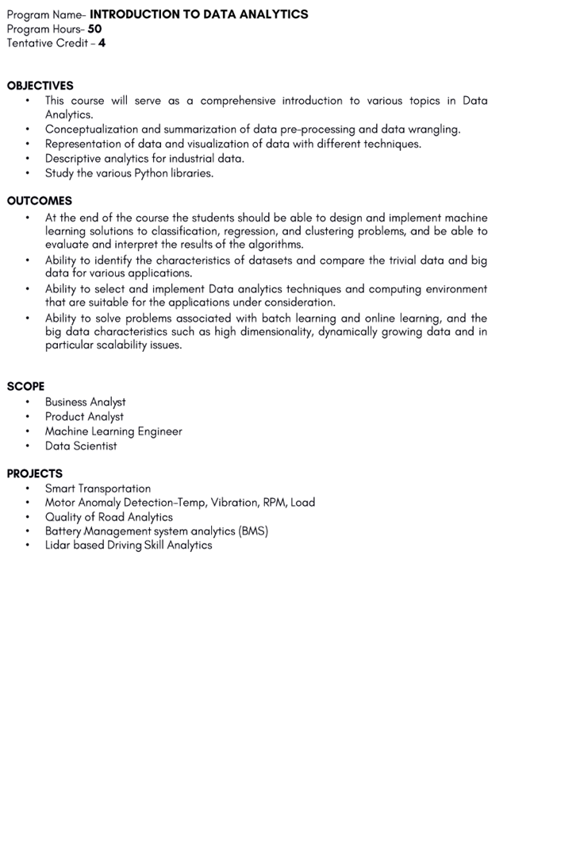

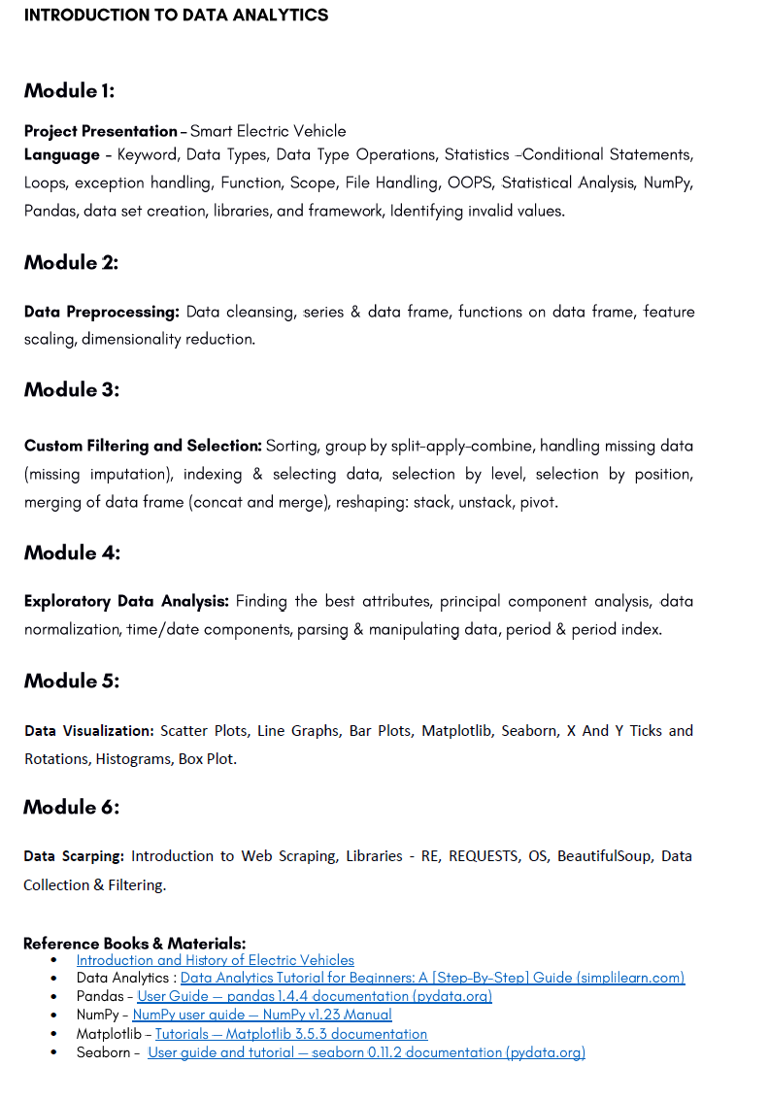

|  |  |
| --- | --- |
| **MCA405: Cloud Computing and Virtualization** | |
| **Teaching Scheme** | **Examination Scheme** |
| Lectures: 3 hrs/Week | Class Test -12Marks |
| Tutorials: 1 hr/Week | Teachers Assessment - 6Marks  Attendance – 12 Marks |
| Credits: 4 | End Semester Exam – 70 marks |

**Prerequisite: -** Operating Systems, Computer Networking.

# Course Objectives:

# To describe grid and cloud computing as an emerging technology.

# To understand the importance of grid and cloud computing along with various security issues.

# To identify the differences between various types of computing techniques, Cloud deployment models and service models.

# To understand the implementation of cloud security and mobile cloud computing concepts.

# To analyze various virtualization and scheduling techniques.

# To study the design approaches used by various cloud service providers.

# Detailed Syllabus

|  |
| --- |
| **Unit-1**  **Recent trends in computing**: Introduction to Grid Computing: Motivation, Definition of Grid Computing, Evolution of Grid, Examples and Usages, Research Possibilities, Benefits of Grid Computing. Cluster Computing, Grid Computing, Utility Computing, Cloud Computing. Introduction to Grid Computing |
| **Unit-2**  **Cloud Computing Fundamentals**: Cloud Computing definition, Types of cloud, Cloud services: Benefits and challenges of cloud computing, Evolution of Cloud Computing, Applications cloud computing, Business models around Cloud – Major Players in Cloud Computing - Issues in Cloud - Eucalyptus - Nimbus - Open Nebula, CloudSim. |
| **Unit-3**  **Cloud Computing Service Models:** Infrastructure as a Service; Platform as a Service; Software as a Service. **Accessing the Cloud:** Web Applications, Web API’s, and Web Browsers. |
| **Unit-4**  **Cloud Storage and Security:** Overview, Advantages, Storage as a Service, Security, Reliability, Advantages, Cautions, Theft, Cloud Storage Providers. **Standards:** Applications, Client, Infrastructure, Services. |
| **Unit-5**  **Virtualization Technologies:** Basics of Virtualization - Types of Virtualization - Implementation Levels of Virtualization - Virtualization Structures - Tools and Mechanisms - Virtualization of CPU, Memory, I/O Devices - Virtual Clusters and Resource management – Virtualization for Data-center Automation. Introduction to MapReduce, GFS, HDFS, Hadoop Framework. |
| **UNIT-6**  **Security in the Cloud:** Security Overview – Cloud Security Challenges and Risks – Software-as-a-Service Security – Security Monitoring – Security Architecture Design – Data Security – Application Security – Virtual Machine Security - Identity Management and Access Control – Autonomic Security. |

|  |
| --- |
| **Text and Reference Books**   1. The Grid- Blueprint for a New Computing Infrastructure, Ian Foster, Carl Kesselman, 2nd Edition, Morgan Kaufmann Publications,2003. 2. Grid Computing: Making the Global Infrastructure a Reality, Francine Berman, Geoffrey Fox, Tony Hey, John Wiley & Sons, 2003. 3. Cloud Computing: Principles and Paradigms, Rajkumar Buyya and James Broberg, John Wiley & Sons, 2011. 4. Cloud Computing, A Practical Approach, Anthony T Velte, Mc Graw Hill, 2010. |

# Course Outcomes:

Students will able to:

|  |
| --- |
| 1. Define Cloud Computing and memorize the different Cloud service and deployment models. |
| 2. Describe importance of virtualization along with their technologies. |
| 3. Use and Examine different cloud computing services. |
| 4. Analyze the components of open stack & Google Cloud platform and understand Mobile Cloud Computing. |
| 5. Describe the key components of Amazon web Service. |
| 6. Design & develop backup strategies for cloud data based on features. |

|  |  |
| --- | --- |
| **MCA406 : Internet of Things** | |
| **Teaching Scheme** | **Examination Scheme** |
| Lectures: 3 hrs/Week | Class Test -12Marks |
| Tutorials: 1 hr/Week | Teachers Assessment - 6Marks  Attendance – 12 Marks |
| Credits: 4 | End Semester Exam – 70 marks |

# Pre-requisites: Network Fundamental and Basic Introduction about Python.

# Course Objectives:

1. Define the Internet of Things.
2. To discussed different type of design of IoT.
3. Describe the important computer network and there uses.
4. Introduction to challenges in Design, Development and Security.
5. Introduction to nature wise requirement of different type IoT Application.
6. Introduction to development IoT application in Python.

# Detailed Syllabus

|  |
| --- |
| **Unit-1**  **Introduction to IoT-** Defining IoT, Characteristics of IoT, Physical design of IoT, Logical**,** design of IoT, Functional blocks of IoT, Communication models & APIs |
| **Unit-2**  **IoT & M2M-** Machine to Machine, Difference between IoT and M2M, Software, define Network |
| **Unit-3**  **Network & Communication aspects-** Wireless medium access issues, MAC protocol survey, Survey  routing protocols, Sensor deployment & Node discovery, Data aggregation & dissemination |
| **Unit-4**  **Challenges in IoT-** Design challenges, Development challenges, Security challenges,  Other challenges |
| **Unit-5**  **Domain specific applications of IoT-** Home automation, Industry applications, Surveillance applications, Other IoT applications |
| **Unit-6**  **Developing IoTs** - Introduction to Python, Introduction to different IoT tools, Developing applications through IoT tools, Developing sensor based application through embedded system platform, Implementing IoT concepts with python |
| **Text and Reference Books**  1. Vijay Madisetti, Arshdeep Bahga, “Internet of Things: A Hands-On Approach”  2. Waltenegus Dargie,Christian Poellabauer, "Fundamentals of Wireless Sensor Networks:  Theory and Practice |

# Course Outcomes:

|  |
| --- |
| 1. Understand to IoTs and their design concepts. |
| 2. To understand M2M and IoT and their differences. |
| 3. To understand the network protocol those are used for IoT Configuration. |
| 4. Students will create, design documents for IoTs with understanding of security issues. |
| 5. Students will understand different types of application of IoTs. |
| 6. Students will able to develop IoTs application using Python. |

|  |  |
| --- | --- |
| **MCA407: Design and Analysis of Algorithm** | |
| **Teaching Scheme** | **Examination Scheme** |
| Lectures: 4 hrs/Week | Class Test -12Marks |
| Lab: 3 hrs/Week | Teachers Assessment - 6Marks  Attendance – 12 Marks |
| Credits: 4 | End Semester Exam – 70 marks |

**Prerequisite:** - C Programming Concepts, Data Structure Concepts, Discrete Mathematics concepts.

**Course Objectives:**

1. To analyze the asymptotic performance of algorithms.
2. To analyze of Advanced Data Structure Concepts.
3. To analyze Greedy and Dynamic Programming Concepts and its application
4. To analyze concepts of Graphs.
5. To analyze Branch and Bound and Backtracking Concepts and its applications.
6. To analyze Deterministic and Non deterministic Problem.

|  |
| --- |
| **UNIT I (10 Hours)**  **Introduction:** Algorithm, Pseudo code for expressing algorithms, Performance Analysis of algorithm-Space complexity, Time complexity, Asymptotic Notation- Big oh notation, Omega notation, Theta notation and Little oh notation, Recurrences and their solutions, Amortized analysis.  **Divide and Conquer:** General method, applications-Binary search, Quick sort, Merge sort, Heap Sort, Strassen’s matrix multiplication. |
| **UNIT II (9 Hours)**  **Advanced Data Structure:** Red Black Tree, Binomial Heap, B tree, Fibonacci Heap.  **Disjoint Sets:** disjoint set operations, union and find algorithms, spanning trees, connected components and biconnected components. |
| **UNIT III (10 Hours)**  **Greedy method:** General method, Applications-Job sequencing with deadlines, 0/1 knapsack problem, Minimum cost spanning trees.  **Dynamic Programming:** General method, applications-Matrix chain multiplication, Optimal binary search trees, 0/1 knapsack problem, Travelling sales person problem. |
| **UNIT II (9 Hours)**  **Graph Algorithm:** Graph Algorithms, BFS, DFS, Minimum Spanning Tree, Kruskal’s Algorithms, Prim’s Algorithms, Single Source Shortest Path, All pair Shortest Path, Maximum flow. |
| **UNIT III (10 Hours)**  **Backtracking:** General method, applications-n-queen problem, graph colouring, Hamiltonian cycles.  **Branch and Bound:** General method, applications - Travelling sales person problem, 0/1 knapsack problem- LC Branch and Bound solution, FIFO Branch and Bound solution. |
| **UNIT VI (8 Hours)**  NP-Hard and NP-Complete problems: Basic concepts, non deterministic algorithms, NP - Hard and NP Complete classes, Cook’s theorem. |

**Text and Reference Books:**

|  |
| --- |
| 1. Introduction to Algorithms, Thomas H CormenLeiserson et al, PHI, 2nd Edition 2001 |
| 1. Computer Algorithms: Introduction to Design and Analysis, Sara Baase and Allen Van Gelder, Pearson Education, 3rd Edition 2000 |
| 1. Algorithm Design, Jon Kleinberg and Eva Tardos, Pearson Education, 1st Edition 2005 |
| 1. The Design and analysis of Algorithms, A V Aho et al, Pearson Education, 3rd Edition 2007 |
| 1. Fundamentals of computer Algorithm,Ellis Horowitz,SartajSahni and Rajasekharam,Galgotia Publication 2009 |

**Course Outcomes:**

After completing the course, students will be able to:

|  |
| --- |
| 1. Understand Asymptotic Notation. |
| 1. Understand Advanced Data Structure Concepts and searching concepts. |
| 1. Understand the Concepts of Greedy Methods and Dynamic Programming methods and solve problem related with its. |
| 1. Understand the concepts of Graph. |
| 1. Understand the concepts of Backtracking and Branch and bound Concepts and solve problem related with its. |
| 1. Understand the Concepts of NP hard and NFA DFA Concepts. |

|  |  |
| --- | --- |
| **MCA408: Digital Image Processing** | |
| **Teaching Scheme** | **Examination Scheme** |
| Lectures: 3 hrs/Week | Class Test -12Marks |
| Tutorials: 1 hr/Week | Teachers Assessment - 6Marks  Attendance – 12 Marks |
| Credits: 4 | End Semester Exam – 70 marks |

**Prerequisite**: - Basic Logical operations, Computer Graphics.

# Course Objectives:

# To describe and explain basic principles of digital image processing.

# To study basic image operations.

# To understand the algorithms that perform basic image processing (e.g. noise removal and image enhancement).

# To design and implement algorithms for advanced image analysis (e.g. image morphing, image segmentation).

# To expose students to current applications in the field of DIP.

# Detailed Syllabus

|  |
| --- |
| **UNIT I**  Introduction to digital image processing, applications, steps of digital image processing, Components of Image Processing system, Image sampling and Quantization. |
| **UNIT II**  **Image Enhancement in Spatial Domain:** Meaning of spatial domain, image negatives, log transformation, power law transformation, Introduction to histogram Processing, histogram equalization, histogram specification, Enhancement using logical AND and logical OR operator, Image subtraction, Image Averaging. |
| **UNIT III**  **Image Enhancement in Frequency Domain:** meaning of frequency domain, one dimensional Fourier frequency domain and its inverse, Two dimensional Fourier frequency domain and its inverse, filtering in frequency domain, Smoothing Frequency-Domain Filters- Ideal Low pass Filters, Butterworth Low pass Filters, Gaussian Low pass Filters, Sharpening Frequency Domain Filters- Ideal High pass Filters, Butterworth High pass Filters, Gaussian High pass Filters. |
| **UNIT IV**  **Image Restoration:** Introduction to image restoration. Model of the Image Degradation/Restoration Process, Restoration in the Presence of Noise- arithmetic mean filter, geometric mean filter, harmonic mean filter, contra harmonic mean filter, Minimum Mean Square Error (Wiener) Filter, Geometric Mean Filter. |
| **UNIT V**  **Morphological Image Processing:** Basic Concepts from Set Theory, Logic Operations Involving Binary Images, Dilation and Erosion, Opening and Closing, Hit or Miss Transformation, Extensions to Gray-Scale Images- Dilation, Erosion, Opening and Closing. |
| **UNIT VI**  **Image Segmentation:** Detection of Discontinuities- Point Detection, Line Detection, Edge Detection, Global Processing via Graph-Theoretic Techniques, Thresholding- Foundation, Basic Global Thresholding, Basic Adaptive Threshold, Region-Based Segmentation- Basic Formulation, Region Growing, Region Splitting and Merging. |

|  |
| --- |
| **Text and Reference Books**  1**.** Fundamentals of Digital Image Processing, Anil K. Jain, Pearson, IIIrd, 2004.  2. Digital Image Processing, Rafel C. Gonzalez & Richard E. Woods, PHI, 10th, 2005.  3. Digital Image Processing using MATLAB, Rafel, Richard & Steven, Pearson, IInd, 2007.  4. Digital Image Processing, Jayaraman S,Veerakumar T,Esakkirajan S, TMH, Ist, 2009. |

# Course Outcomes:

After completing the course, students will be able to:

|  |
| --- |
| 1. Understand general terminology of digital image processing. |
| 2. Examine various types of images, intensity transformations and spatial filtering. |
| 3. Develop Fourier transform for image processing in frequency domain. |
| 4. Evaluate the methodologies for image segmentation, restoration etc. |
| 5. Implement image process and analysis algorithms. |
| 6. Apply image processing algorithms in practical applications. |

|  |  |
| --- | --- |
| **MCA409: Block Chain Technology** | |
| **Teaching Scheme** | **Examination Scheme** |
| Lectures: 3 hrs/Week | Class Test – 12 Marks |
| Tutorials: 1 hr/Week | Teachers Assessment – 6 Marks  Attendance – 12 Marks |
| Credits: 4 | End Semester Exam – 70 Marks |

**Prerequisite:** Advanced Computer Networks, Cryptography and Network Security.

**Course Objectives:**

# To aware students with blockchain technology.

# To understand the foundational constructs, benefits and opportunities of blockchain technology.

1. To understand the applications of blockchain technology.
2. To evaluate the risks and challenges in implementing blockchain technology.
3. To understand the concept of cryptocurrency.
4. To know about the Hyperledger Fabric.

**Detailed Syllabus:**

|  |
| --- |
| **Unit-1**  **Introduction to Blockchain:** History of centralized services,trusted third party for transactions, understand the difference between centralized, decentralized and distributed peer to peer networks, why Block chain?, Types of Blockchain.  **History of Bitcoins:** How and when Blockchain and Bitcoin started. Milestone on the development of bitcoin, Problem area of Bitcoin, relation to Bitcoin, requirement of block chain in a business environment, sharing economy, requirements deep dive, Internet of value. |
| **Unit-2**  **Consensus**: Mechanism, Types of Consensus Mechanism, Consensus in Blockchain. Decentralization: Disintermediation and Contest Driven Decentralization, Routes to Decentralization, Full Ecosystem Decentralization, Smart Contracts, Decentralized Organizations, Platforms for Decentralization. |
| **Unit-3**  **Blockchain Applications and USE case**: Business drivers of blockchain, Digital currency and finance (including ICOs and alternative funding), Identity, Supply Chain, Healthcare, Ownership and property rights Governance and compliance. |
| **Unit-4**  **Blockchain Challenges and Constraints:** Blockchain risks, Technological challenges, standards Scalability issues, Security and privacy, Legal and regulatory problems, Social and cultural constraints. |
| **Unit-5**  **Ethereum:** Ethereum network, EVM, Transaction fee, Mist, Ether, gas, Solidity - Smart contracts, Truffle, Web3, Design and issue Cryptocurrency, Mining, DApps, DAO. |
| **Unit-6**  **Introduction to Hyperledger Fabric:** What is Hyperledger, Why Hyperledger, Where can Hyperledger be used, Hyperledger Architecture, Membership, Blockchain, Transaction, Chaincode, Hyperledger Fabric, Features of Hyperledger, prerequisiteof Fabric installation |

|  |
| --- |
| **Suggested Readings:** A. Narayanan, J. Bonneau, E. Felten, A. Miller & S. Gold feder, Bitcoin and Cryptocurrency Technologies: A Comprehensive Introduction, Princeton University Press, 2016.  1. B. Singhal & G. Dhameja Beginning Blockchain: A Beginner's Guide to Building Blockchain Solutions, Apress 2018. 2. D. Mohanty, Blockchain - From Concept to Execution, BPB Publications, 2018. 3. Imran Bashir, Mastering Blockchain, 2nd Edition, Packt Publishing, 2018. |

**Course Outcomes:**

After completing the course, students will be able to:

|  |
| --- |
| **1.**Understand what and why of Blockchain. |
| **2.** Explore the major components of Blockchain. |
| **3.**Understand various challenges and constraints of Blockchain. |
| **4.**Learn about Bitcoin, Cryptocurrency and Ethereum. |
| **5.**Identify a use case for a Blockchain application. |
| **6.** Learn about Hyper ledger Fabric model and its Architecture. |

|  |  |
| --- | --- |
| **MCA410:Artificial Intelligence** | |
| **Teaching Scheme** | **Examination Scheme** |
| Lectures: 3 hrs/Week | Class Test -12Marks |
| Tutorials: 1 hr/Week | Teachers Assessment - 6Marks  Attendance – 12 Marks |
| Credits: 4 | End Semester Exam – 70 marks |

**Prerequisite: -** CSH101 C Programming, CSH201 Discrete Mathematics.

# Course Objectives:

# To understand how these algorithms works so the main objective of this course is and how to analyse the data to make a proper decision.

# To know the application areas and building blocks of AI as presented in terms of intelligent agents.

# To initiate the concepts of a Rational Intelligent Agent and the different types of Agents that can be designed to solve problems in different fields.

# To evaluate the different stages of development of the AI field from human like behavior to Intelligent Agents.

# To build intelligent machine which can perform and act like humans.

# Detailed Syllabus

|  |
| --- |
| **Unit-1**  **Introduction:** Overview of Artificial Intelligence- Problems of AI, AI and related fields.  **Problem Solving:** Problems, Problem Space & Search: Defining the Problem as State Space Search, Production System, Problem Characteristics, issues in the design of Search Programs. |
| **Unit-2**  **Search Techniques:** Uniform Search Strategies: Breadth First Search, Depth First Search, Depth Limited Search, Comparing Uniform Search Strategies, Greedy Best-First Search, A* Search, Memory Bounded Heuristic Search: Local Search Algorithms & Optimization Problems: Hill Climbing Search. |
| **Unit-3**  **Knowledge representation:** Knowledge Representation Issues, Representation and Mapping, Approaches to Knowledge Representation, Issues in Knowledge Representation, Knowledge manipulation, Knowledge acquisition. |
| **Unit-4**  **Using Predicate Logic:** Representing Simple Fact in Logic, Representing Instant & ISA Relationship, Computable Functions & Predicates, Resolution, natural deduction.  **Representing Knowledge Using Rules:** Procedural Verses Declarative Knowledge, Logic Programming, Forward Verses Backward Reasoning, Matching, Control Knowledge. |
| **Unit-5**  **Natural Language Processing:** Introduction, Syntactic Processing, Semantic Analysis, Discourse & Pragmatic Processing. |
| **Unit-6**  **Expert System:** Rule based system architecture, Non production system architecture, knowledge organization and validation, Existing Systems (DENDRAL, MYCIN). |

|  |
| --- |
| **Text and Reference Books**  1. “Artificial Intelligence”, Ritch & Knight, TMH, 2006.  2. “Introduction to Artificial Intelligence & Expert Systems”, Patterson, PHI, 2007.  3. “Artificial Intelligence: A Modern Approach”, Russell, S., Norvig, P, Pearson Education, 2006.  4**.** “Introduction to A.I.”, Charnick, Addision Wesley, 1999. |

# Course Outcomes:

After completing the course, students will be able to:

|  |
| --- |
| 1. How to solve a particular problem by using different algorithms which is impossible for humans. |
| 1. How to make proper decisions by gathering information and analyzing them. |
| 1. How expert system works and perform tasks. |
| 1. How to convert a particular sentence into logical statement. |
| 1. Analyze the problem as a state space, graph, design heuristics and select amongst different search based techniques to solve them. |
| 1. Apply concept Natural Language processing to problems leading to understanding of cognitive computing. |

|  |  |
| --- | --- |
| **MCA415: Big Data Analysis** | |
| **Teaching Scheme** | **Examination Scheme** |
| Lectures: 3 hrs/Week | Class Test -12Marks |
| Tutorials: 1 hr/Week | Teachers Assessment - 6Marks  Attendance – 12 Marks |
| Credits: 4 | End Semester Exam – 70 marks |

**Prerequisite:** - Database Management System, Data Mining and Warehousing.

# Course Objectives:

1. To describe the concept of Big data and its features.
2. To understand the importance Big Data Analytics with various challenges.
3. To know about the architecture of Hadoop with its components.
4. To perform analysis on the data using R programming language.
5. To identify the role of cloud computing in Big Data.
6. To generate data and manipulating it using R.

# Detailed Syllabus

|  |
| --- |
| **UNIT I (6 Hours)**  Introduction to Big Data Classification of Digital Data, Big Data and its importance, Four Vs, Drivers for Big data, Big data analytics, Classification of Analytics, Top Challenges Facing Big Data, Responsibilities of data scientists, Big data applications in healthcare, medicine, advertising. |
| **UNIT II (6 Hours)**  Hadoop Architecture Hadoop Architecture, Hadoop Storage: HDFS, Hadoop MapReduce paradigm, Introduction to Hive, Introduction to Pig. |
| **UNIT III ( 6 Hours)**  Introduction to NoSQL & Hadoop Introduction to NoSQL Advantages of NoSQL, SQL versus No SQL, Introduction to Hadoop, Features of Hadoop, Hadoop Versions, Hadoop Versus SQL. |
| **UNIT-IV (8 Hours)**  Types of Analytics & Techniques Open source technology for Big Data Analytics – cloud and Big Data – Mobile Business Intelligence and Big Data. |
| **UNIT V (8 Hours)**  Predictive Analysis Predictive Analytics, Supervised, Unsupervised learning, Clustering Techniques. |
| **UNIT VI (6 Hours)**  Basics of R, Working of R - Creating, listing and deleting the objects in memory - The on-line help Data with R Objects, R data Frames and Matrices, Reading data in a file, Saving data, Generating data, Manipulating data using R |
| **Text and Reference Books**   1. An Introduction to Statistical Learning: With Applications in R: Gareth James, Daniela Witten, Trevor Hastie and Robert Tibshirani. 2. BIG Data and Analytics, Sima Acharya, Subhashini Chhellappan, Willey 3. VigneshPrajapati, “Big Data Analytics with R and Hadoop”, Packet Publishing 2013. 4. The Culture of Big Data, Mike Barlow, by Oreilly 5. Big Data Analytics; Frank J. Ohlhorst, by Wiley |

# Course Outcomes:

After completing the course, students will be able to:

|  |
| --- |
| 1. Understand the role and importance of Big Data and Big Data Analytics. |
| 1. Understand the architecture of Hadoop. |
| 1. Know the role of Pig and Hive. |
| 1. Understand the concept of various types of Analysis. |
| 1. Work on the provided data using R programming. |

|  |  |
| --- | --- |
| **MCA416: Compiler Design** | |
| **Teaching Scheme** | **Examination Scheme** |
| Lectures: 3 hrs/Week  Tutorials: 1 hr/Week | Class Test -12Marks |
|  | Teachers Assessment - 6Marks  Attendance – 12 Marks |
| Credits: 4 | End Semester Exam – 70 marks |

**Prerequisite:** - Theory of Formal Language (Automata), Basic Concepts of C Language, Discrete Mathematics.

# Course Objectives:

1. To learn the process of translating a modern high-level language to executable code.

2. To learn about Automata Theory of basic Concepts.

3. To develop concepts of parsing.

4. To Analyze concept of Chomsky, Syntax tree.

5. To learn run time environment concepts, run time concepts.

6. To understand concepts of code optimization techniques.

**Detailed Syllabus**

|  |
| --- |
| **UNIT I**  Introduction to Compiler: Compilers, Analysis of the source program, The phases of the compiler, Major data structures in a Compiler, Issues in a Compiler Structure, Bootstrapping and Porting. |
| **UNIT II**  Formal Language and Regular Expressions: Languages, Definition Languages regular expressions, Finite Automata – DFA, NFA, Conversion of regular expression to NFA, NFA to DFA. Applications of Finite Automata to Compiler Construction- lexical analysis, Construction of lexical analyses using LEX tool, Phases of Compilation and A simple One-Pass Compiler. |
| **UNIT III**  Context Free grammars and parsing: Context free grammars, derivation, parse trees, ambiguity, Application CFG in compilation-Preprocessing steps in Parsing, LL(1) parsing, Bottom up parsing handle pruning LR Grammar Parsing, LALR parsing, parsing ambiguous grammars, YACC programming specification. |
| **UNIT IV**  Semantics: Syntax directed translation, S-attributed and L-attributed grammars, Intermediate code – abstract syntax tree, translation of simple statements and control flow statements, Context Sensitive features – Chomsky hierarchy of languages and recognizers, Type checking, type conversions, equivalence of type expressions, overloading of functions and operations. |
| **UNIT V**  Run-time Environments: Memory organization during program execution, Fully static run-time environment, Stack-based run-time environments, Dynamic memory, Parameter passing mechanism, Run-time environment for Tiny language. |
| **UNIT VI**  Code Generation: Intermediate code and data structures for code generation, Basic code generation techniques, Code generation of Control statements and Logical expressions, Code generation of Procedure and Function calls, Code generation for a tiny language, A survey of code optimization techniques. |

|  |
| --- |
| **Text and Reference Books:**  1. “Compiler Principles, Techniques and Tools”, Aho, Sethi, Ullman, Pearson Education,2007.  2. “Introduction to Automata Theory, Languages and Computation” ,Hopcroft, RajeevMotwani and Ullman, Addition Wesley, 2006.  3. “Compiler Construction – Principle and Practice”, Kenneth C. Louden, Thomson 2007.  4. “Introduction to Theory of computation”, Sipser, Thomson, 2009. |

# Course Outcomes:

After completing the course, students will be able to:

|  |
| --- |
| 1. Understand concepts of Phase of Compiler. |
| 2. Understand the concept of Automata Theory. |
| 3. Understand the Concept of Parsing and YACC compiler. |
| 4. Understand the concept Run time enviournment and tiny Language Concepts. |
| 5. Understand the concepts of code generation. |
| 6. Understand the connectivity of syntax tree and Chomsky hierarchical tree. |

|  |  |
| --- | --- |
| **MCA417: Advanced Soft Computing** | |
| **Teaching Scheme** | **Examination Scheme** |
| Lectures: 3 hrs/Week | Class Test -12Marks |
| Tutorials: 1 hr/Week | Teachers Assessment - 6Marks  Attendance – 12 Marks |
| Credits: 4 | End Semester Exam – 70 marks |

# Pre-requisites: Mathematics, Algorithm, Programming skills.

# Course Objectives:

* 1. Explain basic concepts, principles, algorithms, and performance metrics of soft computing;
  2. Analyze computing requirements of a computing problem to be solved using soft computing algorithm.

**Detailed Syllabus**

|  |
| --- |
| **Unit-1**  Fuzzy Set Theory: Introduction to Neuro–Fuzzy and Soft Computing, Fuzzy Sets – Basic Definition and Terminology, Set-theoretic Operations, Member Function Formulation and Parameterization, Fuzzy Rules – Extension Principle and Fuzzy Relations, Fuzzy IF-THEN Rules, Fuzzy Reasoning – Fuzzy Inference Systems, Mamdani Fuzzy Models, Sugeno Fuzzy Models, Tsukamoto Fuzzy Models, Input Space Partitioning and Fuzzy Modeling. |
| **Unit-2**  Optimization: Derivative-based Optimization, Descent Methods – The Method of Steepest Descent, Classical Newton’s Method, Step Size Determination, Derivative-free Optimization. |
| **Unit-3**  Genetic Algorithm: Simple Genetic Algorithms, Simulated Annealing, Gradient Free Optimization, Crossover and mutation, Genetic algorithms in search and optimization, Random Search, Downhill Simplex Search. |
| **Unit-4**  Neural Networks: Introduction, Architecture, Back Propagation and Feed Forward Networks, Supervised Learning Neural Networks, Perceptrons, Adline, BackpropagationMutilayerPerceptrons, Radical Basis Function Networks, Unsupervised Learning Neural Networks, Competitive Learning Networks, Kohonen Self-Organizing Networks, Learning Vector Quantization, Hebbian Learning. |
| **Unit-5**  Neuro Fuzzy Modeling: Adaptive Neuro-Fuzzy Inference Systems, Architecture, Hybrid Learning Algorithm, Learning Methods that Cross-fertilize ANFIS and RBFN, Coactive Neuro Fuzzy Modeling, Framework Neuron Functions for Adaptive Networks, Neuro Fuzzy Spectrum. |
| **Unit-6**  Applications: Pattern Recognitions, Inverse Kinematics Problems, Automobile Fuel Efficiency Prediction, Image Processing, Biological Sequence Alignment and Drug Design, Robotics and Sensors, Information Retrieval Systems, Share Market Analysis, Natural Language Processing |

|  |
| --- |
| **Text and Reference Books**   1. Neuro-Fuzzy and Soft Computing”, J.S.R.Jang, C.T.Sun and E.Mizutani, PHI - Pearson Education, 2004. 2. Fuzzy Logic with Engineering Applications”, Timothy J.Ross, McGraw-Hill, 1997. 3. Genetic Algorithms: Search, Optimization and Machine Learning”, Davis E. Goldberg, Addison Wesley, N.Y., 1989. |

# Course Outcomes:

After completing the course, students will be able to:

|  |
| --- |
| 1. Illustrate Fuzzy logic and its applications. |
| 1. Artificial neural networks and its applications. |
| 1. Solving single-objective optimization problems using GAs. |
| 1. Solving multi-objective optimization problems using Evolutionary algorithms (MOEAs). |
| 1. Applications of Soft computing to solve problems in varieties of application domains. |
| 1. Fuzzy logic and its applications. |

|  |  |
| --- | --- |
| **MCA418: Data Science** | |
| **Teaching Scheme** | **Examination Scheme** |
| Lectures: 3 hrs/Week | Class Test -12Marks |
| Tutorials: 1 hr/Week | Teachers Assessment - 6Marks  Attendance – 12 Marks |
| Credits: 4 | End Semester Exam – 70 marks |

**Course objectives:**

1. To understand the overview and definition of Data Science with its crucial role in current business world.
2. To understand the importance of mathematics & Statistics in Data Science.
3. To understand the role of machine learning techniques in Data Science and its different types.
4. To know the integrated role of computers and its components in Data Science
5. To understand the flow and process model of data science project management.

|  |
| --- |
| **Unit 1: Data Science - An Overview**  Introduction to Data Science, Definition and description, history and development, terminologies, basic framework and architecture, difference between Data Science and business analytics, importance of Data Science, primary components of Data Science, users of Data Science and its hierarchy, overview of Data Science techniques, challenges and opportunities in Data Science, industrial application of Data Science techniques. |
| **Unit 2: Mathematics and Statistics in Data Science**  Role of mathematics, importance of probability and statistics, important types of statistical measures: Descriptive, Predictive and prescriptive statistics, introduction to statistical inference, application of statistical techniques, linear algebra: matrix and vector theory, role of linear algebra in Data Science, exploratory data analysis and visualization techniques, difference between exploratory and descriptive statistics. |
| **Unit 3: Machine Learning in Data Science**  Role of machine learning, different types of machine learning techniques and its broad scope: Supervised, unsupervised, reinforcement and deep learning, difference between different machine learning techniques, machine learning algorithms, importance of machine learning in today’s business, difference between classification and prediction. |
| **Unit 4: Computers in Data Science**  Role of computer science in Data Science, various components of computer science being used for Data Science, role of relation data base systems: SQL, NoSQL, data warehousing, importance of operating concepts and memory management, freely available software tools: R, Python, important proprietary software tools, business intelligence tools. |
| **Unit 5: Data Science Project Management**  Data Science project framework, execution flow of a Data Science project, various components of Data Science projects, stakeholders of Data Science project, industry use cases of Data Science implementation, challenges and scope of Data Science project management, process evaluation model, comparison of Data Science project methods, improvement in success of Data Science project models. |
| **Unit 6-Case Studies of Data Science Application:**  Weather forecasting, Stock market prediction, Object recognition, Real Time Sentiment Analysis |

|  |
| --- |
| **Text Books:**   1. Doing Data Science, Straight Talk from The Frontline. Cathy O’Neil and Rachel Schutt, O’Reilly, 2014. 2. Jiawei Han, Micheline Kamber and Jian Pei. Data Mining: Concepts and Techniques, 3rd ed. The Morgan Kaufmann Series in Data Management Systems. 3. K G Srinivas, G M Siddesh, “Statistical programming in R”, Oxford Publications.   **Reference Book:**   1. 1. Introduction to Data Mining, Pang-Ning Tan, Vipin Kumar, Michael Steinbanch, Pearson Education. 2. Brain S. Everitt, “A Handbook of Statistical Analysis Using R”, Second Edition, 4 LLC, 2014. 3. Dalgaard, Peter, “Introductory statistics with R”, Springer Science & Business Media, 2008. 4. Paul Teetor, “R Cookbook”, O’Reilly, 2011. |

**Course Outcome:**

After completing this course, students will be able to appreciate the need of Data Science in day to day life.

|  |
| --- |
| 1. Demonstrate the mathematical foundations needed for data science. 2. Collect, explore, clean and manipulate data. 3. Demonstrate the basic concepts of machine learning. 4. Implement models such as k-nearest Neighbors, Naive Bayes, linear and logistic regression, decision trees, neural networks and clustering. 5. Build data science applications using Python based toolkits. |

|  |  |
| --- | --- |
| **MCA419: Natural Language Processing** | |
| **Teaching Scheme** | **Examination Scheme** |
| Lectures: 3 hrs/Week | Class Test -12Marks |
| Tutorials: 1 hr/Week | Teachers Assessment - 6Marks  Attendance – 12 Marks |
| Credits: 4 | End Semester Exam – 70 marks |

**Course objectives:**

1. Understand approaches to syntax and semantics in NLP.
2. Understand approaches to discourse, generation, dialogue and summarization within NLP.
3. Understand current methods for statistical approaches to machine translation.
4. Understand machine learning techniques used in NLP, including hidden Markov models and probabilistic context-free grammars, clustering and unsupervised methods, log-linear and discriminative models, and the EM algorithm as applied within NLP.

|  |
| --- |
| **Unit I: Natural Language Processing - An Overview**  **Introduction:** Origins and challenges of NLP – Language Modeling: Grammar-based LM, Statistical LM – Regular Expressions, Finite-State Automata – English Morphology, Transducers for lexicon and rules, Tokenization, Detecting and Correcting Spelling Errors, Minimum Edit Distance |
| **Unit 2: Word Level Analysis:** Unsmoothed N-grams, Evaluating N-grams, Smoothing, Interpolation and Backoff – Word Classes, Part-of-Speech Tagging, Rule-based, Stochastic and Transformation-based tagging, Issues in PoS tagging – Hidden Markov and Maximum Entropy models. |
| **Unit 3: Syntactic Analysis**  Context Free Grammars, Grammar rules for English, Treebanks, Normal Forms for grammar – Dependency Grammar – Syntactic Parsing, Ambiguity, Dynamic Programming parsing – Shallow parsing - Probabilistic CFG, Probabilistic CYK, Probabilistic Lexicalized CFGs – Feature structures, Unification of feature structures. |
| **Unit 4: Semantics and Pragmatics:**  Requirements for representation, First-Order Logic, Description Logics – Syntax-Driven Semantic analysis, Semantic attachments – Word Senses, Relations between Senses, Thematic Roles, selectional restrictions – Word Sense Disambiguation, WSD using Supervised, Dictionary & Thesaurus, Bootstrapping methods – Word Similarity using Thesaurus and Distributional methods. |
| **Unit 5: Basic Concepts of Speech Processing:**  Speech Fundamentals: Articulatory Phonetics – Production And Classification Of Speech Sounds; Acoustic Phonetics – Acoustics Of Speech Production; Review Of Digital Signal Processing Concepts; Short-Time Fourier Transform, FilterBank And LPC Methods. |
| **Unit 6: Speech-Analysis and Speech Modeling:**  Features, Feature Extraction And Pattern Comparison Techniques: Speech Distortion Measures– Mathematical And Perceptual – Log–Spectral Distance, Cepstral Distances, Weighted Cepstral Distances And Filtering, Likelihood Distortions, Spectral Distortion Using A Warped Frequency Scale, LPC, PLP And MFCC Coefficients, Time Alignment And Normalization – Dynamic Time Warping, Multiple Time – Alignment Paths.  Speech Modeling: Hidden Markov Models: Markov Processes, HMMs – Evaluation, Optimal S |

|  |
| --- |
| **Text Books:**  1. Daniel Jurafsky, James H. Martin ―Speech and Language Processing‖ Second Edition, Prentice Hall, 2008.  2. Christopher D.Manning and Hinrich Schutze, ― Foundations of Statistical Natural Language  Processing ―, MIT Press, 1999.  **Reference Books:**  1. Siddiqui and Tiwary U.S., Natural Language Processing and Information Retrieval, Oxford University Press (2008).  2. Daniel M Bikel and Imed Zitouni ― Multilingual natural language processing applications Pearson, 2013.  3. Alexander Clark (Editor), Chris Fox (Editor), Shalom Lappin (Editor) ― The Handbook of Computational Linguistics and Natural Language Processing ― ISBN: 978-1-118-.  4. Steven Bird, Ewan Klein, Natural Language Processing with Python, O ‘Reilly.  5. Brian Neil Levine, An Introduction to R Programming.  6. Niel J le Roux, Sugnet Lubbe, A step by step tutorial: An introduction into R application and programming |

**Course Outcome:**

After completing this course, students will be able to appreciate the need of Data Science in day to day life.

1. Have a broad understanding of the capabilities and limitations of current natural language technologies.

2. Able to model linguistic phenomena with formal grammars.

3. Be able to Design, implement and test algorithms for NLP problems.

4. Understand the mathematical and linguistic foundations underlying approaches to the various areas in NLP.

5. Able to apply NLP techniques to design real world NLP applications such as machine translation, text categorization, text summarization, information extraction... etc.

