Discursive channeling: evidence from newspaper responses to anti-waste incineration protests in China

Jingping Liu, Assistant Professor
Department of Applied Social Sciences, Hong Kong Polytechnic University, Hong Kong
Chi Shun Fong, PhD
Department of Political Science, The Pennsylvania State University

Online appendix

A1 Data Description
A1.1 Details of the 32 anti-waste incineration protests
A1.2 Details of the 194 official newspapers
A1.3 Word clouds of each code
A1.4 Data missingness

A2 Robustness Test
A2.1 Responsiveness – Full samples
A2.2 Responsiveness and response – Handling missingness
A2.3 Responsiveness and response – Strictly-defined official newspapers
A2.4 Responsiveness and response – Articles mentioning protest
A2.5 Comparison of the responses of central and local level newspapers

A1.1 Details of the 32 anti-waste incineration protests
Table A1: Large-scale anti-waste incineration protests in China, 2002 – 2021
Year (No. of Protests) | Location (Date) | Form(s) of collective action | Turnout | Framing/claim | Outcome of the WI project | Sources
2006 (1) | Shenzhen, Guangdong (Jan 7th) | Demonstration, Road blockage | 2,000 | 1,2 | Continued | 1. China Daily: http://www.chinadaily.com.cn/cndy/200603/23/content_549875.htm  2. RFA: https://www.rfa.org/cantonese/news/china_pollution_guangdong-20060109.html
2007 (1) | Liulitun, Beijing  (Jun 5th) | Demonstration | 1,000 | 1,2 | Canceled | 1. Sina News: http://news.sina.com.cn/c/2011-02-10/044521930708.shtml  2. Unpublished M.Phil. Thesis https://nccur.lib.nccu.edu.tw/bitstream/140.119/76480/1
2008 (1) | Gaoantun, Beijing  (Aug 30th) | Demonstration, Road blockage | 1,000 | 1,2, 3 | Continued | 1. Sina News: http://finance.sina.com.cn/leadership/mroll/20100408/14337711690.shtml  2. BBC: http://news.bbc.co.uk/chinese/simp/hi/newsid_7590000/newsid_7593900/7593935.stm
2009 (3) | Suzhou, Jiangsu  (Oct 21st) | Demonstration, Road blockage | 5,000 | 1, 2 | Canceled | 1. RFA: https://www.rfa.org/mandarin/yataibaodao/trash-10222009100241.html  2. Sina News: https://news.sina.com.cn/o/2009-11-27/093916678521s.shtml
 | Guangzhou, Guangdong (Nov 23rd) | Demonstration | 1,000 | 1, 2 | Canceled | 1. RFA: https://www.rfa.org/cantonese/news/rights_resident_pollution-11232009122745.html  2. Sina News: http://news.sina.com.cn/c/p/20091216/15228223.shtml
 | Shenzhen, Guangdong (Dec 10th) | Road blockage | 1,000 | 2, 3 | Canceled | 1. Oriental Daily: https://orientaldaily.on.cc/cnt/china_world/20091212/00178_013.html  2. China News Online: https://www.chinanews.com.cn/ny/news/2009/12-22/2031758.shtml
2010(1) | Guangzhou, Guangdong (Jan 19th) | Sit-in protest | 1,000 | 1, 2 | Canceled | 1. Oriental Daily https://orientaldaily.on.cc/cnt/china_world/20100121/00178_024.html  2. RFA: https://www.rfa.org/cantonese/news/rights_resident_pollution-01252010114555.html
2013(2) | Guangzhou, Guangdong (Jul 15th) | Demonstration | 10,000 | 2, 3 | Canceled | 1. RFA https://www.rfa.org/mandarin/yataibaodao/renquanfazhi/yf1-07192013121934.html  2. South China Morning Post https://www.scmp.com/news/china/article/1283465/10000-join-protest-against-incineration-guangzhou
 | Puning, Guangdong (Dec 28th) | Road blockage | 1,000 | 2 | Continued | 1.RFA: https://www.rfa.org/mandarin/yataibaodao/huanjing/yf1-12302013100043.html  2. Wickedonna: https://wickedonna.tumblr.com/post/71407769921
2014(4) | Shantou, Guangdong (Jan 25th) | Demonstration | 10,000 | 2, 3 | Canceled | 1. Oriental Daily: https://orientaldaily.on.cc/cnt/china_world/20140128/00178_031.html  2. RFA: https://www.rfa.org/cantonese/news/incinerator-01272014092557.html
 | Hangzhou, Zhejiang (May 10th) | Road blockage, Violent conflict | 5,000 | 2, 3 | Continued | 1. Sohu News: http://news.sohu.com/20140512/n399419885.shtml  2. BBC: https://www.bbc.com/zhongwen/simp/china/2014/05/140511_china_hangzhou_environment_protest
 | Huizhou, Guangdong (Sep 13th) | Demonstration, Violent conflict | 3,000 | 2, 3 | Continued | 1. NY Times: https://cn.nytimes.com/china/20140915/c15protest/  2. BBC: https://www.bbc.com/zhongwen/simp/china/2014/09/140913_guangdong_boluo_incinerator
 | Shenzhen, Guangdong (Nov 29th) | Demonstration | 1,000 | 2, 3 | Canceled | 1. Oriental Daily: https://orientaldaily.on.cc/cnt/china_world/20141201/mobile/odn-20141201-1201_00178_016.html  2. RFA: https://www.rfa.org/cantonese/news/incinerator-12162014080812.html
2015 (5) | Yunfu, Guangdong (Apr 6th) | Demonstration, Road blockage, Violent conflict | 3,000 | 2 | Canceled | 1. Global times: https://www.globaltimes.cn/content/915930.shtml  2. BBC: https://www.bbc.com/zhongwen/simp/china/2015/04/150408_guangzhou_luoding_waste_incineration
 | Zhanjiang, Guangdong (May 20th) | Demonstration, Violent conflict | 1,000 | 2, 3 | Canceled | 1. RFA: https://www.rfa.org/mandarin/yataibaodao/huanjing/xl1-05212015101200.html  2. Forbes: https://www.forbes.com/sites/forbesasia/2015/06/22/environmental-protests-expose-weakness-in-chinas-leadership/?sh=41b3d2083241
 | Yangjiang, Guangdong (Oct 10th) | Road blockage, Vandalism, Violent conflict | 1,000 | 2 | Canceled | 1. RFA: https://www.rfa.org/mandarin/yataibaodao/huanjing/yf1-10142015103425.html  2. Singtao Daily: https://hk.sports.yahoo.com/news/陽江反建焚化爐-千人抗議爆衝突-215541558.html?guccounter=1
 | Shantou, Guangdong (Nov 29th) | Demonstration, Road Blockage, Violent conflict | 3,000 | 2, 3 | Canceled | 1. RFA: https://www.rfa.org/mandarin/yataibaodao/huanjing/xl2-11302015103144.html  2. Singtao Daily: https://hk.news.yahoo.com/汕頭萬人示威-反建垃圾發電廠-215518878.html
 | Puning, Guangdong (Dec 15th) | Demonstration, Vandalism, Violent conflict | 3,000 | 2, 3 | Continued | 1. Oriental Daily: https://hk.on.cc/cn/bkn/cnt/news/20151217/bkncn-20151217121746636-1217_05011_001.html  2. RFA: https://www.rfa.org/cantonese/news/incinerator-12162015072257.html
2016 (10) | Shantou, Guangdong (Mar 11th) | Demonstration, Sit-in protest | 3,000 | 2 | Canceled | 1. Global Views Monthly: https://www.gvm.com.tw/article/34216  2. RFA: https://www.rfa.org/mandarin/yataibaodao/huanjing/ql1-03152016101038.html
 | Ganzhou, Jiangxi  (Apr 10th) | Demonstration, Violent conflict | 3,000 | 2, 3 | Continued | 1. RFA: https://www.rfa.org/cantonese/news/incinerator-04122016080337.html  2. Sina: https://news.sina.cn/zl/2016-04-25/zl-ifxrpvqz6718690.d.html
 | Jiaxing, Zhejiang (Apr 20th) | Demonstration, Violent conflict | 1,000 | 2 | Cancelled | 1. SBS: https://www.sbs.com.au/news/article/china-rubbish-incinerator-project-scrapped/xj1icnhpz  2. RFA: https://www.rfa.org/english/news/china/police-fire-tear-gas-baton-charge-protesters-in-chinas-zhejiang-04222016111439.html
 | Yiyang, Hunan  (Apr 26th) | Demonstration, Violent conflict | 3,000 | 2 | Canceled | 1. Oriental Daily https://orientaldaily.on.cc/cnt/china_world/20160428/mobile/odn-20160428-0428_00178_014.html  2. RFA: https://www.rfa.org/mandarin/yataibaodao/renquanfazhi/ql1-04272016101342.html
 | Xiantao, Hubei  (Jun 26th) | Demonstration, Violent conflict | 10,000 | 2, 3 | Continued | 1. BBC: https://www.bbc.com/zhongwen/simp/world/2016/06/160627_hubei_incineration  2. Global Times: https://www.globaltimes.cn/content/990629.shtml
 | Ningxiang, Hunan  (Jun 27th) | Demonstration | 1,000 | 2 | Continued | 1. Singtao Daily: https://hk.finance.yahoo.com/ news/湘反建焚化廠示威拘兩人-221117706.html  2. RFA: https://www.rfa.org/mandarin/yataibaodao/huanjing/yf2-06292016101721.html
 | Zhaoqing, Guangdong (Jul 3rd) | Demonstration, Violent conflict | 10,000 | 2, 3 | Canceled | 1. Now TV: https://news.now.com/home/international/player?newsId=184653  2. BBC: https://www.bbc.com/zhongwen/trad/china/2016/07/160703_china_guangdong_protest
 | Shenzhen, Guangdong (Jul 9th) | Demonstration, Violent conflict | 2,000 | 2, 3 | Canceled | 1. RFA: https://www.rfa.org/cantonese/news/china-incinerator-07112016084635.html  2. Dongguan Yangguang Net: https://news.sun0769.com/town/ms/201607/t20160711_6719070.shtml
 | Nanjing, Jiangsu  (Jul 27th) | Demonstration | 3,000 | 1, 2 | Continued | 1. RFA: https://www.rfa.org/cantonese/news/incinerator-08032016094636.html  2. Sohu: https://www.sohu.com/a/108413320_382413
 | Xi'an, Shaanxi  (Oct 15th) | Demonstration, Violent conflict | 10,000 | 2, 3 | Continued | 1. RFA: https://www.rfa.org/english/news/china/incinerator-10172016115134.html  2. VOA: https://www.voachinese.com/a/china-xian-gabbage-burning-project-20161017/3555003.html
2017 (1) | Qingyuan, Guangdong (May 9th) | Demonstration, Violent conflict | 10,000 | 2, 3 | Canceled | 1. RFA: https://www.rfa.org/mandarin/yataibaodao/huanjing/ml2-05102017110322.html  2. VOA: https://www.voacantonese.com/a/news-thousands-protested-trash-incinerator-in-qingyuan-20170510/3846146.html
2018 (1) | Anshan, Liaoning (Dec 4th) | Demonstration, Violent conflict | 3,000 | 2, 3 | Continued | 1. RFA: https://www.rfa.org/cantonese/news/protest-12062018105643.html  2. South China Morning Post https://www.scmp.com/news/china/society/article/2176908/chinese-town-residents-clash-riot-police-protests-over
2019 (2) | Yunfu, Guangdong (Jun 22nd) | Demonstration, Road Blockage, Violent conflict | 10,000 | 2 | Canceled | 1. RFA: https://www.rfa.org/cantonese/news/protest-06242019080952.html  2. Apple Daily: https://collection.news/appledaily/articles/L2PSG6ZNA3YSPTYO5JBG2GR4CE
 | Wuhan, Hubei  (Jul 4th) | Demonstration, Violent conflict | 3,000 | 2, 3 | Canceled | 1. NYT https://www.nytimes.com/2019/07/05/world/asia/wuhan-china-protests.html  2. BBC https://www.bbc.com/news/blogs-china-blog-48904350
Note:
1. Turnout is the lowest-reported number of protesters rounded to the nearest thousand. The outcome is continued if the opposed WI project was not officially canceled after the protest, or it was suspended and then resumed within 12 months.
2. For framing/claim, 1 is WI as a technology is polluting; 2 is public participation in siting, and 3 is environmental monitoring and economic compensation.
3. A project is coded as canceled if the authority halts it following the protest and fails to resume it within 12 months of the protest, based on news reports and data from the Ministry of Ecology and Environment – see https://ljgk.envsc.cn/.

A1.2 Details of the 194 official newspapers
Table A2 presents the list of newspapers included in our study, along with their party-state affiliation (if any).

Table A2: List of newspapers by level and province of newspapers
Central Level
Chinese Name | English Name |  | Official Affiliation (If any)
中华工商时报 | China Business Times |  | All-China Federation of Industry and Commerce
中国信息报 | China Information Daily |  | National Bureau of Statistics
中国农村信用合作报 | China Rural Credit Cooperation News |  | Ministry of Agriculture and Rural Development
中国冶金报 | China Metallurgical News |  | State-owned Assets Supervision and Administration Commission
中国国门时报 | China Gate Times |  | General Administration of Customs
中国城市报 | China City News |  | People's Daily Agency
中国妇女报 | China Women's Daily |  | All-China Women's Federation
中国审计报 | China Audit News |  | Audit Office
中国建材报 | China Building Materials News |  | State Council
中国建设报 | China Construction News |  | Ministry of Housing and Urban-Rural Development
中国房地产报 | China Real Estate News |  | Ministry of Housing and Urban-Rural Development
中国改革报 | China Reform News |  | National Development and Reform Commission
中国旅游报 | China Tourism News |  | Ministry of Culture and Tourism
中国有色金属报 | China Nonferrous Metal News |  | State-owned Assets Supervision and Administration Commission
中国气象报 | China Meteorological News |  | Meteorological Bureau
中国消费者报 | China Consumer News |  | State Administration for Market Supervision
中国环境报 | China Environment News |  | Ministry of Ecology and Environment
中国电力报 | China Electricity News |  | National Energy Administration
中国畜牧兽医报 | China Animal Husbandry & Veterinary News |  | Ministry of Agriculture
中国知识产权报 | China Intellectual Property News |  | State Intellectual Property Office
中国矿业报 | China Mining News |  | China Geological Survey
中国社会报 | China Social News |  | Ministry of Civil Affairs
中国社会科学报 | China Social Science News |  | Chinese Academy of Social Sciences
中国科学报 | China Science News |  | Chinese Academy of Sciences
中国税务报 | China Tax News |  | State Taxation Administration
中国纺织报 | China Textile News |  | State Council
中国经济导报 | China Economic Herald |  | National Development and Reform Commission
中国经济时报 | China Economic Times |  | Development Research Center of the State Council
中国经营报 | China Business News |  | Chinese Academy of Social Sciences
中国能源报 | China Energy News |  | People's Daily Agency
中国证券报 | China Securities Journal |  | Xinhua News Agency
中国财经报 | China Business News |  | Ministry of Finance
中国质量报 | China Quality News |  | State Administration for Market Supervision and
中国贸易报 | China Trade News |  | China Council for the Promotion of International Trade
中国青年报 | China Youth Daily |  | Central Committee of the Communist Youth League of China
中国高新技术产业导报 | China Hi-Tech Industry Herald |  | Ministry of Science and Technology
人民政协报 | People's Political Consultative Conference News |  | National Committee of the People's Political Consultative Conference
人民日报 | People's Daily |  | Central Committee, Communist Party of China (CPC)
人民日报海外版 | People's Daily Overseas Edition |  | Central Committee, CPC
人民法院报 | People's Court News |  | Supreme People's Court
保健时报 | Health Times |  | National Health and Wellness Commission
健康报 | Health News |  | National Health and Wellness Commission
光明日报 | Guangming Daily |  | Central Committee, CPC
公益时报 | Public Welfare Times |  | Ministry of Civil Affairs
农民日报 | Farmer's Daily |  | Ministry of Agriculture
国际商报 | International Business Daily |  | Ministry of Commerce
大众科技报 | Popular Science and Technology News |  | China Association for Science and Technology
学习时报 | Study Times |  | Party School of the Central Committee, CPC
工人日报 | Workers' Daily |  | All-China Federation of Trade Unions
新华每日电讯 | Xinhua Daily Telegraph |  | Xinhua News Agency
新农村商报 | New Rural Business News |  | Ministry of Commerce
检察日报 | Procuratorate Daily |  | Supreme People's Procuratorate
民主与法制时报 | Democracy and Law Times |  | China Law Society
法治日报 | Rule of Law Daily |  | Ministry of Justice
消费日报 | Consumer Daily |  | State-owned Assets Supervision and Administration Commission
环球时报 | Global Times |  | People's Daily Agency
科技日报 | Science and Technology Daily |  | Ministry of Science and Technology
经济参考报 | Economic Reference Daily |  | Xinhua News Agency
经济日报 | Economic Daily |  | Propaganda Department of the Central Committee, CPC
解放军报 | People’s Liberation Army Daily |  | Central Military Commission, CPC
中华建筑报 | China Architecture News
中国企业报 | China Enterprise News
中国商报 | China Business News
中国工业报 | China Industry News
中国航空报 | China Aviation News
今日信息报 | Today's Information Newspaper
西部时报 | Western Times
Local (provincial and municipal) level (in alphabetical order)
Anhui
安庆日报 | Anqing Daily | Anqing Municipal Committee, CPC
安徽日报 | Anhui Daily | Anhui Provincial Committee, CPC
芜湖日报 | Wuhu Daily | Wuhu Municipal Committee, CPC
黄山日报 | Huangshan Daily | Huangshan Municipal Committee, CPC
江淮时报 | Jianghuai Times
Beijing
北京日报 | Beijing Daily | Beijing Municipal Committee, CPC
首都建设报 | Capital Construction News | Beijing Municipal Government State-owned Assets Supervision and Administration Commission
北京商报 | Beijing Business News
北京科技报 | Beijing Science and Technology News
Chongqing
重庆日报 | Chongqing Daily | Chongqing Municipal Committee, CPC
Fujian
厦门日报 | Xiamen Daily | Xiamen Municipal Committee, CPC
湄洲日报 | Meizhou Daily | Meizhou Municipal Committee, CPC
闽商报 | Fujian Business Daily | Fujian Provincial Federation of Industry and Commerce
福建日报 | Fujian Daily | Fujian Provincial Committee, CPC
闽北日报 | Minbei Daily | Nanping Municipal Committee, CPC
闽西日报 | Minxi Daily | Longyan Municipal Committee, CPC
福建科技报 | Fujian Science and Technology Daily
通信信息报 | Communication Information Newspaper
Gansu
兰州日报 | Lanzhou Daily | Lanzhou Municipal Committee, CPC
甘肃经济日报 | Gansu Economic Daily
Guangdong
东莞日报 | Dongguan Daily | Dongguan Municipal Committee, CPC
中山日报 | Zhongshan Daily | Zhongshan Municipal Committee, CPC
佛山日报 | Foshan Daily | Foshan Municipal Committee, CPC
南方日报 | Nanfang Daily | Guangdong Provincial Committee, CPC
广州日报 | Guangzhou Daily | Guangzhou Municipal Committee, CPC
惠州日报 | Huizhou Daily | Huizhou Municipal Committee, CPC
深圳特区报 | Shenzhen Special Economic Zone Daily | Shenzhen Municipal Committee, CPC
湛江日报 | Zhanjiang Daily | Zhanjiang Municipal Committee, CPC
珠海特区报 | Zhuhai Special Economic Zone Daily | Zhuhai Municipal Committee, CPC
西江日报 | Xijiang Daily | Zhaoqing Municipal Committee, CPC
证券时报 | Securities Times | People's Daily Agency
韶关日报 | Shaoguan Daily | Shaoguan Municipal Committee, CPC
21世纪经济报道 | 21st Century Business Herald
南方周末 | Southern Weekend
广东建设报 | Guangdong Construction News
广东科技报 | Guangdong Science and Technology Newspaper
民营经济报 | Private Economy Newspaper
深圳商报 | Shenzhen Business News
Guangxi
广西日报 | Guangxi Daily | Guangxi Provincial Committee, CPC
Guizhou
六盘水日报 | Liupanshui Daily | Liupanshui Municipal Committee, CPC
贵州政协报 | Guizhou People's Political Consultative Conference News | Guizhou Political Consultative Conference Committee
贵州日报 | Guizhou Daily | Guizhou Provincial Committee, CPC
贵阳日报 | Guiyang Daily | Guiyang Municipal Committee, CPC
法制生活报 | Legal Life Newspaper
Hainan
海南日报 | Hainan Daily | Hainan Provincial Committee, CPC
Hebei
保定日报 | Baoding Daily | Baoding Municipal Committee, CPC
廊坊日报 | Langfang Daily | Langfang Municipal Committee, CPC
河北日报 | Hebei Daily | Hebei Provincial Committee, CPC
秦皇岛日报 | Qinhuangdao Daily | Qinhuangdao Municipal Committee, CPC
河北经济日报 | Hebei Economic Daily
现代物流报 | Modern Logistic News
Heilongjiang
伊春日报 | Yichun Daily | Yichun Municipal Committee, CPC
鸡西日报 | Jixi Daily | Jixi Municipal Committee, CPC
黑龙江日报 | Heilongjiang Daily | Heilongjiang Provincial Committee, CPC
黑龙江经济报 | Heilongjiang Economic News
Henan
安阳日报 | Anyang Daily | Anyang Municipal Committee, CPC
开封日报 | Kaifeng Daily | Kaifeng Municipal Committee, CPC
Hubei
湖北日报 | Hubei Daily | Hubei Provincial Committee, CPC
襄阳日报 | Xiangyang Daily | Xiangyang Municipal Committee, CPC
长江日报 | Yangtze River Daily | Wuhan Municipal Committee, CPC
黄石日报 | Huangshi Daily | Huangshi Municipal Committee, CPC
华中电力报 | Central China Electric Power Newspaper
Hunan
常德日报 | Changde Daily | Changde Municipal Committee, CPC
湖南日报 | Hunan Daily | Hunan Provincial Committee, CPC
湘潭日报 | Xiangtan Daily | Xiangtan Municipal Committee, CPC
Jiangsu
南京日报 | Nanjing Daily | Nanjing Municipal Committee, CPC
南通日报 | Nantong Daily | Nantong Municipal Committee, CPC
常州日报 | Changzhou Daily | Changzhou Municipal Committee, CPC
徐州日报 | Xuzhou Daily | Xuzhou Municipal Committee, CPC
扬州日报 | Yangzhou Daily | Yangzhou Municipal Committee, CPC
新华日报 | Xinhua Daily | Jiangsu Provincial Committee, CPC
无锡日报 | Wuxi Daily | Wuxi Municipal Committee, CPC
江阴日报 | Jiangyin Daily | Jiangyin Municipal Committee, CPC
苏州日报 | Suzhou Daily | Suzhou Municipal Committee, CPC
连云港日报 | Lianyungang Daily | Lianyungang Municipal Committee, CPC
镇江日报 | Zhenjiang Daily | Zhenjiang Municipal Committee, CPC
江苏科技报 | Jiangsu Science and Technology Newspaper
Jiangxi
上饶日报 | Shangrao Daily | Shangrao Municipal Committee, CPC
南昌日报 | Nanchang Daily | Nanchang Municipal Committee, CPC
江西日报 | Jiangxi Daily | Jiangxi Provincial Committee, CPC
赣南日报 | Gannan Daily | Ganzhou Municipal Committee, CPC
光华时报 | Guanghua Daily
Jilin
吉林日报 | Jilin Daily | Jilin Provincial Committee, CPC
辽源日报 | Liaoyuan Daily | Lianyuan Municipal Committee, CPC
Liaoning
大连日报 | Dalian Daily | Dalian Municipal Committee, CPC
抚顺日报 | Fushun Daily | Fushun Municipal Committee, CPC
沈阳日报 | Shenyang Daily | Shenyang Municipal Committee, CPC
辽宁日报 | Liaoning Daily | Liaoning Provincial Committee, CPC
Qinghai
青海日报 | Qinghai Daily | Qinghai Provincial Committee, CPC
Shaanxi
汉中日报 | Hanzhong Daily | Hanzhong Municipal Committee, CPC
陕西日报 | Shaanxi Daily | Shaanxi Provincial Committee, CPC
Shandong
德州日报 | Dezhou Daily | Dezhou Municipal Committee, CPC
菏泽日报 | Heze Daily | Heze Municipal Committee, CPC
青岛日报 | Qingdao Daily | Qingdao Municipal Committee, CPC
经济观察报 | Economic Observer
Shanghai
上海证券报 | Shanghai Securities News | Xinhua News Agency
联合时报 | United Times | Shanghai Municipal Committee of the Chinese People's Political Consultative Conference
解放日报 | Jiefang Daily | Shanghai Municipal Committee, CPC
华东电力报 | East China Electric Power News
文汇报 | Wen Wei Po
第一财经日报 | First Financial Daily
上海科技报 | Shanghai Science and Technology News
Shanxi
人民代表报 | People's Representative News | Standing Committee of Shanxi Provincial People's Congress
太原日报 | Taiyuan Daily | Taiyuan Municipal Committee, CPC
山西日报 | Shanxi Daily | Shanxi Provincial Committee, CPC
忻州日报 | Xinzhou Daily | Xinzhou Municipal Committee, CPC
发展导报 | Development Herald
山西经济日报 | Shanxi Economic Daily
科学导报 | Science Herald
Sichuan
南充日报 | Nanchong Daily | Nanchong Municipal Committee, CPC
四川日报 | Sichuan Daily | Sichuan Provincial Committee, CPC
成都日报 | Chengdu Daily | Chengdu Municipal Committee, CPC
自贡日报 | Zigong Daily | Zigong Municipal Committee, CPC
企业家日报 | Entrepreneur Daily
Tianjin
天津日报 | Tianjin Daily | Tianjin Municipal Committee, CPC
中国技术市场报 | China Technology Market News
新金融观察 | New Finance Watch
滨城时报 | Bincheng Times
Xinjiang
新疆日报 | Xinjiang Daily News | Xinjiang Uygur Autonomous Regional Committee, CPC
Yunnan
云南日报 | Yunnan Daily | Yunnan Provincial Committee, CPC
保山日报 | Baoshan Daily | Baoshan Municipal Committee, CPC
大理日报 | Dali Daily | Dali Municipal Committee, CPC
昆明日报 | Kunming Daily | Kunming Municipal Committee, CPC
Zhejiang
台州日报 | Taizhou Daily | Taizhou Municipal Committee, CPC
嘉兴日报 | Jiaxing Daily | Jiaxing Municipal Committee, CPC
浙江日报 | Zhejiang Daily | Zhejiang Provincial Committee, CPC
温州日报 | Wenzhou Daily | Wenzhou Municipal Committee, CPC

A1.3 Word clouds of each code
To assess the content validity of our code, we used R with the quanteda package to create word clouds containing the top-mentioned terms from articles for each code. We selected articles that only contain one code to ensure the uniqueness of the extracted terms. We tokenized Chinese characters in the selected articles into meaningful terms using the Jieba package and their collocations. The top 30 most frequently mentioned terms across all articles were excluded because they are unlikely to be unique to any code. For each code, one unigram (one term at a time) and one bigram (two consecutive terms) word cloud was created. Some terms in a word cloud may appear to be irrelevant to the code for two reasons. First, our unit of coding was a newspaper article, and terms from paragraphs irrelevant to the code were also input into the word cloud as noise. Second, the connection between some terms and the codes could not be understood without context.

Fig. A1 below shows the word clouds of each code with the most relevant terms we identified.

Fig. A1 Word clouds of different codes
A1a Hostility (unigram)  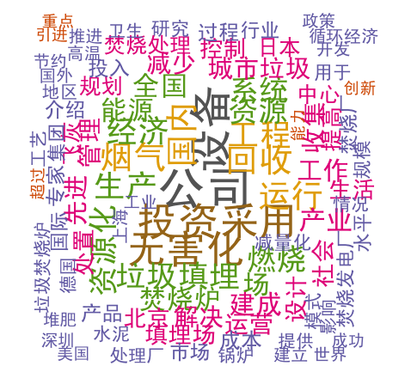 | A1b Hostility (bigram)  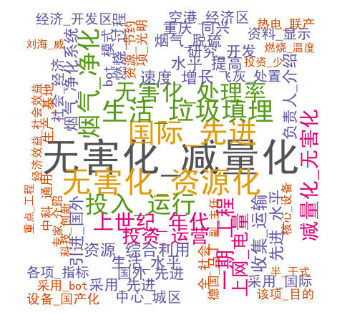
Key words: harm elimination (无害化), volume reduction (减量化), internationally advanced (国际先进), facility (设备)
A1c Sympathy –  policymaking (unigram)   | A1d Sympathy –  policymaking (bigram)  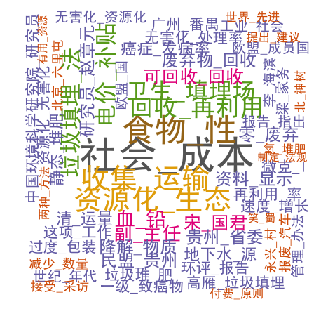
Key words: recycling (回收), composting (堆肥), social cost (社會成本) , utilization (资源化)
A1e Sympathy –  decision-making (unigram)  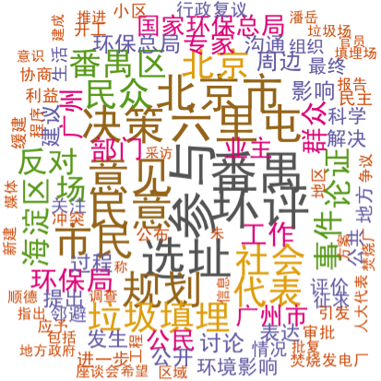 | A1f Sympathy –  decision-making (bigram)  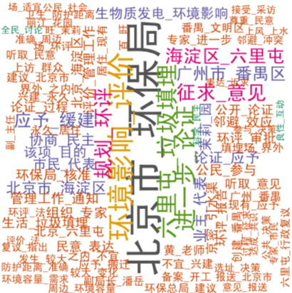
Key words: siting (选址), EIA (环评), opinion (意见/民意), decision-making (决策)
A1g. Sympathy – policy implementation and compensation (unigram)  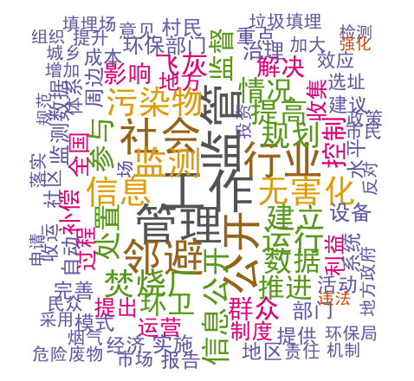 | A1.3h Sympathy – policy implementation and compensation (bigram)  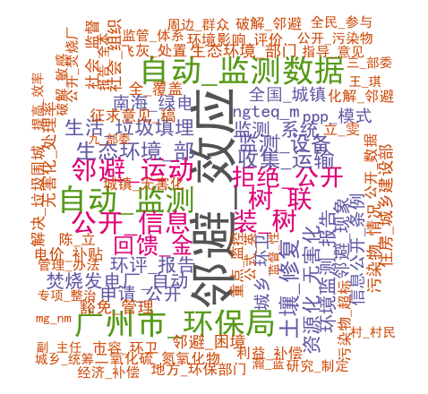
Key words: monitoring (监管/监测), publicizing data (公开信息), NIMBY (邻避), compensation (回馈金)

A1.4 Data Missingness
Fig. A2 shows the percentage of newspapers unavailable on CNKI by the year of publication at both the central and local levels – the denominator is the total number of newspapers that are available on CNKI for at least one year. It shows three distinct patterns. First, on average, newspapers published from 2002 to 2004 had a higher level of unavailability than those published afterward, especially for the local ones - around 30% and 80% for central and local level newspapers, respectively. Second, the degree of unavailability was relatively constant from 2005 to 2021, at around 20% and 30% for central and local level newspapers, respectively. Third, central newspapers were generally more widely available than local newspapers.

Fig. A2 Percentage of unavailable newspapers on CNKI by year of publication
and level of administration, 2002 - 2021
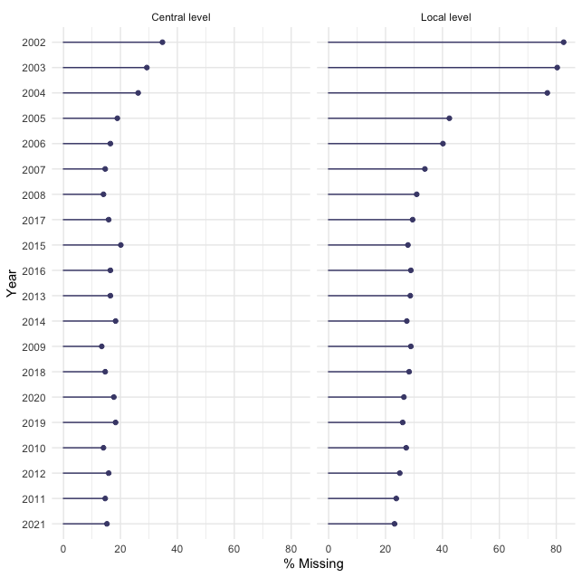
Our findings remain robust despite the missingness. See section A2.2 below.

A2.1 Responsiveness – Full sample
We ran multiple two-tailed Welch's t-tests to compare the average number of articles published during protest and non-protest periods across different definitions of a protest period and present the results in Table A3. In all three models, the number of articles published during protest periods was roughly twice the number published during non-protest periods, and the difference was statistically significant in the last two models.

Table A3: Welch’s t-test results for the mean number of articles published
during protest and non-protest periods (2002–2021)
Temporal Units | Definition of protest periods | Mean  (non-protest period) | Mean (protest period) | p-value – difference in mean
Month | At least one protest happened this month | 3.71 | 8.59 | 0.066
Month | At least one protest happened this month or one to two months earlier | 3.46 | 6.73 | 0.014*
Week | At least one protest happened this week or one to three weeks earlier | 0.85 | 2.09 | 0.001***
Note: * p <0.05, ** p <0.01, ***p < 0.001

A2.2 Responsiveness and response – Handling missingness
For responsiveness, the main issue is the high level of missingness of newspapers published on or before 2004. Although the number of articles published by both levels of newspapers during this period is small, this missingness will still lead to an underestimation of the number of articles published during this non-protest period. We compensate for differences in missingness by inflating the average number of articles published from 2002 to 2004, then rerunning the t-test (as in Table A3) to assess responsiveness. Assuming an equal probability of the missing newspaper and the available newspaper mentioning waste incineration, we inflated the number using this formula $n_{i}= θ_{i}*[(1- {λ_{i})}/{\left(1-τ_{i}\right)}-1]$, where i indicates the level of newspaper, $n_{i}$ is the number of articles to be added, $θ_{i}$ is the number of articles published on or before 2004, $λ_{i}$ is the missingness after 2004, and $τ_{i}$ is the missingness on or before 2004. According to the formula, the total number of articles added to that period is 40.

Table A4 shows that the results remained consistent with those in Table A3.

Table A4: Welch’s t-test on responsiveness – missingness compensated
Temporal Units | Definition of protest periods | Mean  (non-protest period) | Mean  (protest period) | p-value – difference in mean
Month | at least one protest happened this month | 3.90 | 8.59 | 0.076
Month | at least one protest happened this month, or, one to two months ago | 3.68 | 6.73 | 0.022*
Week | at least one protest happened this week, or one to three weeks ago | 0.90 | 2.09 | 0.001***
Note: * p <0.05, ** p <0.01, ***p < 0.001

Our findings on shifts in response strategies remain robust across both protest waves despite missingness, as they were stable across waves, and both local and central newspapers show parallel narrative shifts from hostility to policy implementation and compensation (see Appendix A2.5).

A2.3 Responsiveness and response – Strictly-defined official newspapers
In the main text of the article, we define all government-sanctioned newspapers as official newspapers. Here, we performed robustness checks on the responsiveness, as in Table A3, and response strategies as in Table 4 in the main text by narrowing the definition to newspapers affiliated with the party state (i.e., sponsored or managed by the party state), including government departments, party branches, and central level public institutions (namely, 事业单位 shiye danwei and 人民团体 renmin tuanti). We list the newspaper’s affiliation in Table A2. With the stricter definition, there are 156 newspapers out of 194 newspapers in the full sample, and 872 newspaper articles out of 1,023 articles in the full sample.

Table A5: Welch’s t-test on responsiveness - strictly defined official newspapers
Temporal Units | Definition of protest periods | Mean  (non-protest period) | Mean  (protest period) | p-value – difference in mean
Month | at least one protest happened this month | 3.17 | 7.26 | 0.053
Month | at least one protest happened this month, or, one to two months ago | 2.89 | 5.92 | 0.005**
Week | at least one protest happened this week, or one to three weeks ago | 0.73 | 1.75 | 0.000***
Note: * p <0.05, ** p <0.01, ***p < 0.001

From Table A5, we see that the t-test results remained robust, with a level of statistical significance comparable to that in Table A3, though with slightly lower responsiveness. The results of Table A6 are also similar to those of Table 4 in the main text.

Table A6: Logistic regression results - strictly defined official newspapers
 | Dependent variable: adoption of sympathy-policy implementation and compensation in an article
 | Static model |  |  | Dynamic model
Temporal units | (1)  Month | (2)  3-Month | (3)  4-Week | (4)  Month | (5)  3-Month | (6)  4-Week
After 2012 | 1.90*** (0.191) | 1.76*** (0.230) | 1.94*** (0.185) | 5.83***  (1.00) | 5.46***  (1.06) | 5.97***  (0.990)
Protest period | -0.670* (0.340) | -0.441 (0.269) | -0.324 (0.344) | -0.792* (0.345) | -0.472† (0.277) | -0.711 (0.347)
After 2012*Protest period | 0.833† (0.446) | 0.745* (0.366) | 0.730 (0.484) | 0.934* (0.455) | 0.776*  (0.383) | 1.11† (0.489)
Time trend:  year since 2002 |  |  |  | 0.519*** (0.091) | 0.513*** (0.092) | 0.542*** (0.092)
Time trend* After 2012 |  |  |  | -0.534***  (0.102) | -0.513***  (0.104) | -0.554***  (0.103)
N | 872 | 872 | 872 | 872 | 872 | 872
AIC | 854 | 854 | 856 | 807 | 809 | 808
Notes: 1. Standard error in parentheses and †p<0.10, *p<0.05, **p<0.01, ***p<0.001.

A2.4 Responsiveness and response – Articles mentioning protests
In the main text, we focused on newspaper articles on the contentious issue. Here, we performed robustness checks on the 654 articles specifically mentioning terms related to the anti-waste incineration protests, including waste incineration (Laji fenshao, 垃圾焚烧), protest-related terms (oppose (Fandui, 反对), protest (Kangyi/Kangzheng, 抗议/抗争), street protest (Shangjie, 上街), and letter and petitioning (Xinfang, 信访)), and the locations of the 32 protests.

Table A7: Welch’s t-test results - articles mentioning protests
Temporal Units | Definition of protest periods | Mean  (non-protest period) | Mean  (protest period) | p-value – difference in mean
Month | at least one protest happened this month | 2.20 | 6.85 | 0.048*
Month | at least one protest happened this month, or, one to two months ago | 1.97 | 5.05 | 0.008**
Week | at least one protest happened this week, or one to three weeks ago | 0.50 | 1.70 | 0.000***
Note: * p <0.05, ** p <0.01, ***p < 0.001

From Table A7, we see that the t-test results were even more robust than those in Table A3. Table A8 also shows results similar to those of Table 4 in the main text.

Table A8: Logistic regression results - articles mentioning protests
 | Dependent variable: adoption of sympathy-policy implementation and compensation in an article
 | Static model |  |  | Dynamic model
Temporal units | (1)  Month | (2)  3-Month | (3)  4-Week | (4)  Month | (5)  3-Month | (6)  4-Week
After 2012 | 1.91***  (0.231) | 1.51 ***  (0.289) | 1.99***  (0.222) | 4.91***  (1.180) | 3.91***  (1.246) | 5.09***  (1.167)
Protest period | -0.809*  (0.333) | -0.448†  (0.271) | -0.197  (0.312) | -0.884***  (0.337) | -0.516†  (0.276) | -0.527†  (0.316)
After 2012*Protest period | 0.906†  (0.479) | 1.199**  (0.419) | 0.701  (0.520) | 0.971*  (0.486) | 1.31**  (0.433) | 1.03*  (0.523)
Time trend:  year since 2002 |  |  |  | 0.395***  (0.088) | 0.396***  (0.089) | 0.424***  (0.091)
Time trend* After 2012 |  |  |  | -0.406***  (0.111) | -0.365**  (0.112) | -0.432***  (0.112)
N | 654 | 654 | 654 | 654 | 654 | 654
AIC | 648 | 646 | 652 | 622 | 621 | 626
Notes: 1. Standard error in parentheses and †p<0.10, *p<0.05, **p<0.01, ***p<0.001.

A2.5 Comparison of the responses of central and local level newspapers

Fig. A3 Code distribution across protest waves and newspaper levels

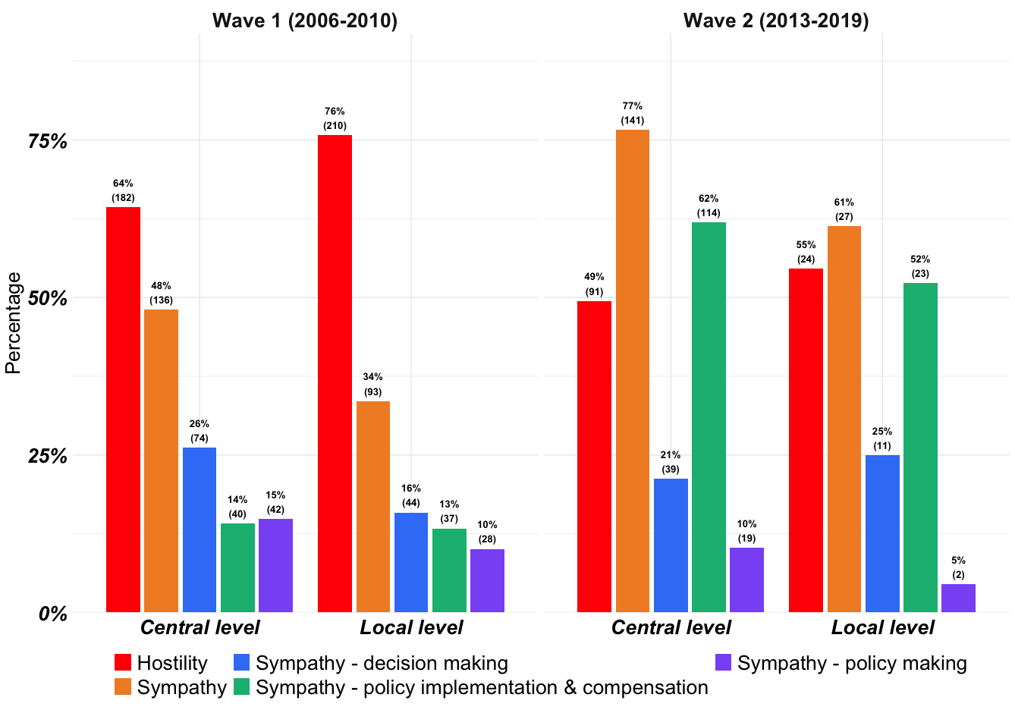

Many studies find that local media in China do not always align their discourse with the central government’s interests, because local authorities face distinct incentive structures when responding to social protests (Cai, 2008, Yang & Chen 2020). Therefore, we distinguish between central and local newspapers and compare their discourses across the two waves of protests. Fig. A3 shows the percentages and numbers of articles with each code in the two waves of protests, by newspaper level.

In the first wave, both central and local newspapers were responsive, publishing 283 and 277 articles, respectively. Local newspapers were especially likely to respond when protests occurred within their own jurisdictions and thus constituted a local concern. The top three provincial-level administrations by number of articles published were Guangdong (N = 77), Jiangsu (N = 40), and Beijing (N = 18), where all seven protests in the first wave took place. Shanghai (N = 20) is an exception: no large-scale protest occurred there, but it is a national economic center and borders Jiangsu. In terms of discourse, central newspapers displayed more sympathetic coverage of the protests than their local counterparts, consistent with scholarship suggesting that local governments have stronger incentives to repress protests that directly target them.

In the second wave, sympathetic narratives on policy implementation and compensation increased sharply and became dominant at both central and local levels. Notably, however, almost 80% of the articles published during the second wave came from central level outlets, even though protests were more numerous and geographically dispersed. This pattern likely reflects both heightened media centralization under Xi’s leadership (Brady, 2017) and the elevation of waste-incineration protests from primarily local grievances to a national-level issue.

References
Brady, A. M. (2017). Plus ça change?: Media control under Xi Jinping. Problems of Post-Communism, 64(3-4), 128-140.
Cai, Y. (2008). Local governments and the suppression of popular resistance in China. The China Quarterly, 193, 24-42.
Yang, Y., & Chen, W. (2020). Different demands, varying responses: Local government responses to workers’ collective actions in South China. The China Quarterly, 243, 839-854.

