User-Guide for MAP Tool

To download “MAP Tool” follow the steps
- Go to link https://www.microsoft.com/en-in/download/details.aspx?id=7826
- As shown in following image select option “MapSetup.exe” to download, click on Next tab it will start downloading exe file.
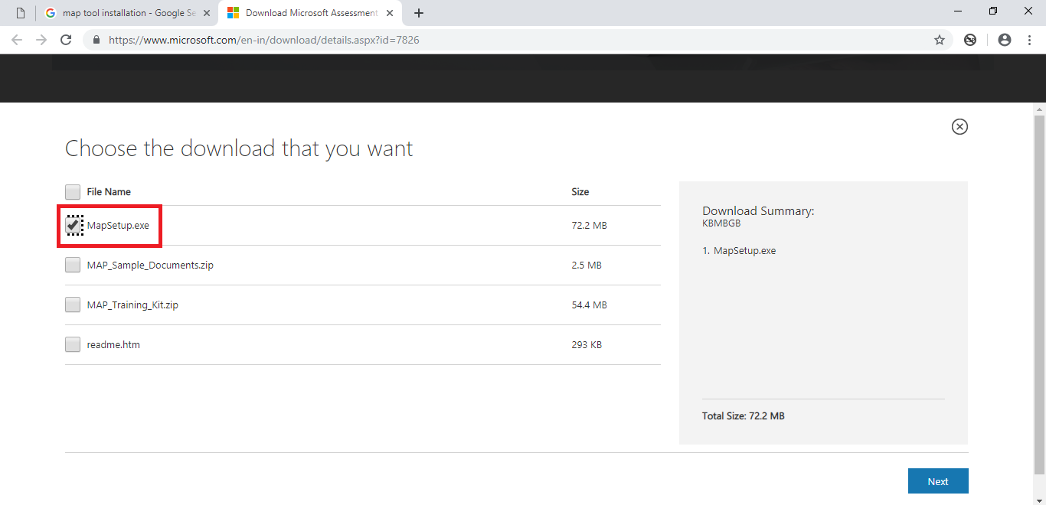

To generate “Inventory” and “performance” report

Steps to generate “Inventory Results” excel
- Open map-tool software
- Initially it will ask for “Data Source”

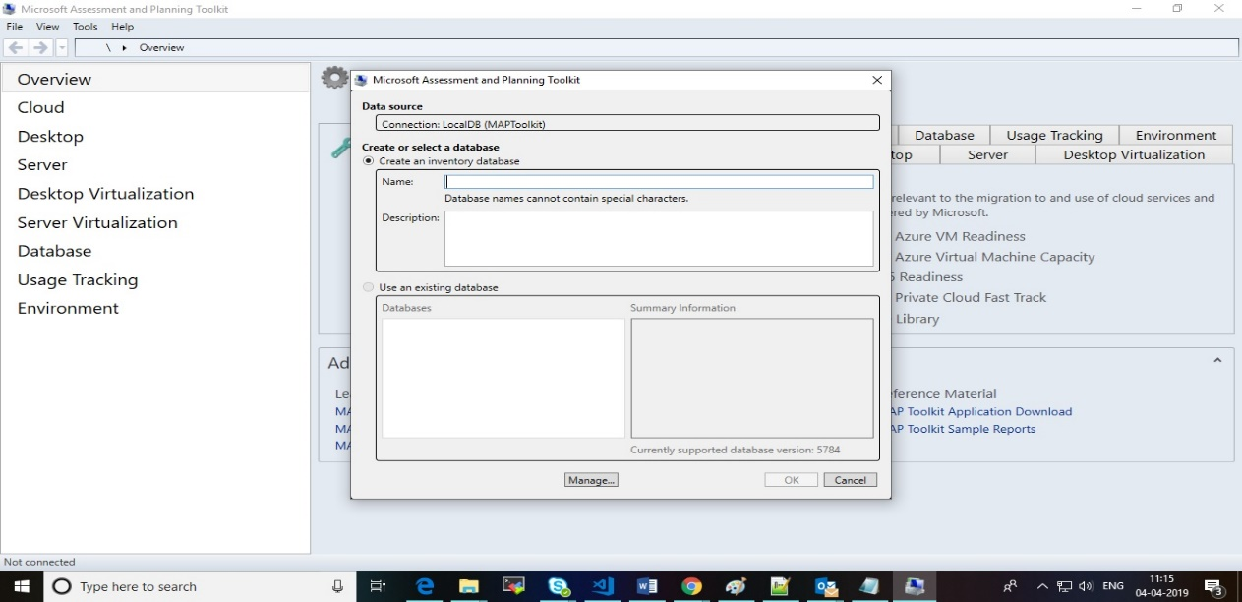
- Define Name for database and then click on OK button. (By default, Database folder created in user profile’s Document folder and we cannot change it (ex C:\Users\pramod.meshram\Documents\MAP\Map tool Database-1)
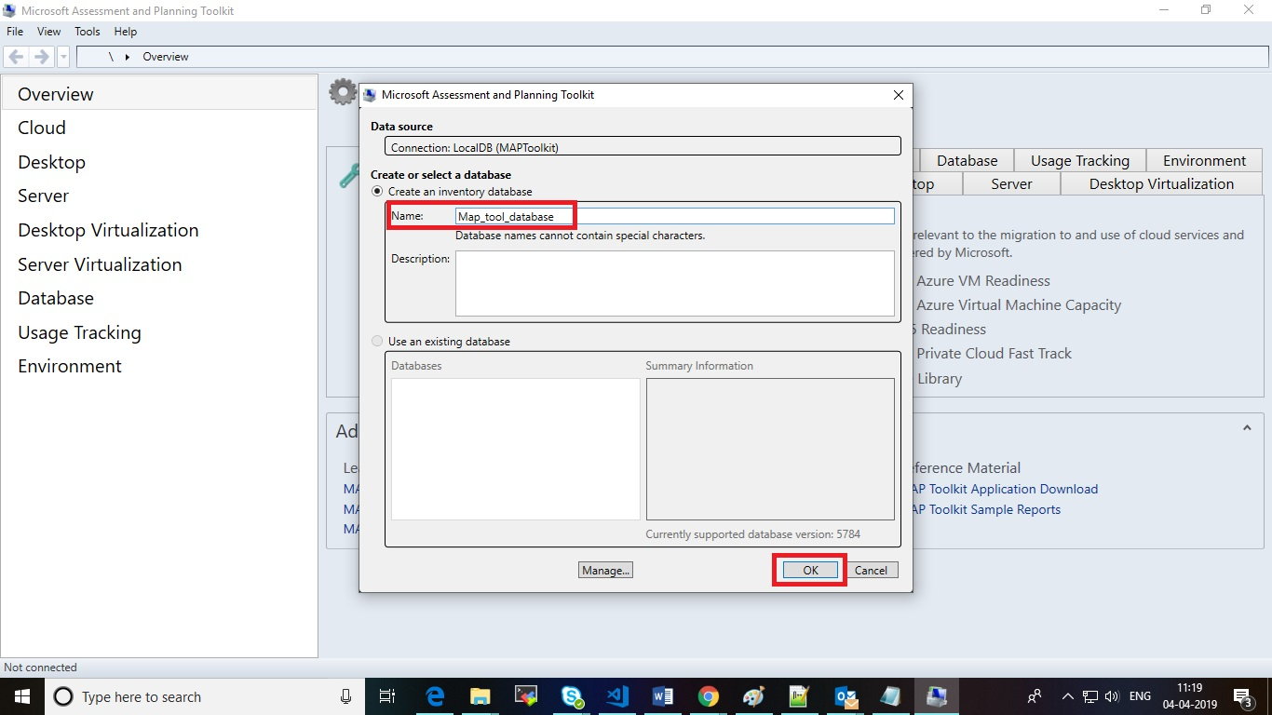

- Click on “Environment tab” from left hand side panel
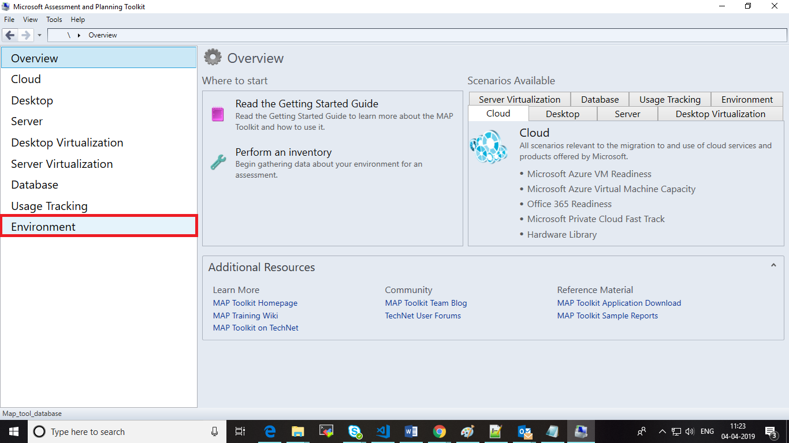
- Click on “Collect inventory data” option
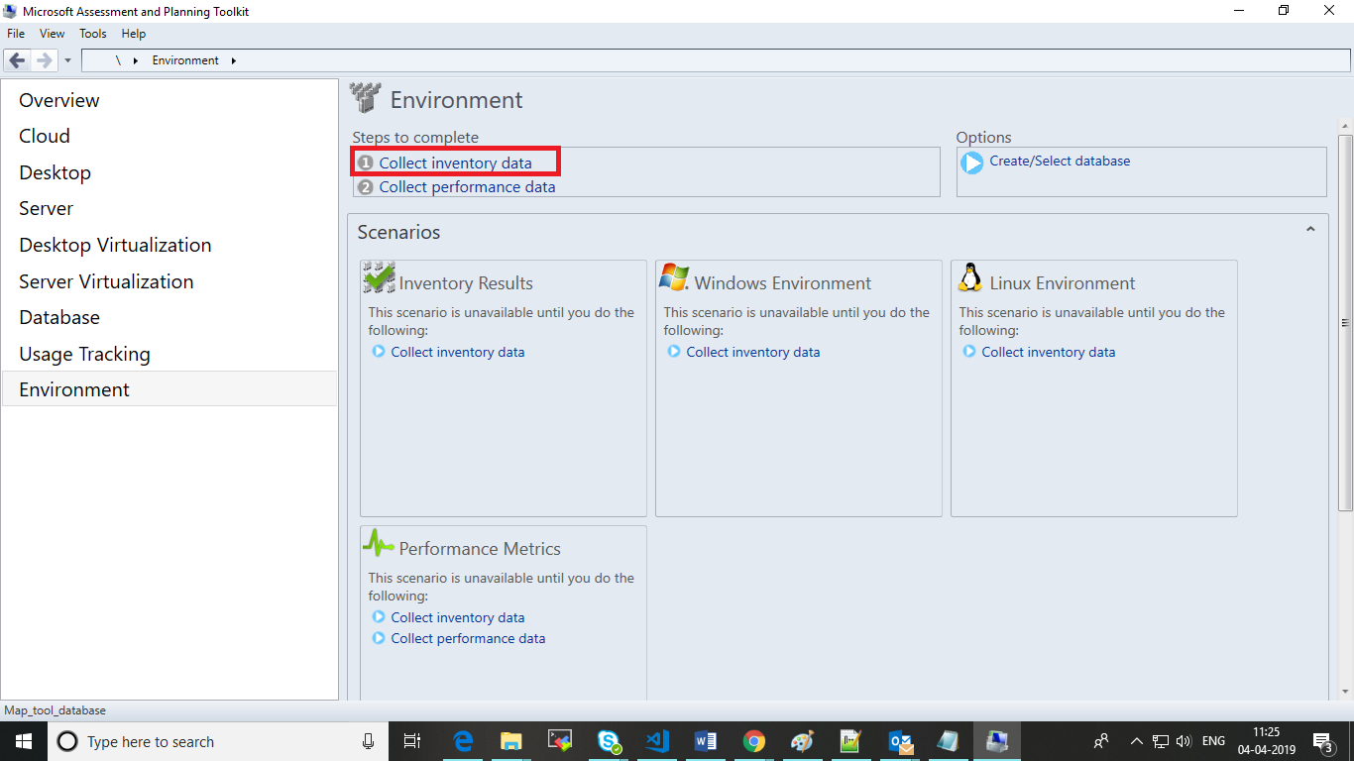
- After click on collect inventory data you will get a pop-up window
- Check two Checkbox as shown in below and then click on next tab
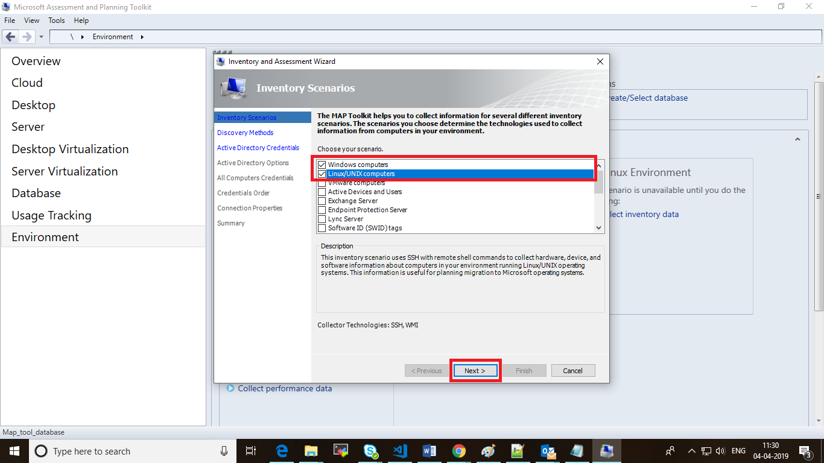
- If user have domain network, then user must choose two option as shown in image (skip next step (i.e. 9th step))
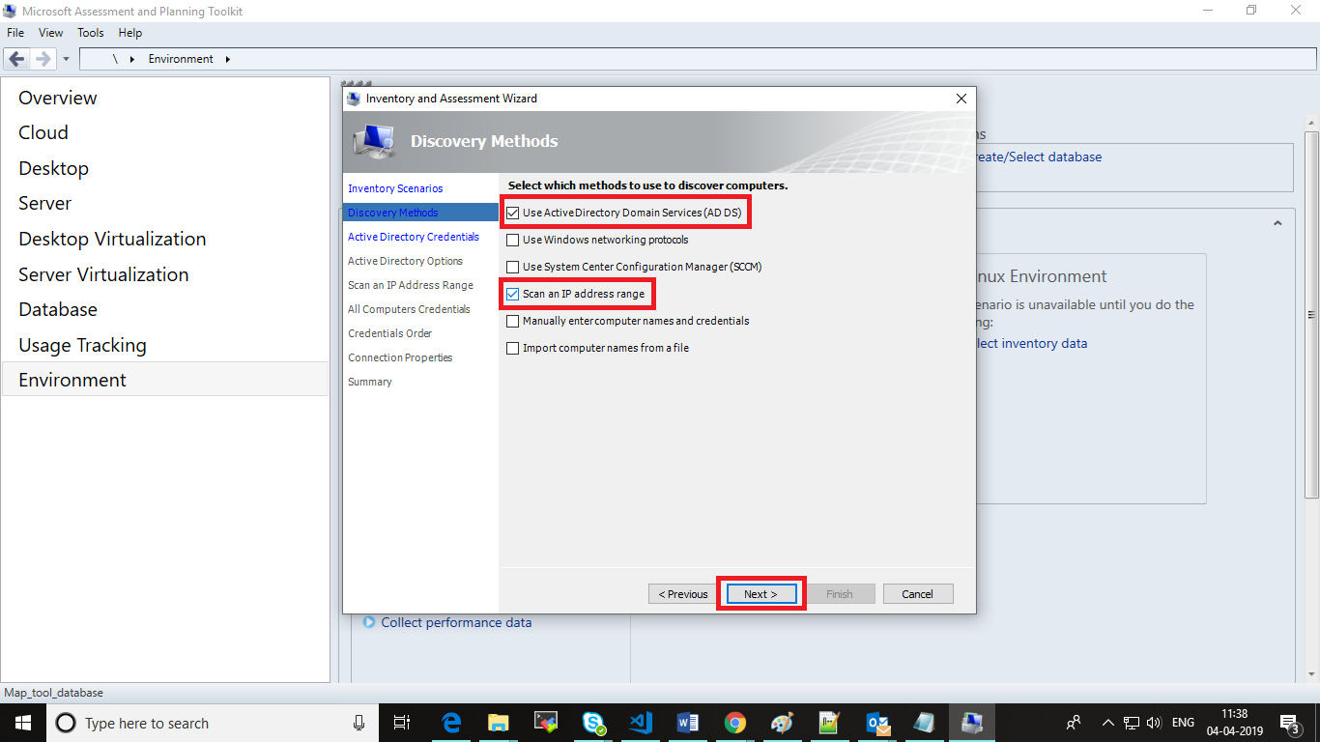
- If user have “General Network (without Domain)” then user must choose only option as shown in image (skip previous step (i.e. 8th step))
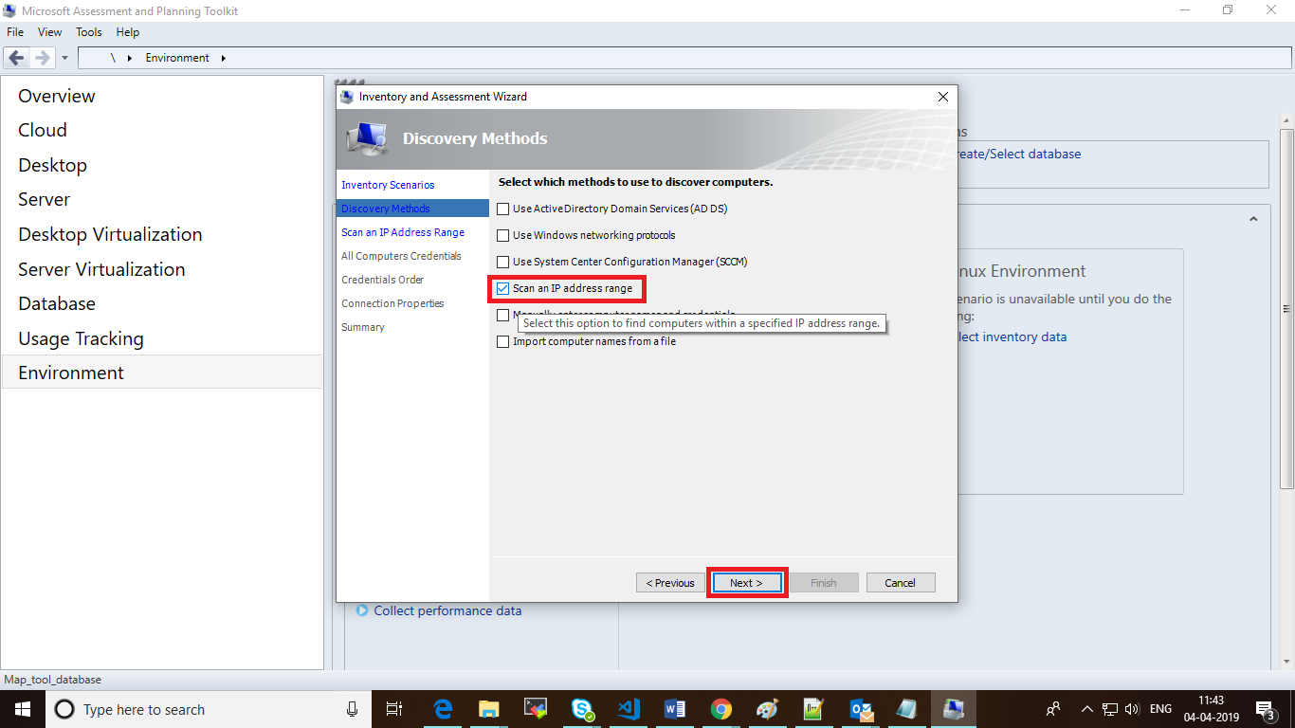
- If user have chosen “Active Directory domain service” then user should follow this step
  - In this step user must provide Domain Name, Domain admin credentials then click on next button
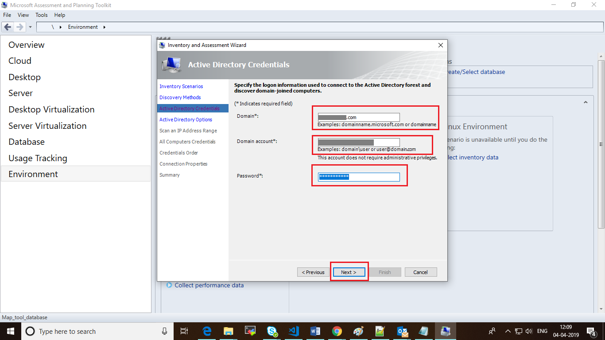
  - Select “find all computers in all domains, container, and organization units” then click on next tab
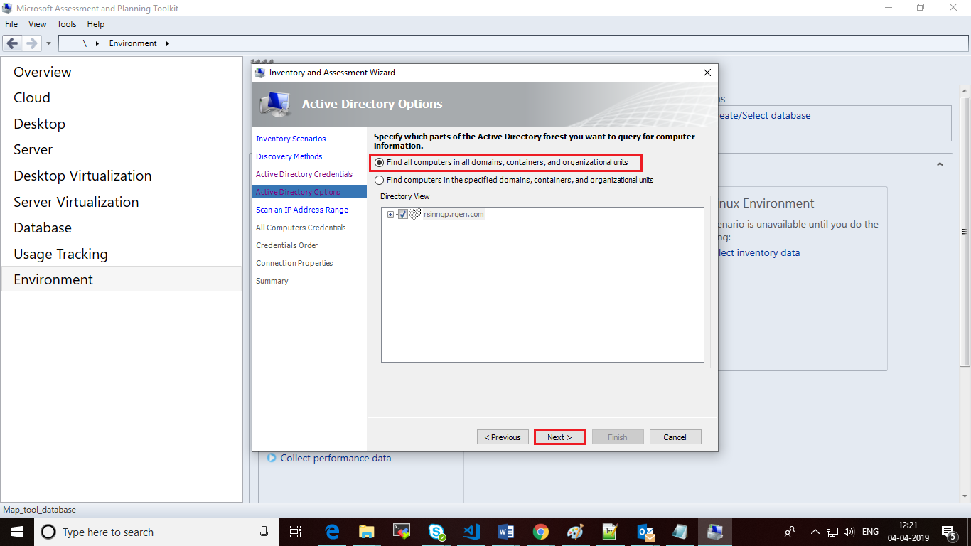
Note: If user have chosen “General Network (without Domain)” then step 10 has been skipped.
- In this Step user must specify IP range of computers in their network to get data of all the machines as shown below
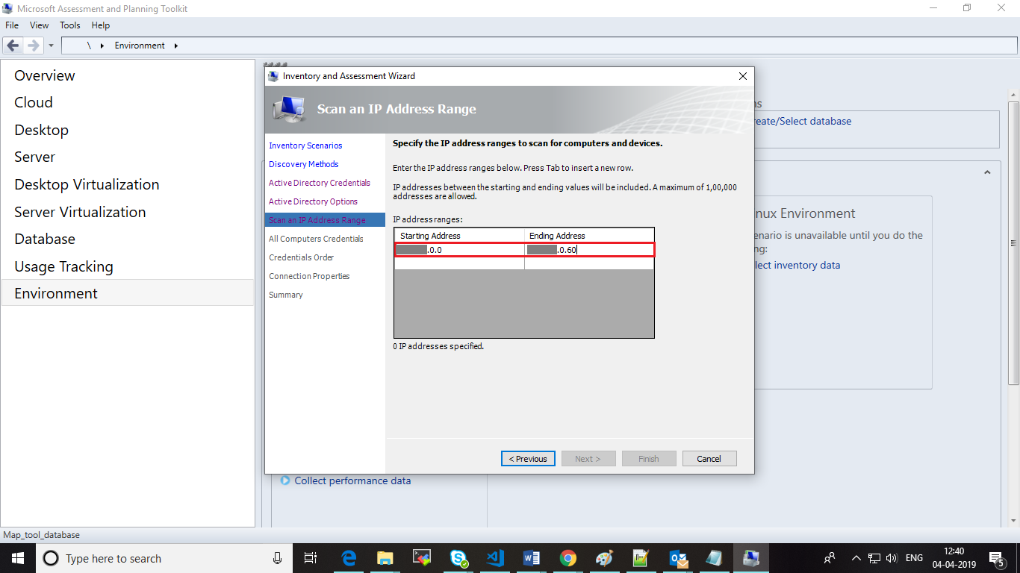
- Click on “Create” tab You will get one pop-up.
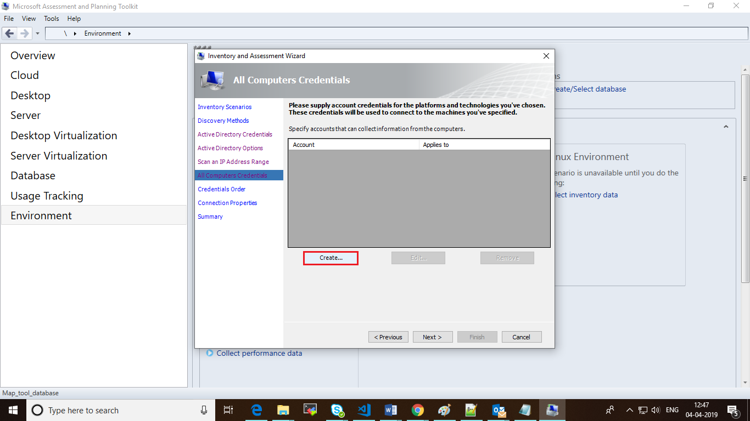

- Enter each Windows machine local admin credential of network (selected in IP range) then check the checkbox in technology panel to apply to (WMI – windows).
Note: Generally, one local admin credentials are common to each system in network.
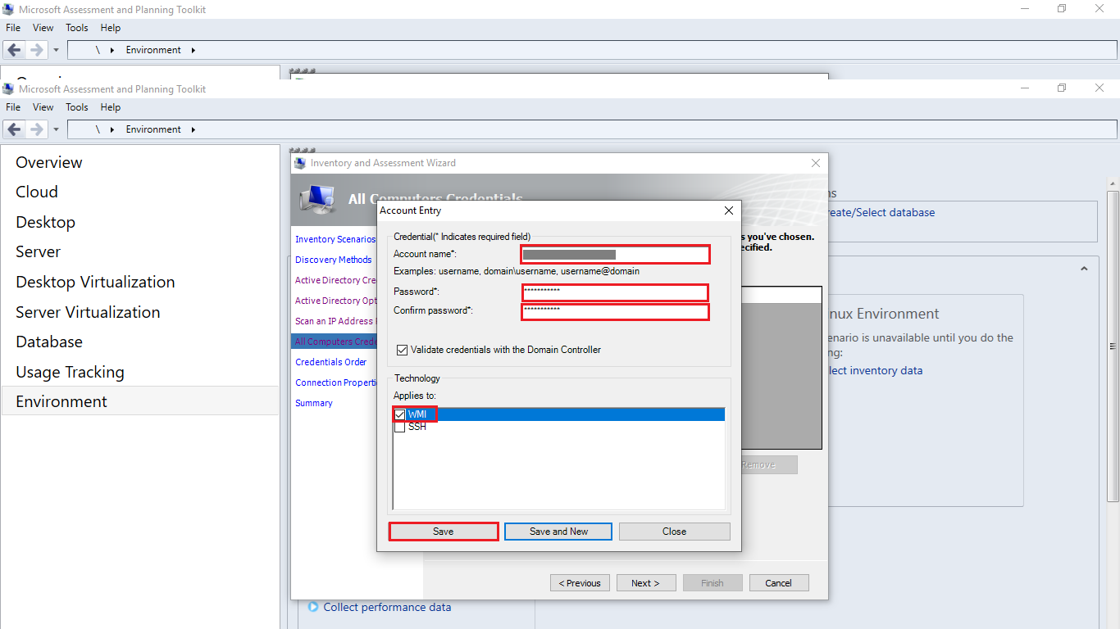
- Follow the same steps for Linux machine, choose option SSH in technology panel and then click on save tab
- After adding accounts credentials click on Next tab
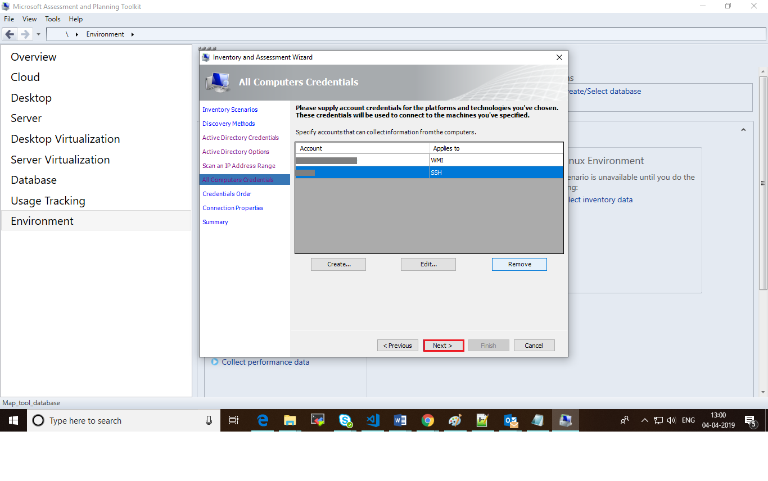
- Click on Next tab
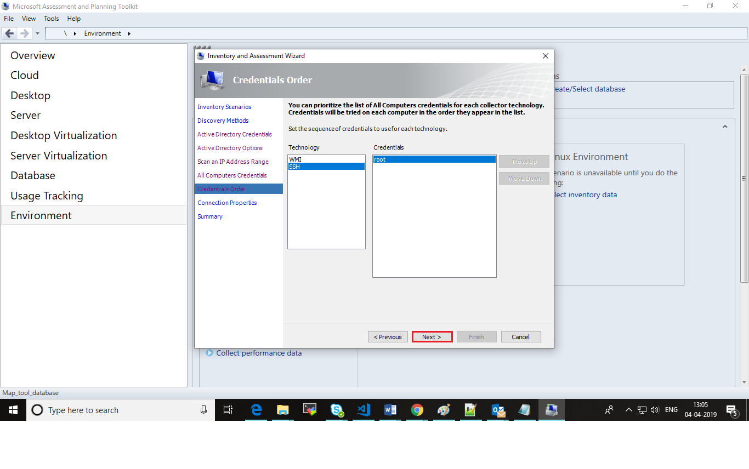
- Click on Next tab again
- On this tab click on Finish tab
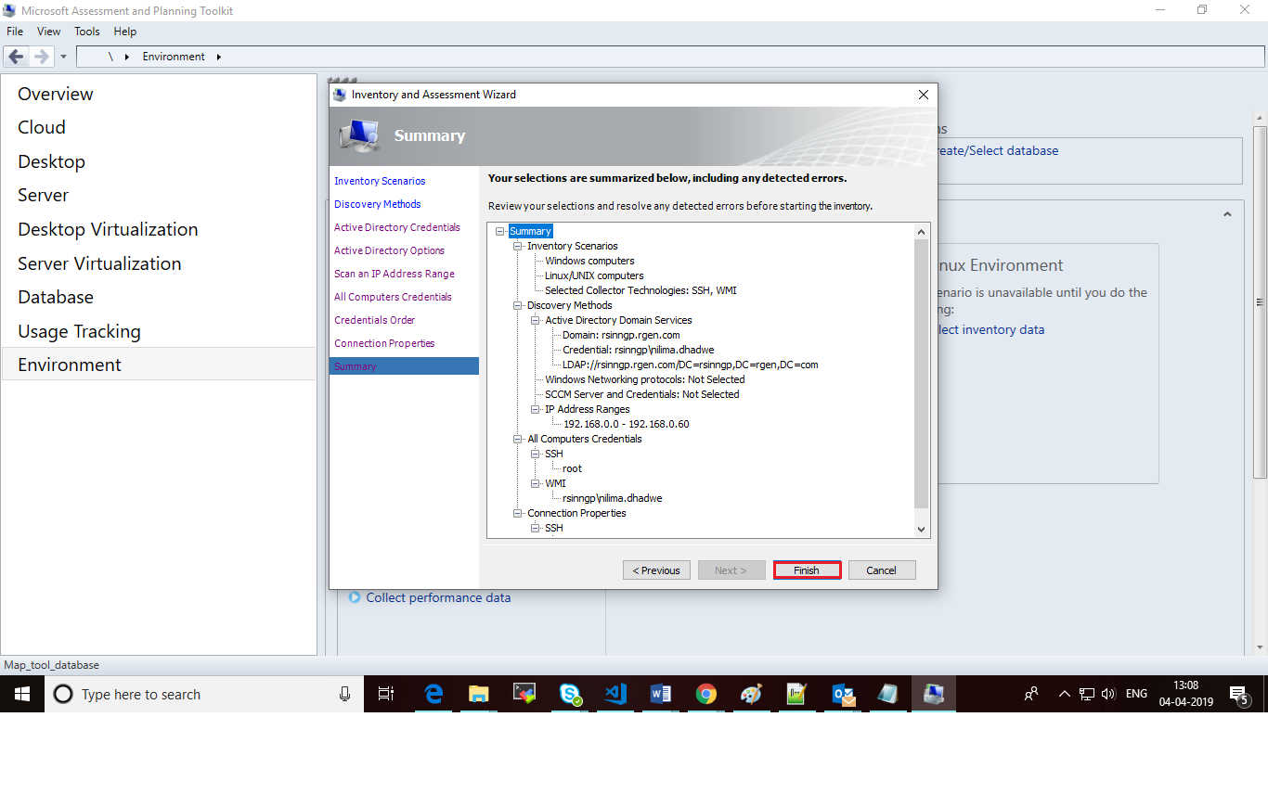
- After clicking on Finish tab user will get pop-up where user will find MAP-tool started to collect inventory data of the defined network range.
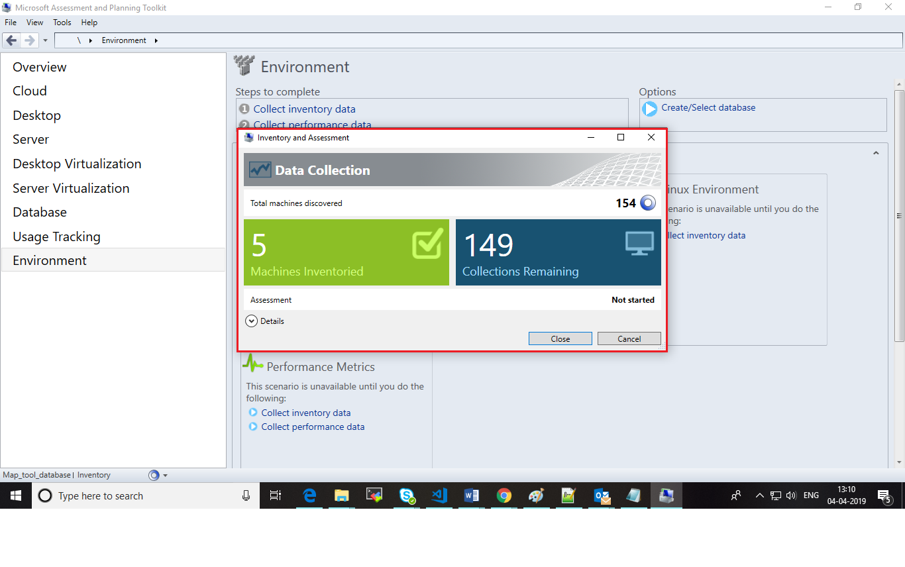
- Wait till it gets completed
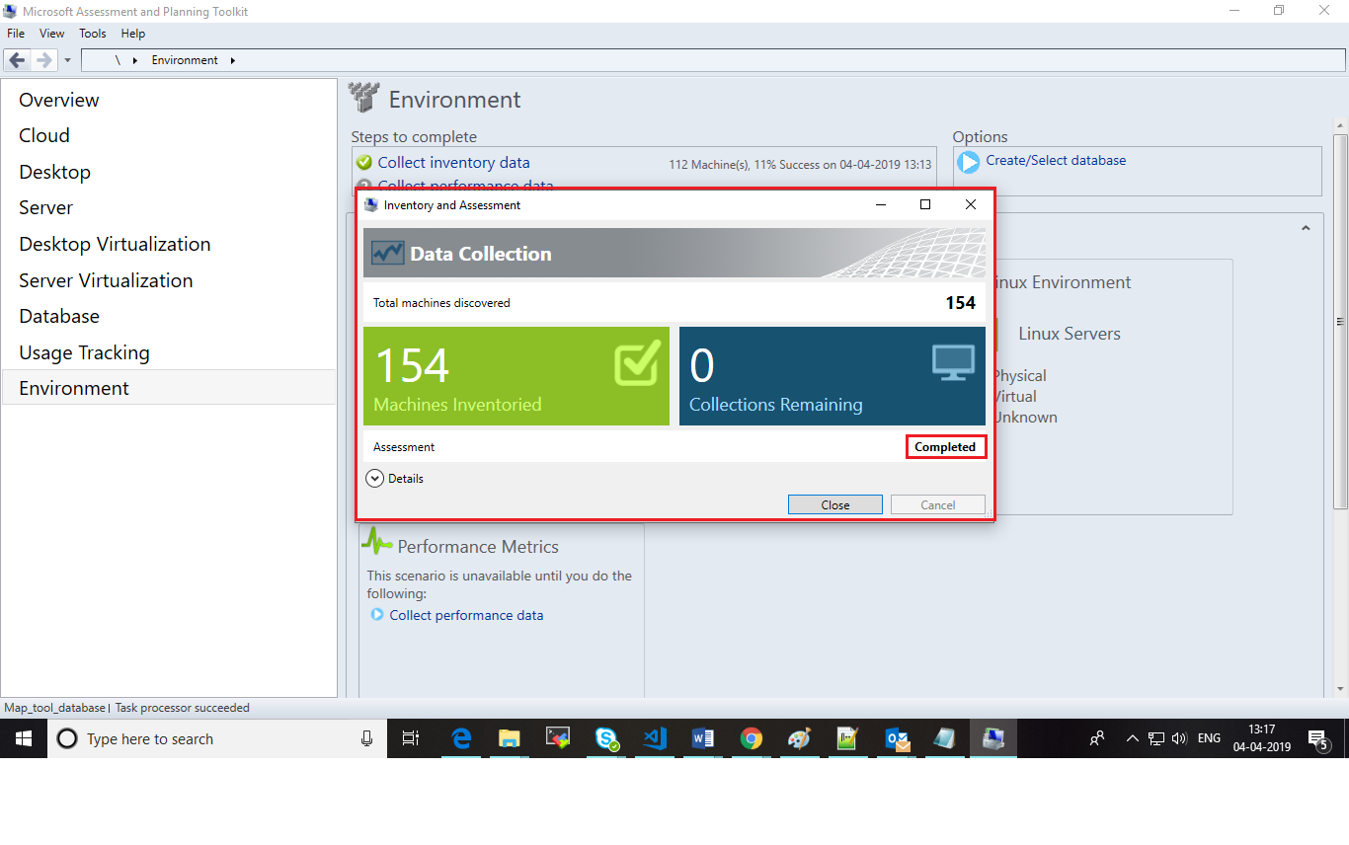
- Close the pop-up. Go to the environment click on Inventory result click on Generate Inventory result report, then user will get one pop-up.
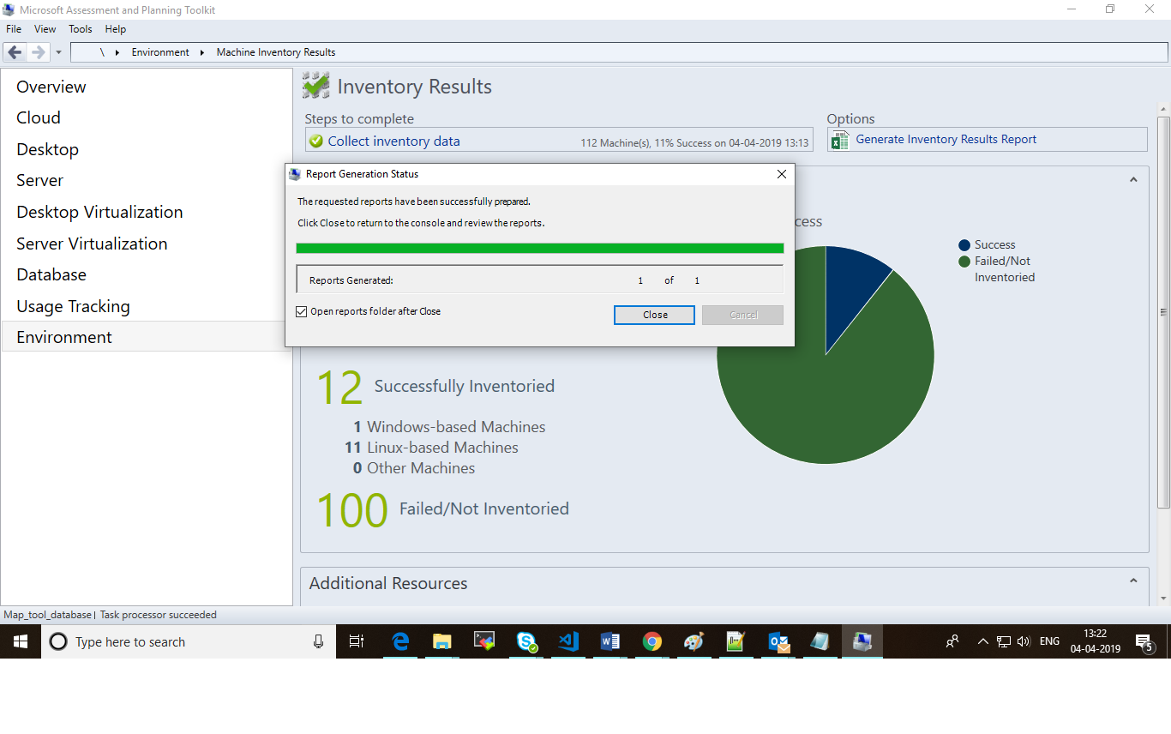
- Click on close tab user will get directory where user will find InventoryResult report.
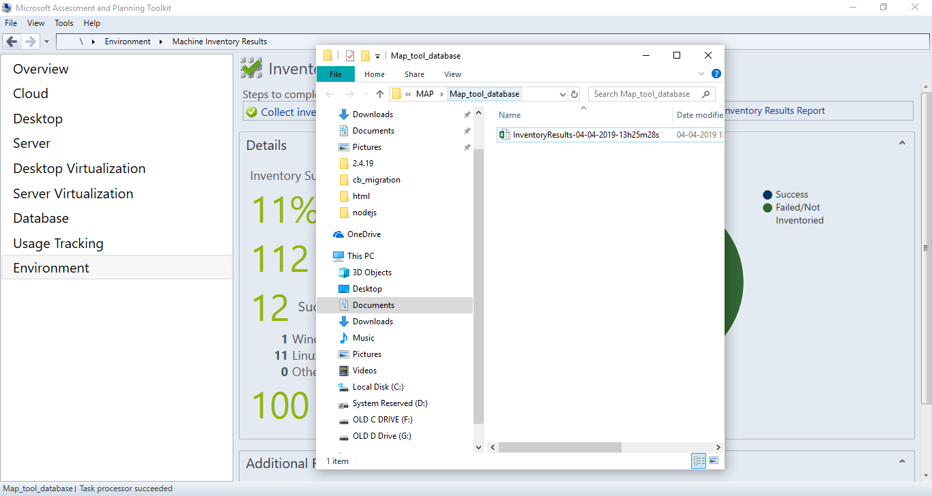

Steps to generate “PerfMetricResults” excel.
- Click on server virtualization tab from left hand side panel click on collect performance data.
- User will get one pop-up.
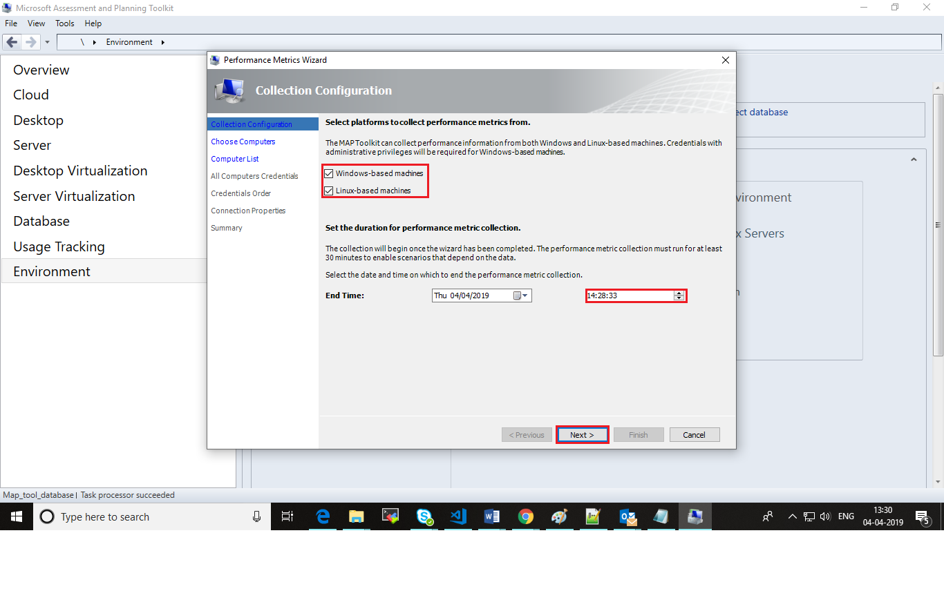
- In this step user must choose time more than 30 minutes of interval form current time to collect performance data and then click on next tab.

- Click on next tab again
- Select all the computers by check checkbox of Computer Name and then click on Next tab
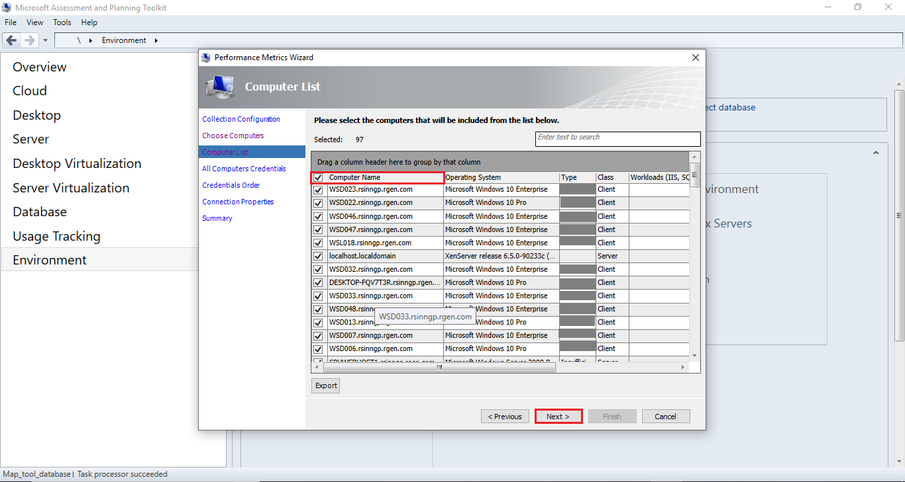
- Click on Next tab three times.
- Click on Finish tab
- User will get one pop-up where user will find MAP-tool started to gather performance data from network
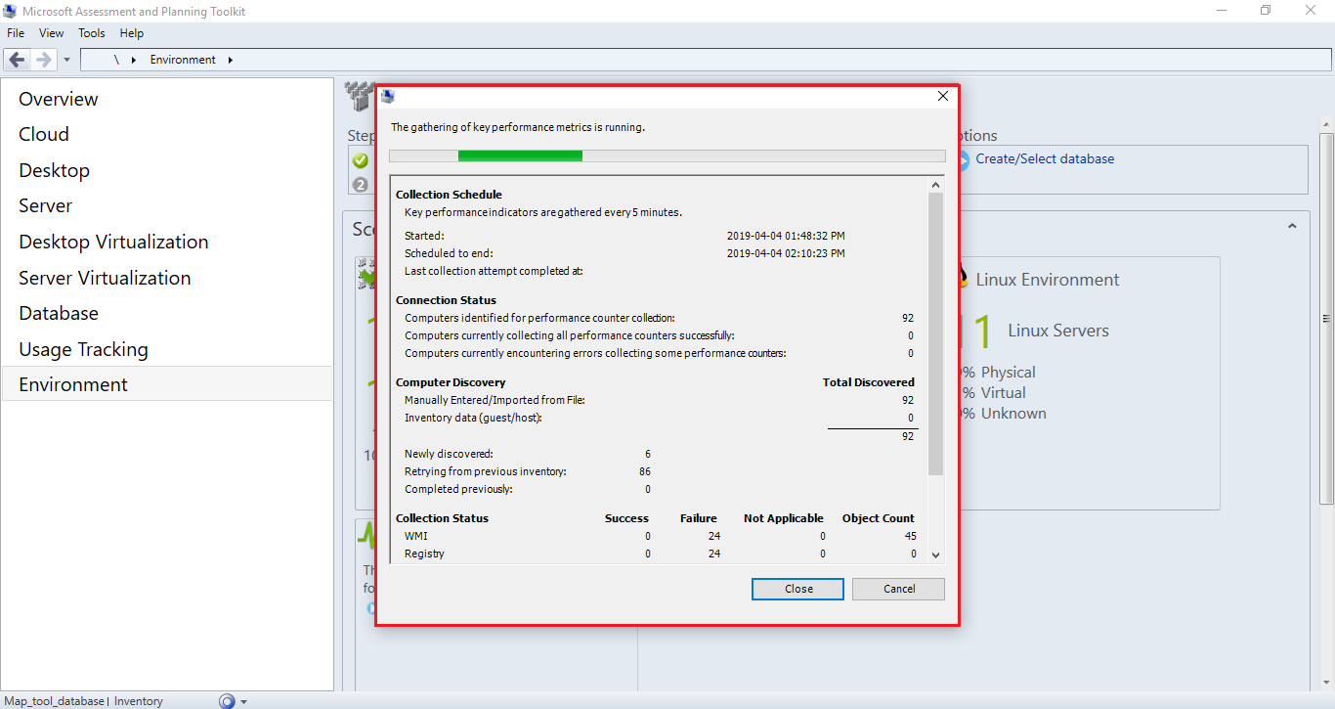
- Wait till it gets completed
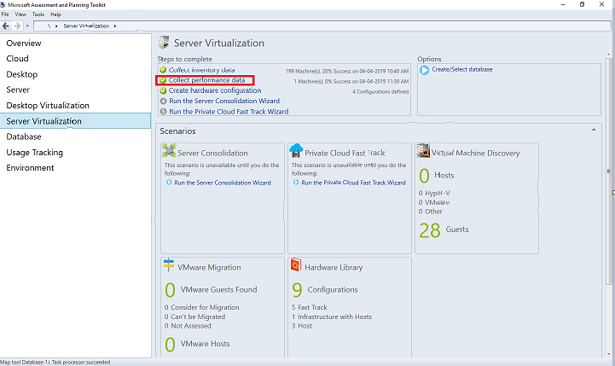
- After complete performance collection the “green right” popup as shown below
- Select Environment and Click on Performance Metrics Report.
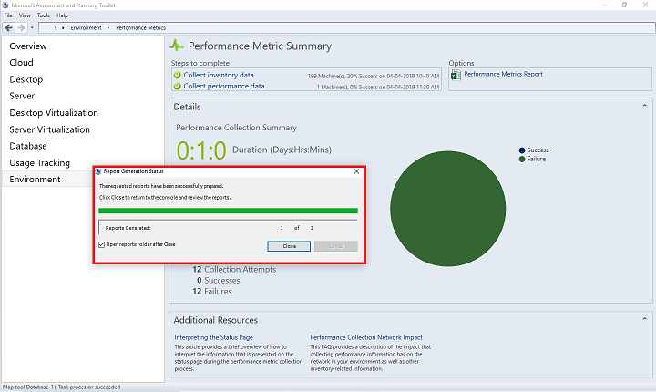
- User will get one pop-up window.

- Close this window then report will get downloaded into Database folder. (Note: - Please do not edit any map_tool generated files.)

To store data of “Inventory” and “performance” reports into database
- Download the utility from GitHub

Steps to run the utility:
- Go to that directory where downloaded .exe file is located.
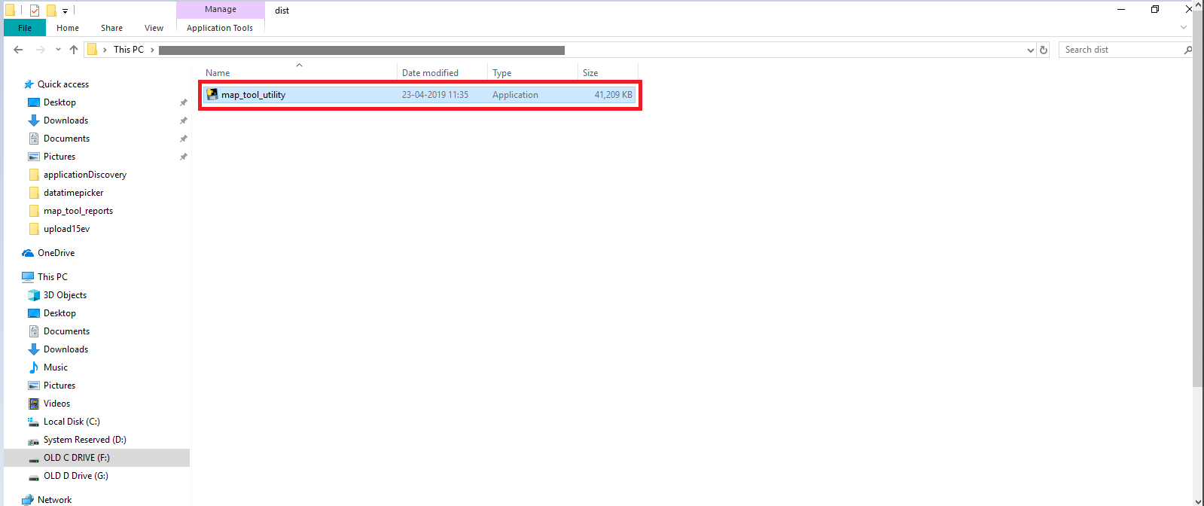
- Double click on the .exe file to start execution.

- After .exe file get started.
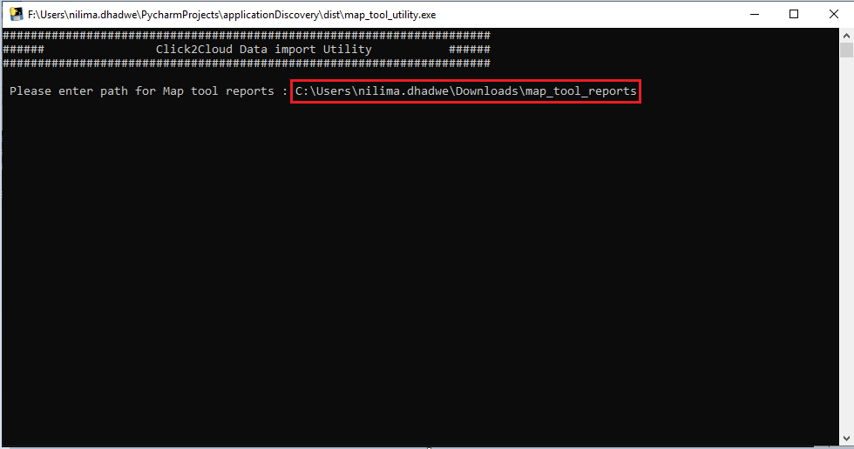
- Enter the local path where map-tool reports are stored.

- Hit ‘Enter’ button
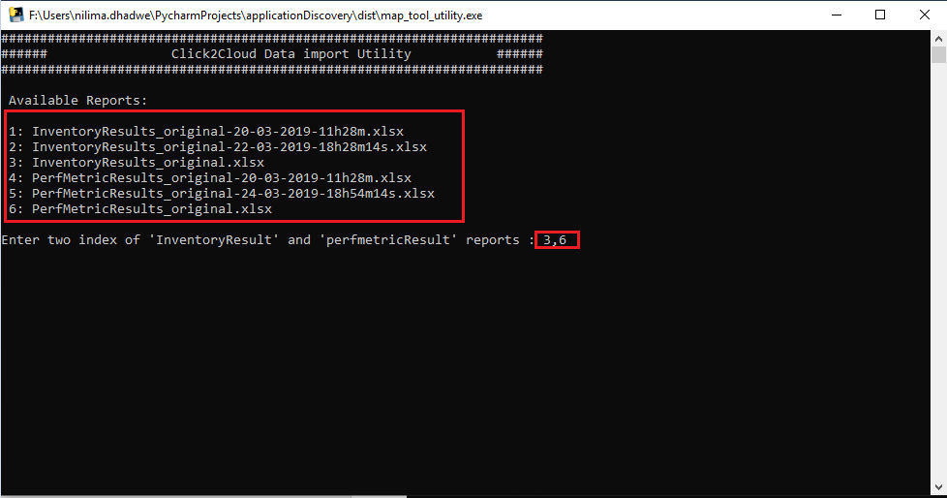
- Choose one index for ‘inventory report’ and one index for ‘prefmetric report’ from given options.

- Hit ‘Enter’ button.
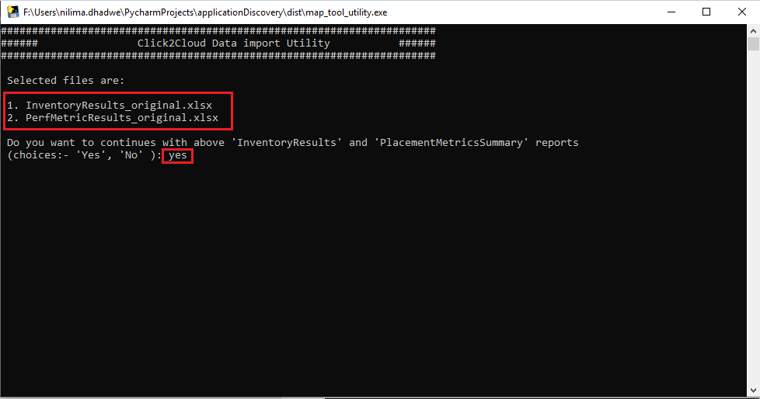
- You will get the list of selected reports, if you want to continue with these reports then put input as ‘yes’.

- Hit ‘Enter’ button.
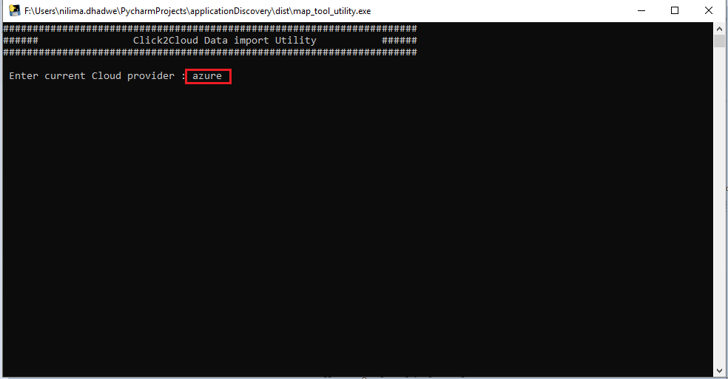
- Enter name for current cloud provider.

- Hit ‘Enter’ button.
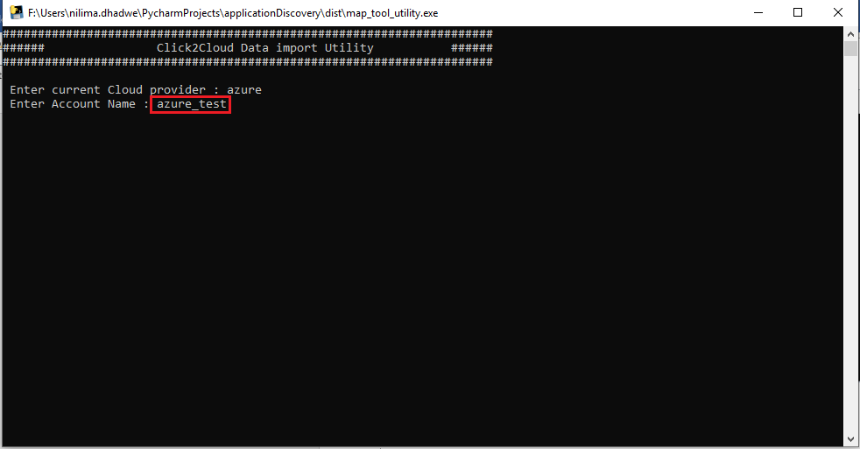
- Enter Account Name of current cloud provider.
- Hit ‘Enter’ button.
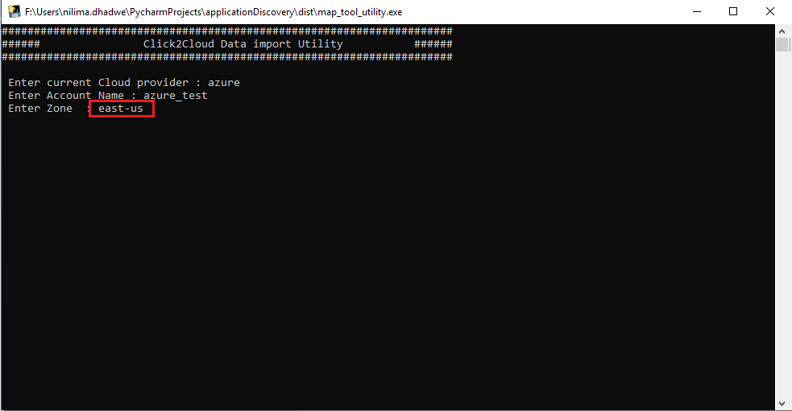
- Enter zone of current cloud provider.

- Hit ‘Enter’ button.
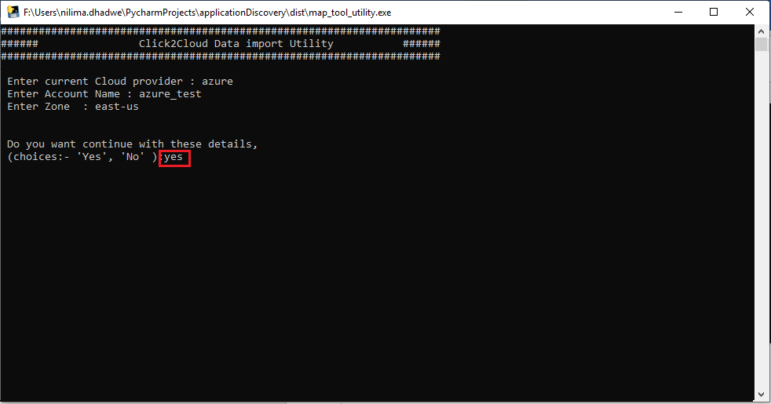
- You will get one message “Do you want to continue with these details”, if ‘yes’ then put input as ‘yes’.

- Then, you will get ‘summary’ of details which you have entered.
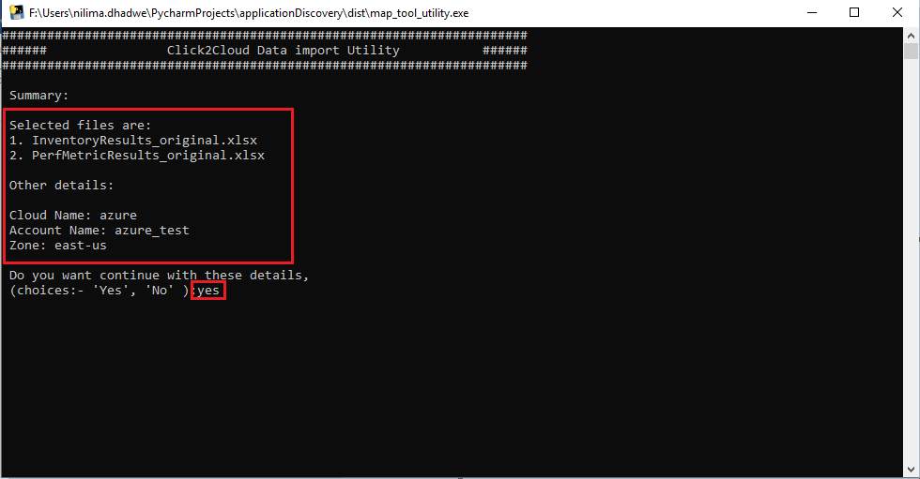
- If you want to continue with these details, put input as a ‘yes’.

- Hit ‘Enter’ button.
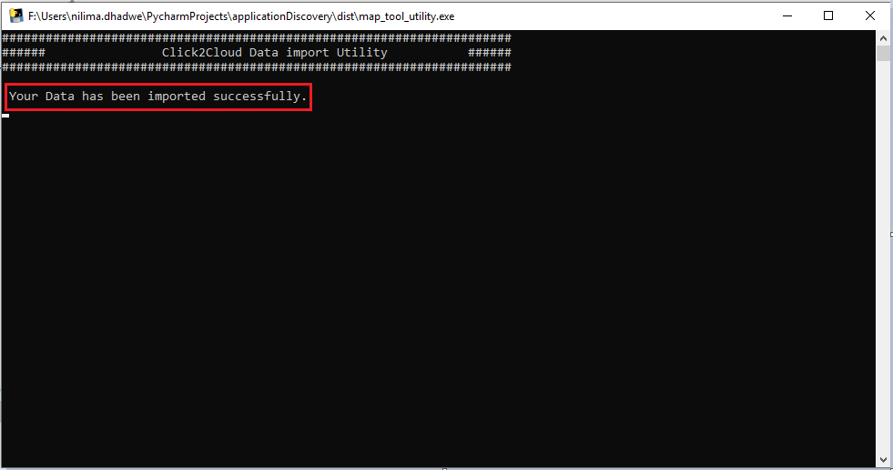
- Then You will get one message “Your data has been imported successfully”.

