**Assignment No 4**

*Advanced Database System Lab(5CS372)*

**2020BTECS00085, MANJIRI CHANDURE**

**Problem Statement:**

**Design and implement a system for managing online multiple-choice tests.**

* **React JS:**
  + React is a popular JavaScript library used for web development.
  + React.js or ReactJS or React are different ways to represent ReactJS.
  + Today’s many largescale companies (Netflix, Instagram, to name a few) also use React JS.
  + React.js is a front-end JavaScript framework developed by Facebook. To build composable user interfaces predictably and efficiently using declarative code, we use React.
  + It’s an open-source and component-based framework responsible for creating the application’s view layer.
  + ReactJs follows the Model View Controller(MVC) architecture, and the view layer is accountable for handling mobile and web apps.
  + React is famous for building single-page applications and mobile apps.
* **MySQL:**
  + MySQL, the most popular Open Source SQL database management system, is developed, distributed, and supported by Oracle Corporation.
  + Node. Js and MySQL are some of the necessary binding needed for any web application.
  + MySQL is one of the most popular open-source databases in the world and efficient as well.
  + Almost every popular programming language like Java and PHP provides drivers to access and perform operations with MySQL.

**Landing Page / HomePage:**



**Registration Page:**

1. **Registering as Student:**

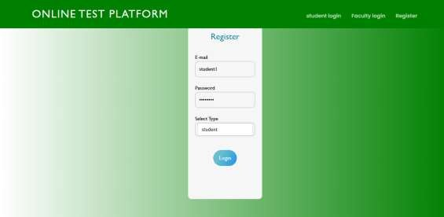

1. **Registering as Faculty:**



**Login In as Faculty:**

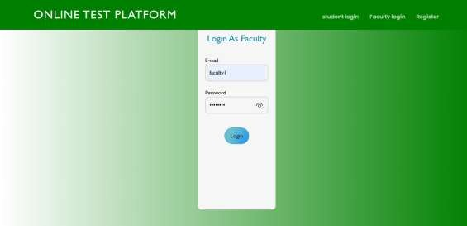

**Adding an Quiz:**



**Quiz Added Successfully:**

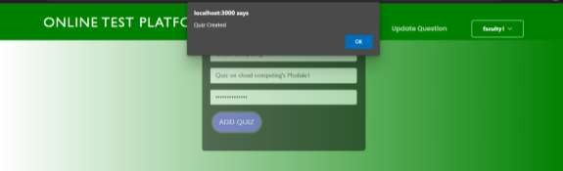

**Adding Question in a Quiz:**

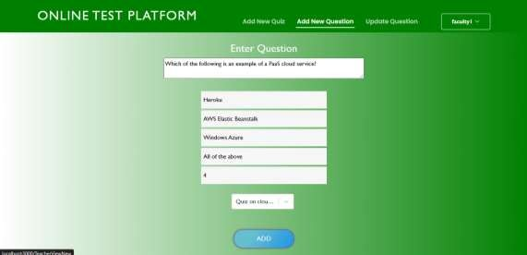

**Login as Student:**

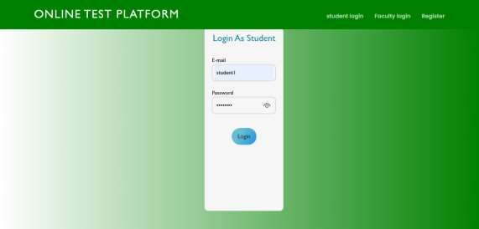

**Home Page for Student:**

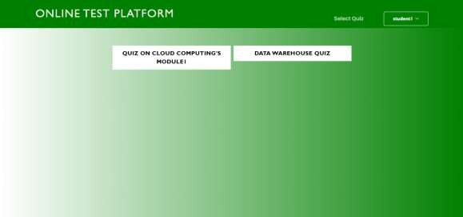

**Online Quiz Platform:**

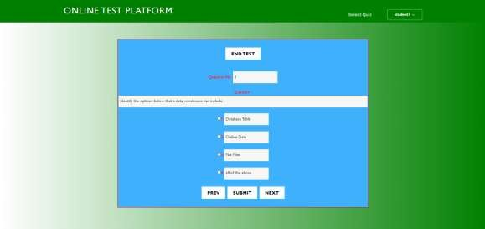

**Conclusion:**

From this Assignment I learnt how to manage User levels at different role. How to give authentication and implementation of Quiz using React js and MySQL.