# Assignment No 5

*Advanced Database System Lab(5CS372)*

**Manjiri Chandure, 2020BTECS00085**

**Problem Statement:**

# Do the performance tuning for Assignment No.3 & 4.

**Solution:**

Today’s consumer is impatient. In fact, online shoppers list slow page load times as the second most frustrating part of online shopping.

So, if our site takes too long to load or if the page layout is unstable, it’s likely your visitors will get frustrated and go elsewhere.

Website performance measures the responsiveness of your website and how quickly it loads, offering up insights to help us optimize our site to ensure it’s as fast and user-friendly as possible.

Here we use Locust to measure performance of website. Locust is a tool that creates a set of testing functions that simulate a heavy number of users. This will determine the main breaking point in terms of performance, security, and application load management. For load testing, Locust uses Python.

It is user-friendly web-based UI. Brings a set of dashboards, visualizations, and test reports that summarize the load testing process.

Provides the testing team with a complete picture of the test's current performance.

Enables the testing team to run multiple test scripts to find out the main performance and load handling problems.

Here is the result of website which no. of user is 15:

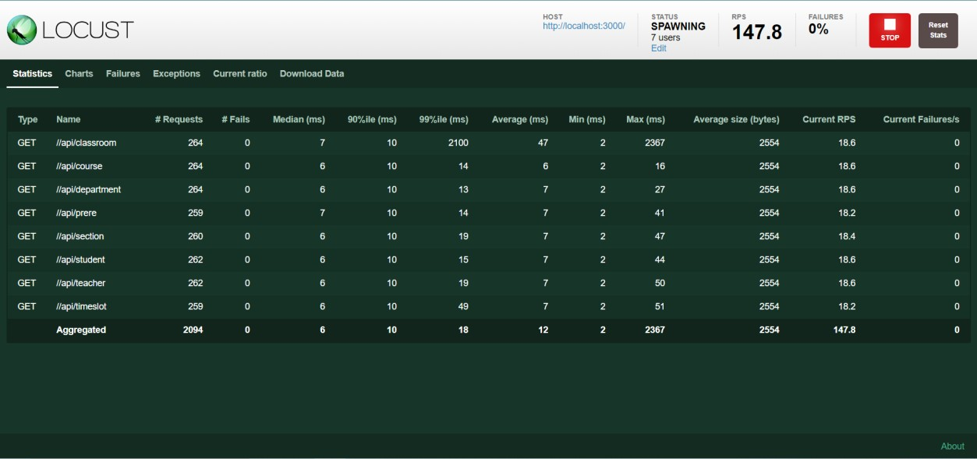

Here is the chart:

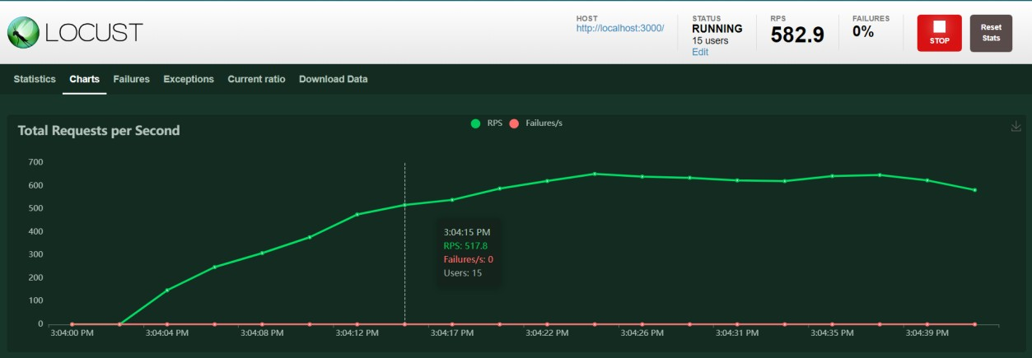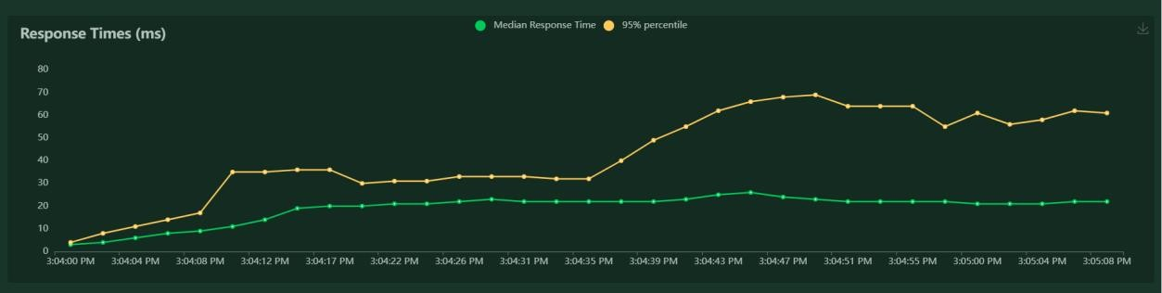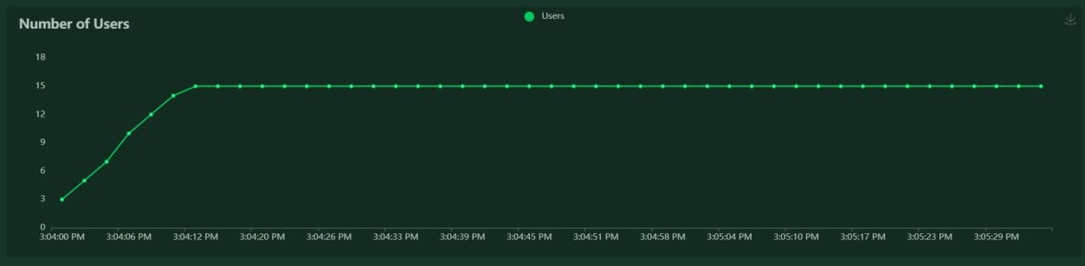

Here no of user is 200:

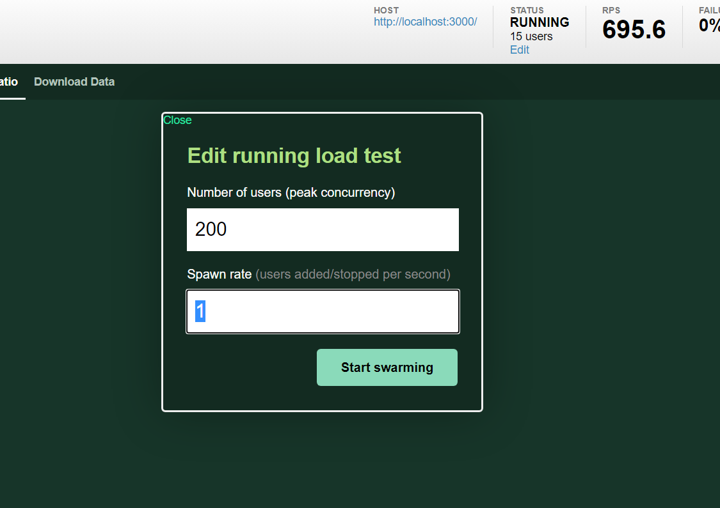

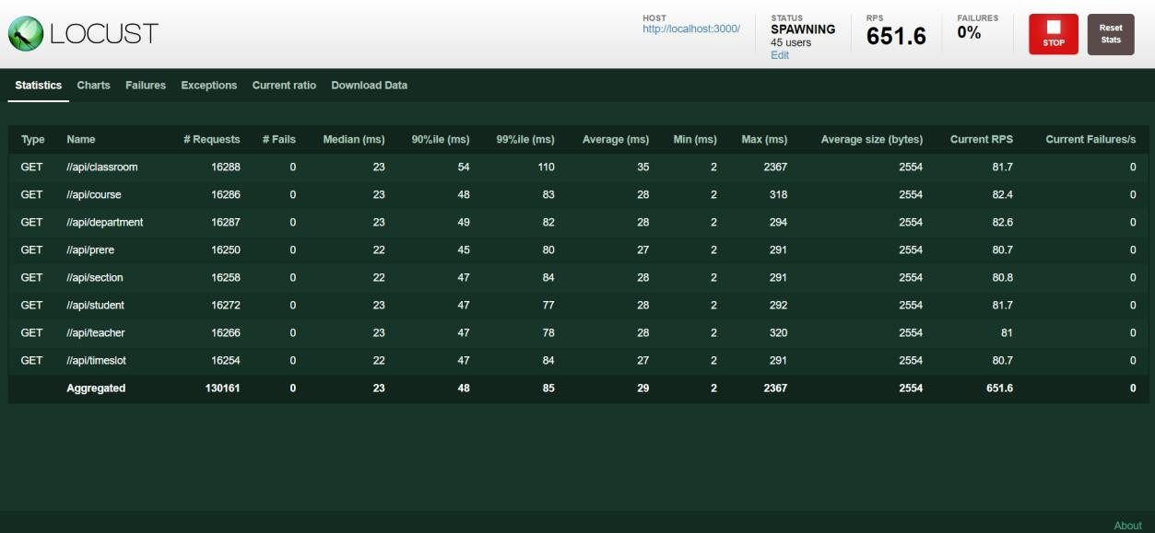

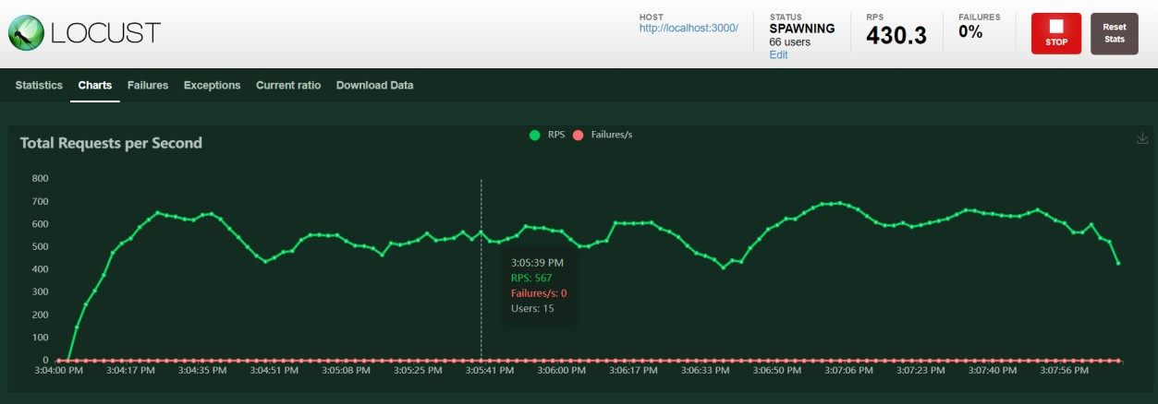

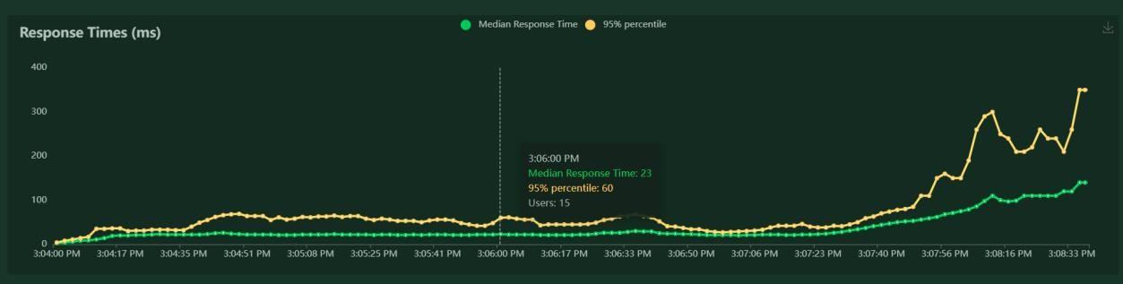

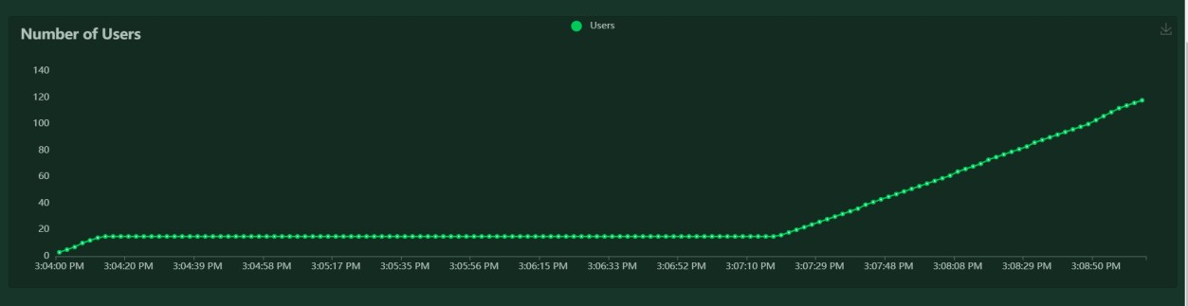

# Conclusion:

From this we get to know how to check performance of the website using locust website, and also get to know if no of users is increased then what is the performance of website.