**SET Assignment – 1**

***Introduction to FOSS***

**1. Differentiate between free software, Open source software and proprietary software with respect to its properties.**

Ans:

**Free Software:** it means that the users have the freedom to run, copy, distribute, study, change, and improve the software. The term “free software” is sometimes misunderstood—it has nothing to do with price. It is about freedom. e.g. Mozilla Firefox, and Moodle.

**Open Source Software:** Open Source Software is something that you can modify as per your needs, and share with others without any licensing violation burden. When we say Open Source, the source code of the software is available publicly with Open Source licenses like GNU (GPL) which allows you to edit the source code and distribute it. Read these licenses and you will realize that these licenses are created to help us. e.g. Linux, VLC Media Player.

**Proprietary Software:** Proprietary software is computer software where the source codes are publicly not available only the company that has created them can modify them. Here the software is developed and tested by the individual or organization by which it is owned not by the public. This software is managed by a closed team of individuals or groups that developed it. We have to pay to get this software and its commercial support is available for maintenance. The company gives a valid and authenticated license to the users to use this software. But this license puts some restrictions on users also like.

**2. Enlist some examples along with their purpose and properties (at least 10) of**

**FOSS and proprietary software with respect to the database.**

Ans:

FOSS

1. MySQL: A free, open-source relational database management system (RDBMS) with a wide range of features such as data storage, indexing, transactions, and more.

2. PostgreSQL: An open-source object-relational database system (ORDBMS) that provides a flexible and powerful platform for managing data.

3. MongoDB: An open-source document-oriented NoSQL database system designed to be highly scalable and able to store large amounts of data.

4. Apache Cassandra: An open-source, distributed NoSQL database system, designed to provide a fault-tolerant, highly available, and consistent data store.

5. Redis: An open-source, in-memory data store that supports a wide range of data structures and is highly performant.

Proprietary

1. Oracle Database: A commercial relational database that provides a wide range of features such as data warehousing, replication, backup and recovery,and analytics.

2. Microsoft SQL Server: A commercial RDBMS from Microsoft that provides a range of features including high availability, scalability, and security.

3. IBM DB2: A commercial relational database system from IBM that provides a wide range of features such as data warehousing, replication, and analytics.

4. SAP HANA: A commercial in-memory database system designed to provide a highly available and reliable data store.

5. Microsoft Access: A commercial database system designed to provide a comprehensive data management system for small businesses and organizations.

**3. Enlist some examples of free open source exam software for online**

**assessment.**

Ans:

· TCExam

· VirtualX

· Moodle

· TAO

· Kaldin

· Papershala

· Edbase

· Mettl

· FlexiQuiz

· Eklavvya

· Think Exam

**4. Demonstrate any one exam software which is open source and freely**

**available.**

Ans:

**FlexiQuiz**

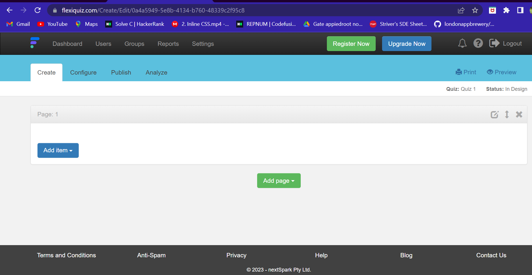

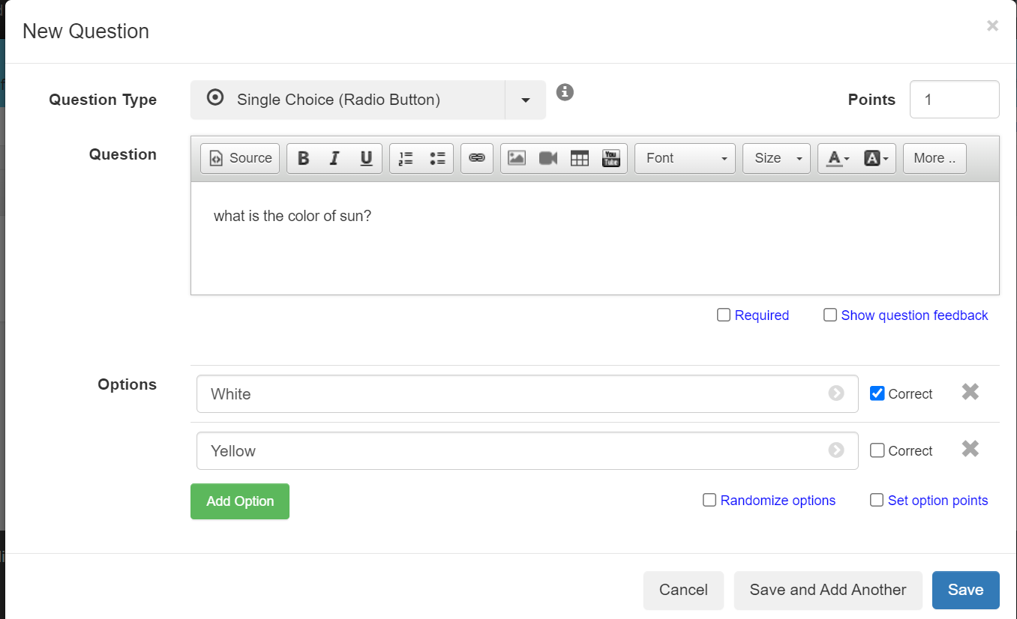

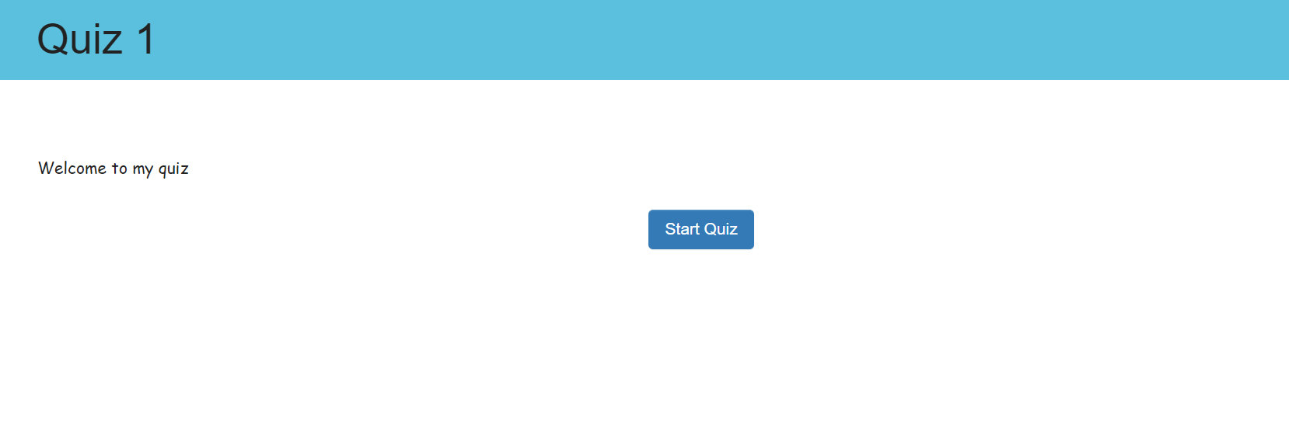

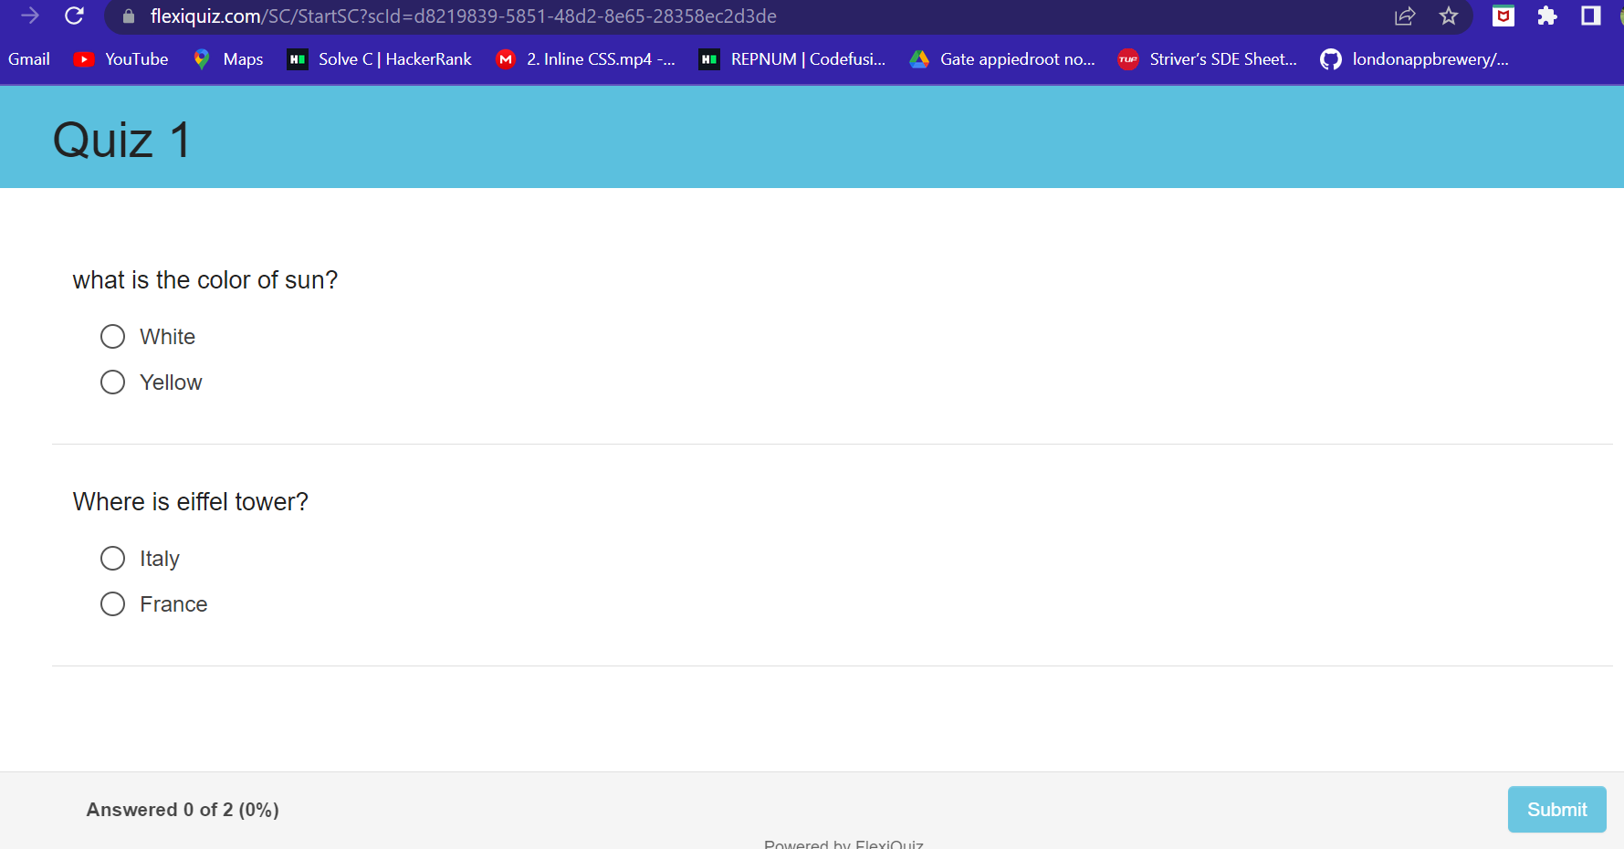

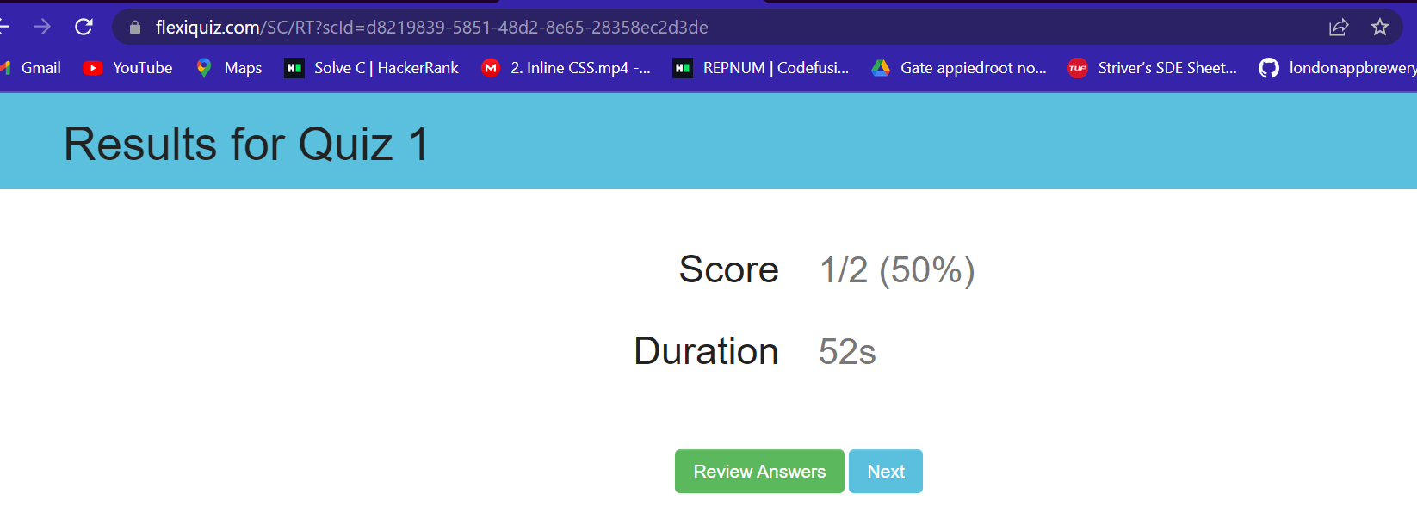

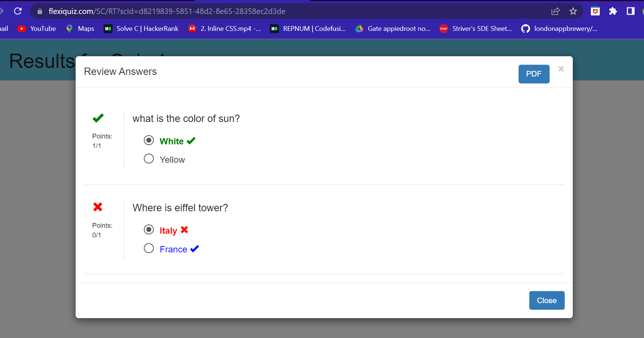

**5. Demonstrate FOSS software related to the database.**

Ans:

**MySQL**

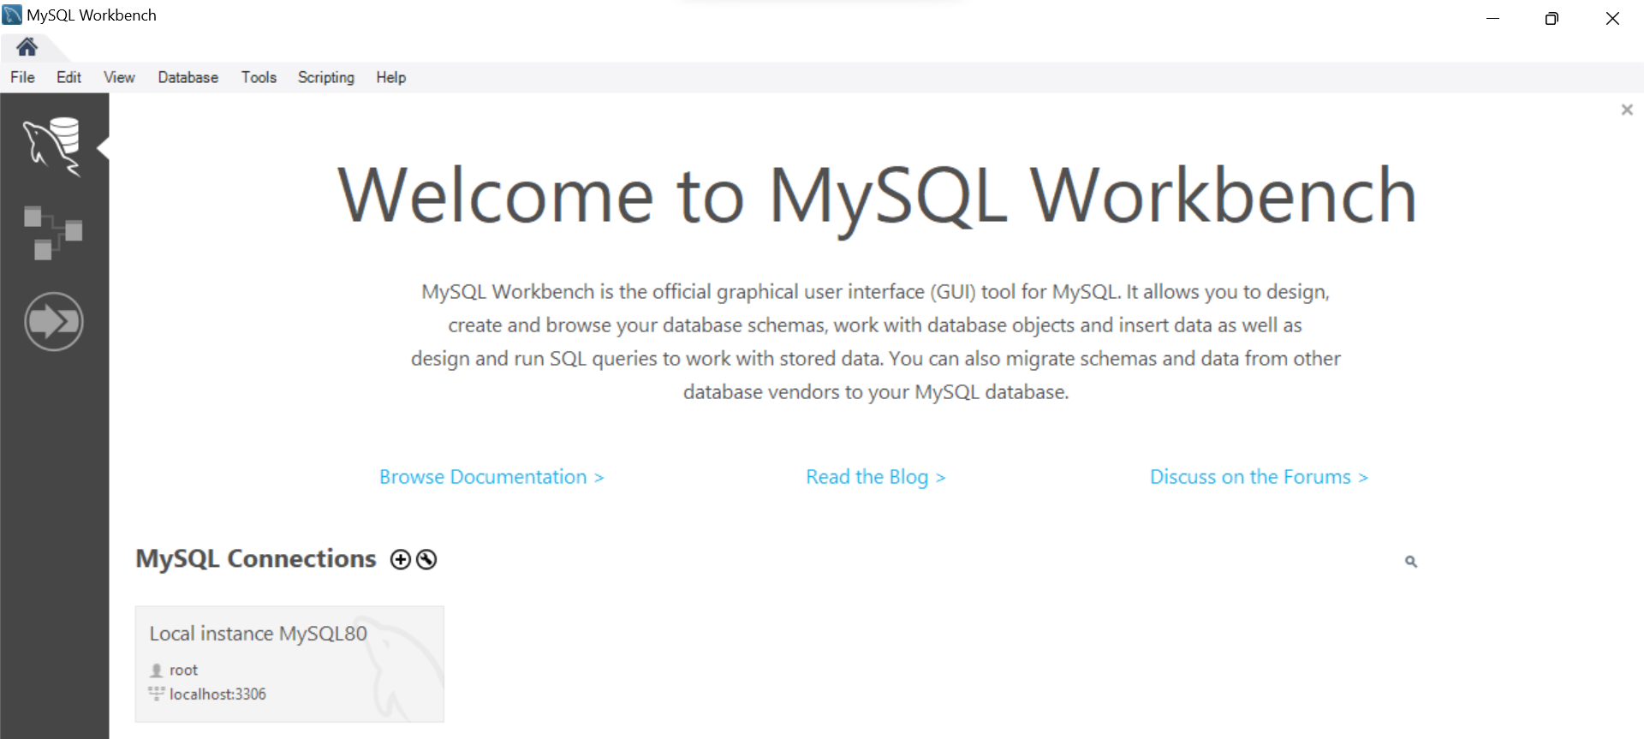

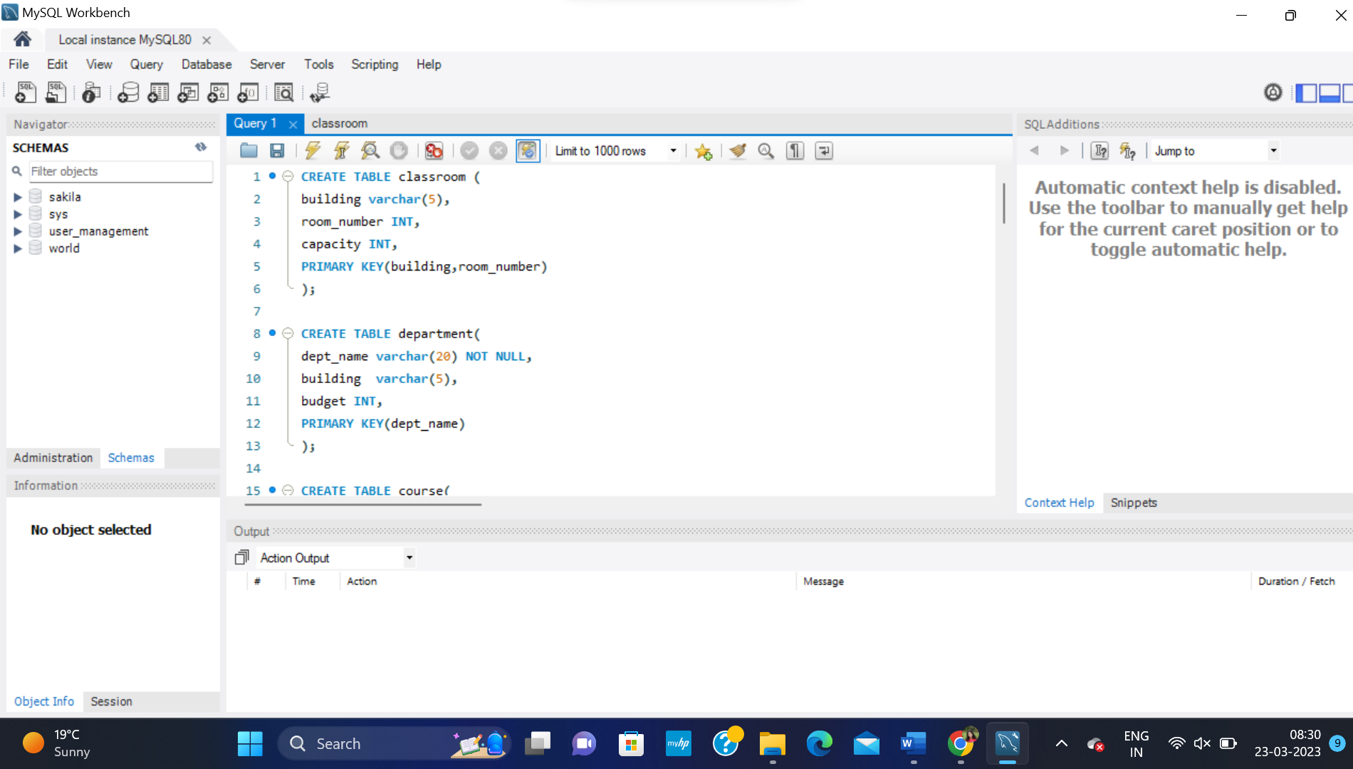

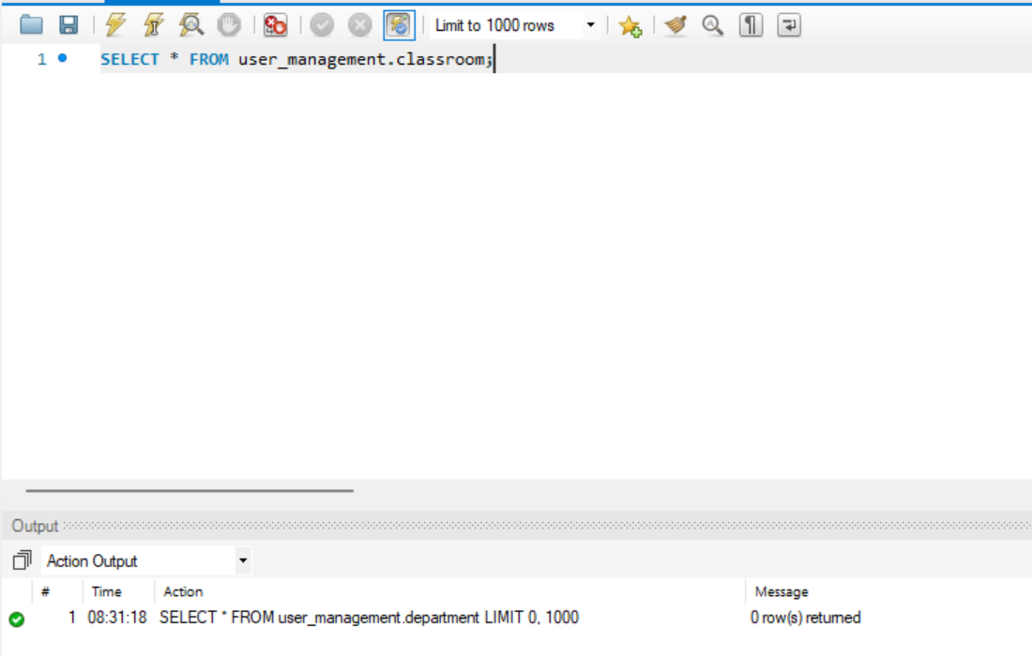

**6. How does the Exam software work?**

Ans :

Exam software is designed to facilitate the delivery and processing of online exams and assessments. It provides a secure environment for students to take their tests and quizzes, as well as providing instructors with the tools to create and deliver exams and monitor student progress. The exam software is typically broken down into two main parts: the student interface and the instructor interface. The student interface is the portion of the software that students use to take their exams. This typically includes login credentials, access to the exam questions, and in some cases, a timer to keep track of the amount of time students have to take the exam. The instructor interface is used by instructors to manage the exams. This includes creating exam questions, setting parameters for the exam (such as time limits and required passing scores), and monitoring student performance. The instructor interface also typically includes reporting and analytics, to allow instructors to get a deeper understanding of how students are performing on the exams. Overall, exam software is a powerful tool for both instructors and students, providing a secure and streamlined platform for testing and assessment