Load hospital_quearterly_measures.csv file into HDFS.

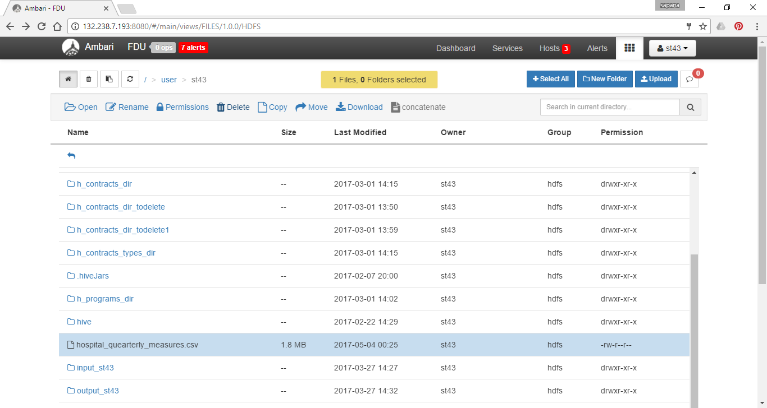

Make a connection to server

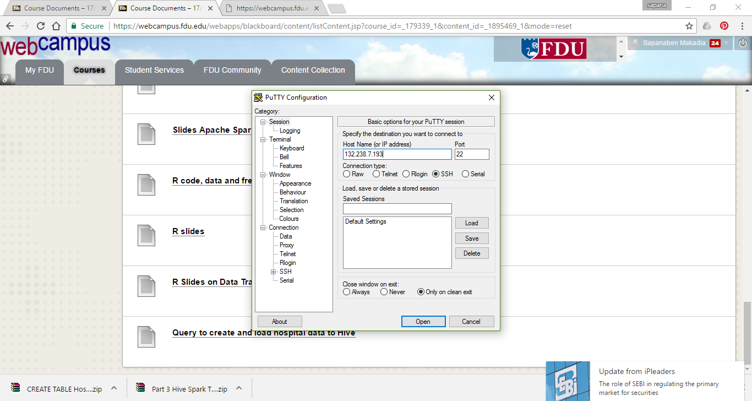

Connect to hive

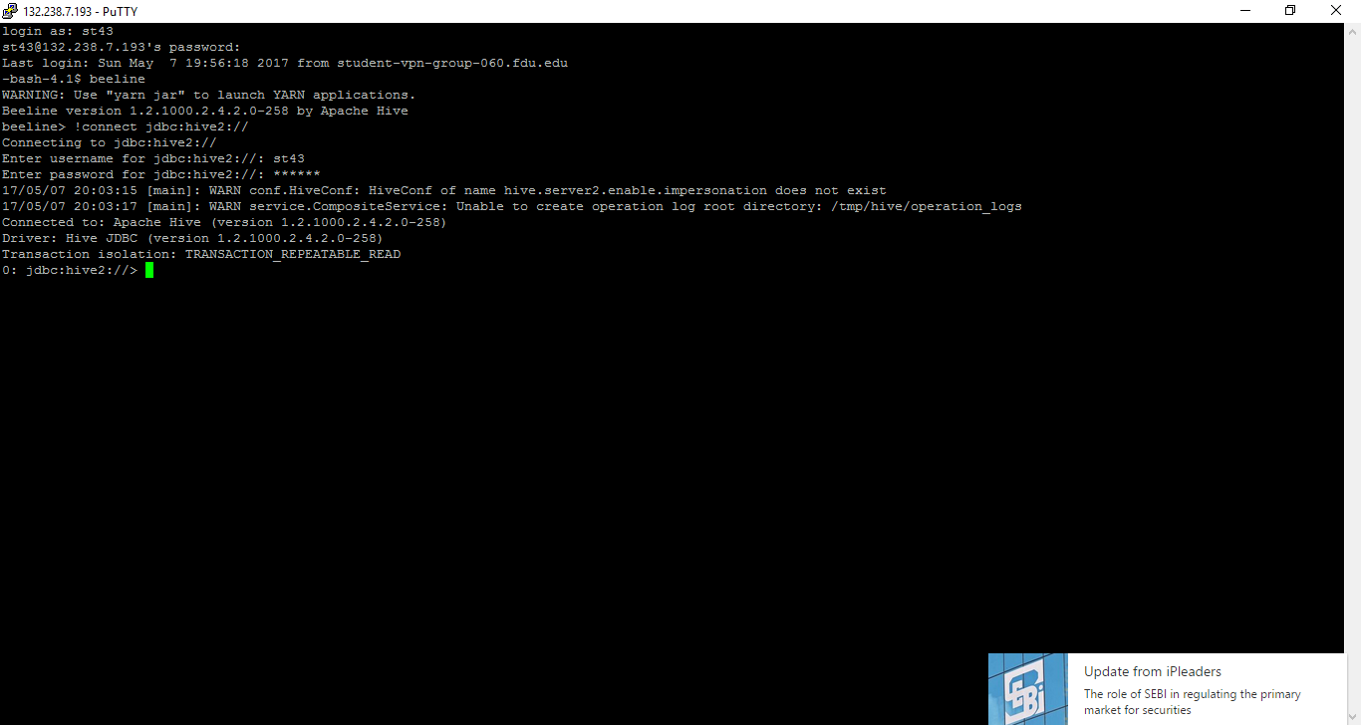

Create new database called tableau_st43

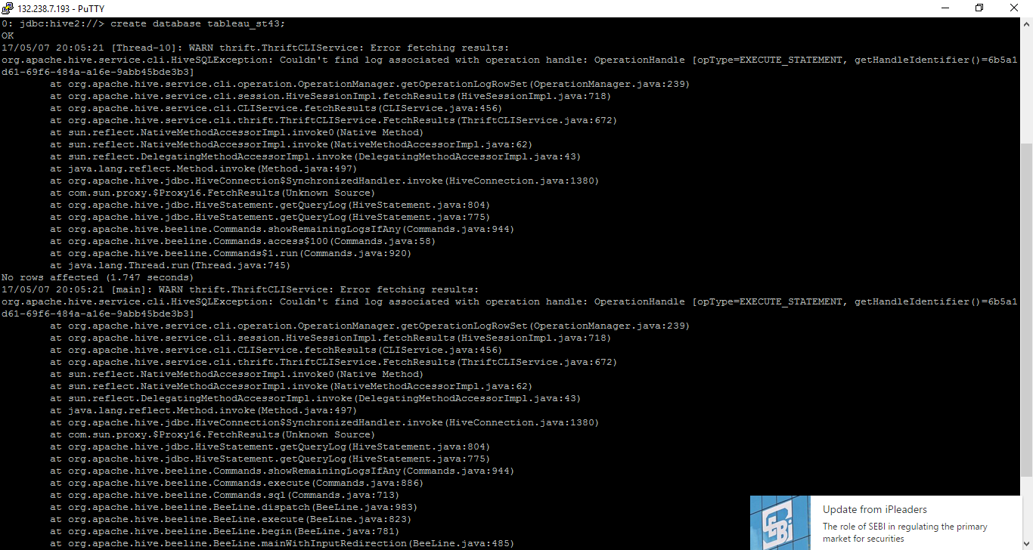

Use that database

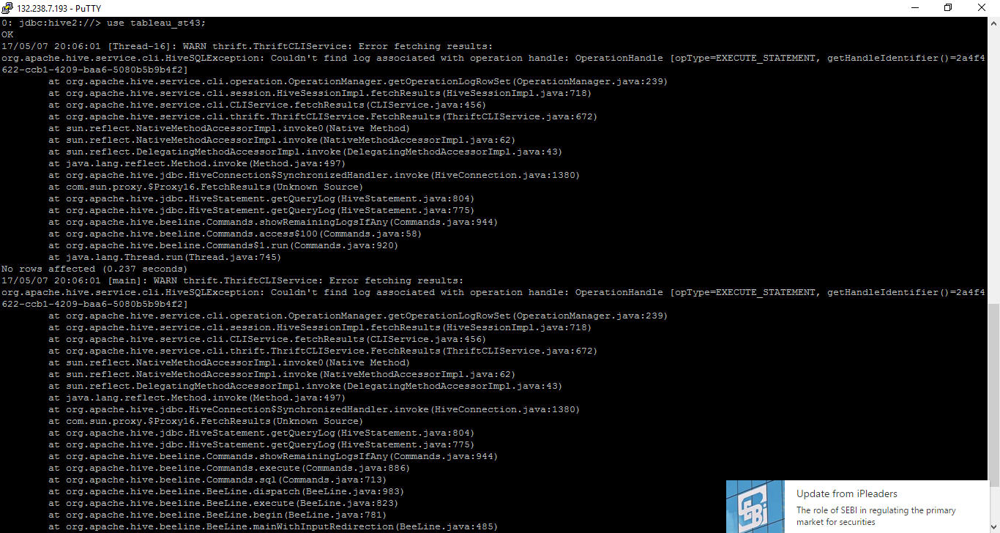

Create new table called Hospital

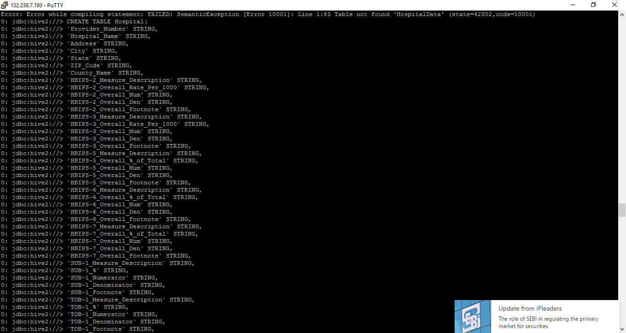

Make sure Table is there or not

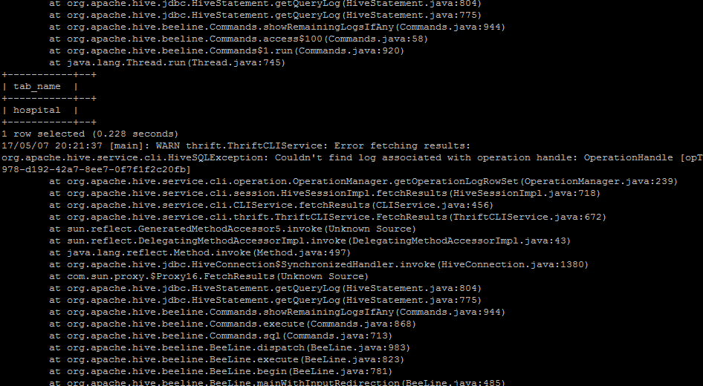

Load data into that table

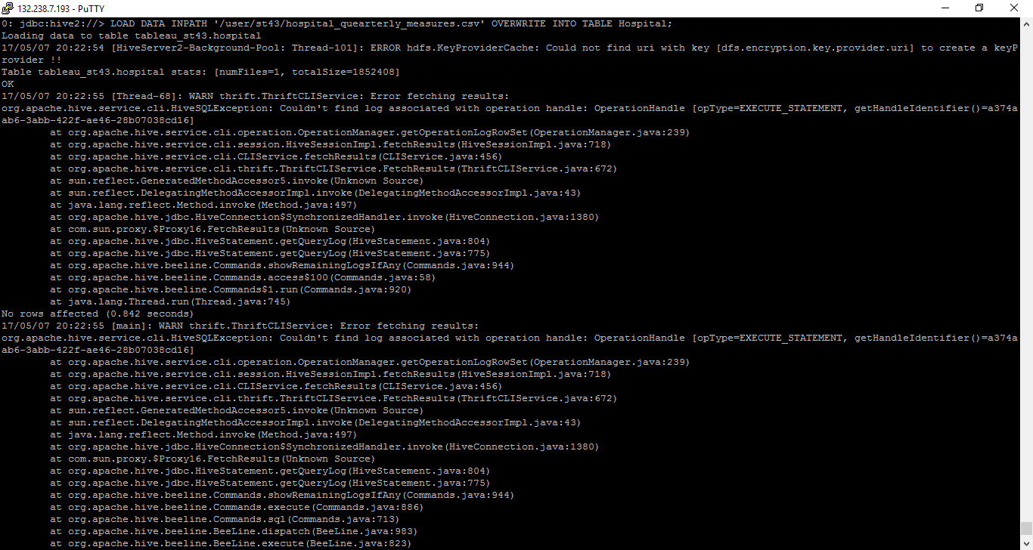

Make connection to Hive from Tableau

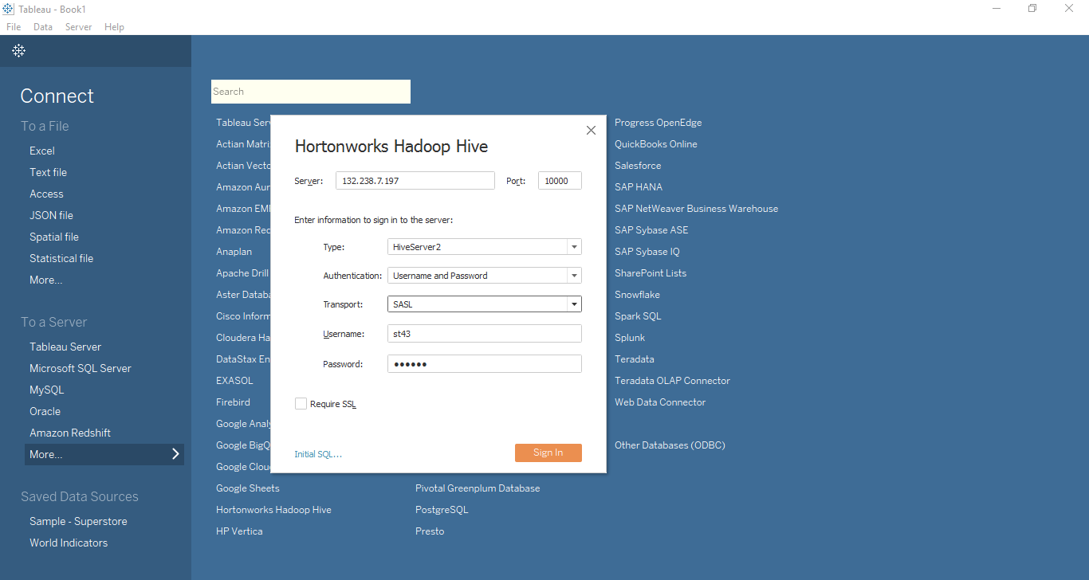

First you need to install drivers for Hortonworks hive ODBC

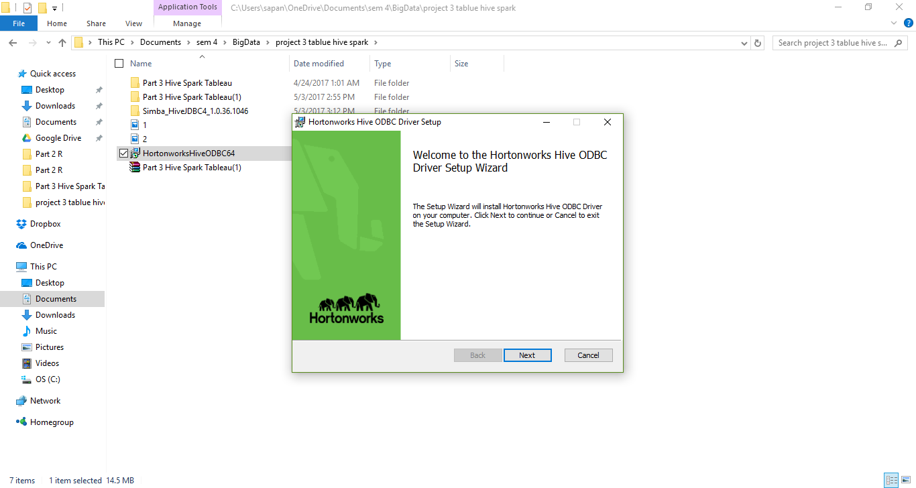

Select the schema which is come up a your database name

Then choose table that you want

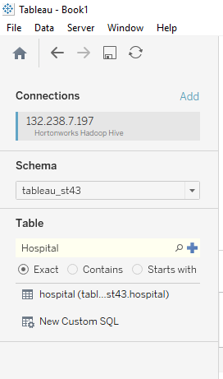

Now you can see the data source of that table

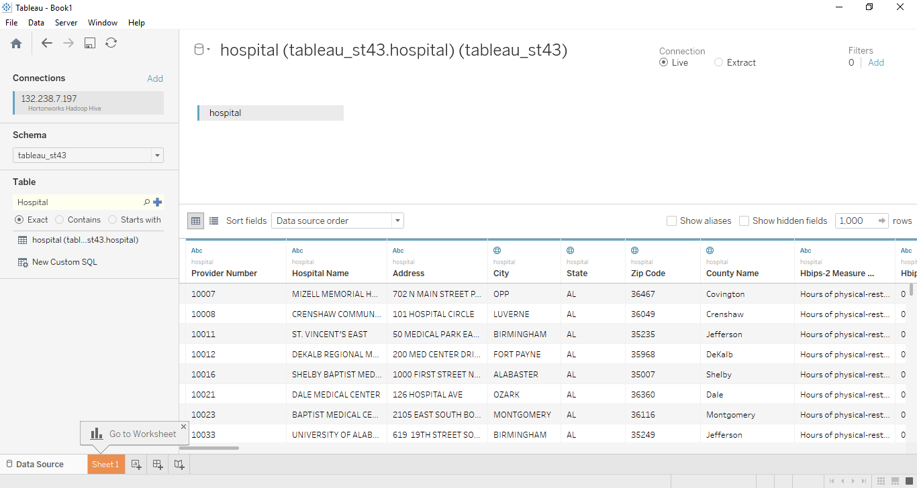

**Analysis:**

Number of hospitals per state

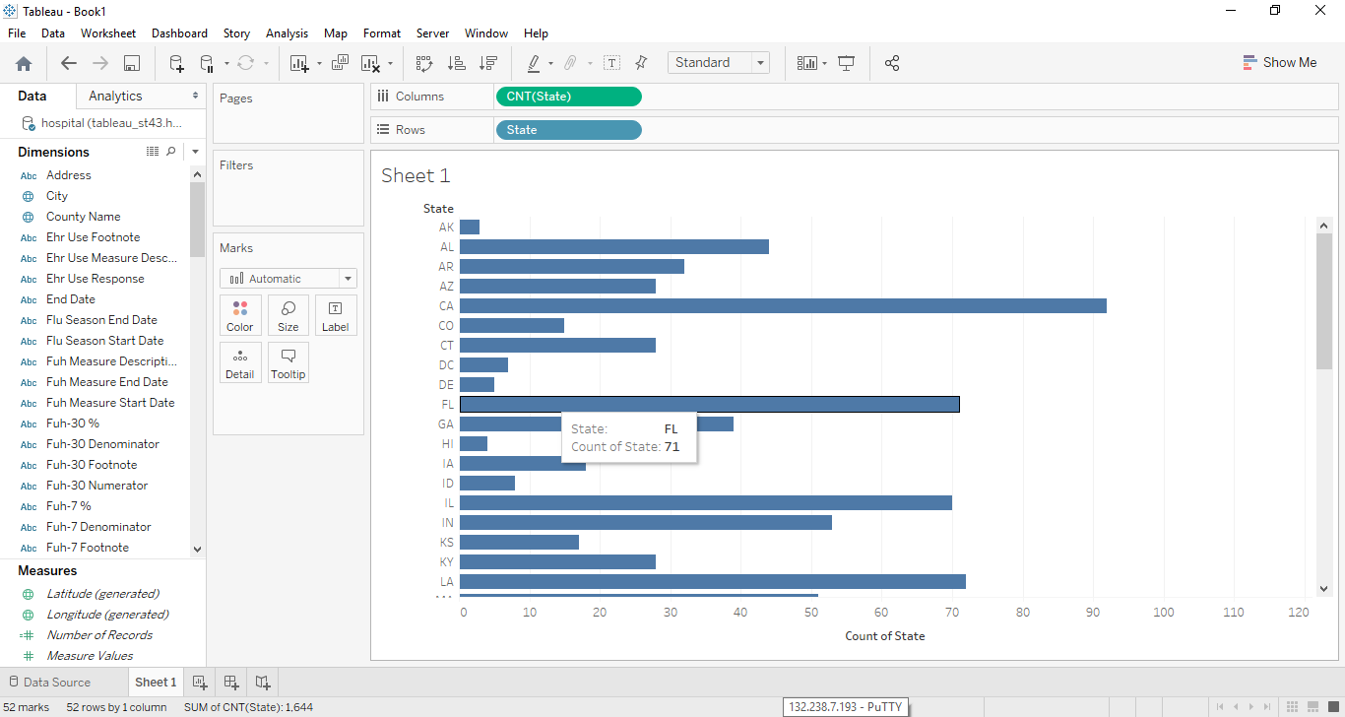

Top 10 states with the largest number of hospitals

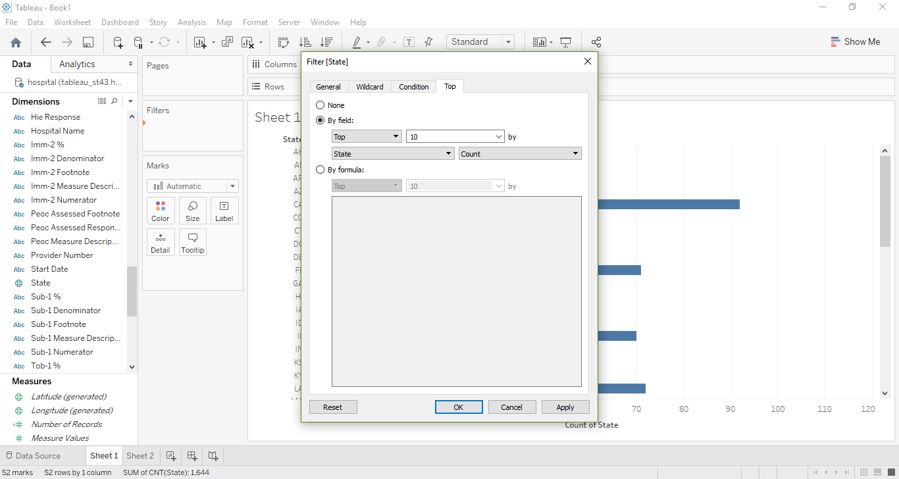

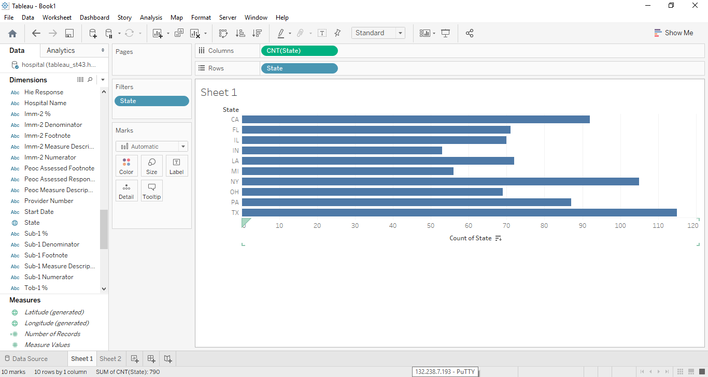

Bottom 10 smallest number of hospitals per state

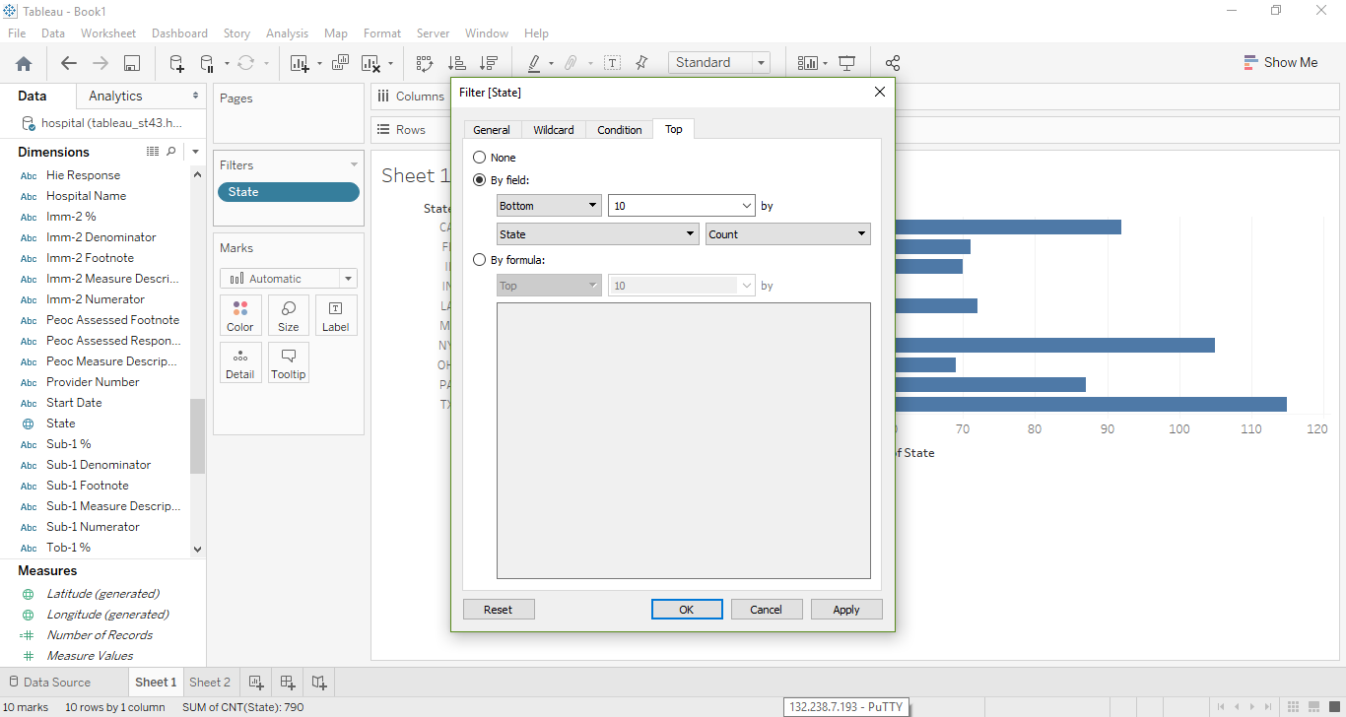

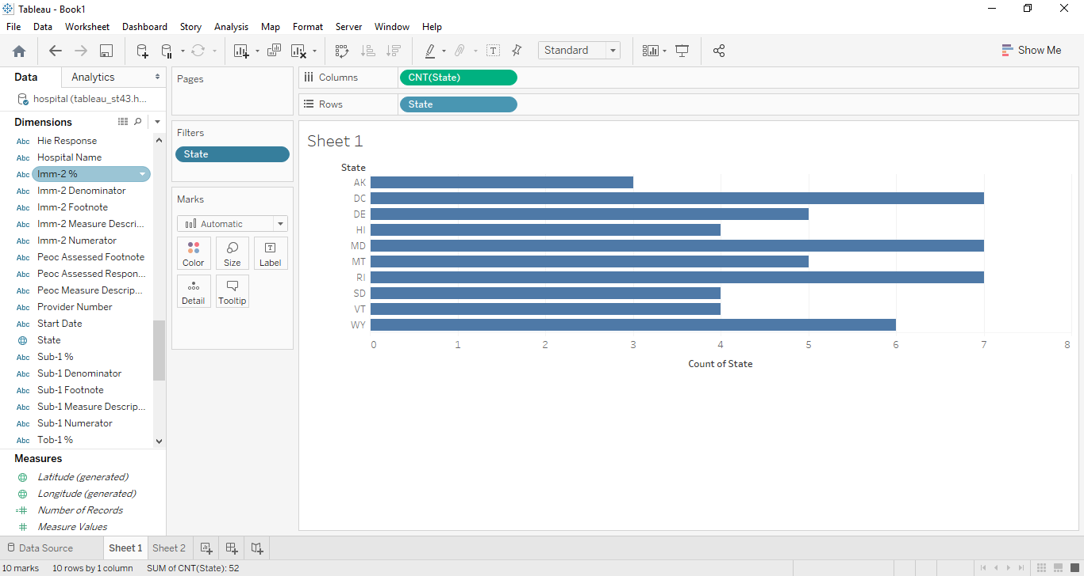

Number of hospitals per city/state

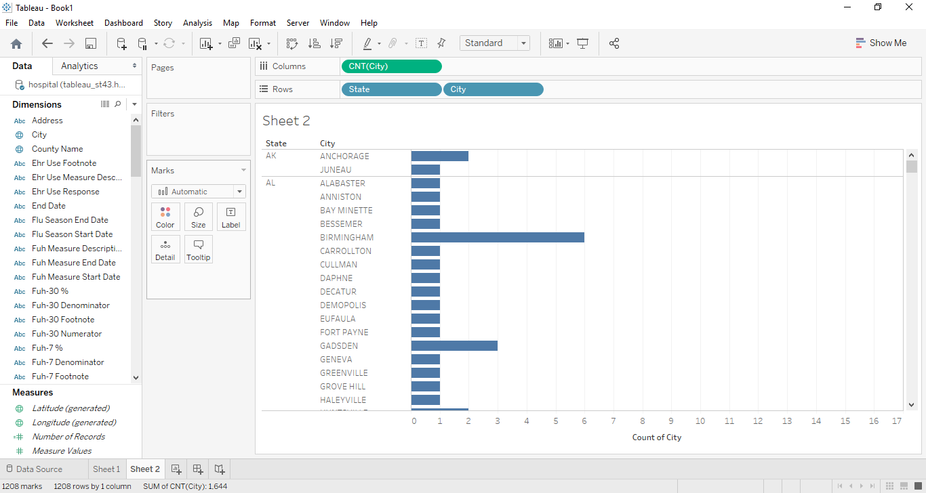

Top 10 city/state combinations with the largest amount of hospitals

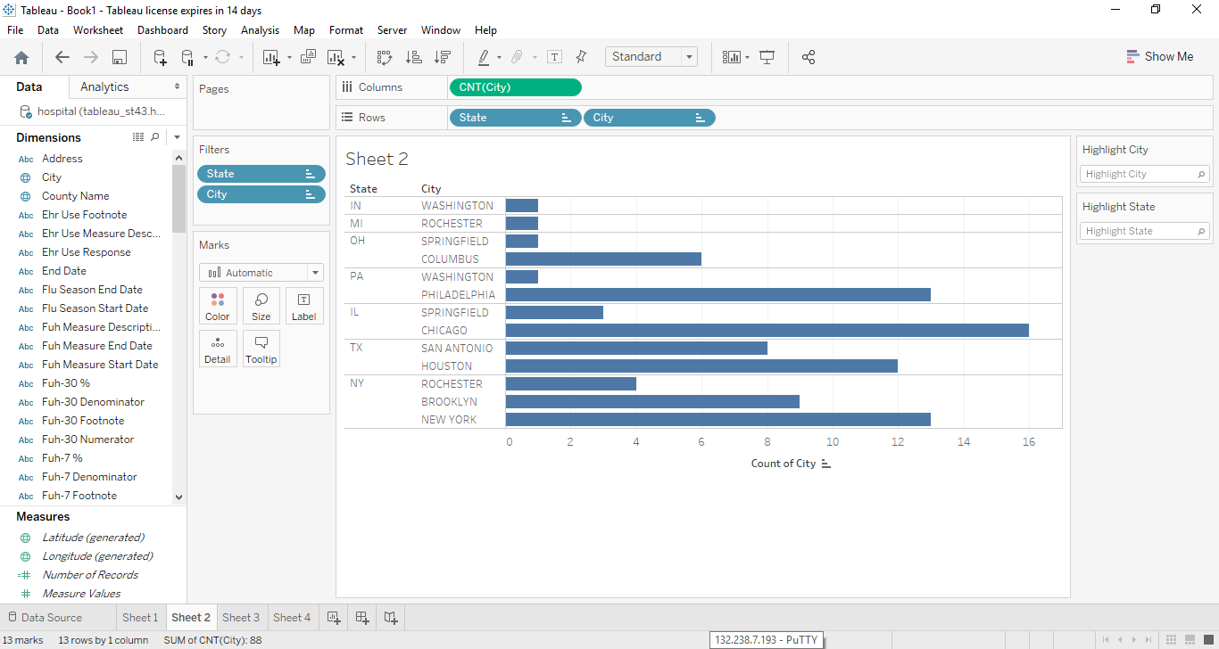

Bottom 10 smallest number of hospitals

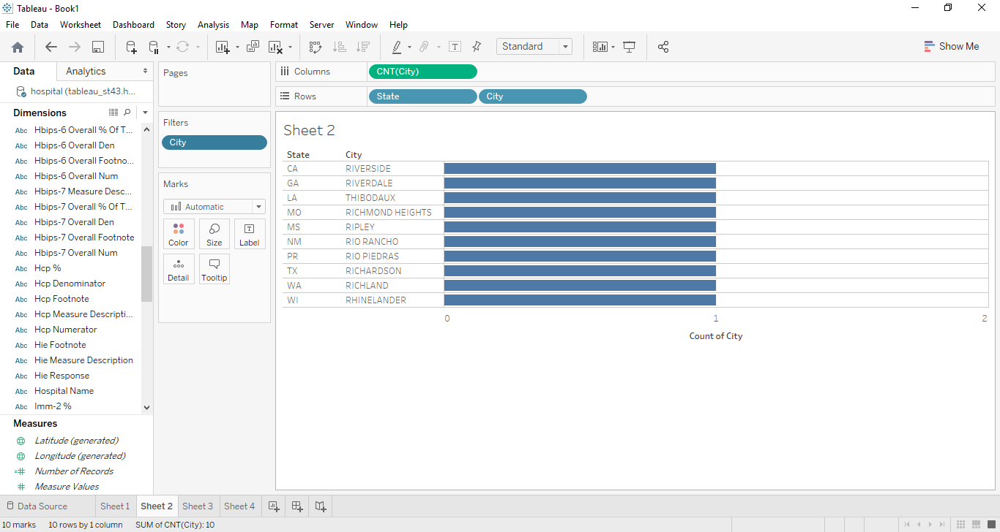

Number of hospitals per Zip

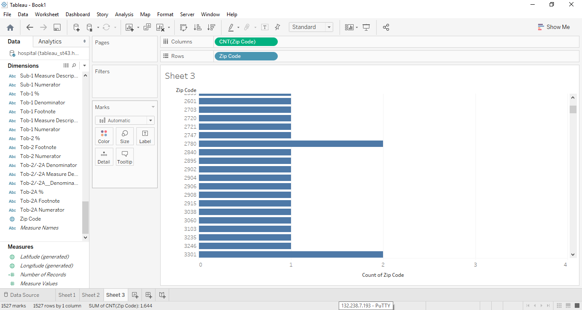

Top 10 zip codes with the largest number of hospitals

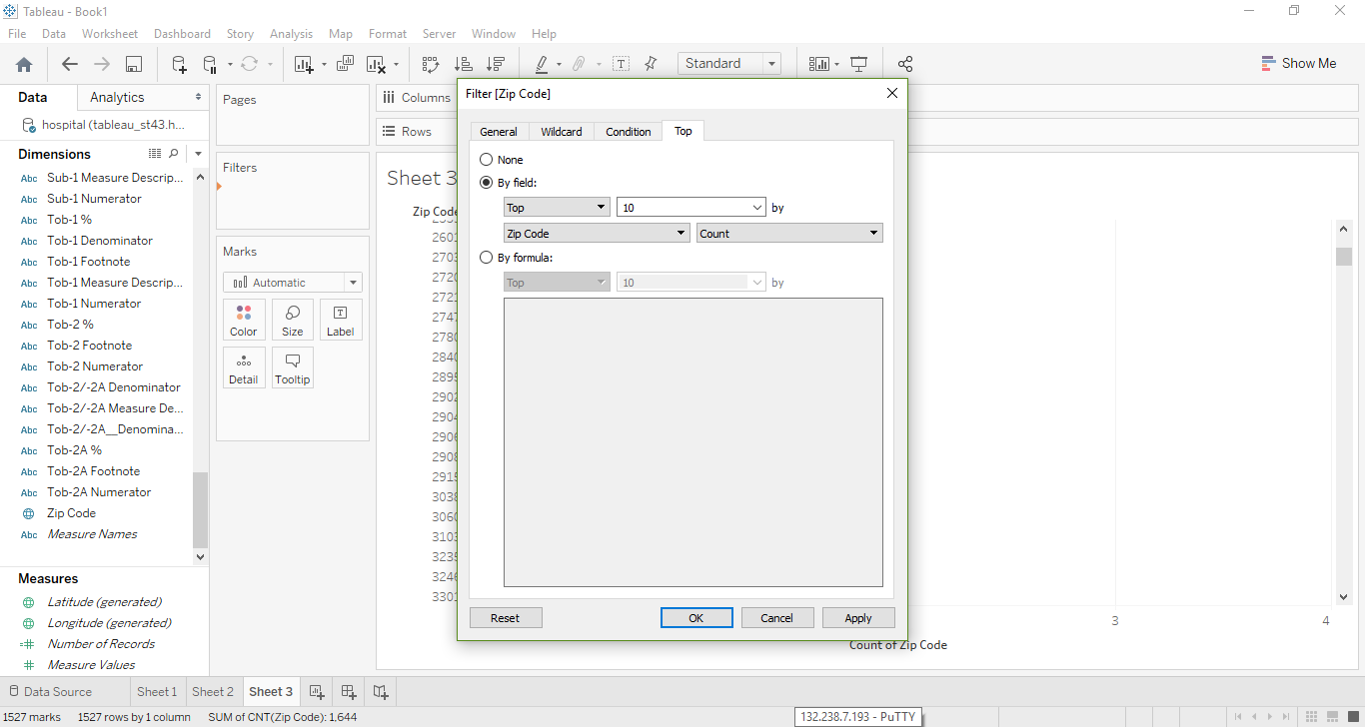

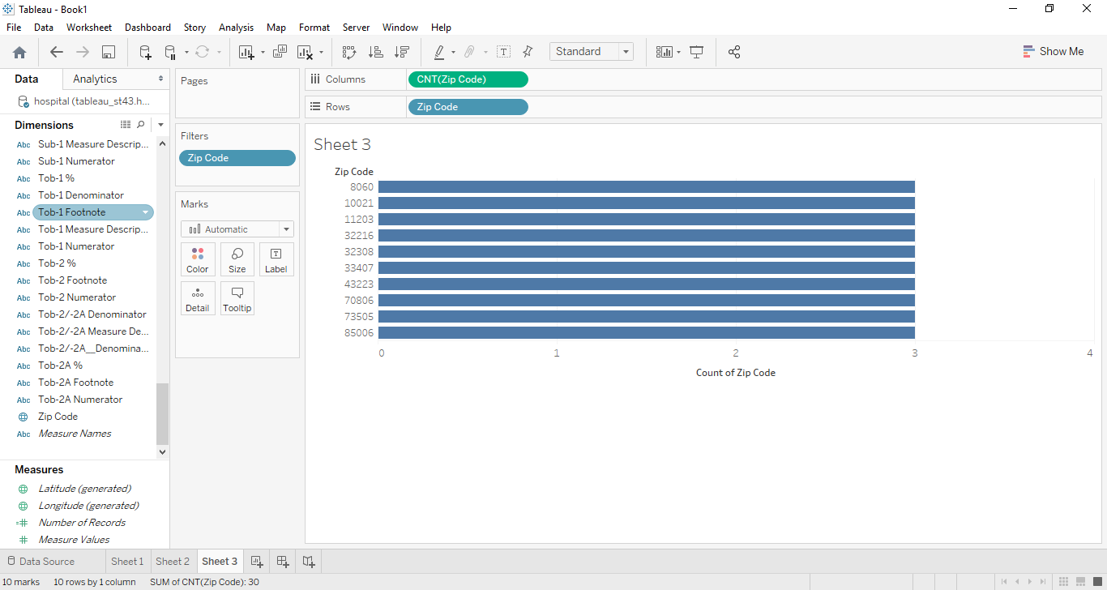

Bottom 10 smallest number of hospitals

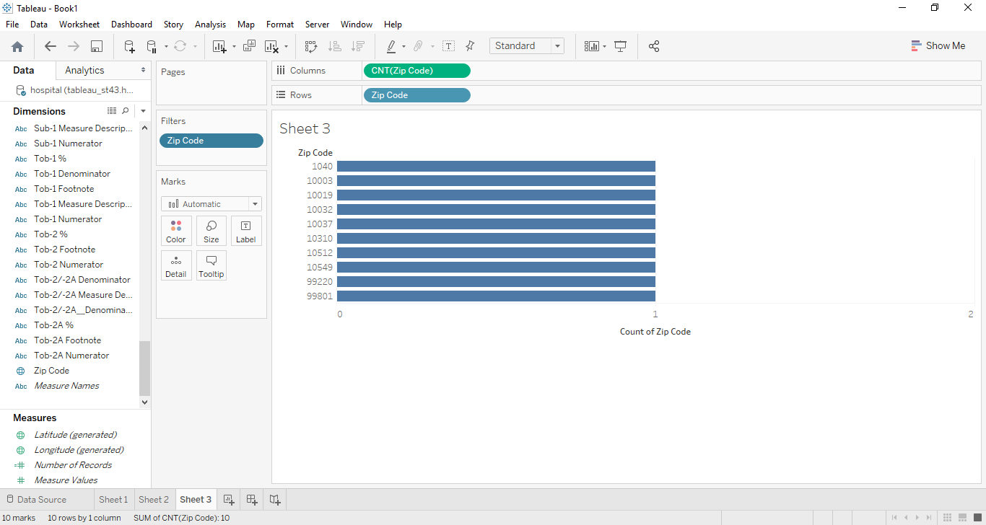

Build a bar chart showing hospitals and their corresponding values from column

HBIPS-2_Overall_Den.

Allow filtering by State (add a slider)

Allow filtering by the first letter of a hospital name. Use an appropriate control()

