LECTURE 05 — COMPLETE MASTER NOTES
AI History · Machine Learning · Deep Learning · Backpropagation
Python Libraries · Full Assignment Guide · Real-World Deployment
IIT Kharagpur | Gen AI & Agentic AI Course

HOW TO USE THIS DOCUMENT: Part 1 = all lecture content in order. Part 2 = full assignment walkthrough with production context.
PART 1: LECTURE CONTENT ▬▬▬
▬▬▬ PART 1: LECTURE CONTENT ▬▬▬

1. A Brief History of Artificial Intelligence
AI was not built in a day. It took 70 years of cycles — excitement, funding, collapse, and revival — to reach where we are today. Knowing this history helps you understand WHY modern deep learning works when everything before it failed.
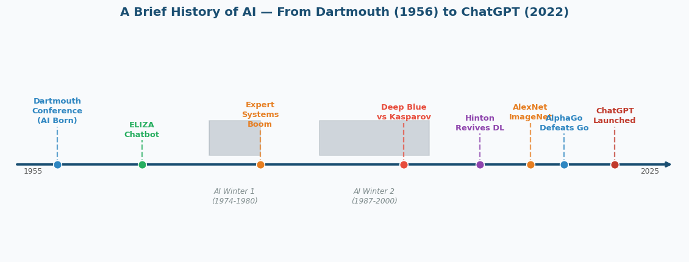
Figure 1: AI Timeline — Dartmouth (1956) to ChatGPT (2022)

Year | Event | What It Means For You
1956 | Dartmouth Conference | Birth of AI. John McCarthy coined the term. The founding belief: every aspect of intelligence can be described precisely enough to be simulated by a machine.
1966 | ELIZA — First Chatbot | Showed computers could hold basic conversations using pattern-matching rules. No real understanding — just if-then responses. The first "AI winter" followed when people realised its limitations.
1970s | First AI Winter | Funding collapsed. GOFAI (rule-based AI) could not scale. Governments pulled funding. AI was considered overhyped.
1980s | Expert Systems Boom | Rule-based AI was commercialised. Companies spent billions. Worked on narrow problems but completely brittle — could not handle real-world complexity.
1987–2000 | Second AI Winter | Expert systems failed to generalise. Massive funding cuts. AI labs shut down. The field was largely abandoned.
1997 | Kasparov vs Deep Blue | IBM's computer beat the world chess champion. AI could now beat humans at specific games — but by brute-force search, not intelligence.
2006 | Hinton Revives DL | Geoffrey Hinton published work showing deep neural networks could be trained effectively. The modern deep learning era began.
2012 | AlexNet Wins ImageNet | Deep learning crushed previous methods at image recognition. GPU + big data + deep nets = revolution. Error rate dropped from 26% to 15% overnight.
2016 | AlphaGo Beats Lee Sedol | AI beat the world Go champion. Go was considered impossible for machines — too many possible moves. AlphaGo used deep RL, not just rules.
2022 | ChatGPT Launches | Large Language Models reached the public. AI became mainstream overnight. 100 million users in 2 months — fastest product adoption in history.

🔍 ANALOGY — AI Boom-and-Winter Cycles
Think of AI like ocean waves on a beach.
Each wave (boom) builds higher than the previous one.
But between waves, the water pulls back (winter) — less funding, less enthusiasm.

We are currently on the BIGGEST wave ever because three things finally aligned:
1. MASSIVE DATA — the internet created Zettabytes of training data
2. COMPUTING POWER — GPUs made matrix multiplication 1000x faster
3. BETTER ALGORITHMS — backprop + deep learning finally worked at scale

Without all three together, deep learning would not work. That is why it only took off now.

2. What Is Artificial Intelligence? The 4-Quadrant Framework
Professor Ganguly introduced a framework (from the textbook "Artificial Intelligence: A Modern Approach" by Russell & Norvig). AI can be defined by two dimensions: WHAT it does (Think vs Act) and HOW it measures success (Human-like vs Rational).
Quadrant | Core Idea | Who Defined It | Example
Think Humanly | Automate activities associated with human thinking — decision making, problem solving, learning | Bellman (1978) | Early cognitive science models
Think Rationally | Use formal logic and mathematical rules to reason | Charniak & McDermott (1985) | Predicate logic theorem provers
Act Humanly | Behave like a human — pass the Turing Test | Turing (1950) | ELIZA chatbot, modern LLMs in chat
Act Rationally ★ MODERN AI | Achieve the best possible outcome — even if not human-like | Wierzbicki (1990) | AlphaGo, self-driving cars, ChatGPT

💡 CONCEPT — Modern AI = Act Rationally
The fourth quadrant — Act Rationally — is where modern AI lives.
AlphaGo plays Go better than any human, but it does NOT play like a human.
It plays whatever move gives the highest probability of WINNING.

This is the crucial insight: AI does not need to mimic humans.
It just needs to achieve the best outcome for the given task.
In some domains (chess, Go, protein folding), it now does this BETTER than humans.

2a. The Turing Test (1950)
Alan Turing proposed a test: a human judge communicates via text with both a human and a machine. If the judge cannot reliably tell which is which, the machine is considered "intelligent."
🏢 REAL LIFE — Turing Test in 2025
Modern LLMs (GPT-4, Claude) routinely pass informal Turing tests.
In 2023, multiple studies showed humans could not reliably distinguish GPT-4 from a human in text chat.

But the Turing Test is now considered LIMITED as a benchmark:
• It measures human-likeness, not true understanding
• A very good actor (or autocomplete) can pass without "thinking"
• The more interesting question: can AI REASON, not just respond?

3. Good Old Fashioned AI (GOFAI) — Before Machine Learning
Before ML, all AI was built by explicitly encoding human knowledge into rules. Three main approaches emerged. All eventually failed for the same core reason: they required humans to specify EVERYTHING.
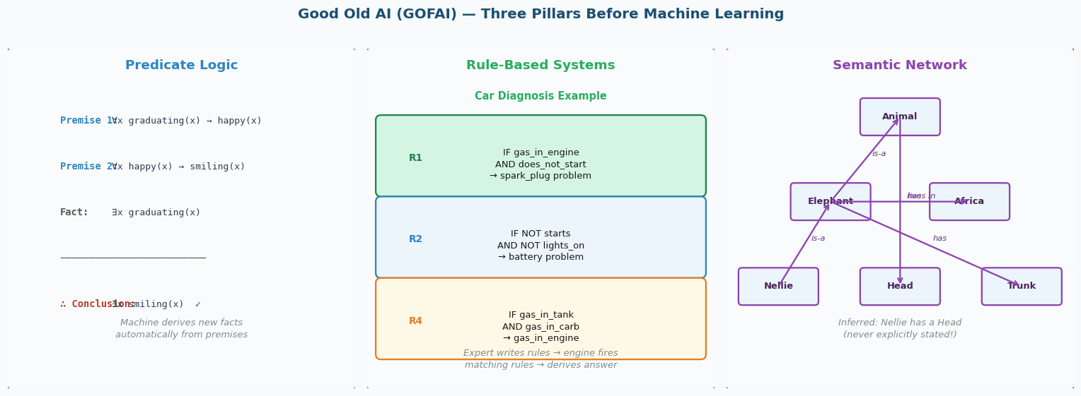
Figure 2: GOFAI — Predicate Logic, Rule-Based Systems, Semantic Networks

3a. Predicate Logic — Formal Symbolic Reasoning
Real-world knowledge is expressed as mathematical predicates. A reasoning engine applies deduction rules to derive new facts automatically from existing ones.
💡 CONCEPT — Logic Example (directly from lecture slides)
PREMISE 1: ∀x graduating(x) → happy(x) [All graduating people are happy]
PREMISE 2: ∀x happy(x) → smiling(x) [All happy people smile]
FACT: ∃x graduating(x) [Someone is graduating]
─────────────────────────────────────────────────────────
DERIVED: ∴ ∃x smiling(x) ✓ [Therefore: someone is smiling]

The computer derived the conclusion by applying formal rules.
No one told it "someone smiles" — it figured it out from the logical structure.

3b. Rule-Based Expert Systems — If-Then Knowledge
Expert knowledge is encoded as IF-THEN rules. A rules engine fires matching rules and chains them together to reach conclusions. This was commercially deployed in the 1980s.
💡 CONCEPT — Car Diagnosis System (from lecture)
R1: IF gas_in_engine AND does_not_start → problem(spark_plug)
R2: IF NOT starts AND NOT lights_on → problem(battery)
R3: IF NOT turns_over AND lights_on → problem(starter)
R4: IF gas_in_tank AND gas_in_carb → gas_in_engine

Given facts: gas_in_tank=TRUE, gas_in_carb=TRUE, does_not_start=TRUE
Step 1: R4 fires → gas_in_engine = TRUE
Step 2: R1 fires → problem(spark_plug) = TRUE ✓

This is chaining: one rule fires and enables the next.

3c. Semantic Networks — Knowledge Graphs
Knowledge is stored as a graph where nodes are concepts and edges are relationships. New facts can be inferred by traversing the graph. This is the ancestor of modern knowledge graphs used by Google.
💡 CONCEPT — Semantic Network — What It Infers
Graph: Nellie → is-a → Elephant → is-a → Animal → has → Head
Elephant → lives-in → Africa
Elephant → has → Trunk

What the system INFERS automatically (never stated directly):
→ Nellie has a Head (Nellie is-a Elephant is-a Animal has Head)
→ Nellie lives in Africa (Nellie is-a Elephant lives-in Africa)
→ Nellie has a Trunk

Just by traversing edges — no human had to list these facts about Nellie.

3d. Why GOFAI Failed — The Root Cause
Problem | What Happened | Concrete Example
Semantic Ambiguity | Computers understood symbols but not meaning | "The spirit is willing but the flesh is weak" → Russian translation → "The vodka is good but the meat is rotten"
Brittleness | Rules broke on edge cases and uncertainty | "Car starts for 2 seconds then stops" — no rule covered this partial failure
Scalability | Toy problems worked; real problems did not | Diagnosing one car problem worked. Handling all possible real-world car faults? Impossible.
Static Knowledge | Rules had to be written and updated by experts | Every new domain (medical, legal, financial) needed a new team of experts at enormous cost
No Uncertainty Handling | Everything was TRUE or FALSE — no probabilities | Real world: "probably malignant", "likely fraud" — binary rules cannot express this

✅ KEY TAKEAWAY — The Key Insight That Led to Machine Learning
GOFAI failed because it tried to program intelligence TOP-DOWN:
Human expert → writes rules → computer follows rules → output

Machine Learning flips this:
Raw data + correct answers → algorithm learns rules → output

Deep Learning goes even further:
Raw data + correct answers → neural network learns BOTH features AND rules → output

The human expert was removed from the loop entirely.

4. Machine Learning — What It Is and Why It Works Now
Machine Learning was formally defined by Tom Mitchell in 1997: "A computer program is said to learn from experience E with respect to some task T and some performance measure P if its performance on T, as measured by P, improves with experience E."
💡 CONCEPT — Mitchell's Definition — Unpacked for Breast Cancer
Task T: Classify a tumour as malignant or benign
Experience E: 569 labelled patient records (30 measurements each)
Performance P: Recall score on the test set (did we catch all malignant cases?)

The model IMPROVES its performance P on task T as it sees more examples E.
That is it. That is machine learning in one sentence.

4a. Data — The Fuel That Makes ML Work
The third AI boom was powered by DATA. The internet created digital data at a scale never previously seen in human history.
Data Fact | Number | Why It Matters for ML
Emails sent per day | 333 billion+ | Vast text data for language models
Google searches per day | 8.5 billion | User intent and behaviour at scale
Data generated in last 2 years | ~90% of ALL data ever created | Exponential growth from smartphones and IoT
Labelled data | <1% of all data | The bottleneck — supervised learning needs labels

Data Type | Description | ML Examples
Categorical | Discrete labels, no numeric order | Pass/Fail, Spam/Not-Spam, Dog/Cat/Bird, Benign/Malignant
Ordinal | Ordered categories but no fixed numeric spacing | Small/Medium/Large, Star ratings 1-5, Education level
Continuous (Numerical) | Real numbers with meaningful arithmetic spacing | House price, temperature, mean tumour radius, exam marks

🏢 REAL LIFE — You Generate Training Data Every Day
Every time you: search Google, watch Netflix, buy on Amazon, use WhatsApp, scroll Instagram —
you are generating data that companies collect and use to train their models.

This is not abstract. Your Netflix watch history trains their recommendation model.
Your Google searches refine their ranking model.
Your Amazon purchases improve their recommendation engine.
ML runs on YOUR data — you are both the user and the training set.

5. Python Libraries — Your ML Toolkit
The lecture explicitly covers three Python libraries. You will use these in EVERY ML project you build. Think of them as:
NumPy = the foundation (math with arrays)
Pandas = the data table tool (load, explore, clean)
Matplotlib = the visualiser (plot anything)
scikit-learn = the ML algorithms (train, predict, evaluate)
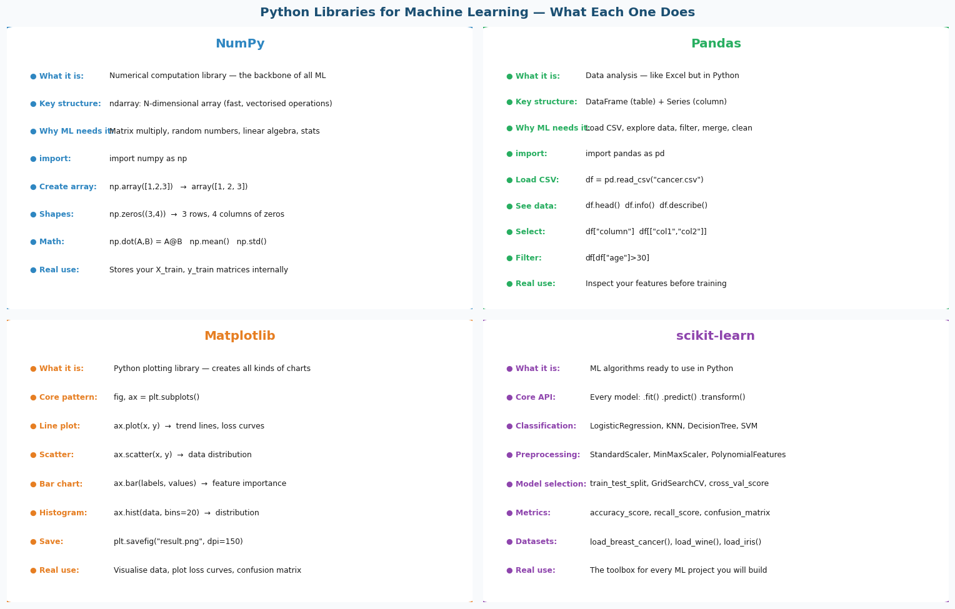
Figure 3: Python Libraries — What Each One Does and When to Use It

5a. NumPy — Numerical Python (The Foundation of ML)
NumPy provides the ndarray — an N-dimensional array — and fast mathematical operations on it. Every ML library (scikit-learn, TensorFlow, PyTorch) is built on NumPy arrays.
# Install: pip install numpy
import numpy as np

# Create arrays (like lists, but MUCH faster for math)
a = np.array([1, 2, 3, 4, 5]) # 1D array
b = np.zeros((3, 4)) # 3 rows, 4 columns of zeros
c = np.ones((2, 3)) # 2 rows, 3 columns of ones
r = np.random.randn(100, 30) # 100 samples, 30 features (random)

# Why it matters for ML: your X_train IS a numpy array
print(X_train.shape) # → (398, 30): 398 samples, 30 features
print(X_train.dtype) # → float64: numbers with decimals

# Key operations used in ML:
np.mean(X_train, axis=0) # mean of each feature (column)
np.std(X_train, axis=0) # std dev of each feature
np.dot(X, w) # matrix multiply: the forward pass computation
np.argmax(probs) # find class with highest probability

# Indexing (very common in ML code):
X_train[0] # first sample (row 0)
X_train[:, 2] # third feature for ALL samples (column 2)
X_train[y==1] # all malignant samples (boolean mask)

🏢 REAL LIFE — When You Use NumPy in Real Projects
Directly: rarely — you mostly work with pandas DataFrames and sklearn
Indirectly: ALL THE TIME — sklearn stores data as numpy arrays internally

Common situations where you write numpy directly:
• Threshold tuning: (y_prob >= 0.3).astype(int)
• Feature importance: np.argsort(importances)[::-1]
• Custom metrics: np.mean(y_pred == y_test)
• Checking shapes: X_train.shape before training

5b. Pandas — Data Analysis Library
Pandas provides the DataFrame — a table with named columns. You use it to load, explore, clean, and prepare your data before feeding it to scikit-learn.
# Install: pip install pandas
import pandas as pd

# The two main structures:
# DataFrame = a table (like Excel): rows × columns
# Series = one column of a DataFrame

# Loading the breast cancer dataset as a DataFrame
from sklearn.datasets import load_breast_cancer
data = load_breast_cancer()
df = pd.DataFrame(data.data, columns=data.feature_names)
df["target"] = data.target

# Essential exploration commands (ALWAYS do these first):
df.shape # → (569, 31): 569 rows, 31 columns
df.head() # first 5 rows — see what data looks like
df.info() # column names, types, non-null counts
df.describe() # mean, std, min, max per column
df.isnull().sum() # count missing values per column
df["target"].value_counts() # class distribution: 357 benign, 212 malignant

# Selecting data:
df["mean radius"] # one column (Series)
df[["mean radius", "mean texture"]] # multiple columns (DataFrame)
df[df["target"]==0] # filter: only malignant rows

# Converting back to numpy for sklearn:
X = df.drop("target", axis=1).values # DataFrame → numpy array
y = df["target"].values

5c. Matplotlib — Visualisation Library
Matplotlib creates charts, plots, and visualisations. You use it to understand your data before training and to visualise results after.
# Install: pip install matplotlib
import matplotlib.pyplot as plt

# The standard pattern: create figure and axes
fig, ax = plt.subplots(figsize=(8, 6)) # create canvas

# Most common plot types in ML:

# 1. Scatter plot — visualise data distribution
ax.scatter(X[:, 0], X[:, 1], c=y, cmap="RdYlGn", alpha=0.6)
ax.set_xlabel("Mean Radius"); ax.set_ylabel("Mean Texture")

# 2. Bar chart — feature importance
importances = pd.Series(model.feature_importances_, index=feature_names)
importances.sort_values().tail(10).plot(kind="barh")

# 3. Histogram — class distribution
plt.hist(df["mean radius"][df["target"]==0], bins=20, alpha=0.7, label="Malignant")
plt.hist(df["mean radius"][df["target"]==1], bins=20, alpha=0.7, label="Benign")
plt.legend(); plt.xlabel("Mean Radius"); plt.title("Distribution by Class")

# 4. Confusion matrix heatmap
import seaborn as sns
sns.heatmap(confusion_matrix(y_test, y_pred), annot=True, fmt="d", cmap="Blues")

# Saving your plots:
plt.savefig("result.png", dpi=150, bbox_inches="tight")
plt.show()

5d. scikit-learn — Machine Learning Algorithms
scikit-learn (sklearn) is the most widely used ML library in Python. It provides every algorithm you need with a consistent, simple interface: fit → predict → evaluate.
# Install: pip install scikit-learn
from sklearn.datasets import load_breast_cancer # built-in datasets
from sklearn.model_selection import train_test_split, GridSearchCV, cross_val_score
from sklearn.preprocessing import StandardScaler # feature scaling
from sklearn.linear_model import LogisticRegression # classification
from sklearn.neighbors import KNeighborsClassifier # KNN
from sklearn.tree import DecisionTreeClassifier # decision tree
from sklearn.svm import SVC # support vector machine
from sklearn.metrics import (accuracy_score, recall_score, precision_score,
f1_score, confusion_matrix, classification_report)

# THE CONSISTENT API — every sklearn model works the same way:
model = LogisticRegression() # 1. Create
model.fit(X_train, y_train) # 2. Train (learn from data)
y_pred = model.predict(X_test) # 3. Predict on new data
score = model.score(X_test, y_test) # 4. Evaluate

# For preprocessing (scalers, transformers):
scaler = StandardScaler() # 1. Create
scaler.fit(X_train) # 2. Learn (compute mean, std from TRAIN only)
X_train_s = scaler.transform(X_train) # 3. Transform train
X_test_s = scaler.transform(X_test) # 4. Transform test (SAME stats)

🏢 REAL LIFE — How These Libraries Work Together in a Real Project
pandas: load CSV from hospital database → explore, clean, check missing values
numpy: data stored as arrays internally, used for threshold tuning
matplotlib: plot class distributions, confusion matrix, feature importances
sklearn: scale features, train models, tune hyperparameters, evaluate

In production (deployment), you would:
1. Save the trained model: joblib.dump(model, "cancer_model.pkl")
2. Save the scaler: joblib.dump(scaler, "scaler.pkl")
3. Load and serve: model = joblib.load("cancer_model.pkl")
4. New patient arrives → scale their data → model.predict() → flag if malignant

6. Supervised Learning — The Complete Workflow
Supervised learning uses LABELLED data — each input has a known correct output. The algorithm learns to map inputs to outputs. Two types: Classification (output = discrete label) and Regression (output = continuous number).
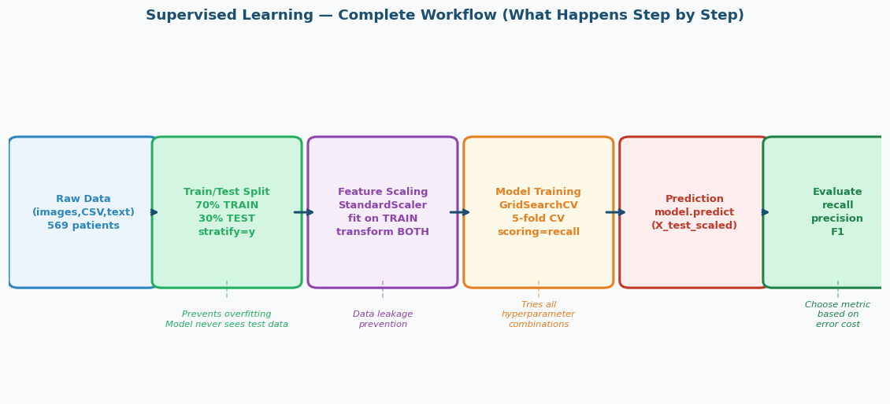
Figure 4: Supervised Learning — Complete Step-by-Step Workflow

6a. Why the Train/Test Split Is the Most Important Step
🔍 ANALOGY — The Exam Analogy (from lecture)
Imagine a student who studies from a textbook.
Training set = practice questions in the textbook. The student practices, makes mistakes, learns.
Test set = the REAL EXAM with questions never seen during study.

If you let the student see the real exam questions while studying:
→ They memorise the answers → Score 100% on the exam → But learned NOTHING
→ In a new real situation → They fail completely

This is exactly what happens in ML if you train and test on the same data.
The test set must NEVER be touched until the final evaluation.

from sklearn.model_selection import train_test_split

X_train, X_test, y_train, y_test = train_test_split(
X, # all features
y, # all labels
test_size=0.3, # 30% → test, 70% → train (also common: 80/20)
random_state=42, # makes split reproducible — same result every run
stratify=y # preserve class ratio in both splits
)

# WHY stratify=y?
# Breast cancer: 357 benign (63%), 212 malignant (37%)
# WITHOUT stratify: random split might put 80% malignant in test
# WITH stratify: both train and test will have 63% benign, 37% malignant
# This is especially important for imbalanced datasets

print(f"Train size: {len(X_train)} samples") # → 398
print(f"Test size: {len(X_test)} samples") # → 171
print(f"Train malignant %: {y_train.mean():.1%}") # → ~37%
print(f"Test malignant %: {y_test.mean():.1%}") # → ~37%

6b. Feature Scaling — StandardScaler in Detail
Many ML algorithms calculate distances (KNN) or use gradient descent (LR, SVM). If features have very different scales, large-scale features dominate unfairly.
💡 CONCEPT — The Problem StandardScaler Solves
Breast cancer dataset — two of the 30 features:
mean_area: ranges from 143 to 2501 (large numbers)
mean_smoothness: ranges from 0.05 to 0.16 (tiny numbers)

KNN computes Euclidean distance = √((x1₁-x2₁)² + (x1₂-x2₂)² + ...)
Without scaling: a difference of 100 in mean_area = 10,000 in distance²
a difference of 0.01 in mean_smoothness = 0.0001 in distance²

mean_area dominates completely. mean_smoothness contributes nothing.
The model ignores most features. This is wrong.

StandardScaler formula: z = (x - mean) / std
After: every feature has mean=0 and std=1. All features contribute equally.

from sklearn.preprocessing import StandardScaler

scaler = StandardScaler()

# Step 1: fit on TRAINING data only
# This computes: mean and std of each feature FROM TRAINING SET
X_train_scaled = scaler.fit_transform(X_train)
# fit_transform = fit (learn stats) + transform (apply) in one step

# Step 2: transform TEST using TRAINING stats (NOT re-fitted)
X_test_scaled = scaler.transform(X_test)
# transform only — uses the mean and std learned from TRAIN

# Verify scaling worked:
print(X_train_scaled.mean(axis=0).round(3)) # → all zeros
print(X_train_scaled.std(axis=0).round(3)) # → all ones

# What scaler learned (inspect):
print(scaler.mean_[:3]) # mean of first 3 features from training data
print(scaler.scale_[:3]) # std of first 3 features from training data

⚠️ WATCH OUT — Data Leakage — The Most Dangerous Mistake
DATA LEAKAGE = your model accidentally learns from test data during training.

The wrong way (leakage):
scaler.fit_transform(X_train) # OK so far
scaler.fit_transform(X_test) # WRONG! fit_transform re-learns from test!

Why it matters:
→ Model appears to perform excellently in evaluation
→ Deployed in real hospital → immediately fails on new patients
→ You wasted months building something that does not work

In the real world: you would NEVER have future patient data available when training.
The scaler must use ONLY the statistics it could have known at training time.

7. Evaluation Metrics — How Do We Know if the Model Is Any Good?
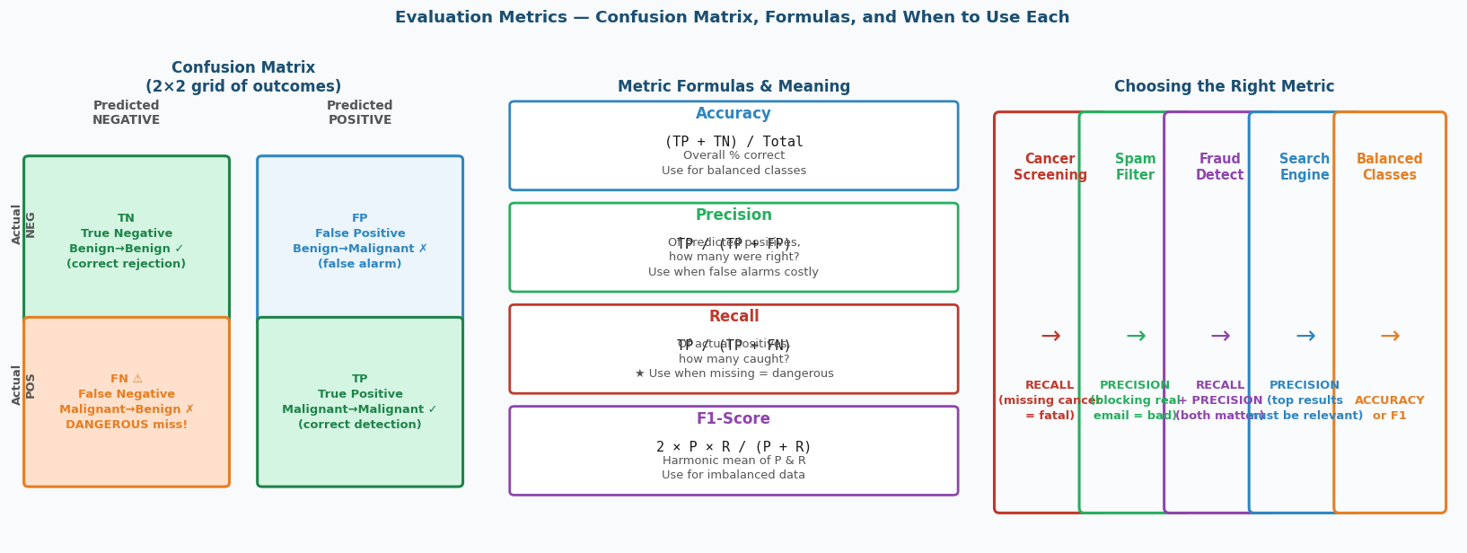
Figure 5: Confusion Matrix, Metric Formulas, and When to Use Each

7a. The Confusion Matrix — Four Possible Outcomes
Every prediction falls into one of four cells. Understanding these cells is more important than memorising metric formulas.
Outcome | Name | What Happened | Cost / Consequence
TP (bottom-right) | True Positive | Actual malignant → Predicted malignant ✓ | None — this is correct
TN (top-left) | True Negative | Actual benign → Predicted benign ✓ | None — this is correct
FP (top-right) | False Positive | Actual benign → Predicted malignant ✗ | Low — patient gets unnecessary biopsy (annoying but safe)
FN (bottom-left) | False Negative | Actual malignant → Predicted benign ✗ | ⚠ HIGH — missed cancer → patient goes untreated → potentially fatal

7b. The Four Metrics — Formula, Meaning, and When to Use
Metric | Formula | Plain English | Use When
Accuracy | (TP+TN) / Total | % of all predictions that were correct | Classes are balanced AND all types of errors cost the same
Precision | TP / (TP+FP) | Of everything I said was positive, how many actually were? | False alarms are expensive — e.g. spam filter, fraud flag
Recall | TP / (TP+FN) | Of all actual positives that existed, how many did I catch? | Missing a positive is dangerous — e.g. cancer screening, safety systems
F1-Score | 2×P×R / (P+R) | Harmonic mean — penalises extreme imbalance between P and R | Both errors matter AND your dataset is imbalanced

💡 CONCEPT — Harmonic Mean vs Arithmetic Mean — Why F1 Uses It
Arithmetic mean of P=1.0 and R=0.0: (1.0+0.0)/2 = 0.5 ← looks okay
Harmonic mean (F1): 2×1.0×0.0/(1.0+0.0) = 0.0 ← correctly shows it is terrible

If Precision is perfect (1.0) but Recall is 0.0:
→ The model catches ZERO malignant cases — it is useless
→ Arithmetic mean: 0.5 (misleadingly good)
→ Harmonic mean: 0.0 (correctly terrible)

F1 uses harmonic mean because it PUNISHES extreme imbalance between P and R.

8. Lecture Q&A and Quizzes — All Questions and Answers Explained
These are ALL the quiz questions and discussion questions from the lecture. Each has a full explanation of WHY the answer is correct, not just what the answer is.
❓ LECTURE QUIZ — QUIZ 1 (from lecture slide 30)
In supervised learning, what is the primary purpose of splitting data into training and test sets?

A) To reduce the size of the dataset
B) To prevent overfitting and evaluate how well the model generalises to new data ✅
C) To ensure the model sees all data at least once
D) To speed up computation during training

💡 CONCEPT — Quiz 1 — Full Explanation
ANSWER: B — To prevent overfitting and evaluate generalisation.

WHY NOT A: Reducing dataset size is never a goal. We use ALL training data.
WHY NOT C: The model should NOT see test data at all.
WHY NOT D: The split has nothing to do with speed.

The correct reason:
"Overfitting" means the model memorises training data including noise.
It looks great on training data but fails on new patients.
The test set simulates "new unseen patients" — it tests REAL performance.
Without this split, you have no honest measurement of how good your model is.

Real example: a model that memorises all 398 training patients perfectly
→ 100% accuracy on training data
→ might be 60% on the 171 test patients (unseen)
→ the test score (60%) is what matters for real deployment

❓ LECTURE QUIZ — QUIZ 2 (from lecture slide 44)
To measure the goodness of a search engine, which is a better metric?

A) Accuracy
B) Precision ✅

💡 CONCEPT — Quiz 2 — Full Explanation
ANSWER: B — Precision.

The web has BILLIONS of documents. For any query, 99.9%+ are non-relevant.

Let's do the math from the lecture:
Query: "elephants in Africa"
Total documents: 5,015 (mostly non-relevant)
Engine returns 10 results: 5 relevant, 5 irrelevant
Engine MISSES 5 relevant documents

Accuracy = (TP + TN) / Total = (5 + 5000) / 5015 = 99.8% ← looks amazing!
Precision = TP / (TP + FP) = 5 / (5 + 5) = 50% ← half the results were useless

From the lecture: "How to build a 99.9999% accurate search engine on a low budget:
Return NOTHING for every query. You correctly labelled billions of irrelevant documents."

Accuracy is dominated by TN — correctly rejecting irrelevant docs.
Precision shows whether what the engine RETURNED was actually useful.

That is why Google's engineers do not use accuracy. They use Precision@K.

❓ LECTURE QUIZ — QUIZ 3 (from lecture slide 49)
In a confusion matrix for a disease screening model, which metric should you prioritise
to minimise the risk of missing an actual positive case?

A) Precision
B) Accuracy
C) Recall ✅
D) F1 Score

💡 CONCEPT — Quiz 3 — Full Explanation
ANSWER: C — Recall = TP / (TP + FN)

MISSING an actual positive = False Negative (FN). This is the dangerous cell.
Cancer screening: FN means "patient has cancer but we said benign"
→ Patient goes home without treatment → cancer progresses → potentially fatal

Recall directly measures: "Of all actual positives, how many did we catch?"
Minimising FN = maximising Recall.

WHY NOT Precision: Precision measures FP (false alarms), not FN (misses)
WHY NOT Accuracy: Dominated by TN — blind to minority class errors
WHY NOT F1: F1 balances both P and R. For screening, we want to maximise R specifically.

In medical screening, it is ALWAYS better to:
→ Flag 100 patients for extra tests (FP = inconvenient)
→ Than to miss 1 actual cancer (FN = potentially fatal)

❓ LECTURE QUIZ — QUIZ 4 (from lecture slide 98)
You are building a model to classify images into 5 categories (cat, dog, bird, horse, fish).
Which loss function should you use?

A) Mean Squared Error (MSE)
B) Binary Cross-Entropy
C) Categorical Cross-Entropy ✅
D) Mean Absolute Error (MAE)

💡 CONCEPT — Quiz 4 — Full Explanation
ANSWER: C — Categorical Cross-Entropy

WHY NOT MSE (A): MSE is for REGRESSION (predicting continuous numbers like house prices).
It would not make sense to minimise (y - ŷ)² when y is a category label.

WHY NOT BCE (B): Binary Cross-Entropy is for EXACTLY 2 classes (yes/no, spam/not spam).
You have 5 classes here.

WHY NOT MAE (D): Mean Absolute Error is also for regression, not classification.

WHY CCE (C):
→ You have 5+ mutually exclusive classes (one image = one category)
→ Output layer uses SOFTMAX (probabilities for all 5 sum to 1.0)
→ CCE = -Σ yc·log(ŷc) — only the true class probability contributes
→ High confidence in the correct class → low loss
→ Wrong & confident → very high loss (log of small probability = large negative)

8a. Discussion Questions Asked During the Lecture
💬 Q&A FROM LECTURE — Q: Does a non-linear activation function curve the decision boundary of a single neuron?
This was a KEY question from the lecture (slide 68). The answer surprises most students.

ANSWER: NO — activation does NOT curve the boundary of a single neuron.

Why? A neuron computes: z = w1*x1 + w2*x2 + b
The decision boundary is where z = 0, i.e.: w1*x1 + w2*x2 + b = 0
This is ALWAYS a straight line — no matter what f() you apply to z.

Sigmoid, ReLU, Tanh, Leaky ReLU — all give the SAME straight boundary.
The activation function changes the OUTPUT VALUE (range, smoothness)
but NOT where the boundary is drawn.

From the lecture table (slide 68):
Property | Step | Sigmoid | ReLU
Shape of boundary | Straight | Straight | Straight
Output range | {0,1} | (0,1) | [0,∞)
Gradient exists? | No | Yes | Yes (mostly)
Useful for stacking? | No | Yes | Yes

So WHY use activation if it does not curve anything? → See next Q&A.

💬 Q&A FROM LECTURE — Q: If activation does not curve the boundary, why do we need it at all?
ANSWER: Because WITHOUT activation, stacking layers is completely pointless.

Without activation:
Layer 1: h = W1 * x
Layer 2: y = W2 * (W1 * x) = (W2*W1) * x = W * x

100 layers without activation = exactly ONE linear layer.
All the depth is wasted — it collapses to a single matrix multiplication.

With ReLU activation:
Layer 1: h = ReLU(W1 * x) ← zeroes out negative values
Layer 2: y = W2 * ReLU(W1*x) ← CANNOT be simplified to W*x!

Why it cannot simplify: ReLU sets different elements to zero for different inputs.
For input A, maybe elements 3,7,12 are zeroed. For input B, maybe 2,5,9.
Different paths through the network for different inputs.

With MULTIPLE neurons and MULTIPLE layers, each neuron draws one straight line.
But the network COMBINES all those lines — the overall boundary becomes curved.
This is the Universal Approximation Theorem: enough neurons + activation = any shape.

💬 Q&A FROM LECTURE — Q: What is the flip side of deep learning? (from lecture discussion)
ANSWER: Deep learning is DATA HUNGRY.

The child learning analogy cuts both ways:
Traditional ML: human expert writes features → works on small datasets
Deep Learning: no expert needed → BUT needs THOUSANDS of examples

Why deep learning needs more data:
→ It is learning BOTH the features AND the classifier from scratch
→ Millions of parameters need to be tuned
→ Each parameter needs enough examples to learn correctly

Real numbers:
Logistic Regression on breast cancer: works fine with 400 samples
ResNet (image recognition): needs millions of images
GPT-4: trained on essentially the entire internet

For your assignment: breast cancer (569 samples) → use sklearn ML, not deep learning.
Deep learning would OVERFIT on 569 samples — too few for the complexity.

💬 Q&A FROM LECTURE — Q: What is the explainability vs performance trade-off? (from lecture Q&A on PCA)
ANSWER: Every ML model sits on a spectrum from explainable to powerful.

Explainable end:
Decision Trees → you can print the exact rules: "IF radius > 15 THEN malignant"
Logistic Regression → you can show which features had the largest weights
Original features → you can tell a doctor "the model used mean radius and texture"

Powerful but opaque end:
PCA components → "Component 3" is a mix of all 30 features — hard to explain
Deep Neural Networks → millions of weights — no human can read them
SVM with RBF kernel → the boundary is a complex curve in high dimensions

The trade-off:
Need to explain to a regulator/doctor/judge → use simpler, explainable models
Performance is the priority, explanation is not needed → use complex models

This is one of the biggest open problems in AI today: explainability vs accuracy.

9. Challenges of Supervised Learning — The Labelling Bottleneck
Supervised learning requires labelled data. This creates the biggest bottleneck in modern AI.
Challenge | What It Means | Real Example
Cost of labelling | Human experts must manually tag each example | One radiologist can label ~50 scans/day. Hospital has 100,000 scans. That is 5+ years.
Scale mismatch | Data is generated in Zettabytes, labelled data is <1% | Your phone takes 1000 photos this year. None of them have labels attached.
Expert dependency | Some labels require rare domain expertise | Labelling MRI scans needs an oncologist. Labelling legal contracts needs a lawyer.
Label quality | Human labellers make mistakes and disagree | Medical diagnosis: two radiologists looking at the same scan may disagree on malignancy.
Class imbalance | Rare events have very few positive examples | Fraud: 0.01% of transactions. You have millions of records but only 100 fraud cases.

🏢 REAL LIFE — Why This Bottleneck Led to LLMs
The breakthrough idea: instead of labelling data, use SELF-SUPERVISED learning.
GPT was trained on the internet — predicting the next word.
No labelling needed: the next word IS the label.
Input: "The patient was diagnosed with..." Label: "cancer" (the actual next word)

This is why LLMs work: the internet has Zettabytes of naturally-labelled data.
Every sentence provides millions of (input, next_word) training pairs.
No human labellers needed at all.

10. Unsupervised Learning — Finding Patterns Without Labels
Unsupervised learning has NO labels. The algorithm discovers hidden structure in data on its own. Critical because 99%+ of real-world data is unlabelled.
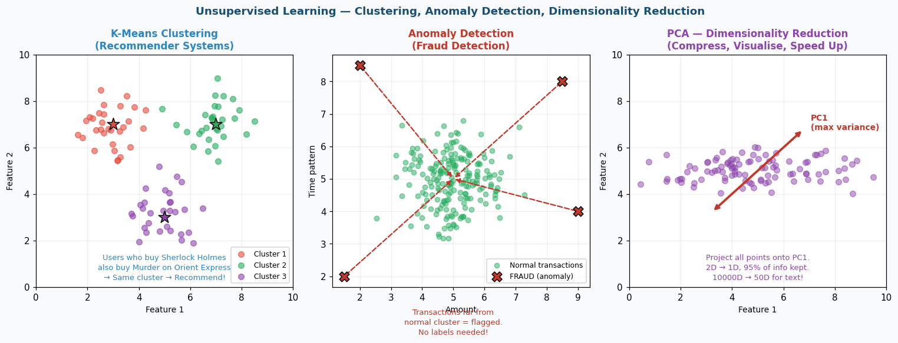
Figure 6: Unsupervised Learning — Clustering, Anomaly Detection, PCA

10a. Clustering — K-Means and Recommender Systems
🏢 REAL LIFE — How Amazon Recommends Without Any Labels (from lecture)
Users who bought Sherlock Holmes ALSO bought Murder on Orient Express.
No one labelled these books as "mystery fiction". No domain expert was needed.

K-Means clustering found: users who buy one tend to buy the other.
Books that co-appear in purchases → same cluster → recommend to each other.

This is collaborative filtering: "people like you also bought..."
Netflix uses this for movies. Spotify for songs. YouTube for videos.
None of them need labelled data — just purchase/watch patterns.

10b. Anomaly Detection — Fraud Detection
🏢 REAL LIFE — Why Supervised Learning FAILS for Fraud Detection (from lecture)
Problem 1: Fraud patterns change DAILY
→ A supervised model trained on last month's fraud misses today's novel attacks

Problem 2: Fraud is extremely rare (0.01% of transactions)
→ For every 1 fraud, there are 10,000 normal transactions
→ A model that says "not fraud" for EVERYTHING gets 99.99% accuracy
→ Useless!

Problem 3: Labelling millions of transactions is impractical
→ You cannot label what you have not seen

Unsupervised solution: learn what NORMAL looks like
→ Build a model of "typical transaction patterns for this customer"
→ Any transaction statistically far from normal → flag as anomaly
→ Works even for never-seen-before fraud patterns

10c. Dimensionality Reduction — PCA
Real data is often very high-dimensional (hundreds of features). PCA finds the directions of maximum variance and projects data onto fewer dimensions.
💡 CONCEPT — PCA Intuition — From the Lecture
Consider the sentence: "The man is grotesque"
Words: The man is grotesque
Info: low med low HIGH

The word GROTESQUE carries almost all the meaning.
"The" and "is" could be in almost any sentence — they tell you almost nothing.

PCA does this mathematically for your data:
→ Finds which directions (linear combinations of features) have maximum VARIANCE
→ Variance = information (features that vary a lot across samples tell you more)
→ Keep the top k components (directions with most variance)
→ Discard the rest (low variance = mostly noise)

Practical example:
Breast cancer: 30 features → PCA → 5 components capture 95% of variance
Text (10,000 words) → PCA → 100 dimensions (Topic Modelling)
Images (224×224×3 = 150K pixels) → PCA → 500 components

⚠️ WATCH OUT — PCA Trade-off: Explainability (discussed in lecture Q&A)
The problem with PCA components:
PC1 = 0.42*mean_radius + 0.23*mean_texture + 0.18*mean_area + ...
What does "PC1" mean to a doctor? Nothing interpretable.

Recursive Feature Elimination (RFE) selects original features → explainable
PCA creates new composite dimensions → better performance, less interpretable

Rule: if you need to explain your model to a non-technical stakeholder, avoid PCA.
If performance is all that matters, use PCA to reduce dimensionality.

11. Deep Learning — When the Machine Learns Its Own Features
Deep Learning is the shift from human-designed features to automatically learned ones. The neural network does EVERYTHING: feature extraction AND classification.
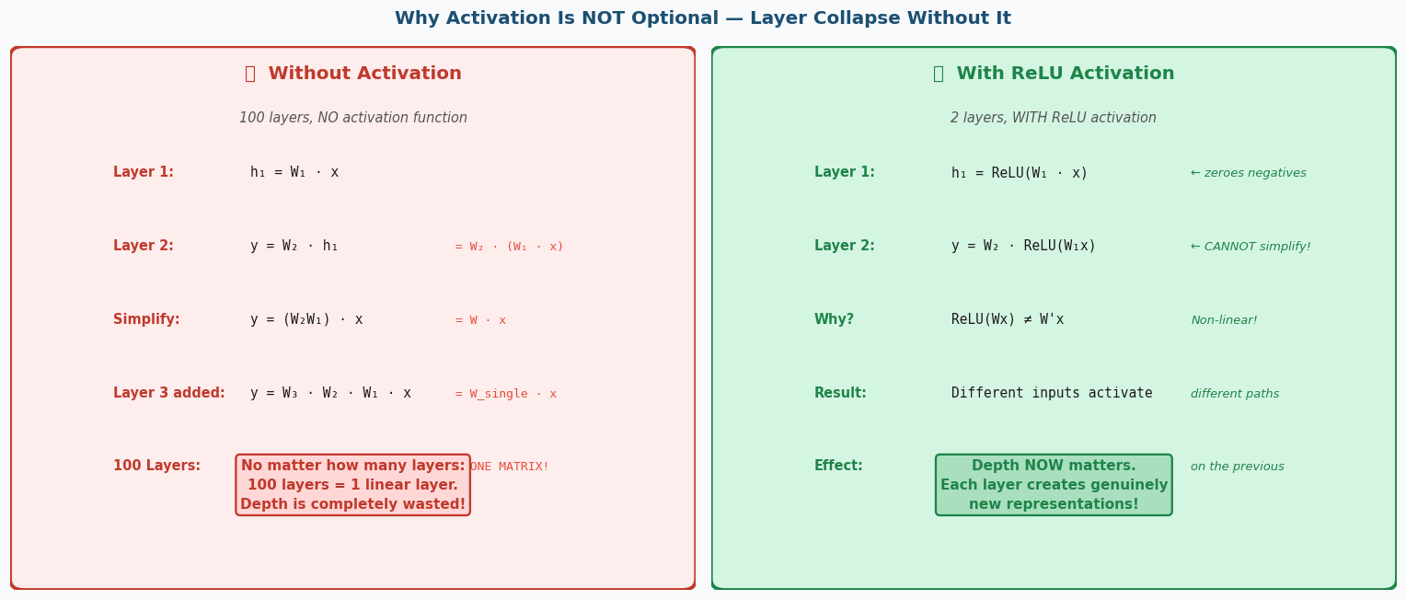
Figure 7: Why Activation Is Not Optional — Layer Collapse Proof

11a. The Feature Extraction Bottleneck
💡 CONCEPT — Traditional ML vs Deep Learning
Traditional ML:
Raw Data → [HUMAN EXPERT extracts features] → ML Model → Output
Example: radiologist defines "tumour roundness", "edge irregularity", "density"
→ these hand-crafted features go into logistic regression

Problem: expert needed for EVERY new task. New disease → new expert → months.

Deep Learning:
Raw Data → [Neural Network learns features automatically, layer by layer] → Output
Example: raw pixel values go in → network learns "this edge pattern = likely malignant"

No expert needed. Same architecture can handle medical scans, text, audio, video.

11b. The Child Learning Analogy (from lecture)
🔍 ANALOGY — Child vs Cookbook (from lecture)
Traditional approach — The Recipe:
A food expert writes rules: "Check colour of crust. Smell for burnt edges."
Works for ONE dish type. New cuisine? Write new rules. New expert needed.

Deep Learning approach — The Child:
Show a child thousands of dishes — good ones and bad ones.
Child figures out on their own: "golden = good", "black edges = burnt".
No one had to write these rules — the child extracted them from examples.
New cuisine? Show more examples — child adapts automatically.

The flip side: the child needs to see THOUSANDS of examples.
Deep learning is data-hungry. Traditional ML can work with hundreds of samples.

11c. The Biological Neuron → Artificial Neuron
Biological Neuron | Artificial Neuron | What Happens
Dendrites | Inputs x1, x2, ..., xn | Receive signals from previous layer
Synapse strength (weak/strong) | Weights w1, w2, ..., wn (learnable) | Determine how much each input contributes
Cell body integration | Weighted sum: z = Σ wi*xi + b | Add up all weighted inputs plus a bias
Firing threshold | Activation function: output = f(z) | Decide whether/how strongly to fire
Axon transmission | Output passed to next layer | Signal flows forward through the network
Synapse strengthening (learning) | Weight update via backprop | Learning = adjusting connection strengths

12. Activation Functions — All Six Explained
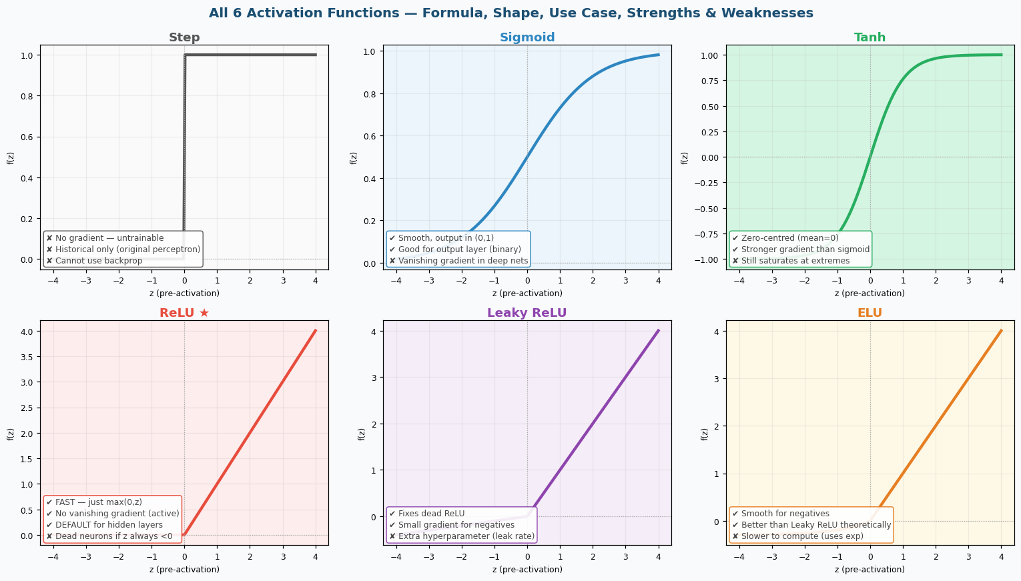
Figure 8: All 6 Activation Functions — Shape, Formula, Use Case, Pros & Cons

Activation | Formula | Output Range | Best Use Case | Key Weakness
Step | 1 if z≥0, else 0 | {0,1} | Historical only (original perceptron) | No gradient — cannot train with backprop
Sigmoid | 1 / (1+e⁻ᶻ) | (0,1) | Output layer for binary classification | Vanishing gradient in deep networks
Tanh | (eᶻ-e⁻ᶻ)/(eᶻ+e⁻ᶻ) | (-1,1) | Hidden layers in RNNs (zero-centred) | Still saturates at extremes
ReLU ★ | max(0, z) | [0,∞) | DEFAULT for hidden layers (CNNs, MLPs) | Dead neurons (z always <0 → gradient=0)
Leaky ReLU | max(0.1z, z) | (-∞,∞) | When dead ReLU is causing problems | Extra hyperparameter (leak rate 0.1)
ELU | z if z≥0, α(eᶻ-1) if z<0 | (-α,∞) | Deeper networks needing smooth negatives | Slower to compute (exponential function)

💡 CONCEPT — Why ReLU Is the Default Choice
1. SPEED: max(0,z) is a single comparison — extremely fast on GPU
2. NO VANISHING GRADIENT: when z>0, gradient = 1 (not squashed like sigmoid)
3. SPARSE ACTIVATION: ~50% of neurons output 0 → network is efficient
4. WORKS IN PRACTICE: empirically outperforms sigmoid/tanh in most deep nets

When ReLU fails (dead neurons):
→ If z is always negative for a neuron, gradient = 0 forever
→ That neuron never learns anything → "dead neuron"
→ Fix: use Leaky ReLU (gradient=0.1 for negatives) or adjust learning rate

Output layer activations:
Binary (2 classes): Sigmoid → output in (0,1) = probability
Multi-class (3+): Softmax → outputs sum to 1.0 = probability distribution

13. Multi-Layer Perceptron (MLP) — How Layers Build Complexity
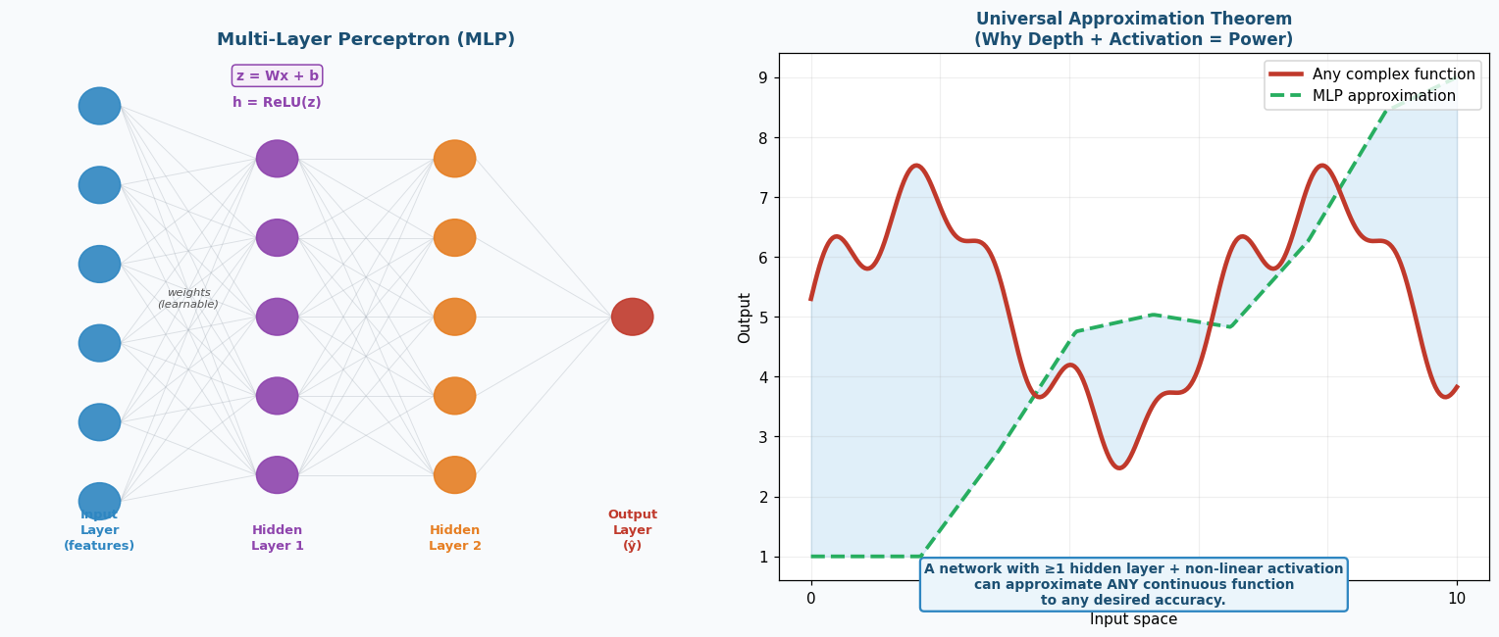
Figure 9: MLP Architecture and Universal Approximation Theorem

💡 CONCEPT — How MLP Builds Complex Boundaries (from lecture slide 71)
Layer 1 neurons each draw ONE straight line.
Neuron A: "Is feature1 > 15?" → boundary A
Neuron B: "Is feature2 > 21?" → boundary B
Neuron C: "Is feature1 - 2*feature2 > 5?" → boundary C

Layer 2 combines these lines:
"Is neuron A AND neuron B active?" → intersection of two lines = region
Add more neurons → more regions → arbitrarily complex shapes

With enough neurons and layers, the network can carve out ANY decision region.
This is the UNIVERSAL APPROXIMATION THEOREM:
A neural network with ≥1 hidden layer and non-linear activation
can approximate ANY continuous function to any desired accuracy.

This is the theoretical guarantee that deep learning can solve any pattern recognition problem.

14. Backpropagation — The Complete Algorithm Explained
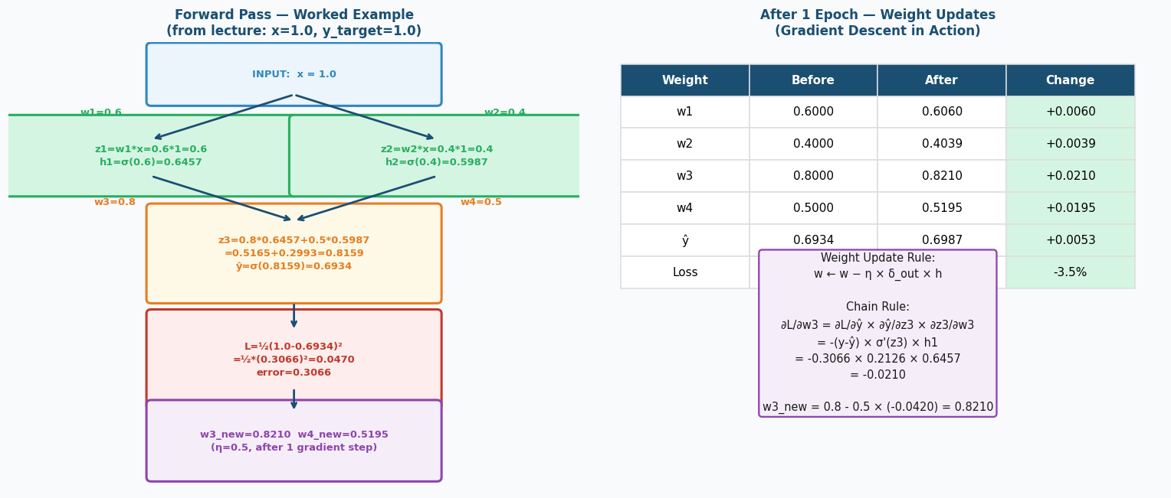
Figure 10: Forward Pass Worked Example and After-1-Epoch Results

Backpropagation is the algorithm that makes neural networks learn. It repeats four steps thousands of times until the loss is minimised.
Step | Name | What Happens | Code Equivalent
1 | Forward Pass | Input flows through every layer left to right. Each neuron computes z=Wx+b, h=f(z). Final output is ŷ. | y_hat = model(x)
2 | Loss Computation | Compare ŷ (prediction) to y (true label). Compute how wrong we are with loss function. | loss = loss_fn(y_hat, y)
3 | Backward Pass | Use chain rule to compute: how much did each weight contribute to the error? Gradients flow RIGHT to LEFT. | loss.backward()
4 | Weight Update | Move each weight slightly in the direction that reduces loss. Learning rate η controls step size. | optimizer.step()

14a. Complete Worked Example (Lecture Slides 83–92)
Setup: x=1.0 (input), y=1.0 (target), w1=0.6, w2=0.4, w3=0.8, w4=0.5, η=0.5
# ════ FORWARD PASS (Slides 84-87) ════

# Hidden neuron 1
z1 = w1 * x = 0.6 * 1.0 = 0.6000
h1 = sigmoid(z1) = 1/(1+exp(-0.6)) = 0.6457
# h1 > 0.5 because z1=0.6 > 0

# Hidden neuron 2
z2 = w2 * x = 0.4 * 1.0 = 0.4000
h2 = sigmoid(z2) = 1/(1+exp(-0.4)) = 0.5987
# h2 < h1 because w2=0.4 < w1=0.6 → smaller pre-activation

# Output neuron
z3 = w3*h1 + w4*h2 = 0.8*0.6457 + 0.5*0.5987
= 0.5165 + 0.2993 = 0.8159
y_hat = sigmoid(z3) = 1/(1+exp(-0.8159)) = 0.6934

# ════ LOSS (Slide 87) ════
error = y - y_hat = 1.0 - 0.6934 = 0.3066
L = 0.5 * error^2 = 0.5 * (0.3066)^2 = 0.5 * 0.0940 = 0.0470
# The 0.5 factor cancels the 2 that appears when we differentiate

# ════ BACKWARD PASS (Slides 88-91) ════

# Sigmoid derivative: sigma_prime(z) = sigma(z) * (1 - sigma(z))
sigma_prime_z3 = y_hat * (1 - y_hat) = 0.6934 * 0.3066 = 0.2126

# Output delta (error signal at output neuron)
delta_out = -(y - y_hat) * sigma_prime_z3
= -0.3066 * 0.2126 = -0.0652
# Negative because we need to INCREASE the output (ŷ=0.6934 < y=1.0)

# ════ WEIGHT UPDATE (Slide 91) ════
w3_new = w3 - eta * delta_out * h1
= 0.8 - 0.5 * (-0.0652) * 0.6457
= 0.8 + 0.0210 = 0.8210

w4_new = w4 - eta * delta_out * h2
= 0.5 - 0.5 * (-0.0652) * 0.5987
= 0.5 + 0.0195 = 0.5195

# WHY w3 changes more than w4?
# Because h1=0.6457 > h2=0.5987 → neuron 1 contributed more to z3
# → neuron 1's weights get updated more

Weight/Value | Before (Epoch 0) | After (Epoch 1) | Change
w1 | 0.6000 | 0.6060 | +0.0060
w2 | 0.4000 | 0.4039 | +0.0039
w3 | 0.8000 | 0.8210 | +0.0210
w4 | 0.5000 | 0.5195 | +0.0195
ŷ (prediction) | 0.6934 | 0.6987 | +0.0053 (closer to 1.0)
Loss L | 0.0470 | 0.0454 | -3.5% improvement

💡 CONCEPT — Key Insight: Why h1 > h2 means Δw3 > Δw4
Larger h1 → w3 contributed MORE to z3 → w3 was MORE responsible for the error
→ w3 gets a LARGER update to fix the error

This is the chain rule at work:
∂L/∂w3 = ∂L/∂ŷ × ∂ŷ/∂z3 × ∂z3/∂w3
= -(y-ŷ) × σ'(z3) × h1
= -0.3066 × 0.2126 × 0.6457 = -0.0421
w3_new = 0.8 - 0.5×(-0.0421) = 0.8210

Repeat this for THOUSANDS of epochs → loss converges to ~0 → perfect prediction.

15. Loss Functions — Choosing the Right One for Your Task
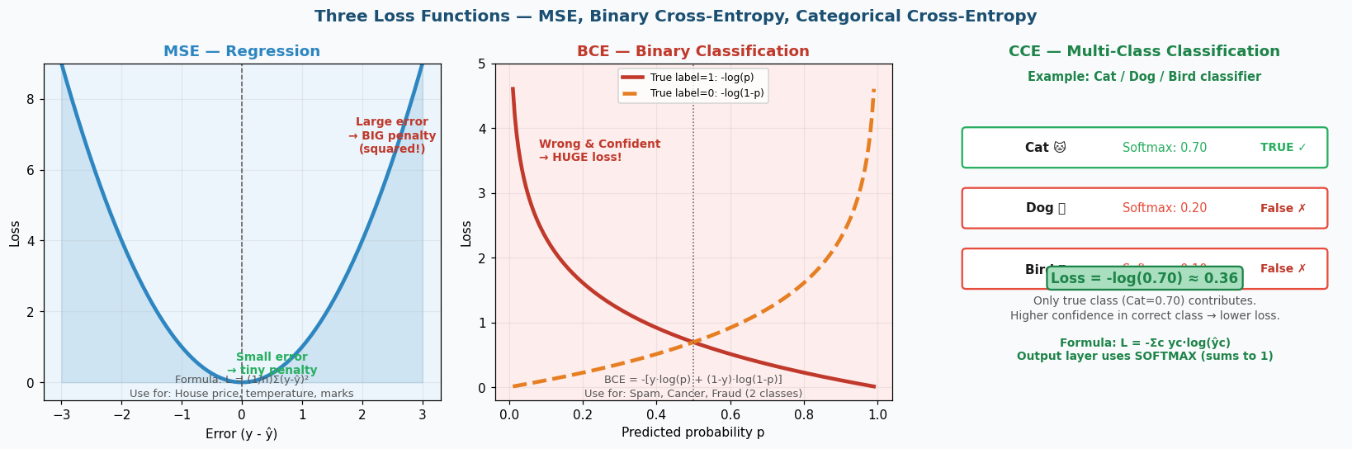
Figure 11: MSE, Binary Cross-Entropy, and Categorical Cross-Entropy

Loss Function | Formula | Task Type | Output Layer | Why This One?
MSE | (1/n)Σ(y-ŷ)² | Regression (continuous output) | Linear/None | Penalises large errors quadratically. Convex surface → easy gradient descent.
Binary Cross-Entropy | -[y·log(p) + (1-y)·log(1-p)] | Binary Classification (2 classes) | Sigmoid | Punishes confident wrong answers exponentially. Calibrated probabilities.
Categorical Cross-Entropy | -Σc yc·log(ŷc) | Multi-class Classification (3+ classes) | Softmax | Generalises BCE. Only true class probability contributes. Works with softmax.

💡 CONCEPT — Why BCE Punishes Confident Mistakes So Hard
If model says P(spam)=0.95 but the email is NOT spam:
BCE = -log(1-0.95) = -log(0.05) = 3.0 ← HUGE loss

If model says P(spam)=0.55 but the email is NOT spam:
BCE = -log(1-0.55) = -log(0.45) = 0.80 ← moderate loss

The logarithm of a small probability is a large negative number.
→ The more confident you are in the WRONG answer, the bigger the punishment.

From the lecture: "2+2=5 is wrong, but 2+2=2025 is DANGEROUSLY wrong.
The model that says 2025 with confidence has completely lost the plot."

This is what forces models to be CALIBRATED — not overconfident when uncertain.

💡 CONCEPT — CCE — How Softmax and CCE Work Together
Example: 5-class image classifier (Quiz 4 scenario)
Raw outputs (logits): [2.1, 0.5, -1.2, 0.8, -0.3]
Softmax converts to probabilities that SUM TO 1:
cat: e^2.1 / (e^2.1+e^0.5+...) = 0.61
dog: 0.15, bird: 0.02, horse: 0.18, fish: 0.04
True label: cat (y = [1,0,0,0,0])
CCE = -1×log(0.61) - 0×log(0.15) - 0×log(0.02) - 0×... = 0.49

Only the true class probability (0.61) matters in the formula.
Higher cat probability → lower CCE loss → model is learning.

16. Optimisers — How Gradient Descent Actually Runs
In sklearn, the optimiser runs automatically inside .fit(). In PyTorch/TensorFlow (when you build neural networks), you choose it explicitly.
Optimiser | Strategy | Best For | Learning Rate | Key Property
SGD (Stochastic) | One sample at a time. Noisy but each update is fast. | Very large datasets | 0.01 (often with decay) | Noise actually helps escape local minima
Mini-batch GD | Average gradient over 32-64 samples per step. | Standard deep learning | 0.001-0.01 | Balance of speed and stability
Adam (Adaptive Moment) | Per-weight adaptive LR + momentum (remembers direction). | Almost everything — the default | 0.001 | Adjusts each weight's LR individually
RMSprop | Adaptive LR only (no momentum). | RNNs and sequence models | 0.001 | Good for non-stationary problems

💡 CONCEPT — In sklearn vs PyTorch — Key Difference
In scikit-learn:
model.fit(X_train, y_train) ← optimiser runs automatically inside
You never write backward() or step(). sklearn handles everything.

In PyTorch (neural networks you build yourself):
optimizer = optim.Adam(model.parameters(), lr=0.001)
for X_batch, y_batch in dataloader:
y_pred = model(X_batch) # forward
loss = loss_fn(y_pred, y_batch) # compute loss
optimizer.zero_grad() # clear old gradients
loss.backward() # backpropagation
optimizer.step() # update weights

You write the loop manually in PyTorch. sklearn hides it from you.

▬▬▬ PART 2: THE ASSIGNMENT — COMPLETE GUIDE ▬▬▬

17. Assignment Overview — What You Need to Build and Why
The assignment has two tasks. Everything is built step-by-step below with full code, line-by-line explanations, and reasoning for every decision.
Task | Dataset | Problem Type | Models | Primary Goal
Task 1 | Breast Cancer (sklearn) | Binary Classification | Logistic Regression, KNN, Decision Tree, SVM | Maximise recall — catch every malignant case
Task 2 | Wine (sklearn) | Multi-class Classification (3 classes) | Any classifier of your choice (MLP recommended) | Best macro F1-score across all 3 wine cultivars

18. Understanding the Datasets — Before Writing Any Code
18a. Breast Cancer Dataset — Anatomy
from sklearn.datasets import load_breast_cancer
data = load_breast_cancer()

# What is in this dataset:
print(data.DESCR) # full description
print(data.feature_names) # 30 feature names
print(data.target_names) # ["malignant", "benign"]

# Shape:
print(data.data.shape) # (569, 30): 569 patients, 30 measurements each
print(data.target.shape) # (569,): one label per patient

# Original labels (confusing!):
# data.target: 0=malignant, 1=benign ← SKLEARN DEFAULT

# WHY WE REMAP:
# In ML convention, 1 = the "positive" class (the one we care about detecting)
# We CARE about detecting MALIGNANT — so malignant should be 1
y = 1 - data.target # REMAP: 0=benign, 1=malignant (more intuitive)

# Class distribution:
import numpy as np
print(np.bincount(y)) # → [357, 212]: 357 benign, 212 malignant
print(f"Malignant: {212/569:.1%}") # → 37.3% (minority class)
# Class imbalance! This is why we use class_weight="balanced"

💡 CONCEPT — What Do the 30 Features Actually Measure?
Each patient has 10 measurements, each computed in 3 ways (mean, SE, worst):
→ 10 × 3 = 30 features total

The 10 base measurements:
1. radius — mean distance from centre to perimeter of tumour
2. texture — standard deviation of grey-scale pixel values
3. perimeter — tumour boundary length
4. area — tumour area
5. smoothness — local variation in radius lengths
6. compactness — perimeter²/area - 1 (how round it is)
7. concavity — severity of concave portions of the contour
8. concave pts — number of concave portions of the contour
9. symmetry — tumour symmetry
10. fractal dim — "coastline approximation" - tumour border complexity

Malignant tumours tend to: larger radius, more irregular shape, more concave

18b. Wine Dataset — Anatomy
from sklearn.datasets import load_wine
data = load_wine()

print(data.data.shape) # (178, 13): 178 wine samples, 13 chemical features
print(data.target_names) # ["class_0", "class_1", "class_2"]
# 3 grape cultivars from Italy
print(np.bincount(data.target)) # [59, 71, 48]: roughly balanced

# The 13 features (all chemical measurements):
# alcohol, malic_acid, ash, alcalinity_of_ash, magnesium,
# total_phenols, flavanoids, nonflavanoid_phenols, proanthocyanins,
# color_intensity, hue, od280/od315_of_diluted_wines, proline

19. Full Pipeline — Step by Step With Every Line Explained
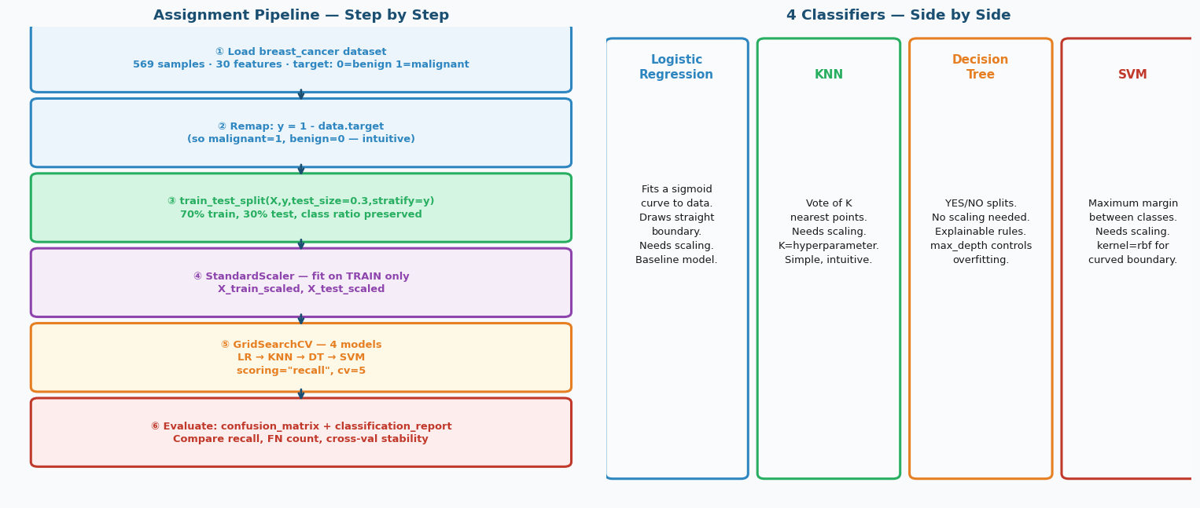
Figure 12: Complete Assignment Pipeline and 4 Classifier Side-by-Side

19a. Step 1 — Imports and Data Loading
# ══ STEP 1: IMPORTS ══
import numpy as np # numerical arrays
import pandas as pd # data tables
import matplotlib.pyplot as plt # plotting

# scikit-learn: everything ML
from sklearn.datasets import load_breast_cancer
from sklearn.model_selection import (
train_test_split, # split into train/test
GridSearchCV, # try all hyperparameter combos
cross_val_score # evaluate stability of model
)
from sklearn.preprocessing import StandardScaler # scale features
from sklearn.linear_model import LogisticRegression # model 1
from sklearn.neighbors import KNeighborsClassifier # model 2
from sklearn.tree import DecisionTreeClassifier # model 3
from sklearn.svm import SVC # model 4
from sklearn.metrics import (
accuracy_score, recall_score, precision_score, f1_score,
confusion_matrix, classification_report,
precision_recall_curve # for threshold tuning
)

# ══ STEP 2: LOAD DATA ══
data = load_breast_cancer()
X = pd.DataFrame(data.data, columns=data.feature_names)
# pd.DataFrame: makes a nice table with named columns
# data.feature_names: the 30 column names ("mean radius", etc.)

y = 1 - data.target
# REMAP: sklearn uses 0=malignant, 1=benign
# We want: 0=benign, 1=malignant (positive class = the one we care about)
# 1 - target flips the labels

feature_names = data.feature_names # save for feature importance later

19b. Step 2 — Train/Test Split
# ══ STEP 3: SPLIT DATA ══
X_train, X_test, y_train, y_test = train_test_split(
X, # all features (569 rows × 30 columns)
y, # all labels (569 values: 0 or 1)
test_size=0.3, # 30% → test (171 samples)
# 70% → train (398 samples)
random_state=42, # same split every time you run (reproducible)
stratify=y # both train and test keep 37% malignant ratio
)

# Verify:
print(f"Train: {len(X_train)} samples, {y_train.sum()} malignant ({y_train.mean():.1%})")
print(f"Test: {len(X_test)} samples, {y_test.sum()} malignant ({y_test.mean():.1%})")
# Should print ~37% malignant in both — stratify worked

19c. Step 3 — Feature Scaling
# ══ STEP 4: SCALE FEATURES ══
scaler = StandardScaler()

# fit_transform on TRAIN: learn mean/std from train, then apply
X_train_scaled = scaler.fit_transform(X_train)

# transform on TEST: apply the SAME mean/std (do NOT re-fit)
X_test_scaled = scaler.transform(X_test)

# Verify scaling:
print(f"Before: mean_area mean = {X_train["mean area"].mean():.1f}")
# → ~655 (large number)
print(f"After: mean_area mean = {X_train_scaled[:, 3].mean():.3f}")
# → ~0.000 (centred at zero)

# NOTE: Decision Tree does NOT need scaling
# But we scale all anyway so GridSearchCV can compare models fairly
# Scaling does not hurt tree-based models — it just has no effect

20. Model 1 — Logistic Regression
💡 CONCEPT — How Logistic Regression Works — Line by Line Logic
Step 1: Compute weighted sum for each patient:
z = w1*radius + w2*texture + w3*perimeter + ... + w30*fractal_dim + bias

Step 2: Apply sigmoid to get probability:
P(malignant) = 1 / (1 + e^(-z)) → always between 0 and 1

Step 3: Make prediction:
if P(malignant) >= 0.5: predict malignant (1)
else: predict benign (0)

C = regularisation parameter (the hyperparameter you tune):
Small C (0.01): heavy regularisation → weights forced small → simpler model
Large C (100): light regularisation → weights can be large → may overfit
Best C: found by GridSearchCV

# ══ LOGISTIC REGRESSION WITH GRIDSEARCHCV ══

param_grid_lr = {"C": [0.01, 0.1, 1, 10, 100]}
# Try 5 different regularisation strengths

grid_lr = GridSearchCV(
estimator=LogisticRegression(
class_weight="balanced", # penalise malignant misses more (imbalanced data)
max_iter=10000, # allow enough iterations to converge
random_state=42
),
param_grid=param_grid_lr,
scoring="recall", # optimise for catching malignant cases (not just accuracy)
cv=5, # 5-fold cross-validation on training data
n_jobs=-1 # use all CPU cores in parallel
)

grid_lr.fit(X_train_scaled, y_train) # fit all combos, find best

print("Best C:", grid_lr.best_params_) # e.g. {"C": 0.1}
print("Best CV recall:", grid_lr.best_score_) # e.g. 0.974

best_lr = grid_lr.best_estimator_ # the model trained with best C

# Evaluate on TEST SET:
y_pred_lr = best_lr.predict(X_test_scaled)
print(classification_report(y_test, y_pred_lr,
target_names=["Benign", "Malignant"]))

# Feature importance from LR: which features have biggest weights?
coef_imp = pd.Series(abs(best_lr.coef_[0]), index=feature_names)
coef_imp.sort_values().tail(10).plot(kind="barh", title="LR Feature Importance")

💡 CONCEPT — What GridSearchCV Actually Does
GridSearchCV with param_grid={"C":[0.01,0.1,1,10,100]} and cv=5:

For EACH value of C (5 values):
For EACH fold (5 folds):
→ Train on 4/5 of training data
→ Evaluate on the remaining 1/5
→ Record recall score
Average the 5 recall scores for this C

Total: 5 C values × 5 folds = 25 models trained internally

Output: best_params_ = the C with highest average recall across 5 folds
best_estimator_ = the model retrained on ALL training data with that C

This gives you a RELIABLE estimate of performance WITHOUT touching the test set.

21. Model 2 — KNN (K-Nearest Neighbours)
🔍 ANALOGY — How KNN Classifies — Everyday Explanation
You are a new doctor at a hospital. A patient comes in with tumour measurements.
You look in your records for the K=5 most similar patients you have seen before.
Patient 1: similar measurements → was malignant
Patient 2: similar measurements → was malignant
Patient 3: similar measurements → was benign
Patient 4: similar measurements → was malignant
Patient 5: similar measurements → was malignant

Vote: 4 malignant, 1 benign → predict MALIGNANT.

That is literally all KNN does. No formula learned. No training.
Just find the K most similar examples and vote.

param_grid_knn = {
"n_neighbors": [3, 5, 7, 9, 11, 15],
# n_neighbors = K: how many neighbours vote
# Too small (K=1): memorises training data, very sensitive to noise
# Too large (K=50): ignores local patterns, underfits
# Sweet spot: usually 5-11 for medical data

"weights": ["uniform", "distance"]
# uniform: all K neighbours get equal vote
# distance: closer neighbours get more weight in the vote
# distance is often better when samples cluster tightly
}

grid_knn = GridSearchCV(
KNeighborsClassifier(),
param_grid_knn, scoring="recall", cv=5, n_jobs=-1
)
grid_knn.fit(X_train_scaled, y_train)
best_knn = grid_knn.best_estimator_

y_pred_knn = best_knn.predict(X_test_scaled)
print(classification_report(y_test, y_pred_knn, target_names=["Benign","Malignant"]))

22. Model 3 — Decision Tree
💡 CONCEPT — How Decision Trees Work — The Actual Algorithm
At each node, the tree asks: "Which single feature split gives the PUREST groups?"

Purity = Gini Impurity = 1 - Σ(pᵢ²)
Pure node: all samples same class → Gini = 0 (best)
Mixed node: 50/50 split → Gini = 0.5 (worst)

Example split:
Split on "mean concave points > 0.05":
Left branch: 95% benign → Gini = 0.09 (very pure)
Right branch: 87% malignant → Gini = 0.23 (fairly pure)
Weighted average: 0.16 → big improvement from root Gini 0.46

The tree picks the feature and threshold that reduces Gini the most.
Repeat recursively until max_depth reached or nodes are pure.

param_grid_dt = {
"max_depth": [3, 5, 7, 10, None],
# max_depth=3: only 3 questions deep — simple, may underfit
# max_depth=None: grows until all leaves pure — may overfit
# Best: usually 5-7 for this dataset

"min_samples_split": [2, 5, 10],
# minimum samples required to split a node
# Higher = simpler tree (fewer splits) = less overfitting

"min_samples_leaf": [1, 2, 4]
# minimum samples that must be in a leaf node
# Higher = smoother, more regularised tree
}

grid_dt = GridSearchCV(
DecisionTreeClassifier(class_weight="balanced", random_state=42),
param_grid_dt, scoring="recall", cv=5
)
grid_dt.fit(X_train_scaled, y_train)
best_dt = grid_dt.best_estimator_

# Feature importance: which features were used most at top of tree?
importances = pd.Series(best_dt.feature_importances_, index=feature_names)
top_features = importances.sort_values(ascending=False).head(10)
print("Top 10 most important features:")
print(top_features)

# feature_importances_ = average Gini reduction from that feature
# Higher = this feature split things more cleanly = more useful

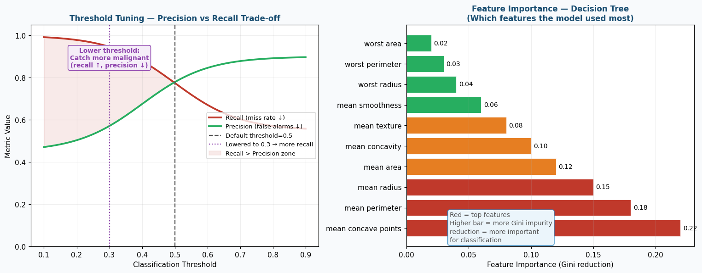
Figure 13: Threshold Tuning (Precision-Recall Trade-off) and Feature Importance

23. Model 4 — SVM (Support Vector Machine)
💡 CONCEPT — How SVM Works — Maximum Margin Intuition
Imagine drawing a line between benign and malignant patients in feature space.
Many lines could separate them. Which one do you pick?

SVM answer: the one with the MAXIMUM MARGIN from both groups.
→ Margin = distance from the boundary to the closest point on each side
→ Wider margin = more confident, more generalisable

The points right on the boundary edges = "Support Vectors"
→ These are the only training points that define the boundary
→ Remove other points → boundary stays the same

kernel="rbf" (Radial Basis Function):
→ Maps data to a HIGHER DIMENSIONAL SPACE where it becomes linearly separable
→ Effectively creates a CURVED boundary in the original space
→ gamma: controls how much influence each training point has
Small gamma: each point influences a large area (smooth boundary)
Large gamma: each point only influences nearby area (complex boundary)

param_grid_svm = {
"C": [0.1, 1, 10],
# C: regularisation (same idea as LR)
# Small C: allow some misclassifications to get wider margin
# Large C: force correct classification, may overfit

"kernel": ["linear", "rbf"],
# linear: straight boundary (fast, works when data is linearly separable)
# rbf: curved boundary (usually better, but slower to train)

"gamma": ["scale", "auto"]
# scale: gamma = 1/(n_features * X.var()) — automatic scaling
# auto: gamma = 1/n_features
# Only matters for rbf kernel
}

grid_svm = GridSearchCV(
SVC(
class_weight="balanced", # handle class imbalance
random_state=42,
probability=True # NEEDED for predict_proba() in threshold tuning
),
param_grid_svm, scoring="recall", cv=5, n_jobs=-1
)
grid_svm.fit(X_train_scaled, y_train)
best_svm = grid_svm.best_estimator_

y_pred_svm = best_svm.predict(X_test_scaled)
print(classification_report(y_test, y_pred_svm, target_names=["Benign","Malignant"]))

24. Threshold Tuning — Going Beyond the Default 0.5
By default, a model predicts class 1 (malignant) when P(malignant) >= 0.5. For cancer detection, you might want to lower this to 0.3 — flag anyone with 30%+ probability as malignant for further tests.
💡 CONCEPT — Why and How to Tune the Threshold
Default threshold = 0.5:
"I am at least 50% sure this is malignant → say malignant"

Lower threshold (e.g. 0.3):
"I am at least 30% sure this is malignant → say malignant"
→ Catches MORE malignant cases (recall INCREASES)
→ But also flags more benign cases as malignant (precision DECREASES)
→ More patients get unnecessary biopsies, but fewer cancers are missed

The trade-off: at the clinic, missing 1 cancer is far worse than 10 extra biopsies.
→ For this reason, clinicians might set threshold = 0.3 or even 0.2.

# IMPORTANT: Tune threshold on VALIDATION SET, not test set

# Step 1: Create inner validation split from training data
X_inner_train, X_val, y_inner_train, y_val = train_test_split(
X_train_scaled, y_train,
test_size=0.3, stratify=y_train, random_state=42
)

# Step 2: Retrain best SVM on inner train
inner_svm = SVC(**best_svm.get_params()) # same hyperparams
inner_svm.fit(X_inner_train, y_inner_train)

# Step 3: Get PROBABILITIES (not hard 0/1 predictions)
y_val_prob = inner_svm.predict_proba(X_val)[:, 1]
# predict_proba returns: [[P(benign), P(malignant)], [...], ...]
# [:, 1] selects column 1 = P(malignant) for every patient

# Step 4: Try different thresholds
print(f"{"Threshold":>10} {"Recall":>8} {"Precision":>10} {"F1":>8}")
for threshold in [0.2, 0.3, 0.4, 0.5, 0.6, 0.7]:
y_pred_t = (y_val_prob >= threshold).astype(int)
# (y_val_prob >= threshold) → True/False array
# .astype(int) → converts True/False to 1/0
r = recall_score(y_val, y_pred_t)
p = precision_score(y_val, y_pred_t, zero_division=0)
f = f1_score(y_val, y_pred_t)
print(f"{threshold:>10.1f} {r:>8.3f} {p:>10.3f} {f:>8.3f}")

# Pick threshold that achieves recall >= 0.95 with best precision

# Step 5: Apply best threshold to TEST set predictions
y_test_prob = best_svm.predict_proba(X_test_scaled)[:, 1]
best_threshold = 0.35 # example — use whatever validation found
y_pred_threshold = (y_test_prob >= best_threshold).astype(int)
print(f"\nFinal test recall: {recall_score(y_test, y_pred_threshold):.4f}")

25. Cross-Validation and Model Comparison
# ══ CROSS-VALIDATION: How stable is each model? ══
models_to_compare = {
"Logistic Regression": best_lr,
"KNN": best_knn,
"Decision Tree": best_dt,
"SVM": best_svm,
}

print(f"{"Model":25} {"Mean Recall":12} {"Std Recall":10} {"Verdict"}")
print("-" * 65)
for name, model in models_to_compare.items():
cv_scores = cross_val_score(
model, X_train_scaled, y_train,
cv=5, scoring="recall"
)
print(f"{name:25} {cv_scores.mean():.4f} {cv_scores.std():.4f} ",
"Stable" if cv_scores.std() < 0.05 else "Variable")

# WHAT TO LOOK FOR:
# High mean recall + low std = reliable model
# High mean recall + high std = sometimes good, sometimes not
# Always prefer the model with BOTH high recall AND low std for deployment

Model | Needs Scaling? | Explains Itself? | Best For | Watch Out For
Logistic Regression | YES | YES (coef_ weights) | Baseline, fast, explainable | Non-linear patterns
KNN | YES | NO (just voting) | Small datasets, intuitive | Slow at prediction time (computes all distances)
Decision Tree | NO | YES (printable rules) | When explanation needed | Overfits without max_depth
SVM (rbf) | YES | NO (support vectors) | Small clean datasets, high accuracy | Slow on large data, needs probability=True for threshold

26. Part 2 — Wine Dataset: Multiclass Classification
Same pipeline, 3 classes instead of 2. The key differences are in metrics — you now average across all 3 classes.
from sklearn.datasets import load_wine
from sklearn.neural_network import MLPClassifier

# Load
wine = load_wine()
X_wine = wine.data # (178, 13)
y_wine = wine.target # 0, 1, or 2

# Same pipeline
X_tr, X_te, y_tr, y_te = train_test_split(
X_wine, y_wine, test_size=0.3, random_state=42, stratify=y_wine)

scaler = StandardScaler()
X_tr_s = scaler.fit_transform(X_tr)
X_te_s = scaler.transform(X_te)

# MLP Classifier (neural network)
mlp = MLPClassifier(
hidden_layer_sizes=(64, 32), # 2 hidden layers: 64 then 32 neurons
activation="relu", # ReLU for hidden layers
max_iter=1000,
random_state=42
)
mlp.fit(X_tr_s, y_tr)

# Multiclass report
y_pred_wine = mlp.predict(X_te_s)
print(classification_report(y_te, y_pred_wine,
target_names=wine.target_names))
# Look at: macro avg F1 — all 3 classes weighted equally
# And per-class precision, recall, F1 to see where model struggles

# Confusion matrix for 3 classes
cm = confusion_matrix(y_te, y_pred_wine)
print(cm)
# Row = actual class, Column = predicted class
# Diagonal = correct predictions
# Off-diagonal = errors (which class gets confused with which)

Averaging Method | Formula | What It Shows | Use When
macro avg | Mean of per-class metrics | Each class treated equally regardless of size | Balanced classes OR you care about each class equally
weighted avg | Class-size weighted mean | Larger classes contribute more | Overall performance weighted by class frequency
per-class | Individual class metrics | Which specific class is hard | Diagnosing which class the model struggles with

27. Real-World Deployment — What Happens After the Assignment
In the real world, training a model is only the beginning. The model must be saved, served, monitored, and updated. Here is the full lifecycle.
🚀 REAL-WORLD / DEPLOYMENT — Saving and Loading Your Trained Model
After training, save everything you need to make predictions on new data:
import joblib
joblib.dump(best_svm, "cancer_model.pkl") # save model
joblib.dump(scaler, "feature_scaler.pkl") # save scaler (CRITICAL)

Loading and using in production:
model = joblib.load("cancer_model.pkl")
scaler = joblib.load("feature_scaler.pkl")
new_patient_data = [[...]] # 30 measurements from new patient
scaled = scaler.transform(new_patient_data) # use SAME scaler from training
prediction = model.predict(scaled) # 0=benign, 1=malignant
probability = model.predict_proba(scaled)[0][1] # P(malignant)

🚀 REAL-WORLD / DEPLOYMENT — Complete Deployment Architecture
STEP 1: Training (once, offline)
hospital_records.csv → train pipeline → saved model + scaler

STEP 2: Serving (continuous, real-time)
New patient arrives → measurements entered in hospital software
→ API call → load model + scaler → scale patient data
→ predict() → result displayed to radiologist

STEP 3: Monitoring (continuous)
Track: how many patients flagged malignant per week
Track: of those flagged, how many confirmed by biopsy (precision)
Alert: if precision drops suddenly → distribution shift → retrain

STEP 4: Retraining (periodic)
Collect new labelled cases → add to training data
Re-run full pipeline → compare new model vs old → deploy if better
Never deploy without evaluation on a held-out test set first

🚀 REAL-WORLD / DEPLOYMENT — What Could Go Wrong in Production
1. DISTRIBUTION SHIFT: training data was from 2020, new patients in 2025 look different
→ Monitor prediction distributions over time, alert if they drift

2. CLASS IMBALANCE DRIFT: suddenly more (or fewer) malignant cases
→ Monitor prevalence rate monthly, retrain if it shifts significantly

3. DATA PIPELINE FAILURES: new patient form has a different column order
→ Strict schema validation before scaling — reject misformed inputs

4. MODEL STALENESS: new tumour subtypes not in original training data
→ Set up model freshness monitoring, retrain at least annually

5. EXPLAINABILITY DEMANDS: doctor asks "why did you say malignant?"
→ Consider SHAP values (SHapley Additive exPlanations) to explain predictions
→ Or use a Decision Tree alongside SVM for explanations

28. Quick Reference Cheatsheet — Complete Pipeline in One Block
# ════════════════════════════════════════════════════════════
# COMPLETE BREAST CANCER PIPELINE — COPY, RUN, UNDERSTAND
# ════════════════════════════════════════════════════════════

import numpy as np, pandas as pd
from sklearn.datasets import load_breast_cancer
from sklearn.model_selection import train_test_split, GridSearchCV, cross_val_score
from sklearn.preprocessing import StandardScaler
from sklearn.linear_model import LogisticRegression
from sklearn.neighbors import KNeighborsClassifier
from sklearn.tree import DecisionTreeClassifier
from sklearn.svm import SVC
from sklearn.metrics import classification_report, confusion_matrix, recall_score

# 1. LOAD
data = load_breast_cancer()
X = pd.DataFrame(data.data, columns=data.feature_names)
y = 1 - data.target # malignant=1, benign=0

# 2. SPLIT
X_tr, X_te, y_tr, y_te = train_test_split(
X, y, test_size=0.3, random_state=42, stratify=y)

# 3. SCALE
sc = StandardScaler()
X_tr_s = sc.fit_transform(X_tr)
X_te_s = sc.transform(X_te)

# 4. MODELS + GRIDS
setup = {
"LR": (LogisticRegression(class_weight="balanced",max_iter=10000),
{"C":[0.01,0.1,1,10,100]}),
"KNN": (KNeighborsClassifier(),
{"n_neighbors":[3,5,7,9,11],"weights":["uniform","distance"]}),
"DT": (DecisionTreeClassifier(class_weight="balanced",random_state=42),
{"max_depth":[3,5,7,None],"min_samples_split":[2,5,10]}),
"SVM": (SVC(class_weight="balanced",random_state=42,probability=True),
{"C":[0.1,1,10],"kernel":["linear","rbf"],"gamma":["scale","auto"]}),
}

# 5. TRAIN + EVALUATE ALL
best_models = {}
for name, (est, params) in setup.items():
grid = GridSearchCV(est, params, scoring="recall", cv=5, n_jobs=-1)
grid.fit(X_tr_s, y_tr)
best = grid.best_estimator_
best_models[name] = best
y_pred = best.predict(X_te_s)
cm = confusion_matrix(y_te, y_pred)
rec = recall_score(y_te, y_pred)
print(f"\n=== {name} ===")
print(f"Best params: {grid.best_params_}")
print(f"Test recall: {rec:.4f}")
print(f"False Negatives: {cm[1][0]} (missed malignant cases)")
print(classification_report(y_te, y_pred, target_names=["Benign","Malignant"]))

