Lecture 09 — VISUAL (IIT KGP) | RNN, LSTM & Transformer Attention (Beginner Visual Guide) | Prof. Niloy Ganguly — IIT Kharagpur
💡 CONCEPT — What This Lecture Is Really About
Up until now, neural networks treated every input as INDEPENDENT.
"Cat", "sat", "on" — processed as separate, unrelated words.

But language is NOT independent. Word 3 depends on word 1.

This lecture is about solving that problem step by step:
→ RNN: adds memory (hidden state) — but forgets over long sequences
→ LSTM: adds a "notebook" — fixes forgetting, but still slow
→ Attention: look back at RELEVANT parts directly — no bottleneck
→ Transformer: look at EVERYTHING at once — fully parallel

Each architecture is a BETTER SOLUTION to the same core problem: understanding sequences.

1. Sequential Data — Why Order Matters
🔍 ANALOGY — Why Sequence Matters
"Dog bit man" vs "Man bit dog" — same 3 words, completely different meanings.

A regular neural network (MLP/CNN) sees a BAG OF WORDS — no concept of order.
RNN reads words ONE BY ONE, left to right, remembering what came before.

Without memory of order, these two sentences are IDENTICAL to the model. That is wrong.

Data Type | Example | Why order matters
Text / NLP | "The cat sat on the mat" | Predicting next word needs ALL previous words
Speech / Audio | Sound signal across time | A sound has meaning only in time context
Stock prices | $100→$105→$98→$110... | Tomorrow depends on trend, not random days
DNA sequences | ATCGATCG... | Gene meaning depends on base sequence
Video frames | Frame1, Frame2, Frame3... | Action only makes sense across frames

2. Vanilla RNN — The First Memory Network
💡 CONCEPT — RNN Core Idea — Hidden State as Memory
RNN reads a sequence one element at a time.
At each step, it combines: (1) NEW input + (2) what it REMEMBERED before.

That "remembered" thing = the HIDDEN STATE (hₜ)
Think of it as a running summary of everything read so far.

THE FORMULA: hₜ = tanh( Wₕ · hₜ₋₁ + Wₓ · xₜ + b )

Breaking it down:
hₜ = new hidden state (updated memory) ← what we produce this step
hₜ₋₁ = previous hidden state (old memory) ← what we remembered
xₜ = current input (current word/token) ← new information
Wₕ = weight matrix for memory (how much to trust old memory)
Wₓ = weight matrix for input (how much to trust new input)
b = bias (like the constant in y = mx + b)
tanh()= activation function — keeps values between −1 and +1

CRUCIAL: Same Wₕ and Wₓ are used at EVERY step. 3 weight matrices for the WHOLE sequence.

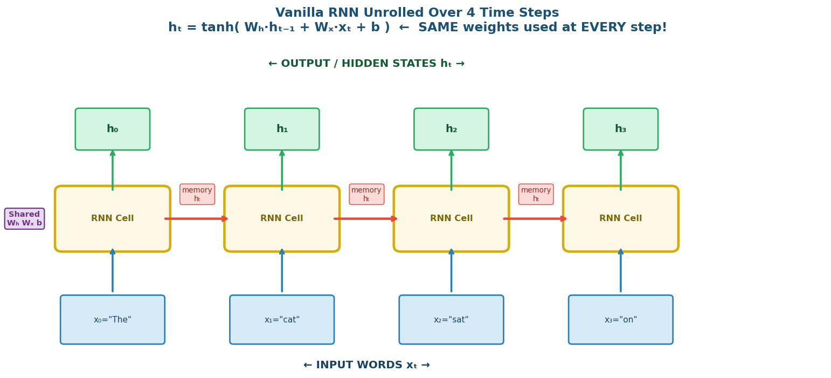
▲ Vanilla RNN Unrolled — Same weights Wₕ, Wₓ, b used at every single time step

🔍 ANALOGY — RNN is Like a Rolling Sticky Note
Imagine reading a book and updating ONE sticky note as you read:

Read "The" → sticky note: "article, noun coming"
Read "cat" → sticky note: "subject = cat"
Read "sat" → sticky note: "cat doing a sitting action"
Read "on" → sticky note: "cat sitting on something..."

Each new word UPDATES the note using the same rule.
Sticky note = hidden state hₜ. The update rule = Wₕ · hₜ₋₁ + Wₓ · xₜ + b

Problem: After 1000 words, the note is so overwritten that word 1 is GONE.

2a. Activation Functions — Why tanh and When to Use Sigmoid
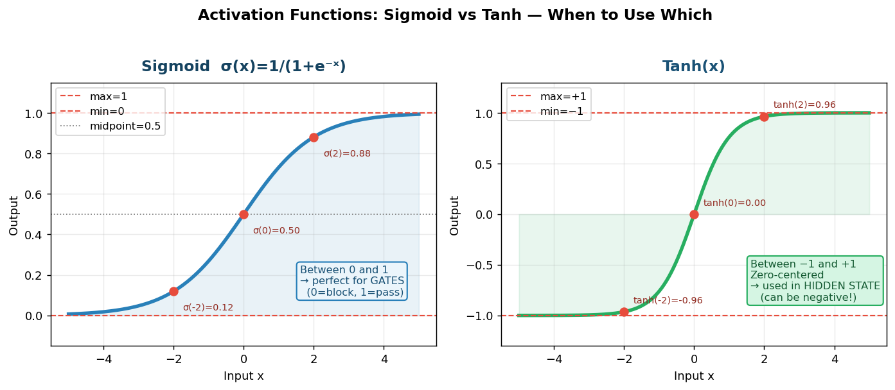
▲ Sigmoid (0 to 1) used in GATES — Tanh (−1 to +1) used in HIDDEN STATE updates

💡 CONCEPT — tanh vs Sigmoid — The Key Difference
TANH — used in hidden state updates:
• Output: −1 to +1 (can be negative — expresses direction AND magnitude)
• Zero-centered (better for gradient flow)
• Used when: hₜ = tanh(Wₕ·hₜ₋₁ + Wₓ·xₜ + b)

SIGMOID — used in LSTM gates:
• Output: 0 to 1 (perfect for "how much to let through")
• 0 = completely block, 1 = completely pass through
• Think of it as a VOLUME KNOB from 0% to 100%
• Used when: fₜ = σ(Wf · [hₜ₋₁, xₜ] + b) ← forget gate

Quick lookup:
σ(−2) = 0.12, σ(0) = 0.50, σ(2) = 0.88
tanh(−2) = −0.96, tanh(0) = 0, tanh(2) = 0.96

2b. RNN in Python — Step by Step
▶ Vanilla RNN from Scratch — NumPy
_import numpy as np
_
_# Toy example: 3-word sentence ["The", "cat", "sat"]
_# Each word represented as a 4-number vector (word embedding)
_x0 = np.array([1.0, 0.0, 0.2, 0.5]) # "The"
_x1 = np.array([0.3, 1.0, 0.1, 0.2]) # "cat"
_x2 = np.array([0.1, 0.2, 1.0, 0.3]) # "sat"
_inputs = [x0, x1, x2]
_
_input_size = 4 # each word = 4 numbers
_hidden_size = 3 # hidden state = 3 numbers (we choose this)
_
_# Weight matrices — random start, learned during training
_np.random.seed(42)
_Wx = np.random.randn(hidden_size, input_size) * 0.1 # shape (3,4)
_Wh = np.random.randn(hidden_size, hidden_size) * 0.1 # shape (3,3)
_b = np.zeros(hidden_size) # shape (3,)
_
_h = np.zeros(hidden_size) # start: no memory [0, 0, 0]
_print("Start h:", h)
_
_for t, xt in enumerate(inputs):
_ h = np.tanh(Wh @ h + Wx @ xt + b)
_ print(f"After word {t}: h = {h.round(3)}")
_
_print("Final h (summary of all 3 words):", h.round(3))

📖 LINE BY LINE:
np.random.randn(3, 4) * 0.1
→ Creates a 3×4 matrix with small random values.
→ Multiply by 0.1 → small starting weights → tanh not saturated at start

h = np.zeros(hidden_size)
→ Start with all-zero hidden state — no memory before reading anything.

for t, xt in enumerate(inputs):
→ Loop runs 3 times — once for each word.
→ t=0 → "The", t=1 → "cat", t=2 → "sat"

h = np.tanh(Wh @ h + Wx @ xt + b)
→ @ is matrix multiplication
→ Wh @ h = "apply memory weights to old hidden state"
→ Wx @ xt = "apply input weights to current word"
→ + b = add bias (extra flexibility, same as b in y=mx+b)
→ tanh() = squish result to be between −1 and +1

WHAT YOU WOULD SEE IF YOU RUN THIS:
Start h: [0. 0. 0.]
After word 0: h = [-0.057 0.033 -0.012] ← "The" processed
After word 1: h = [-0.044 0.041 -0.014] ← updated with "cat"
After word 2: h = [-0.051 0.037 -0.013] ← updated with "sat"
Final h = compressed summary of all 3 words!

3. Vanishing Gradient — Why RNN Forgets Long Sequences
🔍 ANALOGY — The Telephone Game
You whisper a message. It passes through 50 people.
Person 1: "The contract mentions three parties"
Person 50: "The... something... three... ?"

Gradient backpropagation in RNN works exactly like this.
Signal from step 1 must travel through 499 intermediate steps back to update weights.
Each step WEAKENS the signal slightly.
After 500 steps the signal is GONE — the model cannot learn long-range patterns.

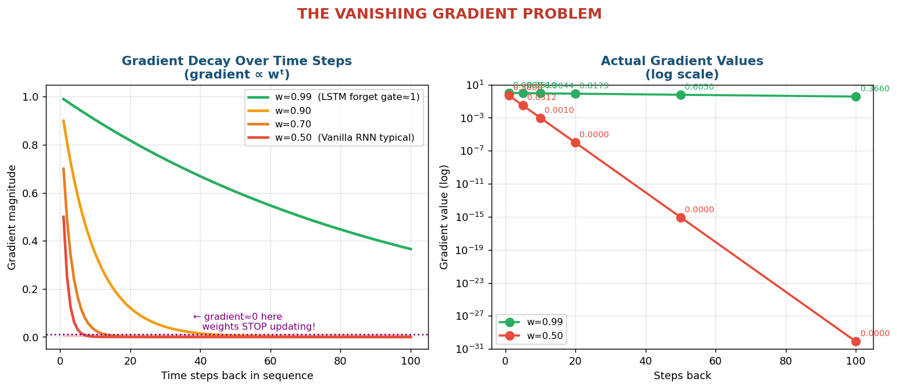
▲ Vanishing Gradient — How quickly gradient magnitude drops with different weight values

💡 CONCEPT — Why Gradient Vanishes — The Simple Math
When training, we update weights using: W = W − η × (∂Loss/∂W)

To update weights at step 1, we need ∂Loss/∂W₁:
∂Loss/∂W₁ ≈ w × w × w × ... (n times) = wⁿ
where w ≈ |∂hₜ/∂hₜ₋₁| (roughly the weight value)

With w = 0.9 (very common in practice):
5 steps back: 0.9⁵ = 0.59 (still OK)
20 steps back: 0.9²⁰ = 0.12 (weakened)
50 steps back: 0.9⁵⁰ = 0.005 (nearly gone)
100 steps back: 0.9¹⁰⁰ = 0.0000265 (GONE)

Gradient = 0 → W = W − η × 0 = W → weights NEVER UPDATE → model never learns.

This is why RNN fails on long sequences: early words have ZERO influence on learning.

⚠️ WATCH OUT — Real World Consequence
5000-word legal document:
Word 1: "The three parties — Alice, Bob, and Carol — agree..."
Word 5000: "All three parties must therefore sign..."

Gradient from word 5000 back to word 1: 0.9⁵⁰⁰⁰ ≈ 10⁻²²⁹
(that is 0.000...0001 with 228 zeros before the 1)

Weight update: W = W − 0.001 × 10⁻²²⁹ ≈ W − nothing ≈ W

Model consistently misses "Carol" (third party mentioned early in doc).
Not because the model is bad — but because the MATH makes it impossible to learn.

4. LSTM — Long Short-Term Memory
🔍 ANALOGY — LSTM is a Professional with a Notebook
Vanilla RNN = trying to remember everything in your head.
After a long meeting you forget what was said in the first 5 minutes.

LSTM = professional with a NOTEBOOK (the cell state):
• FORGET GATE: "Let me cross out notes that are no longer relevant"
• INPUT GATE: "Let me decide what new info is worth writing down"
• CELL STATE: "This is my notebook — long-term memory"
• OUTPUT GATE: "Let me decide what to share from my notebook right now"

The notebook (cell state Cₜ) runs as a CONVEYOR BELT through all time steps.
Gates are LEARNED during training — the model figures out what to keep and forget.

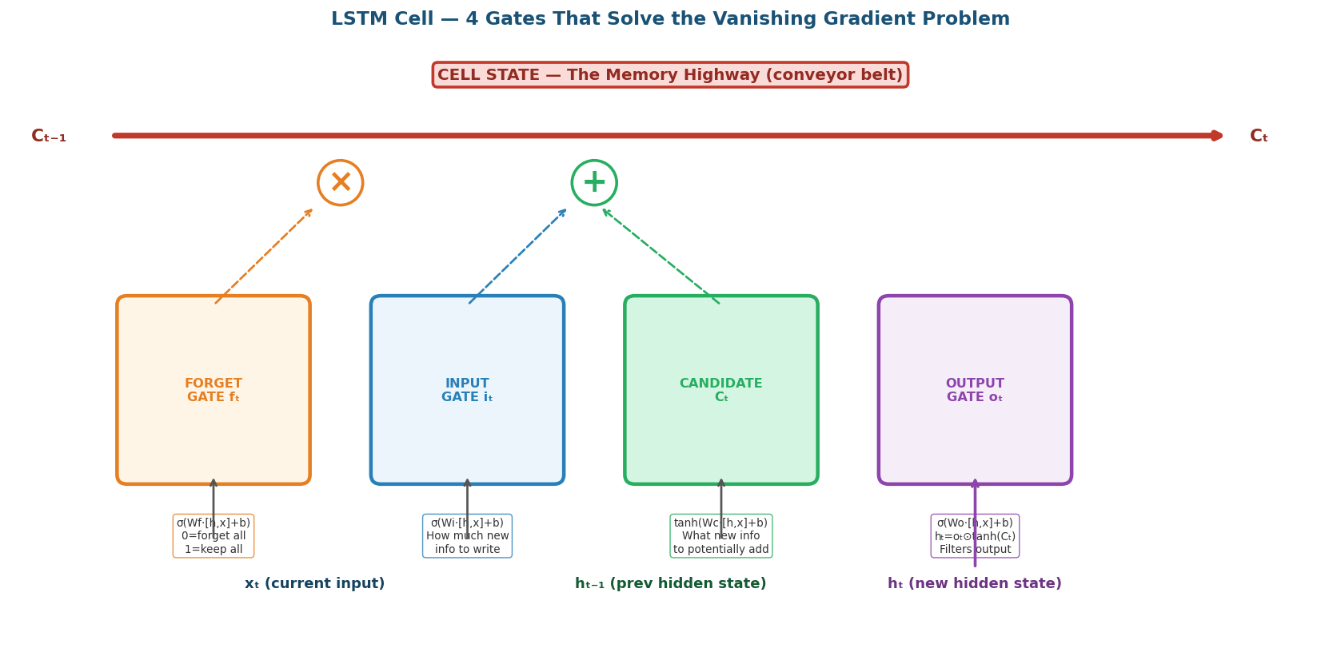
▲ LSTM Cell — 4 Gates Working Together. Cell State (top) = Memory Highway

4a. Gate 1 — FORGET GATE: "What should I erase?"
💡 CONCEPT — Forget Gate — Deciding What to Throw Away
Formula: fₜ = σ( Wf · [hₜ₋₁, xₜ] + bf )

Inputs: previous hidden state hₜ₋₁ + current input xₜ (concatenated)
Output: a number between 0 and 1 FOR EACH memory slot

fₜ = 0.0 → "Completely forget this slot — it is not needed anymore"
fₜ = 0.5 → "Keep 50% of this memory"
fₜ = 1.0 → "Keep 100% — this is important!"

Applied to cell state: fₜ ⊙ Cₜ₋₁
⊙ = element-wise multiply: [0.7, 0.1, 0.9] ⊙ [0.3, 0.5, 0.2] = [0.21, 0.05, 0.18]

Example: "John went to the store. He bought milk."
When reading "He" → forget gate says:
Gender slot: fₜ = 0.95 (KEEP — He = male, we need this to resolve pronoun)
Location slot: fₜ = 0.10 (FORGET — store is no longer relevant)

4b. Gate 2 — INPUT GATE: "What new info to write?"
💡 CONCEPT — Input Gate + Candidate — Deciding What to Add
Two parts working together:

Part 1 — Input gate (HOW MUCH to write):
iₜ = σ( Wi · [hₜ₋₁, xₜ] + bi ) ← sigmoid → 0 to 1
0 = write nothing, 1 = write fully

Part 2 — Candidate (WHAT to write):
C̃ₜ = tanh( Wc · [hₜ₋₁, xₜ] + bc ) ← tanh → −1 to +1
Creates candidate values based on current input + previous hidden state

Combined write operation: iₜ ⊙ C̃ₜ
"Write this fraction of this new information"

Example: reading "dogs" after "He likes":
C̃ₜ = [0.8, −0.2, 0.9, ...] (encodes "preference for dogs")
iₜ = 0.85 (yes, write 85% of this new preference into memory)

4c. Gate 3 — CELL STATE: "Update the notebook"
💡 CONCEPT — Cell State Update — The Core LSTM Operation
Formula: Cₜ = fₜ ⊙ Cₜ₋₁ + iₜ ⊙ C̃ₜ

In plain English:
fₜ ⊙ Cₜ₋₁ = "erase irrelevant parts of old notebook"
iₜ ⊙ C̃ₜ = "add important new information"
Cₜ = the updated notebook

THIS is why LSTM solves vanishing gradient:
Vanilla RNN: hₜ = tanh( Wₕ·hₜ₋₁ + Wₓ·xₜ ) ← hₜ COMPLETELY OVERWRITES hₜ₋₁
LSTM: Cₜ = fₜ·Cₜ₋₁ + iₜ·C̃ₜ ← only PARTIAL update, old is preserved

Gradient through cell state: ∂Cₜ/∂Cₜ₋₁ = fₜ
If fₜ = 1.0: gradient = 1.0 × 1.0 × 1.0 × ... = 1.0 (NO decay!)
If fₜ = 0.0: gradient = 0 (intentional forgetting)

The MODEL chooses when to forget vs remember — that is the brilliance of LSTM!

4d. Gate 4 — OUTPUT GATE: "What to share from the notebook?"
💡 CONCEPT — Output Gate — Filtering What to Show
Formula: oₜ = σ( Wo · [hₜ₋₁, xₜ] + bo )
hₜ = oₜ ⊙ tanh(Cₜ)

The cell state Cₜ = detailed long-term notebook
The hidden state hₜ = short summary you share in conversation

The output gate filters: "for THIS prediction, what from memory is relevant?"

Example: after reading "John went to the bank":
Cell state Cₜ might hold: John=person, bank=financial, went=past, ...
Predicting next word → output gate: "focus on bank (financial) context"
hₜ = 0.85 × tanh(Cₜ) ← filtered version of memory

4e. Worked Example — Real Numbers
💡 CONCEPT — LSTM Step-by-Step Calculation (Prof. Ganguly's Example)
Given: hₜ₋₁=0.5, xₜ=1.0, Cₜ₋₁=0.3, all weights=0.5, all biases=0

STEP 1 — Forget gate:
fₜ = σ(0.5×0.5 + 0.5×1.0) = σ(0.75) = 1/(1+e⁻⁰·⁷⁵) = 0.679
→ KEEP 67.9% of old memory (0.3)

STEP 2 — Input gate:
iₜ = σ(0.5×0.5 + 0.5×1.0) = σ(0.75) = 0.679

STEP 3 — Candidate:
C̃ₜ = tanh(0.5×0.5 + 0.5×1.0) = tanh(0.75) = 0.635

STEP 4 — Update cell state:
Cₜ = 0.679×0.3 + 0.679×0.635
= 0.204 + 0.431 = 0.635 ← memory grew from 0.3 to 0.635

STEP 5 — Output gate → new hidden state:
oₜ = σ(0.75) = 0.679
hₜ = 0.679 × tanh(0.635) = 0.679 × 0.561 = 0.381

Results: new hₜ = 0.381, new Cₜ = 0.635

4f. LSTM in PyTorch
▶ LSTM in PyTorch — 5 Lines
_import torch
_import torch.nn as nn
_
_# Create LSTM layer
_# input_size=4: each word is a 4-number vector
_# hidden_size=8: LSTM internal memory = 8 numbers
_lstm = nn.LSTM(input_size=4, hidden_size=8, batch_first=True)
_
_# Input: 1 sentence, 5 words, each word = 4 numbers
_x = torch.randn(1, 5, 4) # shape: (batch=1, seq=5, input=4)
_
_# Initial memory (all zeros)
_h0 = torch.zeros(1, 1, 8) # initial hidden state
_c0 = torch.zeros(1, 1, 8) # initial cell state
_
_# Run LSTM — PyTorch handles all 4 gates internally!
_output, (hn, cn) = lstm(x, (h0, c0))
_
_print("Input:", x.shape) # (1, 5, 4)
_print("output:", output.shape) # (1, 5, 8) — hidden state at every step
_print("Final hn:", hn.shape) # (1, 1, 8) — last hidden state only
_print("Final cn:", cn.shape) # (1, 1, 8) — last cell state only

📖 LINE BY LINE:
nn.LSTM(input_size=4, hidden_size=8)
→ Creates ALL 4 gate weight matrices automatically (Wf, Wi, Wc, Wo).
→ You never write fₜ=σ(Wf·[h,x]+b) yourself — PyTorch does it.

x = torch.randn(1, 5, 4)
→ 1 = batch size (1 sentence at a time)
→ 5 = sequence length (5 words)
→ 4 = input size (each word is a 4-dim vector)

output vs hn:
→ output shape (1,5,8): hidden state hₜ at EVERY time step
Use this for: predicting one label per word (e.g. POS tagging)
→ hn shape (1,1,8): hidden state ONLY at the LAST time step
Use this for: classifying the whole sentence (e.g. sentiment)

5. LSTM Limitations — Why We Still Needed Something Better
Limitation | What it means | Does LSTM fix it?
Still sequential | Tokens must be processed one at a time. No GPU parallelism. | No — still sequential like RNN
Fixed vector bottleneck | All history crammed into one fixed-size Cₜ vector | Only partially — space still limited
No selective access | To connect word 10 to word 2, must pass through 3,4,5,...,9 | No — still must go step by step
Vanishing gradient | Gradient shrinks to zero over long sequences | Mostly fixed — fₜ keeps gradient alive

⚠️ WATCH OUT — The Fixed Vector Problem — An Analogy
Imagine you have a USB stick with 1GB storage.
You want to store: 10 files → fine.
100 files → tight.
100,000 files → impossible — something gets cut.

LSTM cell state Cₜ = fixed-size USB stick.
5000-word document = 100,000 files.

No matter how good the "forget gate" is, information must be compressed to fit.
The 3rd party mentioned in paragraph 1 gets squeezed out by paragraph 50.

⚠️ WATCH OUT — The Selective Access Problem
Sentence: "Obvijit who is a boy is playing"

To understand "playing" you need:
✓ "Obvijit" (who is playing?)
✓ "is" (tense helper)
✗ "who", "a", "boy" (irrelevant for this)

BUT LSTM must go: Obvijit → who → is → a → boy → is → playing
Signal from "Obvijit" travels through 5 irrelevant steps.
Each step dilutes it.

We want: "playing" directly looks at "Obvijit" — skipping irrelevant words.
That is what ATTENTION does.

6. Attention Mechanism — Selective Focus
🔍 ANALOGY — Attention is Like a Search Engine
When you Google "pizza recipes":
Your QUERY: "pizza recipes"
Web pages each have a KEY: their title/metadata
Web pages each have a VALUE: their actual content

Google computes: how much does your query match each page's key?
Then returns: a weighted mix of the most relevant pages' content.

Self-attention does the SAME THING — but for words in a sentence:
Each word creates a QUERY: "which other words am I looking for?"
Each word creates a KEY: "what do I represent?"
Each word creates a VALUE: "what information do I carry?"

Result: every word gets to look at every other word and decide relevance.

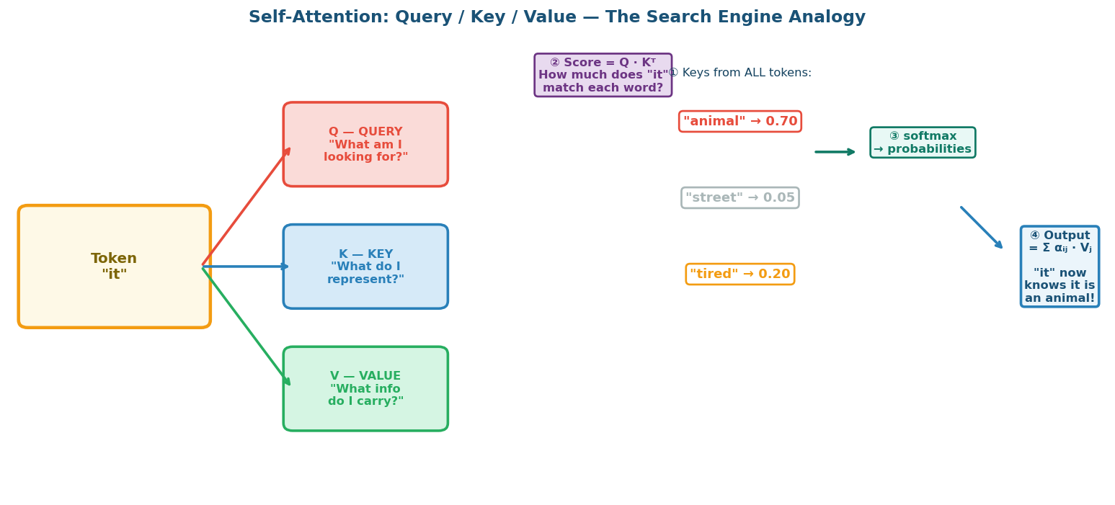
▲ Q/K/V — Self-attention as a search operation. "it" looks up "animal" via query-key matching

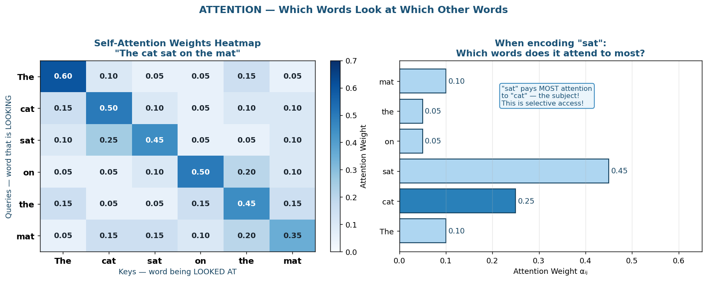
▲ Attention Heatmap — brighter = more attention. "sat" attends most to "cat" (its subject)

💡 CONCEPT — Self-Attention Formula — Step by Step
For every word xᵢ, create three vectors:
qᵢ = xᵢ · Wq (query: what I am looking for)
kᵢ = xᵢ · Wk (key: what I represent)
vᵢ = xᵢ · Wv (value: what info I carry)

Compute how much word i attends to word j:
eᵢⱼ = qᵢ · kⱼᵀ ← dot product = similarity score
eᵢⱼ / √dₖ ← scale to prevent huge values
αᵢⱼ = softmax(eᵢⱼ / √dₖ) ← normalize → probabilities (0 to 1, row sums to 1)

Compute the output for word i:
zᵢ = Σⱼ αᵢⱼ · vⱼ ← weighted sum of ALL value vectors

Result: zᵢ is a context-aware version of xᵢ.
"bank" in "I went to the bank" gets a different zᵢ than "bank" in "river bank".

▶ Self-Attention from Scratch — NumPy
_import numpy as np
_
_# Tiny example: 4 words, each word = 8 numbers
_np.random.seed(42)
_seq_len = 4 # 4 words: "The cat sat down"
_d_model = 8 # each word = 8-dim embedding
_d_k = 4 # query/key dimension
_
_X = np.random.randn(seq_len, d_model) # input: (4, 8)
_Wq = np.random.randn(d_model, d_k) # query weight: (8, 4)
_Wk = np.random.randn(d_model, d_k) # key weight: (8, 4)
_Wv = np.random.randn(d_model, d_k) # value weight: (8, 4)
_
_# STEP 1: Project all words into Q, K, V at once
_Q = X @ Wq # shape: (4, 4) — all 4 words get their query
_K = X @ Wk # shape: (4, 4)
_V = X @ Wv # shape: (4, 4)
_
_# STEP 2: Compute attention scores — how much each word attends to each other
_scores = Q @ K.T / np.sqrt(d_k) # shape: (4, 4)
_
_# STEP 3: Normalize to probabilities
_def softmax(x):
_ e = np.exp(x - x.max(axis=-1, keepdims=True)) # stable version
_ return e / e.sum(axis=-1, keepdims=True)
_
_attn_weights = softmax(scores) # shape: (4, 4) — each row sums to 1.0
_
_# STEP 4: Weighted sum of values
_output = attn_weights @ V # shape: (4, 4)
_
_print("Attention weights row 2 ('sat' attends to):")
_print(attn_weights[2].round(3)) # e.g. [0.10, 0.45, 0.35, 0.10]
_print("Output shape:", output.shape) # (4, 4) — context-aware representations

📖 LINE BY LINE:
Q = X @ Wq
→ ALL 4 words get their query vector simultaneously — no loop needed!
→ This is the key reason Transformers are PARALLELIZABLE on GPU.

scores = Q @ K.T
→ Q shape: (4,4), K.T shape: (4,4) → result: (4,4)
→ scores[2][1] = "how much does word 2 (sat) want to attend to word 1 (cat)?"

/ np.sqrt(d_k)
→ Without this, dot products grow huge as d_k increases.
→ Large values → softmax output ≈ 0 or 1 → gradient vanishes again!
→ Dividing by √4 = 2 keeps scores at reasonable scale.

attn_weights[2] = [0.10, 0.45, 0.35, 0.10]
→ "sat" pays 45% attention to "cat" and 35% to itself.
→ This captures "cat" is the subject of "sat" — grammar learned automatically!

output = attn_weights @ V
→ Each output word = weighted mix of ALL value vectors.
→ "sat"'s output = 0.10×V("The") + 0.45×V("cat") + 0.35×V("sat") + 0.10×V("down")
→ "sat" now KNOWS about its subject "cat" — context-aware!

7. Transformer — Putting It All Together
💡 CONCEPT — Transformer vs RNN — The Key Differences
RNN/LSTM: processes tokens SEQUENTIALLY (word 1 → word 2 → word 3 → ...)
Cannot start word 100 before finishing word 99.
Like a factory line — one item at a time.

Transformer: processes ALL tokens SIMULTANEOUSLY via matrix operations.
Word 1 attends to word 100 DIRECTLY — no intermediate steps.
Like a factory floor — all workers working in parallel.

Cost: Q · Kᵀ creates an N×N matrix. N=1000 words → 1 million values.
Parallelism requires massive GPU compute. That is why AI needs data centers.

7a. Feed-Forward Layer — Expand, Filter, Compress
💡 CONCEPT — Why FFN Expands 4× Then Compresses Back
After attention, each token has a context-aware representation.
But attention is just re-weighting (linear) — it cannot create NEW features.
The Feed-Forward Network (FFN) adds non-linearity and expressive power.

For each token:
FFN(x) = ReLU( x · W₁ + b₁ ) · W₂ + b₂

Step 1: LINEAR EXPAND x (512 dims) → h (2048 dims)
Each token gets a "private workspace" 4× its normal size.

Step 2: RELU FILTER
ReLU zeros out any negative value.
Negative = irrelevant feature in this context → eliminated.

Step 3: LINEAR COMPRESS h (2048 dims) → output (512 dims)
Bring back to original size, but now CLEANER and RICHER.

Example — "Beetle" in a biology class:
Before FFN: 4 dims = [bird:0.3, insect:0.1, car:0.7, music:0.2]
After EXPAND: 16 dims — more specific sub-features for each category
After RELU: context="biology" → car & music = negative → ZEROED OUT
After COMPRESS: 4 dims = [bird:0.0, insect:0.8, car:0.0, music:0.0]
Result: "Beetle" is now PURELY about insects in this context!

7b. Residual Connections — Don't Lose the Original
💡 CONCEPT — Residual Connection — The Skip Highway
After EACH sub-layer (attention or FFN), we do:
output = LayerNorm( x + SubLayer(x) )

x = the ORIGINAL input to the sub-layer.
SubLayer(x) = what the layer computed.
x + SubLayer(x) = original + transformation (keep BOTH)

Without residual: Layer 6 sees only what Layer 5 computed.
Information from the original embedding is lost after 6 layers.

With residual: Original embedding is ALWAYS available at every layer.
Like having both the scenic route AND the highway — pick what you need.

Also helps gradients: gradient can flow DIRECTLY through the + shortcut,
bypassing the complex layer computation entirely.

7c. Positional Encoding — Teaching Word Order Without Sequence
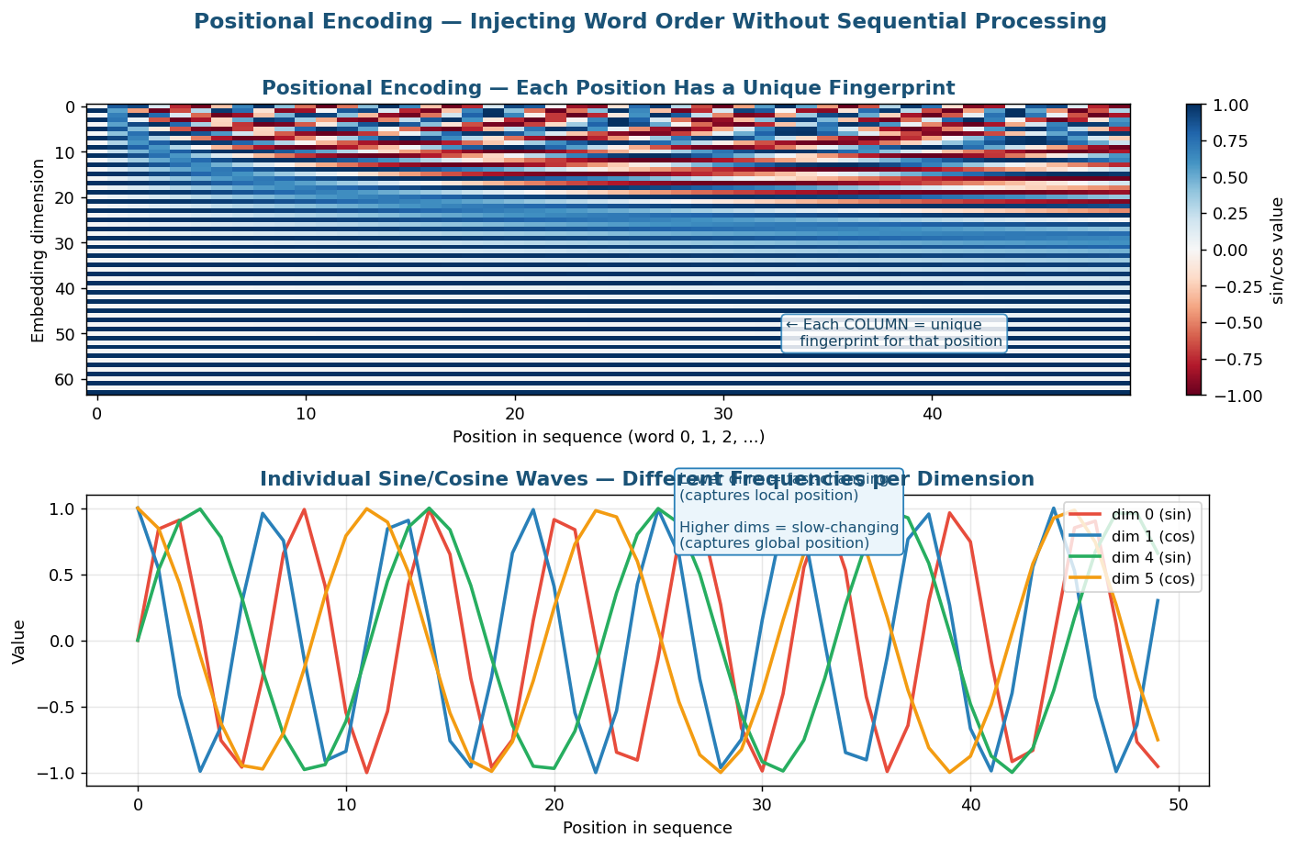
▲ Positional Encoding — each position gets a unique sine/cosine fingerprint

💡 CONCEPT — Why Positional Encoding is Needed
Self-attention looks at ALL words at ONCE — it has no concept of "before" or "after".
"Jack hit Tom" and "Tom hit Jack" would produce the SAME attention matrix
(just with rows/columns swapped) without positional encoding.

Solution: Add a unique position "fingerprint" to each word embedding:
x_input = word_embedding(word) + positional_encoding(position)

Formula:
PE(pos, 2i) = sin( pos / 10000^(2i/d) ) ← even dimensions
PE(pos, 2i+1) = cos( pos / 10000^(2i/d) ) ← odd dimensions

Why sine and cosine?
• Always between −1 and +1 → stable, no explosion
• Smooth and differentiable → good for gradient-based training
• Different positions → different patterns → uniquely identifiable
• Can represent relative distance: model learns "B is 5 steps after A"

IMPORTANT: This does NOT make the model sequential!
All tokens are STILL processed in parallel.
Positional encoding just adds a position signal — like a seat number on a ticket.

▶ Positional Encoding in NumPy
_import numpy as np
_
_def positional_encoding(max_seq, d_model):
_ PE = np.zeros((max_seq, d_model))
_ for pos in range(max_seq):
_ for i in range(0, d_model, 2):
_ denom = 10000 ** (i / d_model)
_ PE[pos, i] = np.sin(pos / denom) # even dim: sine
_ if i+1 < d_model:
_ PE[pos, i+1] = np.cos(pos / denom) # odd dim: cosine
_ return PE
_
_PE = positional_encoding(max_seq=10, d_model=8)
_
_print("Position 0:", PE[0].round(3))
_# → [0. 1. 0. 1. 0. 1. 0. 1. ]
_print("Position 1:", PE[1].round(3))
_# → [0.841 0.540 0.01 0.99 0.001 0.999 0. 1. ]
_print("Position 5:", PE[5].round(3))
_# → completely different pattern — unique fingerprint for position 5!
_
_# Add to word embeddings
_word_embeddings = np.random.randn(10, 8) # 10 words
_x_input = word_embeddings + PE # position-aware input!

📖 LINE BY LINE:
for pos in range(max_seq)
→ Loop over each word position (0=first word, 1=second, ...)

for i in range(0, d_model, 2)
→ Loop over dimension PAIRS: i=0 gives dim 0 and 1, i=2 gives dim 2 and 3, ...
→ range(0, 8, 2) = [0, 2, 4, 6]

10000 ** (i / d_model)
→ Different divisor for each dimension pair → different frequency sine wave
→ Small i → small divisor → fast oscillation (local position info)
→ Large i → large divisor → slow oscillation (global position info)
→ Like a clock: seconds change fast, hours change slow — both tell time together

x_input = word_embeddings + PE
→ Simply ADD positional encoding to word meaning
→ Word meaning + position info fused into one vector
→ Model can now tell position 3 from position 7

7d. Multi-Head Attention — Multiple Lenses at Once
💡 CONCEPT — Why Multiple Heads?
Single-head attention captures ONE type of relationship at a time.
But words have MULTIPLE simultaneous relationships:

In "The animal did not cross the street because it was tired":
Head 1 → co-reference: "it" refers to "animal" (not "street")
Head 2 → verb-subject: "cross" relates to subject "animal"
Head 3 → negation: "did not" modifies "cross"
Head 4 → semantic: "tired" relates to "animal" (a state)

MultiHead(Q,K,V) = Concat(head₁, head₂, ..., headₕ) · Wᴼ
where headᵢ = Attention(Q·Wᵢq, K·Wᵢk, V·Wᵢv)

Each head has its OWN weight matrices → learns its OWN type of relationship.
All heads run in PARALLEL → no extra time cost.
Analogous to CNN filters: each filter detects a different visual feature.

▶ Full Transformer Encoder — PyTorch Built-In
_import torch
_import torch.nn as nn
_
_# One encoder layer = multi-head attention + FFN + residual + layer norm
_encoder_layer = nn.TransformerEncoderLayer(
_ d_model=512, # embedding dimension (each word = 512 numbers)
_ nhead=8, # 8 attention heads in parallel
_ dim_feedforward=2048,# FFN hidden size (4 × d_model)
_ dropout=0.1, # randomly zero 10% of neurons — prevents overfitting
_ batch_first=True # input shape: (batch, seq, d_model)
_)
_
_# Stack 6 encoder layers (standard Transformer has 6)
_encoder = nn.TransformerEncoder(encoder_layer, num_layers=6)
_
_# Test: 2 sentences, 10 words each, 512 dims per word
_x = torch.randn(2, 10, 512) # shape: (batch=2, seq=10, d=512)
_out = encoder(x)
_
_print("Input shape:", x.shape) # torch.Size([2, 10, 512])
_print("Output shape:", out.shape) # torch.Size([2, 10, 512])
_# Shape unchanged — but each word is now CONTEXT-AWARE
_# "bank" in finance context ≠ "bank" in river context

8. The Full Picture — Architecture Evolution
Architecture | Core Innovation | What it Fixes | Still Has Problems
Vanilla RNN | Hidden state hₜ = memory | Can process sequences | Vanishing gradient, no parallelism
LSTM | Cell state + 4 gates | Vanishing gradient (mostly) | Sequential, fixed vector, no selective access
RNN + Attention | Dynamic context per decoder step | Fixed vector bottleneck | Sequential RNN still present
Transformer | Self-attention over full sequence | All of the above | Quadratic cost, context window limit
Modern LLMs (GPT-4) | Massive scale + fine-tuning | Most NLP tasks | Cost, hallucinations, context limits

✅ KEY TAKEAWAY — The Formula That Changed AI
The entire Transformer boils down to:

Attention(Q, K, V) = softmax( Q · Kᵀ / √dₖ ) · V

Where:
Q = X · Wq (queries — what each word is looking for)
K = X · Wk (keys — what each word represents)
V = X · Wv (values — what each word carries)

3 matrix multiplications. 1 softmax. That is literally it.
This enables: ✅ parallelism ✅ selective access ✅ no bottleneck ✅ context-awareness

Published 2017. Many said "attention is NOT all you need." They were wrong.

✅ KEY TAKEAWAY — Exam Quick Reference
"What is learning in engineering?"
→ Learning = learning the weight matrices. Random start, updated via backprop.

"Why does vanilla RNN fail on long sequences?"
→ Gradient ∝ wⁿ → 0 as n grows. Weight updates become zero → model stops learning.

"How does LSTM fix vanishing gradient?"
→ Cell state gradient: ∂Cₜ/∂Cₜ₋₁ = fₜ (forget gate).
→ If fₜ ≈ 1 (remember), gradient ≈ 1. No exponential decay.

"What are the 2 problems LSTM still has?"
→ Fixed vector bottleneck + No selective access (must go through all steps).

"Why is Transformer faster to train than LSTM?"
→ Self-attention = one matrix multiply for ALL tokens at once.
→ LSTM: word 100 waits for words 1-99. Transformer: all 100 at the same time.

"Why do we need positional encoding?"
→ Self-attention is permutation invariant — "Jack hit Tom" = "Tom hit Jack" without PE.
→ PE adds unique fingerprint per position. "Jack hit Tom" ≠ "Tom hit Jack" with PE.

