Lecture 10 -- VISUAL (IIT KGP) | Deep Learning Basics (Beginner Visual Guide) | IIT Kharagpur
CONCEPT -- What This Lecture Covers
This lecture is the FOUNDATION of all deep learning.
Every model from CNN to GPT builds on what you learn here.

You will understand:
1. How a single neuron works (math + analogy)
2. Forward propagation (prediction) and Backward propagation (learning)
3. Activation functions, Loss functions, and Optimizers
4. How to avoid overfitting (regularization)
5. Which neural network type to use for which problem (ANN/CNN/RNN/Transformer)

Everything in Lecture 09 (RNN/LSTM/Transformers) depends on these basics.

1. AI vs Machine Learning vs Deep Learning
People use AI, ML, and DL interchangeably -- but they are NOT the same. Each is a SUBSET of the previous.
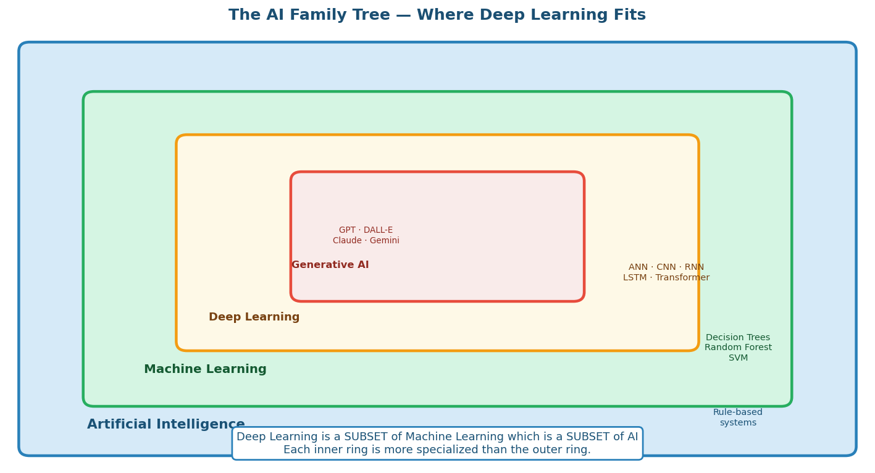
AI is the outermost set; Deep Learning is inside ML; Generative AI is inside DL

ANALOGY -- The Russian Dolls
Think of Russian nesting dolls (one inside another).

AI (outermost doll) = any machine that mimics intelligence (even simple "if-else" rules).
ML (inside AI) = machines that LEARN from data, no hard-coded rules.
DL (inside ML) = ML using multi-layer neural networks inspired by the brain.
GenAI (innermost) = DL models that GENERATE new content (text, images, video).

You cannot have GenAI without DL. You cannot have DL without ML.

Category | Definition | What you need | Examples
Artificial Intelligence | Any machine mimicking intelligent behaviour | Rules OR data | Chess AI, spam filter, Google Maps
Machine Learning | Algorithms that improve automatically from examples | Labelled data + algorithm | Linear regression, decision tree, SVM
Deep Learning | ML using multi-layer neural networks; auto feature learning | Huge data + GPU | Image recognition, speech-to-text, LLMs
Generative AI | DL that creates new content | DL + massive training | GPT-4, Claude, DALL-E, Gemini

CONCEPT -- Why Deep Learning NOW? Three reasons
1. DATA: Internet created massive datasets (ImageNet, Wikipedia, Common Crawl).
2. COMPUTE: GPUs made matrix multiplications 100-1000x faster (NVIDIA CUDA).
3. ALGORITHMS: Better weight init, activation functions (ReLU), optimizers (Adam).

All three came together around 2012 (AlexNet ImageNet win) and DL took off.

CONCEPT -- Key Advantage: Automatic Feature Learning
Traditional ML: YOU manually decide which features matter.
Example for images: you must write code to detect edges, colors, shapes yourself.

Deep Learning: the network DISCOVERS what features matter all by itself.
Hidden layer 1 learns edges -> Layer 2 learns shapes -> Layer 3 learns objects.

You just feed raw pixels. The network figures out what to look at. That is the magic.

KEY TAKEAWAY -- DL vs ML: When to Use Which
Use ML when: Structured tabular data, small dataset, need interpretability.
Use DL when: Unstructured data (images/text/audio), huge dataset, need high accuracy.

DL needs MORE DATA and MORE COMPUTE but gives BETTER RESULTS on complex tasks.

2. Biological vs Artificial Neuron
The idea for neural networks came from biology. We do not copy the brain exactly, but the analogy is very helpful.
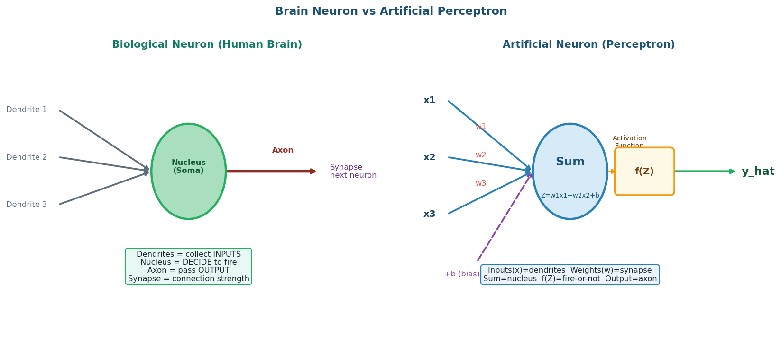
Biological Neuron vs Artificial Perceptron: Same 3-step pattern

CONCEPT -- Single Neuron -- The Perceptron (3 steps)
ONE artificial neuron does exactly 3 things:

STEP 1 -- Collect inputs and weight them:
Z = w1*x1 + w2*x2 + w3*x3 + b
(multiply each input by its weight, sum everything, add bias)

STEP 2 -- Pass through activation function:
output = f(Z) (decides: should this neuron fire?)

STEP 3 -- Send output to next layer.

One neuron = one weighted sum + one activation. That is literally it.

ANALOGY -- The Voting Committee
3 judges voting on "is this email spam?"

Judge 1 (x1=1 if "win money" in email): weight w1 = 0.9 (strong spam signal)
Judge 2 (x2=1 if known sender): weight w2 = -0.8 (if yes, probably NOT spam)
Judge 3 (x3=1 if has link): weight w3 = 0.5 (mild spam signal)
Bias b = -0.1

Z = 0.9(1) + (-0.8)(0) + 0.5(1) + (-0.1) = 1.3
Sigmoid(1.3) = 0.785 -> 78.5% chance of spam -> classify SPAM

The WEIGHTS are what the model LEARNS. They start random, improve via backprop.

Component | Biological name | Artificial name | Role
Inputs | Dendrites | xi (features) | Receive incoming signals
Connection strength | Synapse strength | wi (weights) | How much each input matters
Shift term | -- | b (bias) | Shift decision boundary (intercept)
Cell body | Soma / Nucleus | Z = sum(wi*xi) + b | Collect and sum all inputs
Fire decision | Cell body threshold | f(Z) activation | Decide output signal
Output signal | Axon | y_hat | Pass result to next neuron

CONCEPT -- Perceptron -> Layer -> Neural Network
One neuron = perceptron.
Multiple neurons in parallel = one LAYER.
Multiple layers stacked = Artificial Neural Network (ANN).

Why "DEEP" learning? -> Many hidden layers = "deep" network.
More layers = more complex patterns the model can learn.

Parameter count example: 2 inputs -> 3 hidden -> 1 output
Input->Hidden: 2*3=6 weights + 3 biases = 9
Hidden->Output: 3*1=3 weights + 1 bias = 4
TOTAL: 13 trainable parameters

GPT-3 has 175 BILLION such parameters. Same math, just scaled up enormously.

CODE -- Keras: Building a Neural Network
_import tensorflow as tf
_from tensorflow import keras
_
_model = keras.Sequential([
_ keras.layers.Dense(16, activation="relu", input_shape=(4,)),
_ keras.layers.Dense(8, activation="relu"),
_ keras.layers.Dense(3, activation="softmax"),
_])
_
_model.compile(optimizer="adam",
_ loss="categorical_crossentropy",
_ metrics=["accuracy"])
_
_model.fit(X_train, y_train, epochs=60, batch_size=16)

LINE BY LINE:
keras.Sequential([...]) -> stack layers in sequence (linear flow)

Dense(16, activation="relu", input_shape=(4,))
Dense = fully connected (every neuron connects to every neuron in next layer)
16 = number of neurons in this hidden layer
activation="relu" = which activation function to use
input_shape=(4,) = 4 input features (only in FIRST layer)

Dense(3, activation="softmax")
3 output neurons = 3 classes to predict
softmax converts raw scores to probabilities summing to 1

model.compile(optimizer="adam", loss="categorical_crossentropy")
optimizer = which algorithm updates weights (adam is default choice)
loss = formula that measures how wrong we are

model.fit(X_train, y_train, epochs=60)
Run 60 complete passes through data
Each pass: forward -> loss -> backward -> update weights

3. Forward Propagation
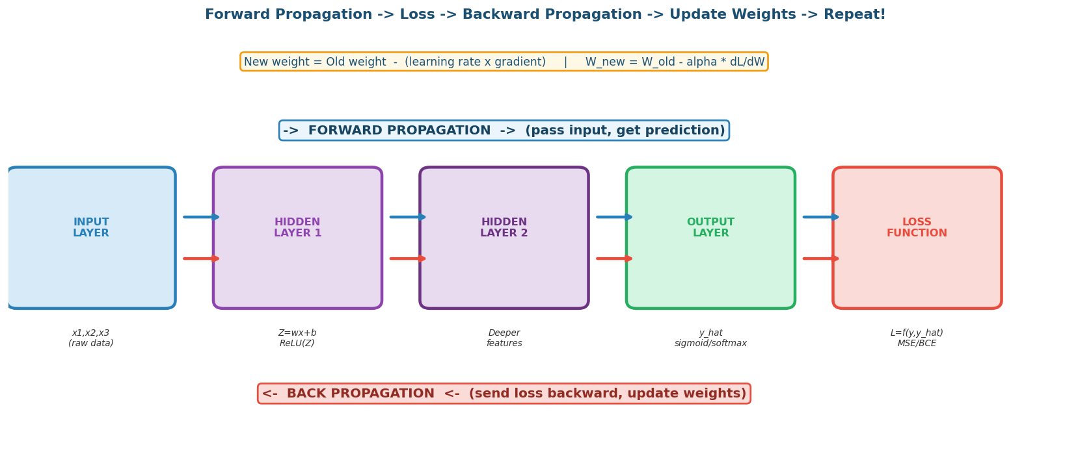
Forward (prediction) -> Loss -> Backward (learning) -> Update -> Repeat

CONCEPT -- Forward Propagation -- The Prediction Pass
Forward propagation = pass data from INPUT through every layer to OUTPUT.

At each layer:
1. Take output from previous layer as input
2. Multiply by weights and add bias: Z = W*X + b
3. Apply activation function: A = f(Z)
4. Pass A to next layer

The final layer gives y_hat (the prediction).
No learning happens here. We are just asking: "What would current weights predict?"

CONCEPT -- Step-by-Step Numeric Example
Problem: Predict house price (normalized) from floor_size and rooms.

Inputs: x1 = 0.8, x2 = 0.6
Weights: w1 = 0.4, w2 = 0.3
Bias: b = 0.1

STEP 1: Z = w1*x1 + w2*x2 + b
= (0.4)(0.8) + (0.3)(0.6) + 0.1
= 0.32 + 0.18 + 0.1 = 0.60

STEP 2: Linear activation: y_hat = Z = 0.60

True value y = 0.85 -> Loss = (y - y_hat)^2 = (0.85 - 0.60)^2 = 0.0625

Model is WRONG. Now backprop fixes w1, w2, b.

4. Backward Propagation
CONCEPT -- Backward Propagation -- The Learning Pass
The loss tells us HOW WRONG we were.
Backprop tells us WHOSE FAULT IT IS -- which weights caused the error.

We take the loss and differentiate with respect to each weight (CHAIN RULE).
This gives the GRADIENT: "if I increase this weight, does loss go up or down?"

Then update each weight using GRADIENT DESCENT:

W_new = W_old - alpha * dL/dW

alpha = learning rate (how big a step)
dL/dW = gradient (which direction to step)

We do this for EVERY weight in EVERY layer, working backwards (output -> input).

ANALOGY -- GPS Recalculating
You are driving to a destination (minimum loss).
You took a wrong turn (wrong weights).

FORWARD PROP = driving in the current direction, arriving at wrong place.
LOSS = GPS says "you are 5 km off target".
BACKPROP = GPS recalculates: "turn left, reduce speed".
WEIGHT UPDATE = you physically steer the car.

Then drive again (next forward pass). Repeat until you arrive (loss ~ 0).

CONCEPT -- Chain Rule -- How Backprop Works
We cannot differentiate loss directly with respect to w1 in layer 1.
w1 does not appear directly in the loss formula.

Instead, use the CHAIN RULE:
dL/dw1 = (dL/d_yhat) * (d_yhat/dZ) * (dZ/dw1)

Breaking it down:
dL/d_yhat = how much does loss change if prediction changes? (from loss formula)
d_yhat/dZ = how much does output change if Z changes? (from activation)
dZ/dw1 = how much does Z change if w1 changes? = x1 (just the input!)

Result: dL/dw1 = 2*(y_hat - y) * f_prime(Z) * x1

Then: w1_new = w1_old - alpha * dL/dw1

Symbol | Name | Meaning | Typical value
alpha | Learning rate | Step size for each weight update | 0.001 for Adam
dL/dW | Gradient | Direction to improve weights | Computed by chain rule
W_new | Updated weight | New parameter after learning | Replaces W_old
epoch | One full pass | All batches processed once | 10-200 typically
batch | Mini-sample | Subset of data per update | 16, 32, 64, 128 records

CONCEPT -- Epoch vs Batch -- Critical Difference
Suppose: 100 training records, batch_size = 20

Batch 1: records 1-20 -> forward -> loss -> backprop -> update weights
Batch 2: records 21-40 -> ...
Batch 3: records 41-60 -> ...
Batch 4: records 61-80 -> ...
Batch 5: records 81-100 -> ...

After all 5 batches = 1 EPOCH (saw all data once)

50 epochs = weights updated 5 * 50 = 250 times total.
More epochs = more learning (but risk of overfitting).

5. Activation Functions
Every neuron needs an activation function. Without it, stacking layers does nothing extra -- the whole network is still just linear regression.
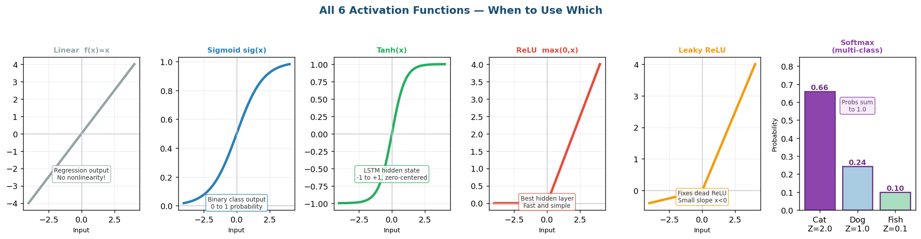
All 6 activation functions -- output range and when to use each

WHY are we doing this?
Without activation functions, multiple layers = ONE linear layer in disguise!

Proof: if f(Z) = Z (linear), then
Layer 1 output = W1*X + b1
Layer 2 output = W2*(W1*X+b1) + b2 = (W2*W1)*X + (W2*b1+b2)

That is just one linear layer! No matter how many layers you add.

Activation functions ADD NONLINEARITY -> network can learn curves, not just lines.
This is why deep networks learn complex patterns that simple regression cannot.

Activation | Formula | Output range | Typical use | Key property
Linear | f(Z)=Z | (-inf, +inf) | Regression OUTPUT | No nonlinearity added
Sigmoid | 1/(1+e^-Z) | (0, 1) | Binary classify output | Vanishing gradient risk
Tanh | (e^Z-e^-Z)/(e^Z+e^-Z) | (-1, +1) | LSTM/RNN hidden state | Zero-centered
ReLU | max(0, Z) | [0, +inf) | Hidden layers (most popular) | Fast; dead neuron risk
Leaky ReLU | max(0.1Z, Z) | (-inf, +inf) | Hidden layers alt | Fixes dead ReLU
Softmax | e^Zi / sum(e^Zj) | (0,1) sum=1 | Multi-class output | Probabilities sum to 1

CONCEPT -- Quick Rule: Which Activation for Which Layer?
HIDDEN LAYERS: use ReLU (default) or Leaky ReLU.

OUTPUT LAYER depends on PROBLEM TYPE:
Binary classification (yes/no, 2 classes) -> Sigmoid (1 neuron)
Multi-class (3+ classes) -> Softmax (N neurons)
Regression (predict a number) -> Linear (1 neuron)

Exception: LSTM gates always use Sigmoid (gate 0-1) and Tanh (cell state).

WATCH OUT -- Vanishing Gradient Problem
Sigmoid and Tanh squash inputs to very small ranges.
Their derivatives become near ZERO for large/small inputs.

During backprop, we multiply many such near-zero gradients (chain rule).
Result: gradient -> 0 exponentially in deep networks.
Early layer weights STOP UPDATING -- network cannot learn.

Fix for dense nets: use ReLU (gradient = 1 for positive Z).
Fix for sequences: use LSTM (gates keep gradient alive across time).

6. Loss Functions
The loss function is the single number measuring how wrong our predictions are. Minimizing it is the goal of training.
Loss Function | Formula | When to use | Output activation
Mean Squared Error (MSE) | L = (1/n) * sum(y - y_hat)^2 | Regression: predict a number | Linear
Mean Absolute Error (MAE) | L = (1/n) * sum|y - y_hat| | Regression: robust to outliers | Linear
Binary Cross-Entropy | L = -[y*log(y_hat) + (1-y)*log(1-y_hat)] | Binary classification (2 classes) | Sigmoid
Categorical Cross-Entropy | L = -sum(yi * log(y_hat_i)) | Multi-class (3+ classes) | Softmax
Sparse Categorical CE | Same but y is integer label | Multi-class with integer labels | Softmax

CONCEPT -- Why SQUARED in MSE?
Suppose 3 prediction errors: +5, -3, +1

Simple average: (5 + (-3) + 1) / 3 = 1 <- positive and negative CANCEL OUT!

With MSE: (25 + 9 + 1) / 3 = 11.67 <- all positive, no cancellation.
Also: squaring PENALIZES big errors more (5^2=25 >> 1^2=1).

That is why MSE is preferred for regression.

7. Optimizers
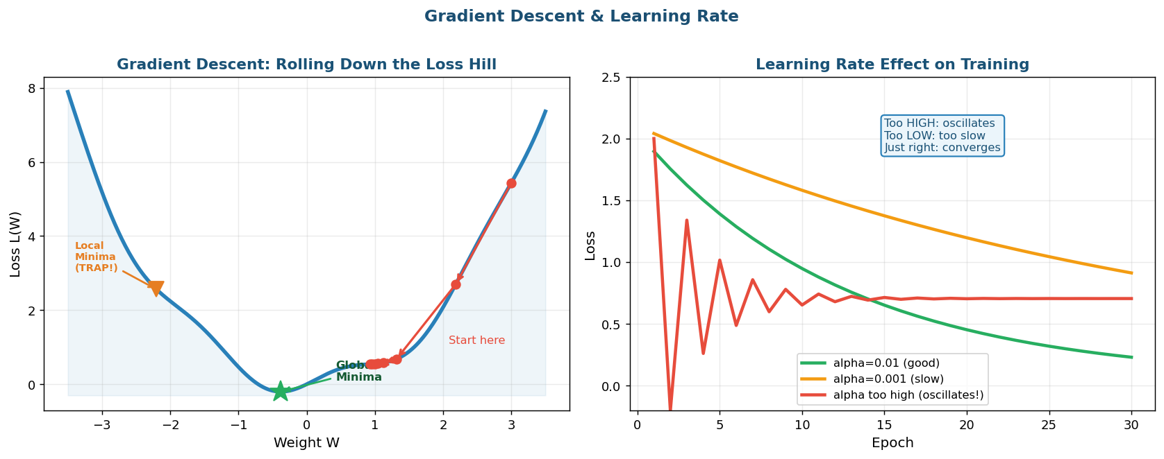
Gradient Descent: Rolling Down the Loss Hill + Learning Rate Effect

CONCEPT -- Gradient Descent -- The Core Update Rule
W_new = W_old - alpha * dL/dW

alpha = LEARNING RATE (how big a step each update takes)
dL/dW = GRADIENT (which direction to move)

If gradient is positive -> loss increases as W increases -> DECREASE W.
If gradient is negative -> loss decreases as W increases -> INCREASE W.

We walk DOWNHILL on the loss surface until we reach the bottom (minimum loss).

Optimizer | How it works | Batch size | Best for
SGD | 1 record per update | 1 | Simple; slow but can escape local minima
Batch GD | All records per update | N (full) | Small datasets; stable but RAM heavy
Mini-Batch GD | Small batch per update | 16-128 | Most practical DL tasks
Adam | Adaptive learning rate per weight; momentum + RMSprop | Mini-batch | DEFAULT for almost everything
AdaGrad | Bigger steps for rare features | Mini-batch | NLP with rare words
RMSprop | Decays old gradients | Mini-batch | RNN / LSTM training

KEY TAKEAWAY -- Optimizer Decision Guide
Starting out / general DL task: -> use Adam, lr=0.001
Training RNN/LSTM: -> use RMSprop or Adam
Transformers / LLMs: -> use AdamW

Specify in Keras: model.compile(optimizer="adam", ...)
Adam is preferred because it automatically adapts learning rate per weight.

8. Regularization -- Preventing Overfitting
CONCEPT -- Overfitting vs Underfitting
UNDERFITTING: high training loss AND high test loss.
Model too simple. Fix: add more layers, neurons, more epochs.

OVERFITTING: very LOW training loss but HIGH test loss.
Model memorized training data; fails on new data.
Fix: regularization techniques below.

JUST RIGHT: low training loss AND similar test loss. <- This is the goal.

ANALOGY -- Student Who Memorized vs Student Who Understood
Student A memorized 1000 exam questions word-for-word.
Practice test: 100/100. Real exam (slight variations): 40/100.
They overfitted to training questions. Memorized noise, not understanding.

A well-regularized model is like a student who understood concepts.
Can handle new variations correctly.

Technique | How it works | When to use | Keras code
Dropout | Randomly turn off p% of neurons each batch | Large networks; overfitting | keras.layers.Dropout(0.3)
L2 Regularization | Penalty lambda*sum(w^2) added to loss | Dense layers | kernel_regularizer=l2(0.01)
L1 Regularization | Penalty lambda*sum|w|; sparse weights | Feature selection | kernel_regularizer=l1(0.01)
Early Stopping | Stop when val loss stops improving | Always good idea | EarlyStopping(patience=5)
Batch Normalization | Normalize activations within batch | Deep nets; CNN | BatchNormalization()

CODE -- Dropout + Early Stopping in Keras
_from tensorflow import keras
_
_model = keras.Sequential([
_ keras.layers.Dense(64, activation="relu", input_shape=(X_train.shape[1],)),
_ keras.layers.Dropout(0.3), # DROP 30% neurons randomly each batch
_ keras.layers.Dense(32, activation="relu"),
_ keras.layers.Dropout(0.2),
_ keras.layers.Dense(1, activation="sigmoid"),
_])
_
_model.compile(optimizer="adam",
_ loss="binary_crossentropy",
_ metrics=["accuracy"])
_
_early_stop = keras.callbacks.EarlyStopping(
_ monitor="val_loss",
_ patience=5,
_ restore_best_weights=True
_)
_
_model.fit(X_train, y_train,
_ epochs=200,
_ batch_size=32,
_ validation_split=0.2,
_ callbacks=[early_stop])

LINE BY LINE:
Dropout(0.3) -> each training batch, randomly zero out 30% of neurons.
Each batch sees a different sub-network -> forces redundancy -> less memorization.
At TEST time, Dropout automatically turns OFF (all neurons active).

EarlyStopping(monitor="val_loss", patience=5)
After each epoch, check validation loss.
If val_loss did not improve for 5 consecutive epochs -> STOP training.
restore_best_weights=True: revert to best weights ever seen.

validation_split=0.2
Keras holds out last 20% of training data for validation.
Validation data is NEVER used for weight updates, only for monitoring.

9. Types of Neural Networks
The architecture you choose is the most important design decision. Each type is designed for a specific data format.
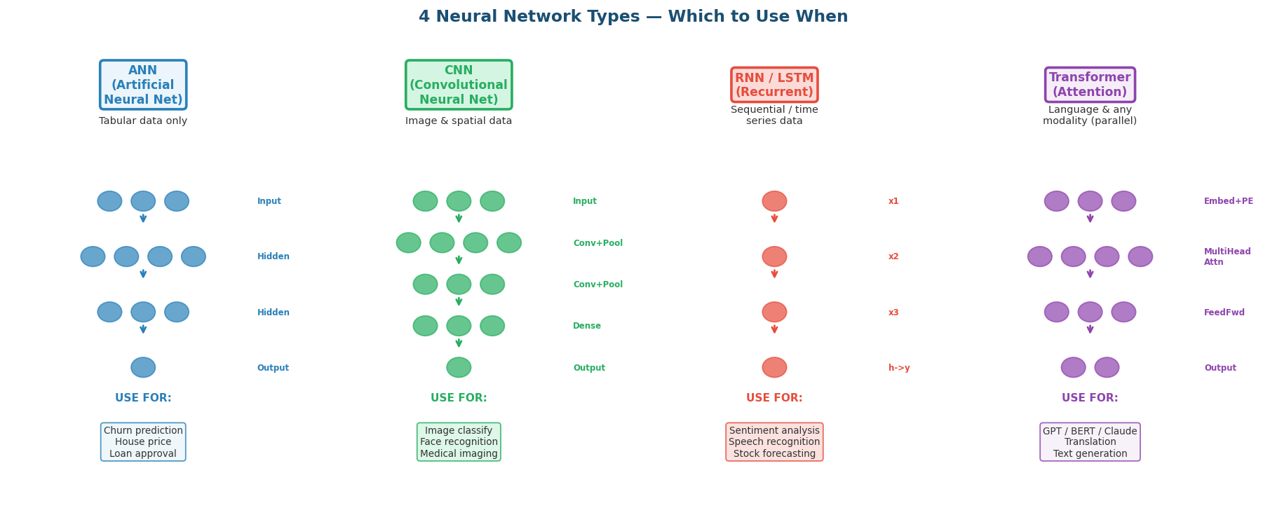
ANN vs CNN vs RNN/LSTM vs Transformer: 4 types, 4 use cases

9.1 ANN -- Artificial Neural Network
CONCEPT -- ANN -- Fully Connected Layers
ANN = stack of Dense (fully connected) layers.
Every neuron in layer N connects to EVERY neuron in layer N+1.

Good for: tabular/structured data (rows and columns).
NOT for: images (spatial), text (sequential).

Also called: MLP (Multi-Layer Perceptron), DNN (Deep Neural Network).

Use for: churn prediction, loan approval, house price, sales forecasting.

CODE -- ANN for Iris Classification (3 classes, 4 features)
_from sklearn.datasets import load_iris
_from sklearn.model_selection import train_test_split
_from sklearn.preprocessing import StandardScaler
_import tensorflow as tf
_
_iris = load_iris()
_X = iris.data
_y = tf.keras.utils.to_categorical(iris.target, 3) # one-hot encode
_X_train, X_test, y_train, y_test = train_test_split(X, y, test_size=0.2)
_scaler = StandardScaler()
_X_train = scaler.fit_transform(X_train)
_X_test = scaler.transform(X_test)
_
_model = tf.keras.Sequential([
_ tf.keras.layers.Dense(16, activation="relu", input_shape=(4,)),
_ tf.keras.layers.Dense(8, activation="relu"),
_ tf.keras.layers.Dense(3, activation="softmax"), # 3 classes
_])
_model.compile(optimizer="adam",
_ loss="categorical_crossentropy",
_ metrics=["accuracy"])
_model.fit(X_train, y_train, epochs=60, verbose=0)
_loss, acc = model.evaluate(X_test, y_test, verbose=0)
_print(f"Test accuracy: {acc:.2%}") # typically 96-100%

LINE BY LINE:
load_iris() -> classic 150-record flower dataset.
4 features: sepal length/width, petal length/width.
3 classes: Setosa (0), Versicolor (1), Virginica (2).

to_categorical(iris.target, 3) -> converts integer labels to one-hot:
class 0 -> [1,0,0] class 1 -> [0,1,0] class 2 -> [0,0,1]
Required for categorical_crossentropy loss.

StandardScaler() -> standardize: (x - mean) / std for each feature.
CRITICAL: fit_transform only on TRAIN, then transform TEST.
Never fit on test data -- that is data leakage.

Dense(3, activation="softmax") -> 3 output neurons (one per class).
Softmax gives e.g. [0.02, 0.91, 0.07] -> predict class 1 (Versicolor).

categorical_crossentropy -> use when labels are ONE-HOT encoded.
sparse_categorical_crossentropy -> use when labels are integers (0,1,2).

9.2 CNN -- Convolutional Neural Network
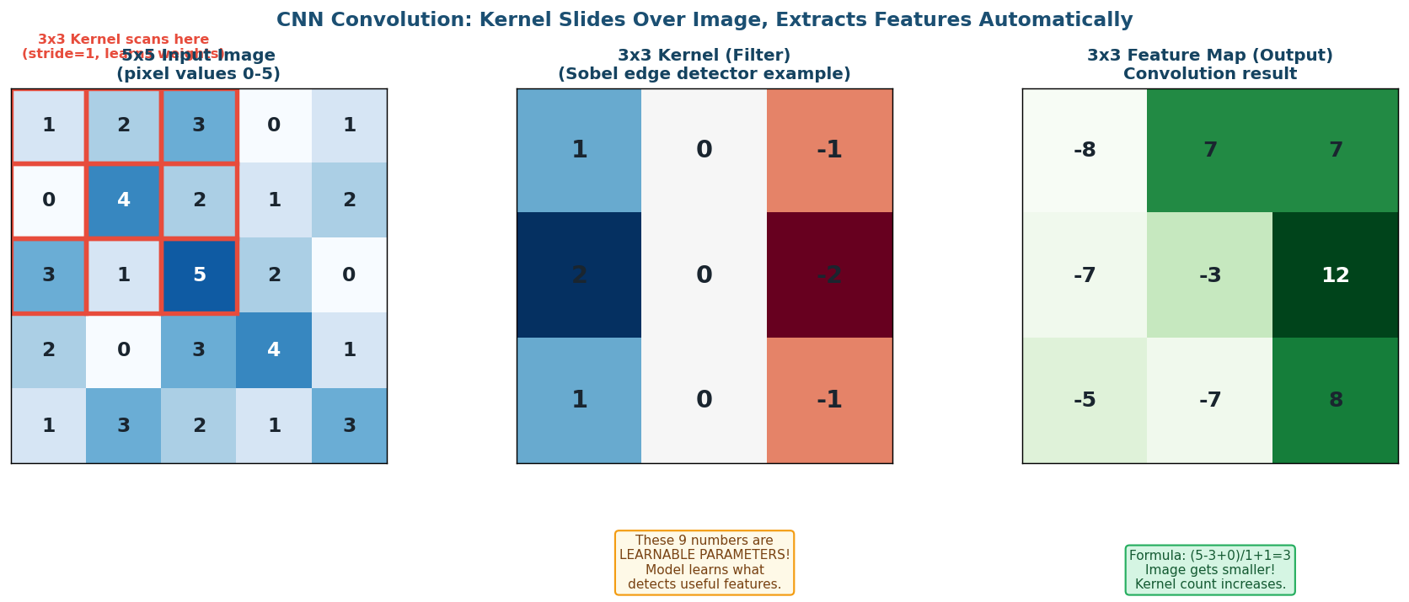
CNN: 3x3 kernel slides over 5x5 image -> 3x3 feature map

CONCEPT -- CNN -- How Convolution Works
Key insight: NEARBY PIXELS are related. Far-away pixels are not.

Instead of connecting to EVERY pixel, CNN uses a small KERNEL (e.g. 3x3).
The kernel slides across the image (stride=1 = move 1 pixel at a time).
At each position: element-wise multiply kernel with image patch -> sum -> 1 output pixel.

This creates a FEATURE MAP across the whole image.
Multiple kernels = multiple feature maps (detecting different things).
Deeper layers = more abstract features (edges -> shapes -> objects).

CONCEPT -- Output Size Formula
Given: Input size N, Kernel size F, Padding P, Stride S

Output size = floor((N - F + 2P) / S) + 1

Example: N=5, F=3, P=0, S=1
Output = (5 - 3 + 0)/1 + 1 = 3 + 1 = 4x4

With padding=1 (same padding):
Output = (5 - 3 + 2)/1 + 1 = 4 + 1 = 5x5 (same size!)

As you go deeper: image SMALLER, number of kernels INCREASES.

CODE -- CNN for MNIST Digit Classification
_import tensorflow as tf
_
_(X_train, y_train), (X_test, y_test) = tf.keras.datasets.mnist.load_data()
_X_train = X_train.reshape(-1, 28, 28, 1) / 255.0
_X_test = X_test.reshape(-1, 28, 28, 1) / 255.0
_
_model = tf.keras.Sequential([
_ # Conv block 1: detect simple features
_ tf.keras.layers.Conv2D(32, (3,3), activation="relu", input_shape=(28,28,1)),
_ tf.keras.layers.MaxPooling2D(2,2),
_
_ # Conv block 2: detect complex features
_ tf.keras.layers.Conv2D(64, (3,3), activation="relu"),
_ tf.keras.layers.MaxPooling2D(2,2),
_
_ # Classification head
_ tf.keras.layers.Flatten(),
_ tf.keras.layers.Dense(128, activation="relu"),
_ tf.keras.layers.Dropout(0.3),
_ tf.keras.layers.Dense(10, activation="softmax"), # digits 0-9
_])
_model.compile(optimizer="adam",
_ loss="sparse_categorical_crossentropy",
_ metrics=["accuracy"])
_model.fit(X_train, y_train, epochs=5, batch_size=64)
_# Result: ~99% accuracy on MNIST

LINE BY LINE:
X_train.reshape(-1, 28, 28, 1)
-1 = figure out batch size automatically (= 60,000)
28, 28 = height and width of image in pixels
1 = grayscale (1 channel). Color images: (28, 28, 3) for RGB.

/ 255.0 -> normalize pixels from [0,255] to [0,1].
Neural nets train faster when inputs are small numbers near 0.

Conv2D(32, (3,3), activation="relu")
32 = number of kernels (filters). Network learns 32 different patterns to detect.
(3,3) = kernel size: 3x3 sliding window.
activation="relu" = apply ReLU after each convolution.

MaxPooling2D(2,2) -> take max value in every 2x2 window.
Reduces image size by half: 26x26 -> 13x13.
Makes the model robust to small shifts in the image.

Flatten() -> convert 2D feature map (5x5x64) to 1D vector (1600).
Dense layers need 1D input.

Dense(10, activation="softmax") -> 10 output neurons for digits 0-9.
sparse_categorical_crossentropy: labels are integers (0,1,...,9) not one-hot.

9.3 RNN / LSTM -- Sequential Data
CONCEPT -- LSTM -- When Sequence Matters
"Dog bit man" vs "Man bit dog" -- same 3 words, completely different meaning.
ANN treats words as INDEPENDENT -- cannot capture this.

RNN adds MEMORY: output of step t is fed as input to step t+1.
Hidden state ht carries "what we have seen so far" forward in time.

Problem with vanilla RNN: vanishing gradient over long sequences.

LSTM FIXES THIS with 3 gates:
Forget gate: what to erase from long-term memory
Input gate: what new info to write to memory
Output gate: what to read and pass forward

Cell state Ct = long-term memory highway (gradient flows unobstructed).

CODE -- LSTM for Sentiment Analysis (IMDb reviews)
_import tensorflow as tf
_
_(X_train, y_train), (X_test, y_test) = tf.keras.datasets.imdb.load_data(num_words=10000)
_X_train = tf.keras.preprocessing.sequence.pad_sequences(X_train, maxlen=200)
_X_test = tf.keras.preprocessing.sequence.pad_sequences(X_test, maxlen=200)
_
_model = tf.keras.Sequential([
_ tf.keras.layers.Embedding(10000, 64), # word -> 64-dim vector
_ tf.keras.layers.LSTM(64, dropout=0.2), # LSTM with 64 units
_ tf.keras.layers.Dense(1, activation="sigmoid"), # positive or negative
_])
_model.compile(optimizer="adam", loss="binary_crossentropy", metrics=["accuracy"])
_model.fit(X_train, y_train, epochs=5, batch_size=64, validation_split=0.1)

LINE BY LINE:
imdb.load_data(num_words=10000)
25,000 movie reviews. Each is a list of integers (word indices).
num_words=10000: keep only the 10,000 most common words.

pad_sequences(X_train, maxlen=200)
All sequences must be the SAME LENGTH for batching.
Reviews longer than 200: TRUNCATE from start.
Reviews shorter than 200: PAD with zeros at start.

Embedding(10000, 64)
Convert each word integer to a 64-dimensional float vector.
The model LEARNS these embeddings during training.
Input: (batch, 200) integers -> Output: (batch, 200, 64) floats.

LSTM(64, dropout=0.2)
64 LSTM units. Reads 200 tokens one by one, maintains hidden state.
Output: final hidden state (batch, 64) = summary of the whole review.

Dense(1, activation="sigmoid") -> probability of positive review (0-1).

9.4 Transformer -- Attention is All You Need
CONCEPT -- Transformer -- Parallel Attention
Problems with LSTM:
1. Sequential: can only read token 5 AFTER processing 1-4. Slow!
2. Long sequences: still struggles (cell state bottleneck).

Transformer solution: SELF-ATTENTION.
Process ALL tokens at once (fully parallel -- much faster on GPUs).
Every token can attend to every other directly (no distance penalty).

Self-Attention formula:
Attention(Q, K, V) = softmax(Q * K_transpose / sqrt(dk)) * V

Q = Query matrix (what am I looking for?)
K = Key matrix (what do I represent?)
V = Value matrix (what info do I carry?)

Dividing by sqrt(dk) prevents softmax saturation for large dimensions.

CODE -- Transformer for Sentiment Analysis (HuggingFace pipeline)
_from transformers import pipeline
_
_# Load pre-trained DistilBERT (encoder-only Transformer)
_classifier = pipeline(
_ "sentiment-analysis",
_ model="distilbert-base-uncased-finetuned-sst-2-english"
_)
_
_reviews = [
_ "This movie was absolutely fantastic!",
_ "Terrible film, complete waste of time.",
_ "Some parts were good but overall disappointing.",
_]
_
_for review in reviews:
_ result = classifier(review)[0]
_ print(f"Review: {review[:40]}...")
_ print(f"Label: {result['label']} Score: {result['score']:.1%}")
_
_# Output:
_# Label: POSITIVE Score: 99.9%
_# Label: NEGATIVE Score: 99.7%
_# Label: NEGATIVE Score: 84.2%

LINE BY LINE:
pipeline("sentiment-analysis", model="distilbert-...")
HuggingFace pipeline = one-line API to use pre-trained models.
Downloads and caches the model automatically (first run only).

distilbert-base-uncased-finetuned-sst-2-english:
distilbert = smaller, faster BERT (40% fewer params, 97% BERT performance)
base = 6 transformer encoder layers, 768 hidden dimensions
uncased = lowercase all text (Apple = apple)
finetuned-sst-2 = fine-tuned on Stanford Sentiment Treebank

classifier(review)[0] -> returns {"label": "POSITIVE", "score": 0.999}

WHY does pre-trained Transformer (99.9%) beat custom LSTM (56%)?
BERT was trained on 800 million words. Already understands language deeply.
Our LSTM was trained on a tiny subset with just 5 epochs.

Model type | Architecture | Strength | Examples
BERT / DistilBERT | Encoder only | Understanding: classify, NER, Q&A | BERT, DistilBERT, RoBERTa
GPT-2, GPT-3, GPT-4 | Decoder only | Generating text: chat, code, completion | GPT-4, Claude, Llama, Mistral
T5, BART | Encoder + Decoder | Text-to-text: translation, summarization | T5, BART, FLAN-T5
ViT | Encoder on image patches | Image classification | ViT, DeiT, Swin Transformer
DALL-E, Stable Diffusion | Diffusion + Transformer | Text-to-image generation | DALL-E 3, Stable Diffusion

10. Full Comparison Table
Property | ANN | CNN | RNN / LSTM | Transformer
Input type | Tabular/structured | Images/spatial | Sequences/time | Text/any (parallel)
Processes | Features independently | Spatial patches | Step by step (sequential) | All tokens at once
Memory | None | Local (kernel) | Hidden state ht | Self-attention (global)
Long-range dependency | None | Limited | Weak (LSTM better) | Excellent
Training speed | Fast | Moderate | Slow (sequential) | Fast (parallel)
Data needed | Small-medium | Medium-large | Medium | Large (billions)
Key innovation | Backprop + layers | Weight sharing + pooling | Gates + cell state | Attention mechanism
Popular models | MLP, TabNet | VGG, ResNet, MobileNet | LSTM, GRU | BERT, GPT, T5, Claude
Example use case | Loan default predict | Cat vs dog classify | Sentiment analysis | ChatGPT, translation

KEY TAKEAWAY -- Golden Rule of Architecture Selection
STRUCTURED / TABULAR data: -> ANN (Dense layers)
IMAGE / video / spatial: -> CNN
TIME SERIES / speech / sequences (moderate): -> LSTM / GRU
LANGUAGE / long sequences / generation: -> Transformer
IMAGES + LANGUAGE (multimodal): -> ViT + Transformer

When in doubt: use a pre-trained Transformer. General-purpose and works well everywhere.

11. Exam Answer Templates
KEY TAKEAWAY -- Exam Answer: What is Deep Learning?
Deep Learning is a subset of Machine Learning using multi-layer neural networks
to automatically learn hierarchical features from raw data without manual feature engineering.

Each layer learns progressively more abstract representations.
Training uses:
1. Forward propagation (input -> prediction)
2. Loss function (measure error)
3. Backward propagation (chain rule to distribute blame)
4. Optimizer (gradient descent to update weights)

Key advantage over ML: handles UNSTRUCTURED data (images, text, audio) natively.

Key architectures: ANN (structured), CNN (images), RNN/LSTM (sequences), Transformer (language).

KEY TAKEAWAY -- Exam Answer: What is Backpropagation?
Backpropagation is the algorithm that trains neural networks.

After a forward pass gives a prediction and the loss is computed,
backprop propagates the gradient of the loss BACKWARDS layer by layer,
using the CHAIN RULE of calculus.

Each weight receives a gradient dL/dW telling it whether to increase or decrease.

The optimizer (e.g. Adam) uses this gradient to update the weight:
W_new = W_old - alpha * dL/dW

This repeats for every batch in every epoch until loss is minimized.

KEY TAKEAWAY -- Exam Answer: CNN vs RNN vs Transformer
CNN: designed for images. Uses sliding kernels to detect local spatial features.
Nearby pixels are related -> kernel exploits this structure.

RNN/LSTM: designed for sequences. Processes tokens one at a time with memory.
LSTM fixes vanishing gradient via forget/input/output gates.

Transformer: designed for language (and now multimodal tasks).
Self-attention lets every token attend to every other directly.
Fully parallel -> much faster training than LSTM.
Foundation of GPT, BERT, Claude, Gemini.

KEY TAKEAWAY -- Key Terminology Cheatsheet
neuron / perceptron = one unit: Z=sum(wi*xi)+b, output=f(Z)
weights (wi) = learnable connection strengths
bias (b) = learnable shift term (intercept)
activation function = f(Z) adds nonlinearity; fire-or-not decision
loss function = measures how wrong predictions are (minimize this!)
gradient = dL/dW; direction to improve weights
learning rate = step size for each weight update (alpha)
epoch = one full pass through all training data
batch = subset of data processed before one weight update
forward prop = input -> prediction (one direction)
backprop = output -> input (update weights via chain rule)
overfitting = works on train, fails on test (memorized)
dropout = randomly disable neurons to prevent memorization
pre-trained model = already trained on huge dataset (use as-is or fine-tune)

