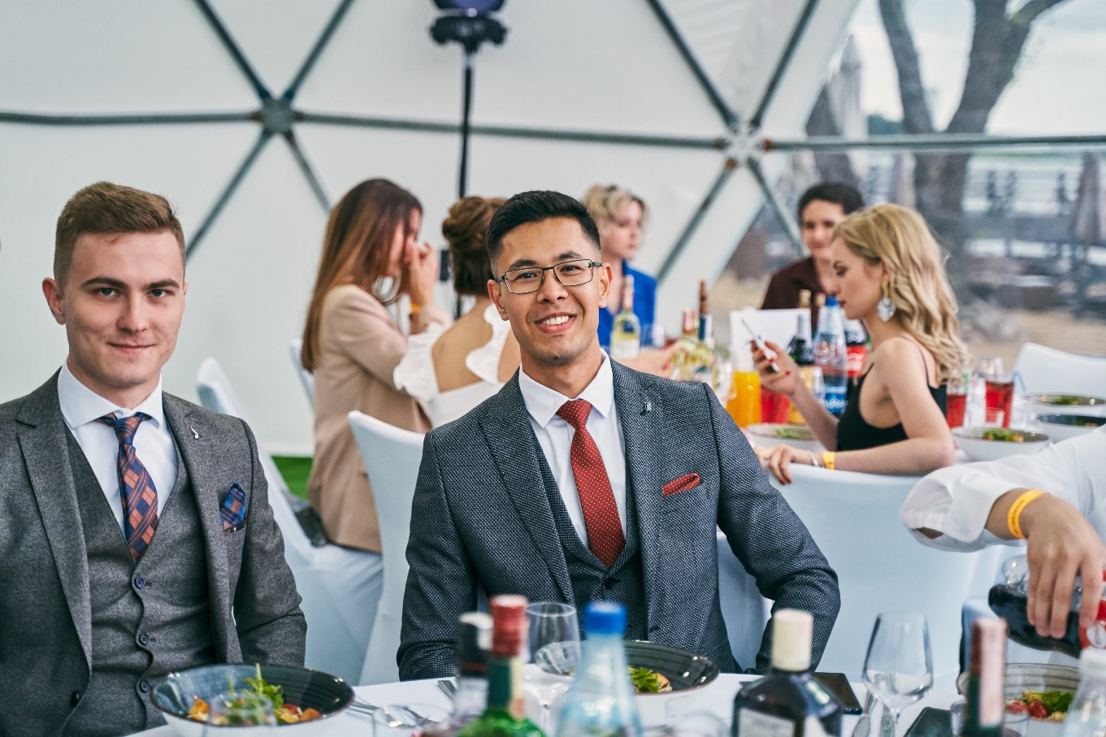

https://linkedin.com/in/sapar-atayev-947640179

**LinkedIn**

**ABOUT ME**

**EDUCATION**

I have been working with the Laravel framework for four years. Developed several projects and participated in many others. Looking for a permanent full-time (part-time) job and new career opportunities. READY to relocate!  
English - Upper Intermediate -> Advanced.

In fact, I'm a pleasant and sociable person, like to make new friends, like to discover something new.

Developing myself as a web-developer is my top priority.

**BELARUSIAN STATE UNIVERSITY OF INFORMATICS AND RADIOELECTRONICS**

Minsk, Belarus

**Information Technologies Engineer**

**2015-2019**

live:sapar.ad3775ag

sapar.ad3775ag@gmail.com

sopa.97@mail.ru

+99365611968

**Skype**

Ashgabat, Turkmenistan

**🖂**

**🖂**

**🕽**

**CONTACTS**

**SAPAR ATAYEV**

LARAVEL DEVELOPER

[**TPS Advertising Agency**](https://tpsadvertising.com/)

**Laravel developer** since June 2021

Keep developing web apps and features on Laravel (REST API, GraphQL). While developing backend, discuss the UI with frontend engineers and web designers and propose frontend fixes and edits. Add new features using Ajax (JQuery). Work in team & solve commit conflicts in git. Make edits to DB schemes.

[**Quality**](https://st.com.tm) **Schools International**

**Education Paraprofessional (part-time)** since March 2022

Assisting the classroom teacher in all aspects of teaching and learning.

Full-time Paraprofessional at the AIS Summer Camp 2023.

[**Oxyca Inc.**](https://www.oxyca.ca/en/)

**Laravel developer (part-time)** since May 2022

Being involved into a big project with microservices architecture on Laravel (REST API, GraphQL). Add new features. Work in team. Design and make edits to DB schemes.

**EXPERIENCE**

[**Sanly Tilsimat**](https://st.com.tm)

**Web developer** March 2020 – June 2021

Developed and maintained several web applications using Laravel for backend and HTML, CSS (SCSS), JS for frontend. Added new features to existing projects on Laravel. Developed Ajax features using Vue.js components for several web applications. Developed from scratch an internet store making frontend on HTML, CSS (SCSS), JQuery and making backend on Laravel with the DB scheme. Got familiar with Nuxt JS & developed frontend for one project using Nuxt JS.

[**Turkmentelecom**](https://telecom.tm/)

**Web developer** August 2019 – January 2020

Developed frontend part for several projects. Added new features to web applications on Laravel. Made (HTML, CSS, JS) fixes to several existing projects.

**SUMMARY**

I make it my goal to strengthen my position as a web developer. It is important for me to have the opportunity of professional growth in the web development sphere. I would be happy to work with friendly, responsive and experienced teammates on projects.

I am ready to spend a lot of time on what I like - development. I can motivate and discipline myself. I am capable of finding common grounds with people, with teammates. I always support criticism to my address according to my technical skills and go forward to eliminate every drawback.

I have fundamental knowledge, skills and four years of experience in technologies that I have mentioned. Nevertheless, this all will not prevent me to go forward and learn new, to learn a lot and develop myself as a web developer. I am ready to do my best to grow up as a stronger and more skillful specialist and promote my employer's interests.

GoLang Basics

October CMS

Vue Basics

jQuery

JavaScript

HTML

RabbitMQ

REST API

PostgreSQL

MySQL

Symfony Basics

Git

GraphQL

PHP

Laravel

**SKILLS**

CSS

<https://alaw.biz/>

<https://brandcoll.com.tm/>

<https://market.turkmenpost.gov.tm/>

<https://archive.gov.tm/>

<https://turkmenatlary.gov.tm/>

<http://garlykkaliy.com.tm/>

<http://maryawtoulag.com.tm/>

<https://tmex.gov.tm/>

[TMEX Mobile app (backend)](https://play.google.com/store/apps/details?id=com.tpsadvertising.digital.birzha&hl=ru)

<https://olivemedic.ca/>

<https://shahsyotag.exchange.gov.tm>

**PORTFOLIO**