**Pizza Sales SQL Queries**

**A. KPI’s**

**1. Total_Revenue**

select sum(total_price) as Total_Revenue from pizza_sales

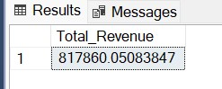

**2. Average_Order_value**

select sum(total_price)/count(distinct(order_id)) as Average_Order_value from pizza_sales

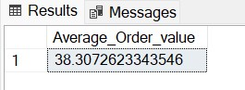

**3. Total_pizza_sold**

select sum(quantity) as Total_pizza_sold from pizza_sales

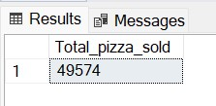

**4. Total_order**

select count(distinct(order_id)) as Total_order from pizza_sales;

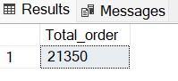

**5. Avg_pizza_per_order**

select cast(cast(sum(quantity) as decimal(10,2))/

cast(count(distinct order_id)as decimal(10,2)) as decimal(10,2)) as Avg_pizza_per_order from pizza_sales

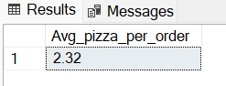

**B. Daily Trend for Total Orders**

select DATENAME(DW, order_date) as order_day, count(distinct order_id) as Total_orders from pizza_sales

group by DATENAME(DW, order_date)

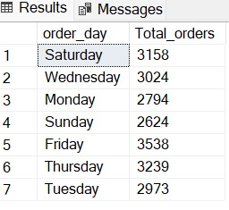

**C. Hourly Trend for Orders**

select DATEPART(HOUR, order_time) as order_hours, count(distinct order_id) as Total_orders from pizza_sales

group by DATEPART(HOUR, order_time) order by DATEPART(HOUR, order_time)

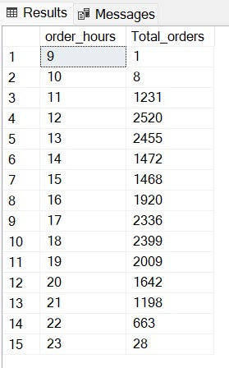

**D. % of Sales by Pizza Category**

SELECT pizza_category, CAST(SUM(total_price) AS DECIMAL(10,2)) as total_revenue,

CAST(SUM(total_price) * 100 / (SELECT SUM(total_price) from pizza_sales) AS DECIMAL(10,2)) AS PCT

FROM pizza_sales

GROUP BY pizza_category

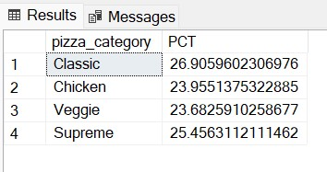

**E. %Sales by Pizza Size**

select pizza_size, cast(sum(total_price) as decimal(10,2)) as total_sales, cast(sum(total_price) * 100 /

(select sum(total_price) from pizza_sales) as decimal(10,2)) as Sales_by_Pizza_Size

from pizza_sales group by pizza_Size order by Sales_by_Pizza_Size desc

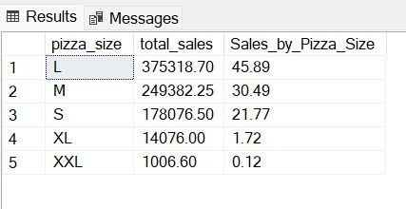

**F. Total_pizza_Sold_by_Pizza_Category**

select pizza_category, sum(quantity) as Total_pizza_Sold

from pizza_sales

group by pizza_category

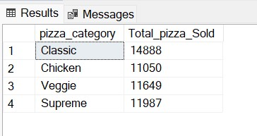

**G. Top 5 Best Sellers by Total Pizzas Sold**

select top 5 pizza_name, sum(quantity) as Total_Pizza_Sold

from pizza_sales

group by pizza_name

order by sum(quantity) desc

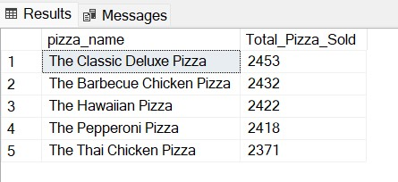

**H. Bottom 5 Best Sellers by Total Pizzas Sold**

select top 5 pizza_name, sum(quantity) as Total_Pizza_Sold

from pizza_sales

group by pizza_name

order by sum(quantity) asc

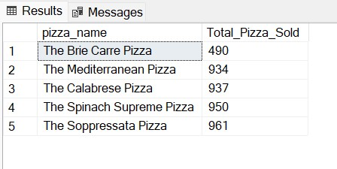

***NOTE***

If you want to apply the Month, Quarter, Week filters to the above queries you can use WHERE clause. Follow some of below examples

SELECT DATENAME(DW, order_date) AS order_day, COUNT(DISTINCT order_id) AS total_orders

FROM pizza_sales

WHERE MONTH(order_date) = 1

GROUP BY DATENAME(DW, order_date)

*\*Here MONTH(order_date) = 1 indicates that the output is for the month of January. MONTH(order_date) = 4 indicates output for Month of April.*

SELECT DATENAME(DW, order_date) AS order_day, COUNT(DISTINCT order_id) AS total_orders

FROM pizza_sales

WHERE DATEPART(QUARTER, order_date) = 1

GROUP BY DATENAME(DW, order_date)

*\*Here DATEPART(QUARTER, order_date) = 1 indicates that the output is for the Quarter 1. MONTH(order_date) = 3 indicates output for Quarter 3.*