Raise API error message and custom exceptions

class CreateJobSerializer(serializers.ModelSerializer):

class Meta:

model = Job

fields = ('name',)

def validate_name(self, value):

if Job.objects.filter(name=value).exists():

raise serializers.ValidationError("Name already exist")

return value

If you still want to use HTTP_202 then Create new exception by inheriting default APIException and override status_code to 202. Now raise the new exception.

from rest_framework.exceptions import APIException

class APIException202(APIException):

status_code = 202

class CreateJobSerializer(serializers.ModelSerializer):

class Meta:

model = Job

fields = ('name',)

def validate_name(self, value):

if Job.objects.filter(name=value).exists():

raise APIException202("Name already exist")

return value

WEBPACK CONFIGURATION :s

annotate(*args, **kwargs)

annotate each object in the QuerySet with the provided list of query expressions. This can be a simple value, or a computed one calculated based on the queryset. Interesting!

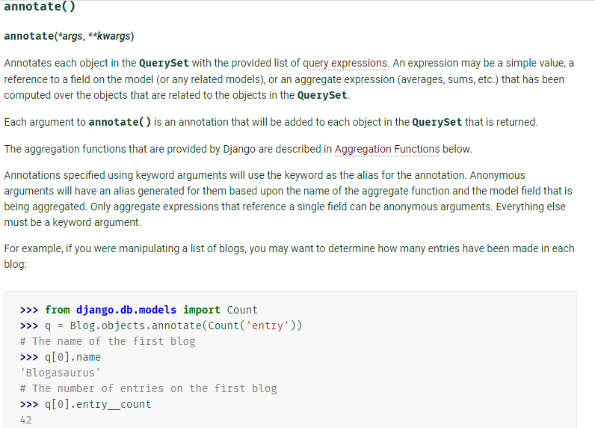

ListCreateAPIView documentation

