Figures for SAPFLUXNET data paper

R. Poyatos

27/12/2019

## Figures

### Figure 1.

* Data workflow. Víctor is on it…

### Figure 2

* This version of the figures uses a low quality version of the base maps because it’s faster to run this way. Inaccuracies in the map result from rasterisation.
* I include two versions of the figure with the maps, one with numeric codes and another without them. Need to improve the layout and/or tweak the parameters controlling the position of the labels to get an optimal figure.
* TODO: use paler colour for forest area, see if I can display IGBP code (EBF, ENF, etc)

### Figure 3. Biomes.

* This figure is OK.
* TODO: explore the possibility that Fig. 2 is (a) world map, (b) biome plot and that figure (3) is more regionally detailed, showing PFT.

### Figure 4. Taxonomy.

* I chose to show genera with >50 trees and species with >30 trees, arbitrarily…
  1. add number of species at the tip
  2. add number of sites at the tip
* Add a third panel ranking species by tree·days?

### Figure 5. Sap flow methods and level.

* OK ### Figure 6. Site and plant level attributes
* TODO: add titles to labels a) stand, b) plant

### Figure 7. Datasets duration and period

* TODO: improve with Víctor.

### Figure 8. Temporal patterns

* TODO: add titles to labels: a) ESP_CAN, Mediterranean, b), c



Figure 1. Data workflow.

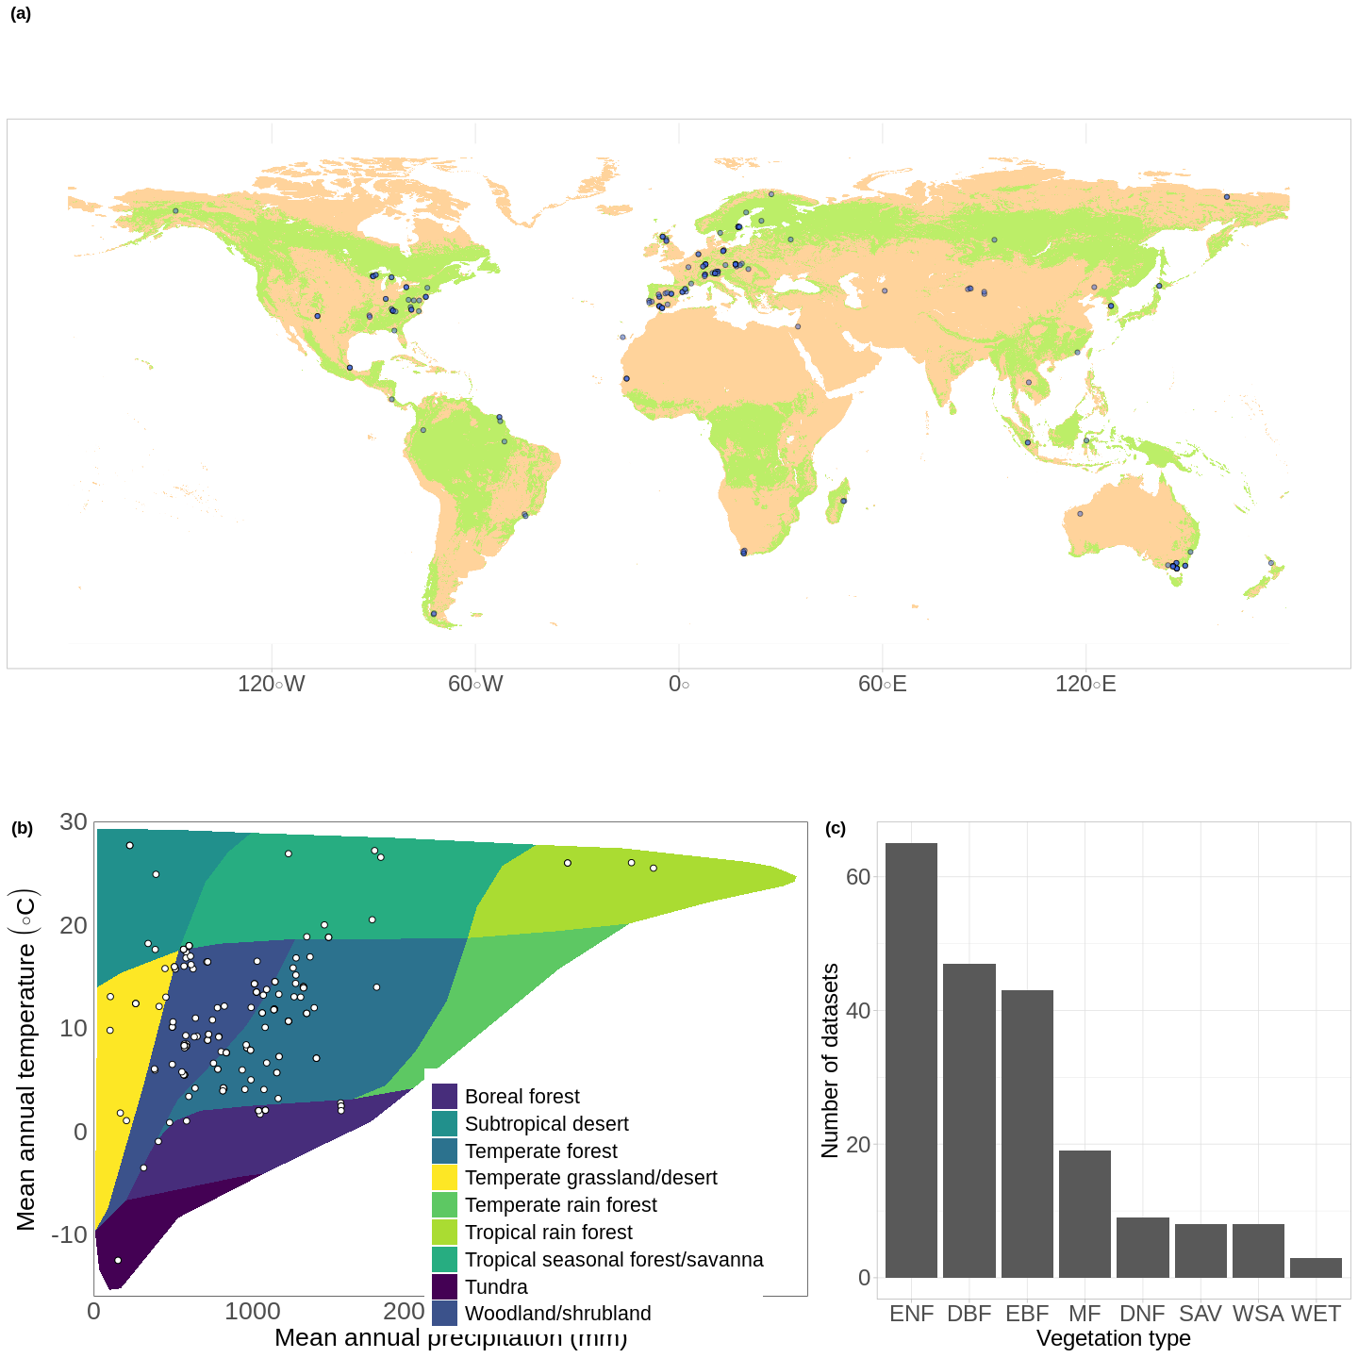

Figure 2. Geographical distribution of SAPFLUXNET datasets.

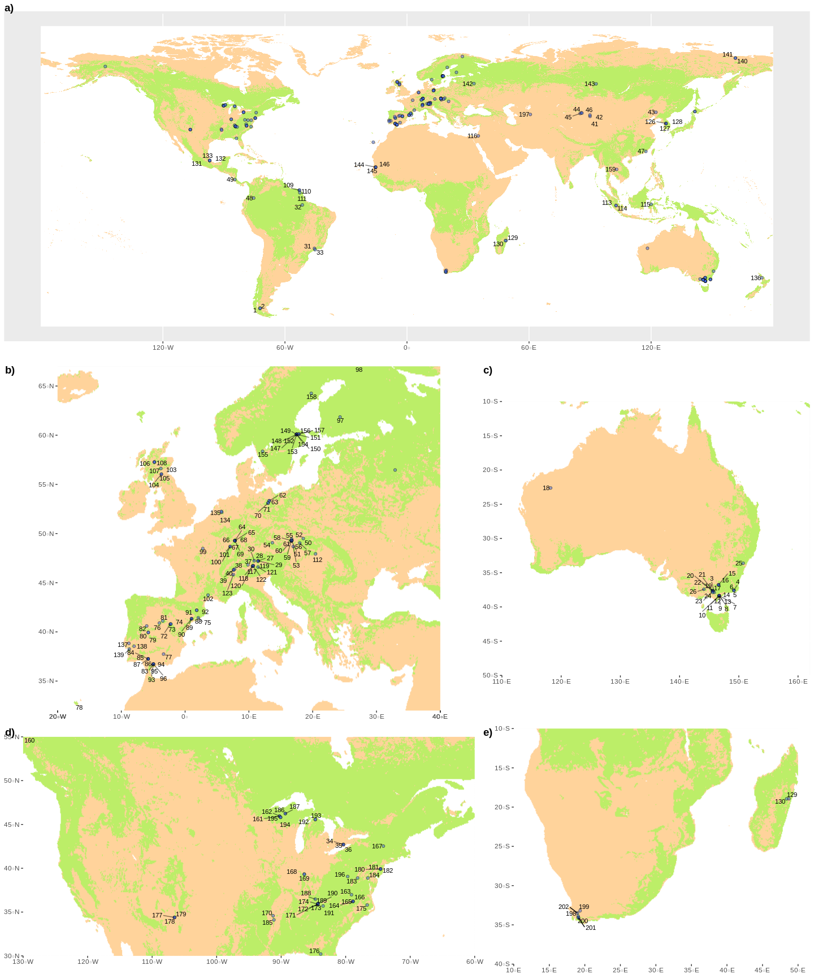 Figure 3. Detailed geographic distribution.

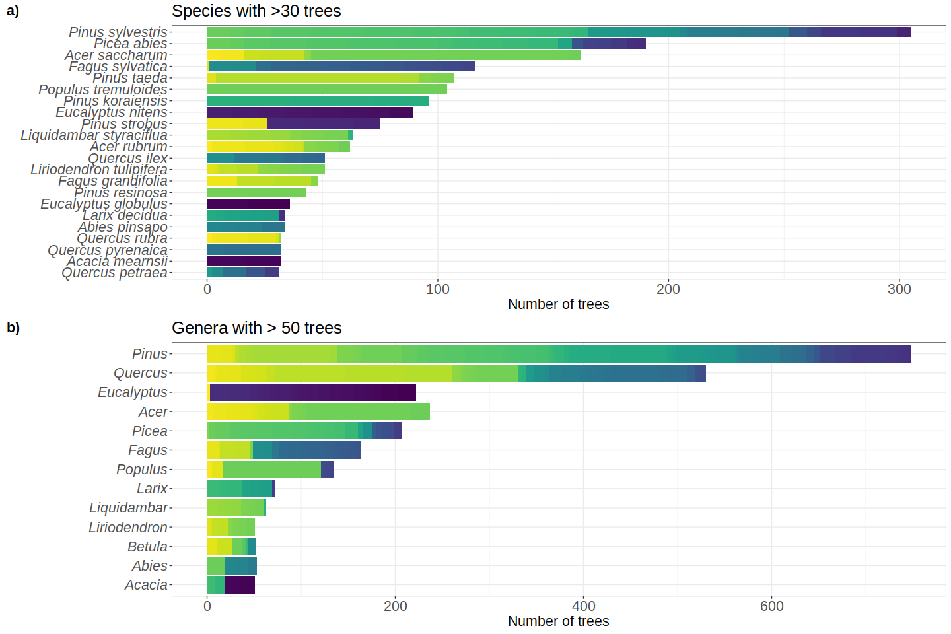 Figure 4. Taxonomic distribution of genera and species in SAPFLUXNET, showing (a) genera with > 50 trees and (b) species with > 30 trees in the database.

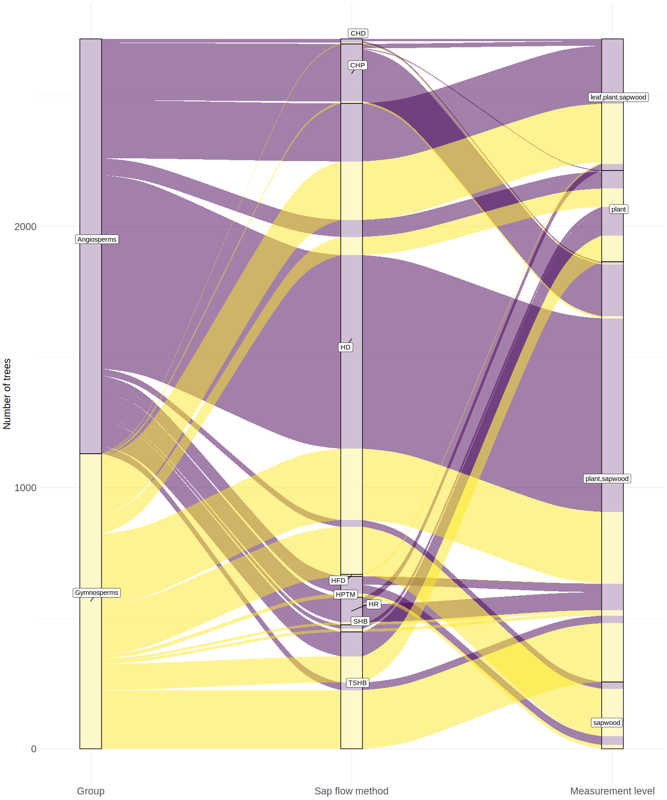

Figure 5. Distribution of trees in SAPFLUXNET according to sap flow method and measurement level.

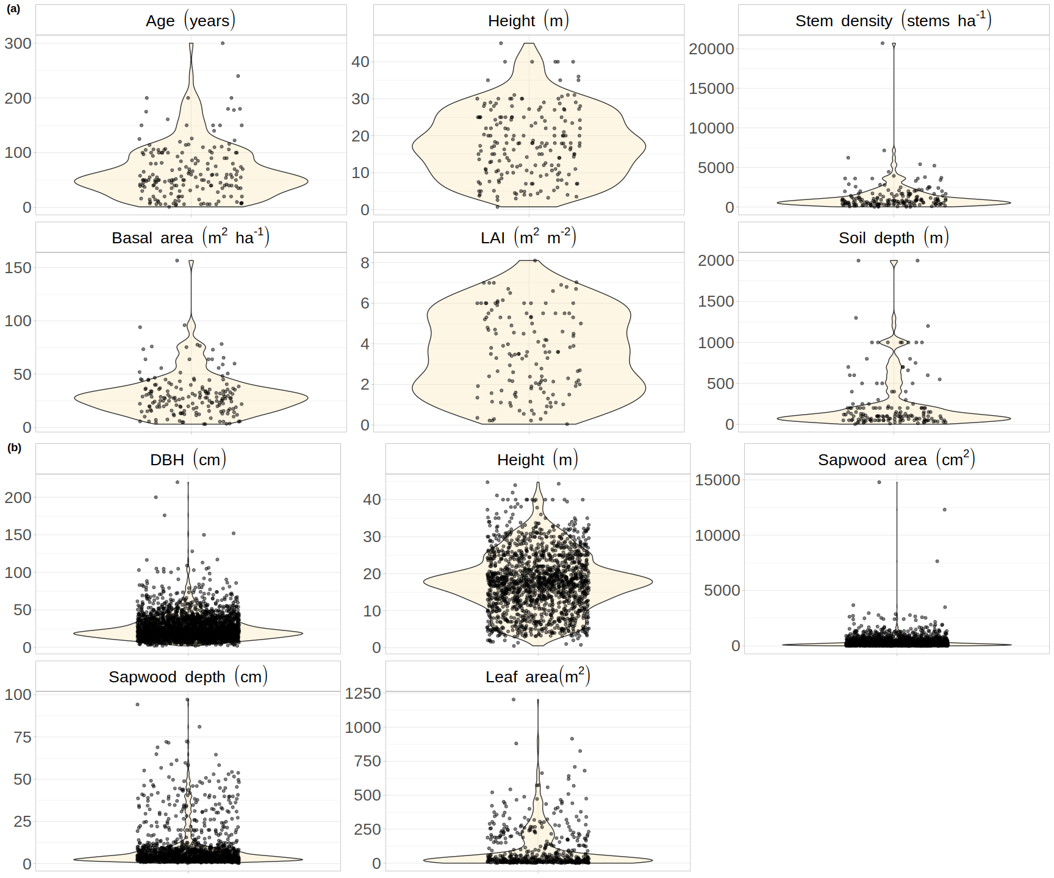

Figure 6. Plant and stand attributes

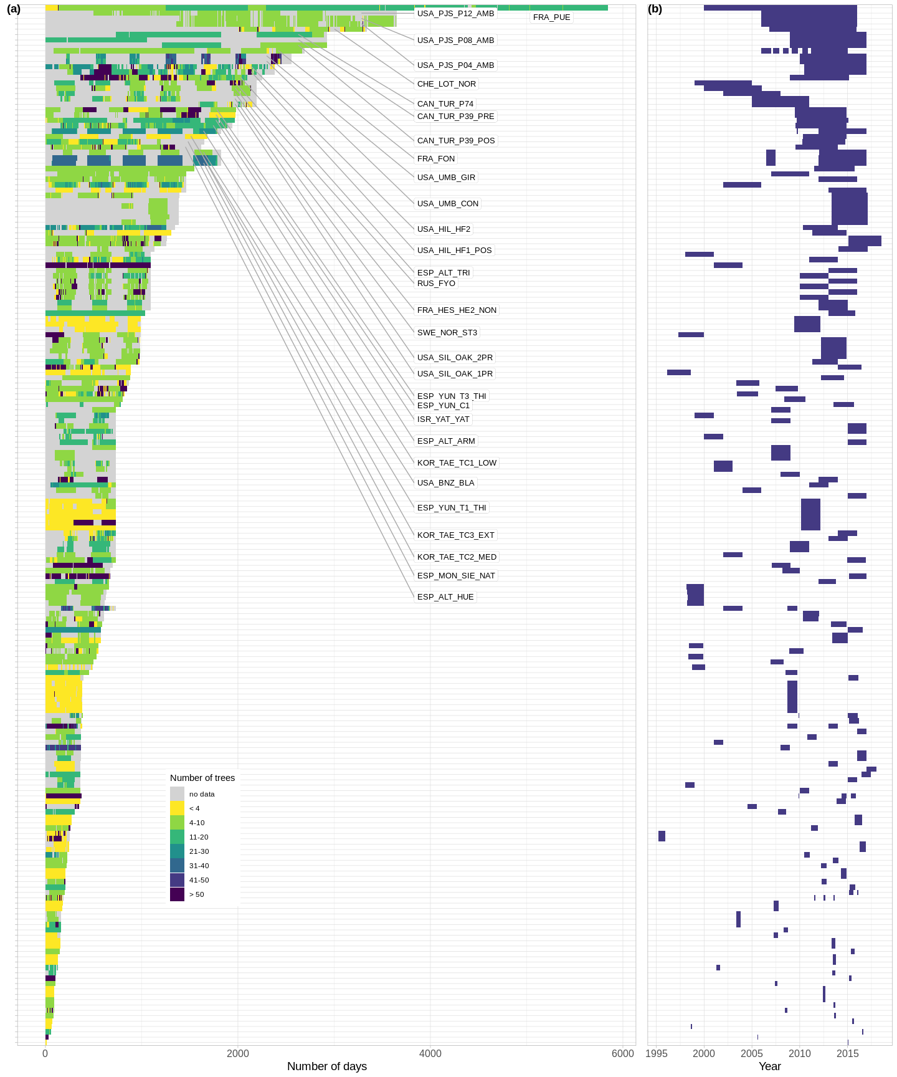

Figure 7. Datasets duration and period

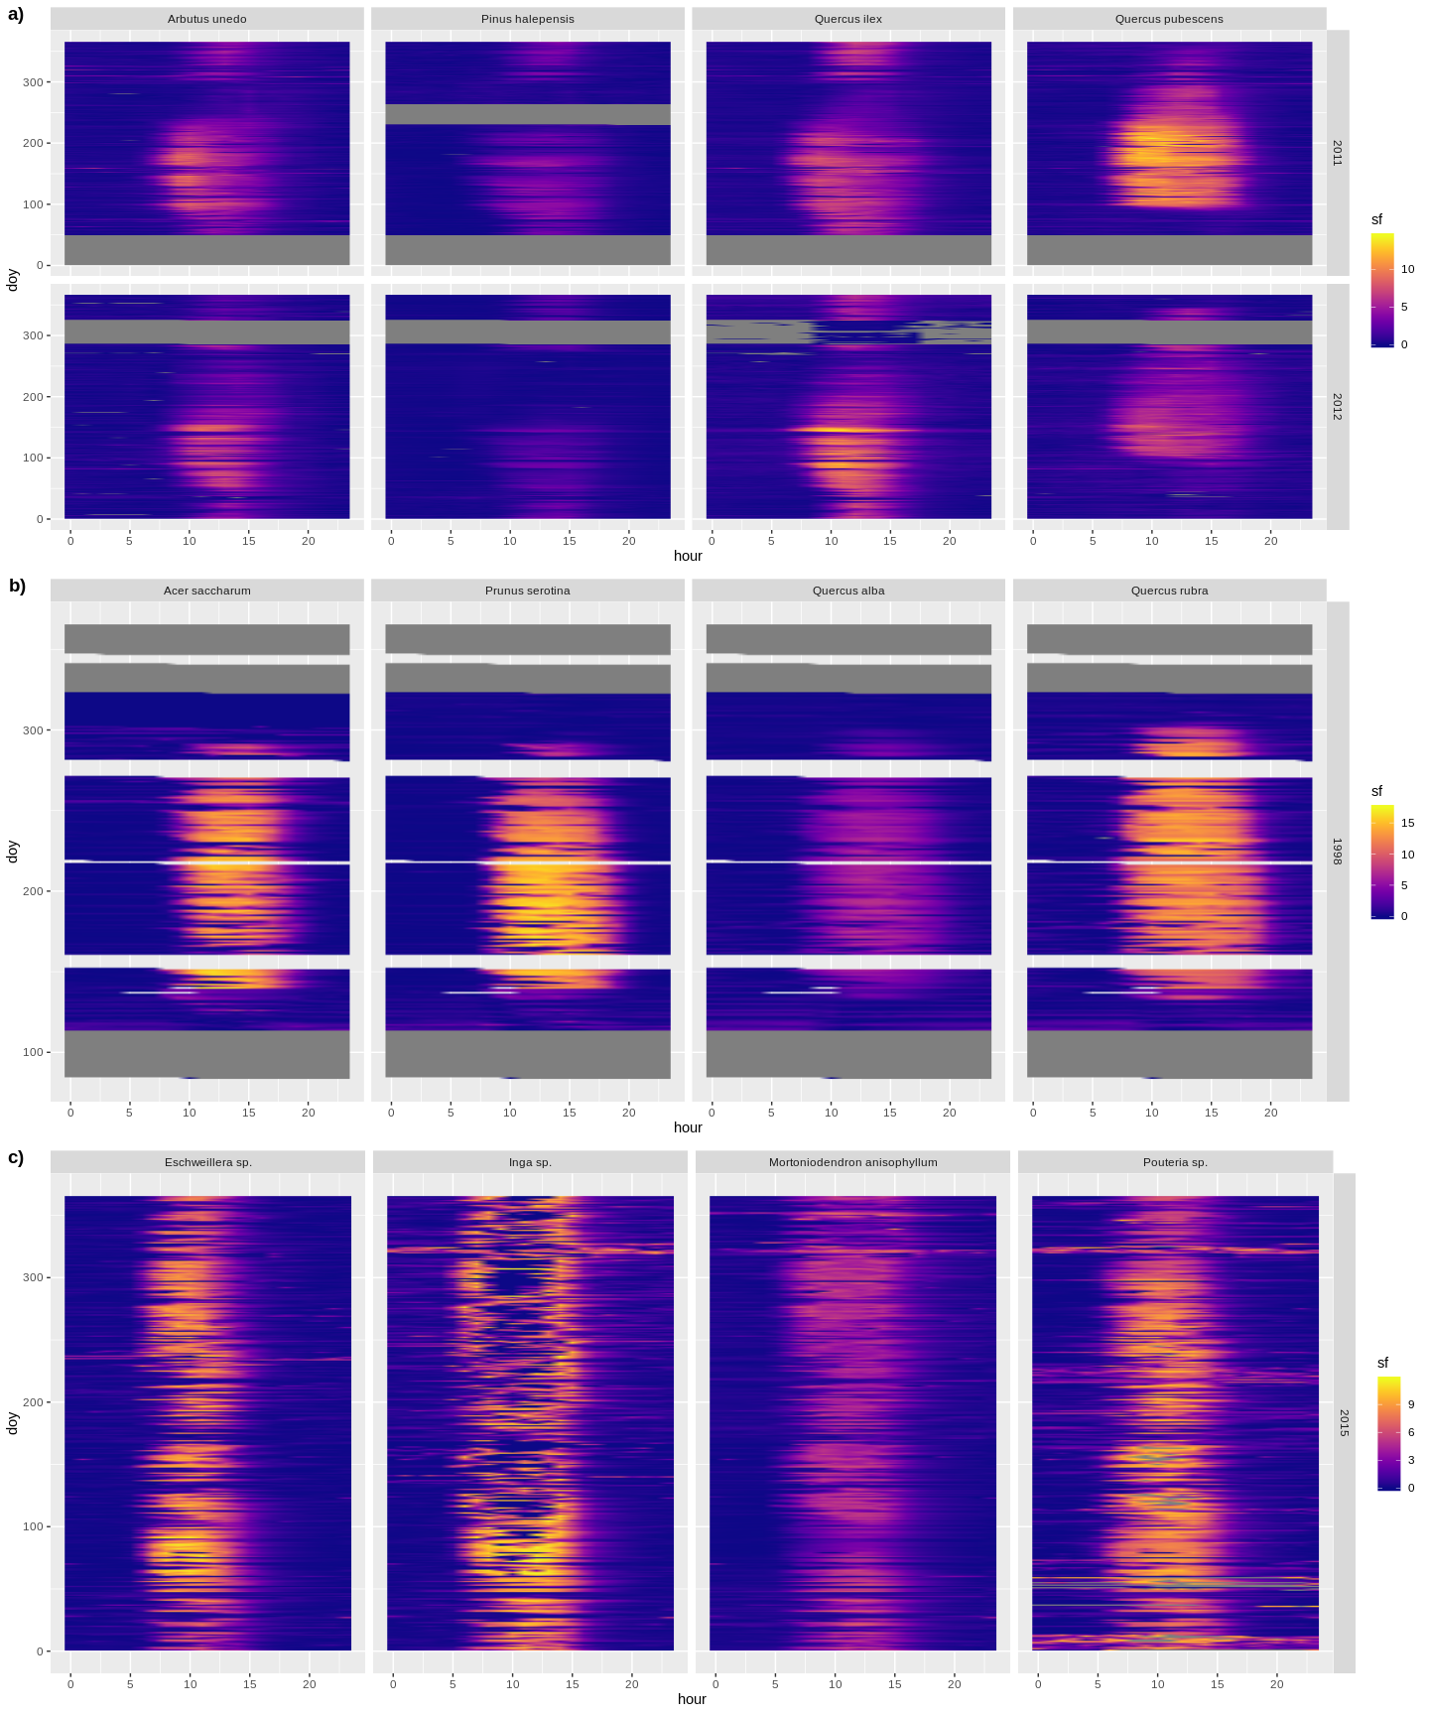

Figure 8. Temporal patterns.

Figure 9. Scaling