Global transpiration data from sap flow measurements: the SAPFLUXNET database

Supplement

03/08/2020

## Table captions

**Table S1** Data checks implemented in the first level of data quality control (QC1).

**Table S2.** Description of site metadata variables.

**Table S3.** Description of stand metadata variables.

**Table S4.** Description of species metadata variables.

**Table S5.** Description of plant metadata variables.

**Table S6.** Description of environmental metadata variables.

**Table S7.** Data checks implemented in the second level of data quality control (QC2).

**Table S8.** Datasets in the SAPFLUXNET database identified by numeric code, dataset code and site name. Number of species per dataset, geographic coordinates and elevation are also shown. Negative coordinate values are shown for Southern and Western Hemispheres.

**Table S9.** Number of plants and number of datasets for each species present in the SAPFLUXNET database.

**Table S10.** Number of plants per genus present in the SAPFLUXNET database.

## Figure captions

**Figure S1.** Overview of the data QC process, showing file management and identifying automatic (in yellow) and manual steps (in red). The column on the left shows the different updates of the status file for each dataset and the column on the right shows generated data reports and steps requiring feedback or manual changes.

**Table S1** Data checks implemented in the first level of data quality control (QC1).

**Figure S2.** (a) Structure of sfn_data objects, which are based on the S4 class. Boxes in the figure represent different slots where data are stored. Each object is identified by the ‘si_code’, stored as a slot in the object, with the format of a character vector. Slots storing time series of data and the associated data flags are of class ‘tibble’ and have all the same number of rows (*i*), corresponding to the the number of timesteps in the dataset and labelled with two POSIXct timestamp vectors (TIMESTAMP, solar_TIMESTAMP).The slot storing sap flow data, ‘sapf_data’ contains(*j*) columns and environmental data (‘env_data’) contains *k* columns, corresponding to the number of environmental variables present. Slots with the suffix ‘md’ refer to the different metadata and all are objects of class ‘tibble’ with different dimensions. For example, the number of rows in ‘plant_md’ depends on the number of plants in the dataset (and this is depicted by the different length of the box). More information on the ‘sfn_data’ class objects can be found in the vignette ‘sfn-data-classes’ of the package [sapfluxnetr](https://github.com/sapfluxnet/sapfluxnetr).  
(b) Summary of an sfn_data object, showing highlights of site metadata, data dimensions, timestamp span and flags present on the data.

**Figure S3.** Example screenshot of the app used for handling outliers and out of range values in time series. The left column shows dataset and variable selection. The central part shows the time series, with out of range values in red and possible outliers in yellow. Rows to replace or remove are selected in a table and written to a text file when done.

**Figure S4.** Detailed geographic distribution of SAPFLUXNET datasets. Datasets are labelled by dataset number in Table S4. Woodland area from Crowther et al. (2015) shown in green.

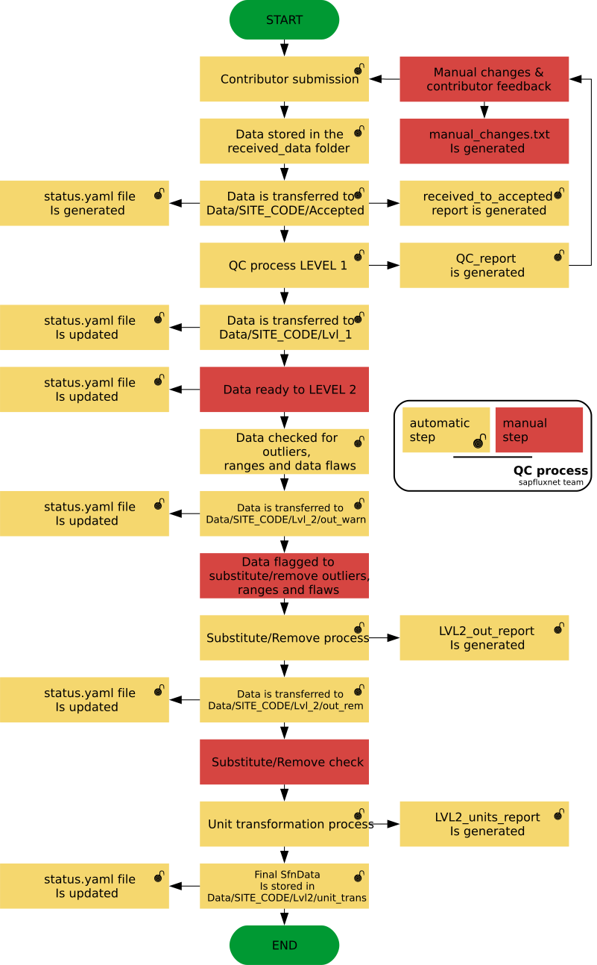 **Figure S1.**

Table S1

| **Check** | **Description** |
| --- | --- |
| Metadata variables | All metadata variables are checked for presence and expected class (numeric, character, logical…). |
| Character variables values | All metadata character variables are checked against the possible values (factor levels) for that variable, raising a warning if some value is out of the expected. |
| E-mail check | E-mail provided by contributors is checked for validity |
| Coordinates and biome | Site coordinates are checked for correctness (are they inside the specified country?) and fixed if needed and possible. MAT and MAP values are obtained for that coordinates and the biome is calculated from that values. |
| Soil texture | Percentages of soil textures are used to calculate the USDA classification category if possible. |
| Species names | Species names in plant and species metadata are checked for spelling errors and the concordance between both metadata is also checked |
| Plant treatments | Check for uniformity in the treatment declared by plant. |
| Environmental variables presence | Check for concordance between the declared variables in the environmental metadata and the environmental data. |
| Timestamp | Format, NA presence (there is data, but there is no timestamp), concordance and continuity are checked. |
| Gap presence: | Data gaps (There is TIMESTAMP but there is no data) are summarised and visualized. |
| Soil water content | Check for percentage swc values and transform them to cm3/cm3 |

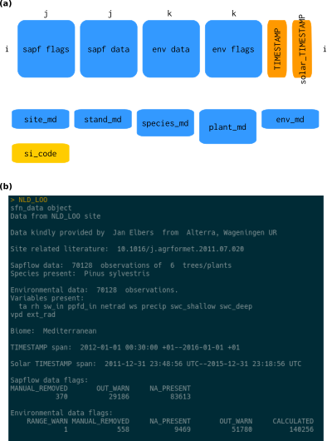 **Figure S2.**

Table S2

| **Variable** | **Description** | **Type** | **Units** |
| --- | --- | --- | --- |
| si_name | Site name given by contributors | Character | None |
| si_country | Country code (ISO) | Character | Fixed values |
| si_contact_firstname | Contributor first name | Character | None |
| si_contact_lastname | Contributor last name | Character | None |
| si_contact_email | Contributor email | Character | None |
| si_contact_institution | Contributor affiliation | Character | None |
| si_addcontr_firstname | Additional contributor first name | Character | None |
| si_addcontr_lastname | Additional contributor last name | Character | None |
| si_addcontr_email | Additional contributor email | Character | None |
| si_addcontr_institution | Additional contributor affiliation | Character | None |
| si_lat | Site latitude (i.e. 42.36) | Numeric | Latitude, decimal format (WGS84) |
| si_long | Site longitude (i.e. -8.23) | Numeric | Longitude, decimal format (WGS84) |
| si_elev | Elevation above sea level | Numeric | meters |
| si_paper | Paper with relevant information to understand the site as DOI links or DOI codes | Character | DOI link |
| si_dist_mgmt | Recent and historic disturbance and management events that affected the measurement years | Character | Fixed values |
| si_igbp | Vegetation type based on IGBP classification | Character | Fixed values |
| si_flux_network | Logical indicating if site is participating in the FLUXNET network | Logical | Fixed values |
| si_dendro_network | Logical indicating if site is participating in the DENDROGLOBAL network | Logical | Fixed values |
| si_remarks | Remarks and commentaries useful to grasp some site-specific peculiarities | Character | None |
| si_code | sapfluxnet site code, unique for each site | Character | Fixed value |
| si_mat | Site annual mean temperature, as obtained from WorldClim | Numeric | Celsius degrees |
| si_map | Site annual mean precipitation, as obtained from WorldClim | Numeric | mm |
| si_biome | Biome classification as per Whittaker diagram, based on mat and map obtained from WorldClim | Character | sapfluxnet calculated |

Table S3

| **Variable** | **Description** | **Type** | **Units** |
| --- | --- | --- | --- |
| st_name | Stand name given by contributors | Character | None |
| st_growth_condition | Growth condition with respect to stand origin and management | Character | Fixed values |
| st_treatment | Treatment applied at stand level | Character | None |
| st_age | Mean stand age at the moment of sap flow measurements | Numeric | years |
| st_height | Canopy height | Numeric | meters |
| st_density | Total stem density for stand | Numeric | stems/ha |
| st_basal_area | Total stand basal area | Numeric | m2/ha |
| st_lai | Total maximum stand leaf area (one-sided, projected) | Numeric | m2/m2 |
| st_aspect | Aspect the stand is facing (exposure) | Character | Fixed values |
| st_terrain | Slope and/or relief of the stand | Character | Fixed values |
| st_soil_depth | Soil total depth | Numeric | cm |
| st_soil_texture | Soil texture class, based on simplified USDA classification | Character | Fixed values |
| st_sand_perc | Soil sand content, % mass | Numeric | % percentage |
| st_silt_perc | Soil silt content, % mass | Numeric | % percentage |
| st_clay_perc | Soil clay content, % mass | Numeric | % percentage |
| st_remarks | Remarks and commentaries useful to grasp some stand-specific peculiarities | Character | None |
| st_USDA_soil_texture | USDA soil classification based on the percentages provided by the contributor | Character | sapfluxnet calculated |

Table S4

| **Variable** | **Description** | **Type** | **Units** |
| --- | --- | --- | --- |
| sp_name | Identity of each measured species | Character | Scientific name without author abbreviation, as accepted by The Plant List |
| sp_ntrees | Number of trees measured of each species | Numeric | number of trees |
| sp_leaf_habit | Leaf habit of the measured species | Character | Fixed values |
| sp_basal_area_perc | Basal area occupied by each measured species, in percentage over total stand basal area | Numeric | % percentage |

Table S5

| **Variable** | **Description** | **Type** | **Units** |
| --- | --- | --- | --- |
| pl_name | Plant code assigned by contributors | Character | None |
| pl_species | Species identity of the measured plant | Character | Scientific name without author abbreviation, as accepted by The Plant List |
| pl_treatment | Experimental treatment (if any) | Character | None |
| pl_dbh | Diameter at breast height of measured plants | Numeric | cm |
| pl_height | Height of measured plants | Numeric | m |
| pl_age | Plant age at the moment of measure | Numeric | years |
| pl_social | Plant social status | Character | Fixed values |
| pl_sapw_area | Cross-sectional sapwood area | Numeric | cm2 |
| pl_sapw_depth | Sapwood depth, measured at breast height | Numeric | cm |
| pl_bark_thick | Plant bark thickness | Numeric | mm |
| pl_leaf_area | Leaf area of eachvvmeasured plant | Numeric | m2 |
| pl_sens_meth | Sap flow measures method | Character | Fixed values |
| pl_sens_man | Sap flow measures sensor manufacturer | Character | Fixed values |
| pl_sens_cor_grad | Correction for natural temperature gradients method | Character | Fixed values |
| pl_sens_cor_zero | Zero flow determination method | Character | Fixed values |
| pl_sens_calib | Was species-specific calibration used? | Logical | Fixed values |
| pl_sap_units | Uniformized sapfluxnet units for sapwood, leaf and plant level | Character | Fixed values |
| pl_sap_units_orig | Original contribution units (at sapwood or plant level) | Character | Fixed values |
| pl_sens_length | Length of the needles or electrodes forming the sensor | Numeric | mm |
| pl_sens_hgt | Sensor installation height, measured from the ground | Numeric | m |
| pl_sens_timestep | Subdaily time step of sensor measures | Numeric | minutes |
| pl_radial_int |  | Character | Fixed values |
| pl_azimut_int |  | Character | Fixed values |
| pl_remarks | Remarks and commentaries useful to grasp some plant-specific peculiarities | Character | None |
| pl_code | sapfluxnet plant code, unique for each plant | Character | Fixed value |

Table S6

| **Variable** | **Description** | **Type** | **Units** |
| --- | --- | --- | --- |
| env_time_zone | Time zone of site used in the TIMESTAMPS | Character | Fixed values |
| env_time_daylight | Is daylight saving time applied to the original timestamp? | Logical | Fixed values |
| env_timestep | Subdaily timestep of environmental measures | Numeric | minutes |
| env_ta | Location of air temperature sensor | Character | Fixed values |
| env_rh | Location of relative humidity sensor | Character | Fixed values |
| env_vpd | Location of relative vapour pressure decifit sensor | Character | Fixed values |
| env_sw_in | Location of shortwave incoming radiation sensor | Character | Fixed values |
| env_ppfd_in | Location of incoming photosynthetic photon flux density sensor | Character | Fixed values |
| env_netrad | Location of net radiation sensor | Character | Fixed values |
| env_ws | Location of wind speed sensor | Character | Fixed values |
| env_precip | Location of precipitation sensor | Character | Fixed values |
| env_swc_shallow_depth | Average depth for shallow soil water content measures | Numeric | cm |
| env_swc_deep_depth | Average depth for deep soil water content measures | Numeric | cm |
| env_plant_watpot | Availability of water potential values for the same measured plants during the sap flow measurements period | Character | Fixed values |
| env_leafarea_seasonal | Availability of seasonal course leaf area data and level | Character | Fixed values |
| env_remarks | Remarks and commentaries useful to grasp some environmental-specific peculiarities | Character | None |

Table S7

| **Data check** | **Description** |
| --- | --- |
| Sap flow units harmonisation | Sap flow expressed in cm3 h-1, sap flow per unit leaf/sapwood area in cm3 cm-2 h-1 |
| Out of range detection | Out of range values are flagged automatically, examined in a visual app and removed if confirmed |
| Outlier detection | Outliers are flagged automatically, examined in a visual app and removed if confirmed |
| Radiation transformations | Interconversion between global radiation (sw_in) and photosynthetically active radiation (ppfd_in) |
| VPD and relative humidity | Interconversion between VPD and relative humidity |
| Extraterrestrial radiation and solar timestamp | Calculation of extraterrestrial radiation and solar timestamp from timestamp and geographical data |
| Sap flow interconversions | When sapwood or leaf areas were available, interconversions were applied between the different expression levels for sap flow (per plant, per sapwood area or per leaf area) |

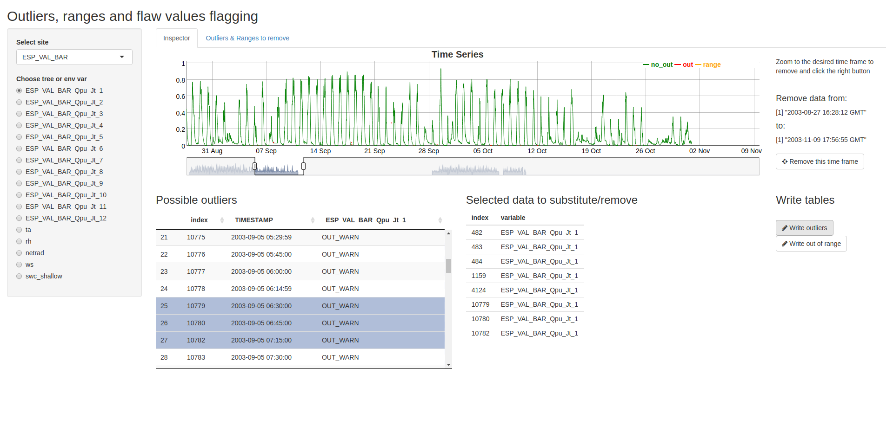 **Figure S3.**

Table S8

| **#** | **Dataset code** | **Site name** | **Lat.** | **Long.** | **Elev.  (m)** | **N spp.** |
| --- | --- | --- | --- | --- | --- | --- |
| 1 | ARG_MAZ | Mazaruca_Patagonia | -51.58 | -72.29 | 550 | 1 |
| 2 | ARG_TRE | Tres Marias | -51.32 | -72.18 | 460 | 1 |
| 3 | AUS_BRI_BRI | Britannia Creek | -37.87 | 145.85 | 707 | 1 |
| 4 | AUS_CAN_ST1_EUC | Cann River | -37.58 | 149.17 | 180 | 1 |
| 5 | AUS_CAN_ST2_MIX | Cann River | -37.58 | 149.17 | 180 | 2 |
| 6 | AUS_CAN_ST3_ACA | Cann River | -37.58 | 149.17 | 180 | 1 |
| 7 | AUS_CAR_THI_00F | Carrajung | -38.38 | 146.68 | 610 | 1 |
| 8 | AUS_CAR_THI_0P0 | Carrajung | -38.38 | 146.68 | 610 | 1 |
| 9 | AUS_CAR_THI_0PF | Carrajung | -38.38 | 146.68 | 610 | 1 |
| 10 | AUS_CAR_THI_CON | Carrajung | -38.38 | 146.68 | 610 | 1 |
| 11 | AUS_CAR_THI_T00 | Carrajung | -38.38 | 146.68 | 610 | 1 |
| 12 | AUS_CAR_THI_T0F | Carrajung | -38.38 | 146.68 | 610 | 1 |
| 13 | AUS_CAR_THI_TP0 | Carrajung | -38.38 | 146.68 | 610 | 1 |
| 14 | AUS_CAR_THI_TPF | Carrajung | -38.38 | 146.68 | 610 | 1 |
| 15 | AUS_ELL_HB_HIG | Ella | -36.78 | 146.58 | 705 | 2 |
| 16 | AUS_ELL_MB_MOD | Ella | -36.78 | 146.58 | 693 | 1 |
| 17 | AUS_ELL_UNB | Ella | -36.78 | 146.58 | 737 | 1 |
| 18 | AUS_KAR | Karijini NP | -22.62 | 118.22 | 710 | 1 |
| 19 | AUS_MAR_HSD_HIG | Maroondah | -37.64 | 145.58 | 468 | 2 |
| 20 | AUS_MAR_HSW_HIG | Maroondah | -37.65 | 145.57 | 297 | 2 |
| 21 | AUS_MAR_MSD_MOD | Maroondah | -37.64 | 145.58 | 467 | 2 |
| 22 | AUS_MAR_MSW_MOD | Maroondah | -37.65 | 145.57 | 261 | 2 |
| 23 | AUS_MAR_UBD | Maroondah | -37.69 | 145.56 | 303 | 3 |
| 24 | AUS_MAR_UBW | Maroondah | -37.89 | 145.57 | 336 | 3 |
| 25 | AUS_RIC_EUC_ELE | Richmond NSW EucFACE | -33.62 | 150.74 | 23 | 1 |
| 26 | AUS_WOM | WombatStateForest | -37.42 | 144.09 | 705 | 2 |
| 27 | AUT_PAT_FOR | Patscherkofel | 47.21 | 11.45 | 1950 | 1 |
| 28 | AUT_PAT_KRU | Patscherkofel | 47.21 | 11.45 | 2180 | 1 |
| 29 | AUT_PAT_TRE | Patscherkofel | 47.21 | 11.45 | 2110 | 1 |
| 30 | AUT_TSC | Tschirgant south | 47.23 | 10.84 | 750 | 1 |
| 31 | BRA_CAM | Campos do Jordão | -22.69 | -45.52 | 2000 | 1 |
| 32 | BRA_CAX_CON | Caxiuana | -1.79 | -51.43 | 15 | 8 |
| 33 | BRA_SAN | Santa Virgínia (PESM) | -23.28 | -45.18 | 1000 | 4 |
| 34 | CAN_TUR_P39_POS | TUR | 42.71 | -80.36 | 184 | 1 |
| 35 | CAN_TUR_P39_PRE | TUR | 42.71 | -80.36 | 184 | 1 |
| 36 | CAN_TUR_P74 | TUR | 42.71 | -80.35 | 184 | 1 |
| 37 | CHE_DAV_SEE | Davos | 46.82 | 9.86 | 1650 | 1 |
| 38 | CHE_LOT_NOR | Lotschental | 46.39 | 7.76 | 1300 | 2 |
| 39 | CHE_PFY_CON | Pfynwald | 46.30 | 7.60 | 615 | 1 |
| 40 | CHE_PFY_IRR | Pfynwald | 46.30 | 7.60 | 615 | 1 |
| 41 | CHN_ARG_GWD | Arghan | 40.75 | 89.99 | 830 | 1 |
| 42 | CHN_ARG_GWS | Arghan | 41.38 | 89.94 | 830 | 1 |
| 43 | CHN_HOR_AFF | Horqin | 42.72 | 122.37 | 226 | 1 |
| 44 | CHN_YIN_ST1 | Yingbazar | 42.45 | 85.72 | 900 | 1 |
| 45 | CHN_YIN_ST2_DRO | Yingbazar | 42.11 | 85.13 | 930 | 1 |
| 46 | CHN_YIN_ST3_DRO | Yingbazar | 42.29 | 85.99 | 930 | 1 |
| 47 | CHN_YUN_YUN | Yunxiao | 23.92 | 117.42 | 0 | 2 |
| 48 | COL_MAC_SAF_RAD | Macagual Universidad de la Amazonia | 1.50 | -75.36 | 360 | 1 |
| 49 | CRI_TAM_TOW | TAMU Soltis Center | 10.39 | -84.63 | 600 | 17 |
| 50 | CZE_BIK | Bik | 49.49 | 18.53 | 875 | 1 |
| 51 | CZE_BIL_BIL | Bilovice | 49.25 | 16.69 | 320 | 1 |
| 52 | CZE_KRT_KRT | Krtiny | 49.32 | 16.75 | 480 | 1 |
| 53 | CZE_LAN | Lanžhot | 48.68 | 16.95 | 150 | 3 |
| 54 | CZE_LIZ_LES | Liz | 49.07 | 13.68 | 858 | 1 |
| 55 | CZE_RAJ_RAJ | Rajec | 49.44 | 16.70 | 600 | 1 |
| 56 | CZE_SOB_SOB | Sobesice | 49.25 | 16.69 | 320 | 1 |
| 57 | CZE_STI | Stitna nad Vlari | 49.04 | 17.97 | 550 | 1 |
| 58 | CZE_UTE_BEE | Utechov | 49.28 | 16.65 | 420 | 1 |
| 59 | CZE_UTE_BNA | Utechov | 49.28 | 16.65 | 390 | 1 |
| 60 | CZE_UTE_BPO | Utechov | 49.28 | 16.65 | 370 | 1 |
| 61 | CZE_UTE_SPR | Utechov | 49.28 | 16.65 | 360 | 1 |
| 62 | DEU_HIN_OAK | Hinnensee | 53.33 | 13.19 | 90 | 1 |
| 63 | DEU_HIN_TER | Hinnensee | 53.33 | 13.19 | 95 | 2 |
| 64 | DEU_MER_BEE_NON | Merzalben | 49.27 | 7.81 | 550 | 1 |
| 65 | DEU_MER_BEE_THI | Merzalben | 49.27 | 7.81 | 550 | 1 |
| 66 | DEU_MER_DOU_NON | Merzalben | 49.27 | 7.81 | 550 | 1 |
| 67 | DEU_MER_DOU_THI | Merzalben | 49.27 | 7.81 | 550 | 1 |
| 68 | DEU_MER_MIX_NON | Merzalben | 49.27 | 7.81 | 550 | 2 |
| 69 | DEU_MER_MIX_THI | Merzalben | 49.27 | 7.81 | 550 | 2 |
| 70 | DEU_STE_2P3 | Stechlin | 53.10 | 13.00 | 78 | 1 |
| 71 | DEU_STE_4P5 | Stechlin | 53.10 | 13.00 | 78 | 1 |
| 72 | ESP_ALT_ARM | Alto Tajo | 40.78 | -2.33 | 1079 | 3 |
| 73 | ESP_ALT_HUE | Alto Tajo | 40.79 | -2.29 | 907 | 2 |
| 74 | ESP_ALT_TRI | Alto Tajo | 40.80 | -2.23 | 981 | 2 |
| 75 | ESP_CAN | Can Balasc | 41.43 | 2.07 | 270 | 4 |
| 76 | ESP_GUA_VAL | Guadarrama | 40.90 | -4.03 | 1140 | 1 |
| 77 | ESP_LAH_COM | LaHarina | 37.74 | -3.38 | 180 | 1 |
| 78 | ESP_LAS | Las Canadas, Teide natinal park tenerife | 28.31 | -16.57 | 2070 | 1 |
| 79 | ESP_MAJ_MAI | Majadas del Tietar | 39.94 | -5.77 | 260 | 1 |
| 80 | ESP_MAJ_NOR_LM1 | Majadas del Tietar | 39.94 | -5.77 | 260 | 1 |
| 81 | ESP_MON_SIE_NAT | Montejo | 41.12 | -3.50 | 1400 | 3 |
| 82 | ESP_RIN | Rinconada experimental catchment | 40.60 | -6.02 | 1200 | 1 |
| 83 | ESP_RON_PIL | Ronda | 36.69 | -5.02 | 1734 | 2 |
| 84 | ESP_SAN_A_45I | Sanabria orchard | 37.25 | -5.80 | 49 | 1 |
| 85 | ESP_SAN_A2_45I | Sanabria orchard | 37.25 | -5.80 | 49 | 1 |
| 86 | ESP_SAN_B_100 | Sanabria orchard | 37.25 | -5.80 | 49 | 1 |
| 87 | ESP_SAN_B2_100 | Sanabria orchard | 37.25 | -5.80 | 49 | 1 |
| 88 | ESP_TIL_MIX | Tillar | 41.33 | 1.01 | 1018 | 2 |
| 89 | ESP_TIL_OAK | Tillar | 41.33 | 1.01 | 1011 | 1 |
| 90 | ESP_TIL_PIN | Tillar | 41.33 | 1.01 | 1065 | 1 |
| 91 | ESP_VAL_BAR | Vallcebre | 42.20 | 1.82 | 1102 | 1 |
| 92 | ESP_VAL_SOR | Vallcebre | 42.20 | 1.81 | 1257 | 1 |
| 93 | ESP_YUN_C1 | Yunquera | 36.72 | -4.97 | 1220 | 1 |
| 94 | ESP_YUN_C2 | Yunquera | 36.72 | -4.97 | 1180 | 1 |
| 95 | ESP_YUN_T1_THI | Yunquera | 36.72 | -4.97 | 1190 | 1 |
| 96 | ESP_YUN_T3_THI | Yunquera | 36.72 | -4.97 | 1185 | 1 |
| 97 | FIN_HYY_SME | Hyytiala Forest Field Station | 61.85 | 24.29 | 185 | 2 |
| 98 | FIN_PET | Petsikko | 69.49 | 27.23 | 251 | 1 |
| 99 | FRA_FON | Fontainebleau-Barbeau | 48.48 | 2.78 | 105 | 2 |
| 100 | FRA_HES_HE1_NON | Hesse | 48.67 | 7.06 | 300 | 1 |
| 101 | FRA_HES_HE2_NON | Hesse | 48.67 | 7.06 | 300 | 1 |
| 102 | FRA_PUE | Puechabon | 43.74 | 3.60 | 270 | 1 |
| 103 | GBR_ABE_PLO | Aberfeldy | 56.62 | -3.80 | 340 | 1 |
| 104 | GBR_DEV_CON | Devilla | 56.03 | -3.72 | 75 | 1 |
| 105 | GBR_DEV_DRO | Devilla | 56.03 | -3.72 | 75 | 1 |
| 106 | GBR_GUI_ST1 | Guisachan | 57.27 | -4.82 | 300 | 1 |
| 107 | GBR_GUI_ST2 | Guisachan | 57.27 | -4.82 | 300 | 1 |
| 108 | GBR_GUI_ST3 | Guisachan | 57.27 | -4.82 | 300 | 1 |
| 109 | GUF_GUY_GUY | Guyaflux | 5.28 | -52.92 | 40 | 6 |
| 110 | GUF_GUY_ST2 | Guyaflux | 5.28 | -52.91 | 45 | 7 |
| 111 | GUF_NOU_PET | Nouragues station | 4.08 | -52.68 | 120 | 10 |
| 112 | HUN_SIK | Sikfokut | 47.93 | 20.44 | 330 | 2 |
| 113 | IDN_JAM_OIL | Jambi | -2.07 | 102.79 | 71 | 1 |
| 114 | IDN_JAM_RUB | Jambi | -2.10 | 102.78 | 90 | 1 |
| 115 | IDN_PON_STE | Pono | -1.49 | 120.06 | 1050 | 8 |
| 116 | ISR_YAT_YAT | Yatir | 31.34 | 35.05 | 650 | 1 |
| 117 | ITA_FEI_S17 | Feichtwald-Matsch | 46.69 | 10.61 | 1715 | 1 |
| 118 | ITA_KAE_S20 | Kaelbergangl-Matsch | 46.70 | 10.61 | 1990 | 1 |
| 119 | ITA_MAT_S21 | Matscher Alm-Matsch | 46.74 | 10.69 | 2100 | 2 |
| 120 | ITA_MUN | Muntatschinig-Matsch | 46.68 | 10.58 | 1160 | 1 |
| 121 | ITA_REN | Renon | 46.59 | 11.43 | 1794 | 3 |
| 122 | ITA_RUN_N20 | Runer Koepfl-Matsch | 46.70 | 10.64 | 2030 | 2 |
| 123 | ITA_TOR | Torgnon | 45.82 | 7.56 | 2100 | 1 |
| 124 | JPN_EBE_HYB | Ebetsu | 43.08 | 141.52 | 40 | 1 |
| 125 | JPN_EBE_SUG | Ebetsu | 43.08 | 141.52 | 40 | 1 |
| 126 | KOR_TAE_TC1_LOW | Taehwa | 37.30 | 127.32 | 160 | 1 |
| 127 | KOR_TAE_TC2_MED | Taehwa | 37.30 | 127.32 | 160 | 1 |
| 128 | KOR_TAE_TC3_EXT | Taehwa | 37.30 | 127.32 | 160 | 1 |
| 129 | MDG_SEM_TAL | Semi-mature forest | -18.93 | 48.71 | 950 | 6 |
| 130 | MDG_YOU_SHO | Young secondary forest | -18.95 | 48.40 | 990 | 1 |
| 131 | MEX_COR_YP | Cortadura | 19.49 | -97.04 | 2180 | 1 |
| 132 | MEX_VER_BSJ | VERACRUZ_BSJ | 19.51 | -96.98 | 1440 | 5 |
| 133 | MEX_VER_BSM | VERACRUZ_BSM | 19.53 | -96.99 | 1524 | 2 |
| 134 | NLD_LOO | Loobos | 52.17 | 5.74 | 25 | 1 |
| 135 | NLD_SPE_DOU | Speulderbos | 52.25 | 5.69 | 50 | 1 |
| 136 | NZL_HUA_HUA | Huapai | -36.80 | 174.49 | 90 | 1 |
| 137 | PRT_LEZ_ARN | LEZIRIAS | 38.83 | -8.82 | 15 | 1 |
| 138 | PRT_MIT | MITRA II | 38.54 | -8.00 | 235 | 1 |
| 139 | PRT_PIN | Pinheiro da Cruz | 38.25 | -8.76 | 5 | 2 |
| 140 | RUS_CHE_LOW | Cherskii | 68.74 | 161.50 | 90 | 1 |
| 141 | RUS_CHE_Y4 | CHE | 68.74 | 161.41 | 6 | 1 |
| 142 | RUS_FYO | Fyodorovskoye | 56.46 | 32.92 | 260 | 3 |
| 143 | RUS_POG_VAR | Pogorelsky Bor | 56.36 | 92.95 | 243 | 3 |
| 144 | SEN_SOU_IRR | Souilène | 16.34 | -15.43 | 10 | 1 |
| 145 | SEN_SOU_POS | Souilène | 16.34 | -15.43 | 10 | 1 |
| 146 | SEN_SOU_PRE | Souilène | 16.34 | -15.43 | 10 | 1 |
| 147 | SWE_NOR_ST1_AF1 | Norunda | 60.09 | 17.48 | 45 | 2 |
| 148 | SWE_NOR_ST1_AF2 | Norunda | 60.09 | 17.48 | 45 | 2 |
| 149 | SWE_NOR_ST1_BEF | Norunda | 60.09 | 17.48 | 45 | 2 |
| 150 | SWE_NOR_ST2 | Norunda | 60.09 | 17.48 | 45 | 2 |
| 151 | SWE_NOR_ST3 | Norunda | 60.09 | 17.48 | 45 | 2 |
| 152 | SWE_NOR_ST4_AFT | Norunda | 60.08 | 17.48 | 45 | 3 |
| 153 | SWE_NOR_ST4_BEF | Norunda | 60.08 | 17.48 | 45 | 2 |
| 154 | SWE_NOR_ST5_REF | Norunda | 60.08 | 17.48 | 45 | 3 |
| 155 | SWE_SKO_MIN | Skogaryd | 58.36 | 12.15 | 76 | 1 |
| 156 | SWE_SKY_38Y | Skyttorp | 60.13 | 17.84 | 50 | 1 |
| 157 | SWE_SKY_68Y | Skyttorp | 60.10 | 17.83 | 50 | 2 |
| 158 | SWE_SVA_MIX_NON | Svartberget | 64.26 | 19.77 | 267 | 2 |
| 159 | THA_KHU | Khu-Muang | 15.27 | 103.08 | 150 | 1 |
| 160 | USA_BNZ_BLA | BNZSPRC1 | 64.70 | -148.32 | 50 | 1 |
| 161 | USA_CHE_ASP | ChEAS | 45.94 | -90.27 | 477 | 6 |
| 162 | USA_CHE_MAP | ChEAS | 45.95 | -90.26 | 1565 | 2 |
| 163 | USA_DUK_HAR | Duke Blackwood Hardwood | 36.98 | -79.09 | 163 | 6 |
| 164 | USA_HIL_HF1_POS | Hill Demonstration Forest | 36.22 | -78.86 | 174 | 5 |
| 165 | USA_HIL_HF1_PRE | Hill Demonstration Forest | 36.22 | -78.86 | 174 | 5 |
| 166 | USA_HIL_HF2 | Hill Demonstration Forest | 36.22 | -78.86 | 174 | 7 |
| 167 | USA_HUY_LIN_NON | Huyck Preserve Lincoln Pond | 42.53 | -74.16 | NA | 1 |
| 168 | USA_INM | INMMSF | 39.32 | -86.41 | 286 | 6 |
| 169 | USA_MOR_SF | Morgan-Monroe State Forest | 39.32 | -86.41 | 275 | 4 |
| 170 | USA_NWH | NWhiteRiver | 34.58 | -91.26 | 48 | 2 |
| 171 | USA_ORN_ST1_AMB | ORNL-FACE | 35.90 | -84.33 | 227 | 1 |
| 172 | USA_ORN_ST2_AMB | ORNL-FACE | 35.90 | -84.33 | 227 | 1 |
| 173 | USA_ORN_ST3_ELE | ORNL-FACE | 35.90 | -84.33 | 227 | 1 |
| 174 | USA_ORN_ST4_ELE | ORNL-FACE | 35.90 | -84.33 | 227 | 1 |
| 175 | USA_PAR_FER | Parker Tract | 35.80 | -76.67 | 5 | 1 |
| 176 | USA_PER_PER | Perry | 30.21 | -83.87 | 14 | 1 |
| 177 | USA_PJS_P04_AMB | PJSEV -Rainfall Manipulation Experiment - Sevilleta NWR, USA | 34.39 | -106.53 | 1911 | 2 |
| 178 | USA_PJS_P08_AMB | PJSEV -Rainfall Manipulation Experiment - Sevilleta NWR, USA | 34.39 | -106.53 | 1911 | 2 |
| 179 | USA_PJS_P12_AMB | PJSEV -Rainfall Manipulation Experiment - Sevilleta NWR, USA | 34.39 | -106.53 | 1911 | 2 |
| 180 | USA_SIL_OAK_1PR | Silas Little Experimental Forest premortality | 39.92 | -74.60 | 33 | 4 |
| 181 | USA_SIL_OAK_2PR | Silas Little Experimental Forest premortality | 39.92 | -74.60 | 33 | 4 |
| 182 | USA_SIL_OAK_POS | Silas Little Experimental Forest premortality | 39.92 | -74.60 | 33 | 5 |
| 183 | USA_SMI_SCB | Smithsonian Conservation Biology Insitute | 38.89 | -78.15 | 273 | 3 |
| 184 | USA_SMI_SER | Smithsonian Environmental Research Center | 38.89 | -76.56 | 19 | 5 |
| 185 | USA_SWH | SWhiteRiver | 34.11 | -91.13 | 44 | 2 |
| 186 | USA_SYL_HL1 | Sylvania Wilderness | 46.24 | -89.35 | 500 | 3 |
| 187 | USA_SYL_HL2 | Sylvania Wilderness | 46.24 | -89.35 | 500 | 4 |
| 188 | USA_TNB | TNBSF | 36.47 | -84.70 | 454 | 4 |
| 189 | USA_TNO | TNOAK | 35.97 | -84.28 | 340 | 5 |
| 190 | USA_TNP | TNPINE | 35.96 | -84.29 | 342 | 5 |
| 191 | USA_TNY | TNYPOP | 35.69 | -83.50 | 850 | 3 |
| 192 | USA_UMB_CON | UMBS | 45.56 | -84.71 | 236 | 5 |
| 193 | USA_UMB_GIR | UMB | 45.56 | -84.70 | 239 | 4 |
| 194 | USA_WIL_WC1 | Willow Creek | 45.81 | -90.09 | 520 | 5 |
| 195 | USA_WIL_WC2 | Willow Creek | 45.81 | -90.09 | 520 | 4 |
| 196 | USA_WVF | WVFEF | 39.06 | -79.69 | 844 | 5 |
| 197 | UZB_YAN_DIS | Yangibazar | 41.65 | 60.62 | 101 | 2 |
| 198 | ZAF_FRA_FRA | Franshoek South Africa | -33.88 | 19.06 | 190 | 1 |
| 199 | ZAF_NOO_E3_IRR | Nooitgedacht farm | -33.20 | 19.34 | 1089 | 1 |
| 200 | ZAF_RAD | Radyn EGVV | -34.08 | 19.11 | 409 | 1 |
| 201 | ZAF_SOU_SOU | Southfield EGVV | -34.09 | 19.09 | 389 | 1 |
| 202 | ZAF_WEL_SOR | Wellington Western Cape | -33.48 | 18.96 | 81 | 1 |

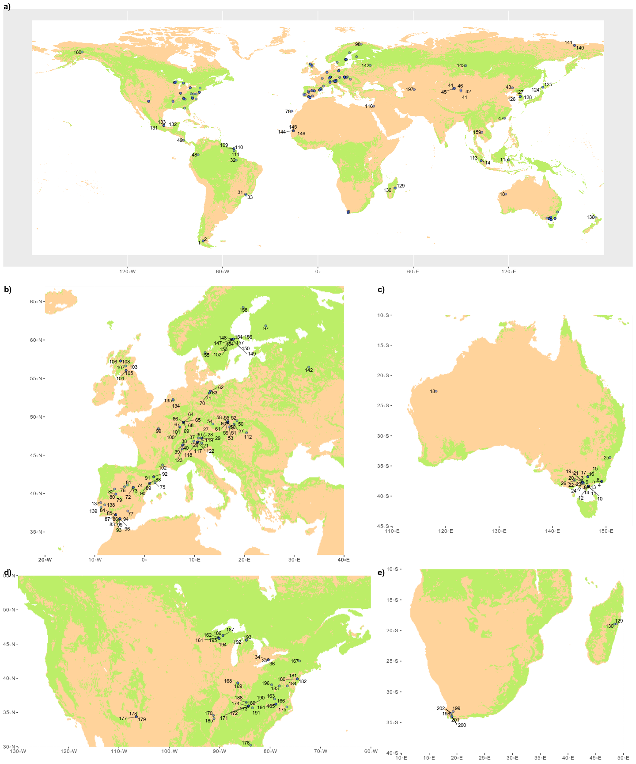 **Figure S4.**

Table S9

| **Species** | **N plant** | **N data** | **Species** | **N plant** | **N data** | **Species** | **N plant** | **N data** |
| --- | --- | --- | --- | --- | --- | --- | --- | --- |
| *Pinus sylvestris* | 290 | 28 | *Acacia tortilis* | 9 | 3 | *Prunus serotina* | 3 | 2 |
| *Picea abies* | 178 | 19 | *Quercus spp.* | 9 | 2 | *Populus canescens* | 3 | 1 |
| *Acer saccharum* | 162 | 9 | *Kandelia obovata* | 8 | 1 | *Eucalyptus camaldulensis* | 3 | 1 |
| *Fagus sylvatica* | 116 | 16 | *Carpinus betulus* | 8 | 2 | *Qualea rosea* | 3 | 1 |
| *Pinus taeda* | 107 | 6 | *Castanopsis acuminatissima* | 8 | 1 | *Licania alba* | 3 | 1 |
| *Populus tremuloides* | 104 | 1 | *Pinus patula* | 8 | 1 | *Eucalyptus dives* | 2 | 1 |
| *Pinus koraiensis* | 96 | 3 | *Eucalyptus radiata* | 7 | 5 | *Licania octandra* | 2 | 1 |
| *Eucalyptus nitens* | 89 | 8 | *Betula pubescens subsp. czerepanovii* | 7 | 1 | *Swartzia racemosa* | 2 | 1 |
| *Pinus strobus* | 75 | 5 | *Avicennia marina* | 6 | 1 | *Manilkara bidentata* | 2 | 1 |
| *Liquidambar styraciflua* | 69 | 10 | *Quercus robur* | 6 | 1 | *Licania membranacea* | 2 | 2 |
| *Quercus ilex* | 62 | 6 | *Fraxinus excelsior* | 6 | 1 | *Eschweilera grandiflora* | 2 | 1 |
| *Acer rubrum* | 62 | 12 | *Cryptocarya laevigata* | 6 | 1 | *Pouteria viridis* | 2 | 1 |
| *Liriodendron tulipifera* | 51 | 11 | *Myrtaceae fam.* | 6 | 1 | *Ampelocera macrocarpa* | 2 | 1 |
| *Fagus grandifolia* | 48 | 4 | *Palaquium luzoniense* | 6 | 1 | *Otoba novogranatensis* | 2 | 1 |
| *Pinus resinosa* | 43 | 1 | *Platea excelsa* | 6 | 1 | *Mortoniodendron anisophyllum* | 2 | 1 |
| *Eucalyptus globulus* | 35 | 2 | *Pouteria firma* | 6 | 1 | *Meliosma idiopoda* | 2 | 1 |
| *Larix decidua* | 34 | 8 | *Agathis australis* | 6 | 1 | *Taxus baccata* | 2 | 1 |
| *Abies pinsapo* | 34 | 5 | *Ostrya virginiana* | 6 | 3 | *Sloanea sp* | 2 | 2 |
| *Acacia mearnsii* | 33 | 2 | *Picea mariana* | 6 | 1 | *Betula sp.* | 2 | 1 |
| *Quercus pyrenaica* | 32 | 2 | *Nothofagus pumilio* | 5 | 1 | *Picea glauca* | 2 | 1 |
| *Quercus rubra* | 32 | 6 | *Nothofagus cunninghamii* | 5 | 1 | *Fraxinus americana* | 2 | 1 |
| *Quercus petraea* | 31 | 5 | *Eucalyptus cypellocarpa* | 5 | 4 | *Carya cordiformis* | 2 | 1 |
| *Pseudotsuga menziesii* | 29 | 5 | *Eucalyptus rubida* | 5 | 1 | *Quercus prinus* | 2 | 1 |
| *Pinus halepensis* | 27 | 2 | *Drimys brasiliensis* | 5 | 1 | *Elaeagnus angustifolia* | 2 | 1 |
| *Quercus velutina* | 24 | 4 | *Alchornea triplinervia* | 5 | 1 | *Qualea tricolor* | 2 | 1 |
| *Tsuga canadensis* | 24 | 2 | *Santiria apiculata* | 5 | 1 | *Lecythis poiteaui* | 2 | 1 |
| *Larix cajanderi* | 23 | 2 | *Quercus michauxii* | 5 | 1 | *Quercus cerris* | 2 | 1 |
| *Betula papyrifera* | 21 | 2 | *Quercus phellos* | 5 | 1 | *Pleuranthodendron lindenii* | 1 | 1 |
| *Quercus montana* | 21 | 3 | *Pinus rigida* | 5 | 3 | *Inga sp.* | 1 | 1 |
| *Quercus pubescens* | 19 | 2 | *Tilia americana* | 5 | 2 | *Cupania macrophylla* | 1 | 1 |
| *Abies balsamea* | 19 | 1 | *Nothofagus antarctica* | 4 | 1 | *Genipa americana* | 1 | 1 |
| *Quercus alba* | 19 | 7 | *Eucalyptus baxteri* | 4 | 2 | *Brosimum alicastrum* | 1 | 1 |
| *Pinus cembra* | 18 | 6 | *Coprosma quadrifida* | 4 | 2 | *Pouteria sp.* | 1 | 1 |
| *Populus euphratica* | 16 | 6 | *Eschweilera coriacea* | 4 | 2 | *Macrolobium costaricense* | 1 | 1 |
| *Olea europaea* | 16 | 5 | *Arbutus unedo* | 4 | 1 | *Eschweilera sp.* | 1 | 1 |
| *Quercus rotundifolia* | 16 | 3 | *Psiadia altissima* | 4 | 1 | *Aspidosperma desmanthum* | 1 | 1 |
| *Hevea brasiliensis* | 16 | 2 | *Quercus suber* | 4 | 1 | *Trophis mexicana* | 1 | 1 |
| *Betula alleghaniensis* | 16 | 2 | *Betula pubescens* | 4 | 2 | *Betula pendula* | 1 | 1 |
| *Pinus nigra* | 15 | 3 | *Fraxinus pennsylvanica* | 4 | 2 | *Iryanthera sagotiana* | 1 | 1 |
| *Picea sitchensis* | 15 | 1 | *Pouteria anomala* | 3 | 1 | *Vantanea sp* | 1 | 1 |
| *Pinus edulis* | 15 | 3 | *Protium tenuifolium* | 3 | 1 | *Recordoxylon speciosum* | 1 | 1 |
| *Juniperus monosperma* | 15 | 3 | *Hieronyma alchorneoides* | 3 | 1 | *Larix kaempferi x Larix gmelinii* | 1 | 1 |
| *Eucalyptus victrix* | 14 | 1 | *Mollinedia schottiana* | 3 | 1 | *Cryptomeria japonica* | 1 | 1 |
| *Eucalyptus obliqua* | 14 | 5 | *Rustia formosa* | 3 | 1 | *Eugenia spp.* | 1 | 1 |
| *Quercus lyrata* | 13 | 2 | *Theobroma cacao* | 3 | 1 | *Ocotea samosa* | 1 | 1 |
| *Celtis laevigata* | 13 | 2 | *Carapa guianensis* | 3 | 1 | *Leptolaena sp.* | 1 | 1 |
| *Quercus coccinea* | 13 | 4 | *Gymnanthes riparia* | 3 | 1 | *Abrahamia ditimena* | 1 | 1 |
| *Populus grandidentata* | 12 | 1 | *Ilex aquifolium* | 3 | 1 | *Brachylaena ramiflora* | 1 | 1 |
| *Malus domestica* | 11 | 3 | *Vouacapoua americana* | 3 | 3 | *Cryptocarya sp.* | 1 | 1 |
| *Eucalyptus tereticornis* | 10 | 1 | *Oxandra asbeckii* | 3 | 2 | *Saurauia pedunculata* | 1 | 1 |
| *Quercus faginea* | 10 | 2 | *Goupia glabra* | 3 | 3 | *Turpinia insignis* | 1 | 1 |
| *Pinus canariensis* | 10 | 1 | *Vernonia arborea* | 3 | 1 | *Sassafras albidum* | 1 | 1 |
| *Elaeis guineensis* | 10 | 1 | *Platanus mexicana* | 3 | 1 | *Ulmus americana* | 1 | 1 |
| *Acacia longifolia* | 10 | 1 | *Clethra macrophylla* | 3 | 2 | *Carya glabra* | 1 | 1 |
| *Pinus pinaster* | 10 | 1 | *Larix sibirica* | 3 | 1 | *Quercus falcata* | 1 | 1 |
| *Thuja occidentalis* | 10 | 1 | *Larix gmelinii* | 3 | 1 | *Cornus florida* | 1 | 1 |
| *Carya tomentosa* | 10 | 2 | *Pinus sibirica* | 3 | 1 | *Licania rodriguesii* | 1 | 1 |
| *Dicorynia guianensis* | 9 | 2 | *Pinus virginiana* | 3 | 1 | *Sextonia rubra* | 1 | 1 |

Table S10

| **Genus** | **N plants** | **Genus** | **N plants** | **Genus** | **N plants** |
| --- | --- | --- | --- | --- | --- |
| *Pinus* | 725 | *Cryptocarya* | 7 | *Ampelocera* | 2 |
| *Quercus* | 326 | *Avicennia* | 6 | *Otoba* | 2 |
| *Acer* | 224 | *Myrtaceae fam.* | 6 | *Mortoniodendron* | 2 |
| *Picea* | 201 | *Palaquium* | 6 | *Meliosma* | 2 |
| *Eucalyptus* | 188 | *Platea* | 6 | *Taxus* | 2 |
| *Fagus* | 164 | *Agathis* | 6 | *Sloanea* | 2 |
| *Populus* | 135 | *Ostrya* | 6 | *Elaeagnus* | 2 |
| *Liquidambar* | 69 | *Drimys* | 5 | *Lecythis* | 2 |
| *Larix* | 64 | *Alchornea* | 5 | *Pleuranthodendron* | 1 |
| *Abies* | 53 | *Santiria* | 5 | *Inga* | 1 |
| *Acacia* | 52 | *Tilia* | 5 | *Cupania* | 1 |
| *Betula* | 51 | *Qualea* | 5 | *Genipa* | 1 |
| *Liriodendron* | 51 | *Coprosma* | 4 | *Brosimum* | 1 |
| *Pseudotsuga* | 29 | *Arbutus* | 4 | *Macrolobium* | 1 |
| *Tsuga* | 24 | *Psiadia* | 4 | *Aspidosperma* | 1 |
| *Olea* | 16 | *Protium* | 3 | *Trophis* | 1 |
| *Hevea* | 16 | *Hieronyma* | 3 | *Iryanthera* | 1 |
| *Juniperus* | 15 | *Mollinedia* | 3 | *Vantanea* | 1 |
| *Nothofagus* | 14 | *Rustia* | 3 | *Recordoxylon* | 1 |
| *Carya* | 13 | *Theobroma* | 3 | *Cryptomeria* | 1 |
| *Celtis* | 13 | *Carapa* | 3 | *Eugenia* | 1 |
| *Pouteria* | 12 | *Gymnanthes* | 3 | *Ocotea* | 1 |
| *Fraxinus* | 12 | *Ilex* | 3 | *Leptolaena* | 1 |
| *Malus* | 11 | *Vouacapoua* | 3 | *Abrahamia* | 1 |
| *Elaeis* | 10 | *Oxandra* | 3 | *Brachylaena* | 1 |
| *Thuja* | 10 | *Goupia* | 3 | *Saurauia* | 1 |
| *Dicorynia* | 9 | *Vernonia* | 3 | *Turpinia* | 1 |
| *Licania* | 8 | *Platanus* | 3 | *Sassafras* | 1 |
| *Kandelia* | 8 | *Clethra* | 3 | *Ulmus* | 1 |
| *Carpinus* | 8 | *Prunus* | 3 | *Cornus* | 1 |
| *Castanopsis* | 8 | *Swartzia* | 2 | *Sextonia* | 1 |
| *Eschweilera* | 7 | *Manilkara* | 2 |  |  |