CECS 285
LAB 2
EXAMINING THE CY FLAG AND THE STACK
Student Name: Kelby Sapien
Student ID: 009193260

Objective:
- Learn how to use instructions: MOV and ADD
- To examine the flag bits of the PSW.
- To examine the stack.

Reference:
- Mazidi and Mazidi, “The 8051 Microcontroller and Embedded Systems,” Chapter 2.
Tasks:
- Write and assemble a program to add the following data and save the final result to register R1. Use the simulator to examine the CY flag. Screen-shot the CY flag whenever the addition generates a carry.
92H, E3H, 66H, 87H, F5H

- Write and assemble a program to:
- MOV the following 6 different values to internal RAM locations: 31H - 36H, then PUSH the contents in those memory locations to the stack, assuming the initial value of SP is 7. When finish the above operation, screenshot the contents in the stack and contents in RAM location 31H – 36H.
Data to be moved to 31H – 36H: A3H, 24H, 38H, 7CH, D3H,79H
- POP the top 6 items from the stack into registers R0 – R5.
Use the simulator to single-step and examine the registers, the stack, and the stack register. After poping all 6 items, screen-shot the contents in registers R0 – R5, the stack, and SP register.

Lab Report:
Submit a lab report with the following items to Beachboard:
- The source code for all programs,
- The required screen shots.

Task 1:
// code
ORG 0000H

MAIN:
; 92H, E3H, 66H, 87H, F5H
; OR MOV R2, #92H
; THEN ADD A, R2; AND SO ON OR DO STEPS BELOW
MOV A, #92H ; MOVE FIRST VALUE INTO A
ADD A, #0E3H ; ADD NEXT VAL TO A
ADD A, #66H
ADD A, #87H
ADD A, #0F5H

MOV R1,A ; MOV TO R1
SJMP MAIN
END

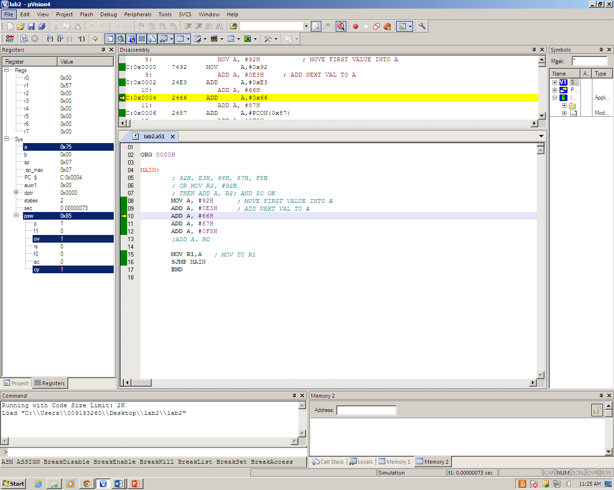

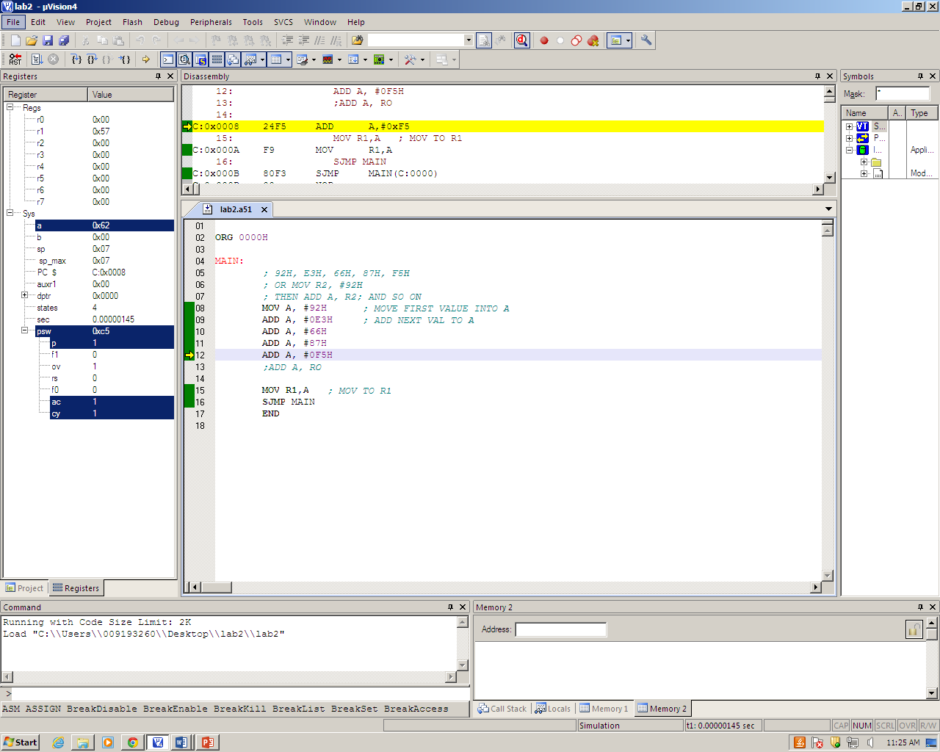
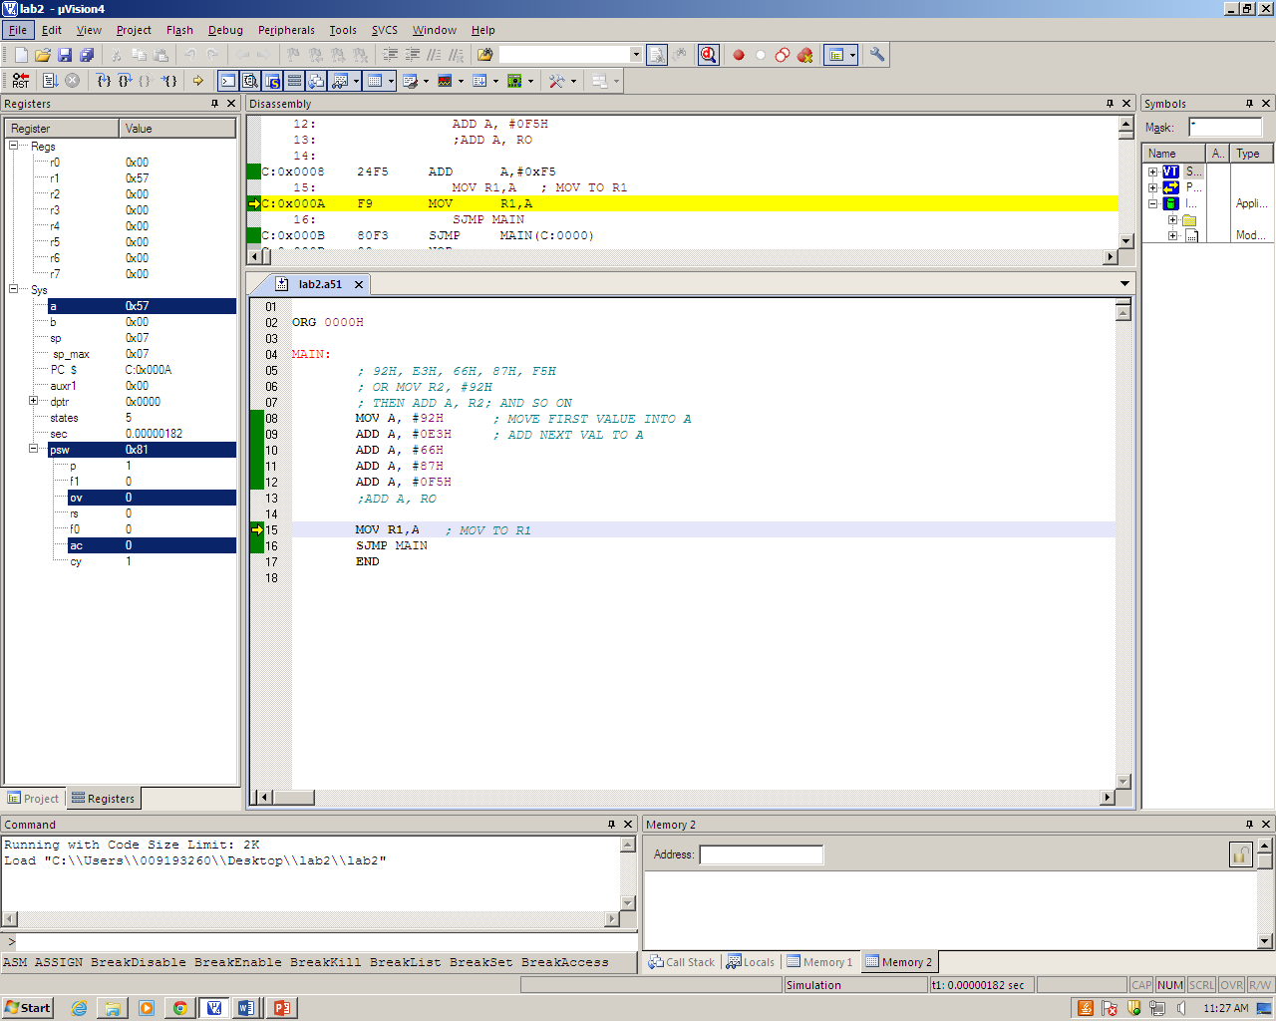

Task 2:
Write and assemble a program to:
- MOV the following 6 different values to internal RAM locations: 31H - 36H, then PUSH the contents in those memory locations to the stack, assuming the initial value of SP is 7. When finish the above operation, screenshot the contents in the stack and contents in RAM location 31H – 36H.
Data to be moved to 31H – 36H: A3H, 24H, 38H, 7CH, D3H,79H
- POP the top 6 items from the stack into registers R0 – R5.
Use the simulator to single-step and examine the registers, the stack, and the stack register. After poping all 6 items, screen-shot the contents in registers R0 – R5, the stack, and SP register.
// Code
ORG 0000H

MAIN:
;values A3H, 24H, 38H, 7CH, D3H,79H
;move to 31H - 36H
MOV 31H, #0A3H
MOV 32H, #24H
MOV 33H, #38H
MOV 34H, #7CH
MOV 35H, #0D3H
MOV 36H, #79H

; push values found in 31H-36H to Stack (pointing to 7, but starting at 8)
; stack is then incremented by 1
PUSH 31H
PUSH 32H
PUSH 33H
PUSH 34H
PUSH 35H
PUSH 36H

; pops values found in stack
; registers 0-5 are then filled
POP 0
POP 1
POP 2
POP 3
POP 4
POP 5

SJMP MAIN

END

A.)

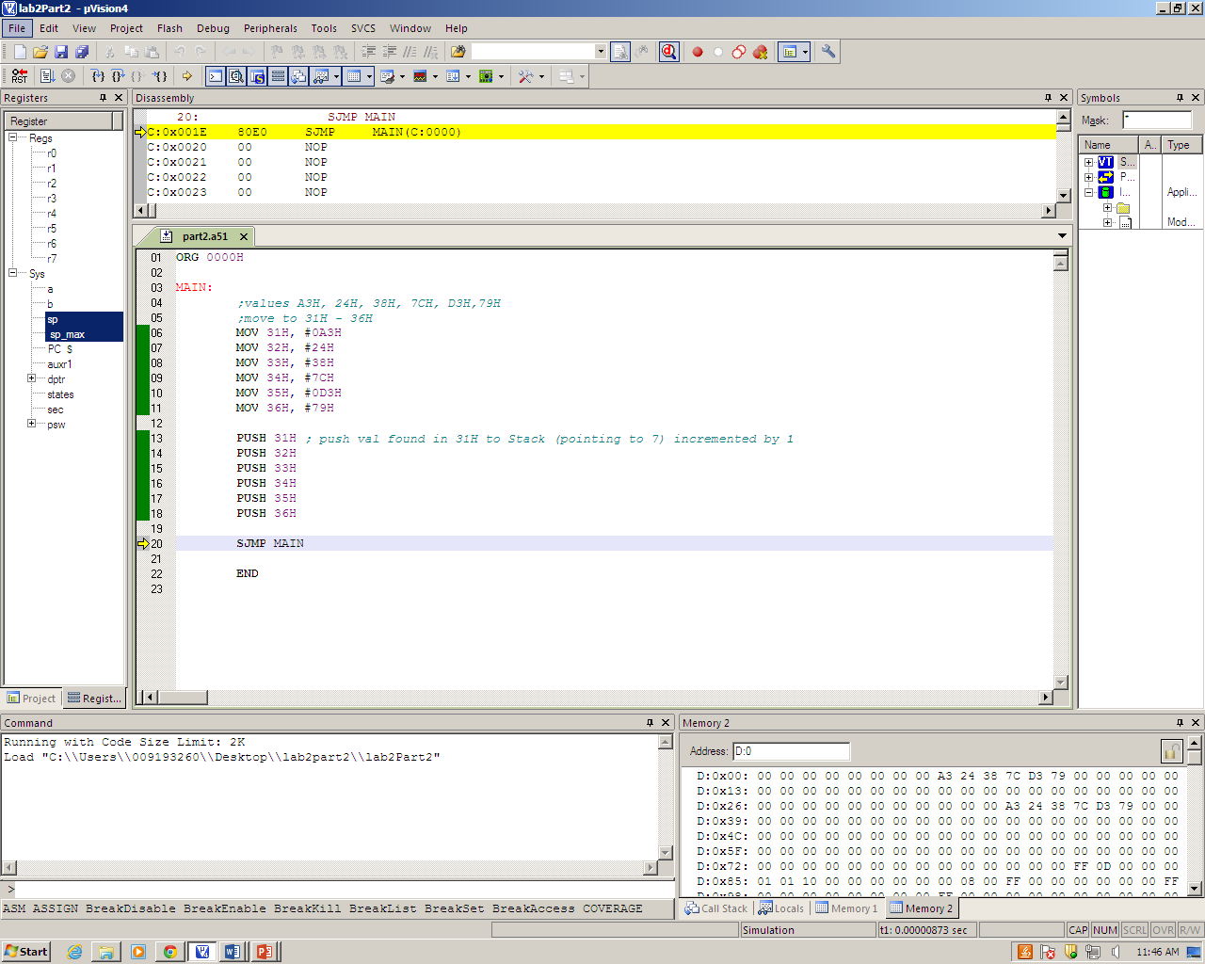
Stack
Register banks
Internal RAM

B.)

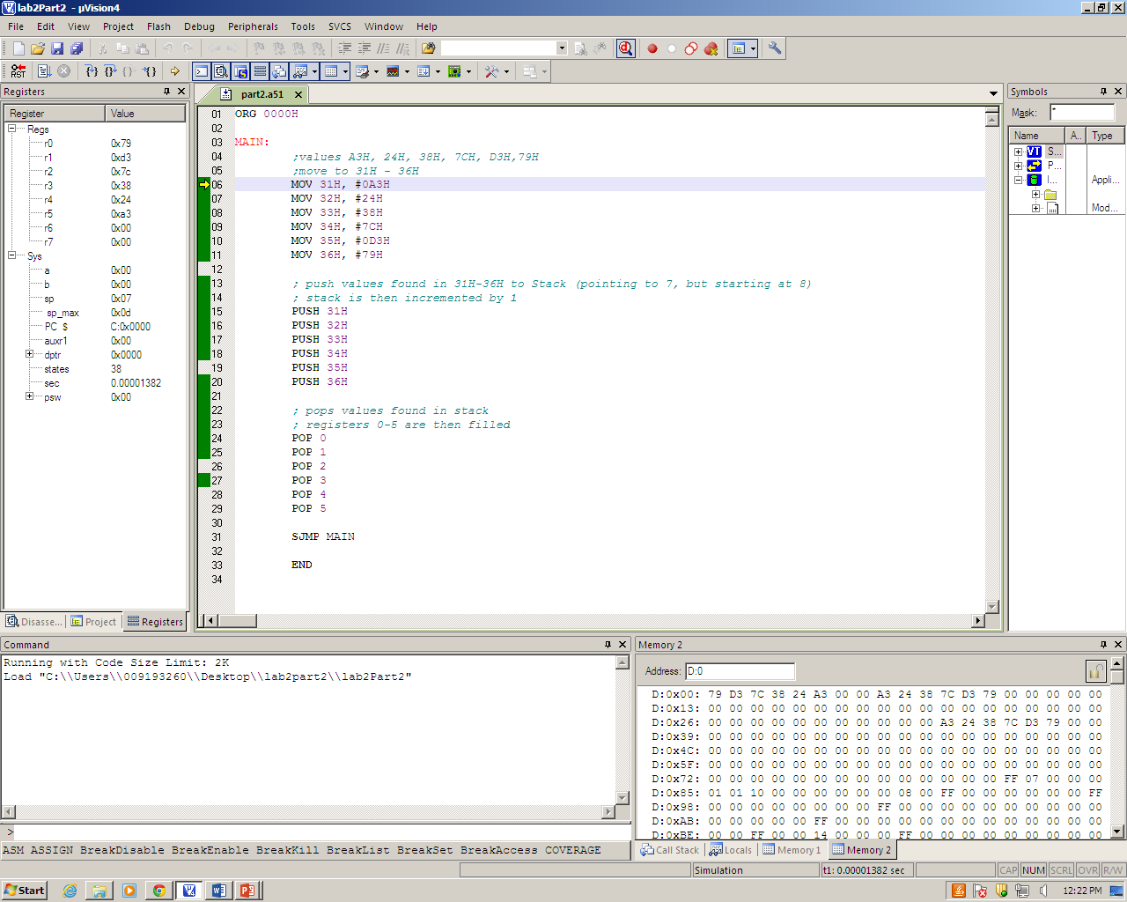
Register banks
Stack
Registers
Stack pointer

