# Lab Exercise -3.10

1. **Using ‘Excel Options’ do the following customization**
   1. Set default two worksheets in a workbook. Original Number is three.

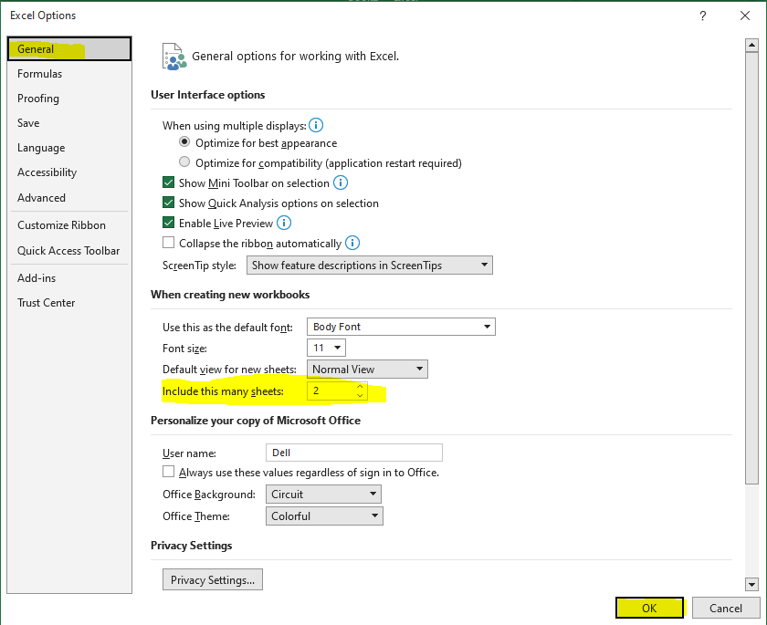

* + - On ‘General Tab’ of ‘Excel Options’
    - Change the value to 2 on ‘Include this many sheets’
    - Click on OK
  1. Disable auto recover for your current workbook.

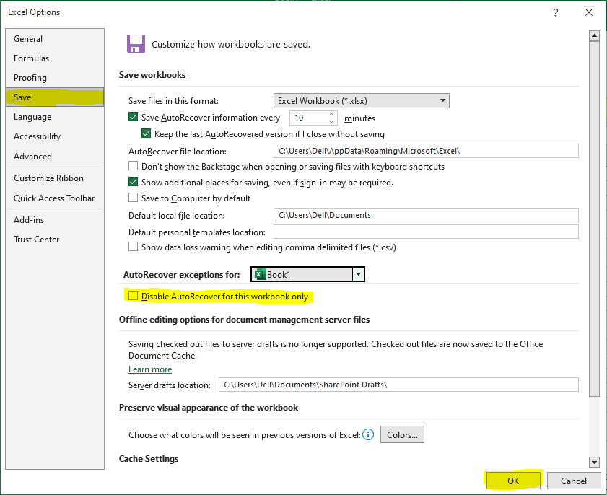

* + - On ‘Save Tab’ of ‘Excel Options’
    - Check ‘Disable AutoRecover for this workbook only’
    - Click on OK
  1. Set the Recent number of documents to be displayed to two

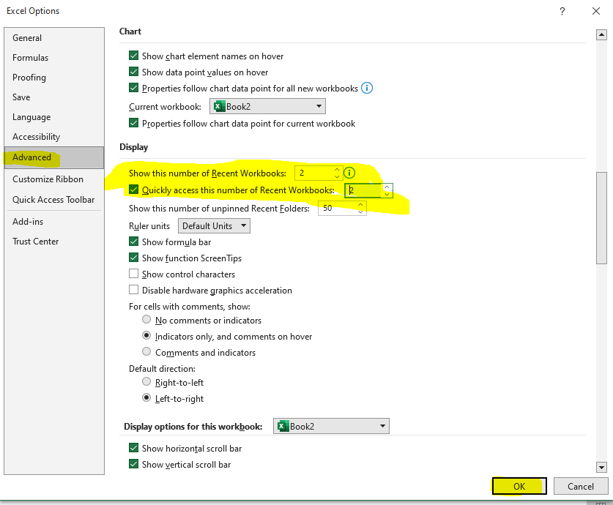

* + - On ‘Advance Tab’ of ‘Excel Options’
    - Change ‘Show this number of workbook’ value to 2
    - Click on OK
  1. Don’t display grid lines

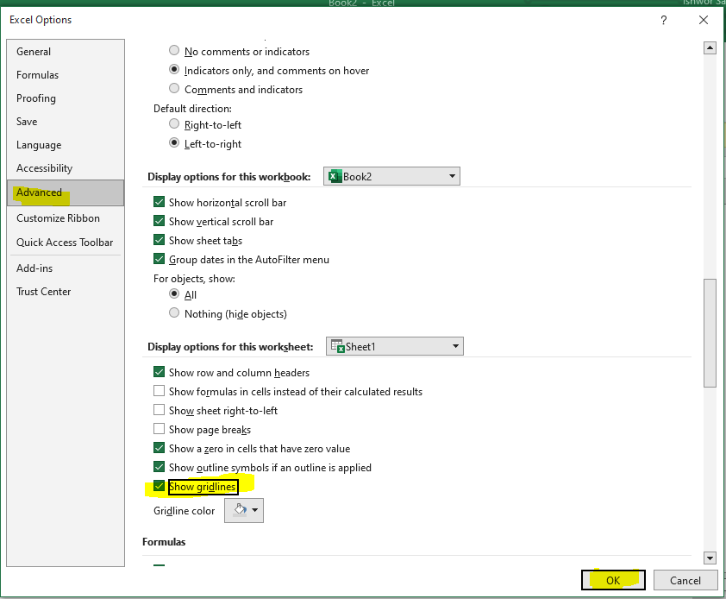

* + - On ‘Advanced Tab’ of ‘Excel Options’
    - Uncheck ‘Show Gridlines’
    - Click on OK
  1. Enable show page breaks

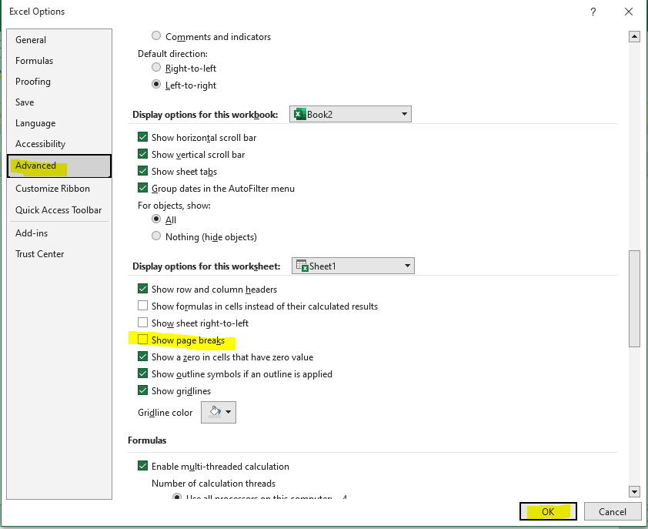

* + - On Advanced Tab’ of ‘Excel Options’
    - Uncheck ‘Show page breaks’
    - Click on OK
  1. Set the Enter key direction so that the cursor moves to right when you press enter in a cell

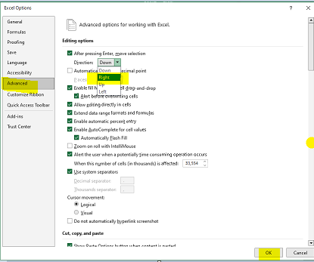

* + - On Advanced Tab’ of ‘Excel Options’
    - Choose Right on Direction for ‘After pressing Enter, move selection’
    - Click on OK

1. **Open a new workbook. Create a table with two columns. Use columns A and B of the worksheet. The headings for the first one should be First Name. Give the heading as Last Name for the second column. Add records in the table. Please enter first name as rahul and the second name as gandhi. Your data should contain multiple records with the same first or last name. Save workbook as “Student.xslx”**

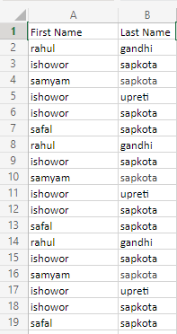

Column Heading added as **First Name** and **Last Name.** List of data added on it.

[Student-Workbook](https://1drv.ms/x/s!AnCi4pjT6ASAhA0C8vuq9z3DuU3n?e=rBPQBx)

1. **Open “Student.xslx”. Create another table using column E and F. Again the heading would be First Name and Last Name. Using string functions, change the name to proper case (for example to Rahul or Gandhi) and store in E and F. Original data should remain. Save and close the worksheet.**

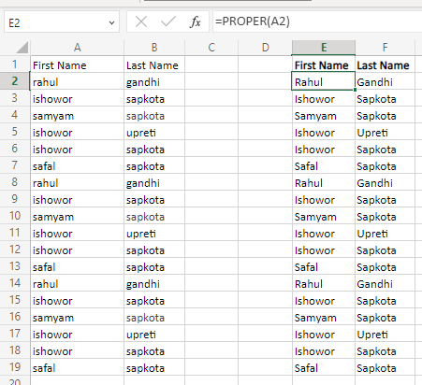

String function PROPER is used for A2 cell data for First Name and B2 for Last Name

[Student-Workbook](https://1drv.ms/x/s!AnCi4pjT6ASAhA0C8vuq9z3DuU3n?e=rBPQBx)

1. **Open “Student.xslx”. Hide columns A and B. Rename Sheet 1 as Student Name. Delete all the worksheets in the work book except Student Name. Add Borders to the table. Format heading as Bold center aligned, increase font size change the font colour and the fill of the heading. Save and Close.**

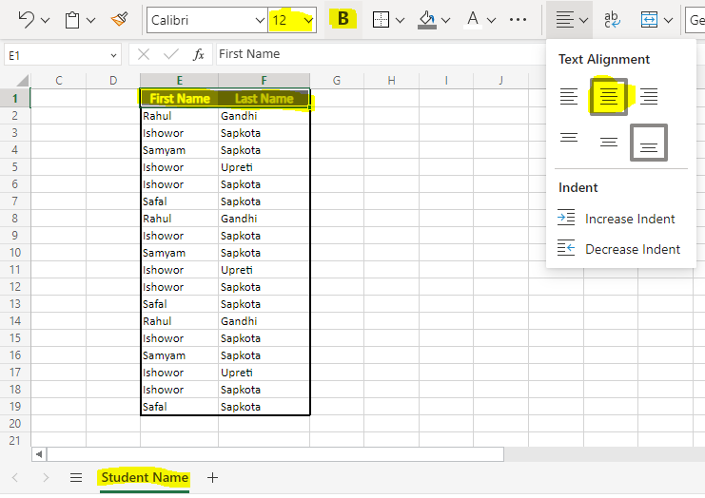

All the changes as per the questions are highlighted.

1. **Open “Student.xslx”. Sort the records in alphabetical order of the first name. Filter all records with last name A. Now use a string function to concatenate the two names (first name and last name) and store in the column D (give heading as Name)**

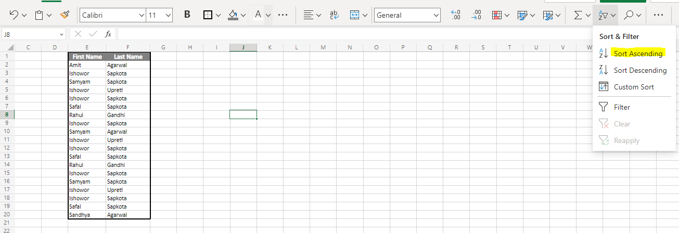

Select the table. Click on Sort Ascending

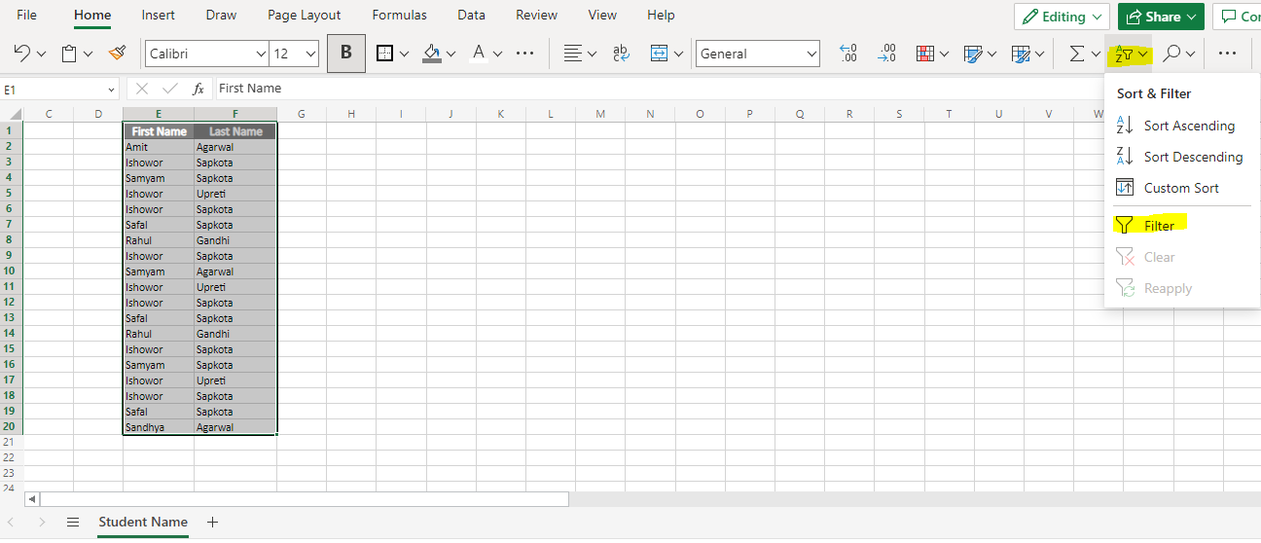

Select the data and click on filter. Down arrow appears on each column heading as in figure below.

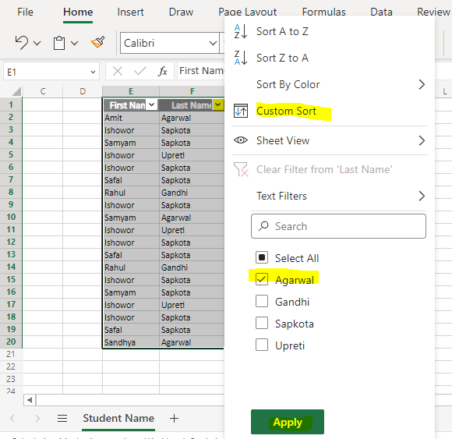

Click on down arrow on last name. Check for **Agarwal**. Click on Apply.

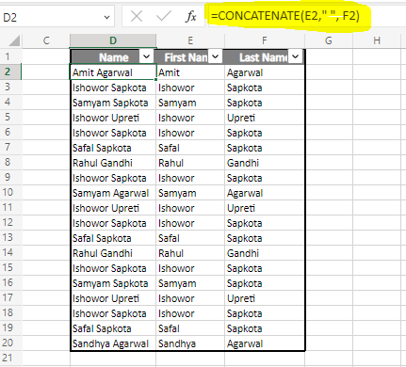

Column Heading for Column D is set to **Name.** Function Concatenate is used on the column. Function is highlighted on the figure.

[Student-Workbook](https://1drv.ms/x/s!AnCi4pjT6ASAhA0C8vuq9z3DuU3n?e=rBPQBx)

1. **Create a new workbook containing Student Marks. Add column headings: Name, English, Hindi, Maths, Science, Social Science, Total Marks, Percentage Marks. Add records to the table. You may copy the names from student.xslx. Add title to the table. Format Table property. Use function to calculate total marks and percentage marks. Freeze the panes so that the headings don’t scroll. Add headers and footers to the worksheet. Preview the worksheet. Save as StudentMarks.xslx and close.**

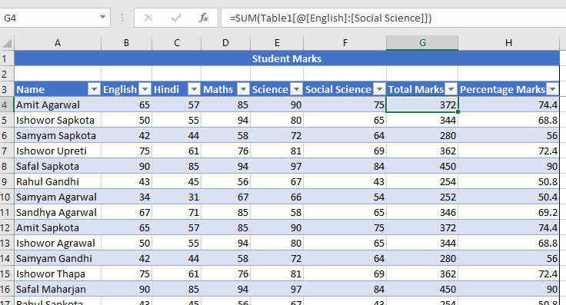

Added all data. Function SUM is used to add all marks.

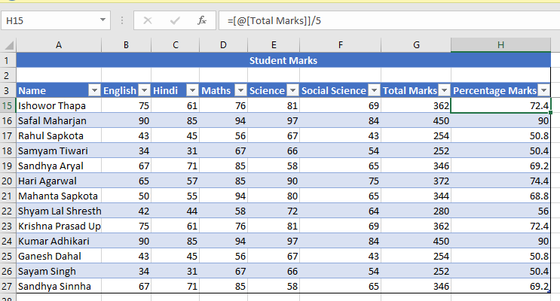

Added Function Total /5 for Percentage Freeze Pane on view is clicked on keeping the selection on A2.

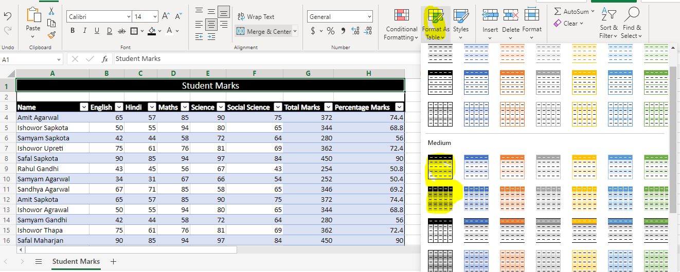

To display the table in the format as shown. Format as table on Home is clicked

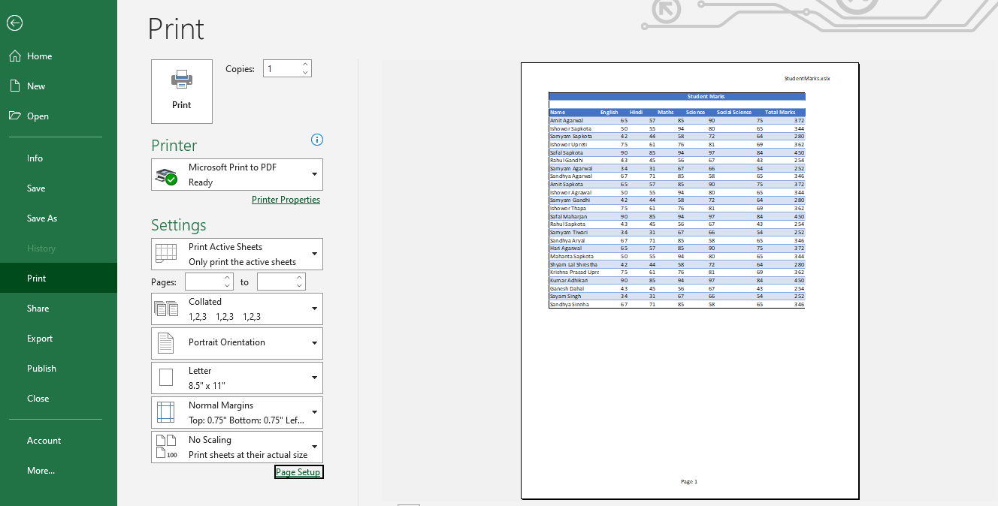

Footer and header are added on Page Setup >> Header/Footer tab. FileName on header right and Page No on footer center.

[Student Marks-Workbook](https://1drv.ms/x/s!AnCi4pjT6ASAhBEAc8VT2JNlaiYY?e=DKusJG)

1. **Create a table of records with columns Name and Donation Amount. Donation Amount should be formatted with two decimal places. There should be at least twenty records in the table. Create a conditional format to highlight top 3 donations with blue color and lowest three with red color. The table should have a heading.**

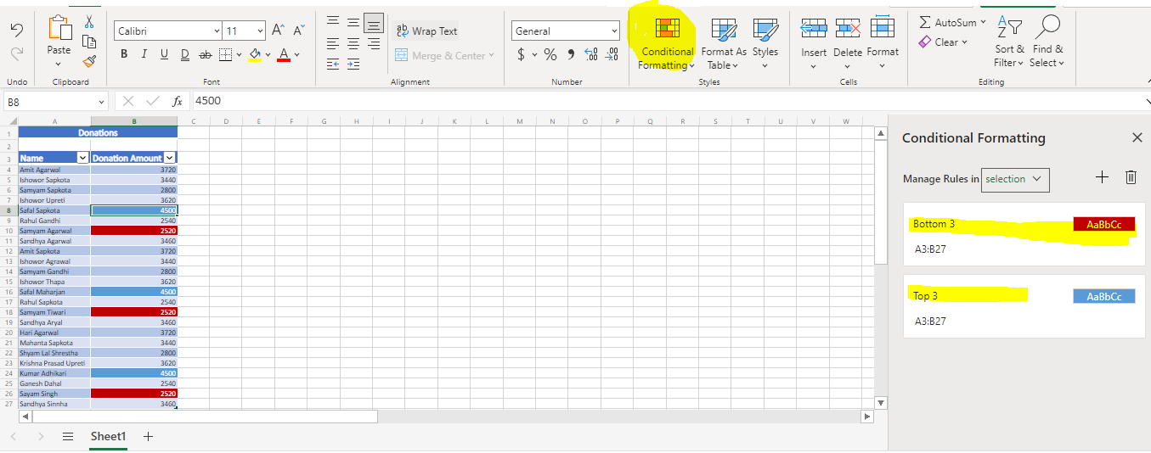

Selecting all data. Clicking on conditional format for top 10 records. A screen for conditional formatting appears with all editable options for formatting and no. of top (Blue)/bottom (red) records data (3 in our case).

[Donations-Workbook](https://1drv.ms/x/s!AnCi4pjT6ASAhBOPEY3E__AFGaLZ?e=44qE1v)

1. **Using Auto fill feature to fill column B with odd numbers and column C with Even Numbers. There should be twenty records in each column. Save the workbook as EvenOdd.xslx.**

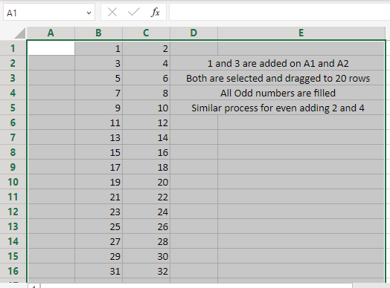

[EvenOdd-Workbook](https://1drv.ms/x/s!AnCi4pjT6ASAhBW3ZGUEL8U1mBVv?e=QlRuaU)

1. **Using the workbook EvenOdd.xlsx. Create a formula in column D1 to add B1 and C1. Copy the formula from D1 to all other following rows Also use formula to display the sum of all the values in column B in cell B35. Similarly for column C in cell C35. Add the label Sum in Cell A35 It should be bold and double underlined.**

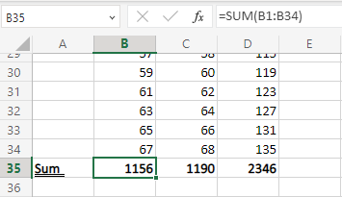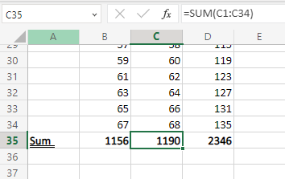

[EvenOdd-Workbook](https://1drv.ms/x/s!AnCi4pjT6ASAhBW3ZGUEL8U1mBVv?e=QlRuaU)

1. **Open Workbook EvenOdd.xslx. Go to sheet 3Type the value 1.5 in cell A1. Come back to sheet 1. Create a formula in E1 to multiply the value of D1 with the value in cell A1 of sheet3. Copy the formula to other rows.**

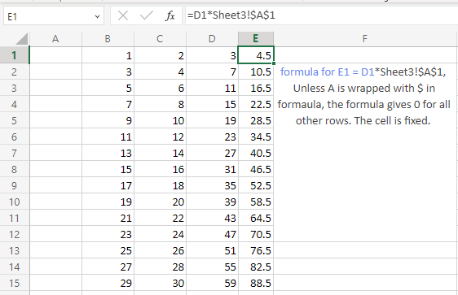

[EvenOdd-Workbook](https://1drv.ms/x/s!AnCi4pjT6ASAhBW3ZGUEL8U1mBVv?e=QlRuaU)

1. **Create a table of expenses for a house hold. The table will have two column: Expense Name and Expense Value in percent.(It will the total percent spend under this head.). Create a pie chart for the same data. Examples of expense heads can be food education, utilities, clothing, house rent. The chart should have proper title, labels and legends.**

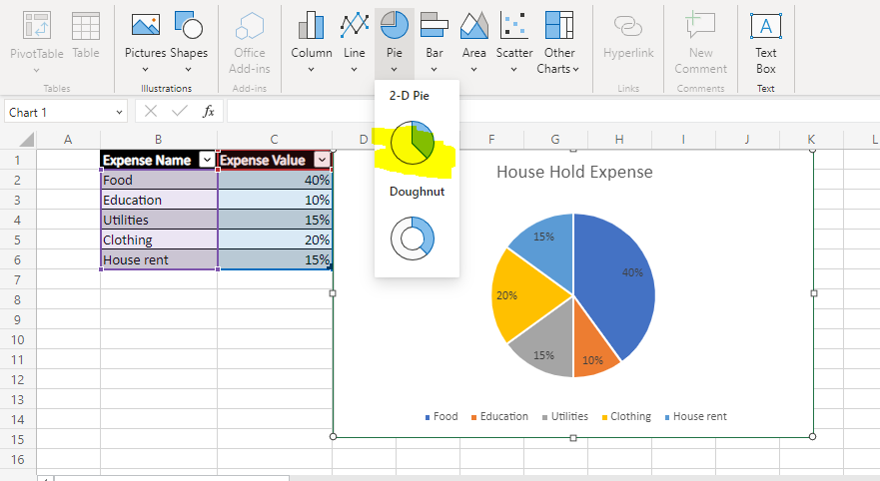

[Household Expense-Workbook](https://1drv.ms/x/s!AnCi4pjT6ASAhBcGEny0Yv47R48B?e=LHPPCB)

1. **Create a list name with all the names in column A, stored in the format last name, First name, for example Gandhi, Rahul. Use converts to text feature to separate the first name and the last name. The original data should not be lost.**

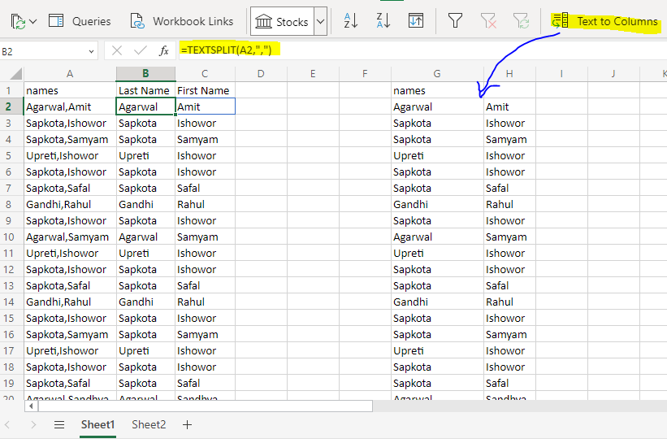

There are two ways: -

* First way using **Text to Columns.**  It will split the original data to two columns holding last name on one column and first name next to it.
* Second way using TEXTSPLIT function which will keep the original data as it is.

[TextToColumns - Workbook](https://1drv.ms/x/s!AnCi4pjT6ASAhBmXE5JapzvZfD-A?e=lm6yUa)