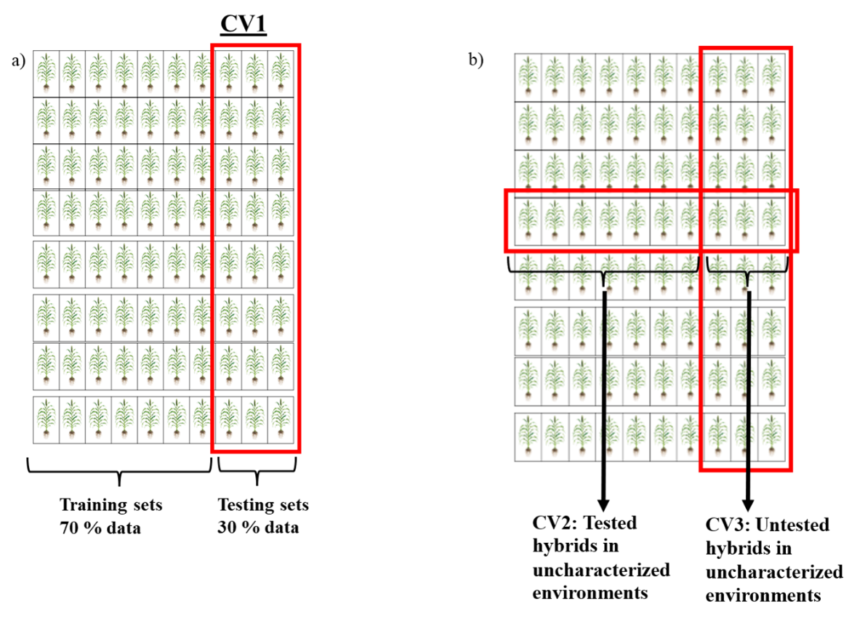
Supplementary figure 1: Cross validation scheme across environments for genomic and phenomic models in predicting sorghum hybrid performance. a) CV1 cross validation scheme across environments with 30% testing hybrids i.e. 30 × 8 = 240, which were predicted by training 70 % of hybrids across environments i.e. 70 × 8 = 560. b) CV2 and CV3 cross validation schemes were performed by leaving one environment out on top of 30 % of hybrids from other seven environments, prediction accuracy was calculated for 70% tested hybrids on uncharacterized environments for CV2 and 30 % untested hybrids in uncharacterized environments for CV3 as shown above.

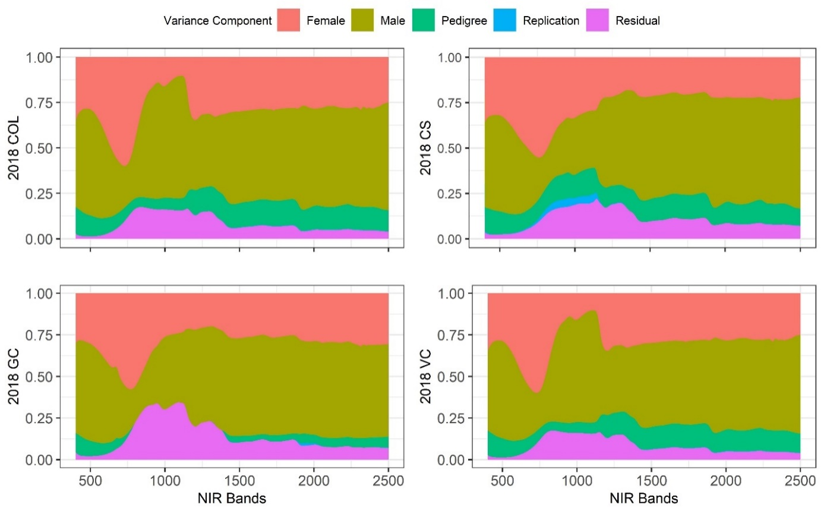
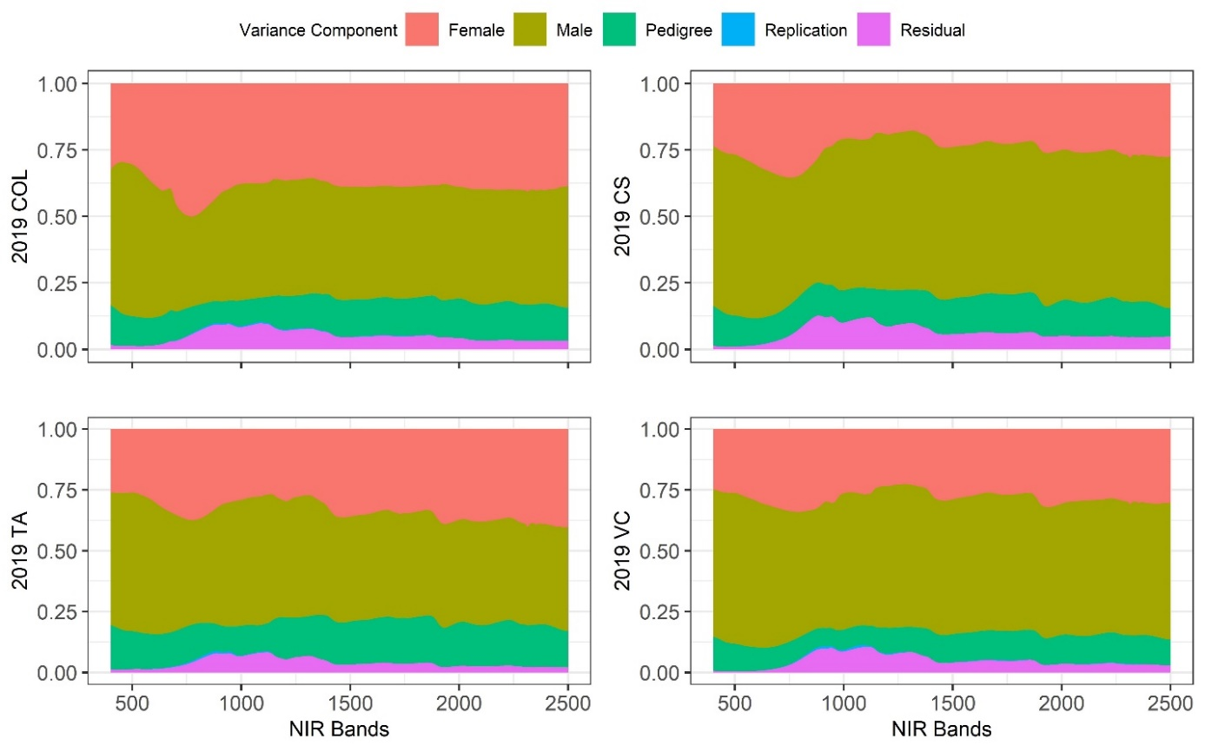
Supplementary figure 2: Percent variation explained by male effects, female effects, female × male effects, and replication across all 4200 near-infrared spectroscopy (NIRS) bands across eight environments by equation $y=1µ+Z_{1}f+Z_{2}m+Z_{3}h+ e$. Abbreviations for locations are COL: Colby, KS, CS: College Station, TX, GC: Garden City, KS, VC: Victoria, TX, TA: Taft, TX.

Supplementary table 1: statistics (mean and standard deviation) on prediction accuracy for the combination of four cross validation scheme (CV) and phenotypic traits for GY (grain yield), DA (days to anthesis), PH (plant height), KHI (kernel hardness index), KD (kernel diameter), and KW (kernel weight) for G (genomic), P (phenomic) and G + P (genomic + phenomic) models.
Model | CV | Trait | Mean | Std. dev. | Trait | mean | Std. dev.
G | CV2 | GY | 0.649 | 0.049 | KHI | 0.685 | 0.089
G | CV3 | GY | 0.636 | 0.119 | KHI | 0.605 | 0.123
G | CV1 | GY | 0.672 | 0.120 | KHI | 0.820 | 0.092
P | CV2 | GY | 0.596 | 0.116 | KHI | 0.862 | 0.037
P | CV3 | GY | 0.567 | 0.149 | KHI | 0.836 | 0.078
P | CV1 | GY | 0.617 | 0.126 | KHI | 0.856 | 0.071
G + P | CV2 | GY | 0.607 | 0.091 | KHI | 0.920 | 0.020
G + P | CV3 | GY | 0.572 | 0.132 | KHI | 0.852 | 0.079
G + P | CV1 | GY | 0.686 | 0.116 | KHI | 0.859 | 0.079
G | CV2 | DA | 0.758 | 0.031 | KD | 0.863 | 0.023
G | CV3 | DA | 0.702 | 0.084 | KD | 0.821 | 0.067
G | CV1 | DA | 0.760 | 0.102 | KD | 0.866 | 0.061
P | CV2 | DA | 0.715 | 0.052 | KD | 0.771 | 0.049
P | CV3 | DA | 0.685 | 0.110 | KD | 0.744 | 0.082
P | CV1 | DA | 0.701 | 0.101 | KD | 0.872 | 0.040
G + P | CV2 | DA | 0.758 | 0.035 | KD | 0.845 | 0.047
G + P | CV3 | DA | 0.700 | 0.111 | KD | 0.833 | 0.057
G + P | CV1 | DA | 0.777 | 0.086 | KD | 0.914 | 0.037
G | CV2 | PH | 0.790 | 0.031 | KW | 0.735 | 0.041
G | CV3 | PH | 0.715 | 0.122 | KW | 0.643 | 0.099
G | CV1 | PH | 0.783 | 0.105 | KW | 0.747 | 0.094
P | CV2 | PH | 0.579 | 0.049 | KW | 0.590 | 0.202
P | CV3 | PH | 0.495 | 0.115 | KW | 0.531 | 0.251
P | CV1 | PH | 0.624 | 0.104 | KW | 0.755 | 0.077
G + P | CV2 | PH | 0.794 | 0.029 | KW | 0.774 | 0.060
G + P | CV3 | PH | 0.730 | 0.106 | KW | 0.728 | 0.106
G + P | CV1 | PH | 0.785 | 0.091 | KW | 0.826 | 0.061
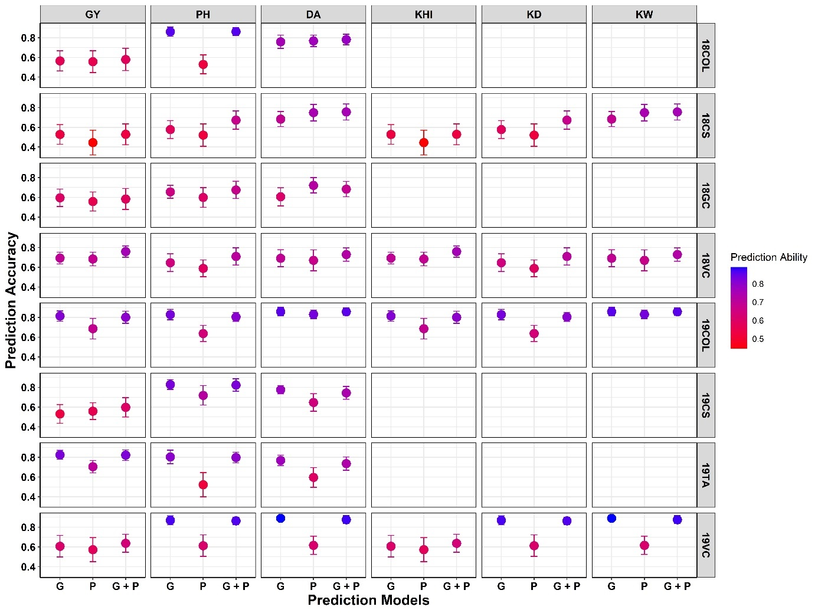
Supplementary figure 3: Prediction abilities of Genomic (G), Phenomic (P), Genomic + Phenomic (G + P) models in predicting GY: Grain Yield, PH: Plant Height, DA: Days to Anthesis, KHI: Kernel Hardness Index, KD: Kernel Diameter, and KW: Kernel Weight for eight environments (18COL: 2018 Colby, KS; 18CS: 2018 College Station, TX; 18GC: 2018 Garden City, KS; 18VC: 2018 Victoria, TX; 19COL: 2018 Colby, Kansas; 19CS: 2019 College Station, TX; 19TA: 2019 Taft, TX; 19VC: 2019 Victoria, TX).

