Data Analysis Project-1

Dataset overview:-
- This dataset contains details of the used cars in Germany which are on sale on eBay.

- The dataset contains 371,528 rows of information, each representing a car listed for sale on eBay online marketplace.
- dateCrawled - When this ad was first crawled. All field-values are taken from this date.
- name - Name of the car.
- seller - Whether the seller is private or a dealer.
- offerType - The type of listing
- price - The price on the ad to sell the car.
- abtest- Whether the listing is included in an A/B test.
- vehicleType - The vehicle Type.
- yearOfRegistration- The year in which which year the car was first registered.
- gearbox - The transmission type.
- powerPS- The power of the car in PS.
- model - The car model name.
- kilometer - How many kilometers the car has driven.
- monthOfRegistration- The month in which which year the car was first registered.
- fuelType- What type of fuel the car uses.
- brand - The brand of the car.
- notRepairedDamage- If the car has a damage which is not yet repaired.
- dateCreated- The date on which the eBay listing was created.
- nrOfPictures- The number of pictures in the ad.
- postalCode- The postal code for the location of the vehicle.
- lastSeenOnline- When the crawler saw this ad last online.
Dataset Link :-
https://drive.google.com/file/d/1NFpNI-AiSLmta139rYaWrNy8xZ0VrbM9/view?usp=sharing
Analysis – 1

- Perform general Data analysis

- Importing all the necessary libraries:
- import pandas as pd
- import seaborn as sns
- import numpy as np
- import matplotlib.pyplot as plt
- import re

Brief Observation
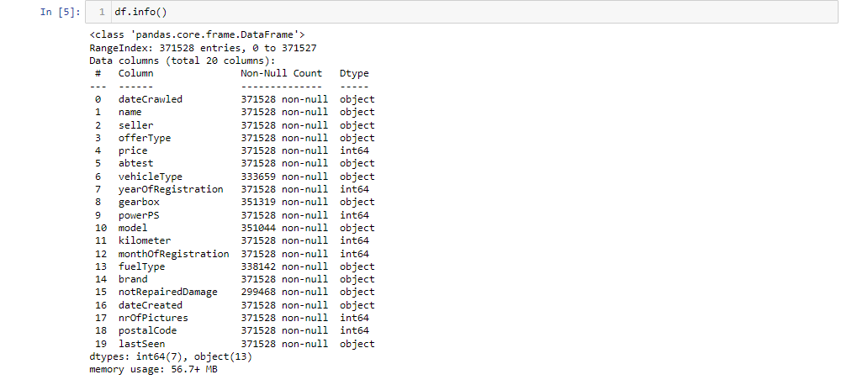
- The dataset consists of 20 columns, 13 columns contain data of object type, 7 columns are int64 type.

Raw Data before cleaning
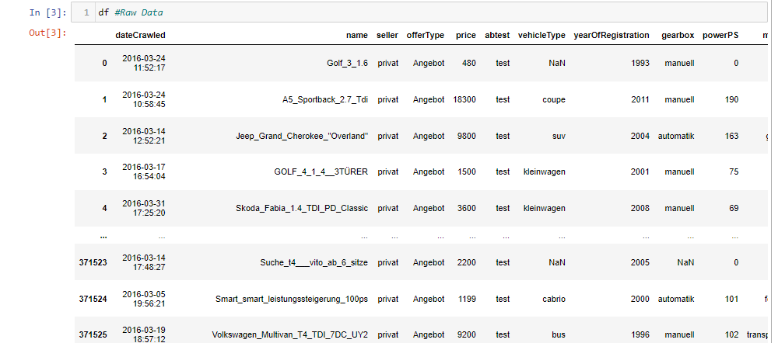

Translating German to English
We can also notice the above table that here some columns contain German words.
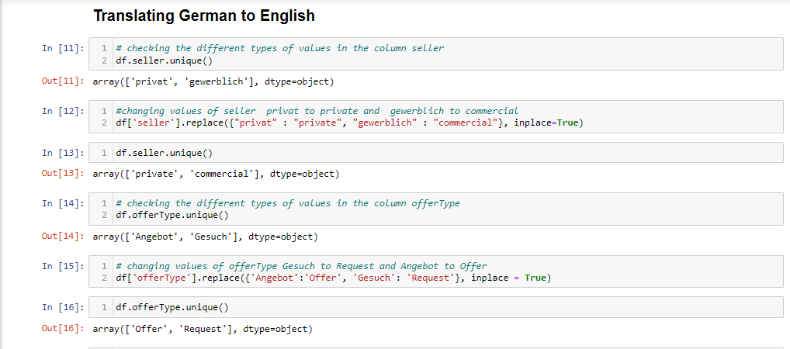
- For the convenience of the non-German speaking client I have translated German language to English language.
- Let's fix that here by taking a look in the distinct values in each one of those columns so we know what words we'll need to translate.
- Using unique() method I have pulled the unique German words and replaced it using replace() method and keep inplace equals to True, to update my dataset.

Updating date time
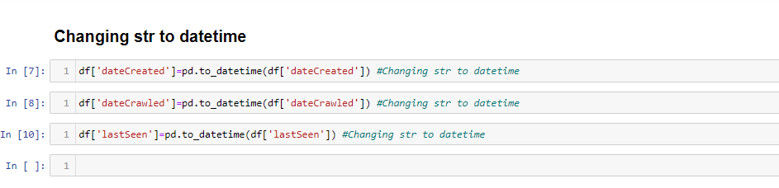
- I have converted all the date time columns from object dtype to datetime dtype

Removing Null values
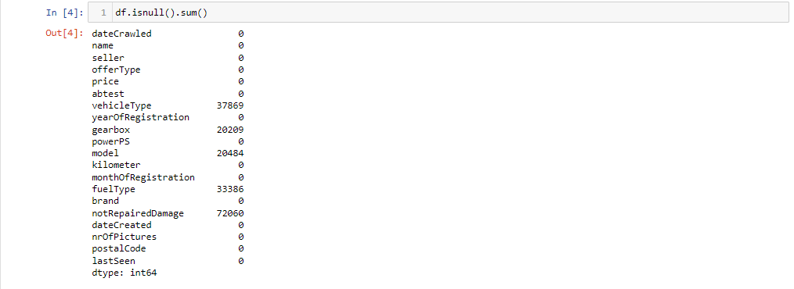

- Here we can see that the 5 columns have NULL values.
- And these 5 columns are categorical columns.

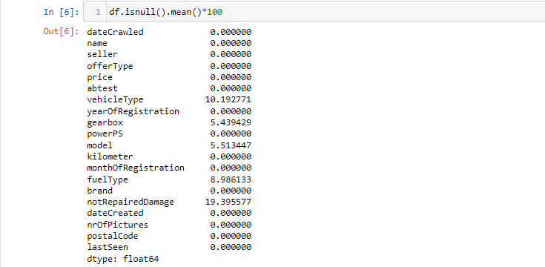

- None of these 5 columns has more than 20% of NULL values.

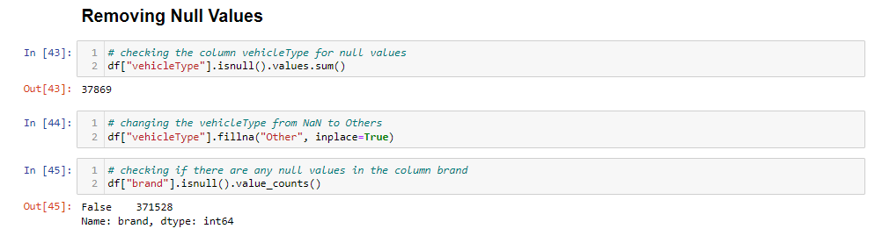
- I have used the following code to replace all the NULL values with fillna
- df["vehicleType"].fillna("Other", inplace=True)
- As it is a categorical column I have fill NULL value as other.

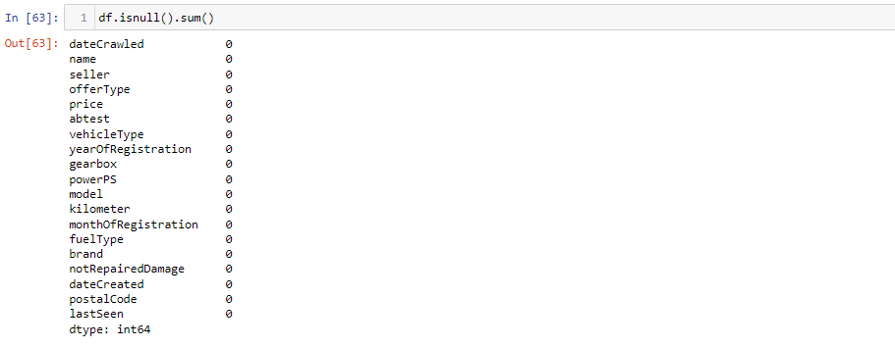

- After replacing the NULL values we can see that there is Zero NULL values present in the dataset.

Removing Duplicates
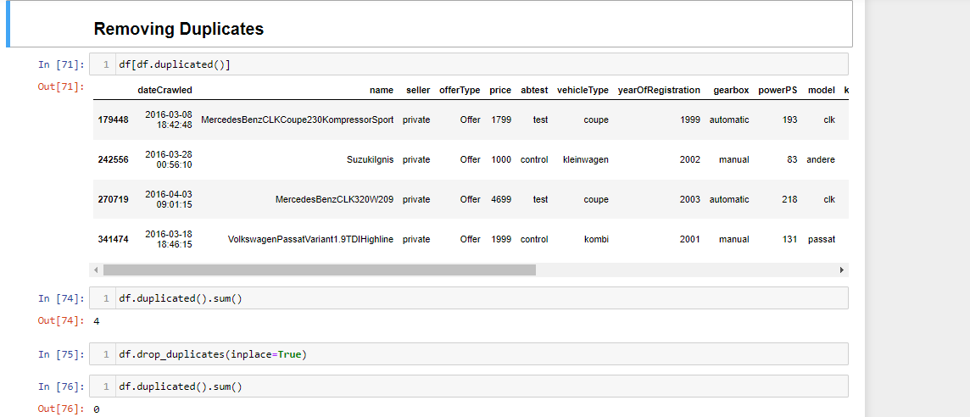
- There are 4 duplicates present in the dataset.
- We have drop the duplicates from the dataset.

Removing underscores
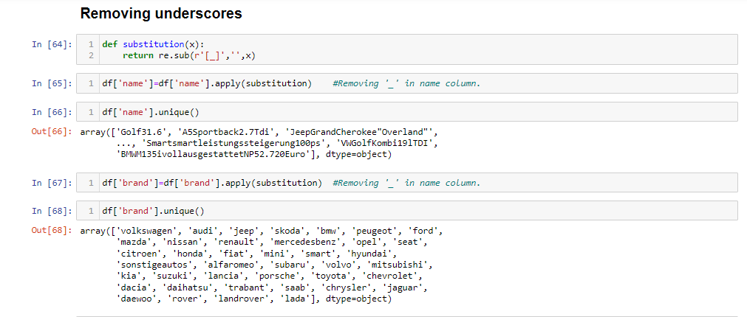
- I have used Regular Expression (Regex) to remove the underscores in the columns. I have used below code to remove the underscores.
- def substitution(x):
return re.sub(r'[_]','',x)

Clean data

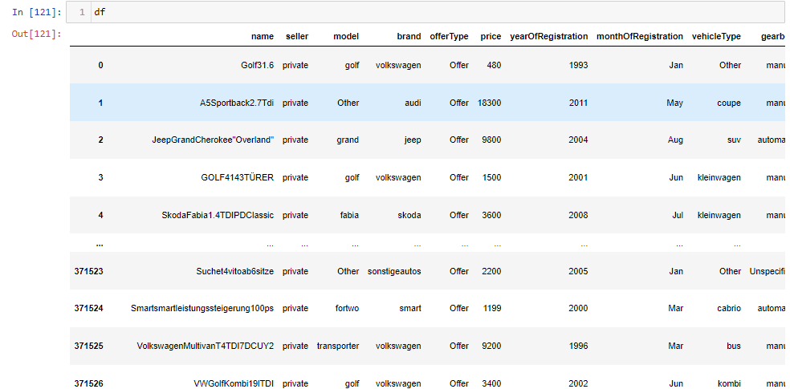

- After cleaning 371524 rows and 19 columns are there in the dataset.
- I have dropped 4 duplicate columns.
- I have dropped the num_of_pictures column. Since all of them are Zero.

- Can you tell me the Distribution of Vehicles based on Year of Registration with the help of a plot?

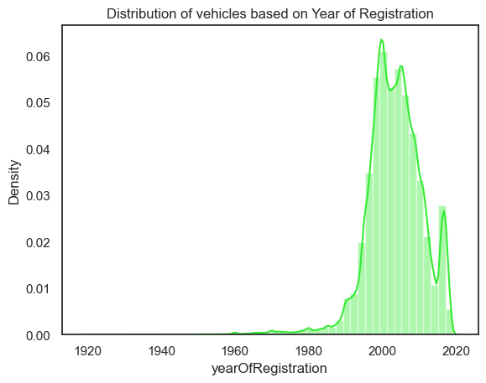
- The number of vehicles registered has increased rapidly since the 1960s.
- From the plot above we can see that the surge of cars is from the years 1990 to 2010.
- The cumulative density line reveals that by 2020, over 90% of vehicles had been registered in the previous 30 years.
- Overall, the visualization shows that the number of vehicles registered has increased steadily over period of time and that the fleet of vehicles on the road is relatively young.

3. Create a plot based on the Variation of the price range by the vehicle type.

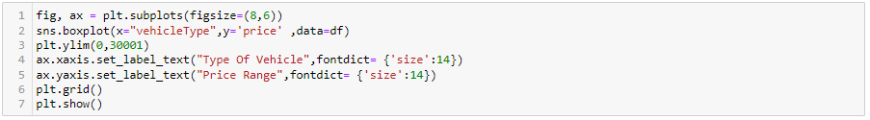
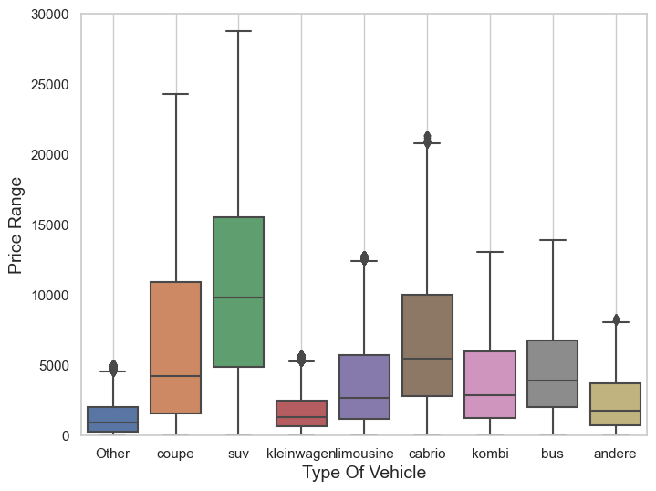

- The above bar graph shows the Average price of vehicles by vehicle types
- From the figure above, we can see, for example, that the median value of an SUV is 10,000, with most values between 5000 and 15000, and the maximum price is something close to 30,000.
- Also, we can see that excluding the other type, kleinwagen and andere are the types of vehicles with the lowest price range.

4. Find out Total count of vehicles by type available on eBay for sale. As well as create visualization for the client.

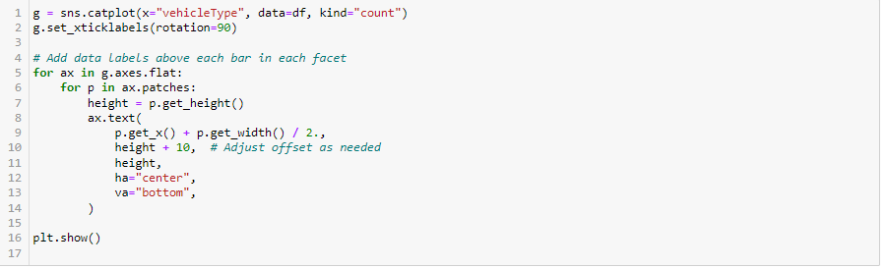

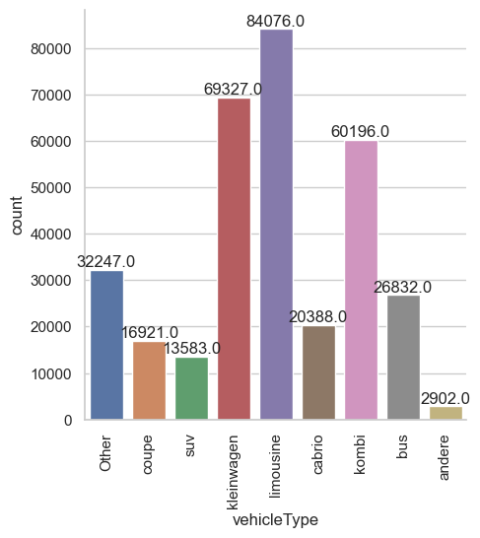

From the figure above, we can see that the “limousine” is the top type of car for selling, and the “andere” has the least amount of cars for sale.

5. is there any relationship between dollar_price and kilometer? (Explain with appropriate analysis)
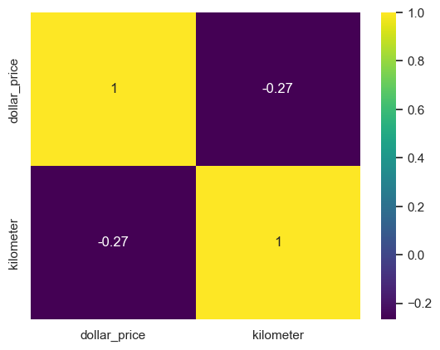

- The heatmap shows a slight negative correlation, which means that as the number of kilometers driven on a car increases, the price of the car tend to decrease.

- The correlation coefficient is -0.27, that there is a slight negative relationship between dollar_price and kilometer.
- The slight negative correlation suggests that mileage is an important factor to consider when pricing a used car.

