Analysis -2

- No of Vehicles by Brand Available on ebay for sale with the help of visualization.

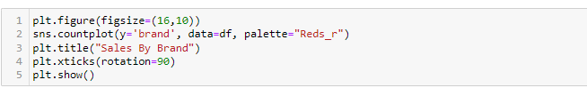

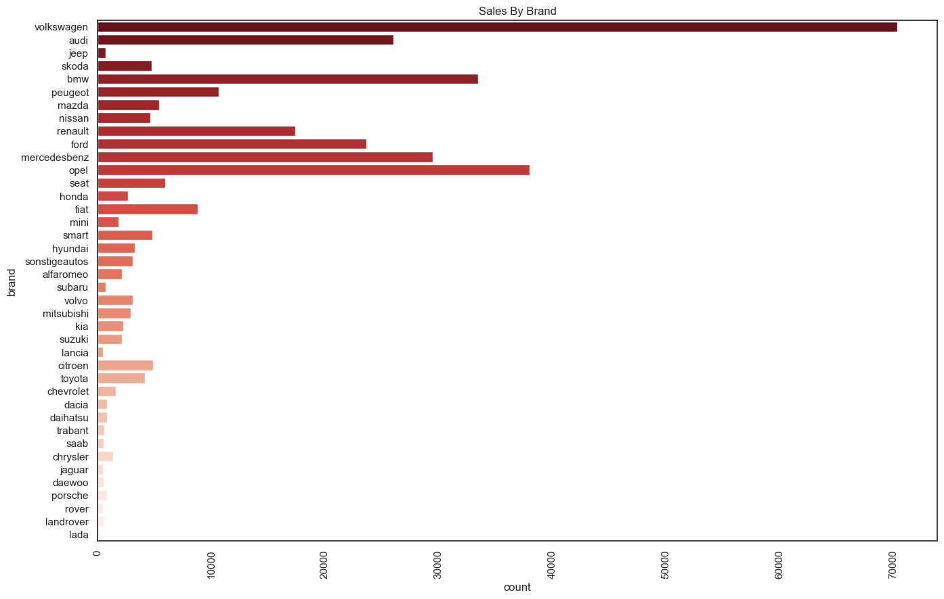
- From the above bar graph we can see the number of vehicles available on ebay based on the brand.
- As we can see the brand “Volkswagen” has the highest count as compared to other brands.
- And we can also interpret that the brand “lada” has the lowest count among all the brands.

What is the Average price for vehicles based on the type of vehicle as well as on the type of gearbox. Explain me with both numerical and visualization analysis.

NUMERICAL ANALYSIS

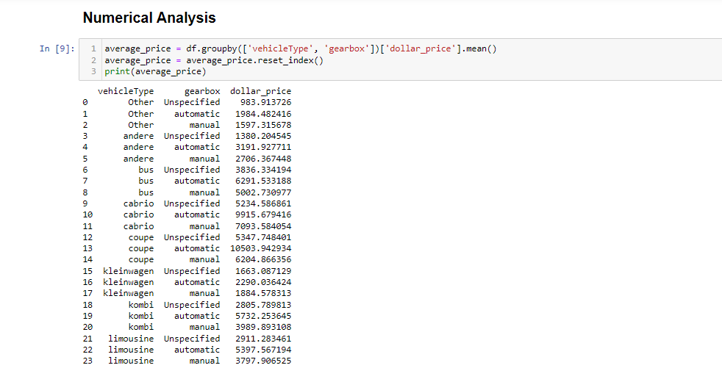

Using groupby() function i have grouped the vehicle type and gearbox and calculated the mean price for each group using mean() function.

The above numerical analysis shows the average price for each vehicle type based on the gear type.

VISUALIZATION ANALYSIS

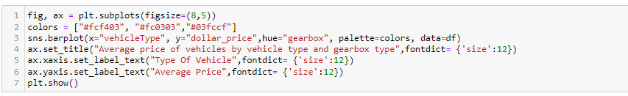

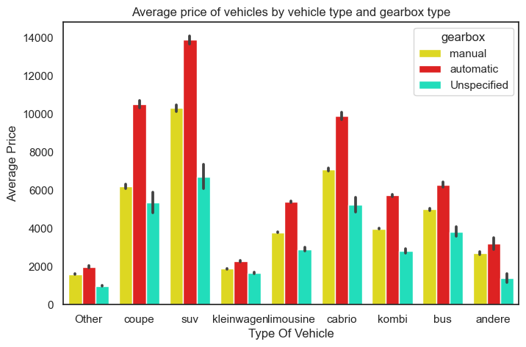

From the above visualisation we can see that the Average price of vehicles that has gearbox type Automatic, unspecified and Manual.

- We can see that the “SUV” type of vehicle shows the highest average price which has the gearbox type “automatic” compare to manual.

What is the marginal probability of private seller?

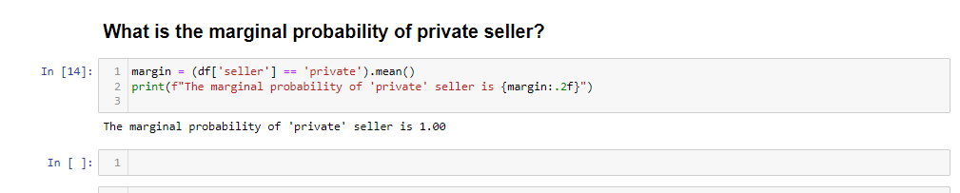

The marginal probability of a private seller being 1.00, suggests that private sellers are the dominant players in the vehicle market. This has a number of implications for both buyers and sellers.

