Analysis – 3
- The memory usage of the data is around 6.1 mb. How can we reduce the memory usage of the data set?
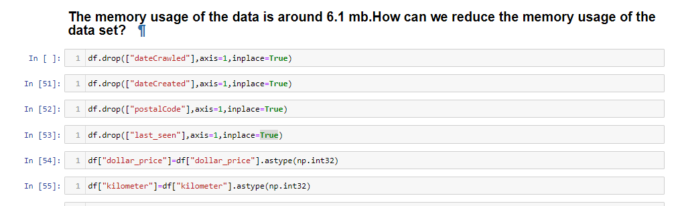

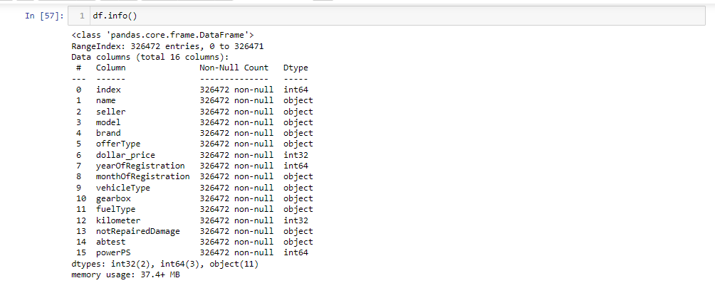

Here I have removed several columns from the "df" dataset using the `drop()` function with the `inplace=True` parameter. The columns being dropped are "num_of_Pictures", "date_crawled", "date_created", "postal_code", and "last_seen".
Then i have changed the data type of the "dollar_price", "kilometre” column using `astype()` from the NumPy library. And converted "price" and "kilometer" to `np.int32`. This helps optimize memory usage and ensures the data is stored in the appropriate format.
Finally, check the dataset's information with `df.info()` to get an overview of its structure.

What is the Average price of vehicle by fuel type and gearbox type.Give a plot.

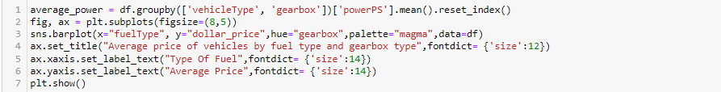
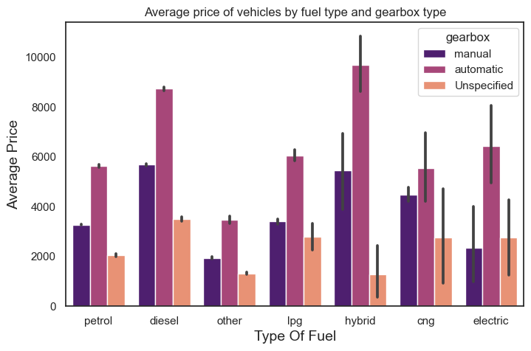

The above plot shows the average price of vehicles by vehicle type and gearbox type.

- From the plot, we see that hybrids and automatic cars have the higher average price.

- The plot also shows that vehicles with automatic gearboxes have higher average power than vehicles with manual gearboxes.

- What is the Average power of a vehicle by vehicle type and gearbox type? Give a plot.
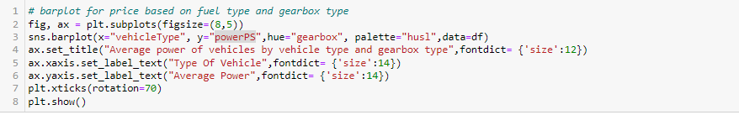
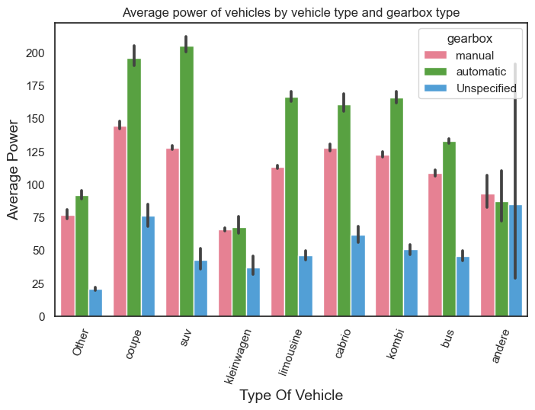

The above plot shows the average power of vehicles by vehicle type and gearbox type.
- The plot shows that the average power of vehicles with automatic gearbox is higher than that of vehicles with manual gearbox for all vehicle types.

- From the plot, we see that automatic SUVs cars have the higher average power.

- And kleinwagen is the least among all the vehicle type.

What is the Average price of a vehicle by brand as well as vehicle type? Use heatmap to explain this?

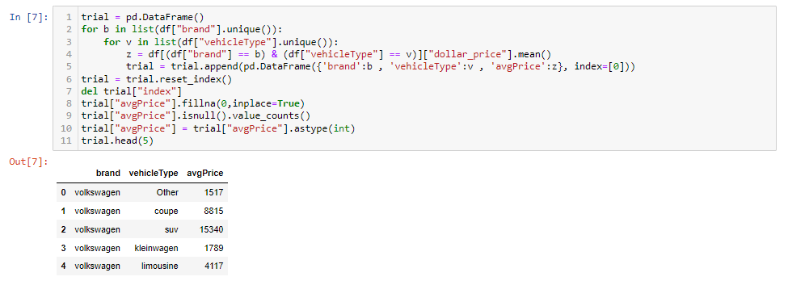

Visualization
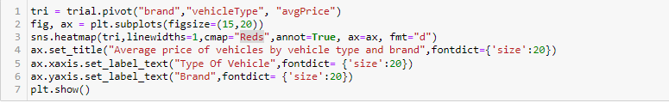

Heatmap for Average price of a vehicle by brand as well as vehicle type
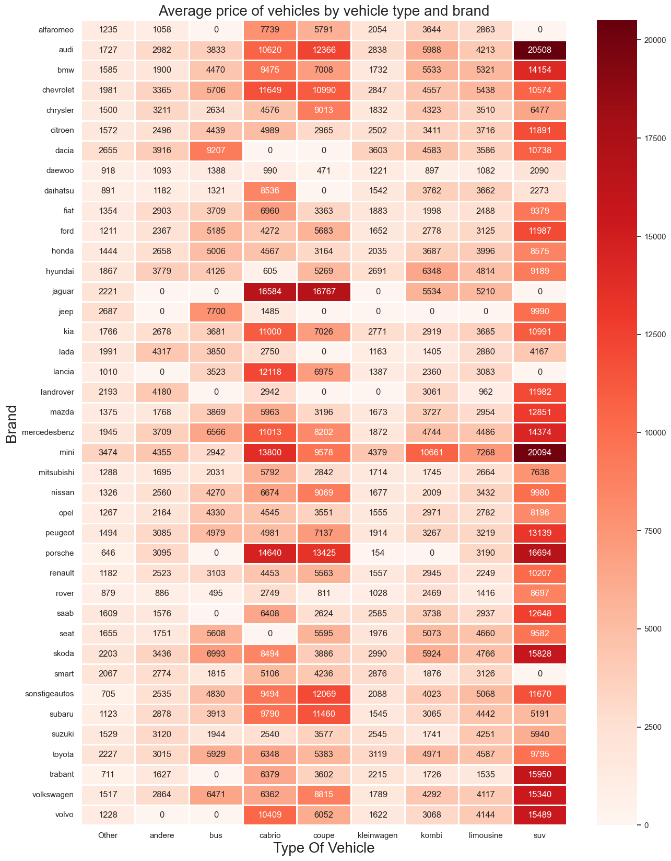
- From the heat map above we see that SUV by Audi has the higher average price.

- The heatmap shows the average price of a vehicle per brand and type of vehicle. The darker the colour of a cell in the heatmap, the higher the average price.

- The average price of a vehicle increases with the size and power of the vehicle.

