

**LA GRANDEE INTERNATIONAL COLLEGE**

**Simalchaur-8, Pokhara Nepal**

Internship Report on

**“Card Payment System Project ”**

Wow Finstack Nepal Pvt Ltd

Nayabazar, Pokhara

At Internship Report Submitted to Pokhara University in partial fulfillment of the requirement for the degree of

**Bachelor of Computer Application (BCA)**

**Submitted By:**

Sapna Baniya

PU Reg No: 2018-1-53-0129

BCA Seven (7th)

**Date: 2023-04-11**

# Declaration

I, hereby declare that the internship report entitled ‘An Internship Report On Card Payment System Project ’ submitted for the partial fulfillment of my BCA degree is my original work and the internship report has not formed the basis for the award of any degree, diploma, or other similar titles.

………………..

Name: Sapna Baniya

Date : 2023-04-11

# Acknowledgement

As per our course under the Pokhara University, I had completed internship in software development sector. During this period, I had got support from the different sectors. First of all, I would like to thank **Pokhara University** for making such fantastic curriculum for intership. Secondly, I would like to thank our BCA department of LGIC and BCA Program Coordinator **Mr. Ramesh Chalise** for supporting me in every steps of intern. Similarly, I would like to thank **Mr. Sujan Tamrakar, CEO of Wow Finstack Nepal Pvt Ltd** for providing us the suitable environment and guidance in web development.

At last, I am really grateful towards my college, teachers and my friends who helped me directly and indirectly during my intern period.

# Executive Summary

# The main aim of this internship is a partial fulfillment of the requirements for the degree of BCA Program at Pokhara University. Under the internship, I had chosen the web development sector.

# The internship helped me to improve my knowledge of web hosting, domain, web designing, code optimization, and testing, and learn new things, generate new ideas, and also the culture of the organization in professional life. It also enhanced my thinking about the quality of like coordination, teamwork, sincerity, and other qualities. All in all, it provided me with rich mines of knowledge and experience.

# During the internship, I worked on developing API for Acquirer Microservice of Card Payment System. This Acquirer System helps to create new merchants and acquirers in the Card Payment System. I also provide the merchant with detailed information about all his/ her logs and transaction logs. The acquirer can also create and manage new card types, connections, and new locations. They can keep track of different chargebacks and request the server for chargeback retrieval if they find it faulty. This system also generates different reports. Because of the internship, I am capable to do backend development, and web designing. During the internship, we were focused on Spring boot, Postgresql, and React.

# Table of Content

Declaration vi

Acknowledgement v

Executive Summary vi

Table of Content vii

List of Figures 5

Abbreviations 6

1. Introduction 1

2. Objectives 2

3. Overview of the Organization 3

3.1 Introduction of Organization 3

3.1.1 Mission, Vision and Objectives 4

3.2 Service Provided 4

3.3 Organizatinal Structure and Hierarchy 5

3.4 ICT Infrastructures used by the Organization 6

4. Overview of the Work Performed 7

4.1 Job Details 7

4.2 Work Assigned 7

5. Narrative 8

5.1 First Week: 8

5.2 Second Week: 8

5.3 Third Week: 8

5.4 Fourth Week: 8

5.5 Fifth Week: 9

5.6 Sixth Week: 9

6. Internship Activities 10

6.1 Core Theoretical Concept vs Practical Experience 10

6.2 Skills Learned During the Internship 10

6.3 Challenges faced during the internship 11

7. Conclusion 12

8.Future prospects and recommendation 12

9. References: 13

# List of Figures

Figure 3.1.1 Organization Map......................................................................................... 3

Figure 3.3.1 Organization Hierarchy....................................................................................5

Figure 3.4.1 Network Connection.......................................................................................6

# Abbreviations

API = Application Programming Interface

ASP = Active Server Page

BCA = Bachelor of Computer Application

CEO = Chief Executive Officer

CRM = Customer Relationship Management

CSS = Cascading Style Sheet

HTML = Hyper Text Markup Language

IT = Information Technology

LGIC = LA Grandee International College

VPN = Virtual Private Network

JS = Java Script

PU = Pokhara University

# Introduction

An internship is a short-term work experience provided by a company or organization to students or recent graduates who are seeking practical training in their field of study.

Internships can also provide students with valuable networking opportunities, references, and a better understanding of their chosen field. Many universities and colleges require or strongly encourage students to complete an internship as part of their academic program.There is no doubt that an internship deepens our knowledge and understanding of subject matters.

The organization where I worked as an intern was Wow Finstack Nepal Pvt Ltd founded in the year 2022 and is located in Nayabazar, Pokhara. It is a young technology company with a mature technology stack created by an experienced team of fintech experts. The company is focused with the aim to completely disrupt and reinvent the concept and practice of digital payments, along with other key areas of financial technology.

I worked with the part of the API Development team. This internship program provided me with a distinct platform to build a solid foundation for my career, understand the workplace culture, gain vital work-related experience and develop relevant skills. This report is a description of my 6 weeks internship carried out as a compulsory component of the course Bachelor in Computer Application (BCA). The following chapter details the tools and techniques used and an overview is given. Afterward, I explain my role and tasks as a trainee and give specific technical details about my main tasks.

# Objectives

During my internship, I have achieved the following objectives:

* For the partial fulfillment of the curriculum of Pokhara University
* To be civilized in the professional carrier
* To learn the behavior of the Organization as well as static and dynamic web pages
* To get involved in teamwork, software development, and social values
* To know and learn about different programming languages and databases and learn a new skill

# Overview of the Organization

## 3.1 Introduction of Organization

**WOW Finstack Nepal Pvt Ltd** is a growing company with the aim of taking the advantages of the emerging technologies in the sector of information technology. It is a young technology company with a mature technology stack created by an experienced team of fintech experts. It is making its entrance with a single-minded aim to completely disrupt and reinvent the concept and practice of digital payments, along with other key areas of financial technology.

It was established in 2022 and located in Nayabazar, Pokhara. There are altogether 17 staffs in this organization and Mr. Sujan Tamrakar is the CEO of the organization. The official website name is [www.wowfinstacknepal.com](http://www.wowfinstacknepal.com) and the email id is info@wowfinstacknepal.com.

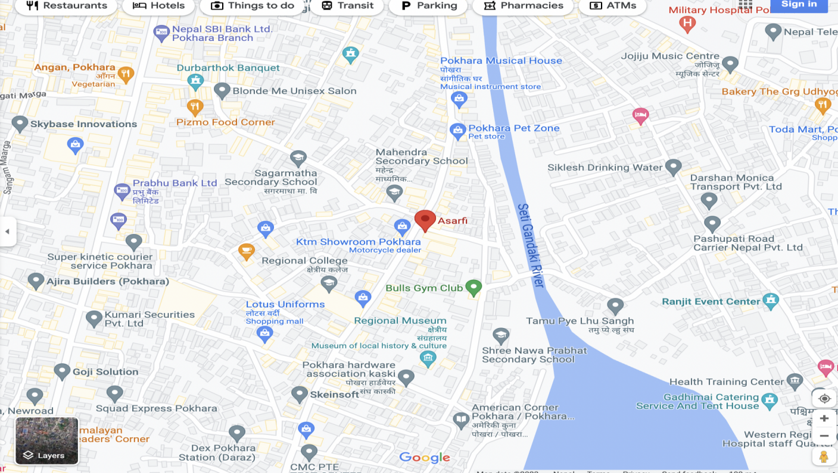

(Figure 3.1.1: Organization Map)

## Mission, Vision and Objectives

* to develop a comprehensive payments and transactional banking solution with tried and tested technology.
* allows bank and fintechs to choose the products that best service their customers
* offers an end to end solution that can be quickly and easily configured to support your specific needs.
* provide a holistic solution to manage your end-to-end payment offering.
* We ensure rapid setup and ease of implementation.

## 3.2 Service Provided

WOW Finstack Nepal Pvt Ltd offers solutions for Card (Debit/Credit/Prepaid) and eWallets Issuing, Acquiring, Payments, Onboarding KYC, and related services. It delivers cost-effective and quality web technology solutions to its prospective clients and maintains a good relationship with them.

## 3.3 Organizatinal Structure and Hierarchy

The WOW Finstack Nepal Pvt Ltd is aformal organization and it is autocratic and it also consists of free-rein leadership. The organizational structure of WOW Finstack Nepal is based on the Top Down approach. At the top of the organization, there is a CEO. Similarly, in the middle level, there is a supervisor. At the bottom, there is the low level technical and non-technical staff. The overall structure of the organization is shown below:

**CEO**

Project Manager

Supervisor

Front-end Developer

Software Support Head

Hardware Support

Back-end Developer

System analyst

(Figure 3.3.1: Organization Hierarchy)

## 3.4 ICT Infrastructures used by the Organization

WOW Finstack Nepal is a web technology service provider so it used various kinds of ICT infrastructures.

Name of the Computer used: Dell Laptops

Total no of computers used: 15

Operating system: Window 10

Computer for administrative purpose: 2

Network Connection Type: Vianet

Router used: Nokia

Network Topology: Star

Vianet

(ISP)

Printer

PC

PC

Router

Server

(Figure 3.4.1: Network Connection)

# Overview of the Work Performed

## 4.1 Job Details

I was involved in the modification of the old acquirer system and portal debugging task. During this period, I understood the basic structure and working flow of the organization structure and many more about the acquirer system. For the development of the system I used the resources available in the Postgresql DBMS and also the features available in the former Acquirer portal. My job was based on the knowledge and experience which I acquire from the college as well as the internet. At also from the training I obtained.

## 4.2 Work Assigned

During my internship period, my role was to develop API for the acquirer system and also to debug the old portal of the acquirer system. I developed the system by using Spring Boot and for the database I used Postgresql. While doing the unit test of the API, I used JUnit and Mockito. While facing problems in the system, I had taken help from my supervisor as well as my senior developer and also from the internet. Similarly, during this period, I learned about the working mechanism of the ATM and CBS. My supervisor Mr. Sujan Tamrakar sir and Mr. Dilip Kumar Shrestha sir provided me with a lot of resources, guidance, and knowledge to build the system.

# Narrative

## First Week:

For the first week of the internship, it was mostly about getting familiar with building a website using a website builder software . During the first week of the internship, I got to learn about the working style of the organization. How the works are assigned etc.

* set up all the software used for the development purpose like Wireguard, orange, IntelliJ, etc.
* Exploring the old portal

## Second Week:

In the second week, I learned about Spring Boot and installed it on my laptop. After that, I started learning and analyzing the old Portal, the features of the system, the system flow, and more.

## Third Week:

Likewise, during the third week, I was almost familiar with my coordinator and my coworkers. Because of that, It became easy for me to ask any query with my co-worker if I had any. In the third week, I started my real work. I set up the system and started completing the task assigned by my supervisor.

## Fourth Week:

In the fourth week, I learned React JS. I started debugging the old portal which was in java and also continued developing API for the card processing system.

## Fifth Week:

My work with the spring boot continued during the fifth week. I learned to conduct testing using JUnit and Mockito and implemented it on my system.

## 5.6 Sixth Week:

We had a meeting with the CEO of WOW Finstack. At the meeting I presented my overall work done during my internship period.

# Internship Activities

## 6.1 Core Theoretical Concept vs Practical Experience

From my internship experience, I analyzed that there is a vast difference between our theoretical knowledge and practical knowledge. Only the knowledge received from the class is not sufficient to work in the real field. The theories and methods which are taught in our academic course are somehow used in the real field but they are not much help. I used different programming languages like Spring Boot, HTML, CSS, and Java, during my internship to complete the project. Similarly, I used the database concept that I had learned theoretically and also I learned how to handle and access the remote server, and networking which is also taught in college. So from my experience, I found that if we apply our theoretical knowledge practically it will be realistic and memorable.

# 6.2 Skills Learned During the Internship

## **Communication Skills:**

During my internship, I developed good communication skills by contacting and indulging with my co-wokers while working on projects and tasks. I learned how to communicate formally and from a business perspective view.

* **Problem Solving:**

I got to know that a task provided is similar to providing a problem along with the task that we eventually have to solve and a task solved could be counted as a problem solved. I learned how to deal with the problems and also I was able to gather some problem-solving skills during the time.

* **Some of the other skills include:**

• Analytical skills

• Interpersonal skills

• Organizational skills

* Programming skills

6.3 Challenges faced during the internship

There are many problems which I had faced during the development of this system. some of them are mentioned below:

* Slow Internet Service: Sometimes, due to slow internet , I was unable to get proper help during my need.
* I also faced some issues at the earlier phase while installing the software and wireguard.
* Another issue I faced was lack of sufficient knowledge. Only the knowledge I got in class was not sufficient to involve in real work.

# 7. Conclusion

The internship of 45 days was really interesting. It helped me to learn and understand different programming ideas, concepts and the real time work process. There were a lot of chances to implement theoritical knowledge in my real time work. This internship helped me to move a step forwards towards my carrier field and my goal to become a Software developer.

Facing day to day work challenges, achieving the objective of the project and learning new things and innovations every day was the best experience I got from my internship. I was able to complete intern of the BCA course. I was also able to get the knowledge about the culture of the organization

All in all the internship became the turning point of my life to uplift my career in IT field.

# 8.Future prospects and recommendation

This internship was fantastic and object-oriented. Due to the short internship period, I was unable to cover all the areas of the acquirer system. After completing my internship, I started working as a Junior Assistant Software Developer in the same company. I am planning to complete these sections which were incomplete during my internship. I also hope to learn more skills and develop more unique ideas on my job. I hope that the ideas and knowledge that I learned during this will be more valuable in my career.

# References:

[1] WOW Finstack Nepal

https://www.wowfinstack.com/

[2] Asarfi.live

https://asarfi.live/

[3] OrangeHRM for Attendance

https://www.orangehrm.com/

[4] Jira for task management

https://www.atlassian.com/software/jira

[5] Confluence for document Management

http://192.168.1.125:9091/login.action

[6] Swagger for API Management and Documentation

http://172.20.20.34:9096/swagger-ui.html#/

[7] Gitlab and Github

https://gitlab.com/

https://github.com/