PROJECT REPORT
Cloud-Based Static Website Deployment
Level 1 • Cloud Computing & DevOps Project
Submitted by: Sapna A

1. Project Overview
This project demonstrates deployment of a static website using GitHub Pages. The website uses HTML, CSS, and JavaScript, with source files maintained in a public GitHub repository. UptimeRobot monitors availability, and Google PageSpeed Insights was used for a performance and quality check.

2. Objectives
- Build and publish a static website.
- Store and manage source files in GitHub.
- Configure GitHub Pages to deploy from the main branch and repository root.
- Document deployment and verification with screenshots.
- Configure website availability monitoring.
- Run a PageSpeed Insights audit and record its results.

3. Technologies and Services
Technology / Service | Purpose
HTML | Website structure and content
CSS | Visual styling and layout
JavaScript | Client-side interactions
GitHub | Source-code repository
GitHub Pages | Static website hosting
UptimeRobot | Website availability monitoring
Google PageSpeed Insights | Website performance and quality audit

4. Repository and Deployment
GitHub repository: https://github.com/sapnaahamed23-hub/cognevance_static-website-deployment
Live website: https://sapnaahamed23-hub.github.io/cognevance_static-website-deployment/
The website source files (index.html, style.css, and script.js) are hosted in the GitHub repository. GitHub Pages is configured to deploy from the main branch and repository root (/(root)). The published website was opened manually and the user confirmed that it displayed correctly.
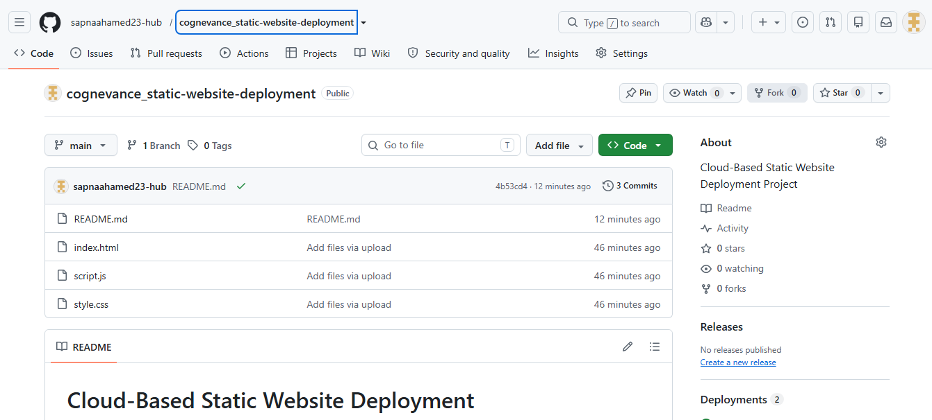
Figure 1: GitHub repository containing the website source files (github-repository.png)
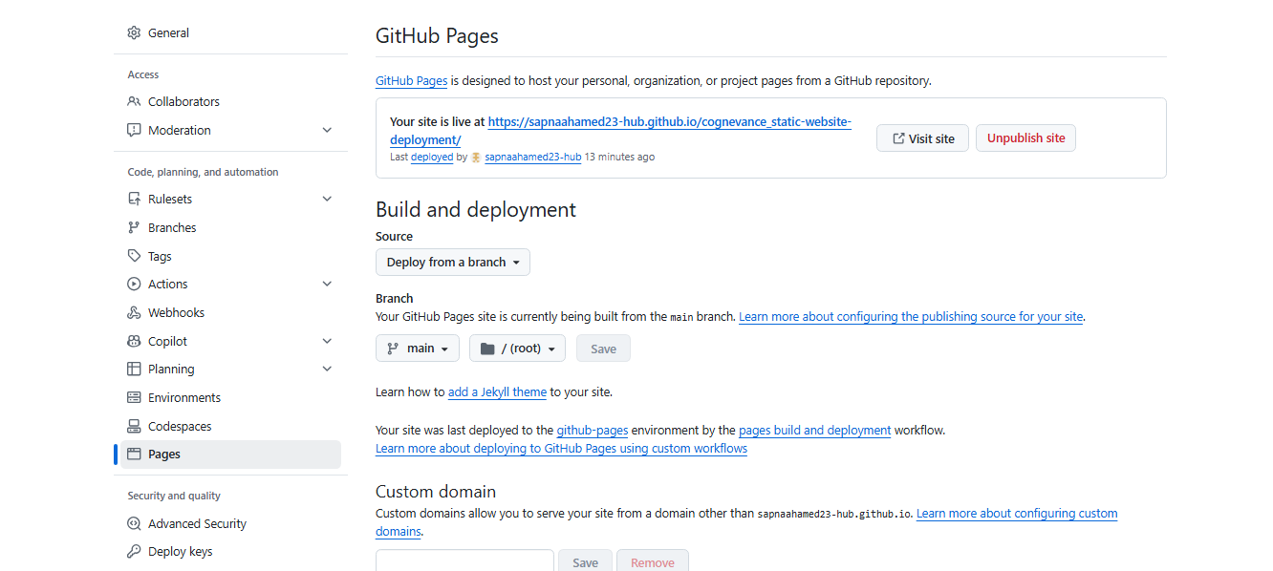
Figure 2: GitHub Pages settings showing the live site deployed from the main branch (root) (github-pages-deployment.png)

Figure 3: Published website – hero section (website-homepage1.png)

Figure 4: Published website – About and Toolkit sections (website-homepage2.png)

Figure 5: Published website – Projects, Contact and footer (website-homepage3.png)

5. Availability Monitoring
A Website Monitor was created in UptimeRobot for the deployed GitHub Pages URL. The dashboard subsequently displayed an 'Up' status. A screenshot was uploaded to the repository screenshots folder as uptime-monitoring.png. This is a point-in-time result and does not establish long-term uptime statistics.
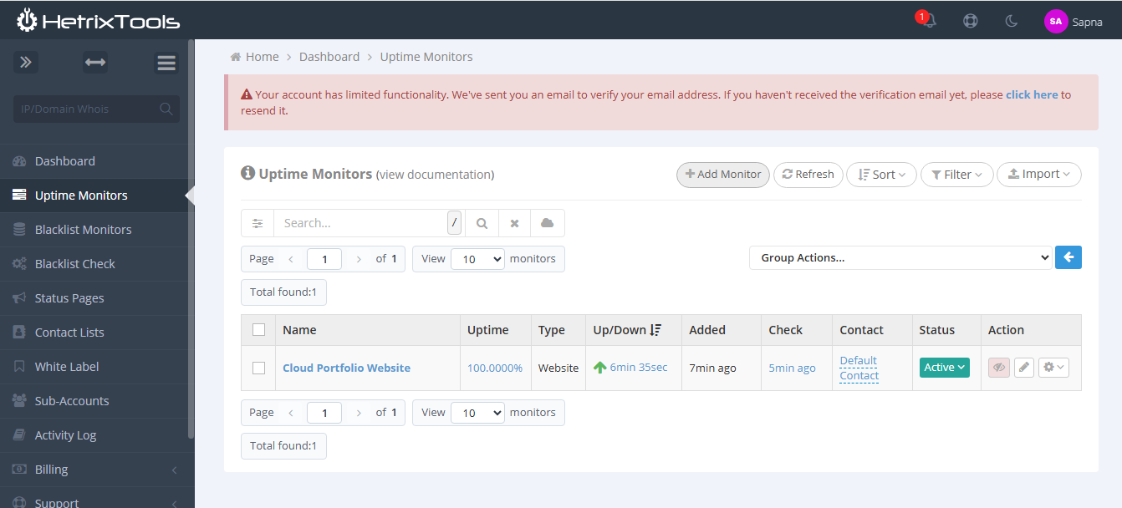
Figure 6: Uptime monitor showing Active status with 100% uptime (uptime-monitoring.png)

6. Performance and Quality Audit
Google PageSpeed Insights was run against the published website. The user reported scores of 100 in all four categories: Performance, Accessibility, Best Practices, and SEO. A screenshot was saved as pagespeed-insights-100.png and uploaded to the repository screenshots folder. Scores may vary between runs and between mobile and desktop testing environments.
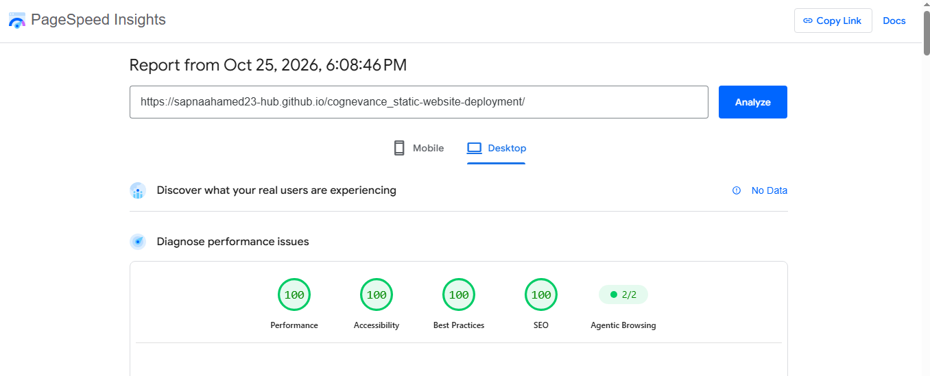
Figure 7: PageSpeed Insights (Desktop) scores of 100 in all categories (pagespeed-insights-100.png)

7. Evidence and Screenshots
The screenshots folder contains the following evidence files:
- github-pages-deployment.png
- github-repository.png
- website-homepage1.png
- website-homepage2.png
- website-homepage3.png
- uptime-monitoring.png
- pagespeed-insights-100.png
Screenshots folder: https://github.com/sapnaahamed23-hub/cognevance_static-website-deployment/tree/main/screenshots

8. Testing and Verification
- The published website was opened manually and confirmed to load correctly.
- The user checked the website on an Android phone and reported no horizontal scrolling.
- The website URL was confirmed to use HTTPS.
- UptimeRobot displayed an 'Up' status.
- The user reported PageSpeed Insights scores of 100 in all four categories.
For repeatable documentation, retain the audit screenshot and note whether the test was run for mobile or desktop. Further browser/device testing may be performed if required by the evaluator.

9. Security and Limitations
The published site is served over HTTPS by GitHub Pages. It is a static website and does not require a server-side application or database. No custom domain has been configured as part of the work documented here. Uptime status and PageSpeed scores are snapshots from the time of testing, not guarantees of continuous availability or identical future scores.

10. Conclusion
The project demonstrates publishing a static website using GitHub Pages, maintaining source files in GitHub, collecting screenshots as evidence, configuring a basic availability monitor, and auditing the site with PageSpeed Insights. It provides a foundation for future cloud and DevOps work, including automated deployment pipelines and infrastructure automation.

11. Submission Links
Repository: https://github.com/sapnaahamed23-hub/cognevance_static-website-deployment
Live deployment: https://sapnaahamed23-hub.github.io/cognevance_static-website-deployment/
Screenshots: https://github.com/sapnaahamed23-hub/cognevance_static-website-deployment/tree/main/screenshots

