SQL Queries

create database coffee_shop_sales_db database created

I used SQL Server Management Studio’s Import Flat File wizard. It automatically read the CSV file, inferred the schema, created a new table in the database, and loaded the data into it.

Checked the Meta Data of the table to check the data type detection:
exec sp_help 'dbo.coffee_shop_sales'

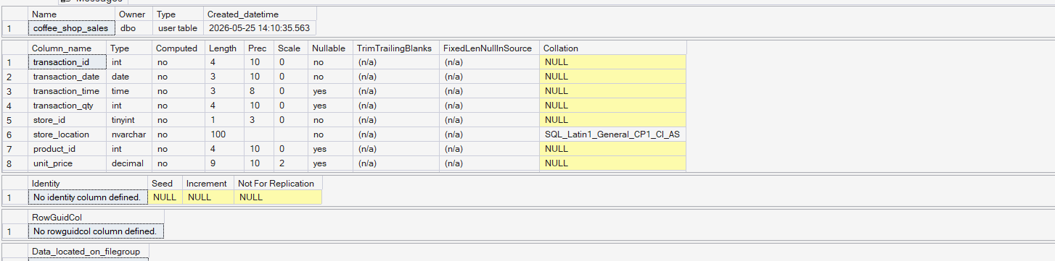

Fixed the column data and data type.
-- update the date column to hh-mm-ss--
UPDATE dbo.coffee_shop_sales
SET transaction_time = CONVERT(TIME(0), transaction_time)
-- change the data type fo the transaction_time column--
ALTER TABLE dbo.coffee_shop_sales
ALTER COLUMN transaction_time TIME(0)

--Change the data type of transaction_qty to INT from tiny int--
ALTER TABLE dbo.coffee_shop_sales
ALTER COLUMN transaction_qty INT

-- changed the data type of unit_price to decimal from float--
ALTER TABLE dbo.coffee_shop_sales
ALTER COLUMN unit_price Decimal (10,2)

-- changed the data type of product_id to decimal from float--
ALTER TABLE dbo.coffee_shop_sales
ALTER COLUMN product_id INT

- Total Sales:
SELECT
CONCAT(ROUND(SUM(unit_price * transaction_qty) / 1000, 0),'K') AS Total_Sales
FROM coffee_shop_sales
WHERE MONTH(transaction_date) = 4;

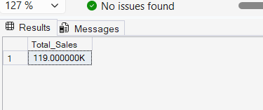

2 SQL query to find difference from the previous month and MOM growth in sales for the selected month:

WITH Monthly_Sales AS
(SELECT
MONTH(transaction_date) AS Month_Number,
ROUND(SUM(unit_price * transaction_qty), 0) AS Total_Sales
FROM coffee_shop_sales
WHERE MONTH(transaction_date) IN (3, 4)
GROUP BY MONTH(transaction_date)
)

SELECT
Month_Number,
Total_Sales,
-- Difference from Previous Month--
ROUND(Total_Sales - LAG(Total_Sales, 1) OVER (ORDER BY Month_Number),2) AS Month_Sales_Difference,
-- MoM Percentage Growth--
ROUND((Total_Sales -LAG(Total_Sales, 1) OVER (ORDER BY Month_Number))/CAST(
LAG(Total_Sales, 1) OVER (ORDER BY Month_Number)AS FLOAT) * 100,2) AS MoM_Sales_Growth_Percentage

FROM Monthly_Sales
ORDER BY Month_Number;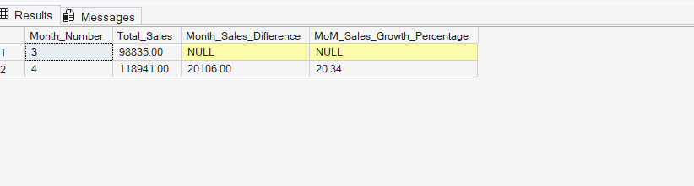

3. Total Orders
SELECT
COUNT(transaction_id) AS Total_Orders
FROM coffee_shop_sales
WHERE MONTH(transaction_date) = 4; -- April

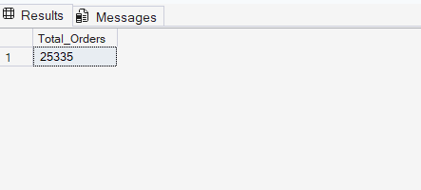

4. SQL query to find difference from the previous month and MOM growth in Orders for the selected month:

WITH Monthly_Orders AS
(SELECT
MONTH(transaction_date) AS Month_Number,
COUNT(transaction_id) AS Total_Orders
FROM coffee_shop_sales
WHERE MONTH(transaction_date) IN (3, 4)
GROUP BY MONTH(transaction_date)
)

SELECT
Month_Number,
Total_Orders,

-- Order Difference from Previous Month
Total_Orders - LAG(Total_Orders, 1) OVER (ORDER BY Month_Number)
AS Difference_From_Previous_Month,
-- MoM Order Growth Percentage--
ROUND((Total_Orders -LAG(Total_Orders, 1) OVER (ORDER BY Month_Number))/
CAST(LAG(Total_Orders, 1) OVER (ORDER BY Month_Number)AS FLOAT) * 100,2) AS MoM_Order_Growth_Percentage
FROM Monthly_Orders;

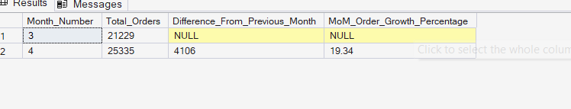
5. Total Orders:
SELECT
SUM(transaction_qty) AS Total_Quantity_Sold
FROM coffee_shop_sales
WHERE MONTH(transaction_date) = 4; -- April

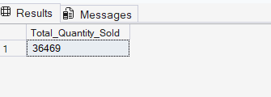

6. SQL query to find difference from the previous month and MOM growth in Total Quanity Sold for the selected month:

WITH Monthly_Quantity_Sold AS
(SELECT
MONTH(transaction_date) AS Month_Number,
SUM(transaction_qty) AS Total_Quantity_Sold
FROM coffee_shop_sales
WHERE MONTH(transaction_date) IN (3, 4)
GROUP BY MONTH(transaction_date)
)

SELECT
Month_Number,
Total_Quantity_Sold,

-- Quantity Difference from Previous Month
Total_Quantity_Sold - LAG(Total_Quantity_Sold, 1) OVER (ORDER BY Month_Number) AS Difference_From_Previous_Month,

-- MoM Quantity Growth Percentage
ROUND((Total_Quantity_Sold - LAG(Total_Quantity_Sold, 1)OVER (ORDER BY Month_Number))/
CAST(LAG(Total_Quantity_Sold, 1)OVER (ORDER BY Month_Number)AS FLOAT) * 100,2) AS MoM_Quantity_Growth_Percentage

FROM Monthly_Quantity_Sold;

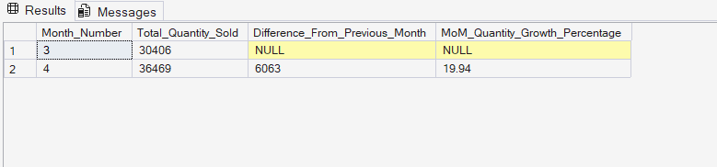

7. Return KPI Values for a specific date for Calendar Heat Map’s Tooltip
SELECT
SUM(unit_price * transaction_qty) AS Total_Sales,
SUM(transaction_qty) AS Total_Qty_Sold,
COUNT(transaction_id) AS Total_Orders
FROM coffee_shop_sales
WHERE transaction_date = '2025-04-18';

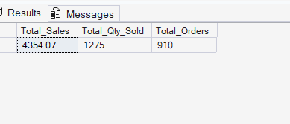

8. Total Sales Analysis for Weekdays and Weekends;

SELECT
CASE WHEN DATEPART(WEEKDAY, transaction_date) IN (1, 7) THEN 'Weekends'
ELSE 'Weekdays'
END AS day_type,
SUM(unit_price * transaction_qty) AS Total_Sales
FROM coffee_shop_sales
WHERE MONTH(transaction_date) = 4 -- April
GROUP BY
CASE WHEN DATEPART(WEEKDAY, transaction_date) IN (1, 7) THEN 'Weekends'
ELSE 'Weekdays'
END;
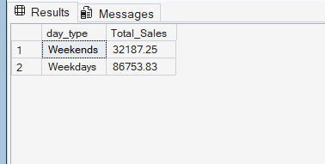

9. Total Sales Analysis by store location:

SELECT
store_location,
SUM(unit_price * transaction_qty) AS Total_Sales
FROM coffee_shop_sales
WHERE MONTH(transaction_date) = 4 -- April
GROUP BY store_location
ORDER BY Total_Sales DESC;

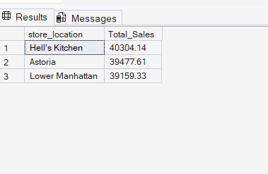

10. Daily sales calculation for the selected month:
SELECT
transaction_date,
SUM(unit_price * transaction_qty) AS Total_Sales
FROM coffee_shop_sales
WHERE MONTH(transaction_date) = 4
GROUP BY transaction_date
ORDER BY transaction_date;

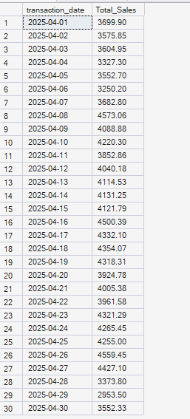
11. Average Daily Sales:
SELECT
ROUND(AVG(Daily_Sales), 2) AS Average_Daily_Sales
FROM (
SELECT
transaction_date,
SUM(unit_price * transaction_qty) AS Daily_Sales
FROM coffee_shop_sales
WHERE MONTH(transaction_date) = 4
GROUP BY transaction_date
) AS DailyTable;

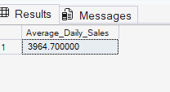

12. Compare daily sales with overall average:
WITH DailySales AS (
SELECT
CAST(transaction_date AS DATE) AS day_of_month,
SUM(unit_price * transaction_qty) AS total_sales,
AVG(SUM(unit_price * transaction_qty)) OVER () AS avg_sales
FROM coffee_shop_sales
WHERE MONTH(transaction_date) = 4
GROUP BY CAST(transaction_date AS DATE)
)

SELECT
day_of_month,
total_sales,
avg_sales,
CASE
WHEN total_sales > avg_sales THEN 'Above Average'
WHEN total_sales < avg_sales THEN 'Below Average'
ELSE 'Equal to Average'
END AS sales_status
FROM DailySales
ORDER BY day_of_month;
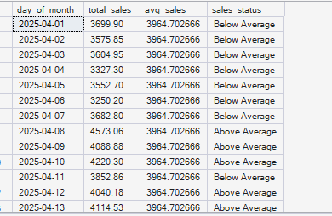

13. Sales by Product Category:
SELECT
product_category,
SUM(unit_price * transaction_qty) AS Total_Sales
FROM coffee_shop_sales
WHERE MONTH(transaction_date) = 4
GROUP BY product_category
ORDER BY Total_Sales DESC;

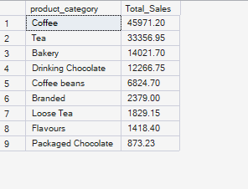

14. Top 10 Product Type by Total Revenue:
SELECT TOP 10
product_type,
SUM(unit_price * transaction_qty) AS Total_Sales
FROM coffee_shop_sales
WHERE MONTH(transaction_date) = 4
AND product_category = 'Coffee'
GROUP BY product_type
ORDER BY Total_Sales DESC;

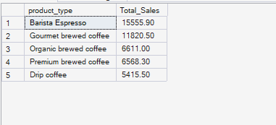

15. Calculation for Heat Map Tooltip( hours and day context)

SELECT
SUM(unit_price * transaction_qty) AS Total_Sales,
SUM(transaction_qty) AS Total_Qty_Sold,
COUNT(*) AS Total_Orders
FROM coffee_shop_sales
WHERE MONTH(transaction_date) = 4
AND DATEPART(WEEKDAY, transaction_date) = 2 -- Monday
AND DATEPART(HOUR, transaction_time) = 8;
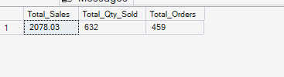

16. Total Sales for peak business hours
SELECT
DATEPART(HOUR, transaction_time) AS hour_of_day,
SUM(unit_price * transaction_qty) AS Total_Sales
FROM coffee_shop_sales
WHERE MONTH(transaction_date) = 5
GROUP BY DATEPART(HOUR, transaction_time)
ORDER BY hour_of_day;

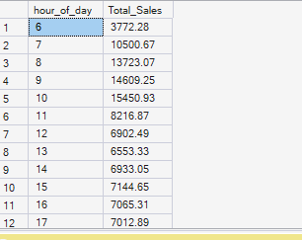

17. Helps to find the total sales for each day of the week for the selected month

SELECT
DATENAME(WEEKDAY, transaction_date) AS Day_of_week,
DATEPART(WEEKDAY, transaction_date) AS Day_Number,
SUM(unit_price * transaction_qty) AS Total_Sales
FROM coffee_shop_sales
WHERE MONTH(transaction_date) = 4
GROUP BY
DATENAME(WEEKDAY, transaction_date),
DATEPART(WEEKDAY, transaction_date)
ORDER BY Day_Number;
