* Like in local.conf we provide the configuration info of themachine, distro, pkgs, image_name etc, in the bblayers.conf file we tell poky where our layers are present
* So layer is a collection of meta-data that provides configuration information like recipes
* And recipes are instruction file on how to build packages, it provides instruction of what exactly to do, whether it is to featch some code, or configure so parameters, or install some packages or remove some packages or apply patch to a certain recipe file, we do all of this in the recipe file
* BBLAYERS ?= " \
* ${TOPDIR}/../poky/meta \
* ${TOPDIR}/../poky/meta-poky \
* ${TOPDIR}/../poky/meta-yocto-bsp \
* ${TOPDIR}/../meta-openembedded/meta-oe \
* ${TOPDIR}/../meta-openembedded/meta-networking \
* ${TOPDIR}/../meta-openembedded/meta-filesystems \
* ${TOPDIR}/../meta-openembedded/meta-perl \
* ${TOPDIR}/../meta-openembedded/meta-python \
* ${TOPDIR}/../meta-virtualization \
* ${TOPDIR}/../meta-freescale \
* ${TOPDIR}/../meta-alb \
* ${TOPDIR}/../meta-bosch \
* ${TOPDIR}/../meta-gplv2 \
* "
* The naming for a layer is to start with meta, so if you want to create a layer you name it as meta-<layer-name>
* To write a recipe also there is a naming convention, so you name the folder name inside which you will have recipes as recipes-<name> like recipes-images, recipes-bsp, recipes-kernel
* 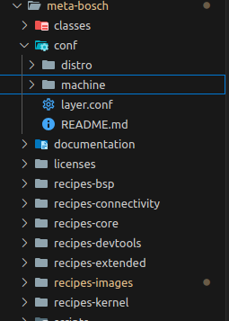
* The extension of a recipe file is .bb
* To check will all layers are already built in our repo run
* 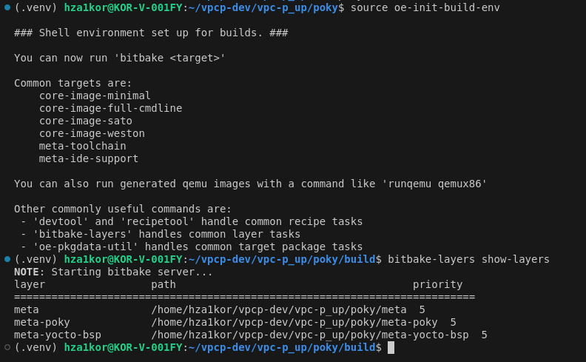
* If you want to add a new layer, you can either manually add it in the bblayers.conf file or bitbake-layers add-layer <path-to-layer>
* To remove a layer either you can manually remove it from the bblayers.conf file or run bitbake-layers remove-layer <path-to-layer>