* To create a new meta layer you can just run
* 
* To add the meta-sapna layer
* 
* Now the bblayers.conf file looks like this
* 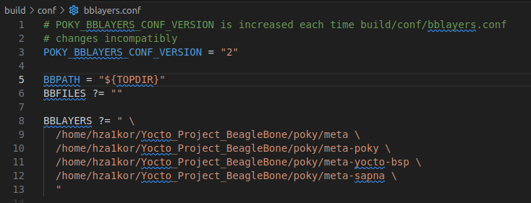
* To see all the layers currently present
* 