DIFFERENT TYPES OF VARIABLE ASSIGNMENT

* ?= : This is used to assign a default value to a variable. It can be overridden.
* ??= : This is also used to assign a default value to a variable. It is considered weak assigned. It can be overridden. If we have multiple ?= kind of assignments, then the first assignment will be considered whereas for ??= if there are multiple assignments, then the last assignment will be considered
* 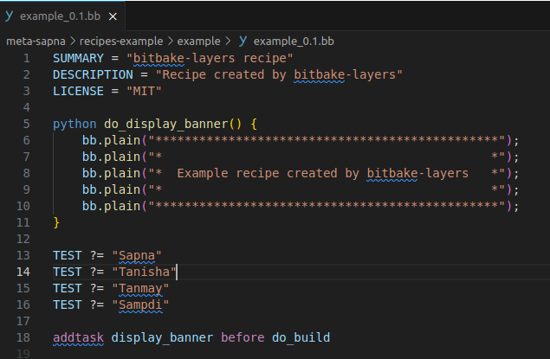
* 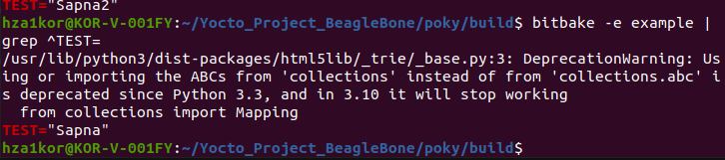
* Using ??=
* 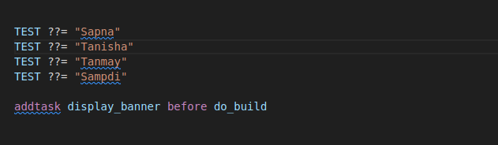
* 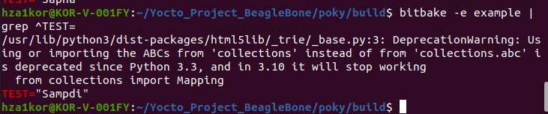
* Between ??= and ?= , ?= has a higher priority then ??=
* 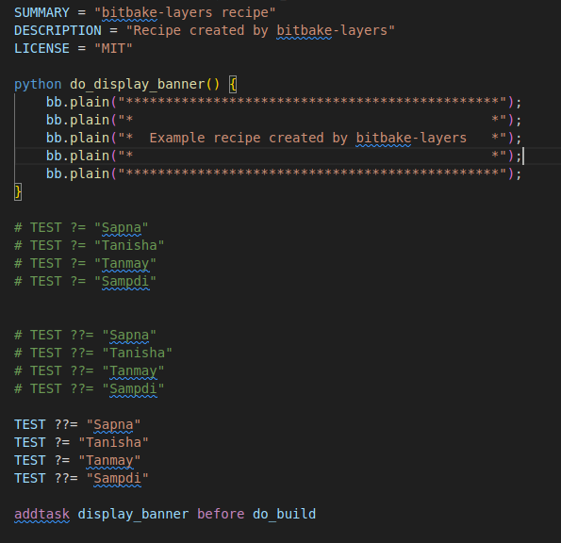
* 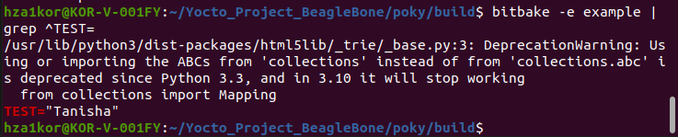
* Difference between = and ?=
* = is a simple variable assignment. It requires “” and spaces are significant. But variables are expanded at the end
* Eg – A ?= “FOO”
* A = “BAR”
* Now the value of A is “BAR”
* Eg2 – A = “BOO”
* B = “${A}”
* A = “BRO”
* Now the value of B is “BRO” because for = variable assignment is done in the end
* = : This is a simple variable assignment. It requires “ “ and spaces are significant. But variables are expanded in the end
* := : This is an immediate variable expansion. The value assigned is expanded immediately
* In the next test bw ?= and := ?= does expansion at the end whereas := is an immediate assignment
* So for A ?= “FOO”
* A := “Hello”
* Now A will be “Hello”
* Eg3 - A = “BOO”
* B := “${A}”
* A = “BRO”
* Now B will be BOO
* += : This appends a value to a variable. The operator inserts a space between the current value and the appended value. It takes effect immediately
* A = “Sapna”
* A += “Tanmay”
* A += “Tanisha”
* Now A will be “Sapna Tanmay Tanisha”
* A ?= “Sapna”
* A += “Tanmay”
* A += “Tanisha”
* Now A will be “Sapna Tanmay Tanisha”
* =+ : This prepends a value to a variable. The operator inserts a space bw the current value and the prepended value, It takes effect immediately
* A = “Sapna”
* A = +“Tanmay”
* A = +“Tanisha”
* Now A is “Tanisha Tanmay Sapna”
* .= : This appends a value to a variable. The operator inserts no space between the current value and the appended value. It takes effect immediately
* A = “Sapna”
* A .=“Tanmay”
* A .=“Tanisha”
* Now A will be SapnaTanmayTanisha
* =. : This prepends a value to a variable. The operator inserts no space bw the current value and the prepended value, It takes effect immediately
* A = “Sapna”
* A =. “Tanmay”
* A =. “Tanisha”
* Now A will be TanishaTanmaySapna
* :append : This appends a value to a variable. The operator inserts no space bw the current value and the appended value. The effects are applied at variable expansion time rather than being immediately applied
* :prepend : This prepends a value to a variable. The operator inserts no space bw the current value and the appended value. The effects are applied at variable expansion time rather than being immediately applied
* :remove : This removes values from lists. Specifying a variable for removal causes all occurrences of that value to be removed from the variable