**LINUX DIRECTORY STRUCTURE**

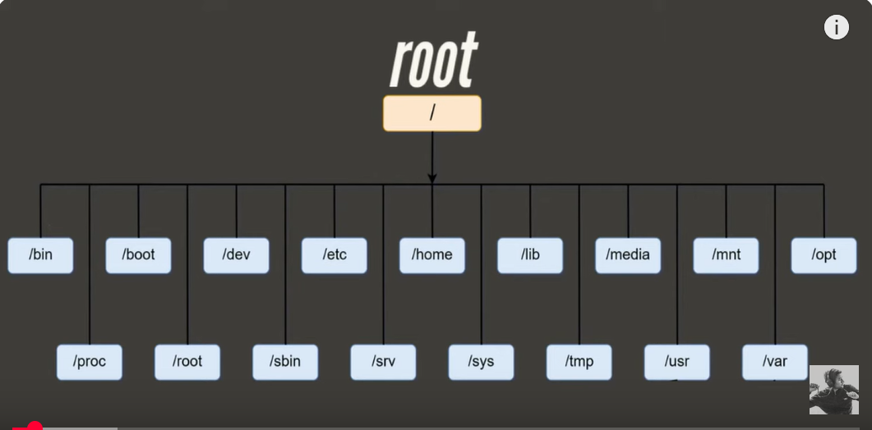

* In linux we say directories, in windows we say folders
* / (forward slash) is the base points, from here all the directories will start. This is called as root
* 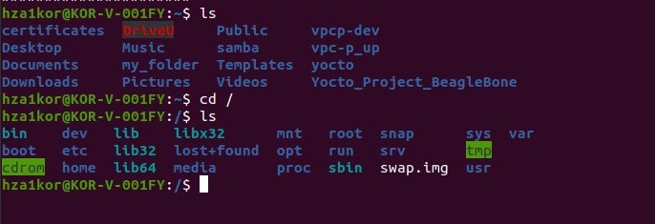
* Here ~ is for home directory
* And / is for root directory
* Only the root user can do changes in the / root directory
* Say I want to add a file in the root directory as a regular user I wont be able to do it, I should switch to super/ root user for that
* Or u can run sudo touch 1.txt
* 
* 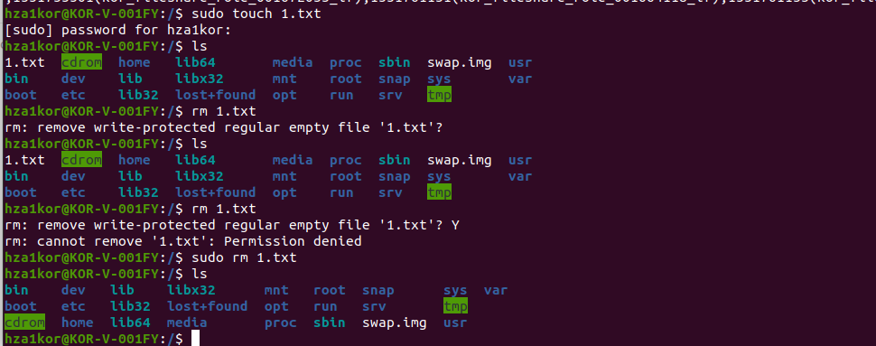
* In the file heirarachy we also have a root directory, this root directory is the home directory for the root user
* 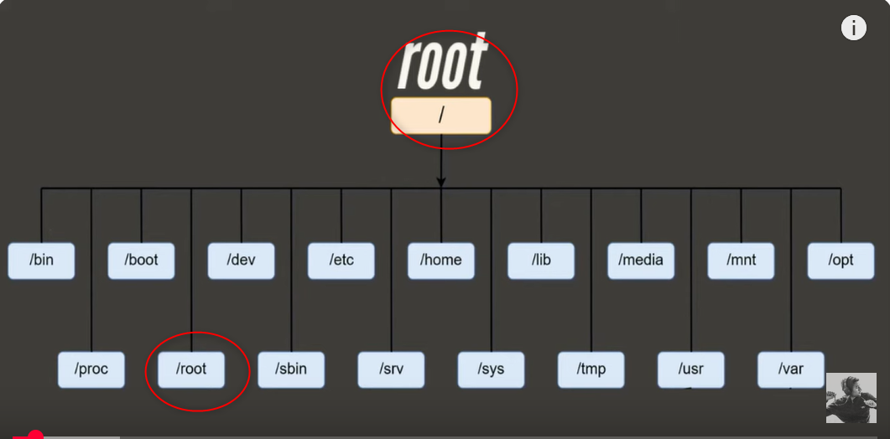
* /home directory – Every user will have its own home directory, which will have his/hers files folders, data, these are separate for each user
* /bin directory – this directory has all the commands needed to run a system used for both privileged and non-privileged users
* /sbin (system binaries) directory – this directory has all the commands needed by the administrator. To run these commands you have to be the root user. These binaries are used for2 major reasons – to do some major changes in the configuration files, or for system maintenance. Eg – ifconfig, adduser, fsck, ethtool, grub-install, deluser
* /proc (process information) directory – When we run any application, or system is running, processors are being used, kernel information are all present in this directory
* 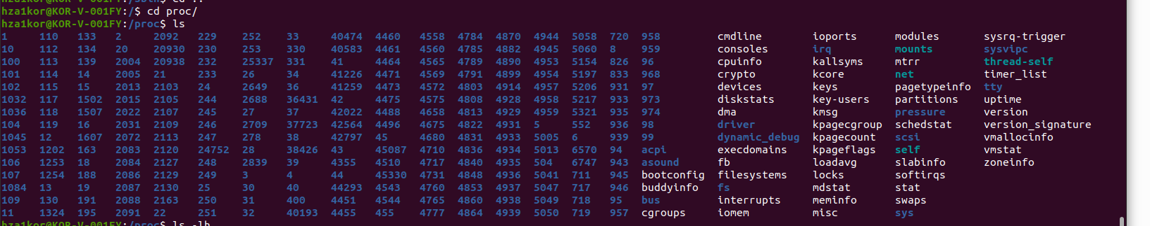
* All these numbers are actually process id’s for programs that are running
* You can get details on cpu info like no of processors, for meminfo we get details on memory like total memory, free memory etc
* /boot directory – whenever our system gets on, and the os is called in the memory, then all the related files will be saved in the boot folder, because when kernel runs anything it follows some steps and those processes are saved inside this
* 
* /dev (device files) directory – in linux everything is divided in 3 parts – directory, file, device files. Files are basic text files or binary files, directories are folders. The device files are special type of files which are an interface to the hardware and the software. Data can be transmitted in 2 ways in hardware, via block or char
* In block data is transferred in chunks whereas in char data is transferred char by char
* A simple example, say with our mic or speakers, data is transferred char by char
* But for hard-disk data is transferred block by block
* /mnt (mount) directory – If you add an external hard disk to your system and you mount it, all the data is stored in mnt folder
* /media directory – When we add any removable device to linux system like CDROM or floppy disk, pendrive. All the info about these media devices are saved in the media directory
* 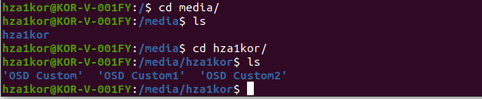
* /etc(editable text configuration) directory – Here we will have the configuration files for the applications, tools
* 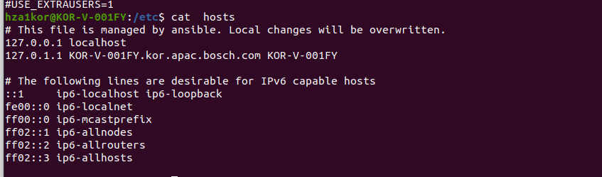
* /srv (service data) directory – All the user specific details for applications like tftp, ftp, www, rsync are available in this directory
* /sys (system) directory – All the kernel and hardware details are present here.
* 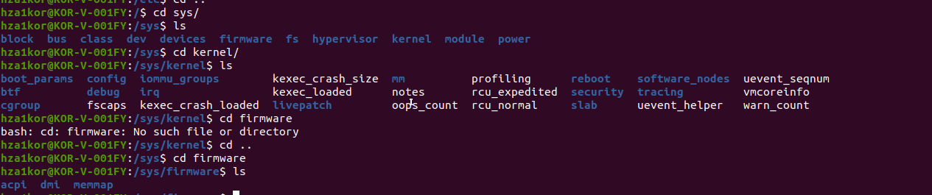
* /lib (system libraries) directory – When we run any application, for that application to run we need certain libraries,like in windows we need dynamic link libraries to run some application, so all the details related to these libraries are present in lib
* To run certain application, we need some libraries, those linraries are present in lib
* 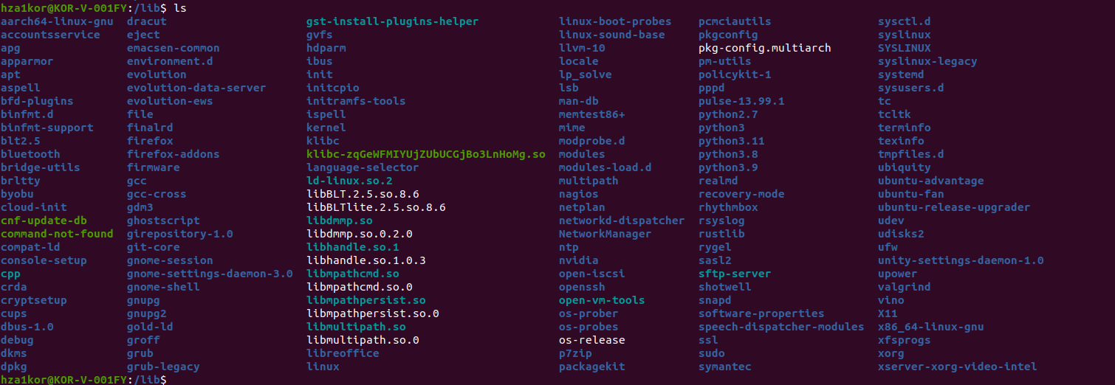
* /tmp (temporary files) directory – When we run some program, to make the prog run it needs some temporary files. These tmp files are created by tmp folder and when the program is done, it will delete those files
* 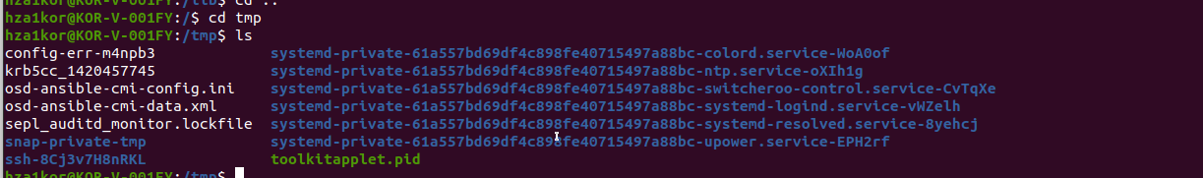
* /usr (user programs) directory – all the data present in this directory is read only. We can find binaries, libraries, documentation and source code.
* /var (variables) directory – In this directory we have files that keep changing time to time. Here we have backup files, cache and log files etc
* /opt (optional packages add on ) directory – all the 3rd party apps that we install, all the data related to those apps will be saved here
* 