What is a linux shell

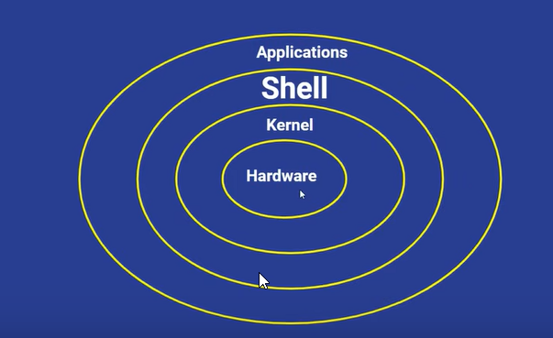

* Hardware is were ram, rom and hadware components are present
* Kernel is core component of the os, it helps communicate bw the userspace and the hw
* Shell is the interaction medium that users use to communicate with the os
* Applications are all the pkgs or utilities that user uses, like text editor, server, google etc

What is shell scripting

* Shell script consists of a set of commands to perform a task
* All the commands are executed sequentially
* Some tasks like file manipulation, program execution, user interaction, automation of task etc can be done

Explain the scripting format

* Command to print the default shell – echo $0
* The line #!/bin/bash at the beginning of a shell script is called the **shebang** (or hashbang). It specifies the interpreter that should be used to execute the script.
* Specifies the Shell Interpreter: It tells the system to execute the script using /bin/bash (Bash shell) instead of any other shell.
* Ensures Consistency: If multiple shells are available (e.g., sh, zsh, dash, bash), the shebang ensures that the script runs in the intended shell.
* Avoids Compatibility Issues: Different shells have different syntax and built-in commands. Without the shebang, the script might run with the default system shell, which could lead to unexpected errors.

How to define a variable in shell, and how to save a cmd value in a variable

#!/bin/bash

name=Sapna

age=24

echo "My name is $name and my age is $age"

hostname=$(hostname)

echo "My hostname is $hostname"

**how to take input from a user**

#!/bin/bash

echo "Hey! What's your name: "

read name

echo "Welcome $name"

**If-else condition in shell scripting**

#!/bin/bash

read -p "Enter your name: " name

read -p “Enter your age: “ age

if [ $age -ge 18 ]

then

echo "$name is elegible to vote"

else

echo "$name is not eligible to vote"

fi

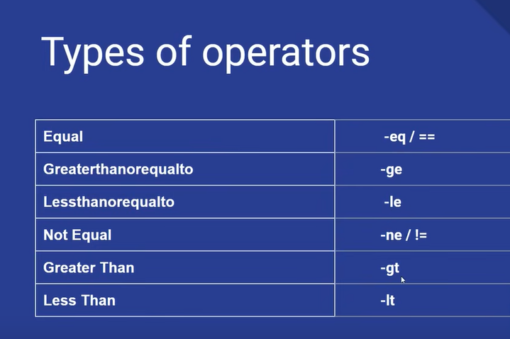

**Switch case in shell scripting**

#!/bin/bash

echo "Enter 1 to check the list of directories in the current path"

echo "Enter 2 to check the cpuinfo of the system"

read choice

case $choice in

1) ls -l;;

2) lscpu;;

*) echo "Wrong choice entered"

esac

**For loop in shell scripting**

#!/bin/bash

echo "Enter a number"

read number

for (( i=0; i<$number; i++))

do

echo "Number is : $i"

done

**while loop in shell scripting**

#!/bin/bash

i=0

final=20

while [ $i -le $final ]

do

echo $i

let i++

done

**Oracle question answer**

#!/bin/bash

for i in {1..20}

do

touch "file$i.c"

done

for i in {1..20}

do

mv "file$i.c" "file$i.cpp"

done

for i in {1..20}

do

rm "file$i.cpp"

done