Knowledge Transfer Documentation

# Understanding Automator Execution Steps

## Clone the Automator Repository

Use the following SSH URL to clone the repository:

ssh://git@sourcecode.socialcoding.bosch.com:7999/pavc_mp_dev/test_automation.git

Switch to the required branch:

git checkout feature/383443_vpc-p_flashing_scripts

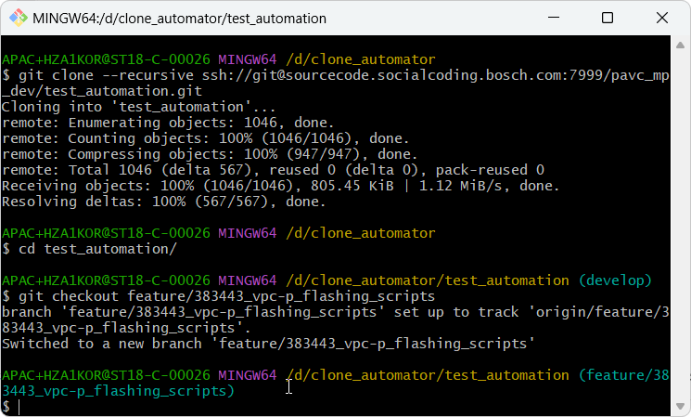

# Run the Script

Execute the script using the command:

./yocto_tester.ps1 -gui

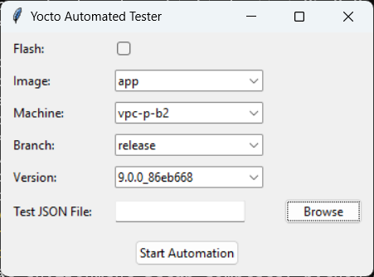

## Script Workflow

Step 1: The script first clones all the necessary repositories.

Step 2: It then creates a virtual environment and downloads all the required packages.

Step 3: Finally, it prompts you to enter the details in the Yocto Automated Tester and starts the execution.

## Parameter Inputs

Image: Choose one of the following options: app, eol, or val.

Machine: Select from vpc-p-b1, vpc-p-b2, or vcu-p-c0.

Branch: Specify either develop or release.

Version: Enter the latest version you want to test (this can be manually entered).

Test JSON File: Provide the JSON file you want to test (e.g., smoke_test.json, xts_test.json).

Flash Option: If you want to flash the binaries for a certain version, enable the flash option (currently, flashing works properly for eol only).

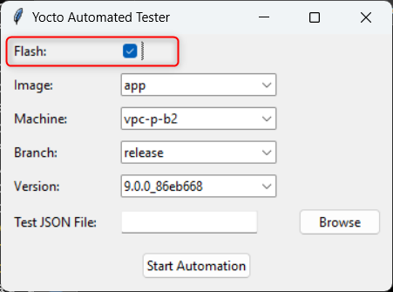

## Start Automation

Click on Start Automation. The system will test the specified image and generate output reports in the reports folder.

# Additional Information

1. Main JSON Files:

Located at: test_automation\config\automations\tests

1. Flash-Related JSON Files:

Located at: test_automation\config\automations\common

1. Modify any project-specific or SSH-related settings via: test_automation\config\automations\config_files
2. Downloaded Artifactory Binaries:

Stored in: test_automation\downloads

1. Log Files:

Located in: test_automation\logs

1. Reports:

Saved in: test_automation\reports

1. XTS Test Framework:

Cloned and saved at: test_automation\test_scripts\tester\VPC-P_Testing_Framework

1. Automator Function Definitions:

Available at: D:\sapna\Eol_automator\test_automation\xc_ce_utils

1. JSON Example:

For an example of how to write JSON, refer to the sample file model.json located in: test_automation\xc_ce_utils\automator

# Summary

Testing: Demonstrated how to run app smoke tests for the 10.8.0 release.

Documentation: Provided detailed instructions on how to run the automator.