FLASHER APP DOCUMENTATION

* The Flasher app is used to flash images directly via TFTP instead of using Trace.
* Note: The steps for the Flasher app are also available at:
* test_scripts\tester\VPC-P_Testing_Framework\Tftp_test\tftp\flash_images\flash-steps.txt

# Pre-requisite

* Ensure that the test_scripts repository is cloned using the following command:
* git clone ssh://git@sourcecode.socialcoding.bosch.com:7999/pavc_mp_dev/test_scripts.git

# Steps to Flash Images via Flasher App

1. Ensure you have the package.zip file (located in the build folder).
2. Boot the board.
3. Login to the board.
4. Open TFTP or run automate_tftp.py (located at test_scripts\tester\VPC-P_Testing_Framework\Tftp_test\automate_tftp.py). You can change the anticipation window and the IP address of the remote setup in the automate_tftp.py code.

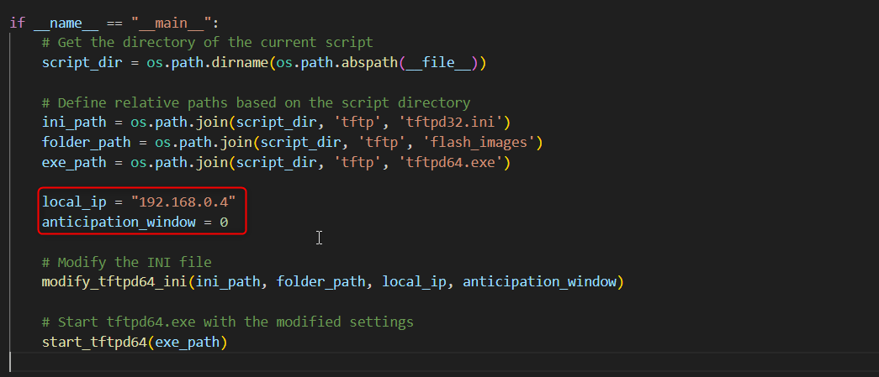

1. Provide the following paths in the script: folder_path for package.zip, exe_path for tftpd64.exe, and ini_path for tftpd32.ini.

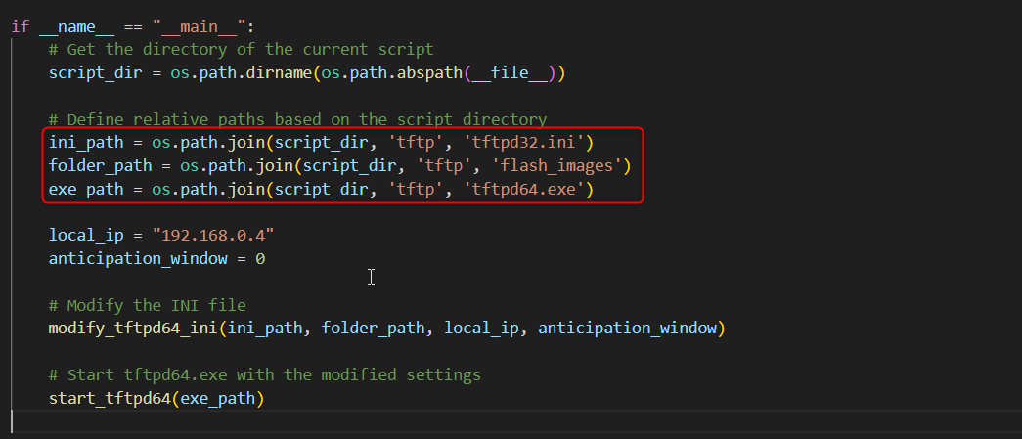

1. Alternatively, you can manually specify the path, IP address, and anticipation window by opening tftpd64.exe.
2. Once logged in via PuTTY, run the following commands:

* Command Script:

tftp -gr package.zip 192.168.0.4  
unzip package.zip  
cp package/* .  
./install.sh  
systemctl stop xts  
/bin/process_xts --config /etc/xts -loglevel min  
(Ensure the correct IP address is provided in the tftp command)

* While the script is running, verify via TFTP that the download is progressing correctly.

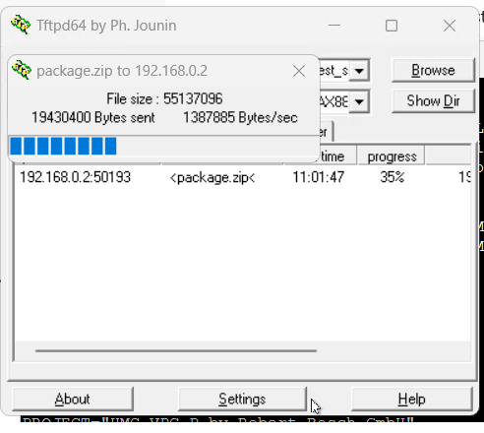

# Post-execution

• After the script finishes, PuTTY logs should display a message such as 'state running reached', indicating success.

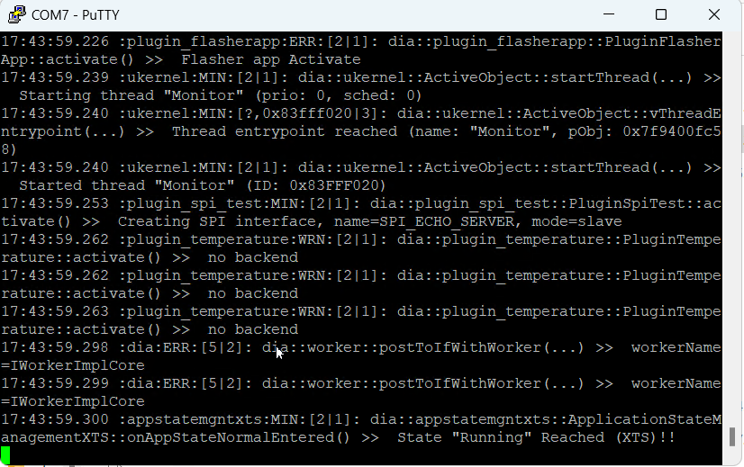

• If errors occur, check the PuTTY logs. Possible issues include an incorrect package.zip location or errors in the deploy.bat file. Rebuild the package and try again if needed.

# Meta-file Requirements

• The meta file should list all images to be flashed. Its name must follow the format: meta-file_***.csv, where *** can be any three letters (uppercase or lowercase).

• For example, if the meta file is named meta-file_EOL.csv, note the ASCII hexadecimal values for E, O, and L:

- E: 0x45

- O: 0x4F

- L: 0x4C

• The meta file (e.g., meta-file_EOL.csv) should have the following format:

image_name,flash_memory(EMMC/NOR),start_address,size_on_disk

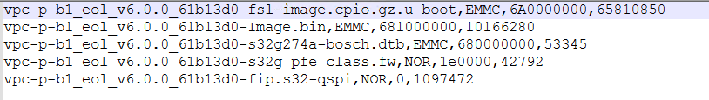

• To determine the size of an image, right-click the image file, select Properties, and check the 'Size on disk' value in bytes.

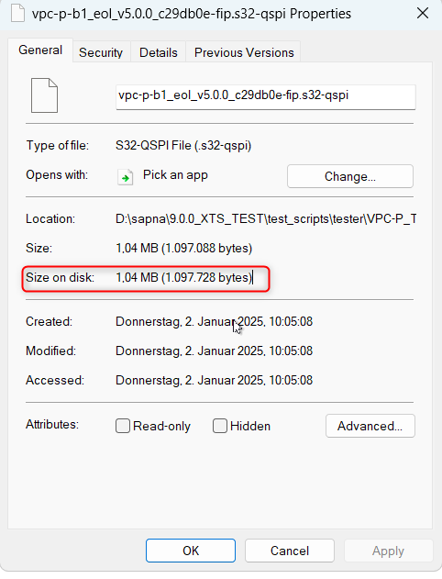

# XTS Commands for Flashing

* Next, use the XTS commands to flash the new binaries on the board using the Flasher app.
* Command to start the flash process (values must be in ASCII hexadecimal):
* --targetIP=ip_address_of_target --testerIP=ip_address_of_tester -m 1063 -m 31011260 E O L 192.168.0.4
* Example:
* --targetIP=192.168.0.2 --testerIP=192.168.0.4 -m 1063 -m 31011260 45 4F 4C 31 39 32 2E 31 36 38 2E 30 30 30 2E 30 30 34 2E
* To check the progress of flashing, use the following command:
* --targetIP=ip_address_of_target --testerIP=ip_address_of_tester -m 1063 -m 31031260
* Example:
* --targetIP=192.168.0.2 --testerIP=192.168.0.4 -m 1063 -m 31031260
* To stop the Flasher app, use this command:
* --targetIP=ip_address_of_target --testerIP=ip_address_of_tester -m 1063 -m 31021260
* Example:
* --targetIP=192.168.0.2 --testerIP=192.168.0.4 -m 1063 -m 31021260

# Expected Outputs

• Start flashing process output: 71 01 12 60 03

• Progress output: 71 03 12 60 03 24

(This command can be run multiple times. Once you see this output, flashing is successful.)

• Stop flasher app output: 71 02 12 60 00

• If the output of any command differs from these values, there may be issues such as an improper meta file name, missing images, or an incorrect start address.

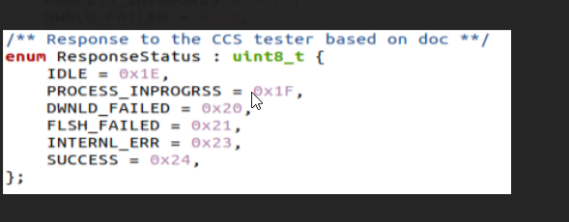

While flashing is in progress, running the progress command should output: 71 03 12 60 03 1F

After stopping the Flasher app, verify the new images by booting the board and running 'cat /etc/os-release'. If the version matches the meta file, the flashing was successful.

# Final Note

• Ensure that package.zip, the images to be flashed, and the meta file are all present in the following location:

test_scripts\tester\VPC-P_Testing_Framework\Tftp_test\tftp\flash_images

• Note: TFTP is not reliable for flashing large images in all setups except SI-Z10 (Old B1 Setup).

• Currently, the Flasher app has not been fully tested since none of the setups were working properly. A demo session will be arranged once the setup is stable.