GTest Setup in CMake Project

# 1. Introduction

* This document outlines the steps to integrate GoogleTest and related tools into a CMake-based project, including code coverage with gcov and reporting with gcovr.

# 2. GoogleTest (GTest)

* GoogleTest is a versatile C/C++ testing framework developed by Google that runs on Linux, Windows, and macOS. It supports multiple test types beyond unit tests.
* Advantages:

1. Cross-platform support for C/C++ code.

2. Supports various test styles (unit, integration, end-to-end).

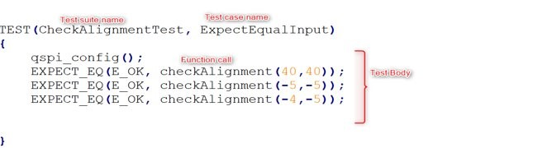

# 3. GoogleMock (GMock)

* GoogleMock extends GoogleTest by providing a framework for creating mock objects in C++, allowing precise control and verification of interactions with external dependencies.

# 4. Code Coverage: gcov and gcovr

* gcov is a profiling tool that generates coverage data to show which lines of code execute and how often.
* Benefits of gcov:

1. Line execution counts.

2. Identification of untested code paths.

3. Timing information for each code section.

* gcovr automates gcov and generates summarized coverage reports in text, XML, or HTML formats, suitable for CI integration.
* gcov data files:

• .gcno files: Generated at compile time with -ftest-coverage, containing graph and line number data.

• .gcda files: Generated at runtime with -fprofile-arcs, containing execution counts and profiling data.

# 5. Steps to Clone and Build for Initial GTest Setup

1. Clone the repository recursively:

git clone --recursive ssh://git@sourcecode.socialcoding.bosch.com:7999/pavc_mp_dev/test_scripts.git

2. Change directory: cd test_scripts

3. Checkout the feature branch: git checkout feature/Gtest_setup

4. Run the build script: ./build.ps1 (or follow manual steps in steps.txt)

5. Executables saved in: build_gtest/exe_generated

6. Coverage reports available in: build_gtest/coverage

7. .gcda files located in: build_gtest/CMakeFiles

While building build.ps1 if you get an error related to installation of python dependencies like -

WARNING: Retrying (Retry(total=0, connect=None, read=None, redirect=None, status=None)) after connection broken by 'NewConnectionError('<pip._vendor.urllib3.connection.HTTPSConnection object at 0x000002659B6CC190>: Failed to establish a new connection: [Errno 11001] getaddrinfo failed')': /simple/gcovr/ ERROR: Could not find a version that satisfies the requirement gcovr (from versions: none) ERROR: No matching distribution found for gcovr

Make sure you add proxy setting for http and https

* **Login as admin**
* **Edit the enviromnent variables**
* **In system variables add two new variables http_proxy and https_proxy with value - http://rb-proxy-in.bosch.com:8080** 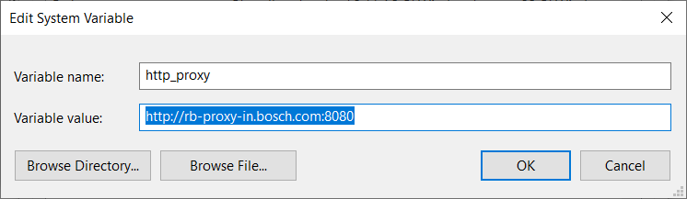

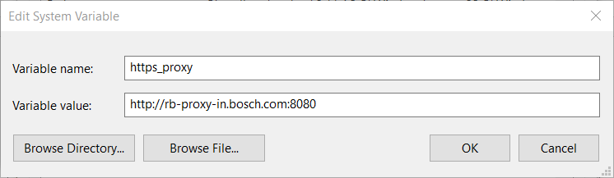

# 6. Test Executable Output

* The test executable (e.g., factorialtest.exe) will run all defined tests and display pass/fail results for each test case.

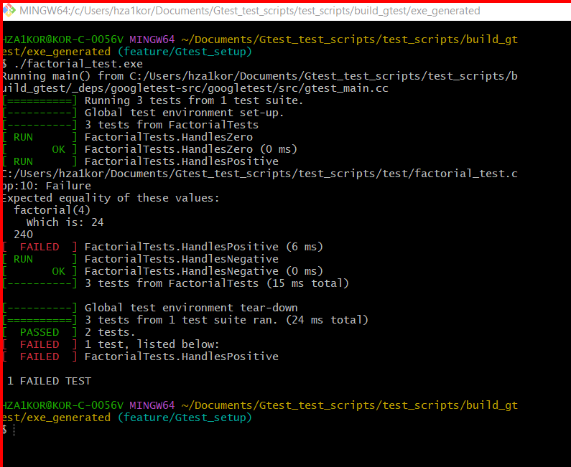

# 7. Coverage Report Output

* Coverage data is presented as line-hit percentages and summarized per file, helping identify untested areas.

